Weekly reports are to be emailed to atbecker@uh.edu by 5:00pm on Tuesdays. The purpose of a weekly report is to: (1) give you text and images for your papers, thesis, and dissertation, (2) document progress, (3) identify if you are stuck or need resources.

Weekly report

1. **My *Goals* from last week**

* Print/ etch a fine channel for the particles to move in.
* Move particles with acceptable level of control. It is not that great now.
* Introduce flow in the simulation environment.

1. **My *Accomplishments* this week**

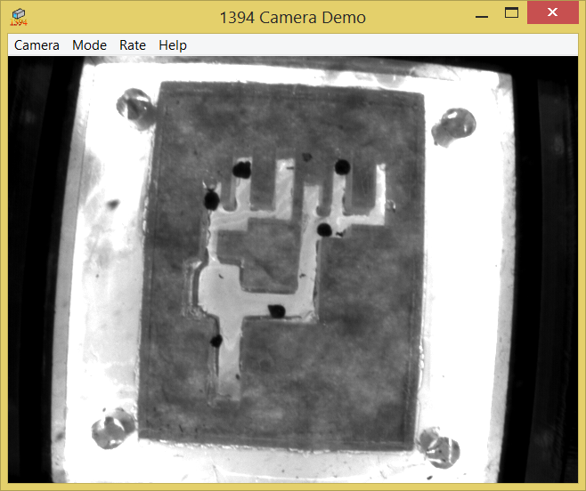

* We made this channel with Sheryl’s design and moved particles around in it.
  + Particles get stuck in corners, size of maze must be increased.
  + We are changing the matlab code to make z field stronger so that there is less interaction with the bottom. **Best solution would be to have particles that can float in water. I would like to contact the Dallas lab about this. Can I?**
  + The code’s aim would be to make them swim. Example: Left= Left coil+ Z coil and y coils pulsating.
  + We tried it with the mm sized beads. They always stick to each other and just orient in the direction of the field unless agitated. But even with that, when they stick together, they make straight chains. They are not suitable.
* We made lists for major, minor and journal level corrections.

1. **My *Goals* for next week**

* Make bigger maze and get particles to float. Moving them won’t be a problem then.
* Video of Sheryl’s assembly and moving particles in curved regions for Dr. O’Kane’s lab.
* Sort my travelling hurdles for the conference.

1. **What I need Dr. Becker to do:**
   1. Update us all on how the vacation is going.
   2. Help with getting in touch with Dallas lab for floating particles if possible.