Weekly reports are to be emailed to atbecker@uh.edu by 5:00pm on Tuesdays. The purpose of a weekly report is to: (1) give you text and images for your papers, thesis, and dissertation, (2) document progress, (3) identify if you are stuck or need resources.

Weekly report

1. **My *Goals* from last week**

* Make bigger maze and get particles to float. Moving them won’t be a problem then.
* Video of Sheryl’s assembly and moving particles in curved regions for Dr. O’Kane’s lab.
* Sort my travelling hurdles for the conference.

1. **My *Accomplishments* this week**

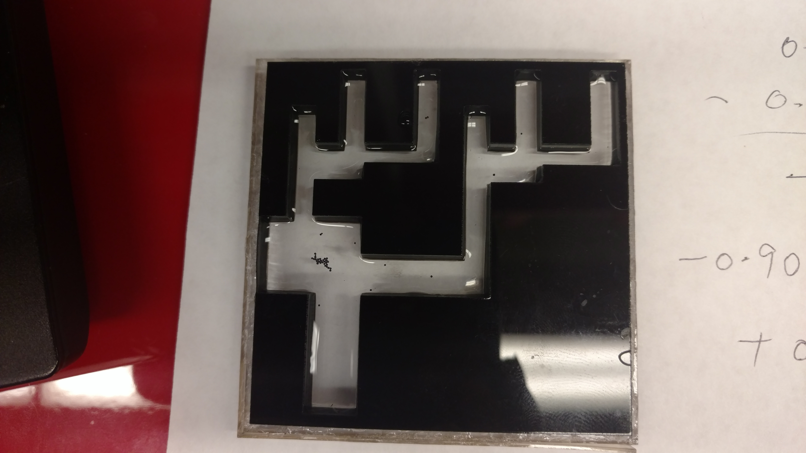

* Biggest maze possible. Interesting notes:
  + Paramagnetic polyethylene Particles are hydrophobic and so they float.
  + Meniscus is an issue. Particles gather at minima even if placed in channels.
  + But getting rid of it by coating walls with oil causes issue of sticking.
  + Conclusion is that meniscus is important to avoid sticking, but maze corners must be rounded to reduce the effects of local minima forming. All paths must be made of equal length.
  + Single particles move much slower than bigger swarms. We will model tis too in the simulations.
  + We have come to this design after trying out the following:
    - Cut out suspended in water 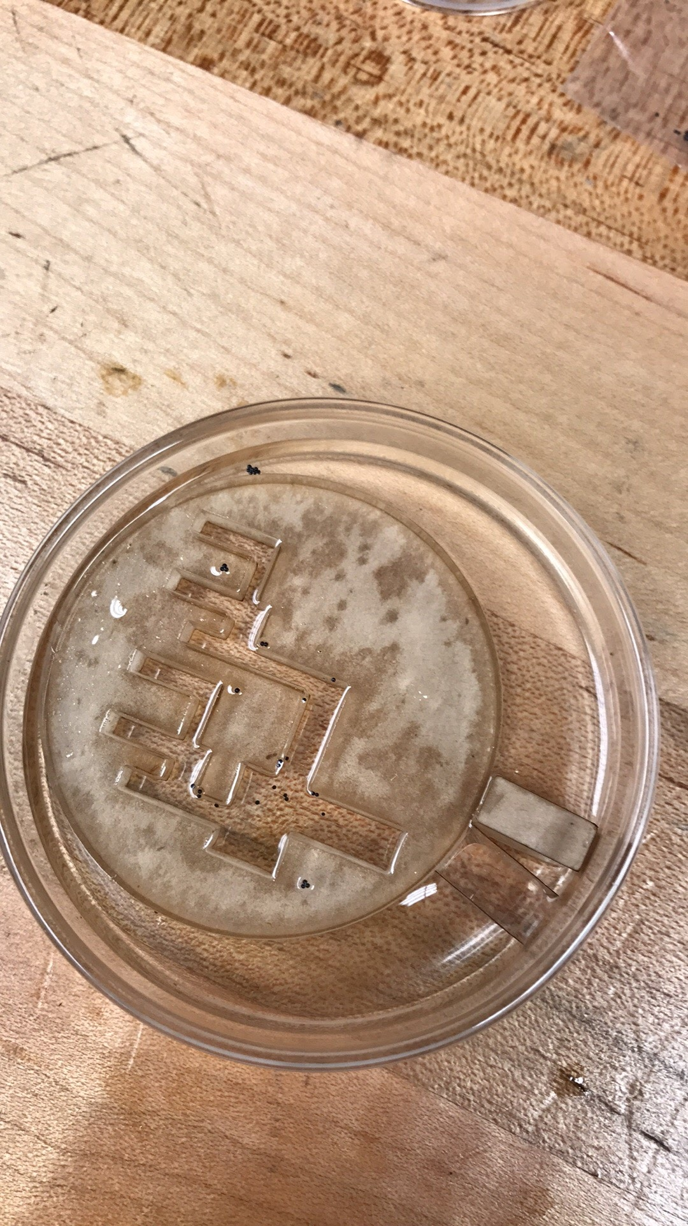
    - Also we tried an inverted maze in water.
* Program works well. Adding arrow directions currently. We can create vector fields with varying strength.

1. **My *Goals* for next week**

* Help Daniel make abstract.
* Correct paper mistakes.

1. **What I need Dr. Becker to do:**
   1. Update us all on how the vacation is going.
   2. Help with getting in touch with Dallas lab for floating particles if possible.