Weekly reports are to be emailed to atbecker@uh.edu by 5:00pm on Wednesdays. The purpose of a weekly report is to: (1) give you text and images for your papers, thesis, and dissertation, (2) document progress, (3) identify if you are stuck or need resources.

Weekly report

1. **My *Goals* from last week**

* Test the deployment mechanism in the fountain.
* Redesign and mount the sensor module retrieval mechanism.
* Begin designing wireless charging system for the ROV. (Javier primarily focused on this task.)

1. **My *Accomplishments* this week**
   1. Project 1: Water and Attached IMU/Depth Sensor to ROV

* The IMU came with a small acrylic housing that had to be cemented together and then the IMU is placed inside and covered in epoxy in order to water proof it and hold it within the housing. The wiring was then soldered to the existing IMU wires extending from the ROV electronics hub and water proofed by coating the connections in liquid electrical tape and two layers of heat shrink. Finally I superglued the IMU housing to the underside of the ROV frame such that the depth sensor will properly function.

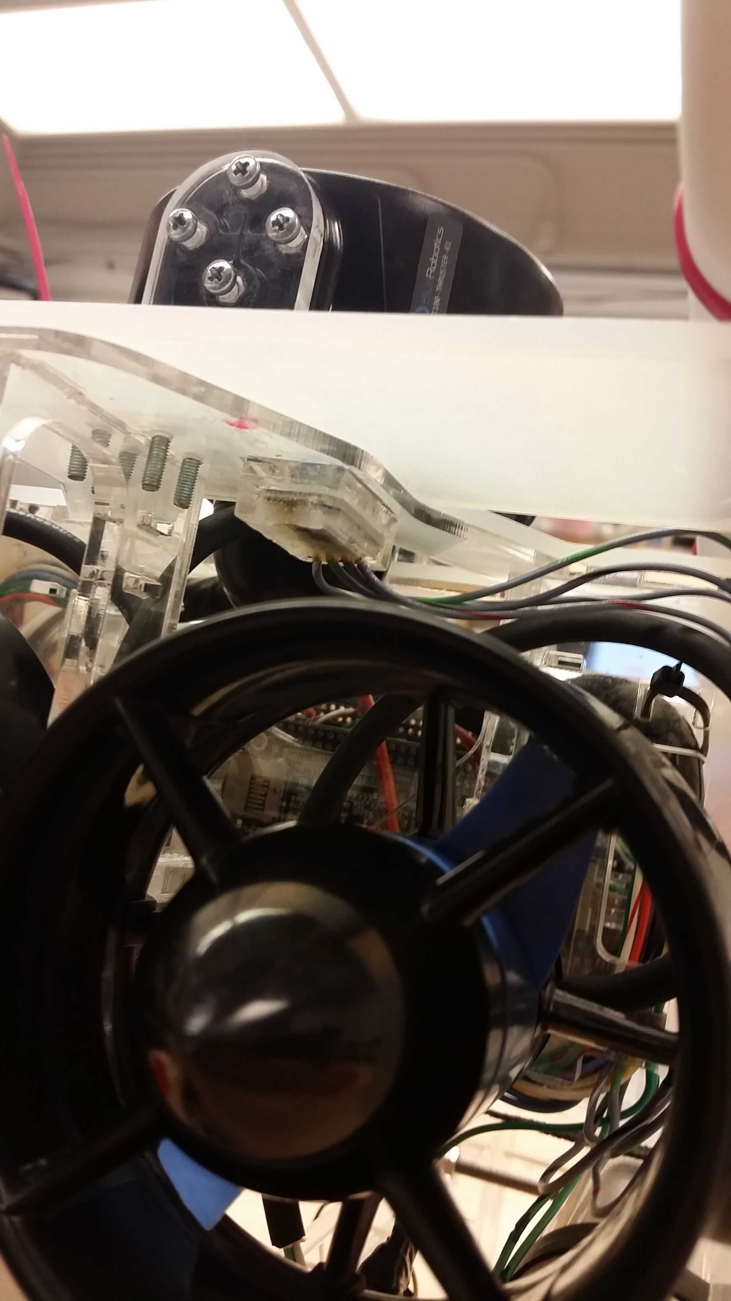

**Figure 1:** IMU fully attached to the ROV frame.

* 1. Project 2: Attached Retrieval Mechanism
     + After the sensor modules were redesigned the existing retrieval mechanism had to be modified to properly hook the floating rings on the top of the sensors. Because of the new sensor module design I was able to greatly reduce the size of the retrieval hooks. The retrieval mechanism is made up of two laser cut, red acrylic hooks that can each hold two sensor modules. The hooks are designed with barbs so that the sensor modules can easily slide up and onto the device but not easily fall off. The hooks are mounted at the bottom of the port and starboard sides of the ROV chassis with screws and lock nuts.

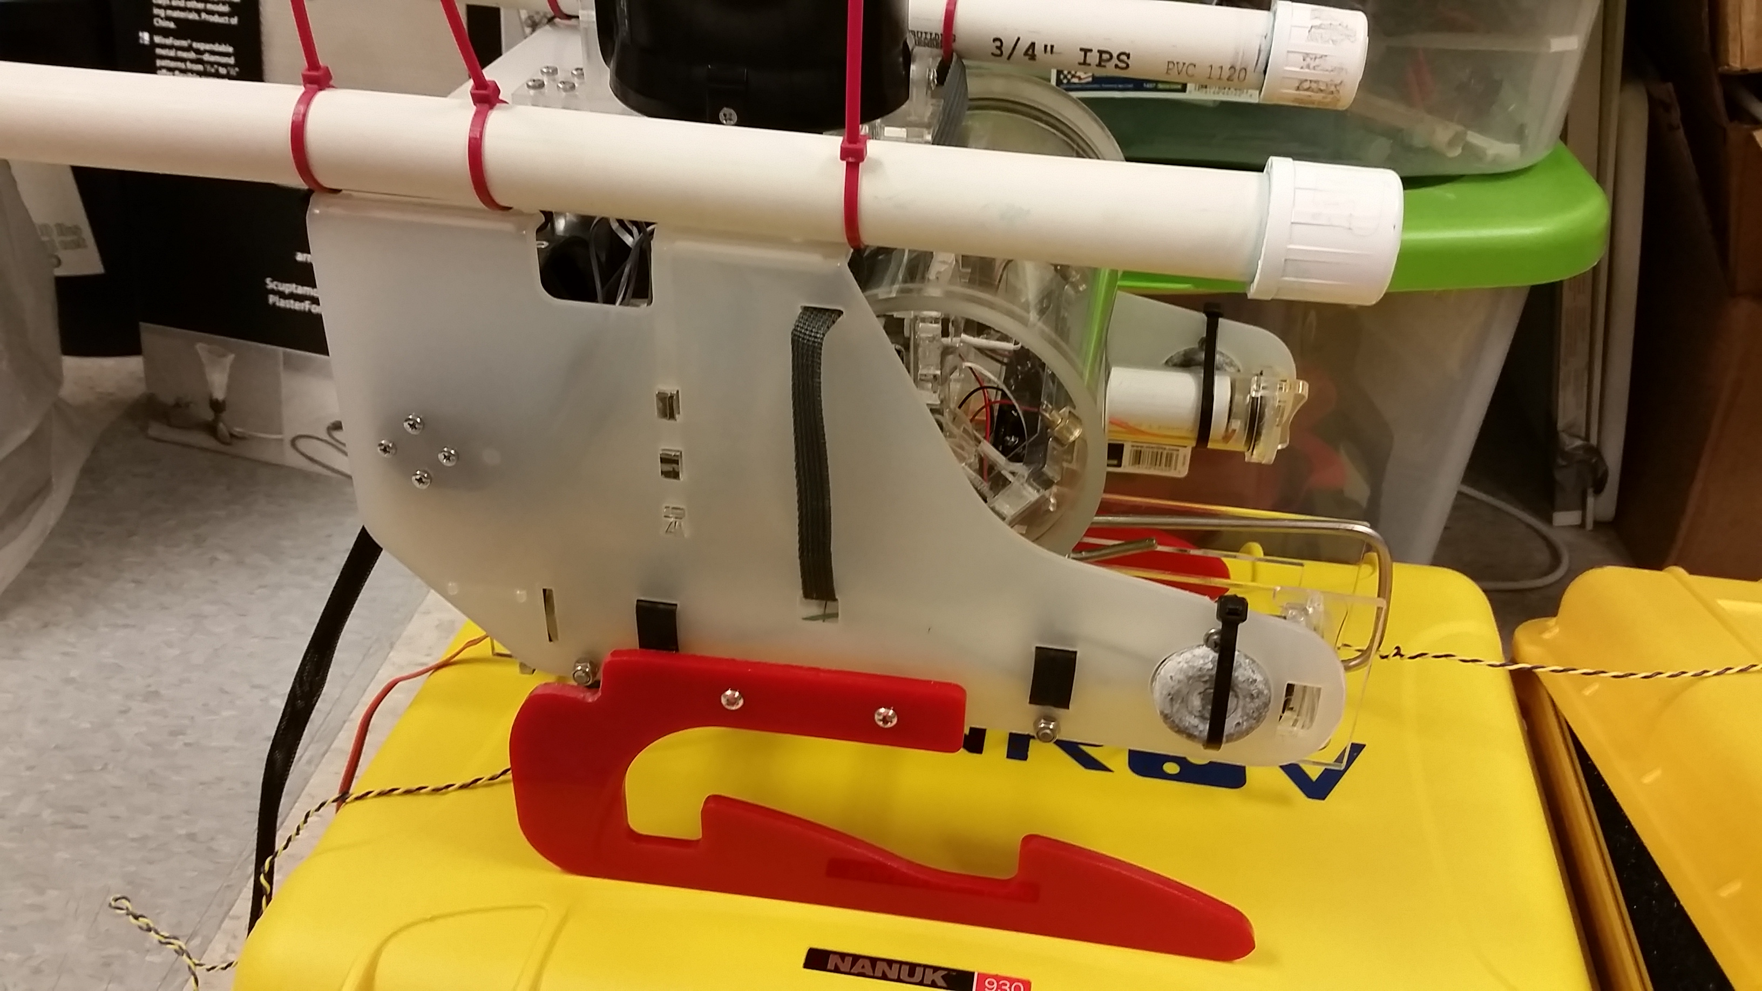

**Figure 2:** ROV with Retrieval Mechanism Fully Mounted

1. **My *Goals* for next week**

* Test the deployment mechanism in the fountain, once all additional electronics are connected to the electronics hub and water proofed.
* Learn basics of javascript to help Austin with OpenROV code.
* Continue designing wireless charging system for the ROV.

1. **What I need Dr. Becker to do:**

Email Loretta and ECE travel about EXACTLY which days we will be traveling. Shiva, Sheryl and my interpretation of one extra day in Vancouver was that we could leave the 23rd and return the 30th, but this was not correct to the ECE dept. so we have not been able to turn in the paperwork despite everyone, except maybe Li, having completed the required forms. I already emailed you about our confusion regarding the travel timeline, but this is fairly urgent in order for us to book flights and hotels within the next 2-4 weeks.