Weekly reports are to be emailed to atbecker@uh.edu by 5:00pm on Tuesdays. The purpose of a weekly report is to: (1) give you text and images for your papers, thesis, and dissertation, (2) document progress, (3) identify if you are stuck or need resources.

Weekly report

1. **My *Goals* from last week**

* Help Daniel make abstract.
* Correct paper mistakes.

1. **My *Accomplishments* this week**

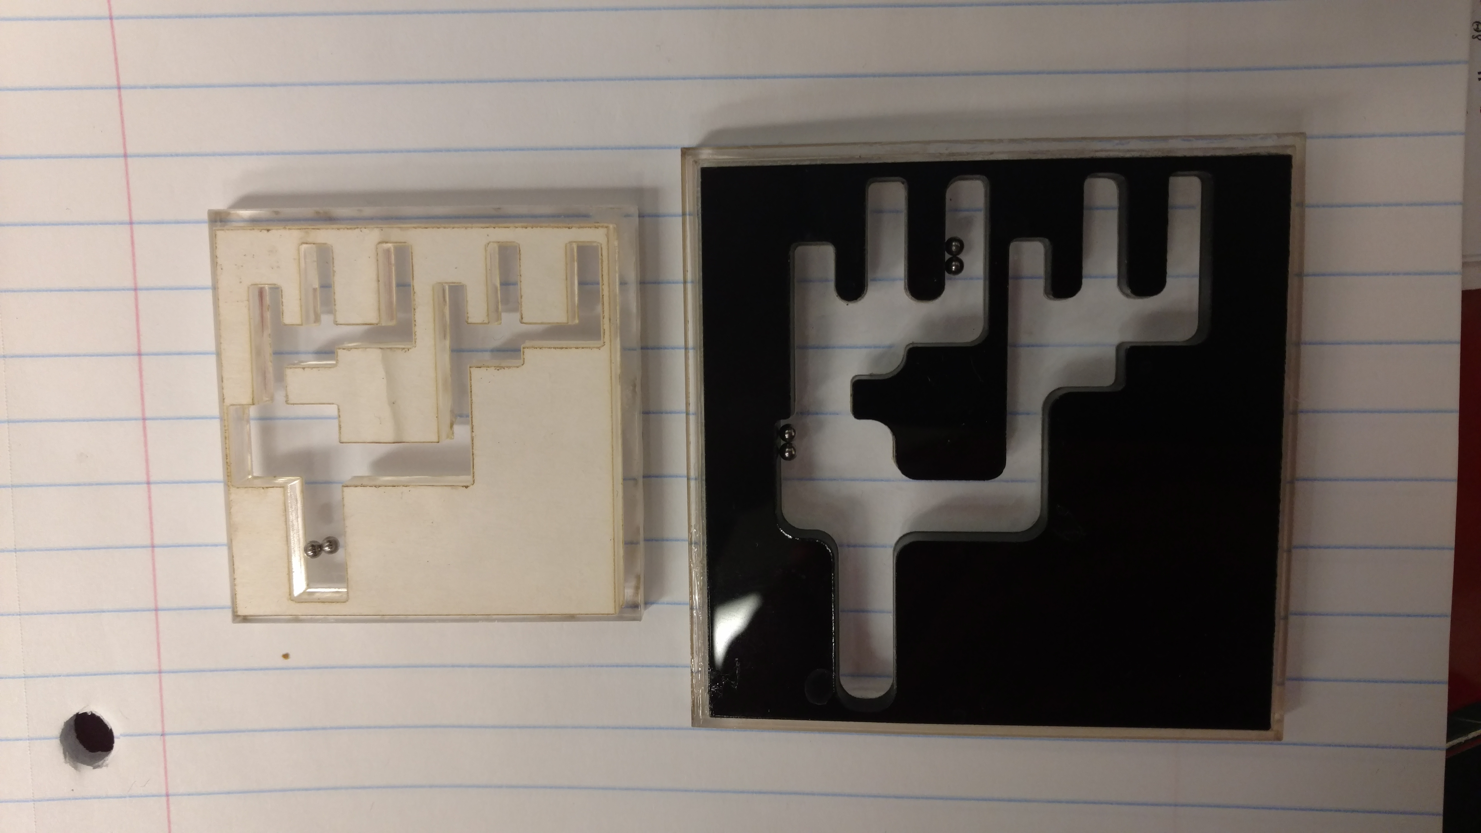

* We made curved edges to reduce meniscus. Doesn’t seem to help that much.
* We tried using steel sphere. They react maximally if nearer to the coil of activation and have weak actuation when farther away. We have to walk the spheres with a saw-tooth motion. Unreliable motion.
* The spheres stick too fast too.
* Contacted Dallas SMU lab. The link for the particles is <http://www.spherotech.com/para_par.htm>
* I feel we need to do more literature survey to find out good particles..
* Program works well. We can have vector control now.

1. **My *Goals* for next week**

* Work on editing the paper
* Work on simulation
* Literature study on particles to be used

1. **What I need Dr. Becker to do:**
   1. Meeting request on Thursday at 2:00 PM