Weekly reports are to be emailed to atbecker@uh.edu by 5:00pm on Wednesdays. The purpose of a weekly report is to: (1) give you text and images for your papers, thesis, and dissertation, (2) document progress, (3) identify if you are stuck or need resources.

Weekly report

1. **My *Goals* from last week**

* Test the deployment mechanism in the fountain, once all additional electronics are connected to the electronics hub and water proofed.
* Learn basics of javascript to help Austin with OpenROV code.
* Continue designing wireless charging system for the ROV.

1. **My *Accomplishments* this week**
   1. Project 1: Preparation for Testing at Rec pool.

* This preparation included the completion of the wireless charging system for the ROV and (attempted) water proofing of all of the motors and other electronic components for these systems. This also included preparing the wireless charging system for a sensor module and two “dumb” sensor modules to act as items for retrieval. After an all-night work shift, we had completely prepared everything for the testing, but had not allowed enough time for some of the epoxy used for waterproofing to fully set. There were some other small and large issues that were revealed with the testing process and we will be working on those throughout the next week.

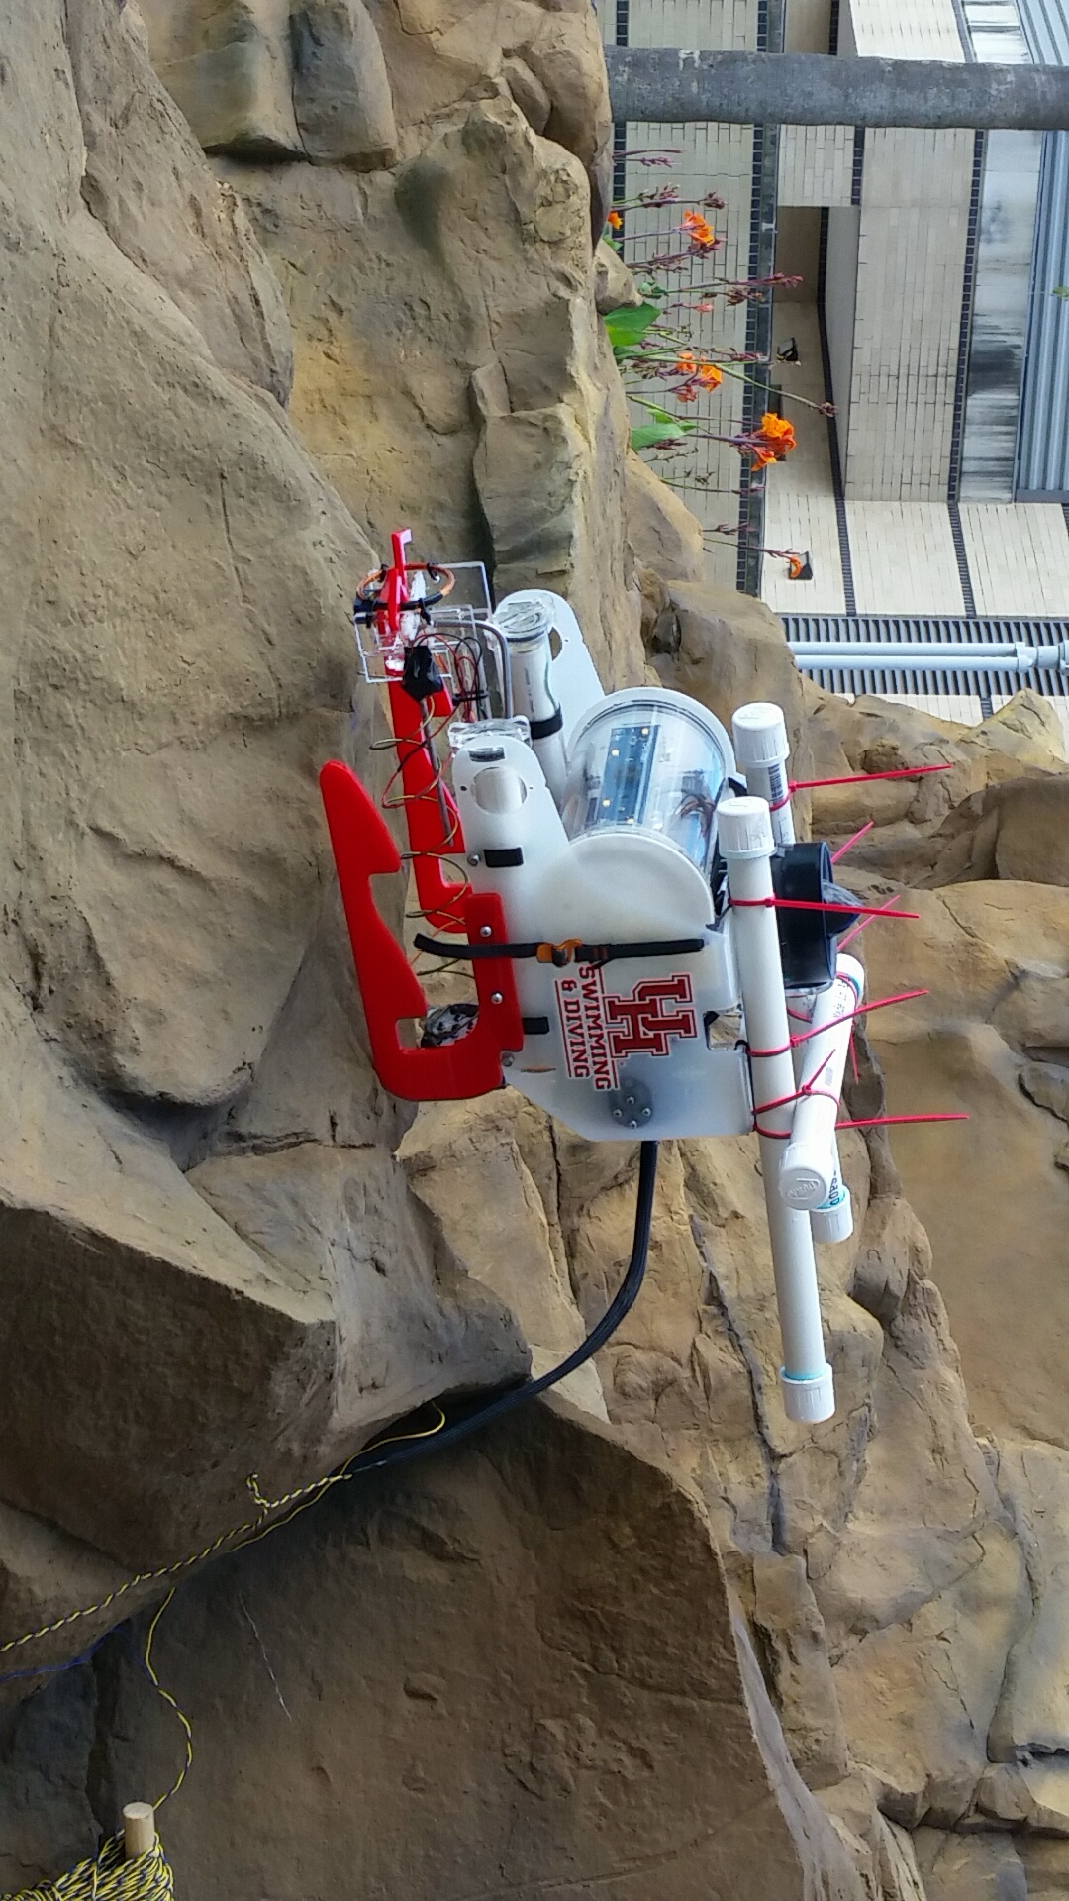

**Figure 1:** Modified ROV gloriously perched upon the rocks of the Rec center’s leisure pool.

* 1. Project 2: Learning javascript
     + I have been reading a book on javascript to slowly increase my understanding of this programming language and the code for the ROVs. I have learned a decent amount but have a long ways to go before being of any use to writing and modifying ROV code.

1. **My *Goals* for next week**

* Test the ROV electronics to ensure they are not damaged.
* Create new sensor module design that can work properly with the ROV.
* Redo the water proofing that failed during testing.
* Continue learning javascript if there is nothing else to work on

1. **What I need Dr. Becker to do:**