Weekly reports are to be emailed to atbecker@uh.edu by 5:00pm on Tuesdays. The purpose of a weekly report is to: (1) give you text and images for your papers, thesis, and dissertation, (2) document progress, (3) identify if you are stuck or need resources.

Weekly report

1. **My *Goals* from last week**

* Work on editing the paper
* Work on simulation
* Literature study on particles to be used
* **My *Accomplishments* this week**
* We found ROS + MATLAB and has stage in it. The initial trials are interesting. It is quite possible to get working on algorithms soon.
* Helped Daniel set up Mathematica simulation. He should have results soon.
* Found Cospheric particles as an interesting upgrade to the current particles. The order is attached.

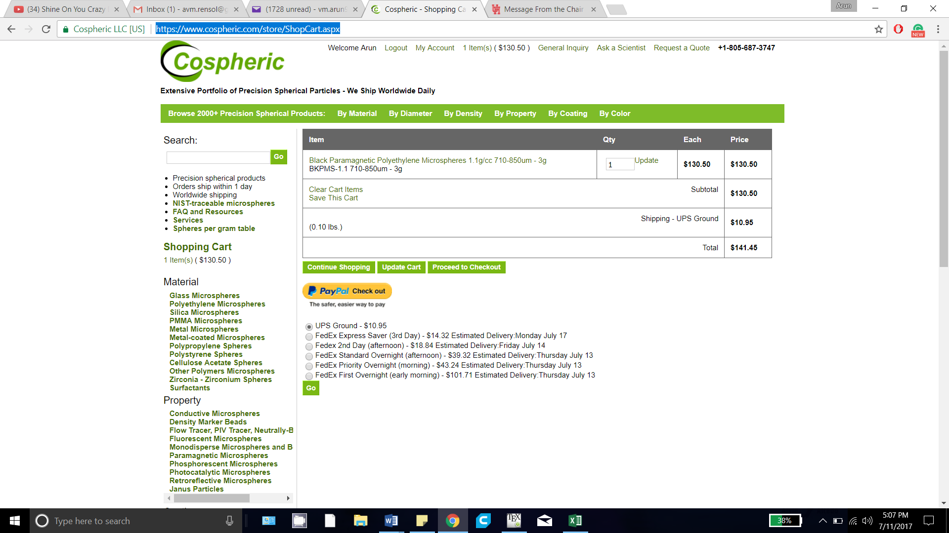

* Floors are clean and waxed. Moved all the equipment back into the lab. Phew!!

1. **My *Goals* for next week**

* Work on editing the paper

1. **What I need Dr. Becker to do:**
   1. Meeting request on Wednesday for paper reviews discussion