Weekly reports are to be emailed to atbecker@uh.edu by 5:00pm on Tuesdays. The purpose of a weekly report is to: (1) give you text and images for your papers, thesis, and dissertation, (2) document progress, (3) identify if you are stuck or need resources.

Weekly report

1. **My *Goals* from last week**
   * Enable surface ship to travel to GPS coordinates
2. **My *Accomplishments* this week**
   1. Project 1: Ocean Big Data
      * Patched holes in surface ship
      * Connected surface ship to mission planner

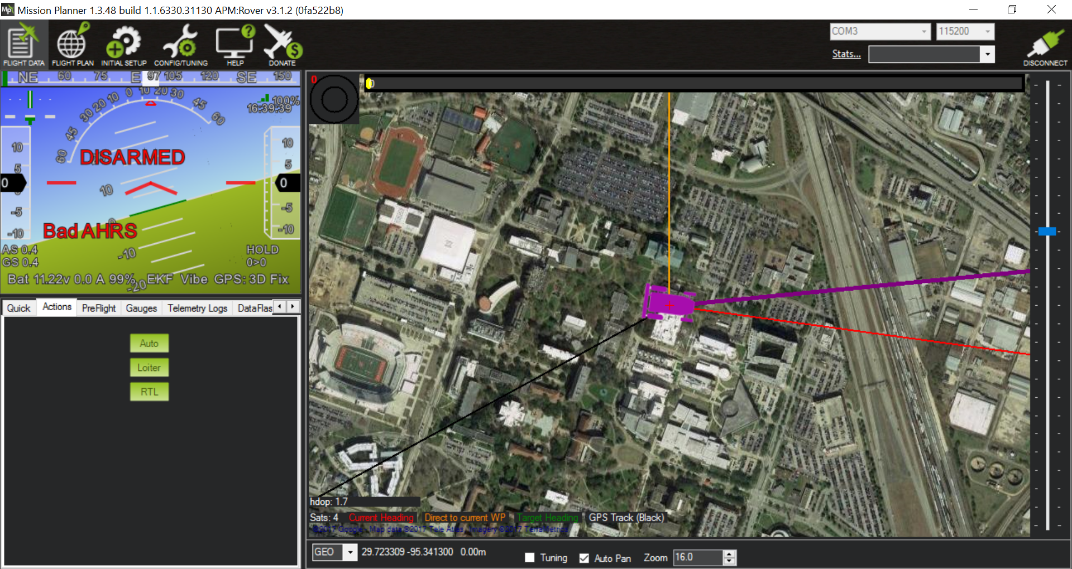

Figure . Flight Data from Mission Planner

1. **My *Goals* for next week**

* objective 1. Perform two experiments using the MI and acoustic systems from Missouri
  1. Meeting with Dr. Becker on Tuesday, July 18th, 2017

1. **What I need Dr. Becker to do:**
   1. Approve the IROS abstract so that I can upload it before the deadline on the 15th.