Weekly reports are to be emailed to atbecker@uh.edu by 5:00pm on Wednesdays. The purpose of a weekly report is to: (1) give you text and images for your papers, thesis, and dissertation, (2) document progress, (3) identify if you are stuck or need resources.

Weekly report

1. **My *Goals* from last week**

* Test the ROV electronics to ensure they are not damaged.
* Create new sensor module design that can work properly with the ROV.
* Redo the water proofing that failed during testing.
* Continue learning javascript if there is nothing else to work on.

1. **My *Accomplishments* this week**
   1. Project 1: Underwater Gauss Gun Testing

* Javier and I tested the Gauss Gun with an aluminum foil cap on the end of the trigger stage and retested the same parts without the cap. Both tests allowed the firing of the small steel ball from the gauss gun into the target sponge, but the velocity was much higher with the end cap. We will retest this same experiment with a needle tip on the end of the steel ball and hopefully puncture the sponge.

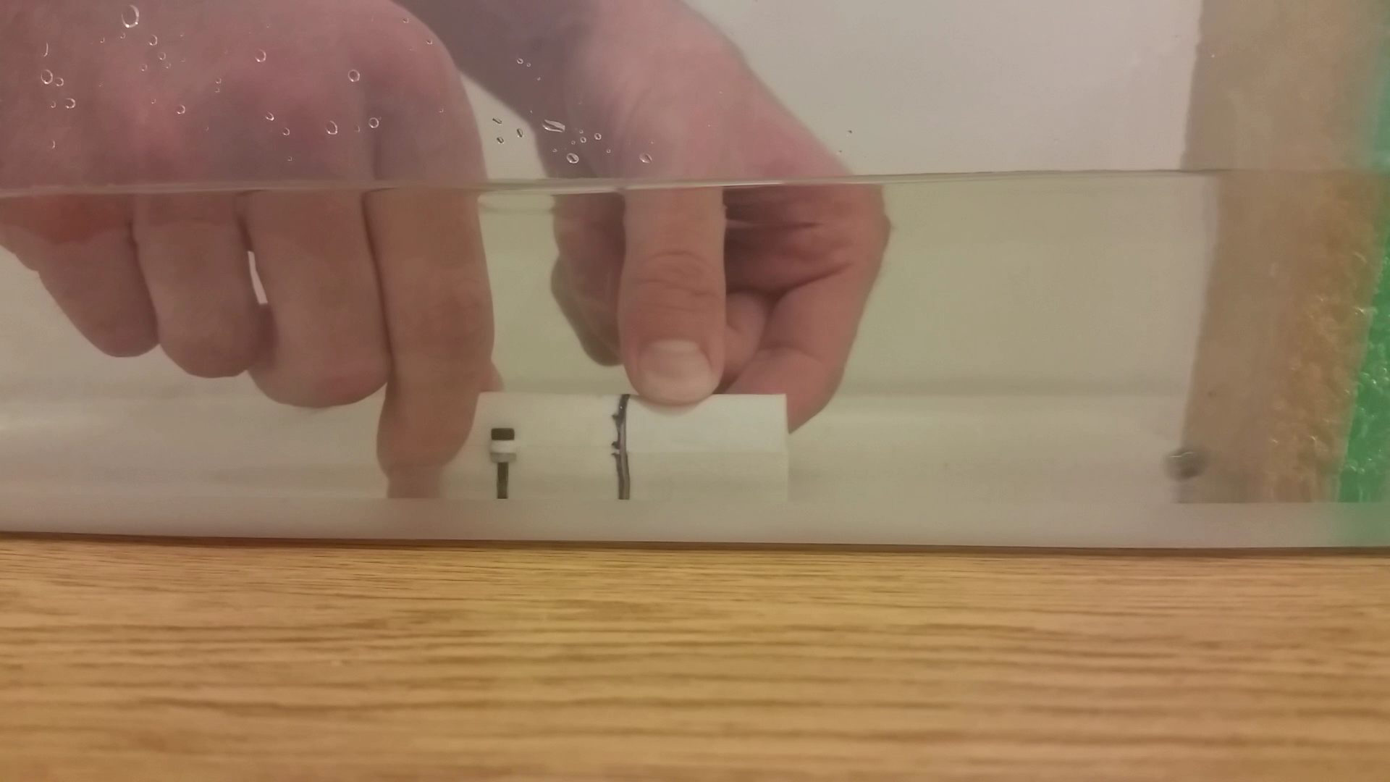

**Figure 1:** Underwater Gauss Gun experiment successfully firing a steel ball.



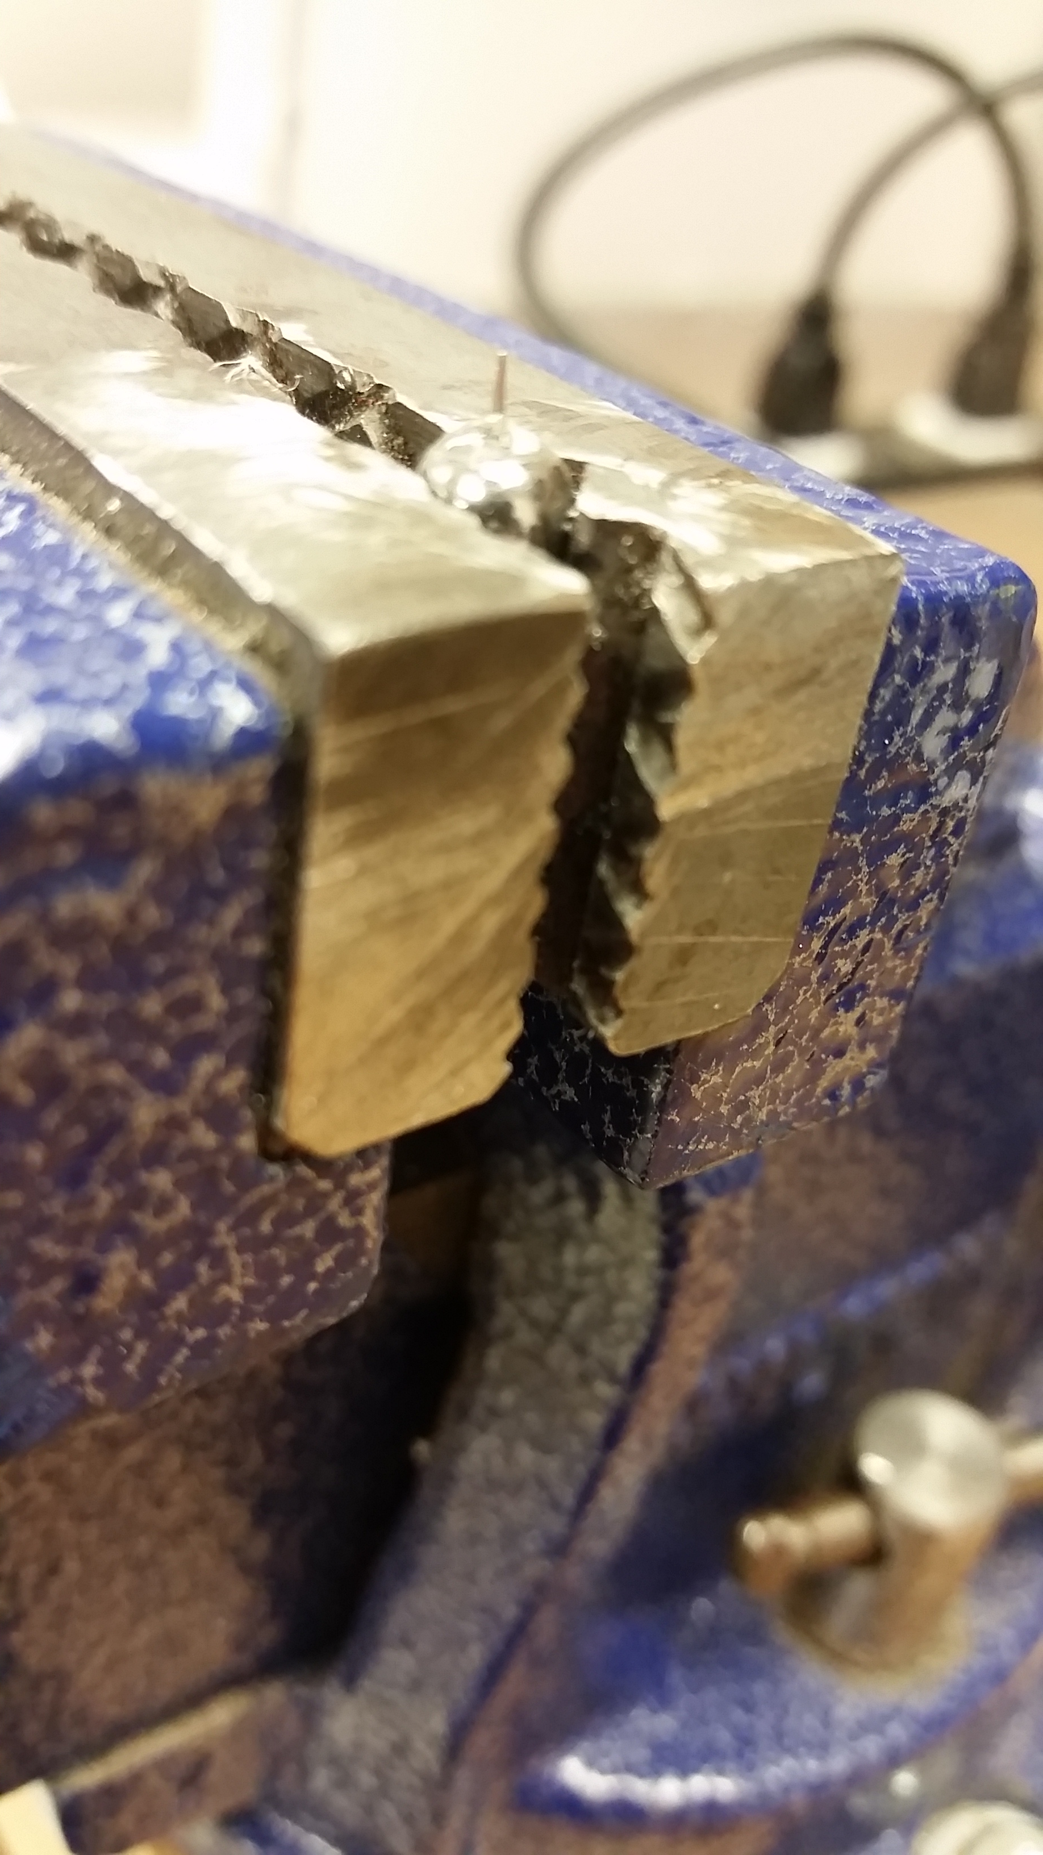

**Figure 2:** Steel Ball with needle tip epoxied to it.

* 1. Project 2: Waterproofing Electronics Hub
     + After completely redoing the epoxy and sealing of the motor wires exiting the end cap of the electronics hub with an exuberant amount of epoxy, liquid electrical tape and heat shrink it seems that water is still finding its way into the air pocket. It looks like there may be a defect (several scratches and a few cracks) in the cylindrical acrylic piece of the electronics hub, which could likely be the entry point for the water. I will try to mend these defects and retest everything but we may have to purchase a new acrylic cylinder if it continues to leak.

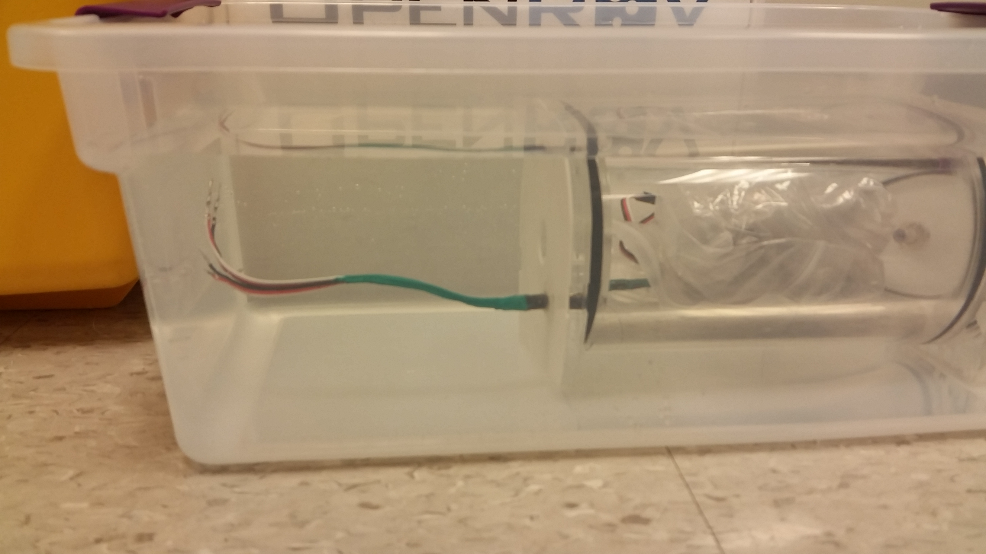

**Figure 3:** Electronics hub being tested for leaks.

1. **My *Goals* for next week**

* Redo the underwater gauss gun tests with a needle piercing spongy material.
* Determine what experiments to perform with the students from Missouri S&T.
* Conduct said experiments with Missouri students.

1. **What I need Dr. Becker to do:**