Weekly reports are to be emailed to atbecker@uh.edu by 5:00pm on Tuesdays. The purpose of a weekly report is to: (1) give you text and images for your papers, thesis, and dissertation, (2) document progress, (3) identify if you are stuck or need resources.

Weekly report

1. **My *Goals* from ~~last week~~ before my vacations**

* Order the rest of the material for the magnetic system
* Finish the design of a superconducting coil and send the results to manufacturer
* Work on the magnetic system programing

1. **My *Accomplishments* this week**

* I did the drawing of a new tip for the magnetic Hammer system. We have met with Larry to speak about the machining.

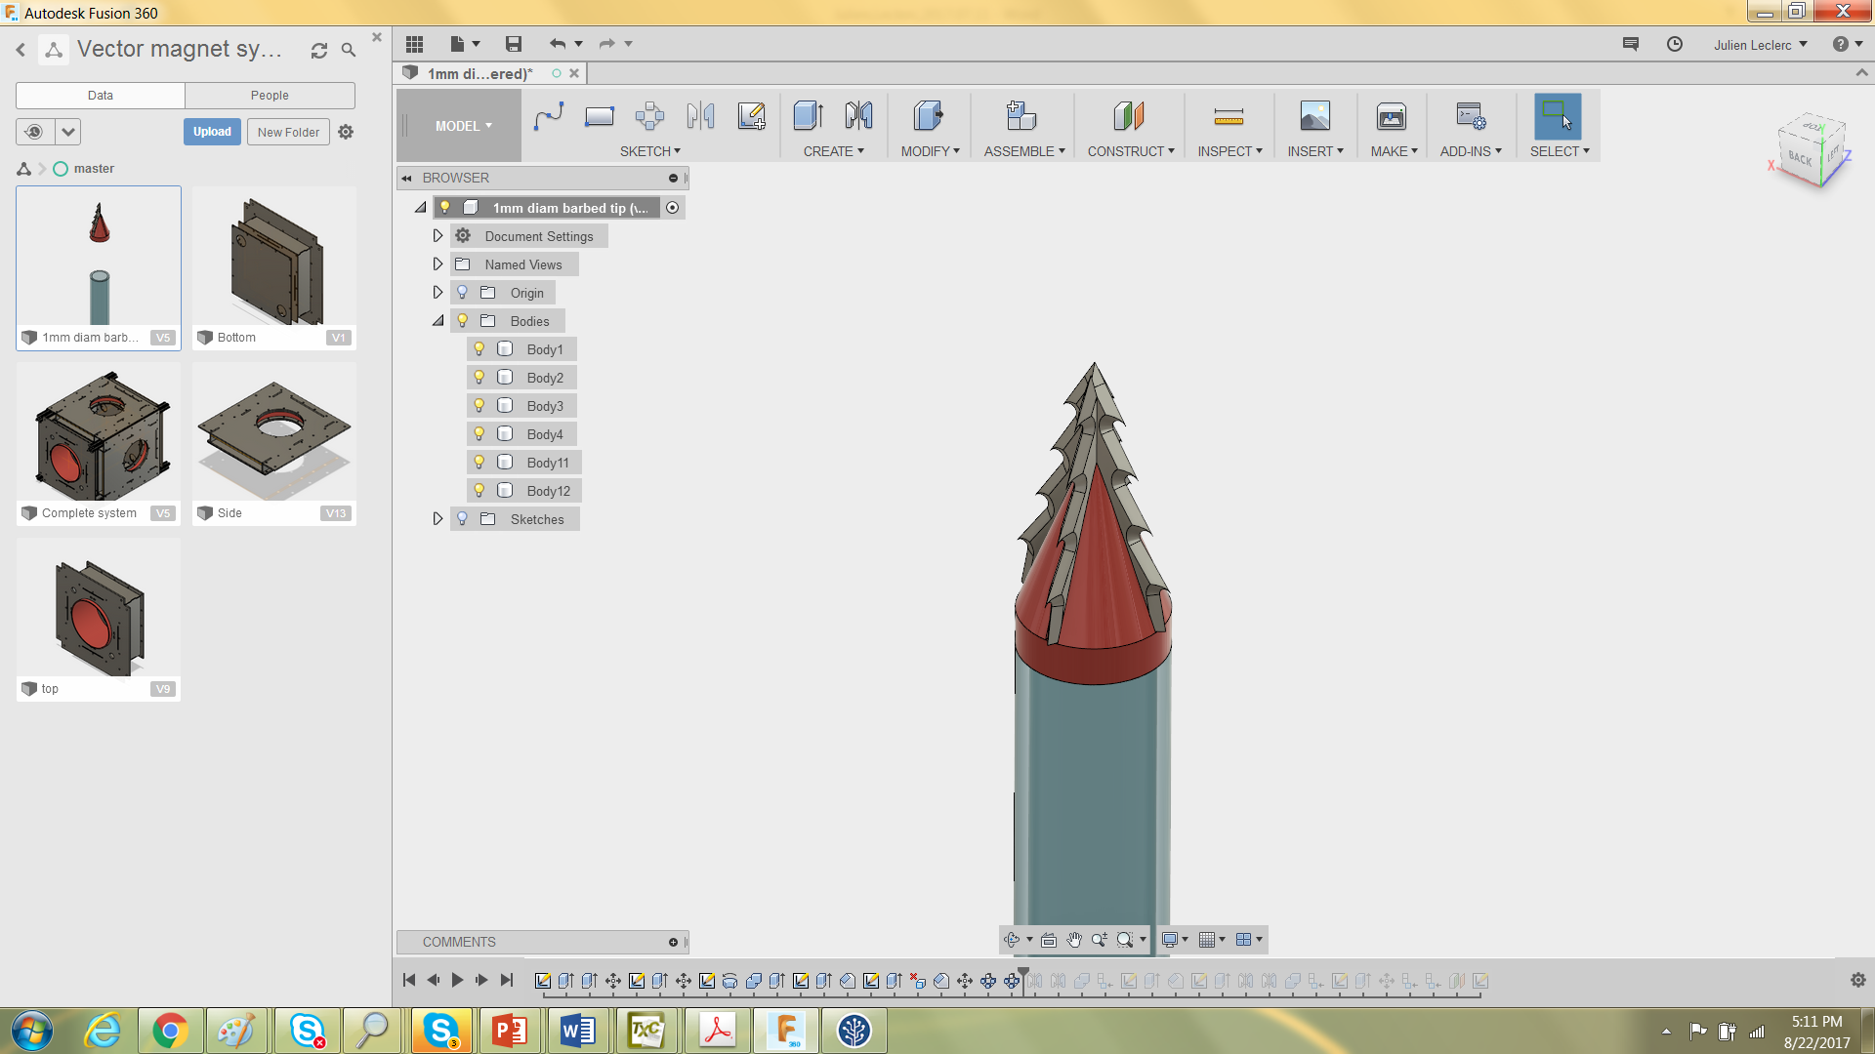

* I finished the modifications on the drawing of the Magnetic system.

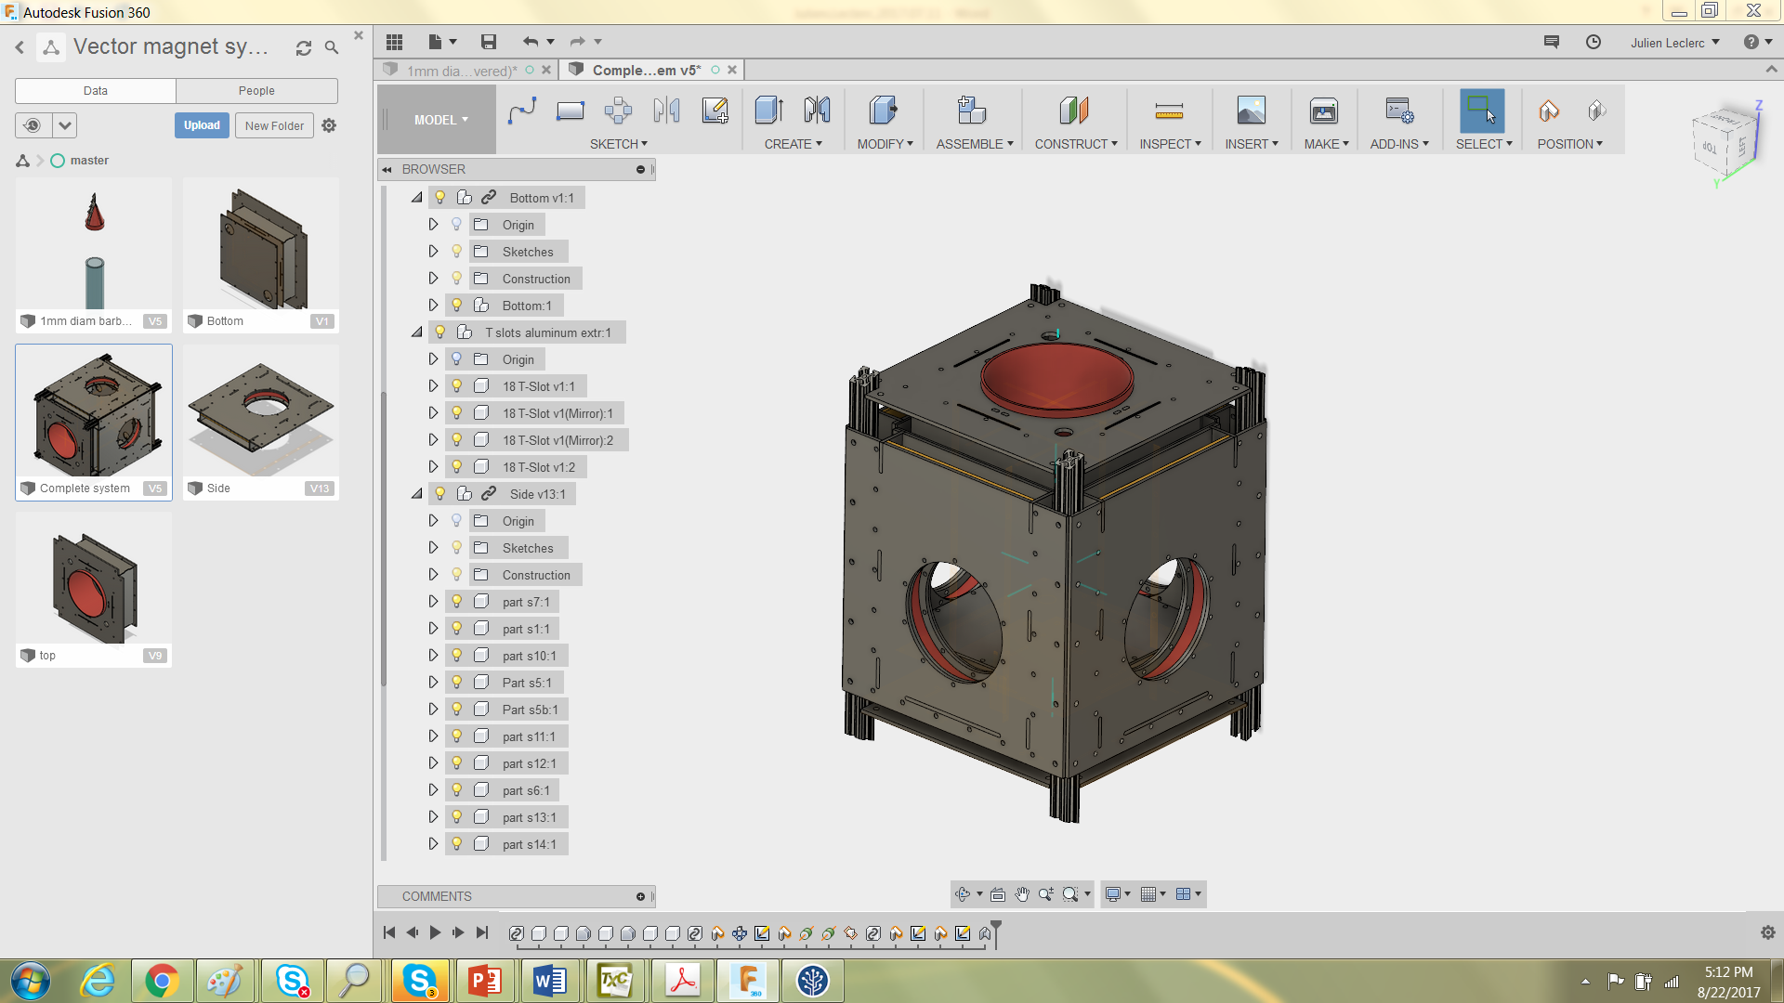

* I did researches for the CubeSat senior design project. It was chosen to develop an active magnetic attitude control for CubeSat. The attitude control can be used to point toward another satellite to perform communication within a swarm of CubeSats. The project will first aim at developing this actuator for ground testing. Depending on the results, it might be converted into a fully functional CubeSat in the future.
* I ordered Titanium for the millirobot tip.
* I am now working on the conversion of the MARSS paper to a journal version.

1. **My *Goals* for next week**

* Finish working on the conversion of the MARSS paper to a Journal paper (I will be done by 8/25/2017.
* Make the design of a superconducting coil to be used on the new magnetic system.

1. **What I need Dr. Becker to do:**

Could you please write a recommendation letter for me?