Weekly reports are to be emailed to atbecker@uh.edu by 5:00pm on Tuesdays. The purpose of a weekly report is to: (1) give you text and images for your papers, thesis, and dissertation, (2) document progress, (3) identify if you are stuck or need resources.

Weekly report

1. **My *Goals* from last week**
   * objective 1
   * …
2. **My *Accomplishments* this week**
   1. Project 1: <NAME>

* deliverable 1. *Deliverables can be documents, code, videos, plots, experiments, etc. Save and backup all work [code, data, LaTeX, images, videos]. Papers and code should be saved to our git server:* [*https://github.com/aabecker*](https://github.com/aabecker)*.*
* I tested <INSERT NUMBER> trials of <EXPLAIN TEST>.
* I generated a figure or plot
* *…*

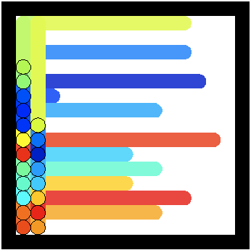

**Figure 1:** <Some description of figure. All plots *must* have labeled axes with units in parenthesis, for instance: *Robot diameter (μm) >*

1. **My *Goals* for next week**

* objective 1.
* …
  1. Meeting with Dr. Becker on <INSERT DATE and TIME>

1. **What I need Dr. Becker to do:**
   1. something for Dr. Becker to do
   2. …