

**ECE 5330/6397: Intro to Robotics Robot Demo 1, Due Sep 2**

***“Pick & Place”***

**Name 1:**

**Name 2: (both must submit to blackboard)**

*By assembling the robot themselves, students become intimately familiar with the limits of the robot, its possible configurations, and introduce themselves to forward & inverse kinematics.*

Students will form 2-person teams. Each team will build and control their own robot arm, powered by servos. We will use these arms to implement automatic controllers, forward and inverse kinematics, and forward/inverse velocity control. Teams may design their own laser-cut components for the final stage of the project. Teams must purchase these items, Amazon often changes prices ☹:

1. four ‘D’ batteries.
2. 1 x OWI Robot Arm kit <http://a.co/7EPgoxR> ($38, but price fluctuates up to $50)
3. 1 x Arduino Mega <http://a.co/acu1G9b> ($15) or suitable clone
4. 3 x L298 Motor Drivers <http://a.co/3N7bQEp> (5 for $15)
5. 5 x Rotary Potentiometers <http://a.co/aE2m0tu> (10 for $11) they must rotate at least 270°
6. 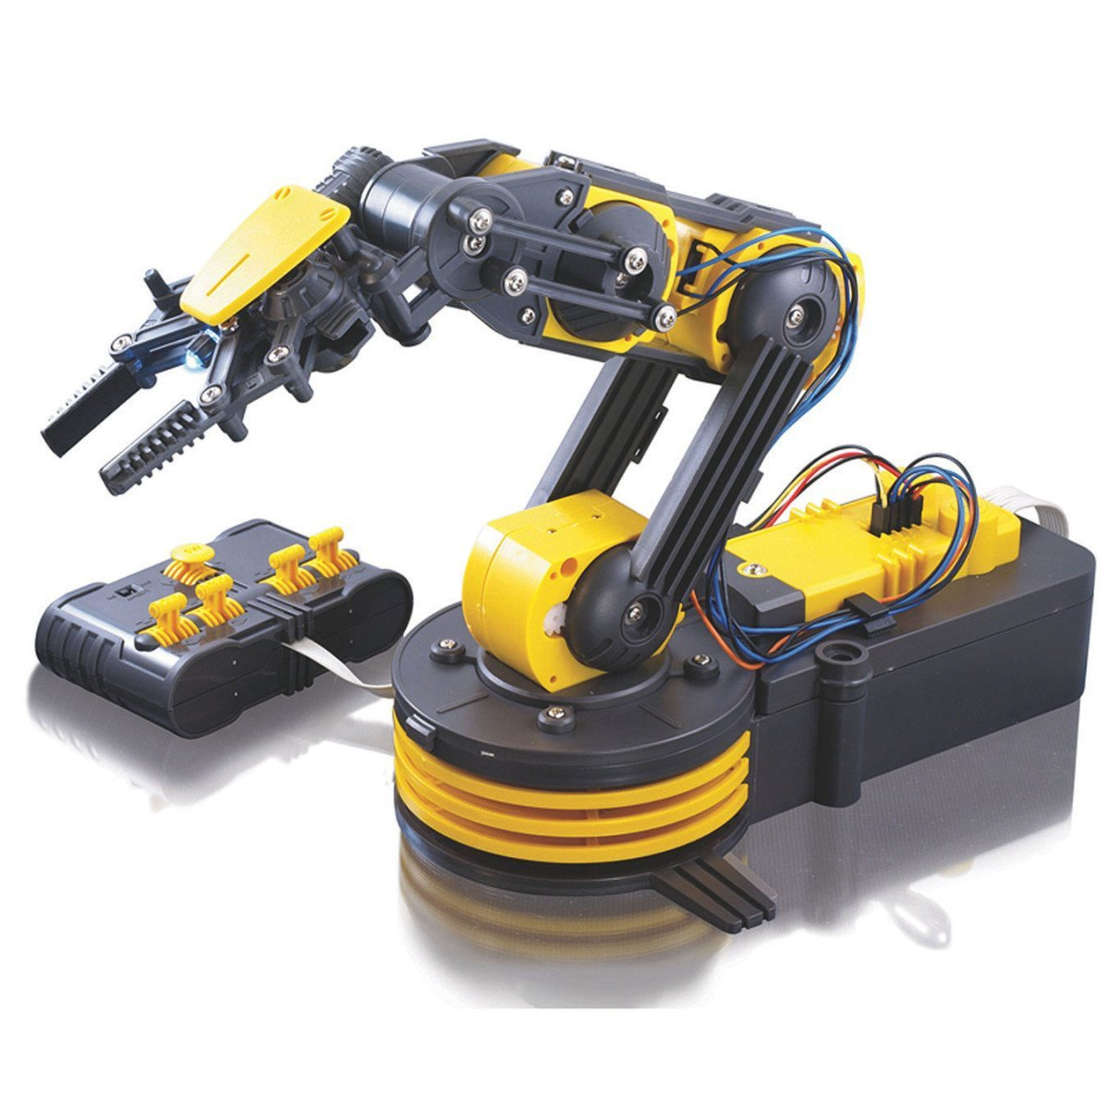1 x *Any* simple lightweight webcam <http://a.co/hAqZq3J> ($14)

Demo 1 is worth 100 points. Give us a link to a *short* **YouTube** video of your robot. The robot must have your name written on its side, and this must be visible in the video.

The video

* **(25 pts)** must show your faces & be ***less*** than 120 seconds long (tip: speed it up)
* **(25 pts)** show the robot picking up an object, then pick another object and lay it on top of the first
* **(25 pts)** use the robot to arrange objects to spell a word.
* Show multiple inverse kinematics solutions (elbow up/elbow down) for reaching an object at the same place & orientation **(15 points for 2 solutions, 25 points for 4 solutions)** *that is, imagine a pen is located at some position and orientation. How many ways can the robot grip the pen with the same gripper angle?*

Enjoy! -Dr. B