

**Intro to Robotics: Robot Demo 2**

***“Single-motor open-loop control”***

**Name 1:**

**Name 2:**

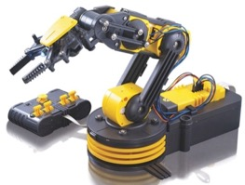

Demo 2 is worth 100 points. Give us a link to a YouTube video of your robot. The robot must have your name written on its side, and this must be visible in the video.

This will use a motor driver to control at least one motor.

1. Move the arm to a “drop-off configuration” (based on the number of seconds to move)
2. Using the Arduino, hardcode a movement to move the robot to a “pick-up configuration” The pickup location must be at least 5cm distance from the drop-off location.
3. Pick an object up (the object may be a colored wooden block).
4. Using the Arduino, hardcode the inverse movement (based on the number of seconds to move) to return to the “drop-off configuration”.
5. Then have the robot drop-off the object
6. Repeat steps 2-5 at least three (3) times.

Example construction: <https://youtu.be/QWVKUh7yAcw> (note: we are making a new video)

The video

* (25 pts) must show your faces & be less than 120 seconds long (you can speed up playback speed)
* (25 pts) 5 repetitions
* (25 pts) analysis of ***repeatability:*** measure the movement length & calculate the mean and standard deviation. *Put this* ***into*** *the video*.
* If *Arduino* controls

|  |  |
| --- | --- |
| 1 DOF | 10 pts total |
| 2 DOF | 15 pts total |
| 3 DOF | 20 pts total |
| 4 DOF | 25 pts total |

Enjoy! Open-loop control is not robust, so your accuracy will probably be poor. The next demo will improve performance by using feedback from position sensors.

1. 1 x Arduino Mega <http://a.co/acu1G9b>  ($15) or suitable clone
2. 5 x L298 Motor Drivers <https://www.amazon.com/dp/B00XAGRQTO/> (5 for $11.98)
3. Jumper wire kit <http://a.co/hCFAGPP> ($5.99)

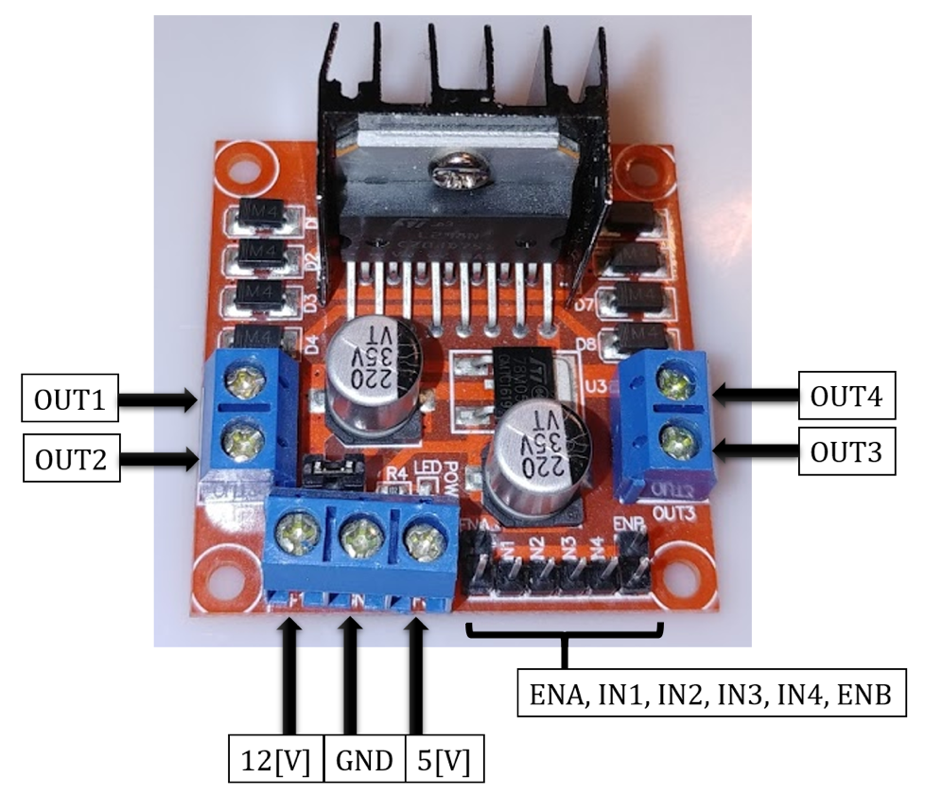

**Instructions**

1. Separate 15 Female/Female wires into 5 sets of 3 wires each.
2. Remove the jumper shunts from ENA and ENB for all drivers
3. Take the first set of 3 Female/Female wires and connect ENA-ENB, IN1-IN4, IN2-IN3. Make sure to connect only the bottom row of ENA-ENB pins that are aligned with IN1, IN2, IN3, and IN4.

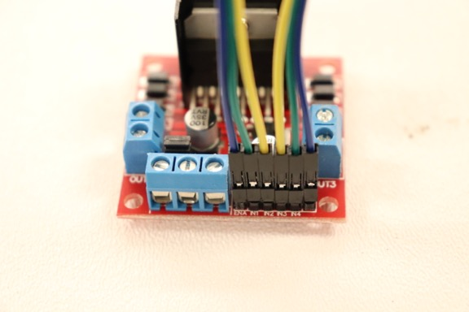

1. Repeat step (3) for the remaining motor drivers.
2. Separate 10 Male/Male wires into 5 sets of 2 wires each.
3. Connect OUT1-OUT4 and OUT2-OUT3

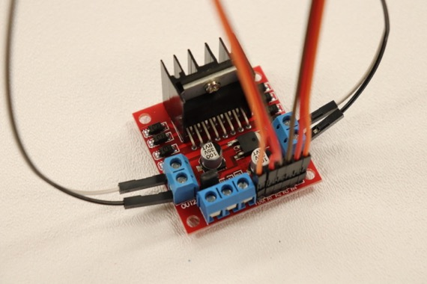

1. Repeat step (6) for the remaining motor drivers.
2. Take 5 Male/Male wires and cut them in half.

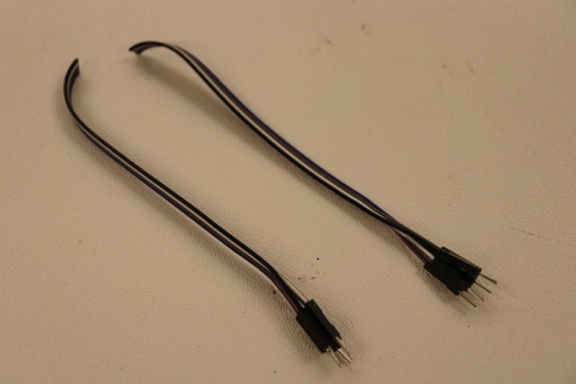

1. Connect first set of 5 wires to every 12[V] terminal (left picture), and the second set of 5 wires to every GND terminal (right picture). Offset the colors slightly to make the connections clearer or cut 5 Male/Female wires with a different color set in half and use the male ends.

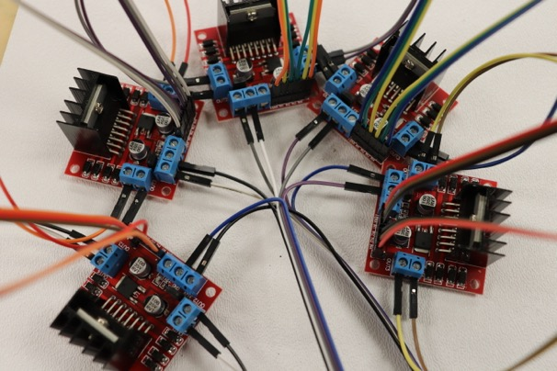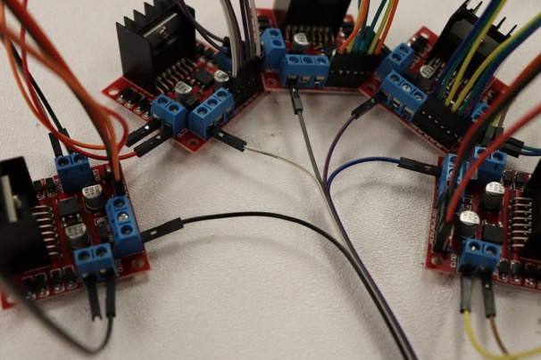

1. Take 10 Male/Female wires and cut them in half.

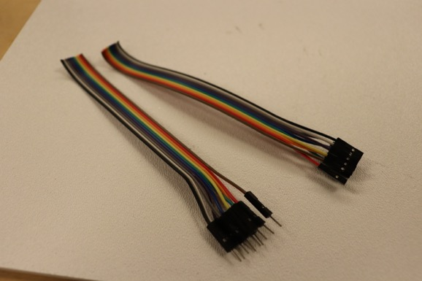

1. Separate the female end of the cut wires into 5 sets of two.
2. 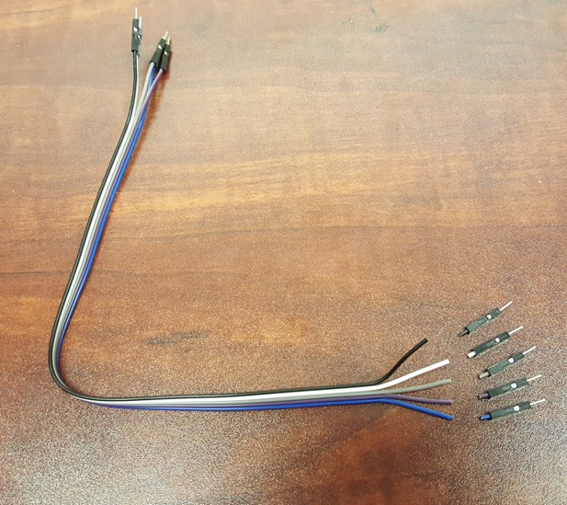Take 5 Male/Male wires and cut one end of the male pin headers off.
3. Strip every end of the wires that does not have a pin header.
4. 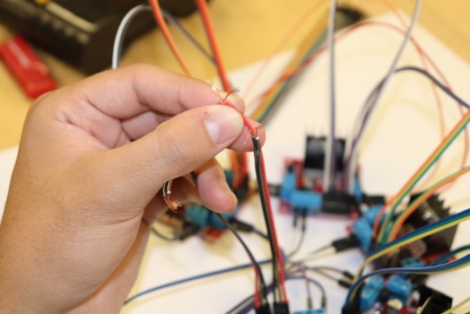For one Driver, cut the wires for the connections from steps (3) and (6) in half. Strip them and twist the same colored wires together. (make sure IN1is connected to IN4, IN2 to IN3, and ENA to ENB).

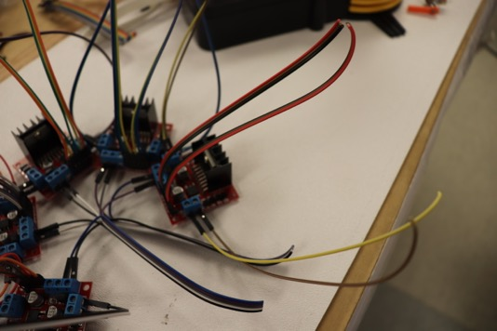

1. Take one set of the female ended wires from step (11) and one end to OUT1/OUT4 and the other to OUT2/OUT3.

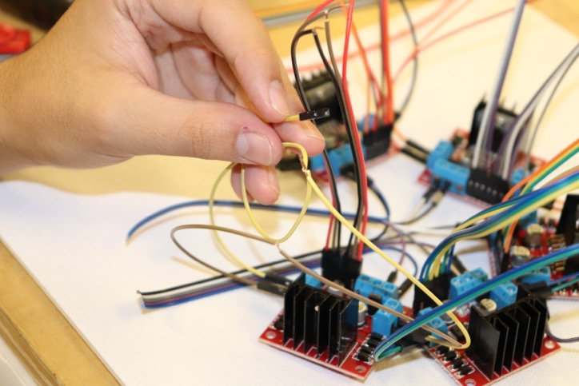

1. Take two of the short male ends from step (10) and connect them to IN1/IN4 and IN2/IN3.

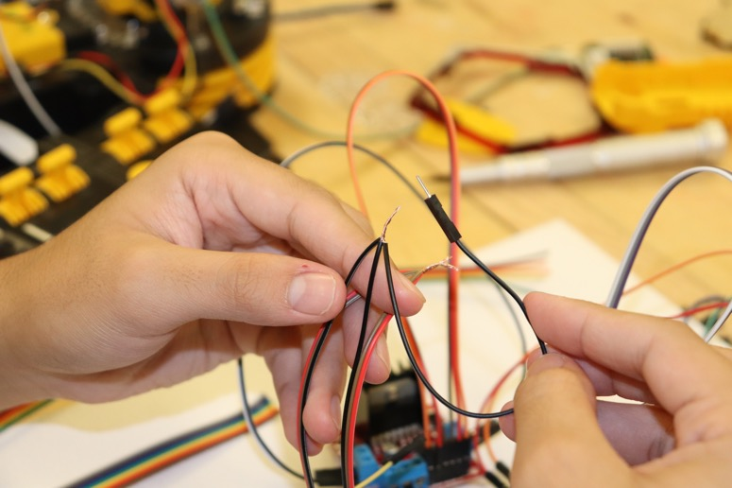

1. 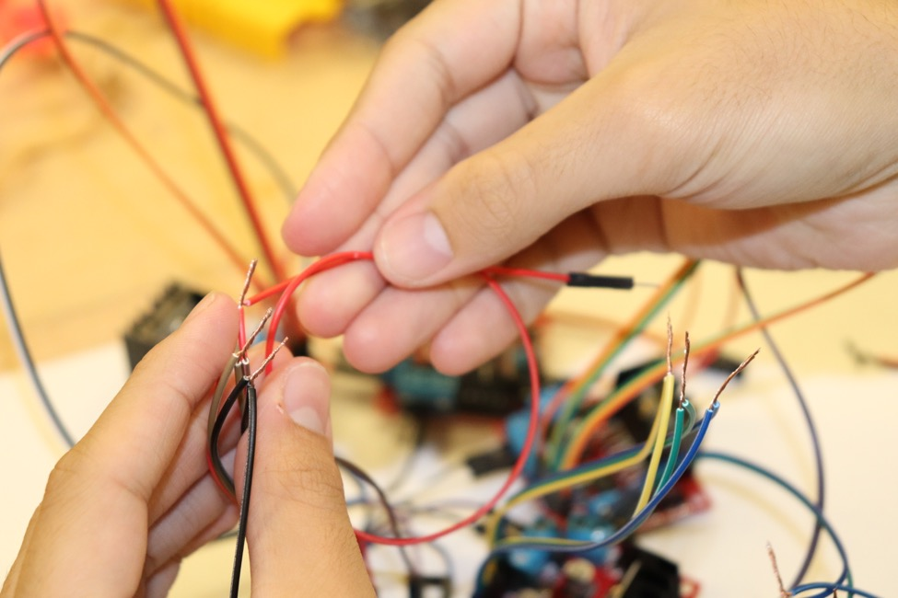Take one long male ended wire from step (12) and connect it to ENA/ENB
2. Repeat (14)-(17) for the remaining motor drivers.
3. Solder connections (left) and insulate them (right) with heat shrink or electrical tape. If using heat shrink, put the heat shrink on the wires first BEFORE soldering.

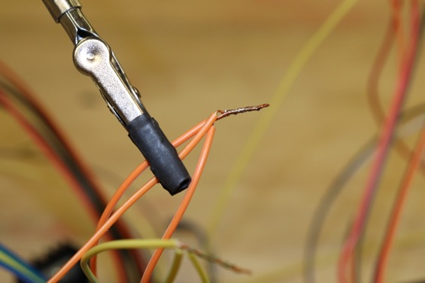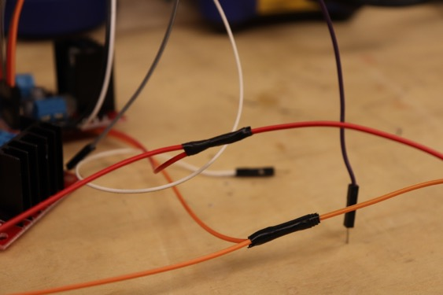

1. 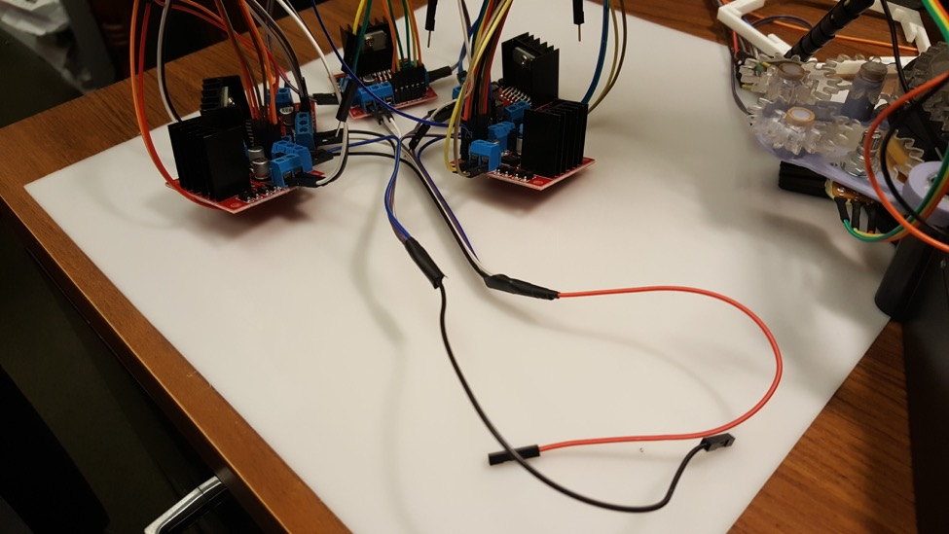Connect the two sets of five wires from (9) into one cable each, with female headers.

**Connections with the Arduino Mega 2560**

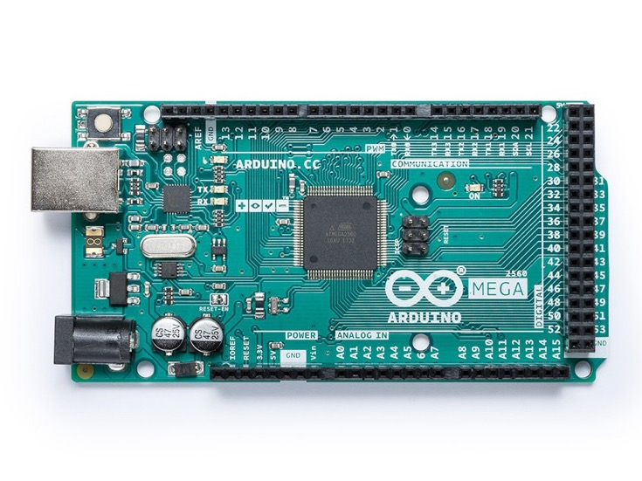

Document your connections to facilitate programming.

1. Connect the 5-1 wire that goes to the 12[V] terminals from (20) to the Robot Arm’s 6[V] wire (the red battery wire) using 1 M/M wire.
2. The wires from (17), the enable pins, should be connected to PWM pins.
3. The wires from (16), the IN1/IN4 and IN2/IN3 pins should be connected to Digital pins.
4. Using 10 M/M wires, connect the wires from (15), the OUT1/OUT4 and OUT2/OUT3 outputs, to the wires for the motors. Each motor should be connected to a separate motor driver.
5. Using 2 M/M wires, connect the light to the Arduino.
6. Connect the ground pin of the Arduino, the 5-1 wire that goes to the GND terminal from (20), and the robot arm (black battery wire) together.
   1. Take 2 M/M wires and cut them in half.
   2. Take 3 of the cut wires, strip the ends, and solder them together.
   3. Connect the first of the three wires to the Arduino GND pin.
   4. The second connects to the wire that goes to the GND terminal from (20).
   5. The third connects to the black battery wire from the robot arm.

Q: Are you having difficulty moving some of your robot joints using the motor controller?

A; you probably are not supplying enough power.  DC motors need current to move.  To check it out, attach a multimeter across your motor leads and measure voltage when the motor is being commanded to move.  If the voltage dips when you command a movement, you need more power.

Q: where do I get more power?

A: In this case, you can either add more batteries, or attach a DC power source.  You can use AC/DC power inverters ("wall warts") that plug into an outlet, or use a desktop PC power source, or use a power source from a lab on campus.  Start with 6 VDC, and increase the voltage if needed.  If you go too high your motors will heat up.  Higher voltages may cause smoke and motor destruction, so experiment carefully.

Q: Why does my robot need more/less power than theirs?

A: Every robot is different.  Some have more friction than others.  There is also quality issues with the cheap motor controllers we use.  You can also try using a higher PWM  (I think  256 is max).  Remember that the motor acts as a low-pass filter, so a 128 setting would only give 50% of the power to the motor.