

**Intro to Robotics: Robot Demo 4**

***“Using a camera”***

**Name 1:**

**Name 2:**

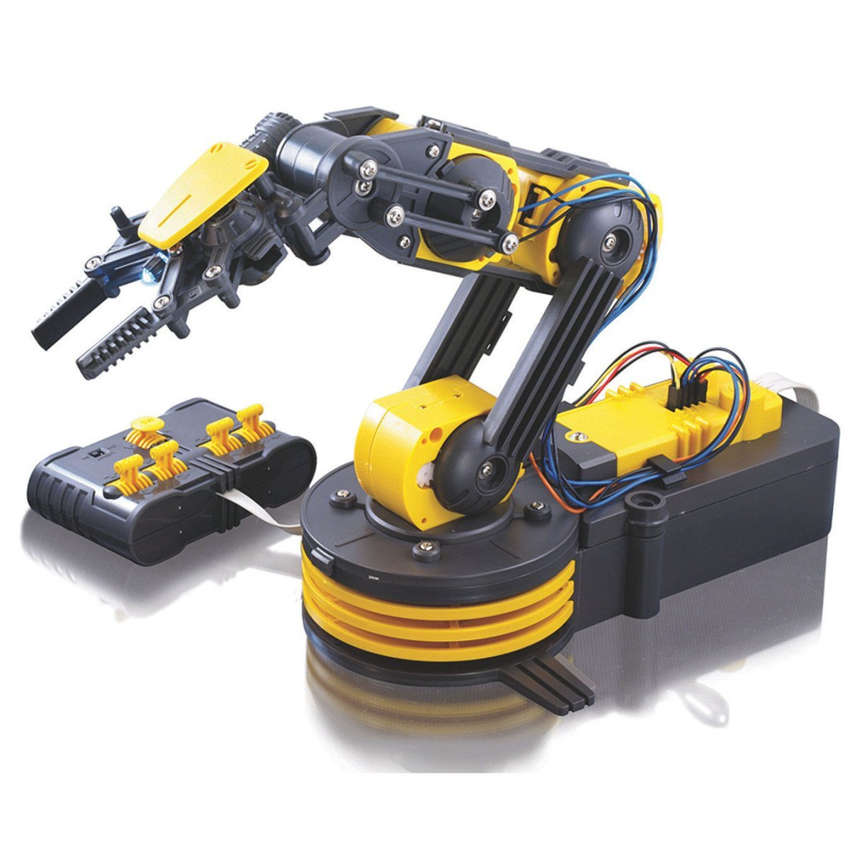

Demo 4 is worth 100 points. Give us a link to a YouTube video of your robot. The robot must have your name written on its side, and this must be visible in the video.

Place a camera in the robot’s end effector. With the camera, identify an object (blob detection). Move the arm to keep the object in the center of the camera image. This requires control of at least 2 links (the waist and one other). You can do this with open-loop control of feedback using the potentiometers (because the camera provides the feedback), or using feedback control.

The video

* (25 pts) must show your faces & be less than 120 seconds long (you can speed up playback speed)
* (25 pts) show the robot tracking an object with one-axis movement as the object moves in 2D, e.g. robot moves just waist joint.
* (25 pts) show the robot tracking an object with at least two-axis movement as the object moves in 2D, e.g. robot moves waist and wrist joint to track an object.
* (25 points) show the image processing – finding the object and computing the centroid.

Enjoy!

-Dr. Becker