- INTRODUCTION
This chapter presents the system analysis and design of the proposed Blood Link System. It builds on the methodology by interpreting collected data into meaningful system requirements and models. The chapter includes system study findings, system analysis using UML tools, and system design components such as architectural design, data flow diagrams, and entity relationship diagrams.
4.0.1 SYSTEM STUDY
Data for the system study was collected through interviews, questionnaires, observation, and document review. The findings revealed several challenges in the current blood donation system, including the absence of a centralized digital platform to connect hospitals and donors, delays in communication during emergencies, poor donor mobilization due to limited awareness, and inefficient manual tracking of blood inventory. Additionally, there is limited access to real-time information on blood availability. These challenges highlight the need for a system that supports real-time communication, improves donor mobilization, automates notifications, and ensures accurate and efficient inventory management. Based on these findings, system requirements were categorized into functional and non-functional requirements.
4.0.2 Functional requirements
System shall:
- Allow hospitals to register and post blood requests
- Enable donors to view blood drives and schedule appointments
- Check blood inventory before processing requests
- Approve, partially fulfill, or reject blood requests
- Notify donors based on blood group and location
- Send alerts for emergencies and low stock levels
- Allow admin to manage donors, hospitals, and inventory
- Generate reports on blood usage and donor activity

4.0.3 Non functional requirements
System shall be:
- User-friendly and easy to navigate
- Reliable in processing requests without failure
- Secure to protect donor and hospital data
- Available for access at all times
- Scalable to support increasing number of users
- Efficient in sending real-time notifications

  - SYSTEM ANALYSIS
4.1.1 USE CASE DIAGRAM
The Use Case Diagram illustrates the interaction between users (Donor, Hospital, and Admin) and the system.
- Donors can register, log in, view blood drives, schedule appointments, and receive notifications.
- Hospitals can register, log in, post blood requests, and view reports.
- Admin manages the entire system including users, inventory, and blood drives.
ILLUSTRATION
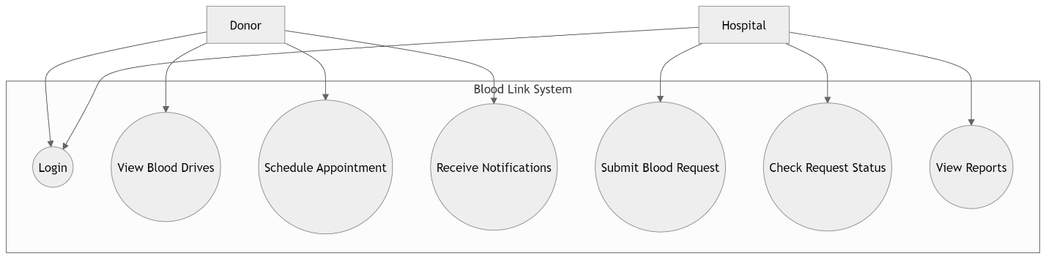
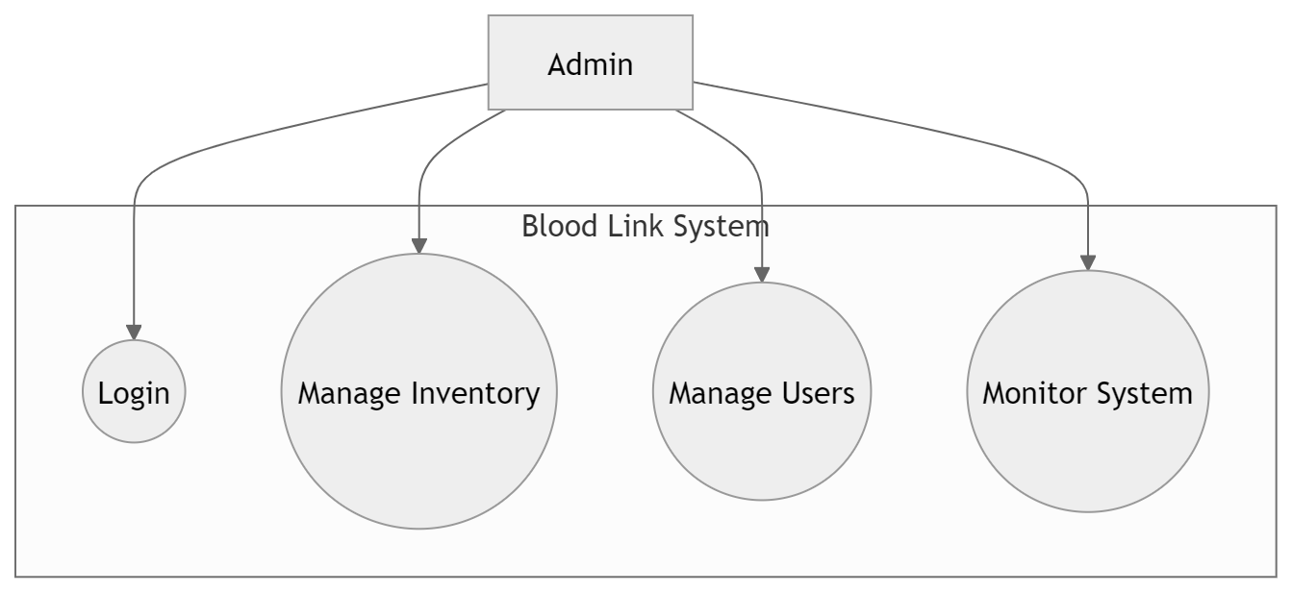
4.1.2 DATA FLOW DIAGRAM(DFD)
The Data Flow Diagram (DFD) illustrates how data moves through the Blood Link System and how different processes interact with users and data stores.
The system consists of the following key processes:
- User Authentication:
This process handles user registration and login for donors, hospitals, and administrators. It verifies user credentials, grants access to the appropriate dashboard, and stores user information in the respective databases (Donor Database and Hospital Database). It ensures that only authorized users can access system functionalities.
- Blood Request Management:
This process allows hospitals to submit blood requests by specifying blood group, number of units, and urgency level and add in their locations. The system records these requests in the Request Database and manages their status (approved, partially fulfilled, or pending). It also coordinates with the inventory management process to determine availability.
- Inventory Management:
This process is responsible for monitoring and updating blood stock levels. It checks whether the available stock meets the requested units and updates the Inventory Database accordingly. Based on the results, it either approves the request, partially fulfills it, or flags it as pending. It ensures accurate tracking and availability of blood units.
- Notification System:
This process handles communication between the system and users. It sends alerts to donors based on blood group, location, and urgency of requests. It also notifies users about blood drives, appointment schedules, and request status updates. This ensures timely response and improved coordination between donors and hospitals

Data flows from donors and hospitals into the system, where it is processed and stored in databases such as Donor Database, Hospital Database, Inventory Database, and Request Database.
Illustration.
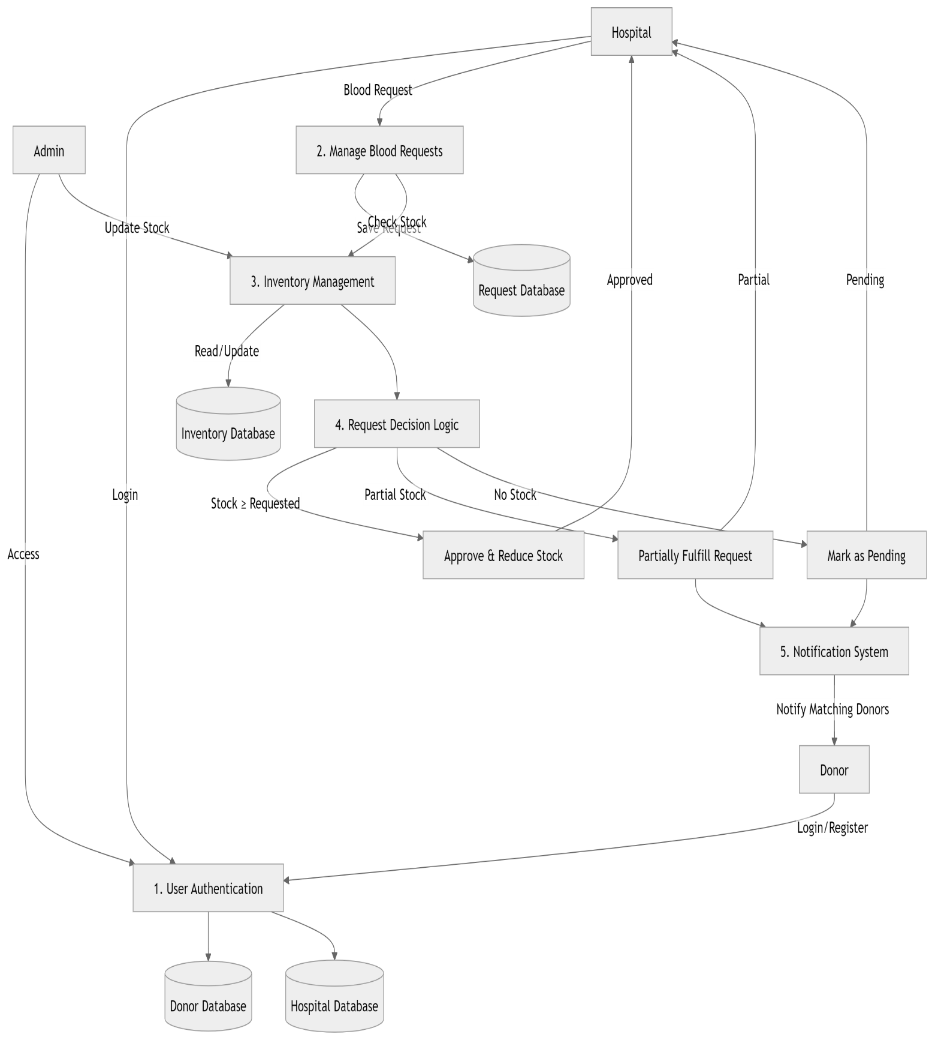

4.1.3 FLOW CHART
The flowchart illustrates how the Blood Link System operates for different users. After login, users are directed to their respective dashboards based on their roles (Donor, Hospital, or Admin).
Hospitals submit blood requests, and the system checks inventory levels. If stock is sufficient, the request is approved; if partially available, it is partially fulfilled; and if unavailable, it is marked pending. The system then prioritizes requests based on urgency and notifies eligible donors.
Donors can view blood drives, schedule appointments, and receive notifications, while administrators manage inventory, users, and system activities. The flowchart clearly shows the decision-making process and interactions within the system.
Illustration
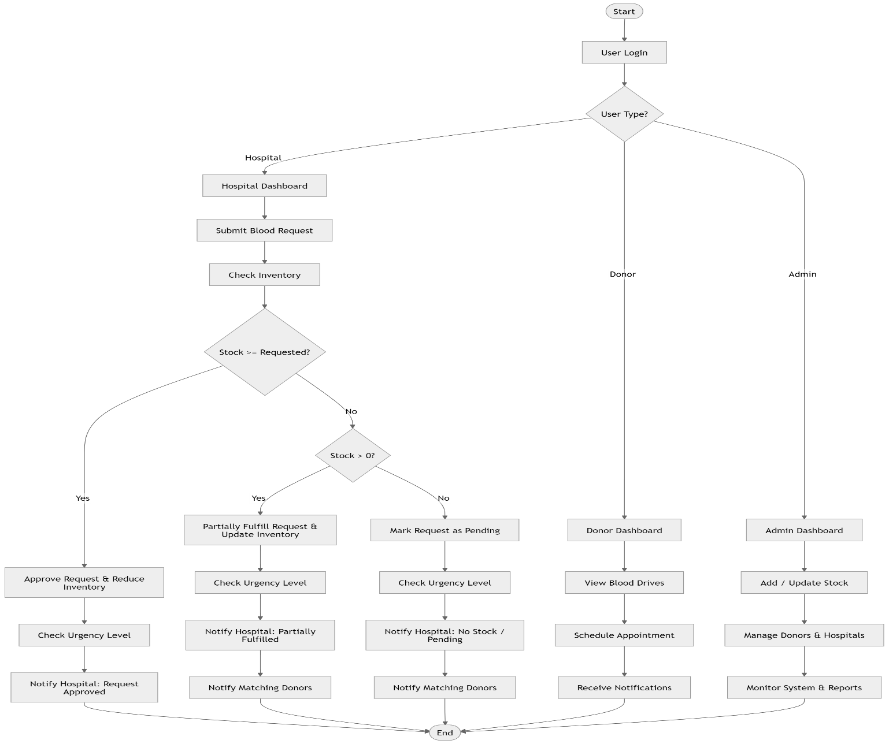
4.2 SYSTEM DESIGN
4.2.1 ARCHITECTURAL DESIGN
The Blood Link System is designed using a three-tier architecture, which separates the system into three distinct layers to improve organization, scalability, and maintainability.
- Presentation Layer (Frontend)
This layer represents the user interface of the system and is developed using HTML, CSS, and JavaScript. It allows users (donors, hospitals, and administrators) to interact with the system through web pages such as dashboards, forms, and notifications. This layer is responsible for collecting user input and displaying system outputs in a clear and user-friendly manner.
- Application Layer (Backend)
This layer contains the core logic of the system and is developed using PHP. It processes user requests, applies decision-making logic, and coordinates system operations. For example, it handles blood request processing, checks inventory availability, determines whether requests are approved or pending, and triggers notifications to donors. This layer acts as a bridge between the user interface and the database.
- Data Layer (Database)
This layer is implemented using a MySQL database and is responsible for storing and managing all system data. It includes records of donors, hospitals, blood requests, inventory levels, appointments, and notifications. The data layer ensures data integrity, consistency, and efficient retrieval of information whenever required by the system.
The use of a three-tier architecture ensures separation of concerns, where each layer performs a specific function independently. This improves system scalability, as each layer can be modified or expanded without affecting others, and enhances maintainability by making the system easier to manage, update, and debug.
4.2.2 DATABASE DESIGN
The database design of the Blood Link System is represented using an Entity Relationship Diagram (ERD), which defines the structure of the system and the relationships between entities. The design ensures proper data organization, integrity, and efficient system operations.
Entities
- Donor
Stores information about individuals who donate blood, including their identification details, blood group, and location.
- Hospital
Represents health facilities that request blood and manage blood inventory within the system.
- Blood Request
Contains details of blood requests made by hospitals, including blood group, number of units required, urgency level, and request status.
- Inventory
Maintains records of available blood units in hospitals, ensuring accurate tracking and updates of stock levels.
- Appointment
Stores information about scheduled blood donation sessions between donors and donation centres.
- Blood Drive
Represents organized blood donation events, including location, date, and time.
- Notification
Stores messages sent to donors, such as alerts for blood requests, blood drives, and appointment reminders.
- Admin
Represents system administrators responsible for managing users, inventory, and overall system operations.

Relationships
- Hospital creates Blood Requests (1: N)
A hospital can create multiple blood requests, but each request is associated with one hospital.
- Donor schedules Appointment (1: N)
A donor can schedule multiple appointments, but each appointment belongs to one donor.
- Blood Drive has Appointments (1: N)
A blood drive can have multiple appointments, while each appointment is linked to a single blood drive.
- Hospital maintains Inventory (1:1)
Each hospital maintains one inventory record that tracks available blood units.
- Admin manages Inventory (1: N)
An administrator can manage multiple inventory records across different hospitals.
- Donor receives Notifications (1: N)
A donor can receive multiple notifications related to blood requests, appointments, and donation events.

These entities and relationships work together to ensure efficient coordination between donors, hospitals, and administrators. The ERD minimizes data redundancy, maintains consistency, and supports effective management of blood donation activities within the system.
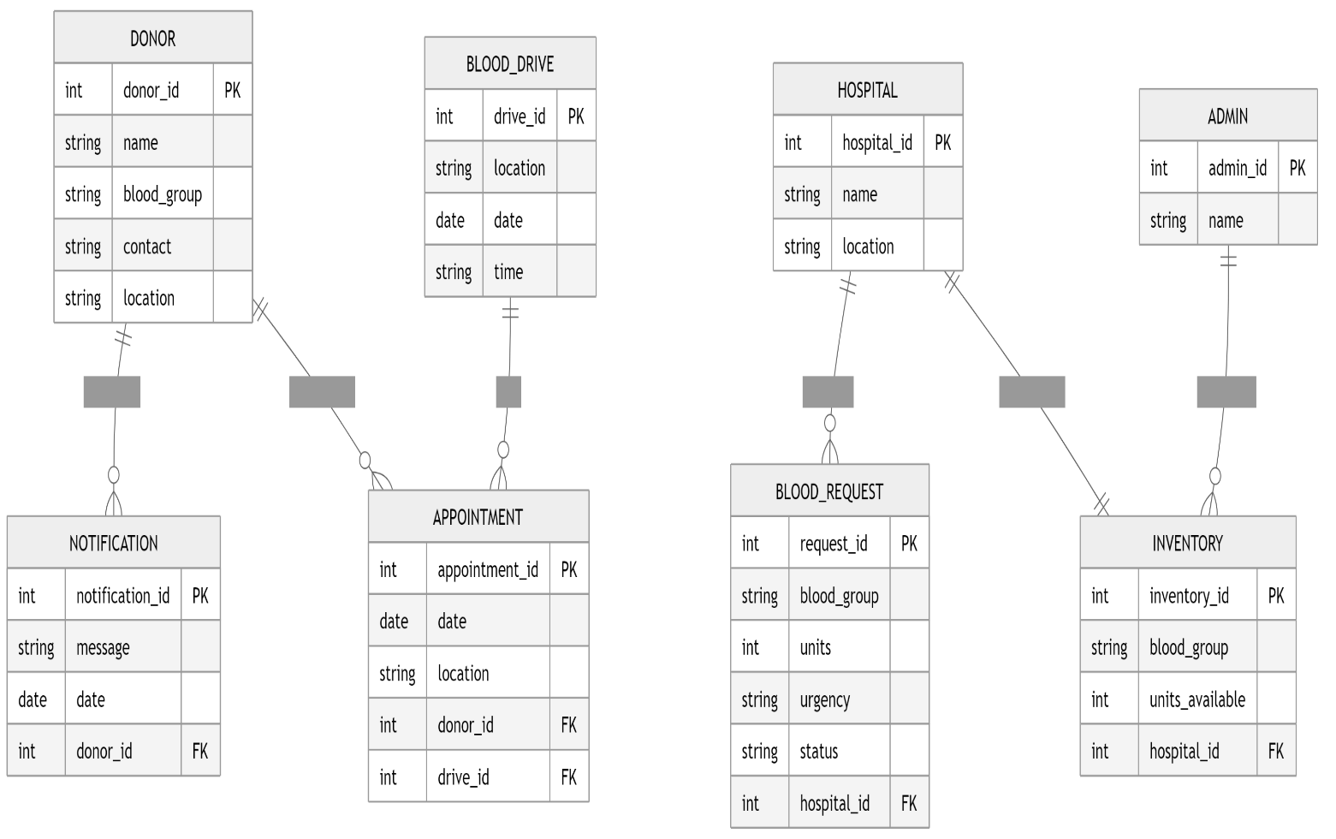

4.2.3 Data Flow Design
The data flow design of the Blood Link System describes how data is input, processed, stored, and output within the system to support efficient operations.

The process begins when users (donors, hospitals, or administrators) input data into the system, such as registration details, login credentials, or blood requests. This data is then validated to ensure accuracy and completeness before being processed by the system.
Once validated, the system applies decision-making logic, particularly in handling blood requests. It checks the available inventory to determine whether the requested blood units can be fully provided, partially fulfilled, or marked as pending. This ensures proper management of available resources.

After processing, the results are stored in the database, including updated inventory levels, request statuses, and user activity records. The system then triggers the notification process, sending alerts to relevant users based on blood group, location, and urgency level.
Finally, the processed information is displayed on user dashboards, providing real-time updates such as request status, available blood drives, and system reports. This structured flow ensures efficient data handling, timely communication, and effective coordination among donors, hospitals, and administrators.

4.3 INTERFACE DESIGN
The system interface includes:
- Donor Dashboard:
Displays donor details, blood drives, notifications, and appointment scheduling
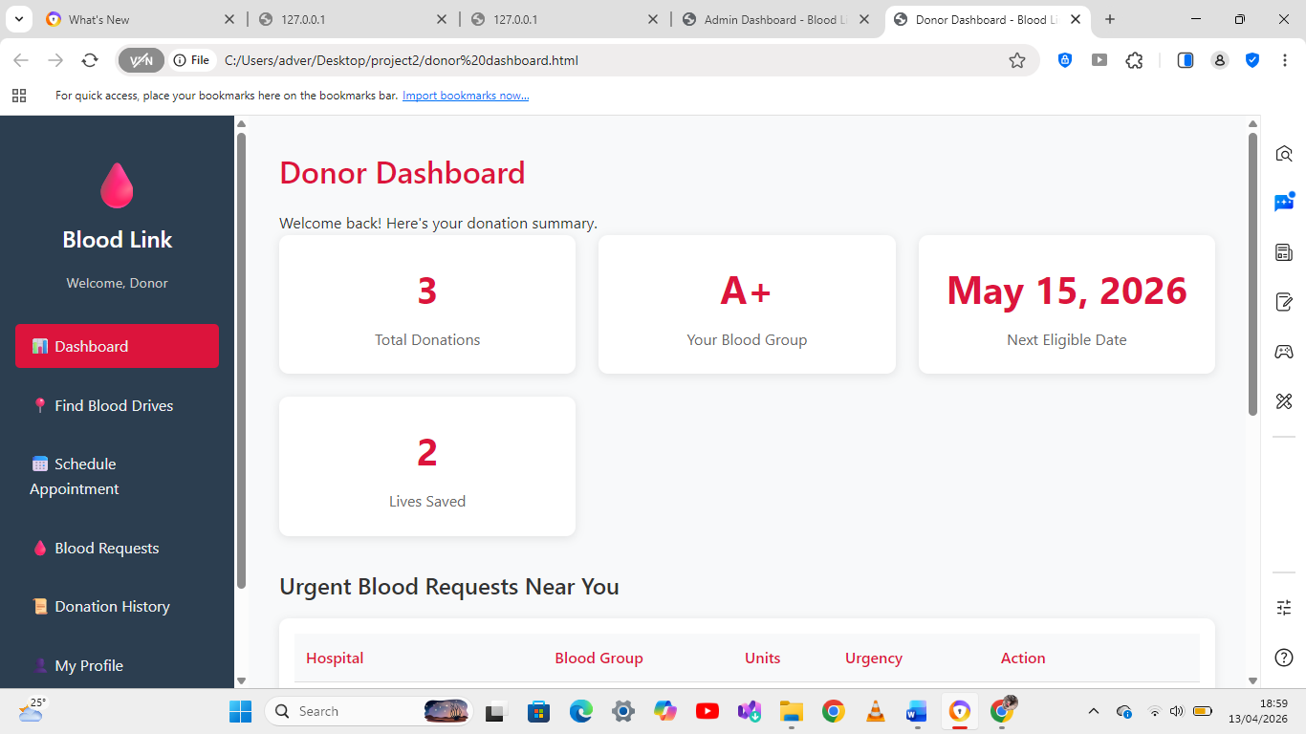
- Hospital Dashboard:
Displays blood requests, reports, history, and hospital details
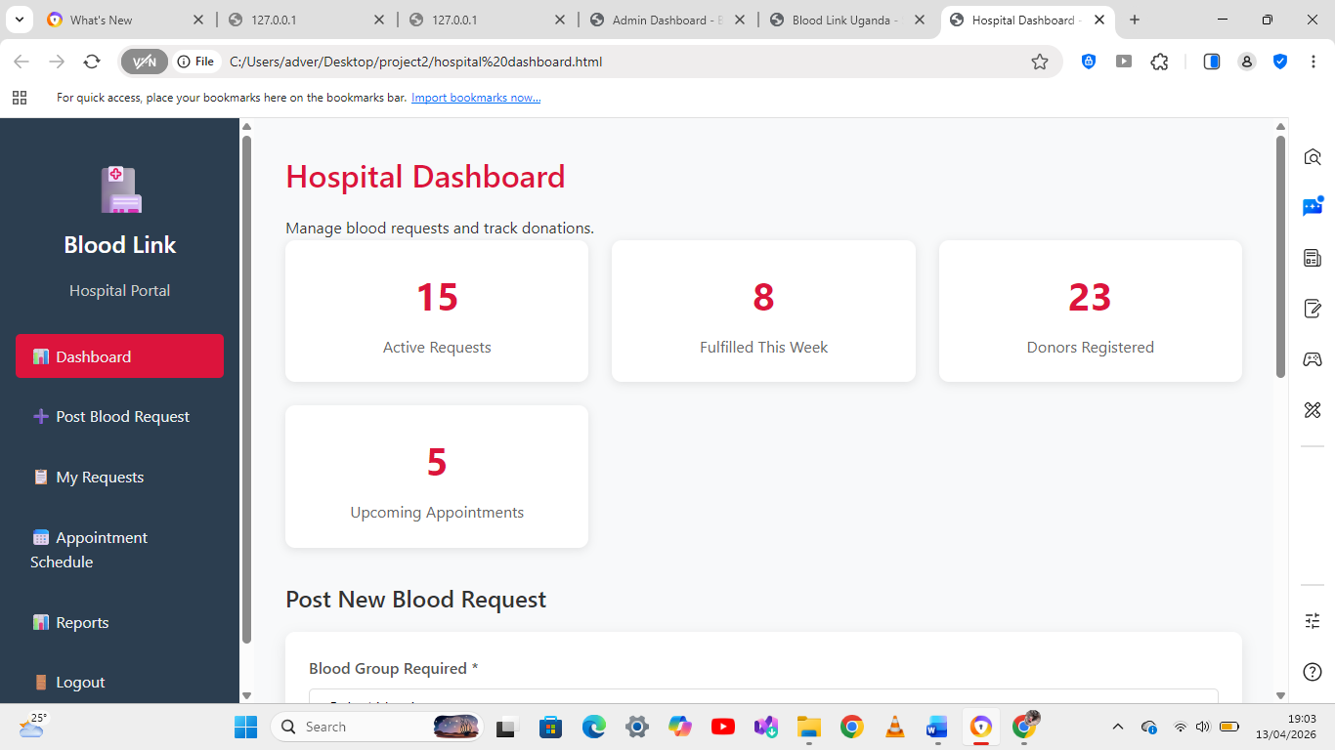
- Admin Dashboard:
Displays system overview, inventory, user management, and reports
The interfaces are designed to be simple, intuitive, and user-friendly.
