**IOT Based Obstacle Avoidance Robot –Software Requirements Specification**

**Version 2.0**

**Prepared by,**

Aishwarya.R (1JT13CS002) Anitha.M (1JT13CS008)

Latha.G.R (1JT13CS025) Meghana.R (1JT13CS027)

**SOFTWARE REQUIREMENT SPECIFICATIONS**

**1.1 Software Requirements and Specification**

A document details the software requirements specification for the IOT BASED OBSTACLE AVOIDANCE ROBOT.The project is design to build an obstacle avoidance robotic vehicle using ultrasonic sensors for its movement. A micro-controller (AT mega 8) is used to achieve the desired operation. A robot is a machine that can perform task automatically or with guidance. Robotics is a combination of computational intelligence and physical machines (motors). Computational intelligence involves the programmed instructions. The project proposes robotic vehicle that has an intelligence built in it such that it directs itself whenever an obstacle comes in its path. An ultrasonic sensor is used to detect any obstacle ahead of it and sends a command to the micro-controller. Depending on the input signal received, the micro-controller redirects the robot to move in an alternate direction by actuating the motors which are interfaced to it through a motor driver.

**1.1.1 Hardware Requirements**

The hardware requirements for the project are

* Arduino UNO R3
* Camera module
* Sound module
* Ultrasonic sensor HC-SR04
* Robot chassis (with 2 continuous servo motor)
* Battery holder (9v Battery power)
* Jumper cables
* Mini bread board

**1.1.2 Software Requirements**

* Operating system: Windows 7,8,
* Arduino UNO R3 drivers
* Arduino IDE
* Programming Language : C,C++

**1.1.3 Functional Requirements**

In a functional requirement defines a function of a software system or its component. A function is described as a set of inputs, the behavior, and outputs. A functional requirement defines a function of a software system or its component. It captures the intended behavior of the system. This behavior may be expressed as services, tasks or functions the system is required to perform.

This section deals with the functional requirements of our project:

1. Robot uses two robotics gear motor & wheel for the movement, which will help it to move forward, backward, left or right.
2. Robot uses two motor & wheel in the back side and one freewheeling ball is placed at the front which helps it to free movement.
3. The robot gets the information from surrounding area through mounted sensors on the robot.
4. If the distance is maximum and robot can move without colliding , the robot moves in forward direction, if the robot senses object near to it, it takes diversion and moves to the safe place and avoids colliding to any objects around the robot.
5. The sensor are placed in such a way that they can cover the maximum area in front of the robot and can be capable to detect an obstacle either obstacle is small or big.
6. When the Ultrasonic Sensor detects the obstacle, robot has to change the direction of its movement.
7. If any obstacle found in the left side then it will stop moving in the left & moves towards right side.
8. It has also a notification LED, an buzzer to play a tone when an object is detected and an button for changing the function of the robot (stopped / moving forward).
9. Movement should be supported in all the directions.
10. The camera module records the on-going events which can be used for security purpose.
11. The photon sensor is attached to the robot so that is can also move in dark place by switching on the light by itself.
12. The robot can also sense the nature of the surrounding environment and adjusts to that nature.

**1.1.4 Non-Functional Requirements**

Non-functional requirement is a requirement that specifies criteria that can be used to judge the operation of a system, rather than specific behavior. They are the metrics that are considered to measure the performance of the developed system.

This section deals with the various non-functional requirements of our project:

1. **Reliability**: As a system provide the right tools for discussion, problem solving it is made sure that the system is reliable in its operation and for securing the sensitive details.
2. **User friendly:** Device provides an friendly environment as it occupies less space and no need to monitor frequently
3. **Privacy and Security:** There are no privacy issues and
4. **Usability:** The system is easy to handle and navigates in most expected way.
5. **Portability**: Portability in high-level computer programming is the usability of the same software in different environments.
6. **Compatibility:** Computing platform means in general sense, where any piece of software is executed.

**1.2 Arduino UNO R3**

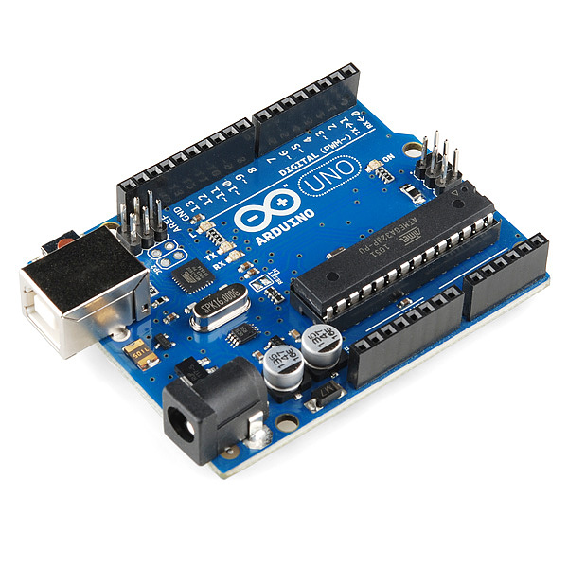

**Figure 1.1:** Arduino UNO R3

This is the new Arduino R3. In addition to all the features of the previous board, the Uno now uses an AT mega 16U2 instead of the 8U2 found on Uno. This allows for faster transfer rates and more memory.

**Features:**

* ATmega328 micro controller
* Input voltage 7-12V
* 14 Digital I/O pins (6 PWM outputs)
* 6 Analog Inputs
* 32k Flash Memory
* SRAM: 2 KB
* Clock speed: 16Mhz
* DC Current per I/O pin: 40 mA
* Operating Voltage :5V
* EEPROM

**1.3 Camera Module**

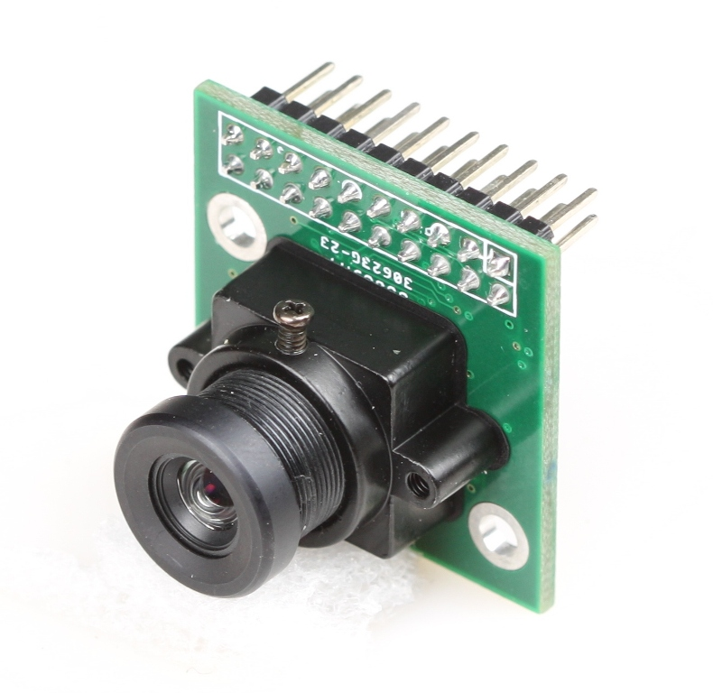

**Figure 3.2:** Camera Module

This camera module can perform image processing such as AWB (auto white balance), AE (automatic exposure) and AGC (automatic gain control), for the video signal coming from CMOS sensor. What’s more, in fusion of other advanced technology such as image enhancement processing under low illumination, and image noise intelligent forecast and suppress this module would output high quality digital video signals by standard CCIR656 interface.

OV7670 built-in JPEG decoder supported real-time encoding for collected image, and external controller can easily read the M – JPEG video streams, achieving the camera design of double stream.

OV7670 supported motion detection and OSD display function of screen characters and pattern overlay, capable of self-defining detection area and sensitivity.

This is an Arduino camera module,  adopted the Surveillance cameras digital image processing chip-OV0706, specially designed for image acquisition and processing application,  based on TTL communication interface, very convenient to connect with Arduino controller, able to read image and data via UART serial port, and then perform some image processing.

**1.4 Ultrasonic Sensor**

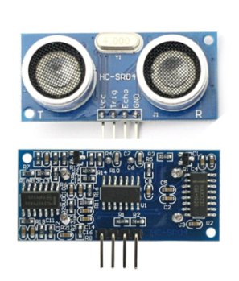

The HC-SR04 ultrasonic sensor uses sonar to determine distance to an object like bats do. It offers excellent non-contact range detection with high accuracy. It comes complete with ultrasonic transmitter and receiver module.

PINS:

VCC: +5VDC

Trig: Trigger (INPUT)

Echo: Echo (OUTPUT)

GND: GND

FEATURES OF ULTRASONIC SENSOR.

* Power Supply :+5V DC
* Quiescent Current : <2mA
* Working Current: 15mA
* Effectual Angle: <15°
* Ranging Distance : 2cm – 400 cm/1″ – 13ft
* Resolution : 0.3 cm
* Measuring Angle: 30 degree
* Trigger Input Pulse width: 10uS
* Dimension: 45mm x 20mm x 15mm

**1.5 Driver controller L298N H-BRIDGE**

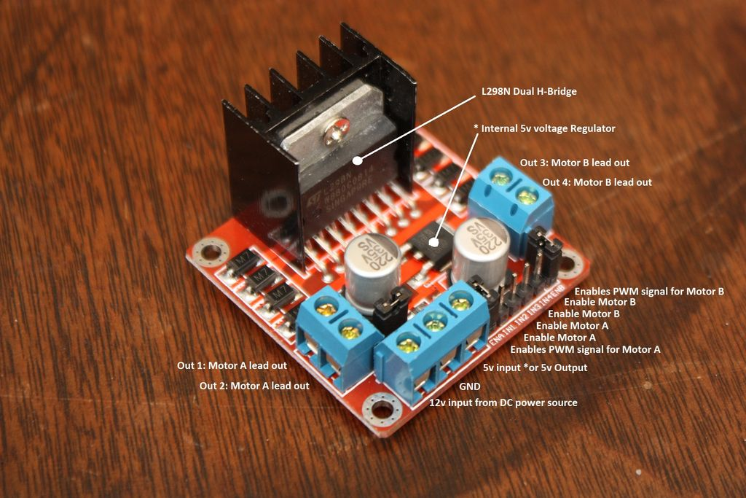

**Usage:**

H-Bridges are typically used in controlling motors speed and direction, but can be used for other projects such as driving the brightness of certain lighting projects such as high powered LED arrays.

**How it works:**

An H-Bridge is a circuit that can drive a current in either polarity and be controlled by *Pulse Width Modulation (PWM).

* Pulse Width Modulation is a means in controlling the duration of an electronic pulse. In motors try to imagine the brush as a water wheel and electrons as a the flowing droplets of water. The voltage would be the water flowing over the wheel at a constant rate, the more water flowing the higher the voltage. Motors are rated at certain voltages and can be damaged if the voltage is applied to heavily or if it is dropped quickly to slow the motor down. Thus PWM. Take the water wheel analogy and think of the water hitting it in pulses but at a constant flow. The longer the pulses the faster the wheel will turn, the shorter the pulses, the slower the water wheel will turn. Motors will last much longer and be more reliable if controlled through PWM.

**Pins:**

* Out 1: Motor A lead out
* Out 2: Motor A lead out
* Out 3: Motor B lead out
* Out 4: Mo (Can actually be from 5v-35v, just marked as 12v)
* GND: Ground
* 5v: 5v input (unnecessary if your power source is 7v-35v, if the power source is 7v-35v then it can act as a 5v out)
* EnA: Enables PWM signal for Motor A (Please see the "Arduino Sketch Considerations" section)
* In1: Enable Motor A
* In2: Enable Motor A
* In3: Enable Motor B
* In4: Enable Motor B
* EnB: Enables PWM signal for Motor B (Please see the "Arduino Sketch Considerations" section)

**Specifications:**

* Double H bridge Drive Chip: L298N
* Logical voltage: 5V Drive voltage: 5V-35V
* Logical current: 0-36mA Drive current: 2A (MAX single bridge)
* Max power: 25W
* Dimensions: 43 x 43 x 26mm
* Weight: 26g

**1.5 DC MOTOR**

**BLOCK DIAGRAM:**

**SENSOR**

**MICROCONTROLLER**

**MOTOR DRIVER**

**LEFT ACTUATOR**

**RIGHT ACTUATOR**

**DATA FLOW DIAGRAM:**

**Sv**

TAKES RIGHT TURN

**OBSTACLE OCCURS**

STORES IMAGE IN CLOUD

CAPTURES IMAGE

OBSTACLE DETECTED

MOVE TILL EDGE

VOICE INPUT

LEFT OR RIGHT

CHANGE DIRECTION

DOES’T CHANGE

**OBSTACLE OCCURS**

RUN THE ROBOT

EDGE DETE-CTED

INITIALIZATION