1. Anatomy of an ArUco Marker
- Black Border: A 1-block thick continuous boundary used to isolate the marker from background noise and determine spatial geometry.
- Payload (Inner Grid): A binary grid (e.g., 6 X 6) encoding a specific mathematical ID. Black represents 0, white represents 1.
- Dictionaries (e.g., DICT_6X6_250): Predefined sets of valid markers mathematically generated to maximize Hamming distance. This prevents false matches, detects occlusion, and ensures rotational asymmetry (the ID cannot match another ID if rotated 90, 180, or 270 degrees).

2. The 2D Detection Pipeline (From Pixels to Data)

Step 1: Preprocessing & Lens Correction
- Grayscale Conversion: Compresses the RGB channels into a single luminance channel (Luminance = 0.299R + 0.587G + 0.114B) to remove color dependency and increase processing speed. These exact values are derived from human perception .
- Adaptive Thresholding: Converts the grayscale image to pure binary (black/white) by calculating local threshold values for small pixel neighborhoods, mitigating uneven lighting and shadows. One matrix (say pXp) is moved through the entire frams like a filter matrix and the grayscaled image is converted into pure balck 0 or pure white 255 based on the values of average intensity around a particular pixel
- Lens Distortion: Radial distortion (barrel/pincushion) bends straight lines. Camera calibration yields a Camera Matrix (K) and Distortion Coefficients (k_1, k_2, p_1, p_2, k_3), allowing cv2.undistort to mathematically un-bend the pixels. In my code i am using a approximate value for a general 720p web camera . This however can be manually calliberated too.

Step 2: Contour Extraction & Topological Hierarchy
- Objective: Find the continuous boundary loops of objects in the binary image.
- Flood-Fill/Hierarchy: To ignore the inner data blocks of the marker, the algorithm uses a hierarchy filter (cv2.RETR_EXTERNAL). By conceptually tracking the "global background" from the edges of the image, it only extracts the outermost black walls, discarding any nested shapes trapped inside.

Step 3: Polygon Approximation (Douglas-Peucker Algorithm)
- Objective: Decimate wobbly, raw pixel boundaries into mathematically sharp vertices.
- The Math: The algorithm draws a line between a start and end point on the contour, finds the furthest vertex, and measures its perpendicular distance d. If d is greater than the error margin e(epsilon) (dynamically calculated based on the contour's perimeter), the vertex is kept, and the curve splits.
- Filtering: Only contours that reduce to exactly 4 corners and are geometrically convex are kept as "Candidate Markers."

Step 4: Perspective Rectification (Untwisting the Marker)
- Homography ($H$): A 3 X 3 transformation matrix that maps the 4 skewed corners of the camera image to a new, perfectly flat destination canvas (e.g., 200 X 200 pixels).
- Inverse Warping: To prevent pixel collisions and black holes in the final image, the algorithm loops through the empty destination grid, uses H^{-1} to calculate the corresponding coordinate in the camera photo, and pulls the color forward using Bilinear Interpolation.
- In-Plane Rotation Resolution: Homography automatically neutralizes arbitrary 2D tilts (like a 60-degree diamond shape) by forcing the highest absolute corner in the camera frame to the Top-Left of the flat canvas.

Step 5: Bit Extraction & Dictionary Decoding
- Majority Vote: The flattened image is divided into a grid (e.g., 8 X 8). The algorithm counts the black and white pixels in each cell. If white > black, the bit is 1. This provides extreme noise reduction.
- Rotation Check: The outer border is stripped, leaving the 6 X 6 payload. The computer checks the payload against the predefined dictionary. If it fails, it rotates the matrix by 90 degrees and checks again.
- Result: A match simultaneously confirms the Marker ID and the absolute Orientation (the true Top-Left corner).
- rejected Array: Shapes that passed Step 3 (geometry) but failed Step 5 (dictionary check) are stored here. This is primarily caused by blurry camera focus or impostor square objects. This can be used for debugging purposes and to find the shapes that the model detected and wernt aruco markers

3. The 3D Pose Estimation (Perspective-n-Point)

The Mathematics of solvePnP
Calculates the 3D position and orientation of the marker relative to the camera lens using the Pinhole Camera Equation:
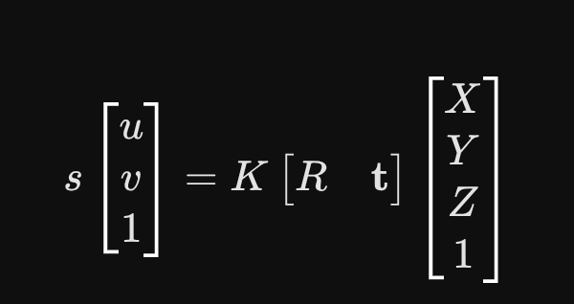
- Inputs: * (X, Y, Z): Physical local coordinates of the 4 marker corners (e.g., 10 cm square centered at origin).
  - (u, v): The 2D sub-pixel coordinates of the corners detected in Step 3.
  - K: The calibrated Camera Intrinsic Matrix.
- Outputs: 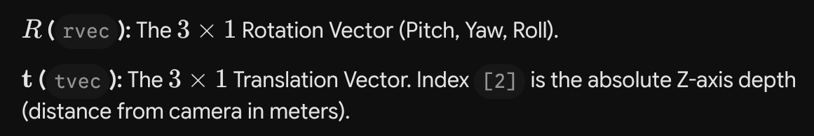
- IPPE Algorithm (SOLVEPNP_IPPE_SQUARE): A modern, non-iterative mathematical solver that leverages planar square geometry to eliminate tracking jitter.

