**RESULTS WHEN REVISITED AFTER READING SUTTON SECTION I**

**1.**

**REWARD**

def get_reward(state, step, last_best_state):

if state[0] >= last_best_state + LEVEL_GRANULARITY:

return 1

else:

return -1

return 0

**HYPERPARAMETERS**

MAX_RUNS=3000

MAXIMUM_STEPS=500

EXPLORATION_STEPS_PER_STATE=100

INTERPOLATION=MAX_RUNS/10

ENV_NAME = "MountainCar-v0"

GAMMA = 0.95

LEARNING_RATE = 0.2

EXPLORATION_MAX = 1.0

EXPLORATION_MIN = 0.1

EXPLORATION_DECAY = 0.99995

LEVEL_GRANULARITY=0.001

**INIT**

self.q_values = np.random.uniform(low = -1, high = 1,

size = (self.num_states[0], self.num_states[1],

env.action_space.n))

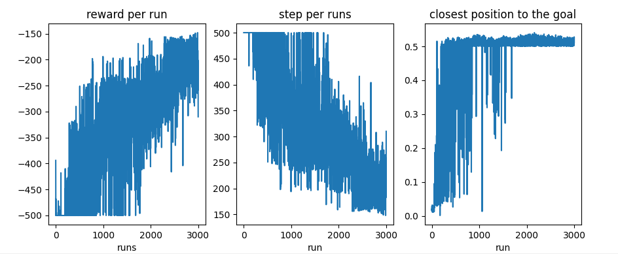

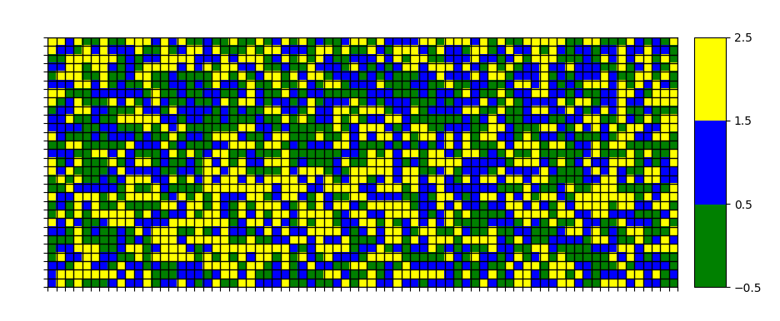 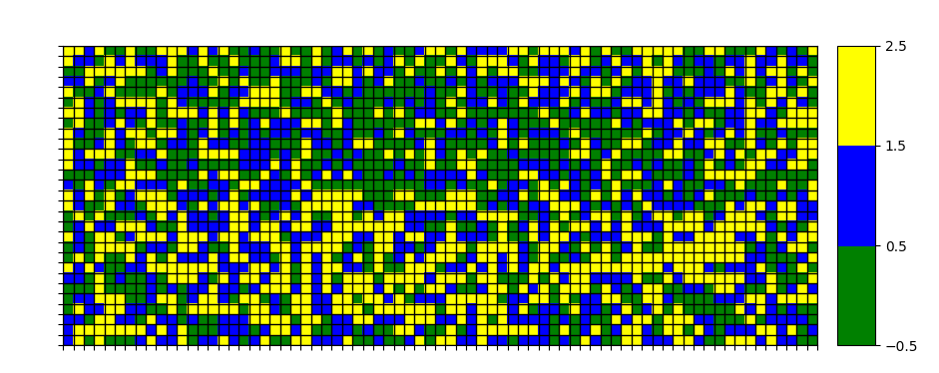 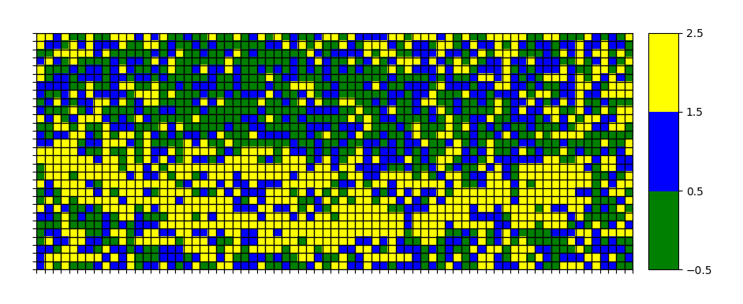

**2.**

**REWARD**

def get_reward(state, step, last_best_state):

if state[0] >= last_best_state + LEVEL_GRANULARITY:

return 1

else:

return -1

return 0

**HYPERPARAMETERS**

MAX_RUNS=3000

MAXIMUM_STEPS=500

EXPLORATION_STEPS_PER_STATE=100

INTERPOLATION=MAX_RUNS/10

ENV_NAME = "MountainCar-v0"

GAMMA = 0.99

LEARNING_RATE = 0.2

EXPLORATION_MAX = 1.0

EXPLORATION_MIN = 0.1

EXPLORATION_DECAY = 0.99995

LEVEL_GRANULARITY=0.001

**INIT**

self.q_values = np.random.uniform(low = -1, high = 1,

size = (self.num_states[0], self.num_states[1],

env.action_space.n))

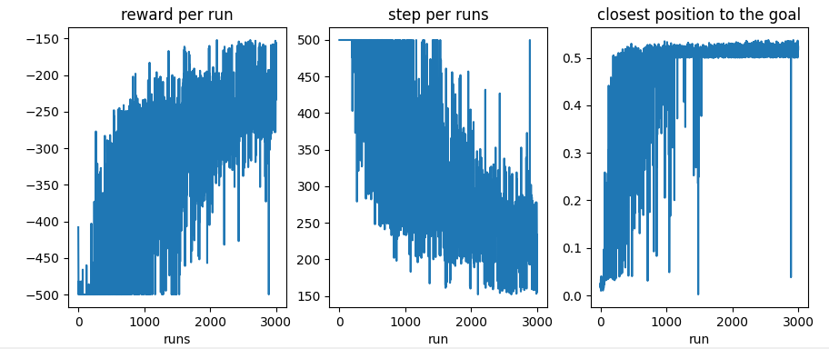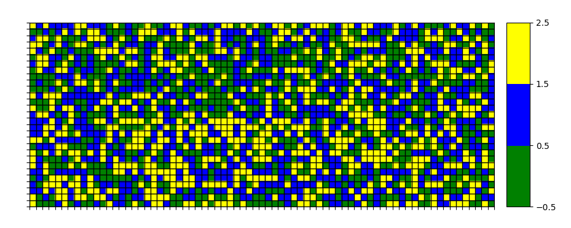

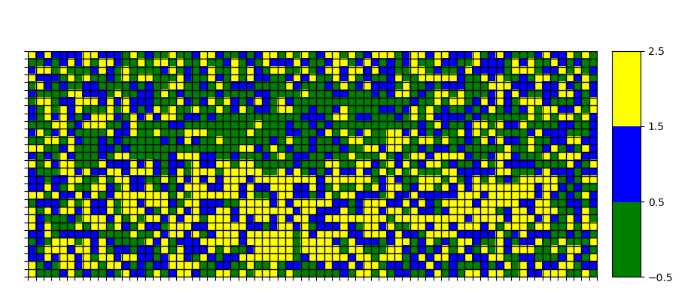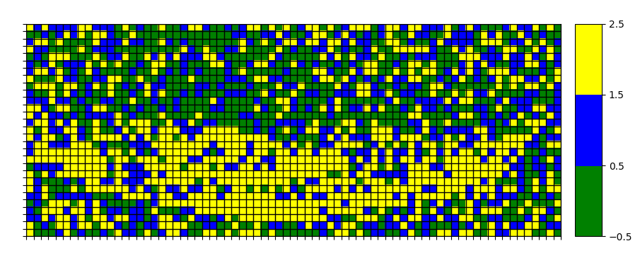

**3.**

**REWARD**

def get_reward(state, step, last_best_state):

if state[0] >= last_best_state + LEVEL_GRANULARITY:

return 1

else:

return -1

return 0

**HYPERPARAMETERS**

MAX_RUNS=3000

MAXIMUM_STEPS=500

EXPLORATION_STEPS_PER_STATE=100

INTERPOLATION=MAX_RUNS/10

ENV_NAME = "MountainCar-v0"

GAMMA = 0.95

LEARNING_RATE = 0.4

EXPLORATION_MAX = 1.0

EXPLORATION_MIN = 0.1

EXPLORATION_DECAY = 0.99995

LEVEL_GRANULARITY=0.001

**INIT**

self.q_values = np.random.uniform(low = -1, high = 1,

size = (self.num_states[0], self.num_states[1],

env.action_space.n))

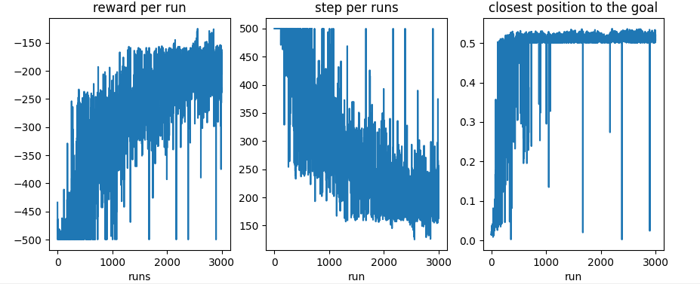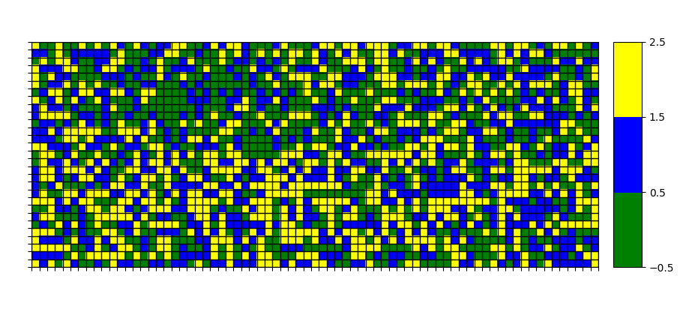

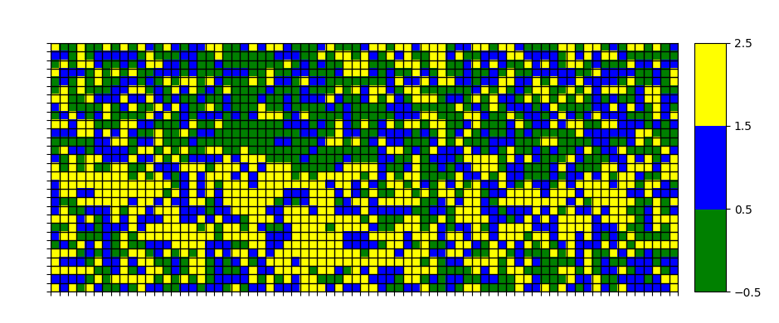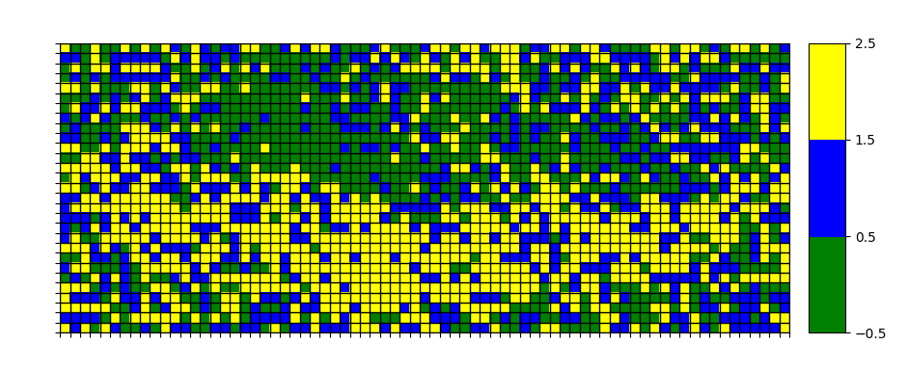

**4.**

**REWARD**

def get_reward(state, step, last_best_state):

if state[0] >= last_best_state + LEVEL_GRANULARITY:

return 1

else:

return -1

return 0

**HYPERPARAMETERS**

MAX_RUNS=3000

MAXIMUM_STEPS=500

EXPLORATION_STEPS_PER_STATE=100

INTERPOLATION=MAX_RUNS/10

ENV_NAME = "MountainCar-v0"

GAMMA = 0.95

LEARNING_RATE = 0.2

EXPLORATION_MAX = 1.0

EXPLORATION_MIN = 0.1

EXPLORATION_DECAY = 0.99995

LEVEL_GRANULARITY=0.001

**INIT**

self.q_values = np.random.uniform(low = 0, high = 0,

size = (self.num_states[0], self.num_states[1],

env.action_space.n))

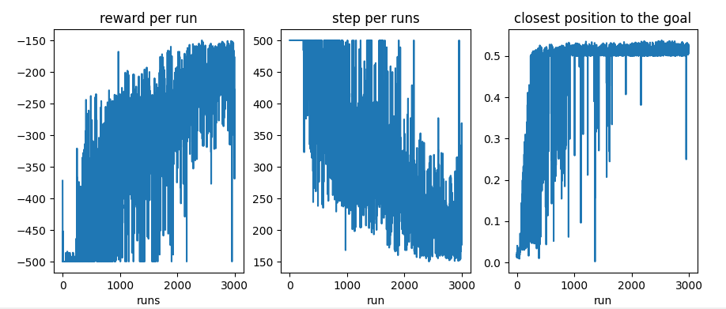

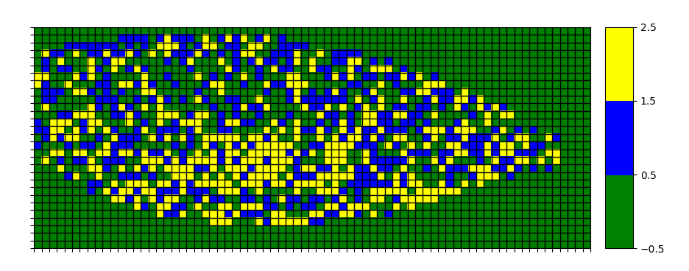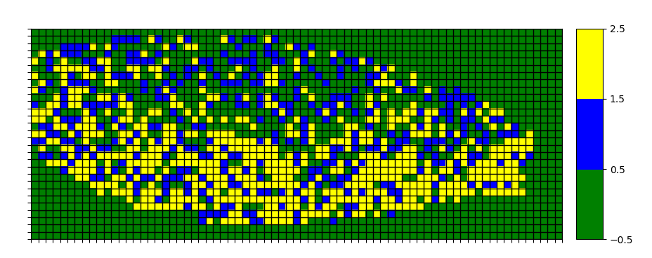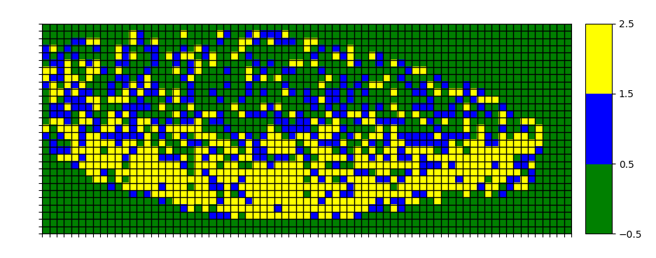

**5.**

**REWARD**

def get_reward(state, step, last_best_state):

if state[0] >= 0.5

return 0

else:

return -1

return 0

**HYPERPARAMETERS**

MAX_RUNS=3000

MAXIMUM_STEPS=500

EXPLORATION_STEPS_PER_STATE=100

INTERPOLATION=MAX_RUNS/10

ENV_NAME = "MountainCar-v0"

GAMMA = 0.95

LEARNING_RATE = 0.2

EXPLORATION_MAX = 1.0

EXPLORATION_MIN = 0.1

EXPLORATION_DECAY = 0.99995

LEVEL_GRANULARITY=0.001

**INIT**

self.q_values = np.random.uniform(low = 0, high = 0,

size = (self.num_states[0], self.num_states[1],

env.action_space.n))

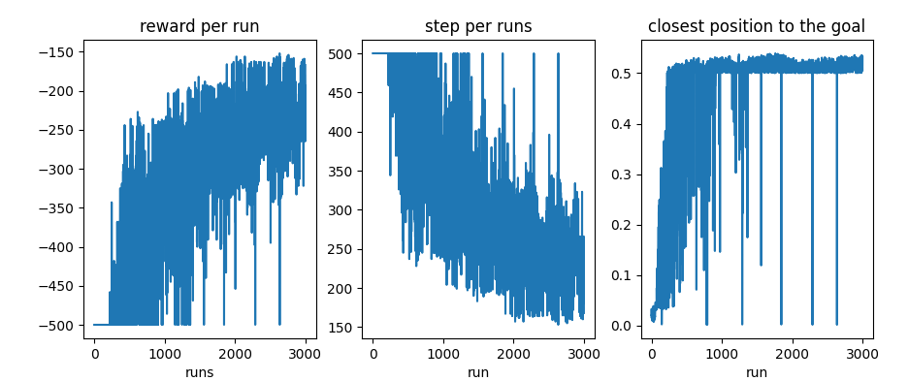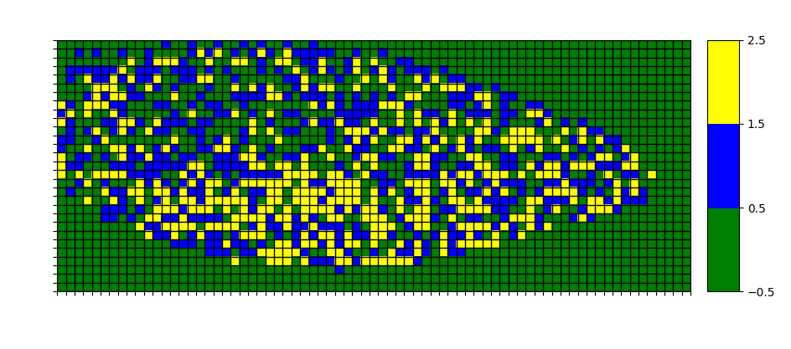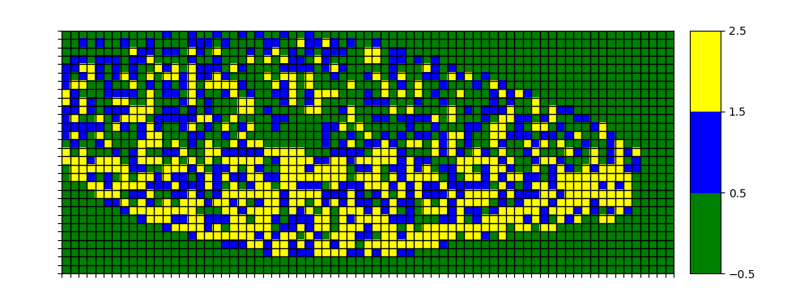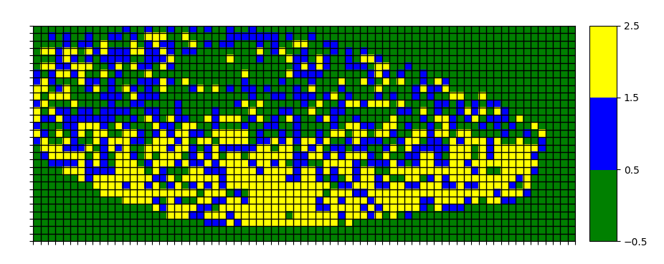

**6.**

**REWARD**

def get_reward(state, step, last_best_state):

if state[0] >= last_best_state + LEVEL_GRANULARITY:

return 0

else:

return -1

return 0

**HYPERPARAMETERS**

MAX_RUNS=3000

MAXIMUM_STEPS=500

EXPLORATION_STEPS_PER_STATE=100

INTERPOLATION=MAX_RUNS/10

ENV_NAME = "MountainCar-v0"

GAMMA = 0.95

LEARNING_RATE = 0.2

EXPLORATION_MAX = 1.0

EXPLORATION_MIN = 0.1

EXPLORATION_DECAY = 0.99995

LEVEL_GRANULARITY=0.01

**INIT**

self.q_values = np.random.uniform(low = 0, high = 0,

size = (self.num_states[0], self.num_states[1],

env.action_space.n))

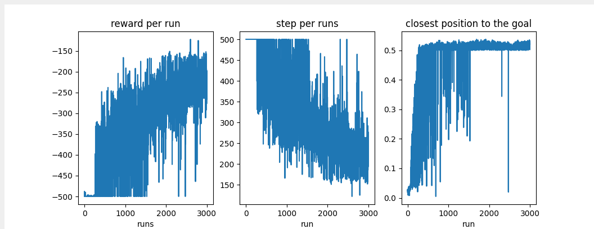

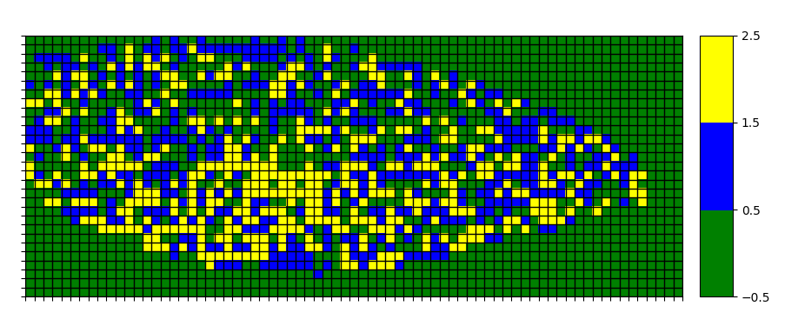 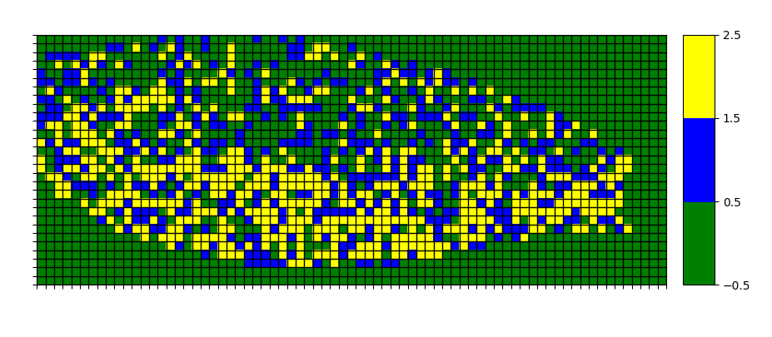 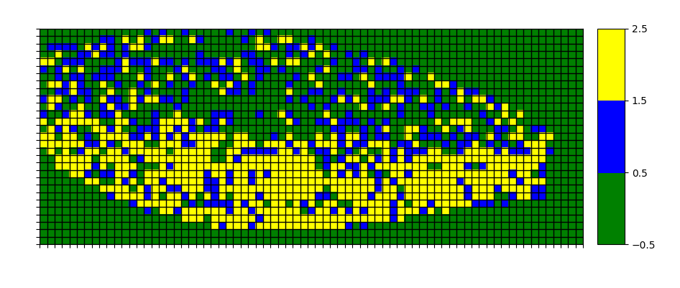

**7.**

**REWARD**

def get_reward(state, step, last_best_state):

if state[0] >= 0.5

return 0

else:

return -1

return 0

**HYPERPARAMETERS**

MAX_RUNS=3000

MAXIMUM_STEPS=500

EXPLORATION_STEPS_PER_STATE=100

INTERPOLATION=MAX_RUNS/10

ENV_NAME = "MountainCar-v0"

GAMMA = 0.95

LEARNING_RATE = 0.2

EXPLORATION_MAX = 1.0

EXPLORATION_MIN = 0.1

EXPLORATION_DECAY = 0.99995

LEVEL_GRANULARITY=0.01

**INIT**

self.q_values = np.random.uniform(low = -1, high = 1,

size = (self.num_states[0], self.num_states[1],

env.action_space.n))

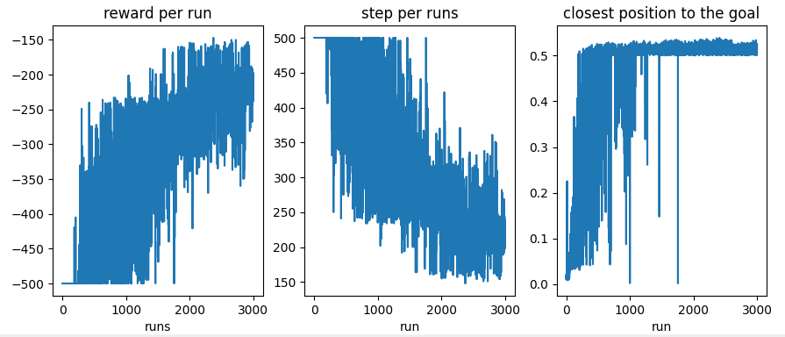

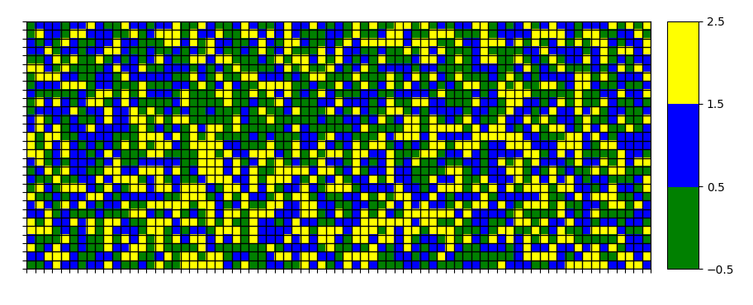

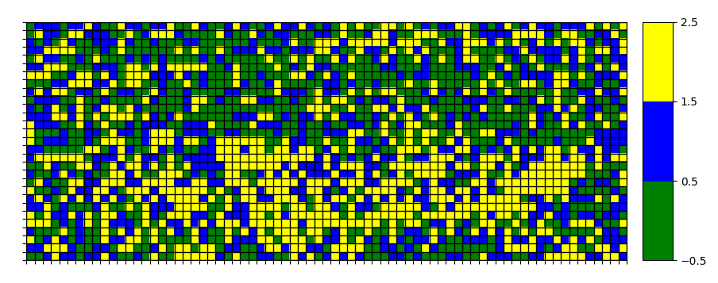

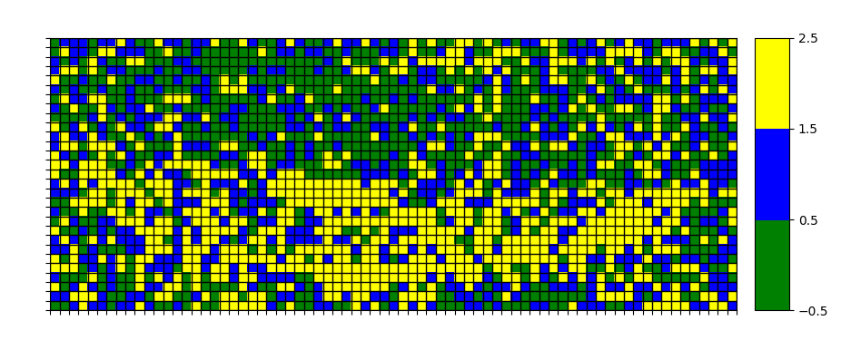

**8.**

**REWARD**

def get_reward(state, step, last_best_state):

if state[0] >= 0.5:

return 1

else:

return 0

return 0

**HYPERPARAMETERS**

MAX_RUNS=3000

MAXIMUM_STEPS=500

EXPLORATION_STEPS_PER_STATE=100

INTERPOLATION=MAX_RUNS/10

ENV_NAME = "MountainCar-v0"

GAMMA = 0.95

LEARNING_RATE = 0.2

EXPLORATION_MAX = 1.0

EXPLORATION_MIN = 0.1

EXPLORATION_DECAY = 0.99995

LEVEL_GRANULARITY=0.01

**INIT**

self.q_values = np.random.uniform(low = -1, high = 1,

size = (self.num_states[0], self.num_states[1],

env.action_space.n))

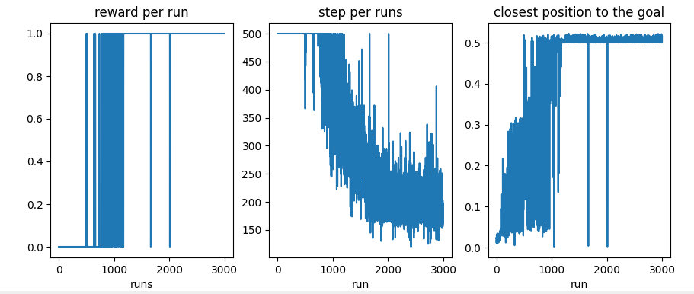

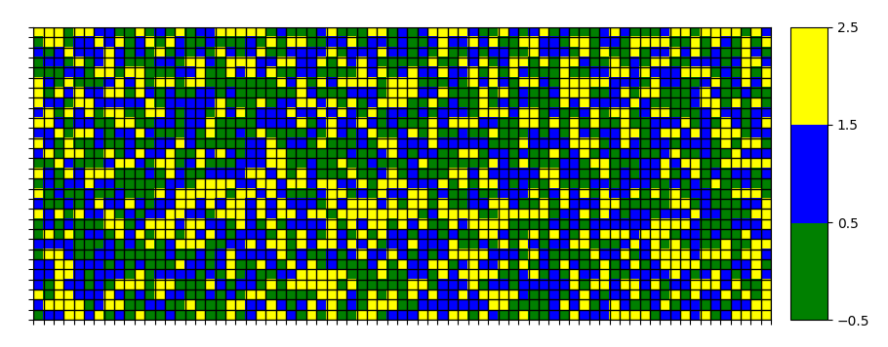

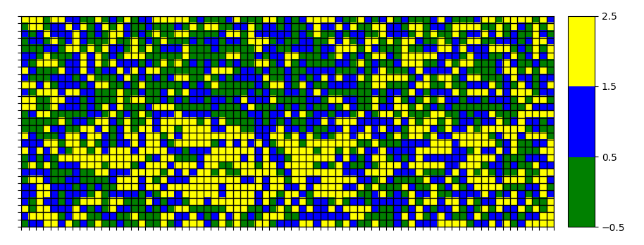

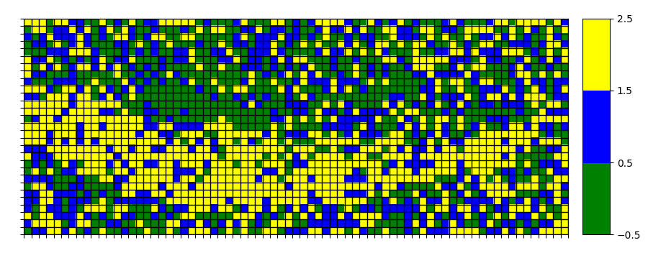

**This configuration has been executed twice:**

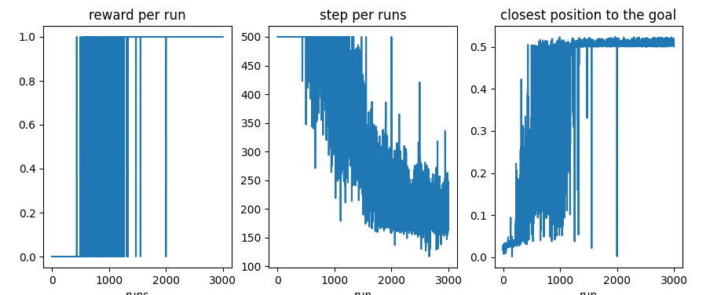

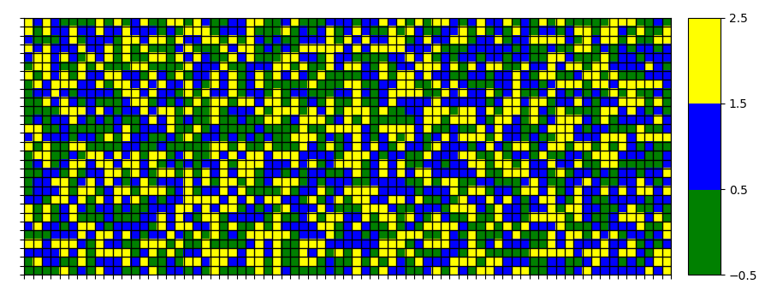

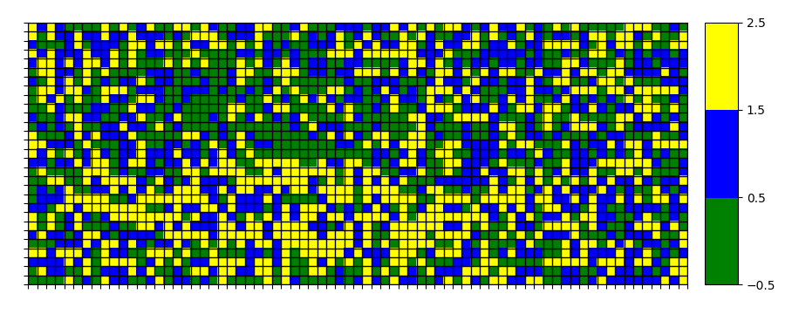

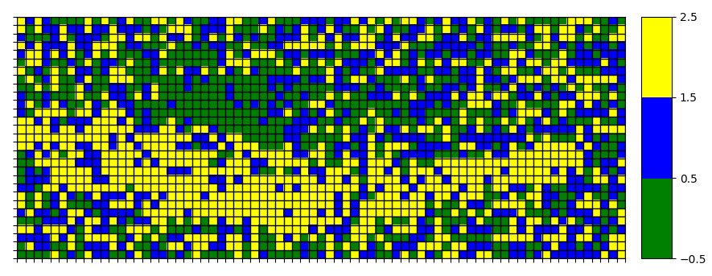

**And now executed without the 50 first iterations being exploration iterations. As you can see, the results are dramatically worse:**

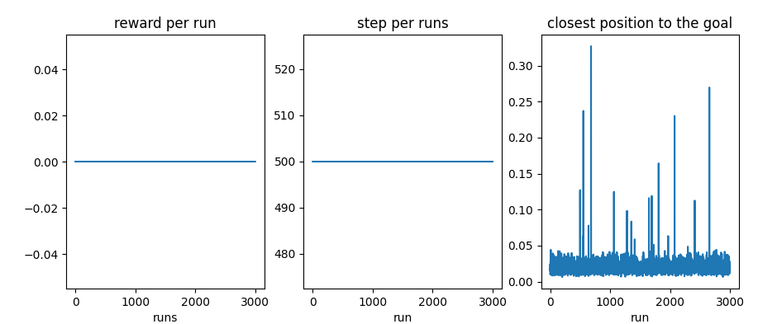

**From now on, the 50 first exploration iterations have been removed, showing the importance of giving room for exploration to the agent:**

**9.**

**REWARD**

def get_reward(state, step, last_best_state):

if state[0] >= 0.5:

return 1

else:

return 0

return 0

**HYPERPARAMETERS**

MAX_RUNS=3000

MAXIMUM_STEPS=500

EXPLORATION_STEPS_PER_STATE=100

INTERPOLATION=MAX_RUNS/10

ENV_NAME = "MountainCar-v0"

GAMMA = 0.95

LEARNING_RATE = 0.2

EXPLORATION_MAX = 1.0

EXPLORATION_MIN = 0.1

EXPLORATION_DECAY = 0.99995

LEVEL_GRANULARITY=0.01

**INIT**

self.q_values = np.random.uniform(low = 0, high = 0,

size = (self.num_states[0], self.num_states[1],

env.action_space.n))

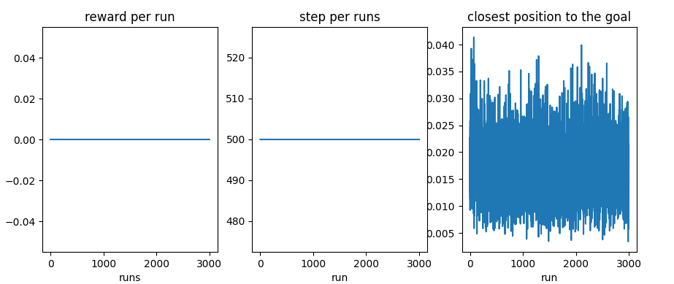

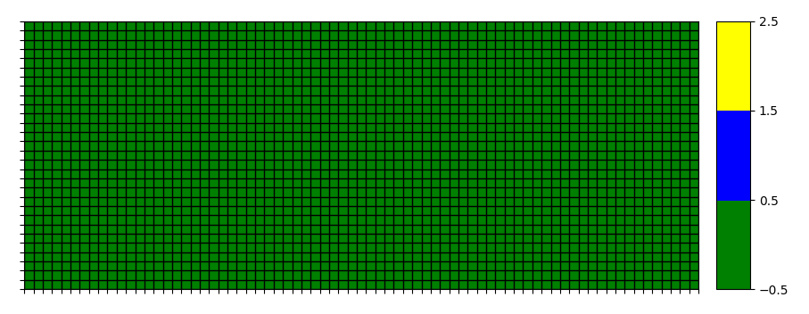

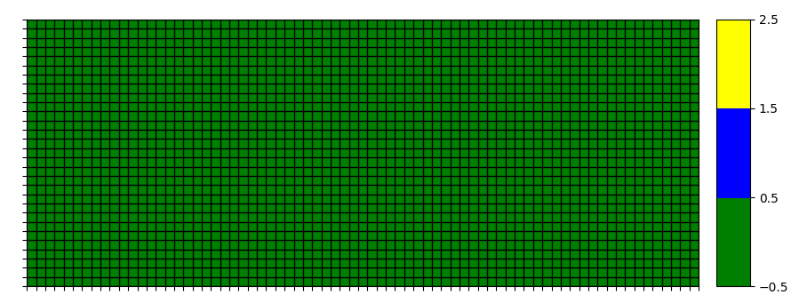

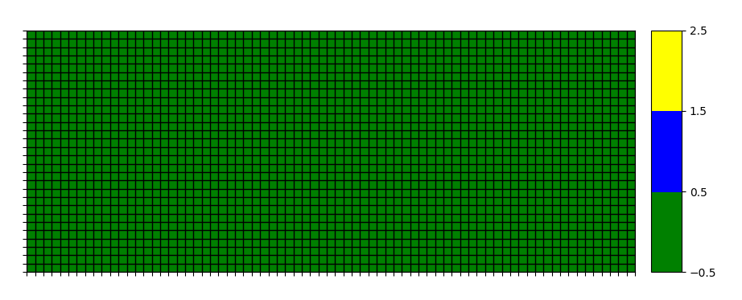

**This configuration has been executed twice with exact same result. Since all Q and rewards are 0 and the actions selection is not chosen randomly when tied up, the matrix is never updated and the actions to take is always -1 (left). If this return is randomized in the following way:**

def act(self, state, occurrences):

if np.random.rand() < self.exploration_rate:

return random.randrange(self.action_space)

untied_matrix=np.random.choice(np.flatnonzero(qsolver.q_values[i][j] == qsolver.q_values[i][j].max()))

action=untied_matrix

return action

**the following results are obtained:**

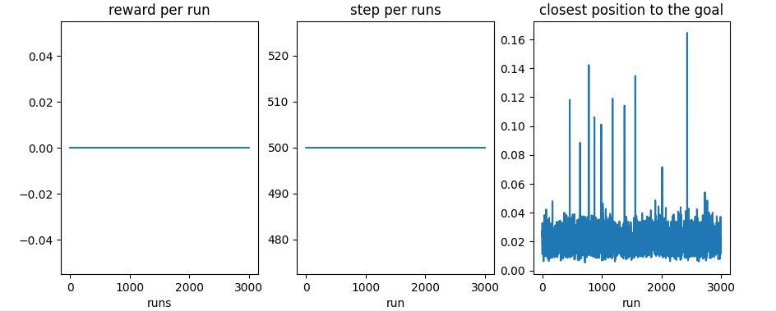

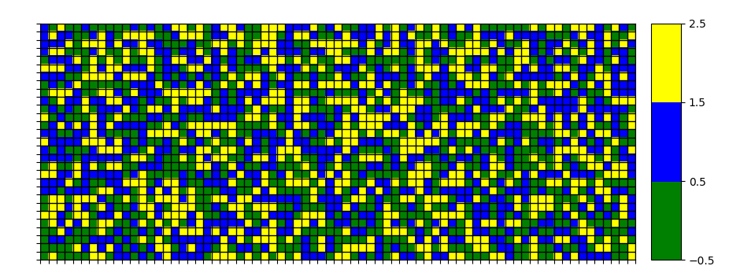

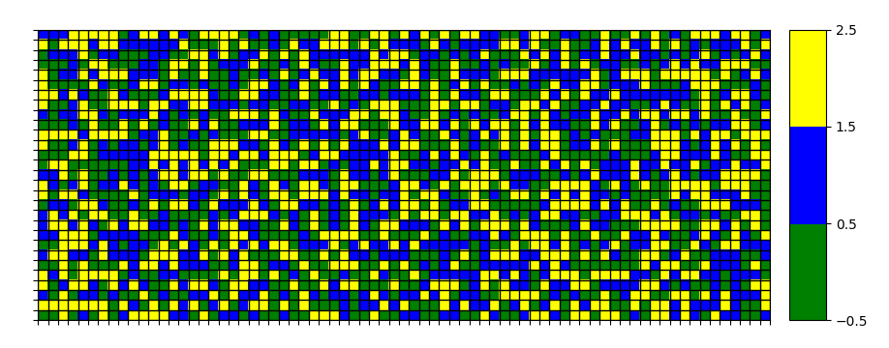

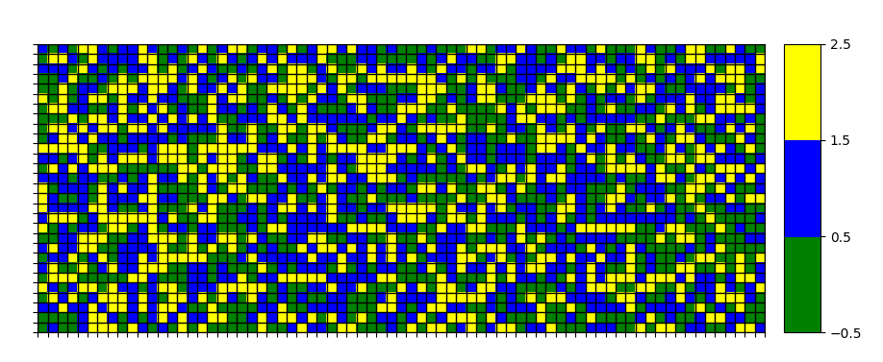

**Note that this is not really different than exactly the same configuration (including breaking ties up modification) but with a randomly q_values initialization between -1 and 1:**



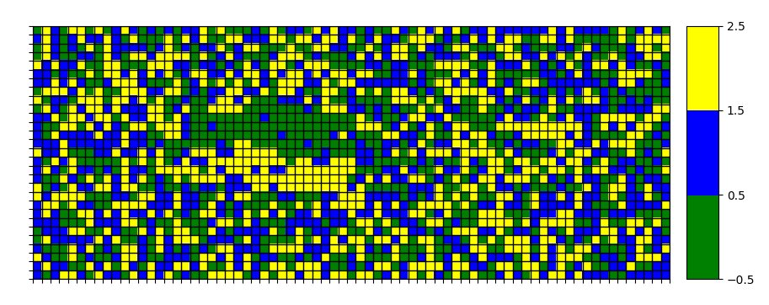

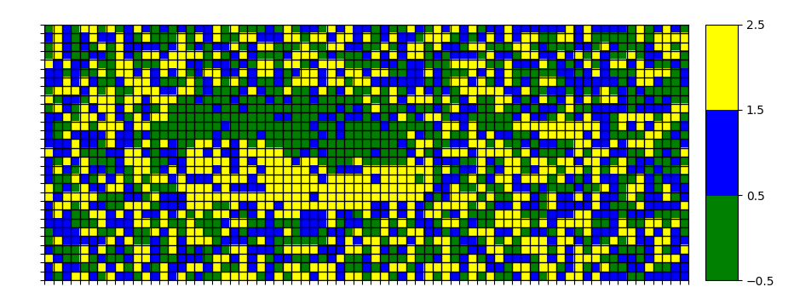

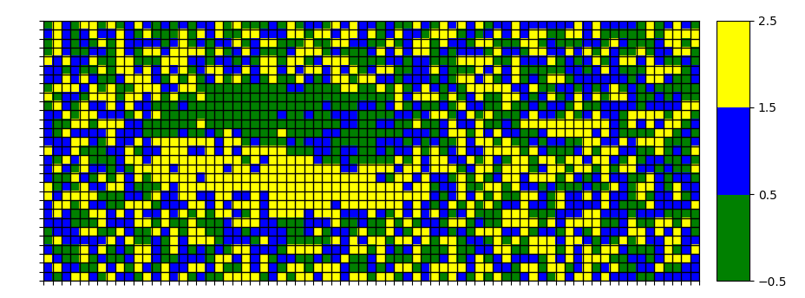

**However, when adding the 50 first exploration iterations back, those are the results:**

