RESULTS OF CARTPOLE PROBLEM BUILT ON RL-STUDIO

Starting point:
gamma: 0.95
epsilon_discount: 0.9998
GOAL → keep the pole always up and in the center

- Reward = 1 if still alive (up), 0 otherwise
- Steps per run = 1000
- states
| 0 | Cart Position | -4.8 | 4.8 |
| 1 | Cart Velocity | -Inf | Inf |
| 2 | Pole Angle | ~ -0.418 rad (-24°) | ~ 0.418 rad (24°) |
| 3 | Pole Angular Velocity | -Inf | Inf |

- Actions
| 0 | Push cart to the left |
| 1 | Push cart to the right |

Process
- First we observe that the robot was suffering from the catastrophic forgetting problem (https://en.wikipedia.org/wiki/Catastrophic_interference). Typical of DQN algorithm beign overtrained, so we decided to make the episodes shorter (500 steps) with the same following result ilustrated in the following graph - cumulated reward per episode.
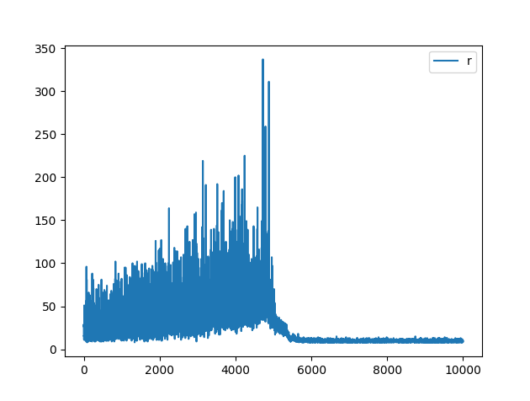
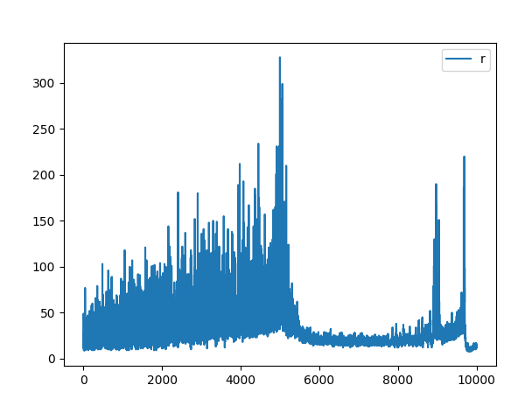
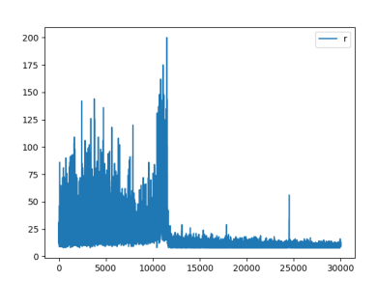

- Then we applied the epsilon discount in a different way.
Instead of multiplying it by a number between 0 and 1 each step, we decided to substract a low quantity instead, going from a logaritmic decrease to a linear decrease, which make the robot explore more at the beginning and less at the end and also stop learning before. We used this blog as inspiration (https://blog.gofynd.com/building-a-deep-q-network-in-pytorch-fa1086aa5435)
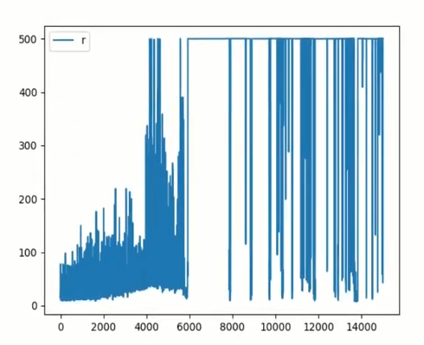

- It improved the results, but we still experienced the catastrophic forgetting randomly in some of our experiments, so we decided to test locking some of the experience_replay buffer to unsuccessfull events stored during the initialization. Exactly, a 10% of the buffer, in this case, the results were always like the shown in the previous picture, achieving 100% of successfull episodes during inference time with the final trained brain.

