RESULTS WHEN REVISITED AFTER READING SUTTON SECTION I

1.
REWARD
def get_reward(state, step, last_best_state):
if state[0] >= last_best_state + LEVEL_GRANULARITY:
return 1
else:
return -1
return 0

HYPERPARAMETERS

MAX_RUNS=3000
MAXIMUM_STEPS=500
EXPLORATION_STEPS_PER_STATE=100

INTERPOLATION=MAX_RUNS/10

ENV_NAME = "MountainCar-v0"

GAMMA = 0.95
LEARNING_RATE = 0.2

EXPLORATION_MAX = 1.0
EXPLORATION_MIN = 0.1
EXPLORATION_DECAY = 0.99995

LEVEL_GRANULARITY=0.001

INIT
self.q_values = np.random.uniform(low = -1, high = 1,
size = (self.num_states[0], self.num_states[1],
env.action_space.n))
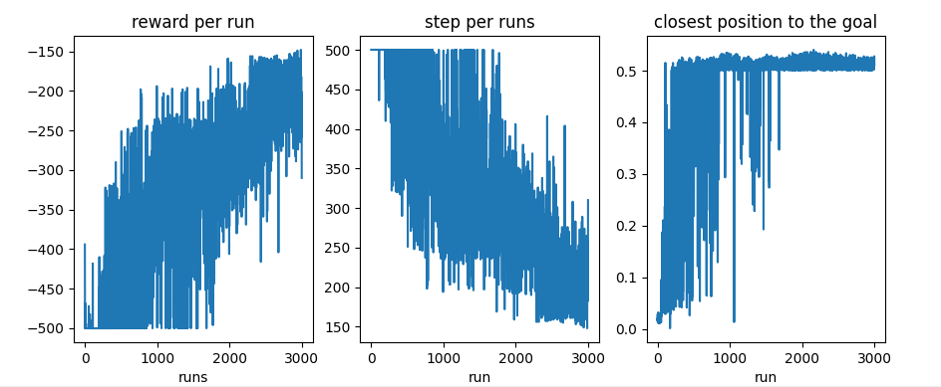
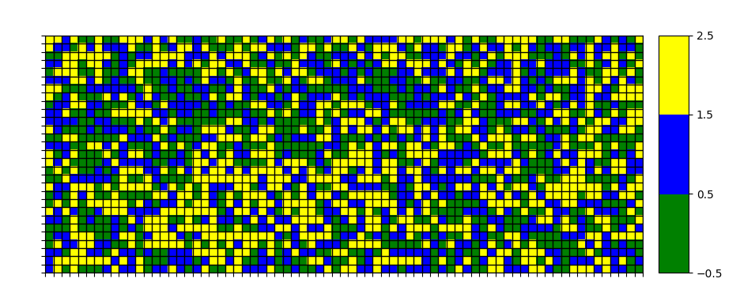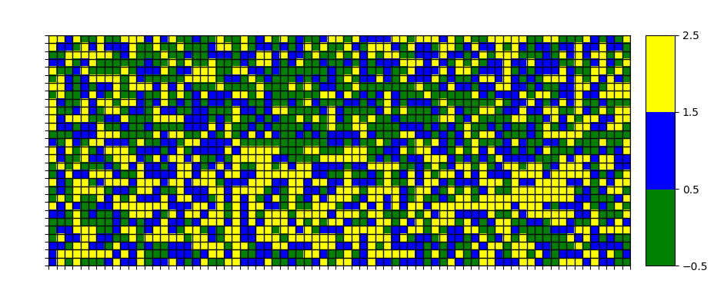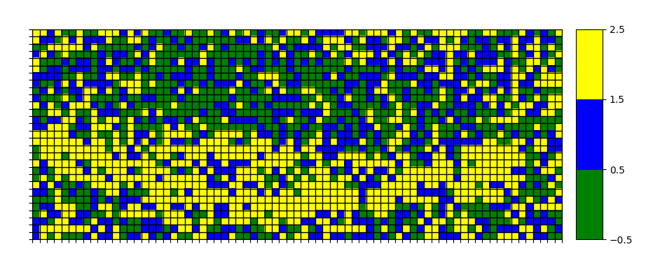

2.
REWARD
def get_reward(state, step, last_best_state):
if state[0] >= last_best_state + LEVEL_GRANULARITY:
return 1
else:
return -1
return 0

HYPERPARAMETERS

MAX_RUNS=3000
MAXIMUM_STEPS=500
EXPLORATION_STEPS_PER_STATE=100

INTERPOLATION=MAX_RUNS/10

ENV_NAME = "MountainCar-v0"

GAMMA = 0.99
LEARNING_RATE = 0.2

EXPLORATION_MAX = 1.0
EXPLORATION_MIN = 0.1
EXPLORATION_DECAY = 0.99995

LEVEL_GRANULARITY=0.001

INIT
self.q_values = np.random.uniform(low = -1, high = 1,
size = (self.num_states[0], self.num_states[1],
env.action_space.n))
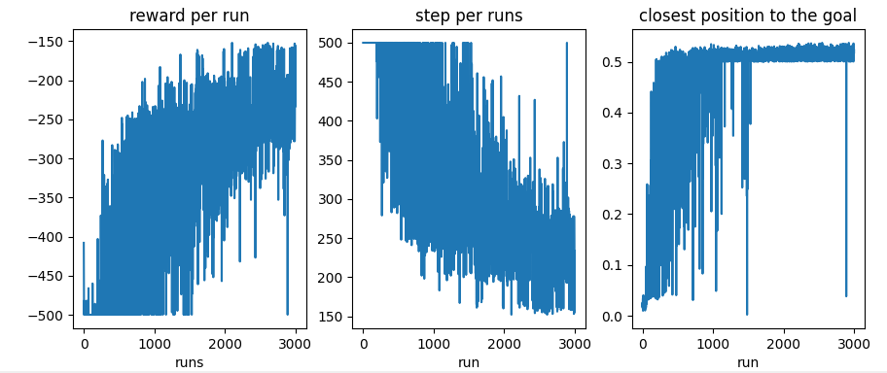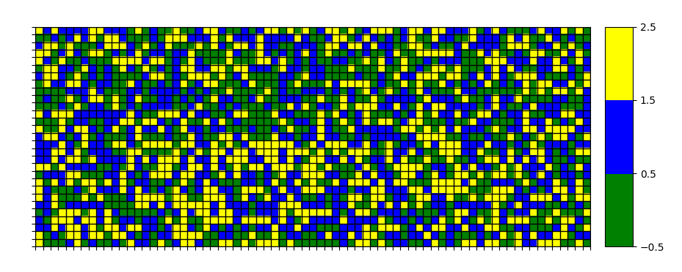
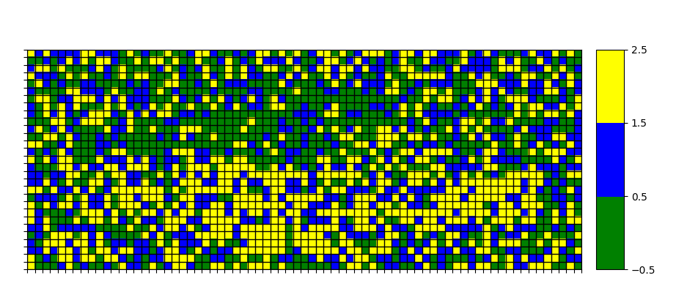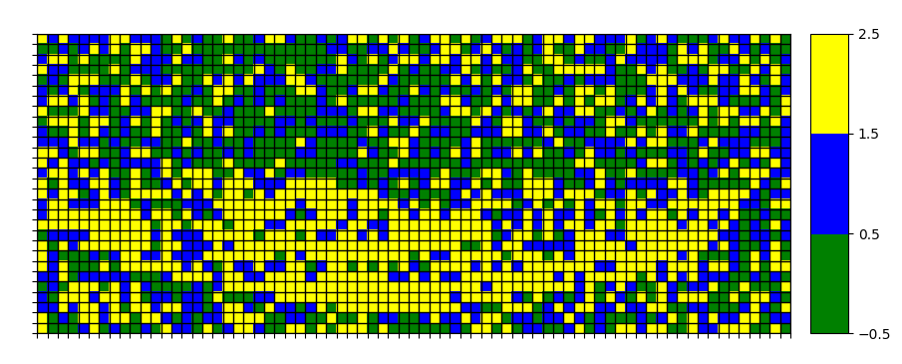
3.
REWARD
def get_reward(state, step, last_best_state):
if state[0] >= last_best_state + LEVEL_GRANULARITY:
return 1
else:
return -1
return 0

HYPERPARAMETERS

MAX_RUNS=3000
MAXIMUM_STEPS=500
EXPLORATION_STEPS_PER_STATE=100

INTERPOLATION=MAX_RUNS/10

ENV_NAME = "MountainCar-v0"

GAMMA = 0.95
LEARNING_RATE = 0.4

EXPLORATION_MAX = 1.0
EXPLORATION_MIN = 0.1
EXPLORATION_DECAY = 0.99995

LEVEL_GRANULARITY=0.001
INIT
self.q_values = np.random.uniform(low = -1, high = 1,
size = (self.num_states[0], self.num_states[1],
env.action_space.n))
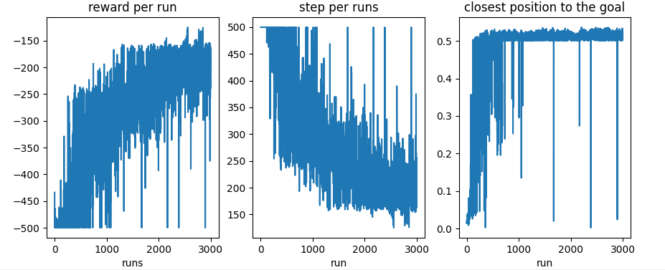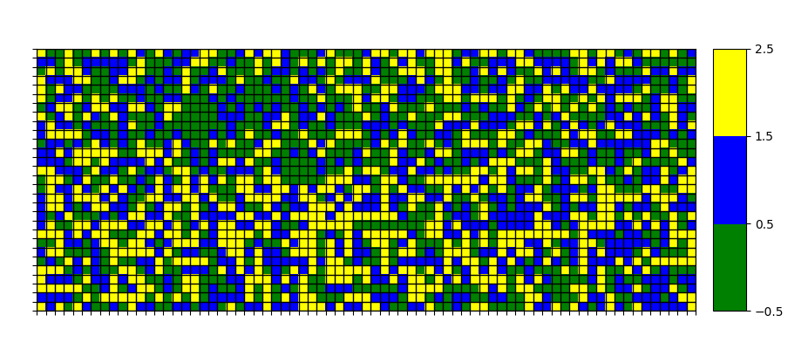
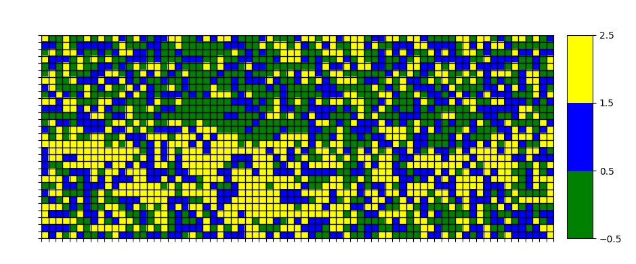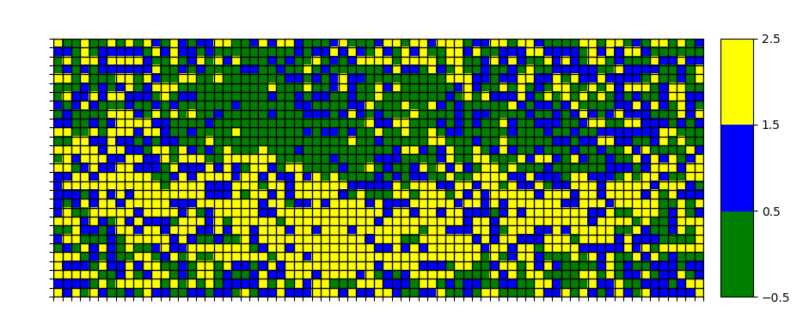

4.
REWARD
def get_reward(state, step, last_best_state):
if state[0] >= last_best_state + LEVEL_GRANULARITY:
return 1
else:
return -1
return 0

HYPERPARAMETERS

MAX_RUNS=3000
MAXIMUM_STEPS=500
EXPLORATION_STEPS_PER_STATE=100

INTERPOLATION=MAX_RUNS/10

ENV_NAME = "MountainCar-v0"

GAMMA = 0.95
LEARNING_RATE = 0.2

EXPLORATION_MAX = 1.0
EXPLORATION_MIN = 0.1
EXPLORATION_DECAY = 0.99995

LEVEL_GRANULARITY=0.001

INIT
self.q_values = np.random.uniform(low = 0, high = 0,
size = (self.num_states[0], self.num_states[1],
env.action_space.n))
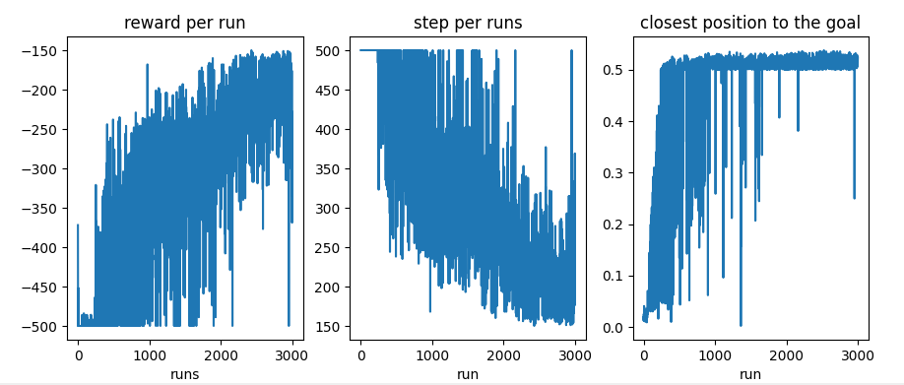

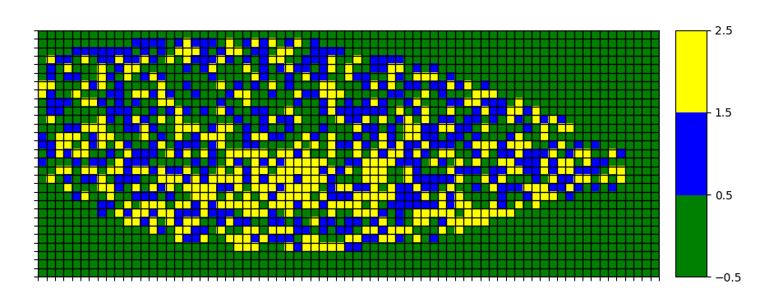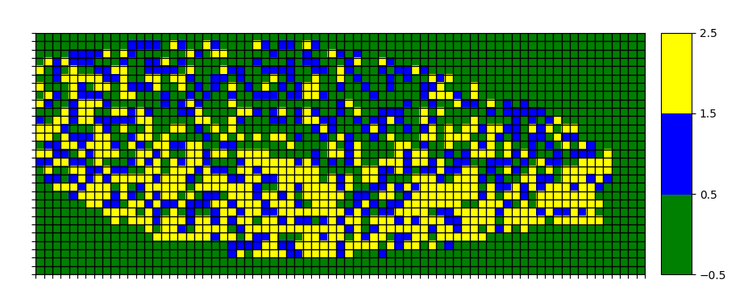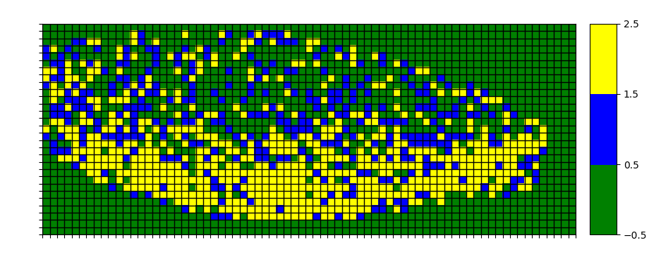
5.
REWARD
def get_reward(state, step, last_best_state):
if state[0] >= 0.5
return 0
else:
return -1
return 0

HYPERPARAMETERS

MAX_RUNS=3000
MAXIMUM_STEPS=500
EXPLORATION_STEPS_PER_STATE=100

INTERPOLATION=MAX_RUNS/10

ENV_NAME = "MountainCar-v0"

GAMMA = 0.95
LEARNING_RATE = 0.2

EXPLORATION_MAX = 1.0
EXPLORATION_MIN = 0.1
EXPLORATION_DECAY = 0.99995

LEVEL_GRANULARITY=0.001

INIT
self.q_values = np.random.uniform(low = 0, high = 0,
size = (self.num_states[0], self.num_states[1],
env.action_space.n))
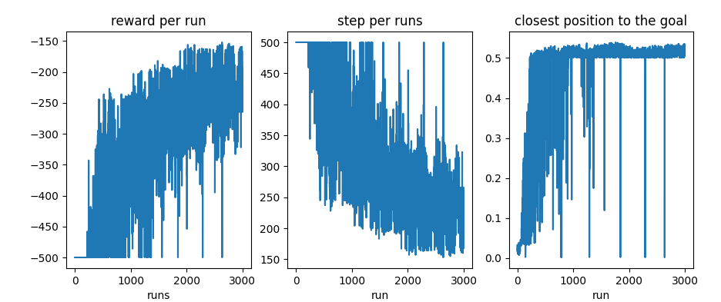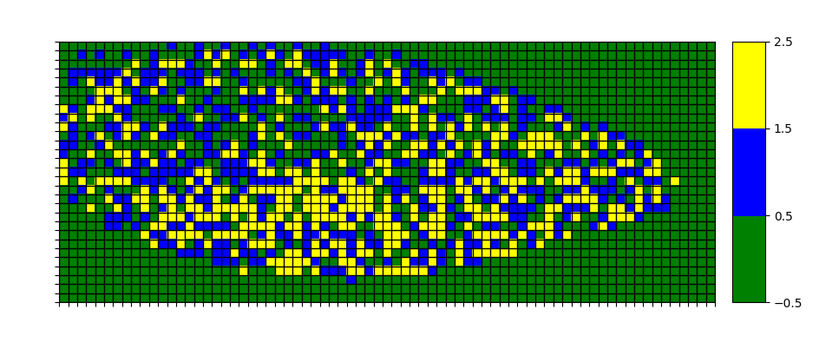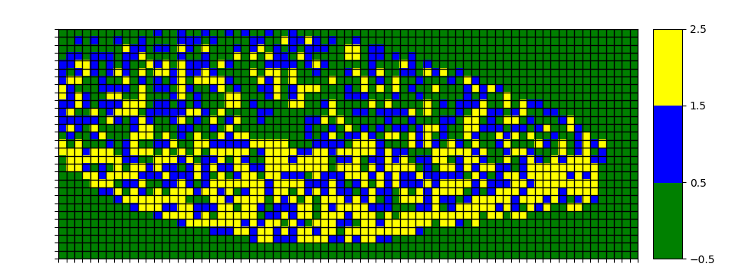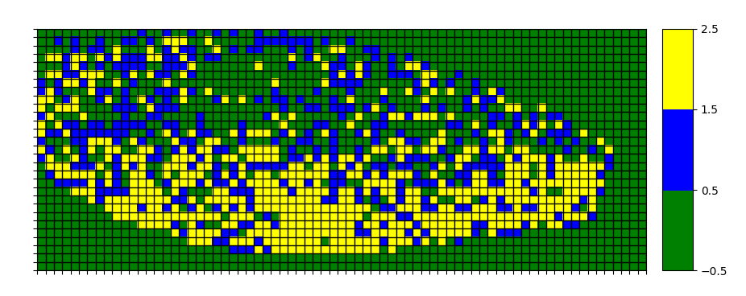

6.
REWARD
def get_reward(state, step, last_best_state):
if state[0] >= last_best_state + LEVEL_GRANULARITY:
return 0
else:
return -1
return 0
HYPERPARAMETERS

MAX_RUNS=3000
MAXIMUM_STEPS=500
EXPLORATION_STEPS_PER_STATE=100

INTERPOLATION=MAX_RUNS/10

ENV_NAME = "MountainCar-v0"

GAMMA = 0.95
LEARNING_RATE = 0.2

EXPLORATION_MAX = 1.0
EXPLORATION_MIN = 0.1
EXPLORATION_DECAY = 0.99995

LEVEL_GRANULARITY=0.01

INIT
self.q_values = np.random.uniform(low = 0, high = 0,
size = (self.num_states[0], self.num_states[1],
env.action_space.n))

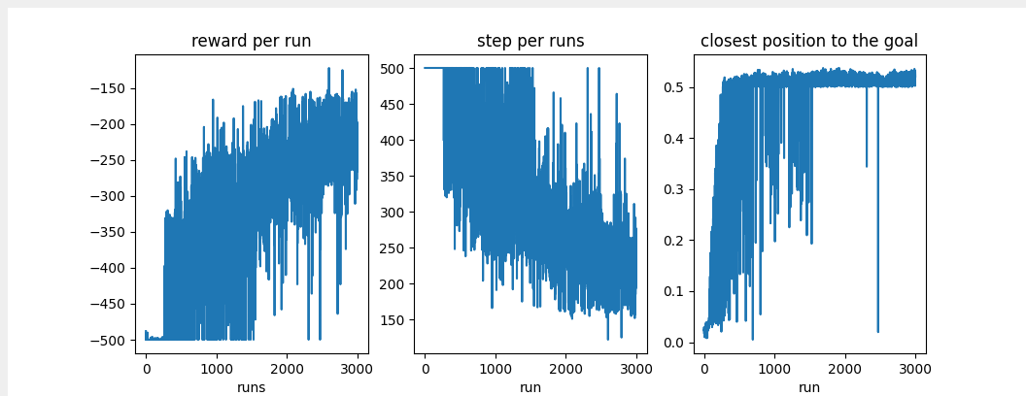
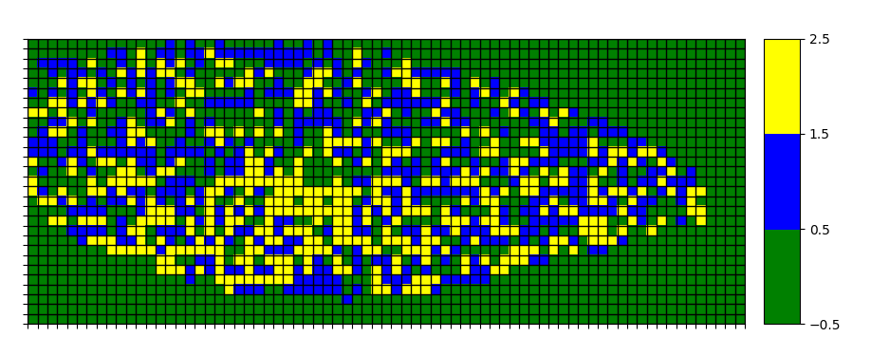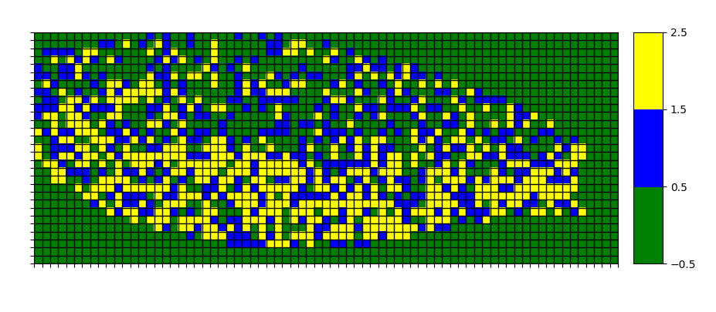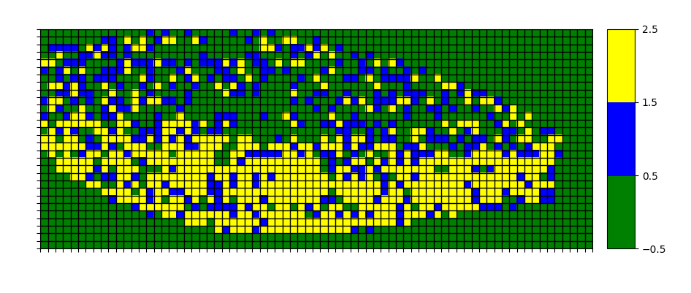

7.
REWARD
def get_reward(state, step, last_best_state):
if state[0] >= 0.5
return 0
else:
return -1
return 0

HYPERPARAMETERS

MAX_RUNS=3000
MAXIMUM_STEPS=500
EXPLORATION_STEPS_PER_STATE=100

INTERPOLATION=MAX_RUNS/10

ENV_NAME = "MountainCar-v0"

GAMMA = 0.95
LEARNING_RATE = 0.2

EXPLORATION_MAX = 1.0
EXPLORATION_MIN = 0.1
EXPLORATION_DECAY = 0.99995

LEVEL_GRANULARITY=0.01

INIT
self.q_values = np.random.uniform(low = -1, high = 1,
size = (self.num_states[0], self.num_states[1],
env.action_space.n))

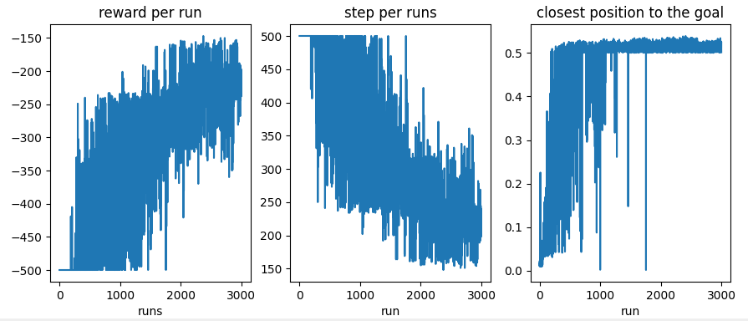
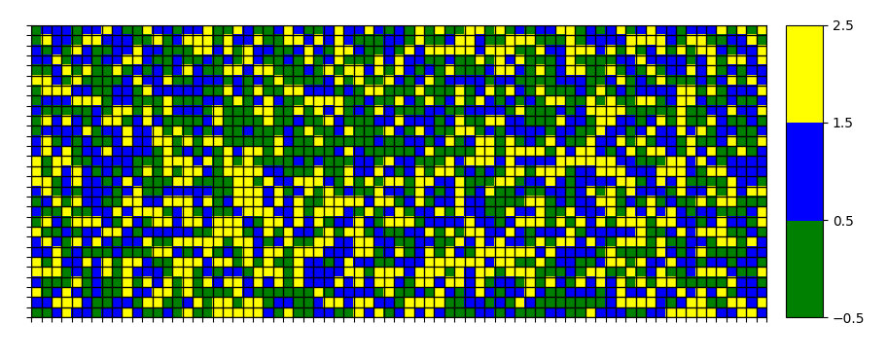
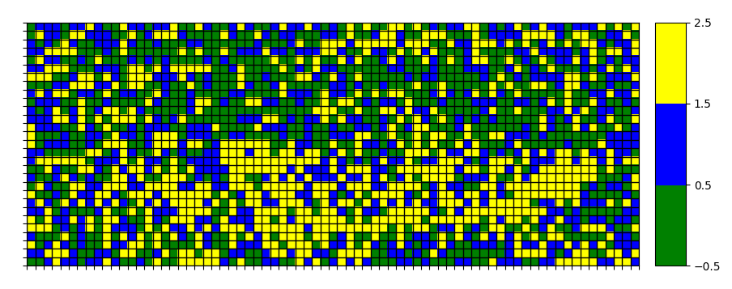
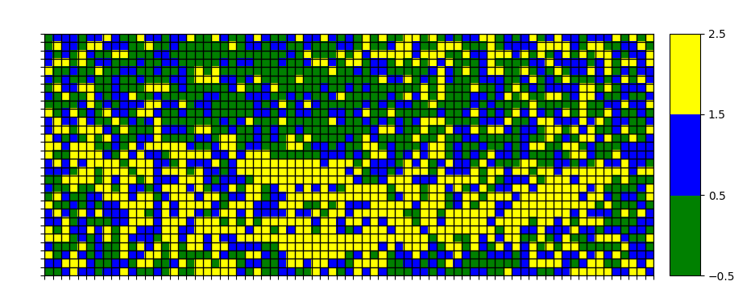

8.
REWARD
def get_reward(state, step, last_best_state):
if state[0] >= 0.5:
return 1
else:
return 0
return 0
HYPERPARAMETERS

MAX_RUNS=3000
MAXIMUM_STEPS=500
EXPLORATION_STEPS_PER_STATE=100

INTERPOLATION=MAX_RUNS/10

ENV_NAME = "MountainCar-v0"

GAMMA = 0.95
LEARNING_RATE = 0.2

EXPLORATION_MAX = 1.0
EXPLORATION_MIN = 0.1
EXPLORATION_DECAY = 0.99995

LEVEL_GRANULARITY=0.01

INIT
self.q_values = np.random.uniform(low = -1, high = 1,
size = (self.num_states[0], self.num_states[1],
env.action_space.n))

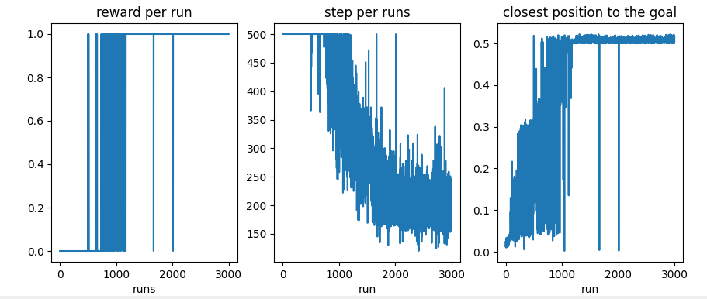
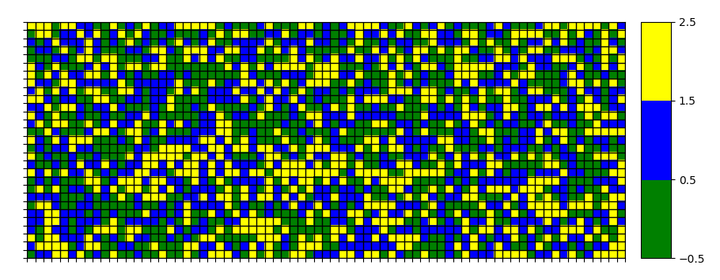
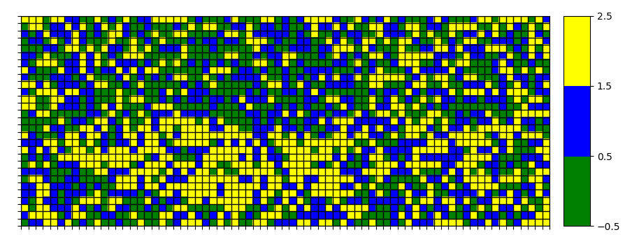
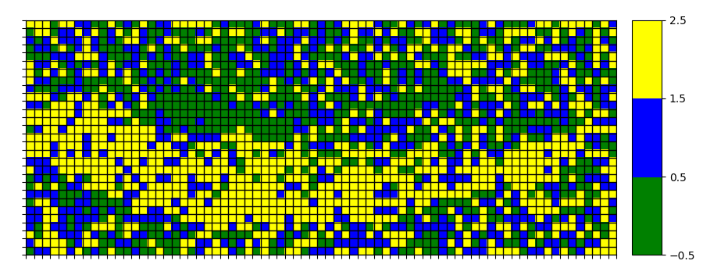

This configuration has been executed twice:
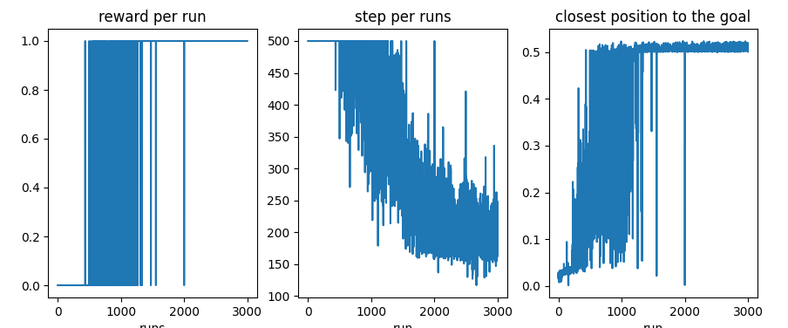
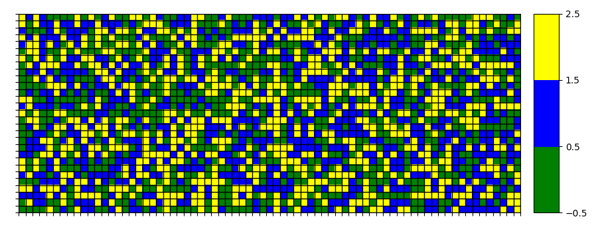
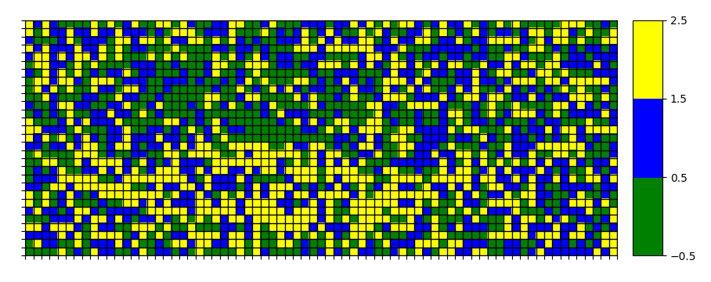
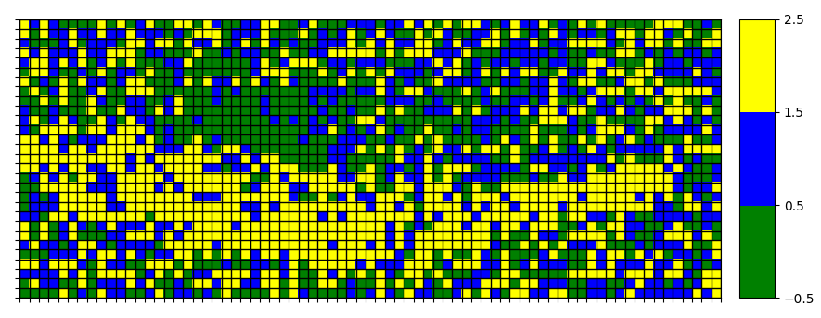

IMPORTANCE OF INITIALIZATION VALUES IN SOME ALGORITHM CONFIGURATIONS
9.
REWARD
def get_reward(state, step, last_best_state):
if state[0] >= 0.5:
return 1
else:
return 0
return 0
HYPERPARAMETERS

MAX_RUNS=3000
MAXIMUM_STEPS=500
EXPLORATION_STEPS_PER_STATE=100

INTERPOLATION=MAX_RUNS/10

ENV_NAME = "MountainCar-v0"

GAMMA = 0.95
LEARNING_RATE = 0.2

EXPLORATION_MAX = 1.0
EXPLORATION_MIN = 0.1
EXPLORATION_DECAY = 0.99995

LEVEL_GRANULARITY=0.01

INIT
self.q_values = np.random.uniform(low = 0, high = 0,
size = (self.num_states[0], self.num_states[1],
env.action_space.n))

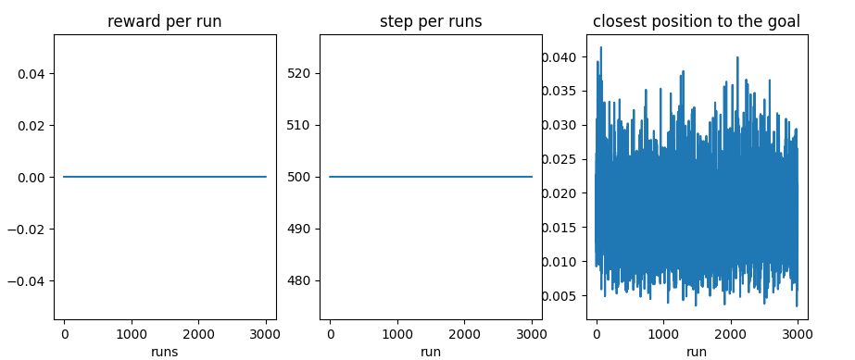
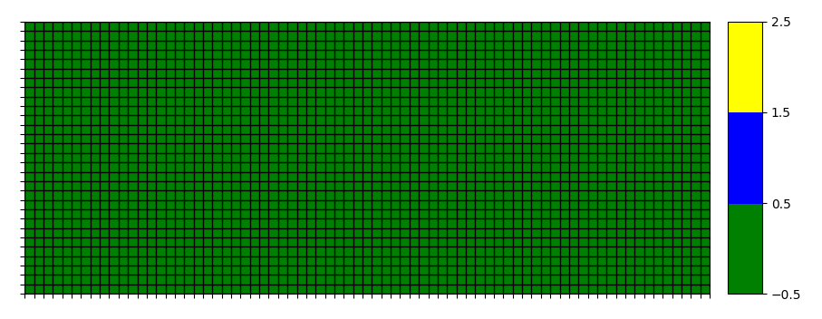
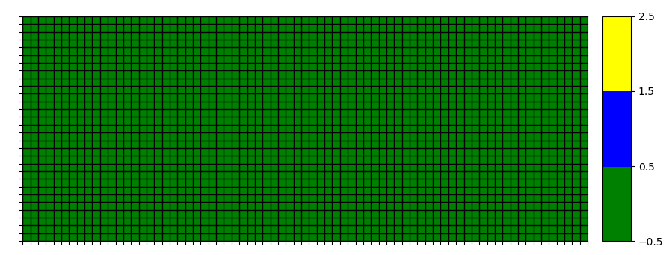
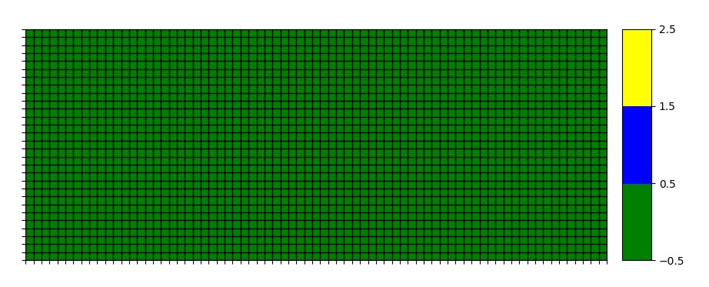
This configuration has been executed twice with exact same result.
Since all Q and rewards are 0 and the actions selection is not chosen randomly when tied up, the matrix is never updated and the actions to take is always -1 (left).
If this return is randomized in the following way:

def act(self, state, occurrences):
if np.random.rand() < self.exploration_rate:
return random.randrange(self.action_space)
untied_matrix=np.random.choice(np.flatnonzero(qsolver.q_values[i][j] == qsolver.q_values[i][j].max()))
action=untied_matrix
return action

the obtained results are still really poor:

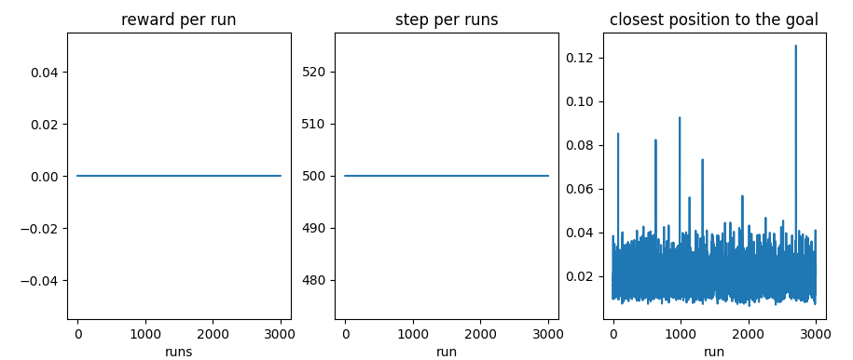
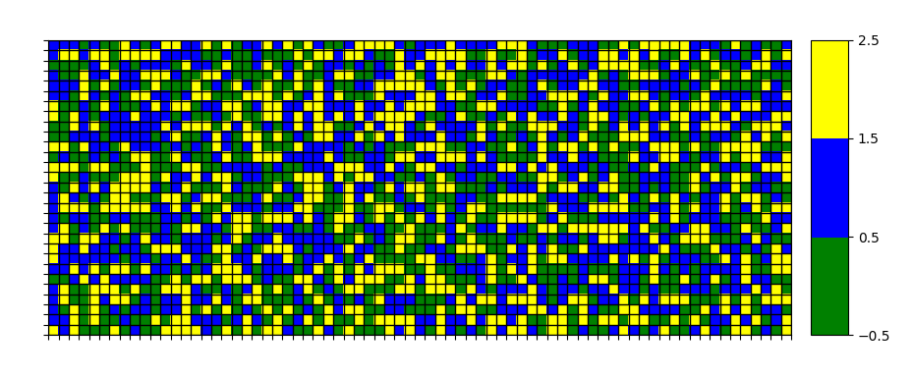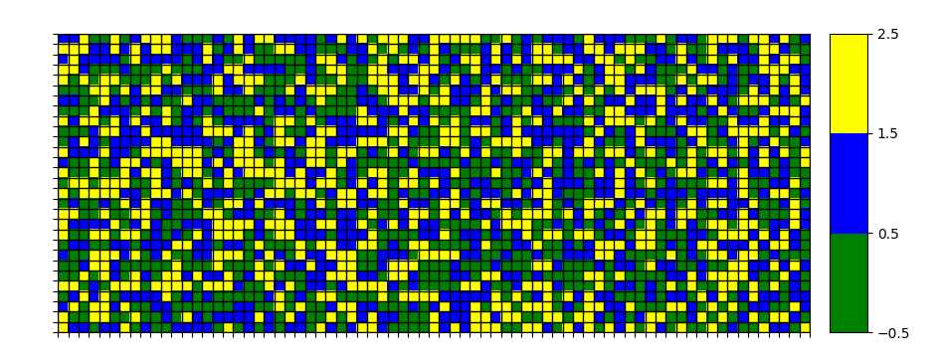
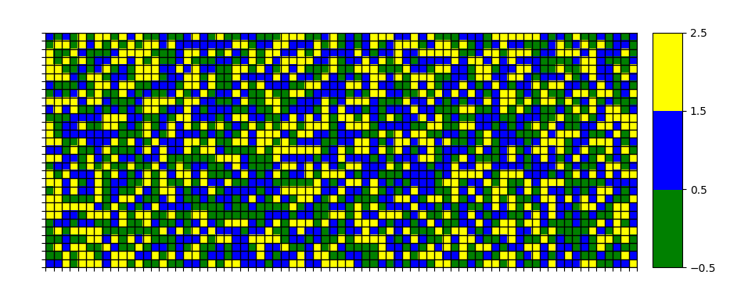

Note that this is not the case when using exactly the same configuration (including breaking ties up modification) but with a randomly q_values initialization between -1 and 1:

