With the environment uploaded:

Basic scenario similar to mountainCar optimal one but updated to this new environment configuration:

#It must be multiple of 10
MAX_RUNS=1500
MAXIMUM_STEPS=700

#This constant is used for showing one q_values matrix each INTERPOLATION runs
INTERPOLATION=MAX_RUNS/10

GAMMA = 0.95
LEARNING_RATE = 0.25

EXPLORATION_MAX = 1.0
EXPLORATION_MIN = 0.05
EXPLORATION_DECAY = 0.9995
EXPLORATION_RUNS=1

DISCRETIZATION_POS=1/50
DISCRETIZATION_SPEED=1/100

def get_reward(state, step, done):
if done:
print("Car has reached the goal")
return 500
elif state[0]<4000:
return (abs(state[0]))/10000
elif state[0]>=4000 and state[0]<13000:
return 0
elif state[0]>=13000:
return (state[0]/10000)**3

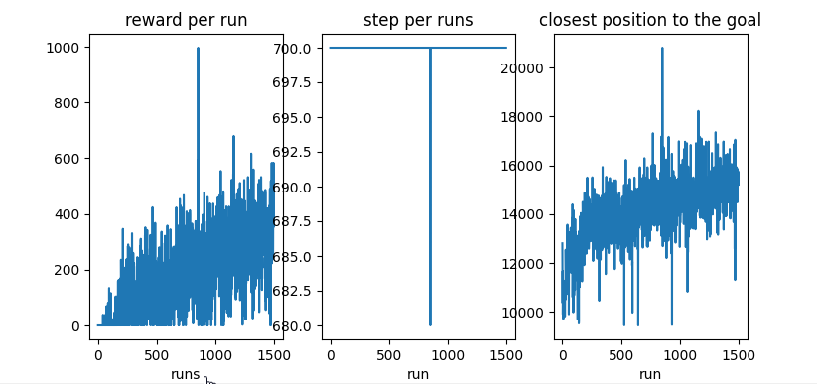

Softer learning rate and reward function with less rewarded area (higher rewarder locations)

#It must be multiple of 10
MAX_RUNS=700
MAXIMUM_STEPS=1000

#This constant is used for showing one q_values matrix each INTERPOLATION runs
INTERPOLATION=MAX_RUNS/10

GAMMA = 0.95
LEARNING_RATE = 0.2

EXPLORATION_MAX = 1.0
EXPLORATION_MIN = 0.05
EXPLORATION_DECAY = 0.9995
EXPLORATION_RUNS=1

DISCRETIZATION_POS=1/50
DISCRETIZATION_SPEED=1/100
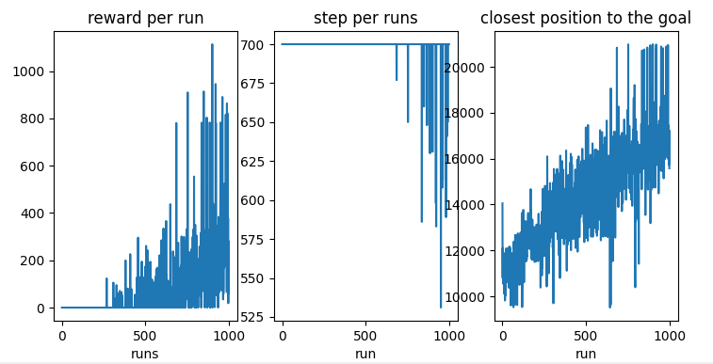

Same but more steps per run:

MAX_RUNS=700
MAXIMUM_STEPS=1000
