UAV directory data storage

# Background

The fact sheet provides instructions for storing the Departments UAV data and extents with the required parameters and nomenclature. All UAV data is to be stored in line with these requirements within the uav directory.

# Uav directory tree

The following sub-directories are approved within the uav directory (Figure 1):

* Year (i.e. 2022)
* Information
* Promotional

Figure 1. Example of the uav directory tree structure.

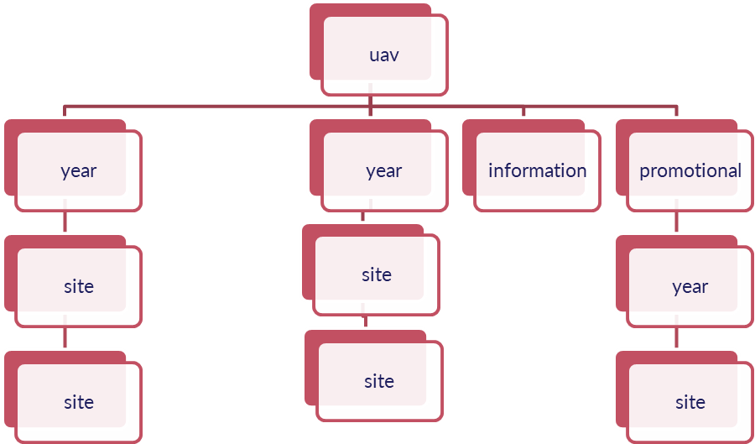

## Year

Uav image captures are separated by year to allow for repeatable monitoring data collection.

## Information

Any usefull information regarding the nomenclature and processing instructions is locted within the information sub-directory.

## Promotional

Any promotional image captures or movies from a uav platform is stored here within the year and site naming sub-directory structure and nomenclature.

# Site directory tree

A directory for each site must be created in the correct nomenclature (three characters followed by two digits). For a detailed list of current tags refer to the “where tags” of the uav_image_nomenclature.xlsx.

Note: a “Where” tag can only be used to identify a property or region.

The following sub-directories are approved within the site directory (Figure 2):

* gcp
* pro
* raw

All products derived from the clipped reference image along with the reference image and associated Pix4D report are stored within the site directory.

## Gcp

Ground Control Points (GCP) may be used for UAV capture and processing. The only acceptable GCP collection is from a Differential GSP (Water Resources) or the Trimble Catalyst (Mangrove Project) or other surveying methodologies.

A minimum of three GCP’s must be sued to outho-rectify an image. If GCP’s have been collected ensure that they have been projected to the correct datum and projection and duplicate GCP’s have been removed.

Figure 2. Example of GCP comma delimited text file appropriate for Pix4D outhorectification.

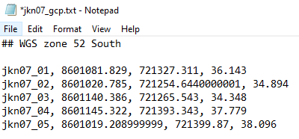

## Pro

The production (pro) sub-directory may only contain a .zip file containing the Pix4D project executable and the project output tree. Naming convention is platform/sesor_site_gcp

|  |  |  |
| --- | --- | --- |
| p4ab_rhd01_n.zip | | |
| What | p4ab | Specifies the uav platform and sensor (p4a) and the altitude (b) |
| Where | rhd01 | Specifies the site location (rhd) and the flight number (01) |
| Orthorectified | n | Specifies if GCP’s have been used to orthorectify the image.  g = orthorectified with three or more GCP’s  n = no GCP’s used |
| Suffix | zip | Zipped directory using Windows zipping tool. |

Table 1. Pix4D production.zip file name nomenclature for PGB BAS 14 storage.

## Raw

Raw data should be renamed (Table 2) and stored in a single directory prior to processing. A notebook created for image renaming is located here[1]. The raw sub-directory may only contain a single .zip file labelled with the correct nomenclature (Table 3) containing all renamed unprocessed UAV site captures. If calibration panel images were collected (i.e. Micasence Rededge camera), calibration panel images are to be stored within a sub-directory within the .zip file called calibrate (Figure 3).

|  |  |  |
| --- | --- | --- |
| rhd01_0001.tif | | |
| Where | rhd01 | Specifies the site location (rhd) and the flight number (01) |
| Image number (incremental) | 0001 | Incremental image number |
| Suffix | tif | The “tif” suffix, for “Tagged Image File Format”. |

Table 2. Individual uav photo naming nomenclature example.

Figure 3. Example of zipped raw data directory including calibration images.

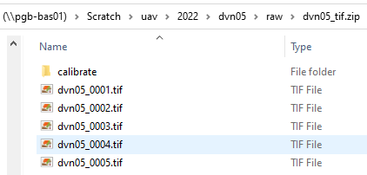

|  |  |  |
| --- | --- | --- |
| rhd01_tiff.zip | | |
| Where | rhd01 | Specifies the site location (rhd) and the flight number (01) |
| Suffix | tif | The “tif” suffix, for “Tagged Image File Format”. |
| Suffix | zip | Zipped directory using Windows zipping tool. |

Table 3. Zipped raw site folder nomenclature example.

# Site directory tree

Figure 2. Site directory tree structure

# Processed UAV images

All UAV processed images are to be names using the following nomenclature (Table 4) and are to be stored within the site directory. For an image to be considered as processed it must be processed through Pix4d and clipped to remove edge noise and/or anomalies. In addition to the final reflectance image all processed/classified site outputs are to be stored within the same directory. For a detailed list of current file names and tag lists refer to the uav_image_nomenclature.docx[2] document or the uav_image_nomenclature_tag_list.xlsx[3].

|  |  |  |
| --- | --- | --- |
| p4ab_rhd01_20220201_refgm2.tif | | |
| What | p4ab | Specifies the uav platform and sensor (p4a) and the altitude (b) |
| Where | rhd01 | Specifies the site location (rhd) and the flight number (01) |
| When | 20220201 | Acquired on 01/02/2022 |
| Processing | refgm2 | Type of image (ref), whether it is geo-rectified (g) and the projection WGS zone 52S (m2). |
| Suffix | tif | The “tif” suffix, for “Tagged Image File Format”. |

Table 4. Processed UAV product nomenclature example.

NOTE: each processing image tags can only be used once.

# UAV reflectance product extent.

As previously stated, all processed UAV reflectance images must be clipped to remove edge noise and anomalies. All final UAV site extents are stored in the uav_extent.mdb geodatabase, in GDA94 Geographic Coordinate System. In addition to this the following attributes are to be defined for easy interpretation by all staff and the Pix4D quality report is also attached for speedy analysis of the UAV reflectance product.

|  |  |  |
| --- | --- | --- |
| Field | Parameters | Description |
| OBJECTID | Short Integer | ESRI |
| SHAPE | Polygon | ESRI |
| site_key | Text (100) | Centroid y with negative and decimal place removed, x centroid with decimal place removed, site, date. |
| site | Text (5) | Site name (3 Characters 2 digits) |
| flight_date | Date (American format) | UAV capture date YYYYMMDD |
| altitude | Short integer | UAV altitude |
| platform | Text (15) | UAV platform (i.e P402) |
| sensor | Text (15) | Sensor type (i.e MicaSense-M) |
| pilot | Text (50) | Name of pilot (Given name Surname) |
| process_date | Date (American format) | Date data was processed within Pix4D located on report. |
| process_class | Text (50) | Any specific parameters used for processing or default. |
| area | Double | Area of the extent (ha) in projected coordinate system GDA 1994 Australia Albers (epsg:3577). |
| directory | Text (255) | Location of the site directory |
| cent_y | Double | Y extent polygon centroid (required for unique identifier) |
| cent_x | Double | X extent polygon centroid (required for unique identifier) |
| SHAPE_Length | Double | ESRI |
| SHAPE_Area | Double | ESRI |

Instruction for appending\loading a new UAV extent to the .

1. Project extent to Geographic Coordinate System: GDA94
2. Calculate area (ha) in projected coordinate reference system GDA 1994 Australia Albers
3. Load new data to uav_extent.mbd
   1. Start editing feature class
   2. Load data using the Load Objects tool ([instructions to add load objects command to ArcMap](https://desktop.arcgis.com/en/arcmap/10.3/manage-data/geodatabases/loading-data-in-arcmap-adding-the-load-objects-com.htm)).
   3. Update any missing fields
   4. Calculate x and y polygon centroid (calculate geometry)
   5. Update unique identifier (site_key) using the following python command using the Filed Calculator.
      1. Set Parser to Python
      2. Press Load…
      3. Navigate to: Z:\Scratch\uav\information\uav_extent_site_key_field_calc.cal
      4. OR paste in: str( !CENT_Y!)[1:3] + str( !CENT_Y!)[4:10] + '00_' + str( !CENT_X!)[0:3] + str( !CENT_X!)[4:11] + '_' +str( !SITE! ) + '_' + str( !DATE_FLT!)

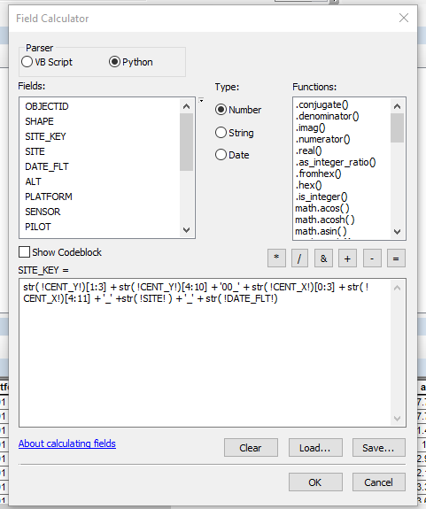

1. Save edits
2. Stop editing.

1. Update notebook location
2. "Z:\Scratch\uav\information\uav_image_nomenclature.docx"
3. "Z:\Scratch\uav\information\uav_image_nomenclature_tag_list.xlsx"