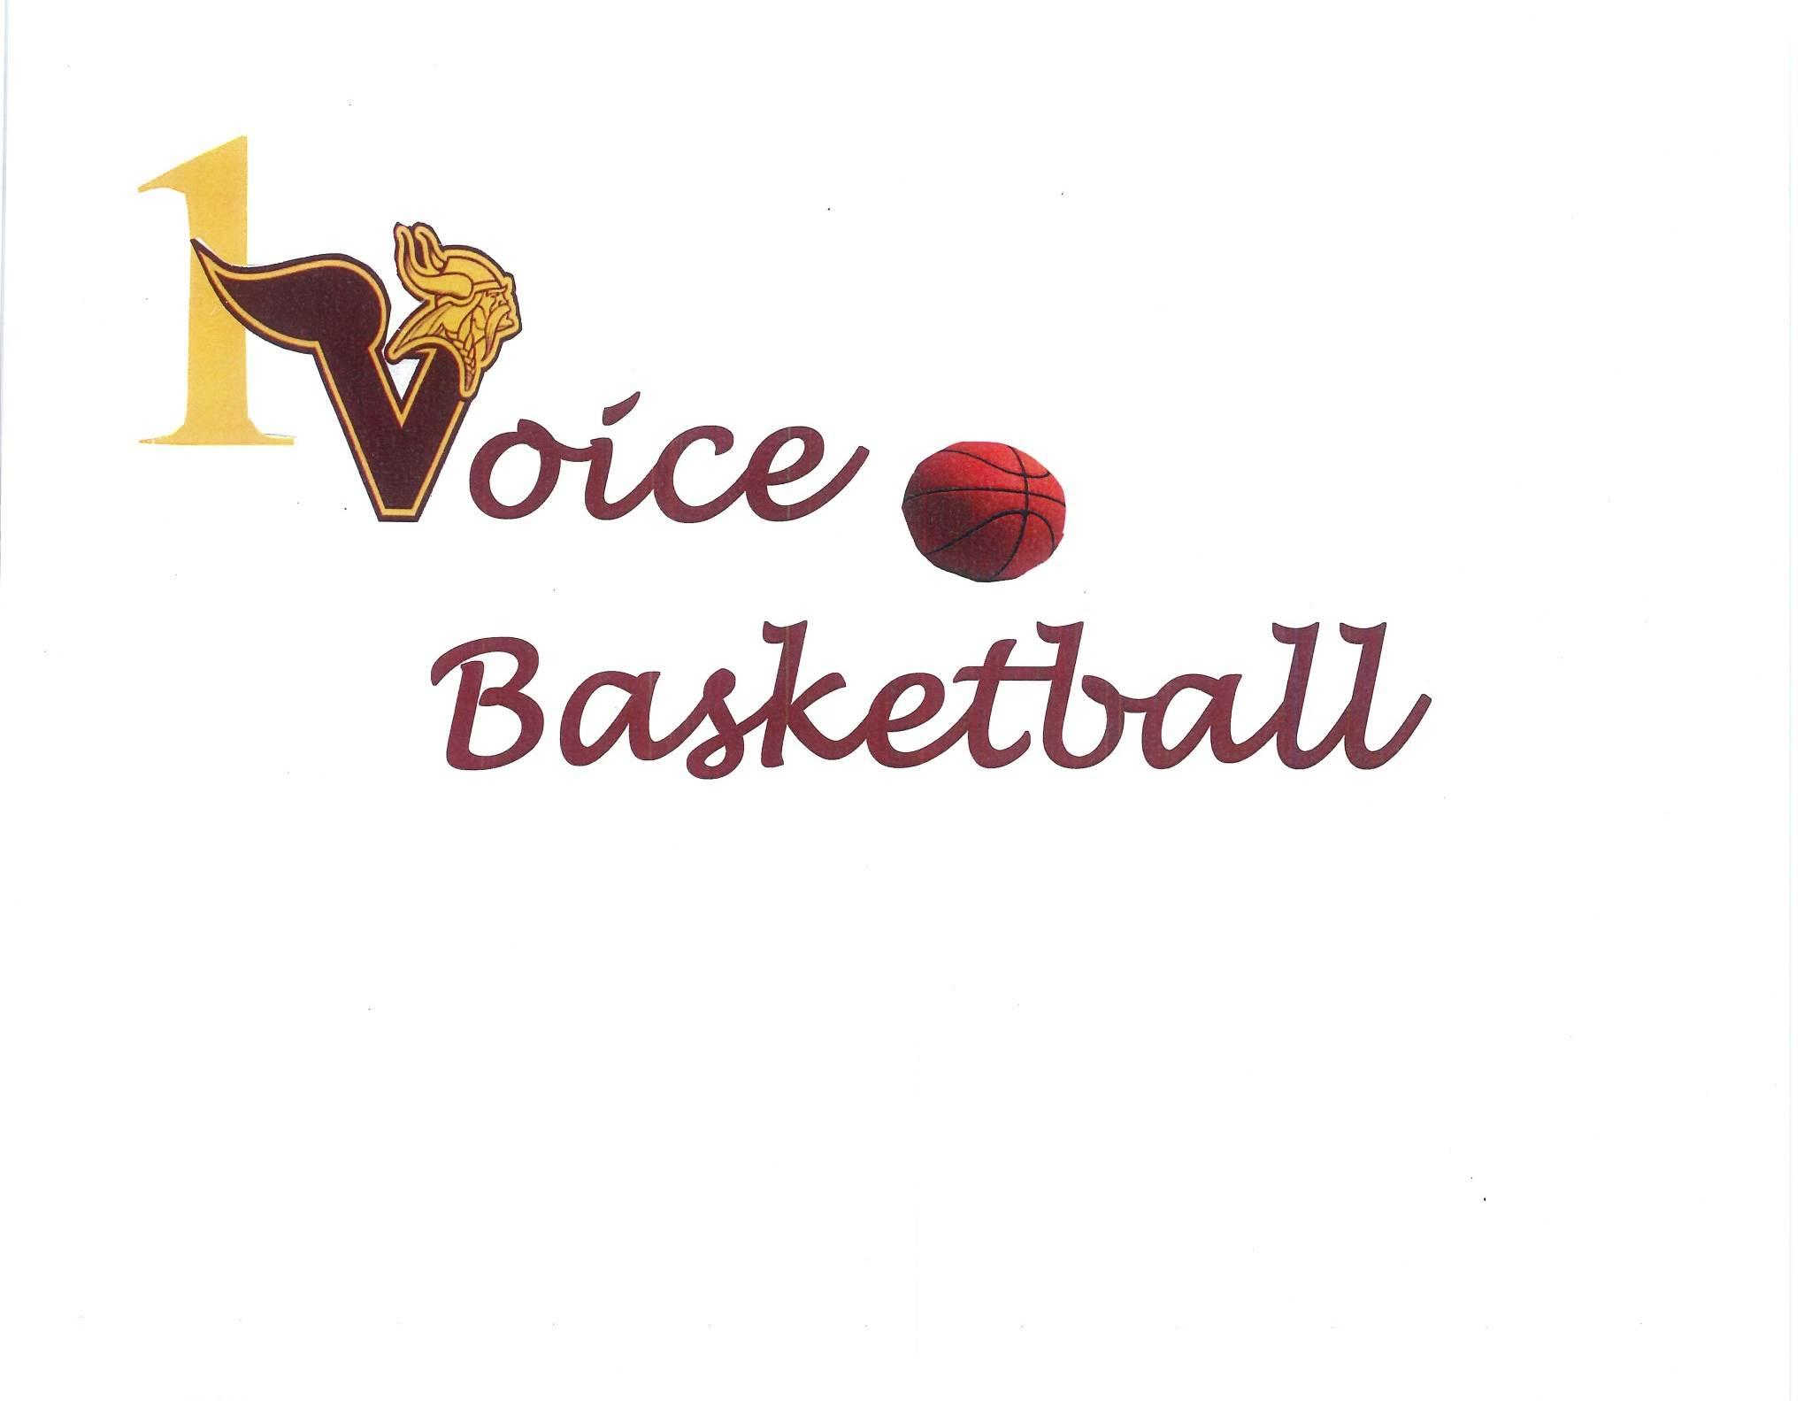

**ONE VOICE BASKETBALL ASSOCIATION,INC.**

**A Non-Profit New Jersey Corporation**

**APPLICATION FOR YOUTH BASKETBALL**

**Applicant Name_____________________________________ Birth Date ____________**

**Parent / Guardian Name(s) _________________________________________________**

**Address _________________________________________________________________**

**Phone Number _________________________ Cell #1 ___________ Cell #2 ___________**

**Alt Phone #1 __________________________ Alt Phone #2 ________________________**

**School _______________________________ Grade _____________________________**

**Emergency Contact Name __________________________________________________**

**Relationship to Applicant __________________________________ Phone __________**

**Alt Phone _____________________________ Alt Phone _________________________**

**Name and Phone Number of Family Physician _________________________________**

**E-mail Address(es) _______________________________________________________**

**RELEASE OF LIABILITY FOR A MINOR**

**I, the parent or guardian of the above named player, a minor, agree that I will abide by the rules and regulations of the basketball program in which we participate. In consideration of the applicant’s participation in the sport and its programs, I, intending to be legally bound, do hereby release and indemnify the *One Voice Basketball Association Inc.* (*OVBA*) its members, coaches, representatives, directors and officers from any and all claims, liabilities, causes of action and dangers arising out of, or in connection with the Applicant’s participation in the programs of the *OVBA, Inc*.**

**Is the Participant taking any medication that would limit safe participation in the activities and/or does the Participant have any physical or mental condition, physical disability, or any other condition that would limit safe participation in the activities,?   
  
NO __________ YES __________**

**Does the Participant have any medical information which he or she believes *One Voice Basketball* should have and know about in the event of medical emergency (including any allergies, reactions to medication)?**

**NO __________ YES __________. If YES, identify and explain as fully as you deem advisable.**

**AUTHORIZATION FOR EMERGENCY MEDICAL TREATMENT**

**The signature below shall be evidence of the parent / guardian of the Applicant named above for emergency medical treatment of any injury or condition during participation in the *One Voice Basketball Association Inc.* activities. In the event that reasonable attempts to contact me or the emergency contact above are unsuccessful, this shall further serve as authorization for the provision of medical services to the Applicant that are deemed medically necessary for the transport, stabilization and treatment of any such injury or condition.**

**Signed _________________________ Witness_________________________**

**Parent / Guardian of Applicant**