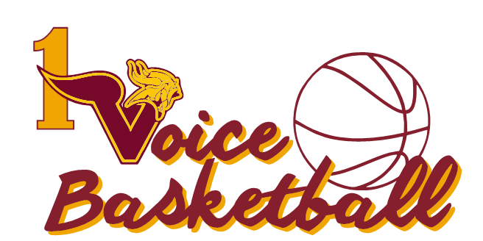

**PHOTO CONSENT**

**I ___________________________, parent / guardian of __________________________**

**(Child)**

**grant OVBA my permission to use photographs taken at OVBA practices, games or events for**

**any legal use, including but not limited to publicity, copyright purposes, illustration,**

**advertising and web content.**

**Furthermore I understand that no royalty, fee or other compensation shall become payable**

**to me by reason of such use.**

**Parent Guardian Name (print): __________________________**

**Parent / Guardian Signature: ___________________________ Date: _______________**

**Player’s Name: _________________________________**

**Phone Number: _________________________________**