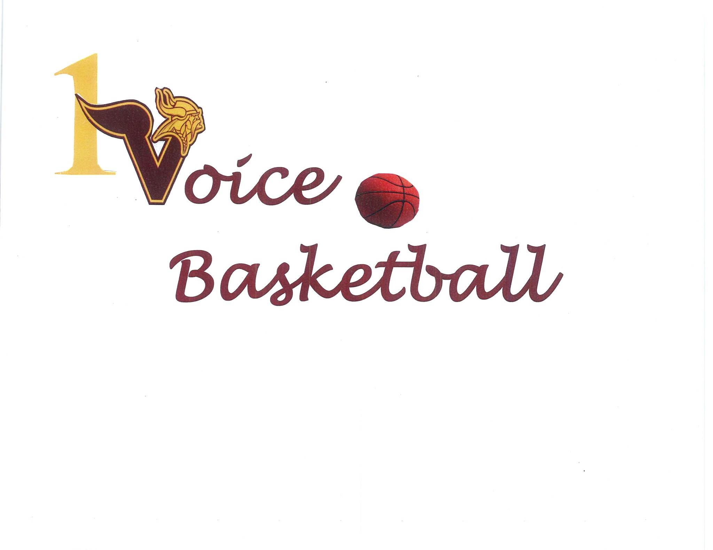

ONE VOICE BASKETBALL ASSOCIATION,INC.
A Non-Profit New Jersey Corporation
APPLICATION FOR YOUTH BASKETBALL

Applicant Name_____________________________________ Birth Date ____________

Parent / Guardian Name(s) _________________________________________________

Address _________________________________________________________________

Phone Number _________________________ Cell #1 ___________ Cell #2 ___________

Alt Phone #1 __________________________ Alt Phone #2 ________________________

School _______________________________ Grade _____________________________

Emergency Contact Name __________________________________________________
Relationship to Applicant __________________________________ Phone __________
Alt Phone _____________________________ Alt Phone _________________________
Name and Phone Number of Family Physician _________________________________

E-mail Address(es) _______________________________________________________

RELEASE OF LIABILITY FOR A MINOR
I, the parent or guardian of the above named player, a minor, agree that I will abide by the rules and regulations of the basketball program in which we participate. In consideration of the applicant’s participation in the sport and its programs, I, intending to be legally bound, do hereby release and indemnify the One Voice Basketball Association Inc. (OVBA) its members, coaches, representatives, directors and officers from any and all claims, liabilities, causes of action and dangers arising out of, or in connection with the Applicant’s participation in the programs of the OVBA, Inc.

Is the Participant taking any medication that would limit safe participation in the activities and/or does the Participant have any physical or mental condition, physical disability, or any other condition that would limit safe participation in the activities,?

NO __________ YES __________

Does the Participant have any medical information which he or she believes One Voice Basketball should have and know about in the event of medical emergency (including any allergies, reactions to medication)?
NO __________ YES __________. If YES, identify and explain as fully as you deem advisable.

AUTHORIZATION FOR EMERGENCY MEDICAL TREATMENT
The signature below shall be evidence of the parent / guardian of the Applicant named above for emergency medical treatment of any injury or condition during participation in the One Voice Basketball Association Inc. activities. In the event that reasonable attempts to contact me or the emergency contact above are unsuccessful, this shall further serve as authorization for the provision of medical services to the Applicant that are deemed medically necessary for the transport, stabilization and treatment of any such injury or condition.
Signed _________________________ Witness_________________________
Parent / Guardian of Applicant

