Coursera Honor Assignment 2

Feedback System for Ristorante Con Fusion

This Project should make it possible for various user and customers to give a review on their experience in the restaurant.

Main Features should include a text field for writing the initial review. Furthermore, there should be a field for entering a username, which should be optional. The reviewer should also be able to give a rating, e.g 5 stars. The review should then be displayed in a list below.

In addition to this, the company will be able to create small surveys, where a question is asked and there are either some multiple choice options, or a blank text field for the user to enter the answer.

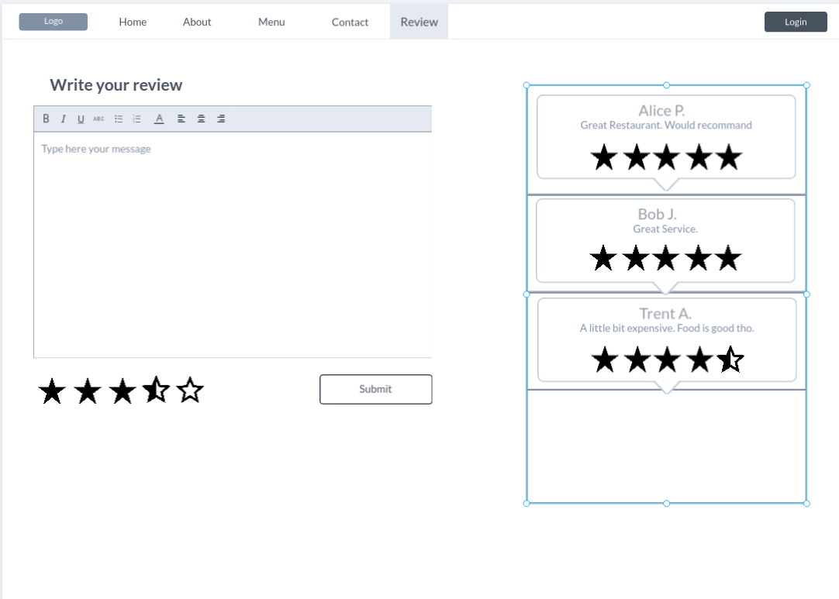
Referencess: Marvelapp.com

The Design is very simple, a user can write his feedback in the text field. Plenty of space is provided but the text is capped at 200 letters. After writing, the user can chose the amount of stars he wants to give. By hovering over it, the stars indicate the rating, and after left clicking on the star the value is set. After pressing the submit button the review will be displayed to the right, next to other reviews, if there are any.

