Neural Correlates of Attention & Inhibition in People with a Problematic Use of Video Games as well as Without – A fMRI Study

The planned fMRI study aims to provide a better understanding of the underlying mechanisms of attention and inhibition, in both people with a problematic use of video games as well as without. Previous evidence on behavioral addiction consistently reported a decline in cognitive functions, compared to healthy people (Ioannidis et al., 2019). More specific, findings in people with excessive video gaming reported problems with impulse control, behavioral inhibition, attention, and executive functioning (e.g., Han, Lyoom and Renshaw, 2012; Little, Luijten, van den Berg, van Rooij, Keemink, & Franken, 2012). Although, previous studies provide common evidence for the effects of problematic use of video games on attention and inhibition, the present evidence is quite small. Therefore, the planned study aims to focus on specific components of the two constructs as well as their differentiation.

Since most of our daily stimuli, especially in the context of gaming, are visual, the paradigms for the scanner exclusively focus on the visual modality, but will be supplemented by a behavioral testing that additionally considers the auditory application of stimuli.

By using fMRI, functional correlates of attention and inhibition as well as their shared and individual components will be identified. The high resolution of the 7-Tesla scanner allows the identification of basal-ganglia structures involved in the processing of attention and inhibition. In addition, resting-state fMRI will be used to identify functional networks associated with attention and inhibition in the context of auditory stimuli while gaming videos are presented. This approach also allows to apply new analysis methods such as connectome based predictive modelling. Previous brain imaging data indicate that individuals with problematic video game use and substance use disorders show an imbalance between neural systems such as the executive control, reward and salience networks which will be in focus of the current study (Wei, Zhang, Turel, Bechara, & He, 2017; Zilverstand, Huang, Alia-Klein, & Goldstein, 2018).

1. Participants

Subjects will be recruited from the University of Duisburg-Essen, Duisburg, the Department of Psychosomatic Medicine and Psychotherapy, LWL-University Clinic Bochum, Ruhr-University Bochum, but also by public announcements. We plan to include a sample of 20 people with problematic use of video games and 40 healthy people. In order to get assigned to the group of problematic use of video games, people need to correspond to DSM-IV criteria for IGA according to the modified diagnostic questionnaire for Internet addiction (i.e., the YDQ) criteria by Beard and Wolf (2001). To participate in the healthy group, neither the people nor their families should show a history of psychiatric disorders. People with a history of head injuries or other major neurological disorder, medical or surgical illnesses, schizophrenia, depression, bipolar disorder, or substance use disorder will be excluded from the study. Furthermore, people with a current medication, smokers, as well as left-handers are not able to participate. Participants must be at least 18 years.

2. fMRI Paradigms

**Alternating attention-/inhibition-task**

*Idea*

Attention and inhibition are frequently described as highly overlapping, by showing similar activation patterns of cortical structures. Although they are depending on each other, attention and inhibition represent two independent constructs with different roles and individual characteristics, measured by different paradigms. However, there is no consensus regarding the frequency of stimulus application neither for quantifying attention nor inhibition. For example, in inhibition studies, some describe a distribution of 50% go-trials and 50% no-go-trials (e.g., Shucard, McCabe, & Szymanski, 2008; Wegmann, Brand, Snagowski, & Schiebener, 2017), whereas others use a distribution of 75% go-trials and 25% stop-trials (e.g., Aron, Fletcher, Bullmore, Sahakian, & Robbins, 2003; Li, Yan, Sinha, & Lee, 2008), both testing the same ability. Based on previous studies, such as Dodds, Morein-Zamir, and Robbins (2010), who reported increased activation in the right insula as well as right inferior frontal cortex with increasing response control demands, the present paradigm aims to investigate the effect of varying the distribution of target and non-target stimuli in terms of separation of attention and inhibition processes, while keeping all other parameters the same.

*Task*

The alternating inhibition-/attention-task based on a classic visual oddball-task. After a short training period (6 stimuli, 2 target/4non-target), participants were asked to react on visually presented target stimuli and to ignore non-target stimuli. Visual stimuli comprise colored points with a size of 100px. The task consists of 18 blocks, A) 6 blocks each with 30 target stimuli and 10 non-target stimuli, B) 6 blocks each with 20 target stimuli and 20 non-target stimuli, and C) 6 blocks each with 10 target stimuli and 30 non-target stimuli. There will be two further low-level baseline conditions in each section which include D) 3 blocks each with 40 non-target stimuli and E) 3 blocks each with 40 target stimuli. All blocks will be presented in a pseudo randomized order, separated in 3 sections. A section contains two blocks of each kind as well as a 3 minutes’ break, following (in order to avoid fatigue) (see also Figure 1).

All stimuli are presented in the same length (200ms) as well as in a randomized order with inter-stimulus intervals randomized between 500ms and 1,000ms. Participants are asked to react to target stimuli as fast as possible by pressing the space bar (time-window to react: 500ms after stimulus presentation). Error rate and reaction time are additionally measured as behavioral parameters.

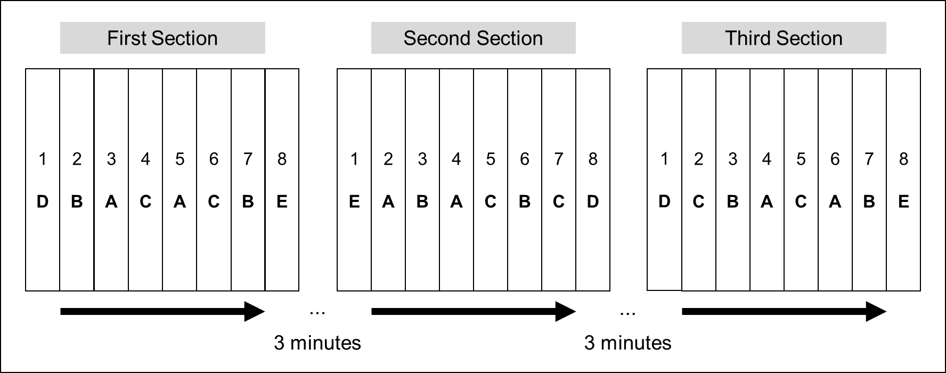

*Figure 1.* Procedure of the paradigm.

Note. A = 30 target stimuli and 10 non-target stimuli; B = 20 target stimuli and 20 non-target stimuli; C = 10 target stimuli and 30 non-target stimuli.; 40 non-target stimuli; E) 40 target stimuli

**Spatiality effects in attention and inhibition**

*Idea*

In our daily life, hardly any visual stimulus occurs after the other in the same place, but rather target stimuli as well as distractors occur in randomized positions. Previous psychological and neurophysiological studies highlighted the relevance of spatial attention in different contexts (e.g., Gandhi, Heeger, & Boynton, 1999). The present task aims to investigate differences of spatial effects in attention and inhibition, in a direct comparison.

*Task*

By applying a modified visual oddball task, we aim to consider the effect of spatiality in both attention and inhibition. We use the same frequency of target stimuli compared to the paradigm before, but only 6 blocks with 30 target-trials (comprising a target stimulus and six non-target stimuli) and 10 non-target-trials (comprising only six non-target stimuli) (inhibition), as well as 6 blocks with 10 target-trials (comprising a target stimulus and six non-target stimuli) and 30 non-target-trials (comprising only six non-target stimuli) (attention). Like the task before, two blocks with 40 non-targets and two blocks with 40 targets are presented as low-level baseline conditions. Within each two blocks of inhibition and attention we randomly modify the spatiality of 1) non-target stimuli, 2) target-stimuli, as well as 3) both (Figure 2).

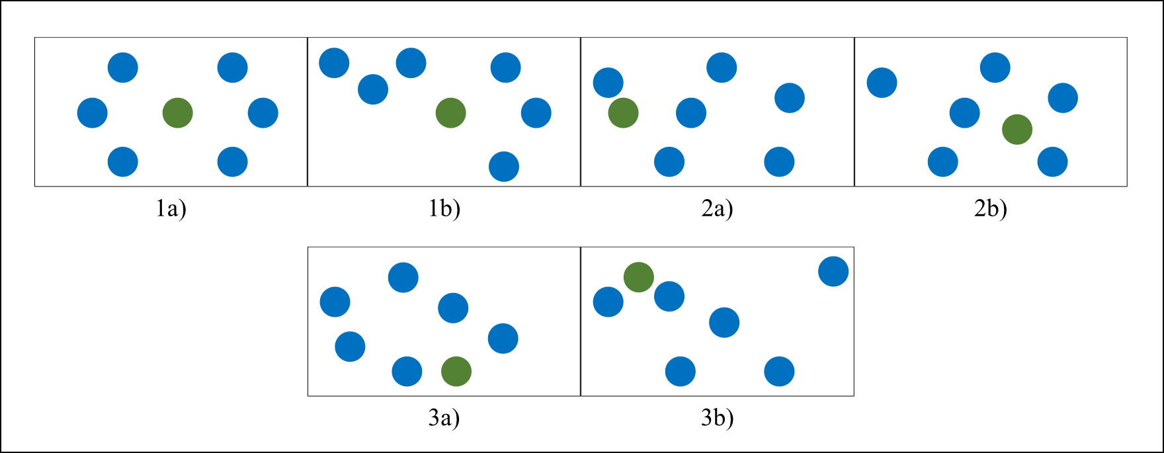

*Figure 2. modification of 1) non-target stimuli 2) target-stimuli, and 3) both*

Between the blocks of inhibition and those of attention, participants will be asked to rest for 3 minutes.

All trials are presented in the same length (200ms) as well as in a randomized order with inter-stimulus intervals randomized between 500ms and 1,000ms. Participants are asked to react to target stimuli as fast as possible by pressing the space bar (time-window to react: 500ms after stimulus presentation) Error rate and reaction time are additionally measured as behavioral parameters.

3. Behavioral Paradigm

**Attention and inhibition while watching a preferred gaming video**

*Idea*

We are permanently faced by an endless array of stimuli, most applied in visual settings. Based on previous findings on media-multitasking which indicated an increase in simultaneously using different technologies (e.g., Jacobsen & Forste, 2011) it can be assumed that this behavior leads to different effects of watching a video while performing an attention/inhibition task. Since people with a problematic use of video games are used to practicing this behavior, we assume different effects, compared to healthy people.

*Task*

Again, we use the idea of the oddball paradigms. In addition to an auditory oddball task, participants will be asked to watch a video on their favorite video game. Within the auditory oddball task, participants should respond to target stimuli and ignore distractors. Similar to the visual oddball task, which will be used in the scanner, the task consists of 18 blocks, 6 blocks with 30 target stimuli and 10 non-target stimuli, 6 blocks with 20 target stimuli and 20 non-target stimuli, and 6 blocks with 10 target stimuli and 30 non-target stimuli. All blocks will be presented in a pseudo randomized order, separated in 3 sections. A section contains two blocks of each kind as well as a 3 minutes’ break, following (in order to avoid fatigue). All stimuli are presented in the same length (200ms) as well as in a randomized order with inter-stimulus intervals randomized between 500ms and 1,000ms. Participants are asked to react to target stimuli as fast as possible by pressing the space bar (time-window to react: 500ms after stimulus presentation) Error rate and reaction time are measured.

Regarding the secondary task, participants should choose their preferred video game, in advance. While performing the auditory oddball task participants will be asked to focus on watching the video without additional task.

**Corsi Block-Tapping Task (working memory)**

*Idea*

Closely related to the functions of attention and inhibition as well as described to be impaired in people with behavioral disorders (Zhou, Zhou, & Zhu, 2016), we plan to additionally investigate working memory capacity, by the most commonly used measure, the corsi block-tapping task.

*Task*

To assess visuo-spatial working memory, we use the corsi block-tapping task, which was originally introduced by Corsi (1972) and consists of a series of nine blocks, which are tapped by an examiner in randomized sequences of increasing length (Corsi, 1972; Milner, 1971,). Within the present study, we use a computerized version, similar to Brunetti, Del Gatto, and Delogu (2014). On a regular tablet-PC, participants get faced by nine white squares. In each sequence, randomly selected squares light up in orange one after the other, beginning with two squares up to a maximum of nine (see figure 3). After each sequence, participants were asked to repeat it by pressing the squares on the tablet. The task ends as soon as the participant has incorrectly repeated a sequence twice or successfully completed the sequences with nine squares. Task-performance is quantified by the maximum number of squares that could be correctly reproduced.



*Figure 3*. The computerized version of the corsi block-tapping task.

4. Questionnaire

The fMRI as well as behavioral investigation will be supplemented by answering most commonly used questionnaires in this context.

**BIS-15**

BIS-15 is a questionnaire on which participants rate their frequency of several common impulsive or non-impulsive behaviors/traits on a scale from 1 (rarely/never) to 4 (almost always/always). BIS-15 consists of 15 items and can be divided into three subscales. Scoring yields a total score and the three subscale scores are derived by factor analysis: attention (rapid shifts and impatience with complexity), motor (impetuous action), and non-planning (lack of future orientation); higher scores signify higher impulsivity (Meule, Vögele, & Kübler, 2011).

**German short-version of the personality inventory for DSM-5**

Maladaptive personality traits were measures by the German short-version of the personality inventory for DSM-5 [PID-5-BF, overall Cronbach's α in our sample = 0.798, (Krueger, Derriger, Markon, Watson, & Skodol, 2015)]. The questionnaire consists of 25 items measuring the personality traits negative affectivity, detachment, antagonism, disinhibition, and psychoticism based on a scale from 0 (= “very false or often false”) to 3 (= “very true or often true”).

References

Aron, A. R., Fletcher, P. C., Bullmore, E. T., Sahakian, B. J., & Robbins, T. W. (2003). Stop-signal inhibition disrupted by damage to right inferior frontal gyrus in humans. Nature neuroscience, 6(2), 115-116.

Beard, K. W., & Wolf, E. M. (2001). Modification in the proposed diagnostic criteria for Internet addiction. Cyberpsychology & behavior, 4(3), 377-383.

Brunetti, R., Del Gatto, C., & Delogu, F. (2014). eCorsi: implementation and testing of the Corsi block-tapping task for digital tablets. Frontiers in Psychology, 5(939), 1-8.

Corsi, P. M. (1972). Human memory and the medial temporal region of the brain. Dissertation Abstracts International, 34(02), 891B. (University Microfilms No. AAI05–77717).

Dodds, C. M., Morein-Zamir, S., & Robbins, T. W. (2010). Dissociating inhibition, attention, and response control in the frontoparietal network using functional magnetic resonance imaging. Cerebral cortex, 21(5), 1155-1165.

Gandhi, S. P., Heeger, D. J., & Boynton, G. M. (1999). Spatial attention affects brain activity in human primary visual cortex. Proceedings of the National Academy of Sciences, 96(6), 3314-3319.

Han, D. H., Lyoo, I. K., & Renshaw, P. F. (2012). Differential regional gray matter volumes in patients with on-line game addiction and professional gamers. Journal of psychiatric research, 46(4), 507-515.

Ioannidis, K., Hook, R., Goudriaan, A. E., Vlies, S., Fineberg, N. A., Grant, J. E., & Chamberlain, S. R. (2019). Cognitive deficits in problematic internet use: meta-analysis of 40 studies. The British Journal of Psychiatry, 1-8.

Jacobsen, W. C., & Forste, R. (2011). The wired generation: Academic and social outcomes of electronic media use among university students. Cyberpsychology, Behavior, and Social Networking, 14(5), 275-280.

Krueger, R. F., Derriger, J., Markon, K. E., Watson, D., Skodol, A. E. C. (2015). *Persönlichkeitsinventar für DSM-5 – Kurzform (PID-5-BF) – Version für Erwachsene.* Göttingen: Hogrefe.

Li, C. S. R., Yan, P., Sinha, R., & Lee, T. W. (2008). Subcortical processes of motor response inhibition during a stop signal task. Neuroimage, 41(4), 1352-1363.

Littel, M., Van den Berg, I., Luijten, M., van Rooij, A. J., Keemink, L., & Franken, I. H. (2012). Error processing and response inhibition in excessive computer game players: An event‐related potential study. Addiction biology, 17(5), 934-947.

Meule, A., Vögele, C., & Kübler, A. (2011). Psychometrische Evaluation der deutschen Barratt Impulsiveness Scale – Kurzversion (BIS-15) [Psychometric evaluation of the German Baratt Impulsiveness Scale - Short version (BIS15)]. *Diagnostica, 57*(3), 126-133. doi:10.1026/0012-1924/a000042

Milner, B. (1971). Interhemispheric differences in the localization of psychological processes in man. British Medical Bulletin,27, 272-277.

Patton, J. H., Stanford, M. S., & Barratt, E. S. (1995). Factor structure of the Barratt impulsiveness scale. Journal of clinical psychology, 51(6), 768-774.

Wegmann, E., Brand, M., Snagowski, J., & Schiebener, J. (2017). Are you able not to react to what you hear? Inhibition behavior measured with an auditory Go/NoGo paradigm. Journal of clinical and Experimental Neuropsychology, 39(1), 58-71.

Wei, L., Zhang, S., Turel, O., Bechara, A., & He, Q. (2017). A tripartite neurocognitive model of Internet gaming disorder. *Frontiers in Psychiatry, 8*, 285.

Zhou, Z., Zhou, H., & Zhu, H. (2016). Working memory, executive function and impulsivity in Internet-addictive disorders: A comparison with pathological gambling. Acta Neuropsychiatrica, 28(2), 92-100.

Zilverstand, A., Huang, A. S., Alia-Klein, N., & Goldstein, R. Z. (2018). Neuroimaging impaired response inhibition and salience attribution in human drug addiction: A systematic review. *Neuron, 98*(5), 886-903. doi:10.1016/j.neuron.2018.03.048