Software Design Document (SDD) Template

Software design is a process by which the software requirements are translated into a representation of software components, interfaces, and data necessary for the implementation phase. The SDD shows how the software system will be structured to satisfy the requirements. It is the primary reference for code development and, therefore, it must contain all the information required by a programmer to write code. The SDD is performed in two stages. The first is a preliminary design in which the overall system architecture and data architecture is defined. In the second stage, i.e. the detailed design stage, more detailed data structures are defined and algorithms are developed for the defined architecture.

This template is an annotated outline for a software design document adapted from the IEEE Recommended Practice for Software Design Descriptions. The IEEE Recommended Practice for Software Design Descriptions have been reduced in order to simplify this assignment while still retaining the main components and providing a general idea of a project definition report. For your own information, please refer to [IEEE Std 1016­1998](http://www.cs.concordia.ca/%7Eormandj/comp354/2003/Project/ieee-SDD.pdf)1 for the full IEEE Recommended Practice for Software Design Descriptions.

1 [http://www.cs.concordia.ca/~ormandj/comp354/2003/Project/ieee](http://www.cs.concordia.ca/%7Eormandj/comp354/2003/Project/ieee)­SDD.pdf

# (Project 8)

**(FANS OF ART)**

# Software Design Document

Name (s):

Nastasel Alexandru, CEN 3.2 B (Chapter 1, Chapter 7)

Robu Raluca-Andreea, CEN 3.3 A (Chapter 2, Chapter 4)

Stancu Justin-Andrei, CEN 3.2 B (Chapter 3, Chapter 5)

Lilea Anamaria Adriana CEN 3.2A (Chapter 6)

Lab Section: SDD

Date: (03/25/2020)

**TABLE OF CONTENTS**

1. **INTRODUCTION**
   1. Purpose
   2. Scope
   3. Overview
   4. Reference Material
   5. Definitions and Acronyms
2. **SYSTEM OVERVIEW**
3. **SYSTEM ARCHITECTURE**
   1. Architectural Design
   2. Decomposition Description
   3. Design Rationale
4. **DATA DESIGN**
   1. Data Description
   2. Data Dictionary
5. **COMPONENT DESIGN**
6. **HUMAN INTERFACE DESIGN**
   1. Overview of User Interface
   2. Screen Images
   3. Screen Objects and Actions
7. **REQUIREMENTS MATRIX**
8. INTRODUCTION 2
   1. Purpose 2
   2. Scope 2
   3. Overview 2
   4. Reference Material 2
   5. Definitions and Acronyms 2
9. SYSTEM OVERVIEW 2
10. SYSTEM ARCHITECTURE 2
    1. Architectural Design 2
    2. Decomposition Description 3
    3. Design Rationale 3
11. DATA DESIGN 3
    1. Data Description 3
    2. Data Dictionary 3
12. COMPONENT DESIGN 3
13. HUMAN INTERFACE DESIGN 4
    1. Overview of User Interface 4
    2. Screen Images 4
    3. Screen Objects and Actions 4
14. REQUIREMENTS MATRIX 4
15. APPENDICES 4

### INTRODUCTION

## Purpose

The purpose of this document is to explain the software of our application to the possible clients. The intended audience is the artist community and anyone interested in art.

## Scope

Web application will allow you to manage the activities of a club for art enthusiasts. It should be free or paid to use from any web browser that can be used on Windows operating systems.

Furthermore, web application needs internet connection to display results. All system information is maintained in a database, which is located on a server. Web application also can represent both summary and detailed information about the art.

## Overview

This document explains how is working the software part of the application. It is organized in seven chapters. The first one explains in little detail the content of the SDD and explain technical word and it contain references. Second chapter give a general description of the functionality, context and design of your project. Third chapters describe in more detail the system architecture. On forth, fifth and sixth chapters are describe the data, component and human interfaces design. And the last one it is a matrix that contain requirements.

## Reference Material

<https://en.wikipedia.org/wiki/Software_design_description>

<https://books.google.ro/books?id=oTxDDAAAQBAJ&pg=PA84&lpg=PA84&dq=how+the+information+domain+is+transformed+into+data+structures.&source=bl&ots=WEKLMzEfhT&sig=ACfU3U3DLtNs1fHMlgTnEFQAvq7VuVKFIA&hl=ro&sa=X&ved=2ahUKEwjgrdSYmLHoAhWTi1wKHS3eBUsQ6AEwAHoECAkQAQ#v=onepage&q=how%20the%20information%20domain%20is%20transformed%20into%20data%20structures.&f=false>

<http://www.umsl.edu/~joshik/msis480/chapt06.htm>

<https://en.wikipedia.org/wiki/Category:Database_management_systems>

<https://en.wikipedia.org/wiki/Audit>

## Definitions and Acronyms

|  |  |  |
| --- | --- | --- |
| **Words** | **Acronyms** | **Definitions** |
| Software design description | SDD | A software design description (a.k.a. software design document or SDD; just design document; also [Software Design Specification](https://en.wikipedia.org/w/index.php?title=Software_Design_Specification&action=edit&redlink=1)) is a written description of a [software](https://en.wikipedia.org/wiki/Software) product, that a software designer writes in order to give a [software development](https://en.wikipedia.org/wiki/Software_development) team overall guidance to the architecture of the software project |
| Bits | N/A | a bit is the smallest unit of data representation (value of a bit may be a 0 or 1). Eight bits make a byte which can represent a character or a special symbol in a character code |
| Fields | N/A | a field consists of a grouping of characters. A data field represents an attribute (a characteristic or quality) of some entity (object, person, place, or event) |
| Records | N/A | a record represents a collection of attributes that describe a real-world entity. A record consists of fields, with each field describing an attribute of the entity |
| Files | N/A | a group of related records. Files are frequently classified by the application for which they are primarily used (employee file). A ***primary key*** in a file is the field (or fields) whose value identifies a record among others in a data file |
| Databases | N/A | is an integrated collection of logically related records or files. A database consolidates records previously stored in separate files into a common pool of data records that provides data for many applications. The data is managed by systems software called database management systems (DBMS). The data stored in a database is independent of the application progr_ Data Dictionary |
| Database management systems | DBMS | A [database management system](https://en.wikipedia.org/wiki/Database_management_system) (DBMS) is a [computer program](https://en.wikipedia.org/wiki/Computer_program) (or more typically, a suite of them) designed to manage a [database](https://en.wikipedia.org/wiki/Database), a large set of structured [data](https://en.wikipedia.org/wiki/Data), and run operations on the data requested by numerous users. Typical examples of DBMS use include [accounting](https://en.wikipedia.org/wiki/Accounting), [human resources](https://en.wikipedia.org/wiki/Human_resources) and customer support systems |
| Audit file | N/A | An audit is an independent examination of financial information of any entity, weather profit oriented or not, irrespective of its size or legal form. When such an examination is conducted with a view to express an opinion thereon" It also attempts to ensure that the books of accounts are properly maintained by the concern as required by law. Auditing has become such a ubiquitous phenomenon in the corporate and the public sector that academics have started identifying an "Audit Society".Auditors perceive and recognize the propositions before them for examination, obtain evidence, evaluate the same and formulate an opinion on the basis of their judgement which is communicated through their auditing report. |

### SYSTEM OVERVIEW

The System Overview is section to give an overview of the system. The project is consisted by a distributed computer system for managing the activity of a club for art enthusiasts, it’s name is Fans of ART, using it helps you manage the resources what are needed for any artistic event that you want to organize, from choosing and inviting the member, to reserving the location where you host the event, as well as all the auxiliary needed documents or paintings that you require.

This system can be used with and without an account. There are several differences if you use it as a guest (a non-registered member) or as a user.

If you use it as a user the first step is to log-in in your account.

After you log in successfully, you have the option to search (it’s possible whatever you have an user or guest account) for any resource what is available, if there is not you will be notified with a message. If you just press enter in the search box without entering any key-words then there will be displayed all the resources available. There are 6 categories: 3D images, Paintings, Cartoons, Watercolors, Digital artwork, Textures.

After you decide which of the 6 resources it fits you the best you have the option to create an event (it’s possible whatever you have an user or guest account) or to request joining an existing one (only the events what are public, only for users) .

If you want to create an event as a user if that is it not scheduled by any other user, any new event will generate a bill of 200lei/day. You can invite as many members you have desired (you may have a limitation given by the location capacity). If the event is public you have the possibility to let other users to join (a request to join can specify in how many days you want to receive the answer if you’re approved to join) too. The creator of the event as well as the members can add images to the event.

If you’re a guest, you can have the possibility too, to create an event, any new event will generate a bill of 400lei/day. You can invite as many members you have desired (you may have a limitation given by the location capacity). But the events created by guests cannot be public, only private. The creator of the event as well as the members can add images to the event.

Once you generate an event the location that you reserve it will not be available one day before and one day after, you should take it into account for the further follow-up meetings.

If a guest wants to become an user with account they need to complete the sign up form. After his/her new account is approved , he/she can update his/hers user webpage (e-mail address and phone number) (if they want to make it public or to edit it).

The Fans of ART Web Application will be available on any browser, minimum requirement is Internet Explorer 11, the operating system is not an issue as well as the hardware capacity of the device.

### SYSTEM ARCHITECTURE

## Architectural Design

The block diagram below shows the principal parts of the system and their interactions.

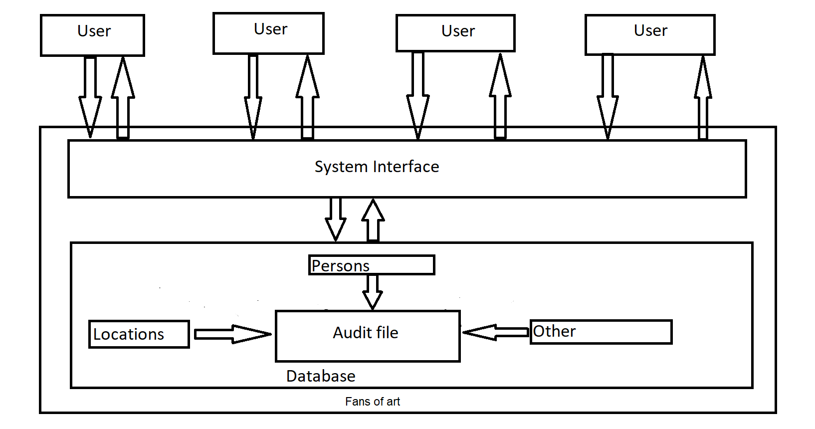

Fig1. Block diagram for Fans of art

## 3.2 Decomposition Description

The context diagram shows the main actors interacting with the system.

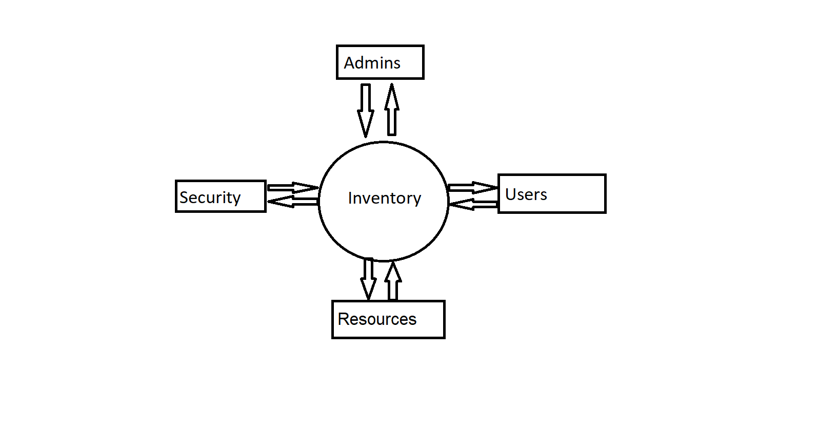

Fig2.Context for diagram Fans of art

## 3.3 Design Rationale

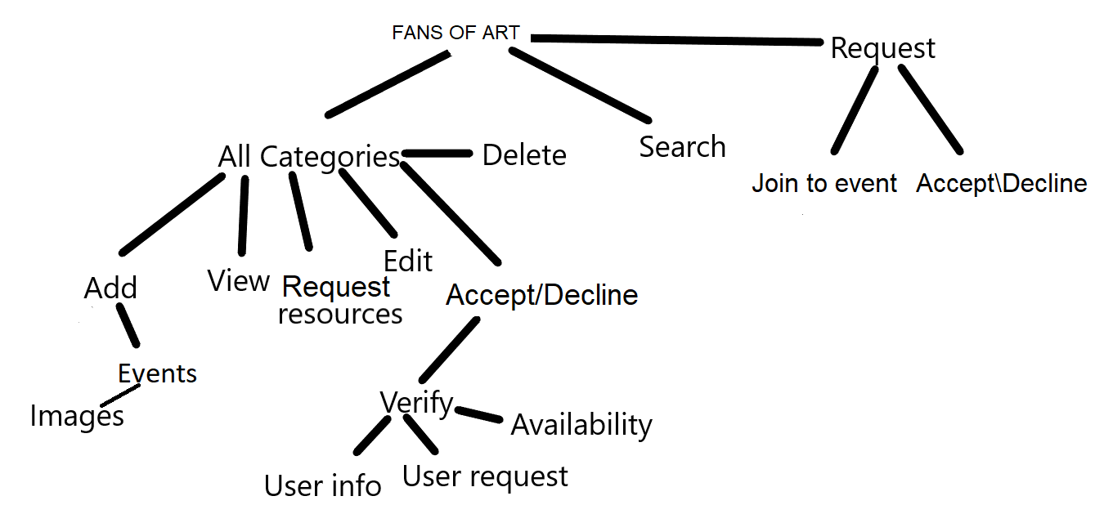

### DATA DESIGN

## Data Description

Data transformation means taking data stored in one format and converting it to another format.

Character encoding lets computers represent individual letters (or other characters) based on codes. In other words, every letter in the alphabet (as well as other text symbols, such as commas or periods) has can be represented as a code. As long as your computer knows which particular code was used to represent letters in a given set of data, it can decode the data in order to translate it into letters and numbers and print them on your screen.

Data are logically organized into:

1. Bits (characters)

2. Fields

3. Records

4. Files

5. Databases

***Bit*** (Character) - a bit is the smallest unit of data representation (value of a bit may be a 0 or 1). Eight bits make a byte which can represent a character or a special symbol in a character code.

***Field*** - a field consists of a grouping of characters. A data field represents an attribute (a characteristic or quality) of some entity (object, person, place, or event).

***Record*** - a record represents a collection of attributes that describe a real-world entity. A record consists of fields, with each field describing an attribute of the entity.

***File*** - a group of related records. Files are frequently classified by the application for which they are primarily used (employee file). A ***primary key*** in a file is the field (or fields) whose value identifies a record among others in a data file.

***Database*** - is an integrated collection of logically related records or files. A database consolidates records previously stored in separate files into a common pool of data records that provides data for many applications. The data is managed by systems software called database management systems (DBMS). The data stored in a database is independent of the application progr_ Data Dictionary

## Data Dictionary

|  |  |  |  |  |
| --- | --- | --- | --- | --- |
| **Function name** | **Field** | **Type** | **Null** | **Default** |
| **Accept_decline_request_of_public_event** | Reason_for_request | text(250) | Yes | **NULL** |
|  | Block_the_user | Enum(“yes”,”no”) | No | **No** |

|  |  |  |  |  |
| --- | --- | --- | --- | --- |
| **Add_event_image** | Image_url | Hyperlink | Yes | [**https://image.shutterstock.com/image-vector/art-pop-illustration-popart-design-260nw-550002070.jpg**](https://image.shutterstock.com/image-vector/art-pop-illustration-popart-design-260nw-550002070.jpg) |
|  | Image_from_personal | image | Yes |  |
| **Add_members** | Maximum_number_of_members | int(2) | Yes | **50 (maximum capacity)** |
|  | Adding_member_username_to_the_list | varchar(50) | No | **NULL** |

|  |  |  |  |  |
| --- | --- | --- | --- | --- |
| **Check_resource_valability** | Resource_Name | enum('Bibo','Carbone','Djapa', 'Duddell’s',Mott 32’) | No | **Bibo** |
|  | Starting_date_reservation | date (Format: YYYY-MM-DD) | No | **CURRENT_DATE** |
|  | End_date_reservation | date(Format: YYYY-MM-DD) | No | **CURRENT_DATE** |
|  | Link_for_the_resources_presentation | Hiperlink | No | <https://www.discoverhongkong.com/ca/dine-drink/whats-hot/best-restaurants-for-art-lovers.jsp> |

|  |  |  |  |  |
| --- | --- | --- | --- | --- |
| **Edit_the_events_as_admin** | Check_if_the_post_respect_the_rules_specify_if_not | Text(100) | yes | **Null** |
|  | Write_the_message_for_information_of_the_user_that_the_event_is_removed | Text(500) | no | **The event is removed due to not respecting our rules (check the rules section). You have 2 days to modify the event according to the rules before your details will be lost.** |

|  |  |  |  |  |
| --- | --- | --- | --- | --- |
| **Request_permission** | Reason_for_request | text(250) | Yes | **NULL** |
| **Search** | Search_criteria | Text(20) | Yes | **NULL** |
| **Verify_if_there_can_be_sent_join_request** | Maximum_number_of_request_selected_by_user | Enum(“50”,”75”, “100”,”125”,”150”, “200”) | No | **50** |
|  | Minimum_period_of_time_for_request | Enum(“anytime”,”1”, “2”,”3”,”4”, “5”) | no | **anytime** |

|  |  |  |  |  |
| --- | --- | --- | --- | --- |
|  | Check_if_the_4_digits_from_the_back_of_the_card_corresponds_to_user_id | Text(4) | No | **NULL** |
| **View_selection** | Select_only_event_type | enum(‘3D images’, ‘Paintings’, ‘Cartoons’, ‘Watercolors’, ‘Digital’ ‘artwork’, ‘Textures’) | No | **NULL** |

### COMPONENT DESIGN

“Users with appropriate permission” in the diagram refers to the users who are given exemptions or/and users of a particular level. Precise permissions are listed in Section 2.3 of SRS.

For diagrams with multiple functions, the design is the same for those functions, except for parameters/methods/classes.

1) Login

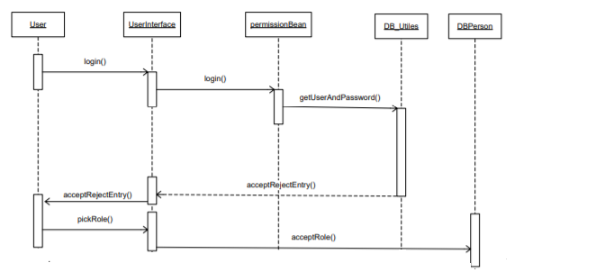

Figure 4. Sequence diagram for Login

2) Create new group

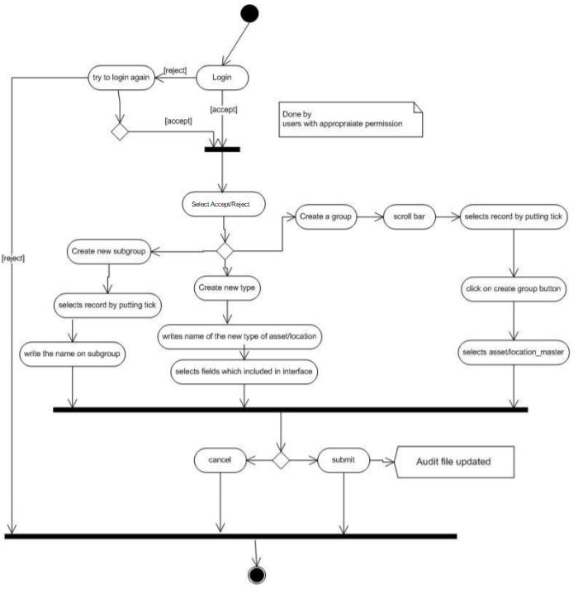

Fig5. Activity diagram for Create new group

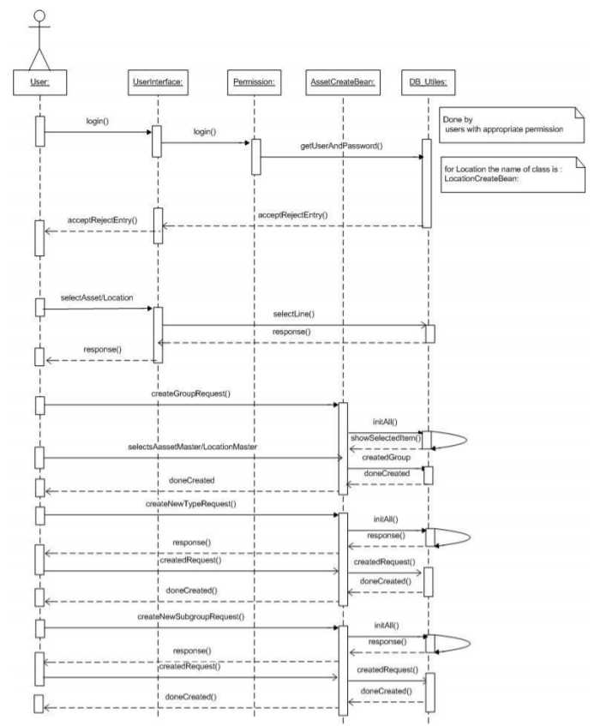

Fig6. Sequence diagram for Create New group

3) Import of persons/locations

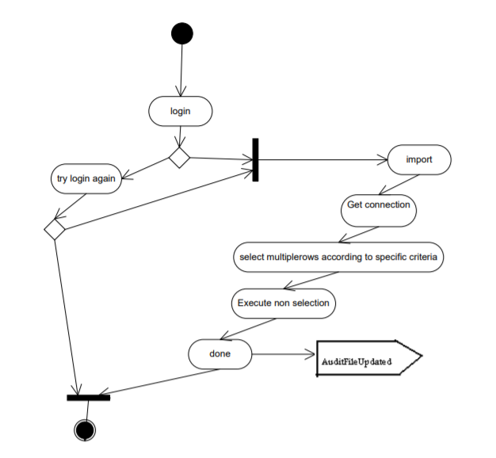

Fig7. Activity diagram for Import of locations / persons

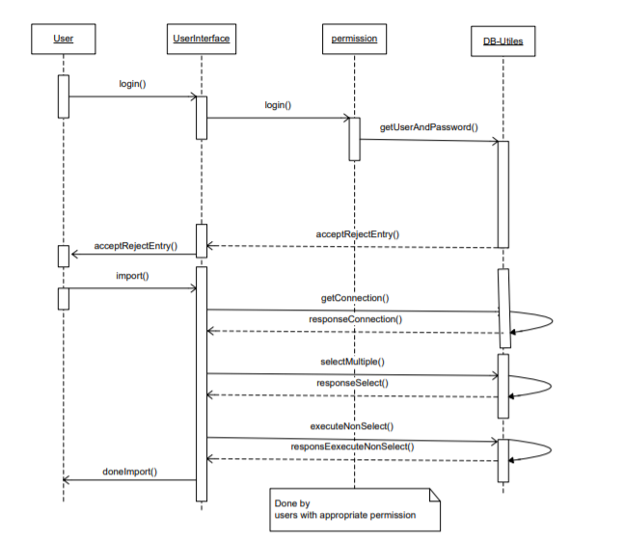

Fig8. Sequence diagram for Import of locations / persons

4). View/Add/Modify

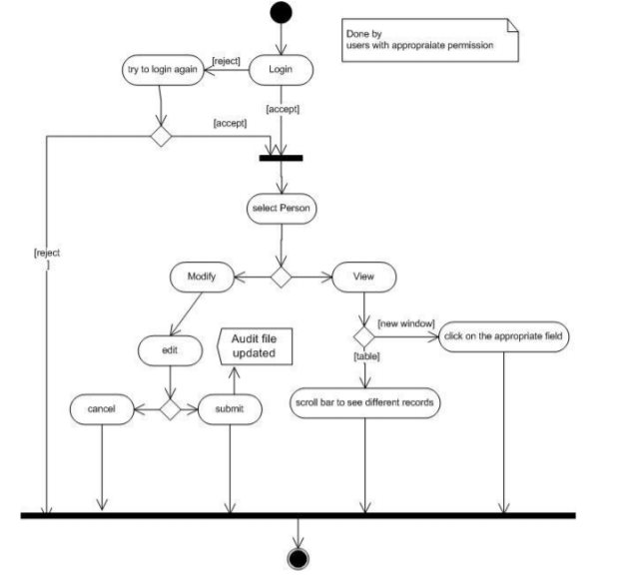

Fig.9 Activity diagram for View / modify

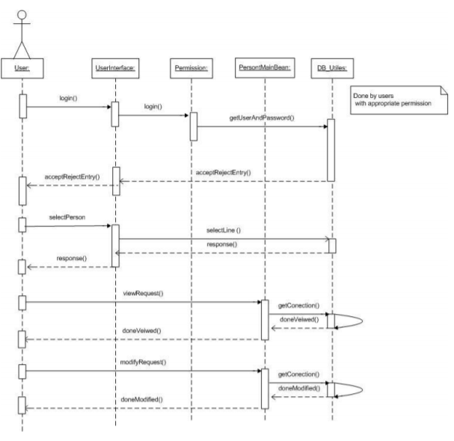

Fig.10) Sequence diagram for Assign / Modify

### HUMAN INTERFACE DESIGN

## Overview of User Interface

Create an account

In order to use the web application a user needs to create an account.

Registration .

Given that a user has entered the web application,has an account and wants to participate in reviewing the resources, they have to provide a username, password and email address.

LogIn functionality .

Given that the user wants to access the resources ,they have to register and login first, they have to provide a username, password and email address.

Reserve resource.

Given that the user wants to reserve a resource ,for each reserved resource it will be retained when it is available and when it is already reserved.

Availability resource

It will be possible for the user to view the reservation calendar of a certain resource.

Search related resource

Given that the user has entered the web application a user should be able to conduct a search by providing for eq: either painting name, events description, event address or events date in the search field. The result is displayed in a list view by default.

Resources Management

A resource can be reserved for an event only if it is not reserved for another event during that time.

Plan the reservation

Given the context of reserving a resource,for each new reservation, the resource will become unavailable for other reservations one day before the event and one after the event.

Search

Given that a user or guest is logged in, according to several search option. The search should be able to search for resources There should also be a free-text search option.

Profile Page

Given that the user registered on the web application, a user should have a profile page. On the profile page a user can edit his/her information, which includes e-mail address and phone number.

## Screen Images

A user/guest should be able to see and access both the login page and the register page .In picture 1 the login page and in picture 2 the register page.

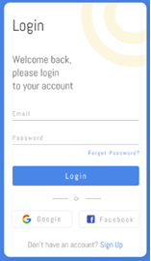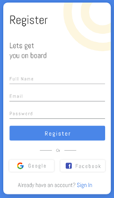

Picture 1 Picture 2

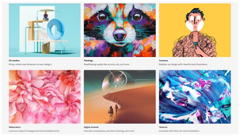

Picture 3 Picture 4

In picture 3 shows the search page/view. Given that a user want to search about something, this view should be able be the default one.Each result item includes painting information.

In picture 4 is the representation of the page where art enthusiasts can search for consoles and the dates on which they can appear, or they can look for data about a contest that has ended.

## Screen Objects and Actions

The web application should provide to the user a way to access and use in the best way for him .

The login/ register should provide the way/key to access the resources.

The search should provide the way of founding the resources that he/she will need

For the login page the button “Login” will give the user the way to login in the web application.Also the buttons “Google” & “Facebook” will give the user an easier way to login .

For the register page the button “Register” will give the user the way to register on the web application as a new user.Also the buttons “Google” & “Facebook” will give the user an easier way to register ,without the problem of forgetting the password .

The magnifying glass button from the Search page has the use to start the process of searching for the thing that the user wants to search.

### REQUIREMENTS MATRIX

|  |  |  |  |  |  |
| --- | --- | --- | --- | --- | --- |
| **REQUIREMENTS MATRIX** | | | | | |
| **Project name: Fans of art** | | | | | |
| **User class UC/Performance Requirements QR** | | **Functional Requirements FR** | | **Performance Requirements QRR** | |
| **User Class ID** | **User Class Case** | **Functional Requirements ID** | **Functional Requirements Case** | **Performance**  **Requirements ID** | **Performance**  **Requirements**  **Case** |
| UC_1 | The User | FR_1 | User registration |  |  |
|  |  | FR_2 | Reserve resource |  |  |
|  |  | FR_3 | Availability resource |  |  |
|  |  | FR_4 | Web application - Related resources search |  |  |
|  |  | FR_5 | Resources Management |  |  |
|  |  | FR_6 | Plan the reservation |  |  |
|  |  | FR_7 | Reserve resource |  |  |
|  |  | FR_8 | Web application - Related resources search |  |  |
|  |  | FR_9 | Web application - Search |  |  |
|  |  | FR_10 | Web application - Profile page |  |  |
| UC_2 | Art Enthusiasts | FR_11 | Create an accoun |  |  |
|  |  | FR_12 | Art enthusiasts log-in |  |  |
|  |  | FR_13 | Manage information |  |  |
|  |  | FR_14 | Manage resources |  |  |
|  |  | FR_15 | Selecting preferred language on the web-portal |  |  |
| UC_3 | Administrator | FR_1 | Administrator log in |  |  |
|  |  | FR_2 | **Verify the users** |  |  |
|  |  | FR_3 | Manage resources |  |  |
|  |  | FR_4 | Manage members |  |  |
|  |  | FR_5 | Manage contribution payments |  |  |
|  |  | FR_6 | Manage users |  |  |
|  |  | FR_7 | Administrator - Adding preferred language on the web-porta |  |  |
| **Performance Requirements ID** | **Performance Requirements Case** |  |  |  |  |
| QR_1 | Prominent search feature |  |  | QR_1 | Prominent search feature |
| QR_2 | Usage of the search feature |  |  | QR_2 | Usage of the search feature |
| QR_3 | Usage of the result in the list view |  |  | QR_3 | Usage of the result in the list view |
| QR_4 | Usage of the information link |  |  | QR_4 | Usage of the information link |
| QR_5 | Response time |  |  | QR_5 | ResponseTime |
| QR_6 | Reliability |  |  | QR_6 | SystemReliability |
| QR_7 | Availability |  |  | QR_7 | SystemAvailability |
|  |  |  |  | QR_8 | Internet Connection |
| QR_9 | Security |  |  | QR_9 | CommunicationSecurity |
|  |  |  |  | QR_10 | AdminLoginAccountSecurity |
|  |  |  |  | QR_11 | AdminAccountSecurity |
|  |  |  |  | QR_12 | UserCreateAccountSecurity |
|  |  |  |  | QR_13 | AdminCreateAccountSecurity |
| QR_14 | Maintainability |  |  | QR_14 | Application extendibility |
|  |  |  |  | QR_15 | Application testability |
| QR_16 | Portability |  |  | QR_16 | Web application portability |