Power System

Power Supply Overview

The BEXUS 28.8 V DC bus powers the experiment. With a total energy need of 223.9 Wh, our current analysis suggests that using two batteries on the gondola may be needed to provide enough energy and safely handle the peak current draw of 1.73 A.
The electrical system uses a simple power distribution setup to safely manage control and sensor electronics. A DC-DC buck converter creates a stable 5V supply for the Raspberry Pi 4 and the Pi-EzConnect HAT. The sensor array, which includes PT100 probes connected through MIKROE-2815 RTD amplifiers, as well as BME280 and BPW21 sensors, runs 3.3 V logic signals from this supply. The low-power logic circuits include filters to cut down on electromagnetic noise and voltage changes during operation.
The safety plan focuses on real-time software monitoring and several layers of hardware protection. To lower the risk of electrical failures, the system uses fast-acting fuses and reverse-polarity protection at the main power inlet.

Power Budget Calculation

The power budget was estimated for the full operating timeline of the experiment, including testing, standby, ascent and float. The 5 V line powers the Raspberry Pi, HAT and sensor electronics and is therefore treated as a continuous load. The 12 V line is used only for the two stepper motors, which are operated sequentially for 15 minutes each. The 28 V line powers the heaters and represents the main intermittent load. To reduce the peak demand on the main power bus, stepper actuation is scheduled so that it does not overlap with peak heater operation.

Flight profile
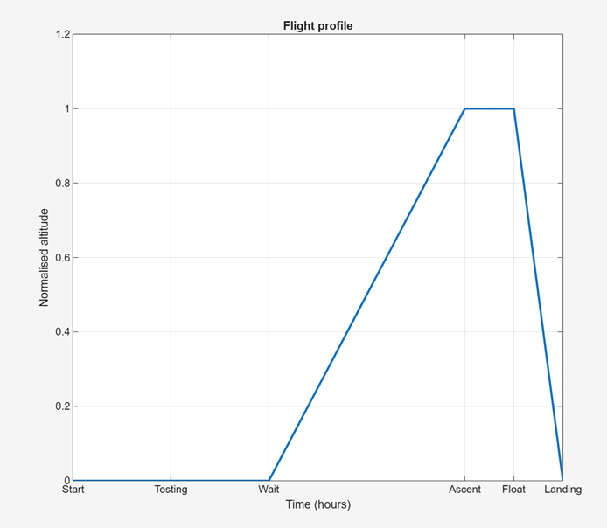
Figure 4.7.2.1: Flight profile

5V line power budget
5V Line consumption
Raspberry Pi 4 consumption (W) | 6.00
Raspberry HAT consumption (W) | 0.05
MIKROE-2815 RTD Amp consumption (W) | 1.60
PT100 probes consumption (W) | 0.08
Pressure sensor consumption (W) | 0.02
UV sensor consumption (W) | 0.02
Stepper driver logic consumption (W) | 0.60
Breakout board consumption (W) | 0.10
Test duration (hours) | 2
Wait duration (hours) | 2
Flight duration (hours) | 6
Peak Current (A) | 1.69
Total Consumption (Wh) | 84.7
Peak Wattage (W) | 8.47
Average Wattage (W) | 8.47

Consumption at 5V
Peak current = 1.69A@5V
Peak wattage = 8.47W
Average wattage = 8.47W
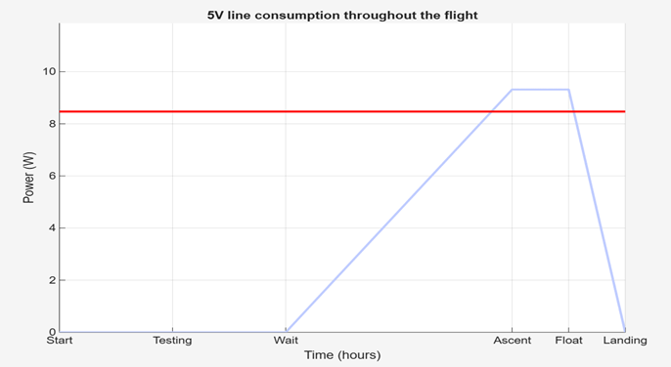
Figure 4.7.2.2: Consumption at 5V
This line powers the onboard computer, sensor readout electronics and motion-control logic, and assumed to remain active throughout the full mission

12V line power budget
12V Line consumption
Stepper motor operating voltage (V) | 12
Stepper motor operating current (A) | 0.42
Number of stepper motors | 2
Duration per stepper (minutes) | 15
Total actuation duration (minutes) | 30
Peak Current (A) | 0.42
Total Consumption (Wh) | 2.52
Peak Wattage (W) | 5.04
Average Wattage (W) | 0.25

Consumption at 12V
Peak current = 0.42A@12V
Total consumption = 2.52Wh
Peak wattage = 5.04W
Average wattage = 0.25W
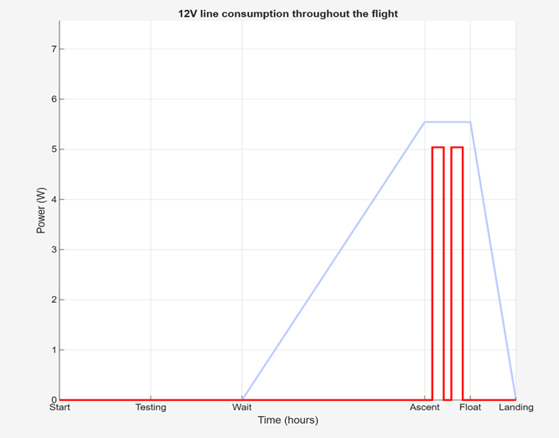
Frigure 4.7.2.3: 12V line consumption throughout the flight
The 12V line is used only for stepper motor actuation. The two motors are operated sequentially, for 15 minutes each.

28V heater line power budget
28V Heater Line consumption
Number of active heaters | 6
Power per heater (W) | 5
Total duration of heating (hours) | 2
Average duty cycle | 0.20
Peak Current (A) | 1.07
Total Consumption (Wh) | 60.0
Peak Wattage (W) | 30.0
Average Wattage (W) | 6.0

Consumption at 28V
Peak current = 1.07A@28W
Total consumption = 60.0Wh
Peak wattage = 30.0W
Average wattage = 6.0W
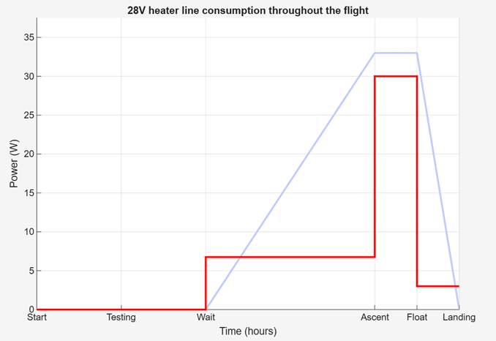
Figure 4.7.2.4: 28V heater line consumption throughout the flight

This line represents the thermal control load and is the main intermittent high-power consumer during the mission.

Summary of total power budget
Power consumption
Peak Current (A) | 1.37
Total Consumption (Wh) | 147.22
Total Consumption (Ah) | 5.26
Peak Wattage (W) | 38.47
Average Wattage (W) | 14.72

Total power consumption
Peak current = 1.37A@28V
Total consumption = 147.22Wh
Peak wattage = 38.47W
Average wattage = 14.72W
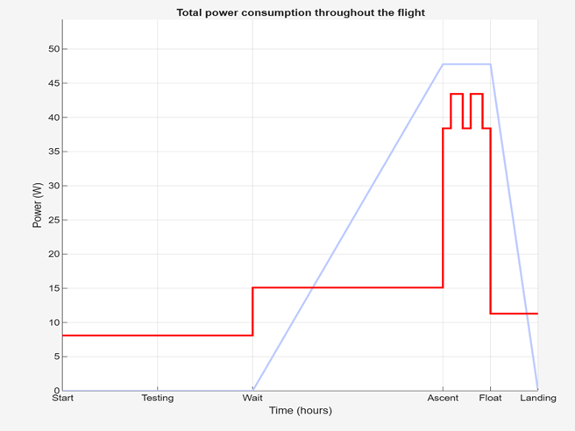
Figure 4.7.2.5: Total power consumption throughout the flight

The experiment power consumption is dominated by the heater line and by the continuous electronics required for sensing and onboard control. Since the stepper motors are only needed for short actuation events, they are operated sequentially and outside the heater peak interval. This reduces the maximum load on the gondola power bus and improves the robustness of the electrical design.

Duty Cycles and Operational Phases

The experiment uses nine 10-watt Kapton heaters. They are placed under the sample plates. The thermal control program manages the power budget as a shared resource and uses time-division multiplexing. Running all nine heaters at once would need about 100 watts, which is more than the system’s power limit and the 223.9 watt-hour battery capacity. The software makes sure that no more than four heaters are on at the same time, so the thermal subsystem never draws more than 40 watts (1.43 A), and the system's peak stays at 48.23 watts (1.73 A). The other six heaters wait in a queue and do not draw any current. By quickly switching which heaters are active using Pulse Width Modulation (PWM), the system keeps the right average duty cycles for all temperature zones without going over the power limit.
During ascent, the main goal is to keep the self-healing coating inactive by holding the aluminum plates at -30°C. The plates get short bursts of heat to stop the samples from reaching very low temperatures. The most important change happens during the activation phase, when the controller heats the plates from -30°C up to the +70°C healing target at about 0.85°C per second. At this point, the multiplexer uses its full 48.23 W system peak, focusing on the nine sample plates to reach the needed temperature quickly. To stay within the four-heater limit, the electronics heater is temporarily set aside. The thermal mass of the extruded polystyrene (XPS) insulated box helps keep the inside temperature steady during this fast heating period.
When the experiment reaches the float phase in the stratosphere, most heat is lost through radiation instead of convection. The multiplexing queue becomes less demanding as the system keeps the plates at +70°C for the 90-minute healing period, making sure energy use stays within the two-battery limit. During descent and recovery, the balloon moves into denser air, which increases cooling by convection. The thermal targets then change to a -20°C floor for the plates to stop the newly healed polymer from getting brittle. The system remains running so it can log data during landing and while waiting for the recovery team.

Software Design

- Purpose:

The On-Board software covers the following functionalities:
- Temperature regulation, based on the control of the on-board heaters and the measurements read by the temperature sensors. Depending on the current phase and temperature, heaters are automatically assigned a duty value representing their heat output, ranging between 0 (off) and 10 (maximum heat output)
- Sensor reading and management for the ambient (temperature/pressure/humidity), temperature (heaters), voltage sensors and UV sensors
- Data storage in a designated log file with timestamps
- Data transmission to the Ground Station.
- Receiving and enacting commands from the Ground Station
- Stepper control for applying micro-cracks

The Ground Station software covers the following functionalities:
- Parsing of the collected data received from the gondola
- Computing relevant data
- Displaying the data in readable graphs
- Transmitting commands to the gondola

- Design:

  - Process Overview:

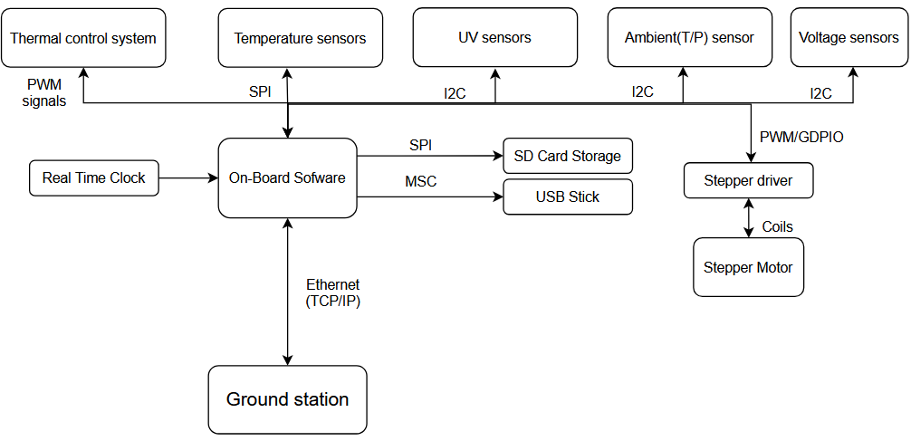
Figure 4.8.1 – Overview Block Diagram

As displayed in figure 4.8.1, the On-Board Computer communicates with UV and ambient sensors through I2C connections, with the temperature sensors through SPI and with the thermal control system using PWM signals. An external Real Time Clock provides the means for timestamping our data. The SD Card and the USB Stick are connected through SPI and MSC respectively. Finally, the Ground Station and On-Board computer exchange data through E-link.

b. General and safety related concepts
For a failsafe system against data loss, the collected data is stored twice, locally, on 1 microSD card and 1 USB Stick, and sent in real-time and stored on the Ground Station. Telemetry and commands are transported over a TCP/IP connection via E-Link (Ethernet). TCP provides ordered, reliable delivery of bytes; message boundaries are defined at the application layer using newline-delimited records.

c. Interfaces
Table 4-6: Interface table
Components |  | Communication Protocol | Physical Interface
A | B | Communication Protocol | B | A
OBC | TS | SPI | Digital Pins | GPIO pins
OBC | UVS | I2C | Digital Pins | GPIO pins
OBC | AS | I2C | Digital Pins | GPIO pins
OBC | TCS | PWM | Digital Pins | GPIO pins using MOSFET driver
OBC | SD card | SPI | SD card edge connector | Micro SD slot
OBC | USB Stick | MSC | USB-A plug | USB-A port
OBC | GS | E-Link | Ethernet | Ethernet
OBC | Stepper | PWM | Motor coils | GPIO pins using Stepper driver

Table 4.81 displays all component communications and their respective communication interfaces and physical connections. The UV and ambient sensors communicate through I2C with the On-Board Computer while the temperature sensors and the temperature control system communicate through SPI and PWM. The SD card and the USB Stick communicate with the On-Board Computer through SPI and MSC respectively. Finally, the On-Board Computer sends collected data and receives commands through E-Link.

d. Communication and commands
Communication between the On-Board computer and the Ground Station can be established using two methods:
- The Ground Station sends a UDP Broadcast message on port 4100 and receives a response if detected by the On-Board Computer
- If the On-Board computer does not receive any broadcast message or discovery is disabled, communication is established on a static IP address.
After establishing a connection, the two systems communicate through TCP/IP on multiple ports as follows:
- 4000 – Telemetry: The On-Board computer sends the monitored parameters to the Ground Station and awaits an ACK message confirming that the data was received.
- 5000 – Commands: The Ground Station can send various commands to the On-Board computer:
  - PING: Used to check if the connection between the On-Board computer and the Ground Station is stable. If stable, the On-Board computer should return PONG
  - STATUS: Used to obtain the current phase, flags and queue depth from the On-Board computer
  - FORCE_START: Used to set the On-Board phase to floating phase, subsequently starting the monitoring and temperature regulation processes.
  - FORCE_STOP: Used to set the On-Board phase to descent phase, stopping the monitoring and temperature regulation processes.
  - HEATERS_OFF: Used to set all heater duties to 0 (off)
  - RESET_CTRL: Used to reset PID integrators to zero
  - SHUTDOWN_SAFE: Used for safely shutting down the On-Board processes
  - ARM_DEBUG <token>: Requires the proper debugging token; Used for enabling debugging commands:
    - DISAARM_DEBUG: Disables debugging commands
    - SET_HEATER_DUTY <heater_index> <duty_value>: Sets the specified heater to a certain duty value
    - SET_ALL_DUTY <duty_value>: Sets all the heater duties to the specified value
    - SET_PID <kp> <ki> <kd>: Manually set PID values
    - CLEAR_OVERRIDES: Clears manual overrides, returning to automatic mode values

d. Data acquisition and storage
- Data will be read from the temperature, ambient, and UV sensors at a specific tick-rate and stored in packets. For each tick, a packet will contain the timestamp, and all sensor readings in a newline-delimited CSV. Example formatting:
SEQ (monotonic counter)
TIMESTAMP (RTC time + “RTC valid” flag)
T_ambient, P_ambient, UV, T_box (etc.)
HEATER_DUTY
STATUS bitfield (SD_OK, USB_OK, I2C_OK, SPI_OK, LINK_OK)

e. Process Flow:
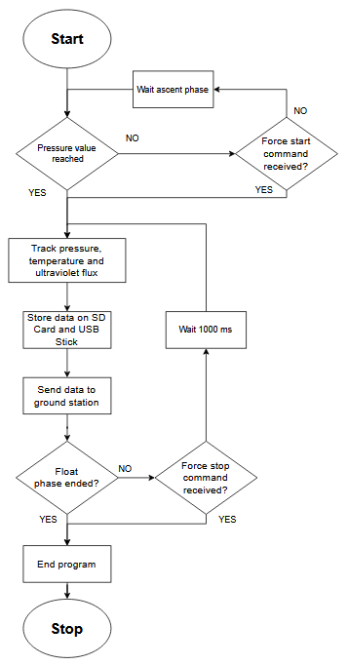
Figure 4.8.2 – Data collection flow diagram

The On-Board Software serves 2 main purposes, each having their own individual process flows. The first functionality is monitoring and collecting data. The collected data is further stored on the SD Card and on the USB Stick, being then sent to the Ground Station to be used and displayed. Before starting to collect data, the thread first checks if the ascent phase is over, determined by the currently measured pressure value. The same criteria can be used to assert if the floating phase is over. The experiment can also be assisted in detecting the current phase through manual commands, such as the force start command or the force stop command.

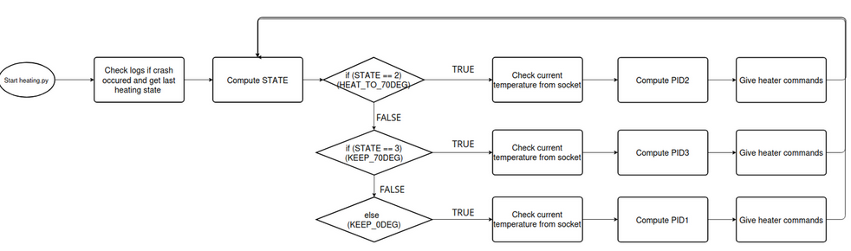
Figure 4.8.3 – Heater regulation flow diagram

The second functionality is responsible for automatically controlling the heaters to maintain an optimal temperature for both the experiment and each observed sample. While in the ascent phase, the heaters will heat up the samples to 70 degrees. During the floating phase, depending on their current temperature, the heaters will either reduce or increase their output in order to maintain constant temperature. During the descent phase, the heaters will stop.
Heating regulation is achieved through the use of a custom PID control loop that receives feedback from the temperature sensors monitoring each sample. As the experiments' power budget is limited, the heating control system allows only 4 heaters to function at the same time, thus maintaining aggregate thermal power at a maximum of 25W.

Ground Support Equipment

The Ground Station includes 2 laptops, one running the experiment, and one spare laptop for redundancy. The laptop running the experiment will be connected to the E-Net network to access the E-Link and communicate with the On-Board Computer. The uplink will be used to send emergency commands to the On-Board Computer, and the downlink will be used to receive relevant data from the sensors on board, both limited to a bandwidth of 2Mbps to adhere to the imposed hardware constraints.
On the running laptop, team members will be able to monitor relevant data received or calculated based on values received from the On-board Computer. Furthermore, commands such as ON, OFF, or RESET can be issued to the On-Board Computer using the uplink.

