Electronics System Overview

The main processing unit in the electronics system is a Raspberry Pi 4 which is suitable for the ambient temperatures reached during the stratospheric flight. Hardware longevity and data integrity will be obtained by keeping the temperature at a constant 0° C floor. Aluminium plates will be controlled from -30°C hibernation state during ascent to a +70°C for the healing phase. To stay within the recommended 1.4 A (40.32 W) constant draw limit, the system utilizes dynamic power allocation and PWM throttling.
The Control Unit, centered on the Raspberry Pi 4, executes the flight software and manages the logic for all phases of the experiment. Control Unit runs a custom PID control loop that processes real-time data from the sensor array to determine the desired duty cycles for the heaters. Raspberry Pi 4 manages thermal regulation and data logging at high-frequency, storing information from 12 different sensors. By monitoring pressure and altitude data, the controller autonomously triggers the activation of healing phases while it remains accessible via the E-link for emergency overrides.
The Sensor Subsystem performs data acquisition which will be used for real-time and post-flight self-healing process analysis. For temperature measurements, ten PT100 RTD sensors are used, nine mounted under every aluminium plate and one for monitoring ambient temperature. These sensors are interfaced through MIKROE-2815 RTD amplifiers on the SPI bus. For ultraviolet radiation measurements, the system has a BPW 21 photodiode. Attitude and pressure are monitored using a BME280 digital barometric sensor.
The Heating Subsystem provides the thermal energy required for the experiment by utilizing nine 10 W Kapton heaters, mounted under every aluminium plate and one 10 W Heater in the Electronics Box. These actuators are controlled via a 9-channel MOSFET driver module that interfaces directly with the Pi’s GPIO pins.
This setup allows for fine-grained Pulse Width Modulation, critical requirement for achieving approximately 0.85°C/s heat ramp for activation of the experiment. The software logic ensures that the heaters are prioritized, capping the electronic heater whenever the plates require a maximum ramp-up to stay within the 1.4 A safety envelope.
Power Subsystem manages the distribution of power and serves as the primary interface between the experiment and the 28.8 V DC supply from the BEXUS gondola.
For protecting the 5.1 V electronics from the voltage heater lines and noisy switching signals, a Pololu D24V50F5 buck converter is used. This regulator steps down the raw voltage to a stable 5.1 V at 5 A, providing clean power to the Pi4. This architecture ensures that power fluctuations caused by high-current heater pulses do not interfere with the stability of the control unit or sensor readings.
The Communication Subsystem facilitates real-time telemetry and ground control via the BEXUS E-link system. An Ethernet connection provides the physical link between the Raspberry Pi 4 and the gondolas communication hub.
During flight, the experiment transmits a continuous telemetry packets, including sensors measurements, heaters states and power, allowing the ground support team to monitor mission phases. The uplink capability also provides remote shell access via TCP, ensuring that the team can perform diagnostics or reset the system if the autonomous flight logic unforeseen atmospheric conditions.

Electronics Architecture and Logic
The electronics architecture separates low-power logic from high-power logic from high-power actuation to prevent noise from interfering with sensor readings. A processing unit coordinates all systems and manages data flow and thermal regulation. The experiment electronics are organized into a central logic that interfaces with power, sensing, and thermal control subsystems.
The following block diagram shows the overall system architecture, highlighting the separation between the 28.8V power rails and the 5.1V logic signals.
As shown in Figure 4.5.1, the primary power line has two distinct purposes. Firstly, it feeds into a Buck Converter which steps down the voltage value to a stable 5.1 V to power the Raspberry Pi 4 and the sensors subsystem. Secondly, the 28.8V line is routed directly to the Heater Control Path.
Heater Control Path
The heating subsystem maintains the electronics box at a survival temperature and helps the plates to reach their 70°C target temperature for the healing process. This path uses a 9-Channel MOSFET Driver that functions as an array of high-speed electronic switches. MOSFETs are connected to the 28.8 V power rail and controlled by the Raspberry Pi 4 via Pulse Width Modulation (PWM) signals.
PWM use allows the control software to rapidly toggle the MOSFETs on and off, effectively “throttling” the power delivered to the nine 10W Plate Heaters and the 10W Electronics Box Heater.
The Raspberry Pi continuously calculates optimal power percentage for each heater based on real-time feedback from the temperature sensors and ajusts the duty cycle of the PWM signals to maintain the desired thermal profile.
Data Flow and Acquisition
The data flow is a multi-stage process that sends environmental data to ground-based stations for monitoring. The Sensor Susbsystem collects data across several digital buses. Data is processed by the Raspberry Pi.
The I2C Bus is used to poll the BME280 digital barometric sensor and the ADC, which transforms the analog signal from the BPW 21 UV photodiode.
The SPI Bus manages 10 MIKROE-2815 RTD amplifiers, which read the values of the electrical resistance from the 10 PT100 RTD sensors located on the plates and inside the chamber.
When the Raspberry Pi 4 receives the data, the flight software manages it in two ways. Internally, the data is immediately timestamped and written on an Industrial MicroSD card to ensure a persistent, non-volatile record of the observed data during flight.
Simultaneously, the Pi splits this data into telemetry frames and transmits them over Ethernet to the BEXUS E-Link.

Subsystem Description
The design utilizes the Raspberry Pi 4 as the primary controller for the COATHEAL experiment. Because the system requires a full operating system to manage multiple high-speed data buses simultaneously, the Pi acts as the central hub, polling sensors, executing the thermal control loops for polymer healing, and handling the telemetry stream. The processing overhead supports a continuous flight software loop that performs real-time calculations while guaranteeing all collected data is mirrored redundantly to both a local microSD card and a USB stick to prevent data loss.
For the heater control subsystem, the architecture centers around nine 10 W Kapton heaters dedicated to the sample plates driven by MOSFET switching modules. The software implements an active/queued Time-Division Multiplexing (TDM) strategy combined with Pulse Width Modulation (PWM). The PID control loop relies on exact feedback from ten PT100 RTD sensors. The Pi handles these readings and outputs a 3.3 V PWM signal to the MOSFETs, which dynamically switch the high-voltage 28.8 V line to the active heaters, safely and reliably retaining the 70°C target during the healing phase.
The sensor subsystem provides comprehensive mapping of the stratospheric environment and the experiment's internal thermal state. To prevent data congestion, the architecture splits the sensor array among distinct electronic interfaces. The system utilizes the SPI bus for the ten MIKROE-2815 RTD amplifiers, providing the high speed and individual chip-select lines necessary for rapid temperature measuring across all plates. For ambient environmental data, the I2C bus supports the BME280 sensor to track pressure, humidity, and external temperature. Additionally, the I2C bus interfaces with an ADC, which processes the analog output from the BPW 21 UV photodiode and delivers the high resolution required for radiation analysis.
Regarding the communication subsystem, the experiment interfaces with the BEXUS E-link through a dedicated Ethernet connection. The data flow prioritizes live telemetry over a reliable TCP/IP protocol, utilizing newline-delimited records to transmit continuous sensor and system health packets to the ground station. While the downlink supports high-bandwidth transmission of the complete sensor array data, the uplink is programmed to accept essential commands, such as manually overriding mission phases, forcing a heater shutdown, or resetting the control unit. The packet structures and transmission frequencies are strictly optimized to ensure uninterrupted monitoring without saturating the allocated E-link bandwidth during flight.

Thermal Design

Thermal context

During the experiment’s ascent, temperatures may drop down to -80 °C within the tropopause. Convection is directly linked to air pressure, resulting in a fast reduction of the film coefficient. If a daytime flight is considered, the date and time, as well as geographic coordinates must be taken into account to estimate the absorbed solar flux. A nighttime flight shall be considered as well, due to easier activation of the cracking mechanism, as greater temperature differences may be achieved.

Physical arrangement

The described conditions pose a significant threat for the electronics, hence thermal insulation (extruded polystyrene – XPS) will be used to protect the Raspberry Pi.
For thermal insulation between the COATHEAL samples and the sample frame, garolite (FR4) shoes will be used. The orthotropic thermal conductivity is accounted for in the numerical simulation.

Analysis setup

A simplified geometry (Figure 4.6.1), which respects the key features of the original model was imported into Ansys to study the thermal behaviour of the experiment.
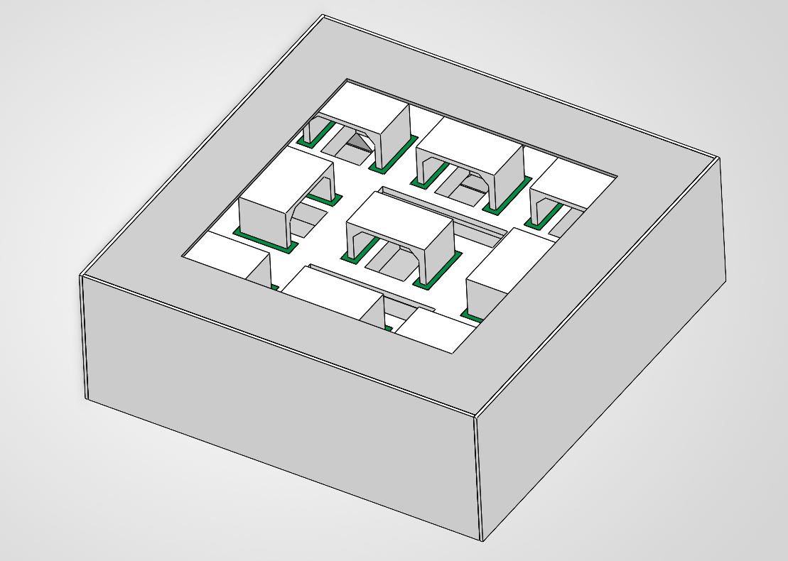
Figure 4.6.1 – Simplified 3D model

The thermal properties (thermal conductivity and specific heat) of the aluminium alloys used were defined with respect to temperature using approximation curves [a], [b], [c] determined by the following formula:

where:
- y – the calculated thermal property (e.g. the thermal conductivity of aluminium 6061-T6).
- a … i – coefficients for curve approximation.
- T – the temperature (in Kelvin) at which the thermal property is calculated.
Calculated results are shown in Table 4-4, along with coefficients used for each calculation.
Table 4-4: Thermal conductivity / Specific heat vs. Temperature
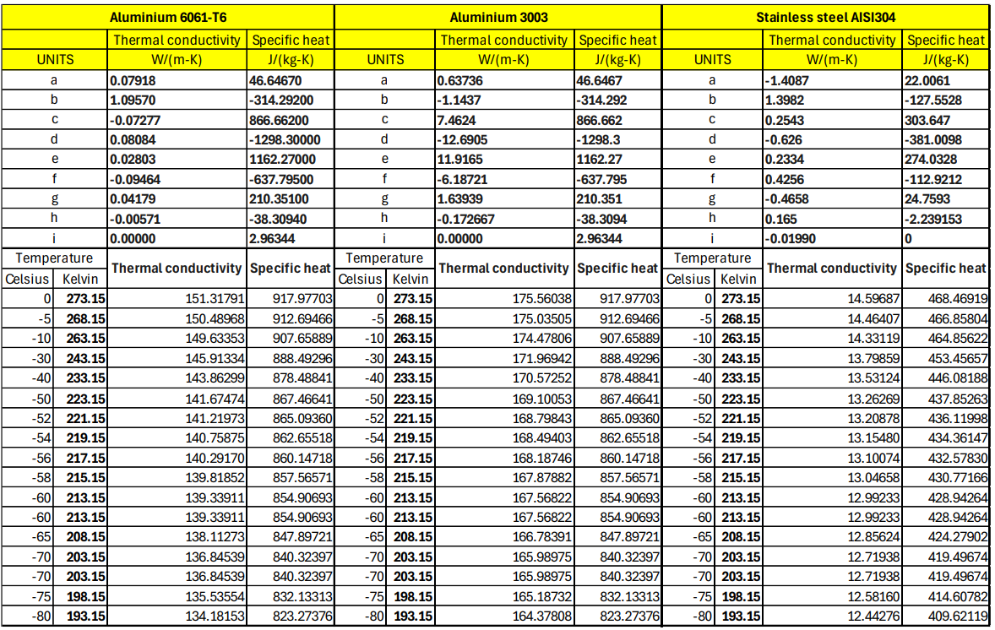
The resulting curves were plotted and are shown in Figure 4.6.2.

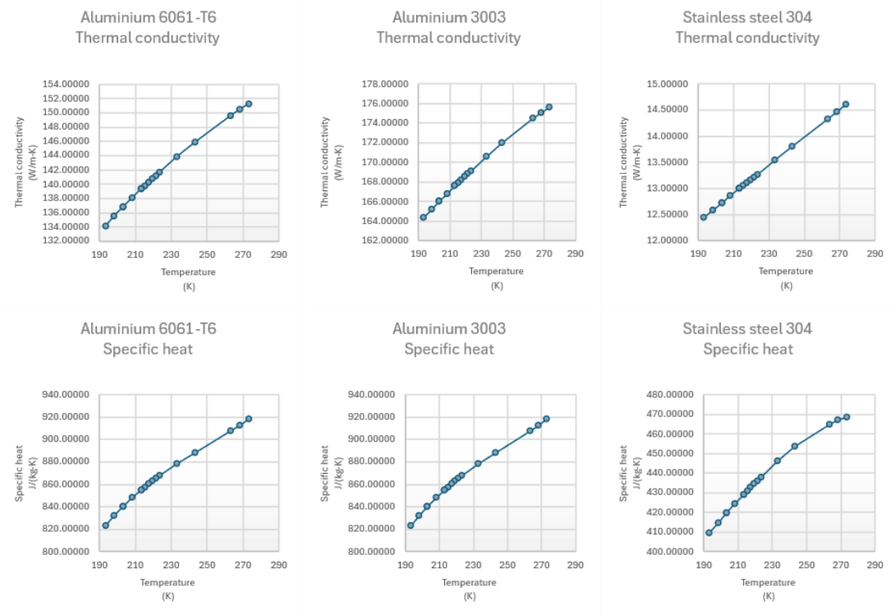
Figure 4.6.2 – Thermal conductivity / Specific heat curves with respect to Temperature

For the remaining materials (XPS, FR4), no detailed data was found and thus, were assumed to have a linear relationship between thermal conductivity / specific heat and temperature.

Material assignments:
- Aluminium 6061-T6: Rexroth profiles, sheet metal panels, sample frame, Raspberry Pi case.
- Aluminium 3003: samples (even though we will use aluminium alloy 2017, thermal characteristics are similar between the two alloys);
- Stainless steel 304: Z-shaped links connecting the sample frame to the Rexroth profiles.
- XPS: thermal insulation around Raspberry Pi.
- FR4: insulating shoes on the samples.

Two separate numerical simulations were run, representing conditions for both daytime and nighttime flight conditions.
To accurately model the absorbed solar flux during a daytime flight, sun positioning data was retrieved using SunCalc, a free-to-use online solar calculator [d]. Having an altitude of to the horizon, the Sun will mostly heat the lateral panels of the experiment. The solar radiation that hits the top of the experiment will be:

In order to calculate lateral solar flux, constant rotation of the gondola was assumed. The average flux is equal to the integral mean value of the instantaneous flux, divided by the total period ():

where is the gondola rotation angle, relative to the Sun. At ground level, is set to 650 W/m2, gradually increasing to 1360 W/m2 at float altitude. These calculations yield the values shown below in Table 4-5, after taking into consideration the absorptivity for each material.
Table 4-5 – Solar flux for all surfaces
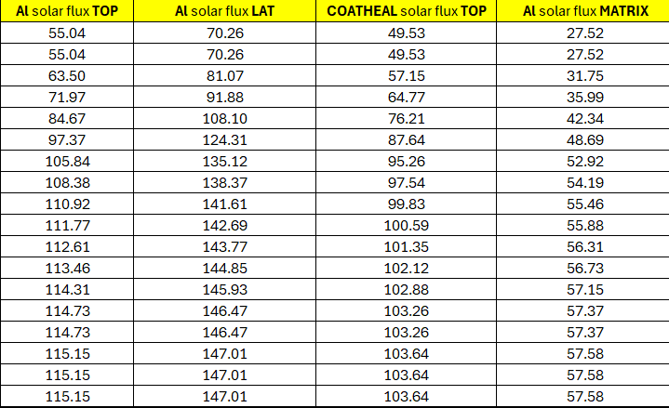

Boundary conditions (daytime flight):
- Internal heat generation, 5W uniformly distributed throughout the Raspberry Pi case body.
- Convection 1, applied onto the external surfaces (detailed in Figure 4.6.3).
- Convection 2, applied to surfaces under the upper grill, having a halved film coefficient.
- Radiation to ambient, on the COATHEAL samples (ϵ = 0.9), the sample frame and the outer panels (ϵ = 0.15), where ϵ is the emissivity of each material.
- Heat flux, simulating the solar flux, applied as specified in Table 4-5.
- Heat flux, representing the heaters on the samples, 10W distributed onto the lower surface of each sample, activated one by one with some overlapping.
The boundary conditions for the nighttime flight simulation only differ by the absence of solar flux, all other conditions remain unchanged.

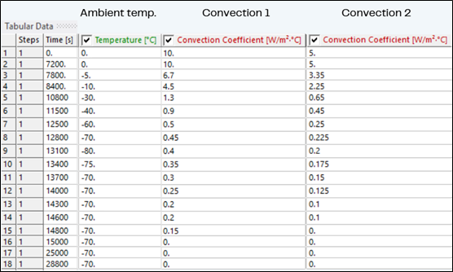
Figure 4.6.3 – Convection related tabular data in Ansys

Initial temperature is set to 20 °C on the entire model to simulate pre-launch conditions.
Time stepping:
- Total time – 8 hours (28800 s).
- Initial time step – 1500 s.
- Maximum time step – 3000 s.
- Minimum time step – 150 s.
Meshing was done using 1 mm elements for the samples and FR4 shoes and 4 mm elements for the other bodies.

Results. Interpretation

After solving the system, the solution reveals the following results (Figure 4.6.4 and Figure 4.6.5):

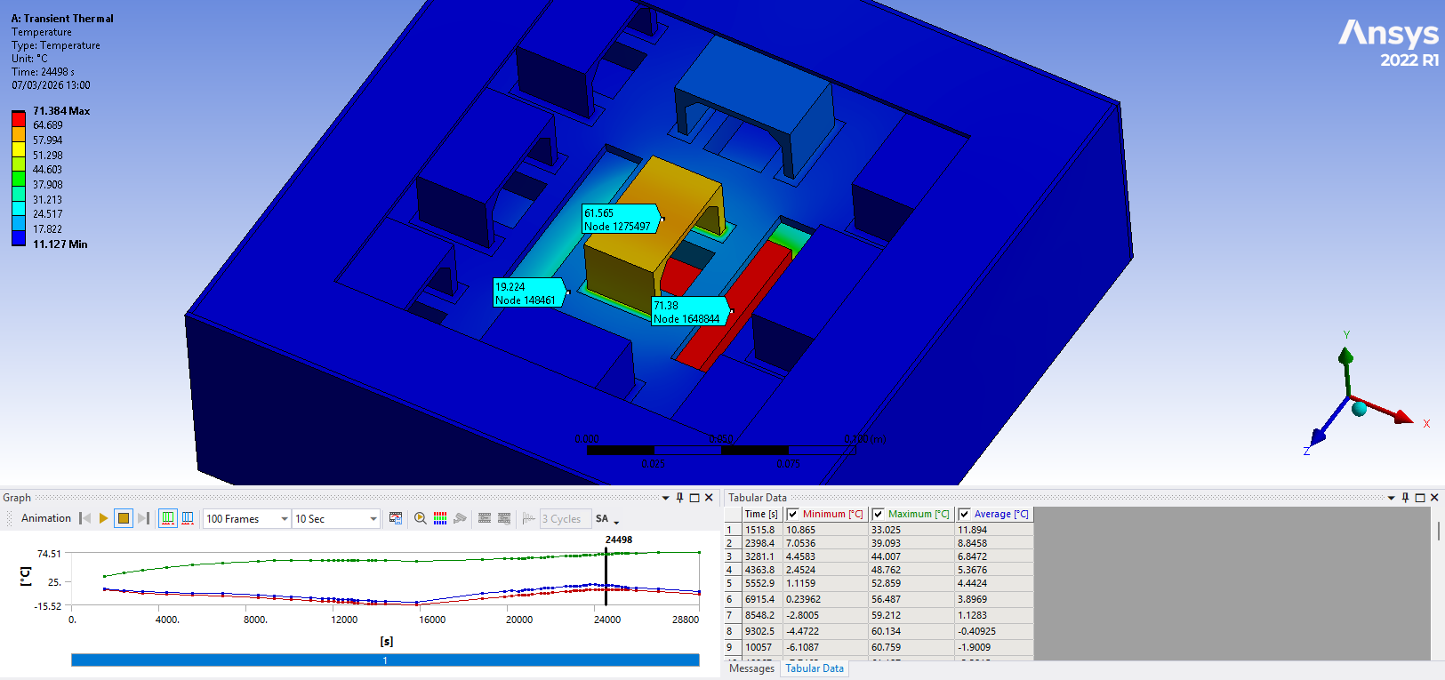
Figure 4.6.4 – Nighttime flight FEA results

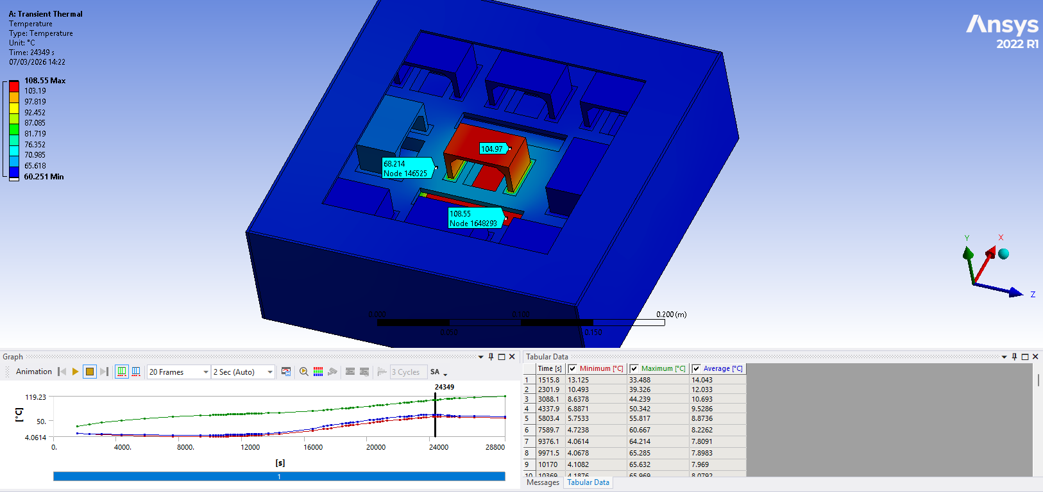
Figure 4.6.5 – Daytime flight FEA results

Between the COATHEAL samples and the frame, in both cases, the temperature difference is ~40 °C. However, a daytime flight will massively increase temperatures, especially after convection becomes negligible, pushing the Raspberry Pi over the temperature limit. Therefore, flying during the night is being considered, further investigation shall reveal a clear answer in future SED versions.

Power System

Power Supply Overview

The BEXUS 28.8 V DC bus powers the experiment. With a total energy need of 223.9 Wh, our current analysis suggests that using two batteries on the gondola may be needed to provide enough energy and safely handle the peak current draw of 1.73 A.
The electrical system uses a simple power distribution setup to safely manage control and sensor electronics. A DC-DC buck converter creates a stable 5V supply for the Raspberry Pi 4 and the Pi-EzConnect HAT. The sensor array, which includes PT100 probes connected through MIKROE-2815 RTD amplifiers, as well as BME280 and BPW21 sensors, runs 3.3 V logic signals from this supply. The low-power logic circuits include filters to cut down on electromagnetic noise and voltage changes during operation.
The safety plan focuses on real-time software monitoring and several layers of hardware protection. To lower the risk of electrical failures, the system uses fast-acting fuses and reverse-polarity protection at the main power inlet.

Power Budget Calculation

The table presents the current estimation of power usage during flight, incorporating the continuous theoretical draw of the computing and sensor subsystems as well as the dynamically throttled Kapton heaters. Although these figures are subject to refinement during physical testing and integration, the preliminary budget demonstrates that a two-battery configuration can reliably support the calculated 223.9 Wh total load over the anticipated flight duration.
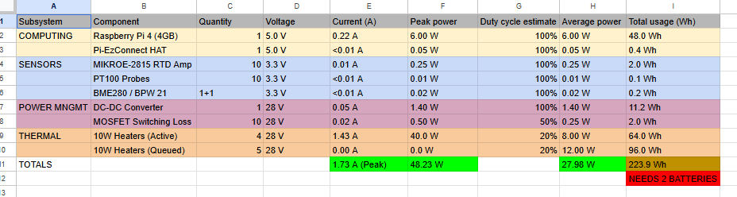

Duty Cycles and Operational Phases

The experiment uses nine 10-watt Kapton heaters. They are placed under the sample plates. The thermal control program manages the power budget as a shared resource and uses time-division multiplexing. Running all nine heaters at once would need about 100 watts, which is more than the system’s power limit and the 223.9 watt-hour battery capacity. The software makes sure that no more than four heaters are on at the same time, so the thermal subsystem never draws more than 40 watts (1.43 A), and the system's peak stays at 48.23 watts (1.73 A). The other six heaters wait in a queue and do not draw any current. By quickly switching which heaters are active using Pulse Width Modulation (PWM), the system keeps the right average duty cycles for all temperature zones without going over the power limit.
During ascent, the main goal is to keep the self-healing coating inactive by holding the aluminum plates at -30°C. The plates get short bursts of heat to stop the samples from reaching very low temperatures. The most important change happens during the activation phase, when the controller heats the plates from -30°C up to the +70°C healing target at about 0.85°C per second. At this point, the multiplexer uses its full 48.23 W system peak, focusing on the nine sample plates to reach the needed temperature quickly. To stay within the four-heater limit, the electronics heater is temporarily set aside. The thermal mass of the extruded polystyrene (XPS) insulated box helps keep the inside temperature steady during this fast heating period.
When the experiment reaches the float phase in the stratosphere, most heat is lost through radiation instead of convection. The multiplexing queue becomes less demanding as the system keeps the plates at +70°C for the 90-minute healing period, making sure energy use stays within the two-battery limit. During descent and recovery, the balloon moves into denser air, which increases cooling by convection. The thermal targets then change to a -20°C floor for the plates to stop the newly healed polymer from getting brittle. The system remains running so it can log data during landing and while waiting for the recovery team.

Software Design

- Purpose:

The On-Board software covers the following functionalities:
- Temperature regulation is based on the control of the on-board heaters and the measurements read by the temperature sensors.
- Sensor reading and management for the ambient (temperature/pressure/humidity), temperature (heaters) and UV sensors
- Data storage in a designated log file with timestamps
- Data transmission to the Ground Station.
- Receiving and enacting commands from the Ground Station

The Ground Station software covers the following functionalities:
- Parsing of the collected data received from the gondola
- Computing relevant data
- Displaying the data in a readable graph
- Transmitting commands to the gondola

- Design:

  - Process Overview:

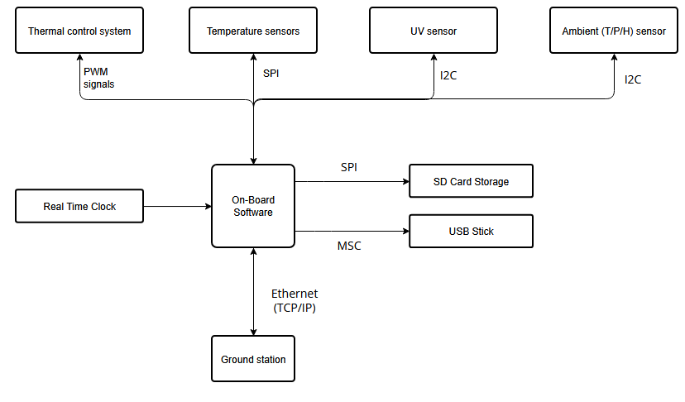
Figure 4.8.1 – Overview Block Diagram

As displayed in figure 4.8.1, the On-Board Computer communicates with UV and ambient sensors through I2C connections, with the temperature sensors through SPI and with the thermal control system using PWM signals. An external Real Time Clock provides the means for timestamping our data. The SD Card and the USB Stick are connected through SPI and MSC respectively. Finally, the Ground Station and On-Board computer exchange data through E-link.

b. General and safety related concepts
For a failsafe system against data loss, the collected data is stored twice, locally, on 1 microSD card and 1 USB Stick, and sent in real-time and stored on the Ground Station. Telemetry and commands are transported over a TCP/IP connection via E-Link (Ethernet). TCP provides ordered, reliable delivery of bytes; message boundaries are defined at the application layer using newline-delimited records.

c. Interfaces
Table 4-6: Interface table
Components |  | Communication Protocol | Physical Interface
A | B | Communication Protocol | B | A
OBC | TS | SPI | Digital Pins | GPIO pins
OBC | UVS | I2C | Digital Pins | GPIO pins
OBC | AS | I2C | Digital Pins | GPIO pins
OBC | TCS | PWM | Digital Pins | GPIO pins using MOSFET driver
OBC | SD card | SPI | SD card edge connector | Micro SD slot
OBC | USB Stick | MSC | USB-A plug | USB-A port
OBC | GS | E-Link | Ethernet | Ethernet

Table 4.81 displays all component communications and their respective communication interfaces and physical connections. The UV and ambient sensors communicate through I2C with the On-Board Computer while the temperature sensors and the temperature control system communicate through SPI and PWM. The SD card and the USB Stick communicate with the On-Board Computer through SPI and MSC respectively. Finally, the On-Board Computer sends collected data and receives commands through E-Link.

d. Data acquisition and storage
- Data will be read from the temperature, ambient, and UV sensors at a specific tick-rate and stored in packets. For each tick, a packet will contain the timestamp, and all sensor readings in a newline-delimited CSV. Example formatting:
SEQ (monotonic counter)
TIMESTAMP (RTC time + “RTC valid” flag)
T_ambient, P_ambient, UV, T_box (etc.)
HEATER_DUTY
STATUS bitfield (SD_OK, USB_OK, I2C_OK, SPI_OK, LINK_OK)

e. Process Flow:
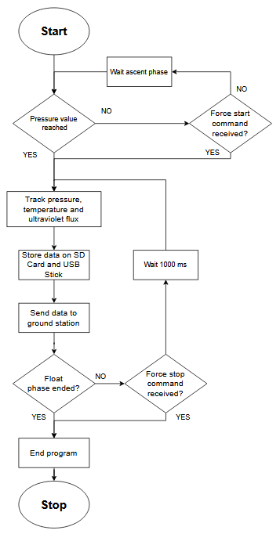
Figure 4.8.2 – Data collection flow diagram

The On-Board Software serves 2 main purposes, each having their own individual process flows. The first functionality is monitoring and collecting data. The collected data is further stored on the SD Card and on the USB Stick, being then sent to the Ground Station to be used and displayed. Before starting to collect data, the thread first checks if the ascent phase is over, determined by the currently measured pressure value. The same criteria can be used to assert if the floating phase is over. The experiment can also be assisted in detecting the current phase through manual commands, such as the force start command or the force stop command.

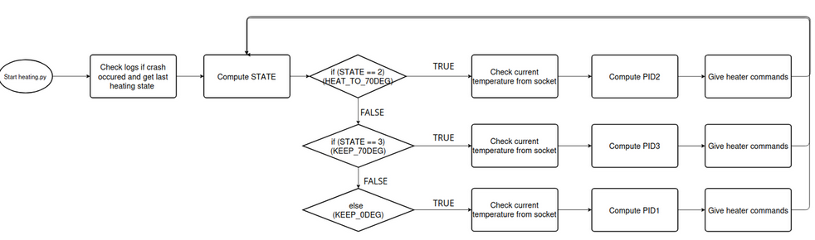
Figure 4.8.3 – Heater regulation flow diagram

The second functionality is responsible for automatically controlling the heaters to maintain an optimal temperature for each sample. While in the ascent phase, the heaters will heat up the samples to 70 degrees. During the floating phase, depending on their current temperature, the heaters will either reduce or increase their output in order to maintain constant temperature. During the descent phase, the heaters will stop.

Ground Support Equipment

The Ground Station includes 2 laptops, one running the experiment, and one spare laptop for redundancy. The laptop running the experiment will be connected to the E-Net network to access the E-Link and communicate with the On-Board Computer. The uplink will be used to send emergency commands to the On-Board Computer, and the downlink will be used to receive relevant data from the sensors on board, both limited to a bandwidth of 2Mbps to adhere to the imposed hardware constraints.
On the running laptop, team members will be able to monitor relevant data received or calculated based on values received from the On-board Computer. Furthermore, commands such as ON, OFF, or RESET can be issued to the On-Board Computer using the uplink

