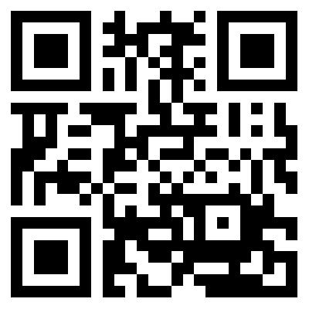**Tanner Barlow**

Mobile: 801-867-5383 | [tanner.barlow@outlook.com](mailto:tanner.barlow@outlook.com) | [www.tannerbarlow.com](http://www.tannerbarlow.com) <https://www.linkedin.com/in/tannerbarlow>

**Relevant Skills**

|  |  |  |  |
| --- | --- | --- | --- |
| C#/.NET | Java | Python | C/C++ |
| Node.js | HTML/CSS | JavaScript | SQL/MySQL |
| JSP | VisualStudio | Eclipse | REST |
| Git/GitHub | Agile | Windows/Linux | Fluent in Spanish |

**Education**

|  |  |
| --- | --- |
| **Bachelor of Science in Computer Science, Dec 2017**  **University of Utah, Salt Lake City, Utah** | **3.78 GPA on 4.0 scale** |

**Relevant Courses:**

|  |  |  |  |
| --- | --- | --- | --- |
| Database Systems | Software Practice in C# | Software Practice in C++ | Computer Systems |
| Probability and Statistics | Algorithms | Models of Computation | Linear Algebra |
| Natural Language Processing | Information Extraction | Data Mining | Personal Informatics |

**Awards and Scholarships**

|  |  |  |
| --- | --- | --- |
| Honors at Entrance – Full ride | Dean’s List (7 times) | Everton Memorial Scholarship |

**Work Experience**

* **Software Engineer Intern, May 2016-August 2016**

**Microsoft, Redmond, Washington**

* + Automated process of converting feedback from Windows 10 international customers to actionable bugs
  + Used NLP technologies to identify meaningful feedbacks (>10 M records) and group by semantic similarity
  + Set up automated cloud-hosted pipeline to run process automatically
* **Microsoft Intern Ambassador and Student Partner, January 2016-Present**

**Microsoft, Salt Lake City, Utah**

* + Resume, interview and career guidance related to Microsoft for university students
  + Coordination and instruction of technical workshops for Microsoft web and machine learning technologies
  + Managed social media outreach and budget for workshops and special events
* **Software Development Intern, May 2015-August 2015**

**FamilySearch, Salt Lake City, Utah**

* + Developed internal tools for team of historical geographical researchers
  + Implemented Java application for bulk operations on database of all “places” in the world (> 7 M records)
  + Starting the planning and design process for new REST API web service to replace Java application

**Favorite Projects**

* Wikipedia Question Answering System (Python)
  + Get Wikipedia articles with REST API request
  + Use Info. Extraction techniques to find ‘factoids’
  + Understand user’s question and respond with factoid
* “Hackathon Management API” (C#)
  + API hosted on Azure cloud platform
  + Endpoints for checking-in participants, renting out hardware, organize teams and manage hackathon
* Coreference Resolver (Java)
  + Train machine learning classifier for referred phrases
  + Use external libraries to identify new noun phrases
  + Identify correct noun phrase referred to by anaphora
* “PomoSphero” timing app for Sphero 2.0 (C#)
  + Connect to Sphero 2.0 robot via Bluetooth
  + Use asynchronous timers to gradually fade color of robot from start to finish, shaking robot when done

**Additional Leadership Experience**

* Executive Board member and Director of Technology for non-profit HackTheU
* President, Computer Programmers at the University of Utah (CPU of U)
* Several leadership positions (trainer, district leader, zone leader, assistant to the president) as a missionary for the LDS church in Santiago, Chile, leading as many as 204 missionaries at one time