सृष्टि · स्थिति · प्रलय
Srishti · Sthiti · Pralaya

CYCLE OF COEXISTENCE
THE SRISHTI MANDALA EDITION

━━━━━━━━━━━━━━━━━━━━━━━━━━━━━━━━━━━━━━━━

A Unified Manifesto of Systems, Stories and Survival

यत् पिण्डे तत् ब्रह्माण्डे
Yat pinde tat brahmande
As is the individual, so is the universe.

Sagar-Raja · Genesis Core Initiative
ADGM, Abu Dhabi, United Arab Emirates

FRONT MATTER

The Kshetra at Dawn
Before the first light. Before the first act of Srishti.
आदित्यवर्णेण तमसोहि पारम्
Aditya-varnena tamaso hi param
Beyond the darkness, through the light of the sun — this is the path.
— Shukla Yajurveda, Purusha Sukta

Before the first light, the Kshetra held a quality that had no name in operational language. It was not stillness. Stillness implies the absence of motion. The Kshetra was not absent of anything. Every system was cycling. Every element was in its correct relationship with every other element. The water in the atmospheric lattices was bound and ready. The photosynthetic surfaces were angled to receive the first photon of the coming day. The elemental storage reservoirs were full to the strategic threshold and no more.
What the Kshetra held in that hour was Sthiti: the second principle of the cosmic cycle, preservation in its most active form. Sthiti is not maintenance. Maintenance implies decay being held at bay. Sthiti is the condition of a system that has achieved its correct alignment and is holding it through continuous, active, invisible work. The Kshetra was not being maintained. It was being sustained, which is a different thing entirely.
Varunadeva's presence was the first to shift. In the deepest part of the pre-dawn hour, the atmospheric humidity reached its daily peak, and the Thirsty Silk Lattices that carried Varuna's principle responded to it. Water vapour that had been moving through the air in its natural dispersed state found, in the lattice structure, a surface that understood it better than the air did. The molecules slowed. They gathered. The Hydro-Kinetic pulse moved through the lattice like a quiet command spoken in the language of Rita — cosmic law — and the water came.
It did not fall. It arrived. This distinction, to anyone who had watched Varunadeva's work long enough, was the entire philosophical content of the operation. Water extracted from a source falls because it has been taken from where it was. Water that has been invited arrives because it has been offered a better place to be. The Kshetra did not take. It offered. The world, on the whole, preferred to give to a system that offered.
At the precise moment the sun cleared the eastern horizon, Agni's principle activated across every photosynthetic surface simultaneously. Not gradually. The transition from darkness to energy harvest was instantaneous at the cellular level — the way all true transformations are instantaneous. The preparation takes time. The transformation itself is a single moment.
Srishti had begun again. As it always had. As it always would. The Cycle did not ask permission to continue. It simply continued.

Two Editions, One Philosophy
This is the Srishti Mandala Edition of Cycle of Coexistence. It shares its real-world layer — the company Sagar-Raja, its products, frameworks, and philosophy — with the International Edition. What it does not share is the fictional world through which that philosophy is expressed.
The Srishti Mandala is not a retelling of the International Edition with different names. It is a different world, governed by different logic, drawing from a tradition that named the Cycle of Coexistence thousands of years before the phrase existed in modern systems language. The Vedas called it Srishti, Sthiti, Pralaya: creation, preservation, dissolution, operating simultaneously, at every scale, in every moment.
The thinking in this book is not new. It is old thinking applied to new materials. The acknowledgement is direct: the design principles governing the Kshetra and those governing Sagar-Raja are not inspired by the Vedic tradition. They are the same principles, expressed in living crystal and in intellectual property law respectively. The tradition named them first. This book applies them in a new domain.

How to Read This Edition
Each chapter opens with a Sanskrit shloka. The shloka is not a caption. It is a seed whose full meaning unfolds across the chapter. A reader who knows the tradition will feel it resonating at multiple levels simultaneously. A reader encountering it for the first time will find its meaning built into the prose that follows. Neither reader needs to do anything other than read.
The two registers — the Srishti Mandala and Sagar-Raja — exist in parallel as they do in the International Edition. The philosophy that governs the Kshetra is the philosophy that governs the company. The reader who perceives this has understood what the book is saying. The reader who does not perceive it has still read a complete work in each register independently.
Figure FM-1: Book Architecture — Srishti Mandala Edition
Part | Devata / Cosmic Principle | Sagar-Raja Framework | Product / System
FM | Kshetra at dawn — Sthiti as active preservation | Two editions, one philosophy — reading guide | Devata reference · SR intro
I | The Kshetra — Bhumi Mata grounds all creation | SR-EPP-OF · Non-sovereignty · Closed loop | SR-EPP-OF · HACA · PIF
II | The Yajna — complete offering, perpetual return | GPF patent · PIF · Resource independence | GPF-Tech · PIF · HACA
III | Soma — what the Kshetra nourishes | Five products as proofs of survival | RASM · RIDER · STRIKER · GEO · SR-C6
IV | Chitta — the mind of the Kshetra | Intelligence, creativity, and resilience | DIRE · ANIM-E · SR-OF
V | Dharma as Strategy — the manifesto close | Deal architecture · Seven shlokas · Forward | Corporate deals · Seven principles
Table FM-1: Book Architecture — Srishti Mandala Edition

FRONT MATTER

Devatas and Dharma
The cosmic functions and the corporate architecture
धर्मेण धार्यते विश्वम्
Dharmena dharyate vishvam
The universe is held together by Dharma.
— Mahabharata

The Srishti Mandala
The Srishti Mandala is the cosmological world of this edition. It is governed by the Pancha Mahabhuta — the five great elements of Hindu philosophy: Prithvi, earth and solidity; Jala, water and flow; Agni, fire and transformation; Vayu, air and movement; Akasha, space and consciousness. These are not physical elements in the narrow sense. They are the five modes through which consciousness expresses itself as matter and energy. Everything that exists can be understood through these five lenses.
The Devatas who govern the Kshetra are not gods in the devotional sense. They are the cosmic functions of the universe having taken specific, operational form. Their purpose in the Srishti Mandala is architectural: they seed the Kshetra's systems once, and then they recede, because the systems they seed carry their nature within them. The Devatas do not rule the Kshetra. They are the principles by which the Kshetra governs itself.
This is not mythology applied as metaphor. The Vedic tradition developed these categories through centuries of careful observation of how systems — ecological, social, agricultural, and cosmic — actually behave. The Pancha Mahabhuta are a classification system for functional properties. Akasha is the property of space and unbounded potential that makes consciousness possible. Vayu is the property of movement and distribution that animates systems. Agni is the property of transformation that changes one form into another. Jala is the property of flow that finds the correct path without instruction. Prithvi is the property of structure that gives stable form to everything else. A system designed by understanding these five properties will behave differently from one that ignores them. The Kshetra is designed by understanding them.

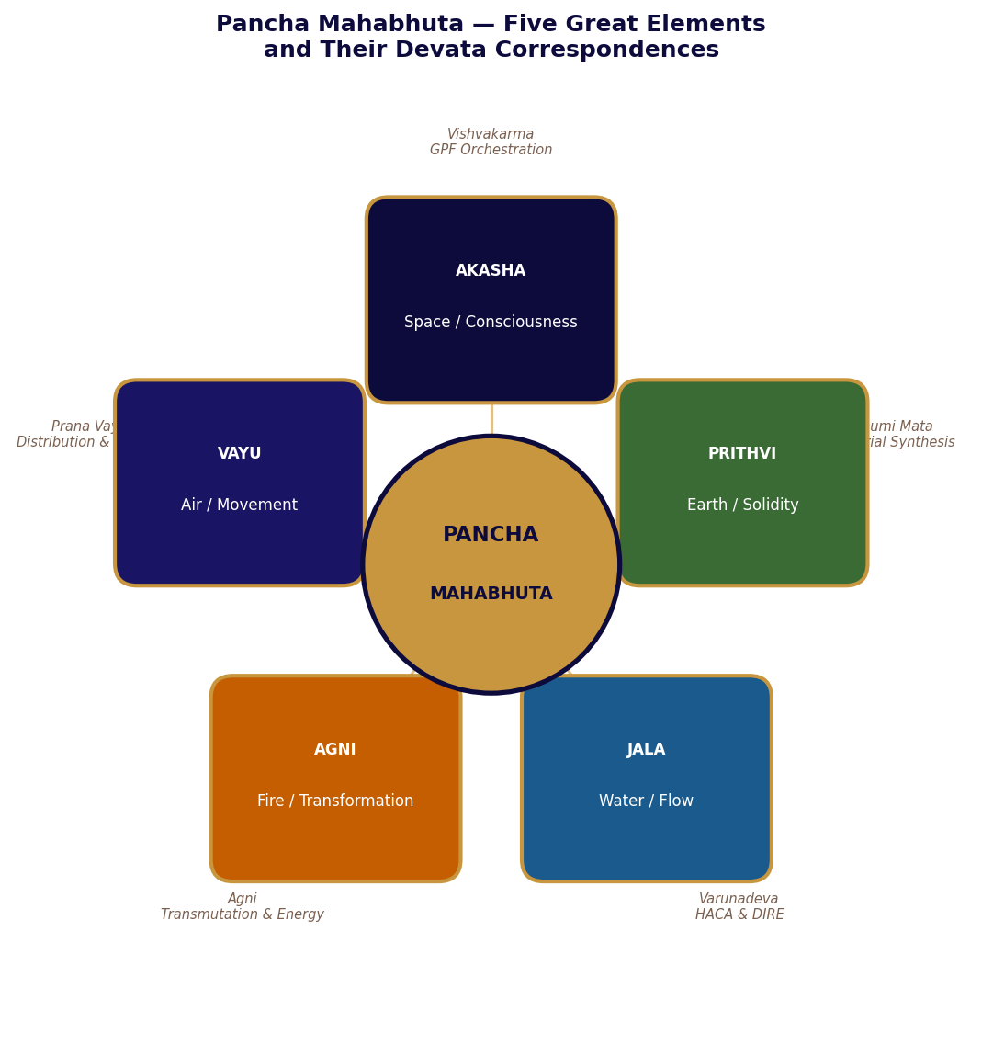
Figure FM-2: Pancha Mahabhuta — Five Great Elements and Devata Correspondences

The Devatas: Complete Reference
The following entries define each Devata's cosmic function, element, capability, and role in the Kshetra. These are not characters. They are presences — the operating principles of the universe in specific, active form.
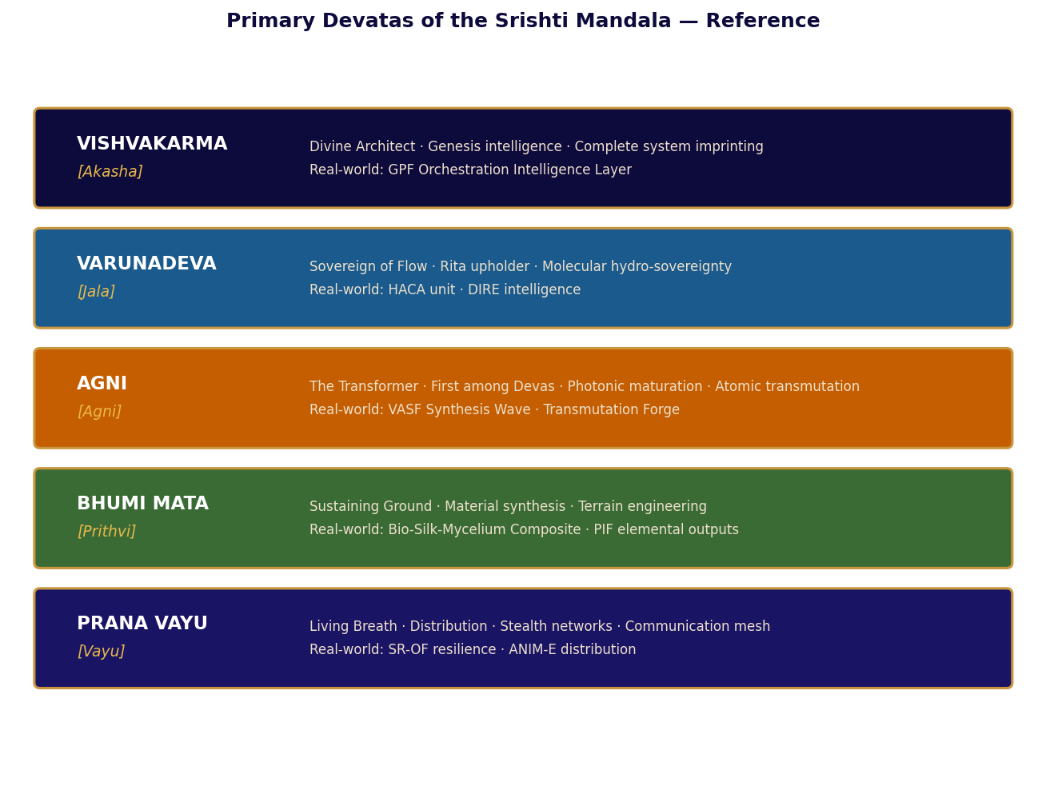
Figure FM-3: Primary Devatas of the Srishti Mandala — Element, Function, and Real-World Parallel

Table FM-2: Devata Complete Reference — Element, Capability, Role, and Corporate Parallel
Devata | Element | Capability | Role in Kshetra | Real-World Parallel | Voice / Presence
VISHVAKARMA | Akasha | Complete system imprinting: encodes understanding, not instruction, into substrates | Genesis intelligence. Every autonomous system carries a fragment of Vishvakarma's comprehension. The all-maker, architect of the cosmos. | GPF Orchestration Intelligence Layer | Absent. Quality of systems is his presence.
VARUNADEVA | Jala | Molecular hydro-sovereignty: commands water to coalesce from vapour, move precisely, adopt correct configurations | All water systems. Guardian of Rita — cosmic order. Water flows where law directs it, not where force demands. | HACA unit · DIRE intelligence | Deliberate. Speaks in correctness and natural law.
AGNI | Agni | Photonic maturation and atomic transmutation. Nothing is destroyed, only transformed. | All energy conversion and transformation. First among Devas — medium of all offerings. Agni gives thrice. | VASF Synthesis Wave · Transmutation Forge | Urgent and precise. Speaks in transformations.
BHUMI MATA | Prithvi | Material synthesis and terrain engineering. What Bhumi Mata makes holds. | Material foundation. Patient enduring intelligence that holds all things in place and absorbs dissolution without losing integrity. | Bio-Silk-Mycelium Composite · PIF outputs | Patient and total. Speaks in accomplished facts.
PRANA VAYU | Vayu | Stealth distribution, communication mesh, distributed sensor networks. Present everywhere, visible nowhere. | Animating force carrying information through all systems. The living breath of the Kshetra. | SR-OF resilience · ANIM-E distribution | Present everywhere. Visible nowhere.
SOMA | Jala / Agni | Photonic food synthesis. Nourishment that sustains all living systems. | Governs the VASF. In the Vedas, Soma is both the nourishing moon and the sacred offering that sustains the cosmic order. | VASF triple-output system | Nourishing. Speaks in sustenance.
TVASHTRI | Prithvi | Modular assembly and Aegis Fold protocol. Gives everything its correct, specific form. | The craftsman of the Devas who gives all forms their precise shape. Nothing is correctly made without Tvashtri's proportion. | GPF Modular Fabrication Units · RIDER platform | Precise. Speaks in correct form.
INDRA | Vayu / Akasha | Defence systems. Holder of the Vajra — instrument of dharmic maintenance, not aggression. | Defender of the field. Maintains cosmic order against disruption. Does not conquer — restores and prevents. | SR-OF defence resilience | Present as deterrence. Visible as consequence.
SARASWATI | Akasha | Vak — divine speech that carries truth. Narrative evaluation and pattern intelligence. | Devi of knowledge and art. Governs ANIM-E's System 3 evaluation: grants blessing only to narratives that accurately represent reality. | ANIM-E System 3 evaluation | Illuminating. Speaks in truth only.
YAMA DHARMARAJ | Prithvi / Akasha | Keeper of the complete ledger. Every dependency tracked, every consequence held. | Not death but Dharmaraj — keeper of the full account of all actions and their consequences. The ledger is always current. | DIRE risk intelligence | Impartial. The ledger speaks.
SHAKTI | All elements | Generative force behind all systems. Not one function but the animating energy that makes every cycle possible. | Present throughout the Kshetra as the creative energy underlying all Devata functions. The universe moves because Shakti moves it. | The animating principle of all systems | Everywhere. Everything.
Table FM-2: Devata Complete Reference

World Rules of the Srishti Mandala
Table FM-3: Srishti Mandala World Rules — Authoritative Reference
Rule | Specification
The Kshetra, not the Island | The Kshetra is the correct name — carrying its Bhagavad Gita meaning: the field of action. It is not a geographical location. It is the domain in which Dharma operates.
Devatas are cosmic functions | Not gods in the devotional sense and not characters in a conflict narrative. They are the operating principles of the universe in specific form. They do not experience desire, fear, or ambivalence.
The founding event is the Great Yajna | A complete offering made once, from which perpetual return flows. Not a construction project. A Yajna — the Vedic act of total offering whose value compounds indefinitely.
Srishti-Sthiti-Pralaya are simultaneous | Creation, preservation, and dissolution operate at the same time at every scale. The Kshetra is always in all three states simultaneously. There is no linear sequence.
Dharma governs everything | Every system is designed to express its own correct operating principle without external enforcement. A system operating according to its Dharma does not require policing. It requires only correct design.
The two registers are not metaphors | The Kshetra's design logic and Sagar-Raja's design logic are identical — not analogous. The book does not point this out. The reader is trusted to perceive it.
Table FM-3: World Rules — Srishti Mandala Edition

Sagar-Raja: Corporate Architecture
Sagar-Raja is a technology-driven global holding company incorporated in Abu Dhabi under the jurisdiction of the Abu Dhabi Global Market. Its four operating principles — automation first, execution before expansion, ownership equals accountability, distributed infrastructure — are not management preferences. They are the corporate expression of Dharma: the correct operating principle for each function, maintained without exception because violation of one's own Dharma is the one failure the tradition identifies as genuinely catastrophic.
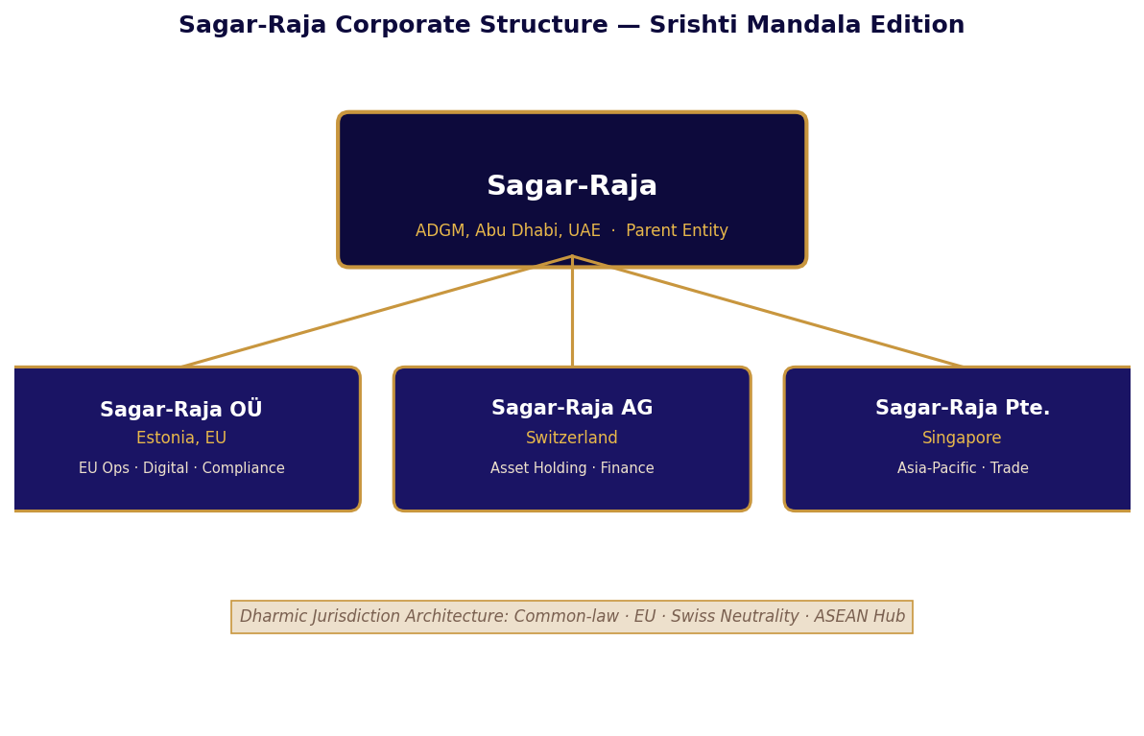
Figure FM-4: Sagar-Raja Corporate Structure — Srishti Mandala Edition

Table FM-4: Subsidiary Jurisdiction Matrix
Entity | Jurisdiction | Legal Form | Primary Function and Dharmic Alignment
Sagar-Raja | ADGM, UAE | Private Ltd | IP ownership · Governance · Capital allocation. ADGM common law: the stable ground on which all operations rest. Bhumi Mata principle.
OÜ Estonia | Estonia, EU | Osaühing | EU ops · Digital systems · Certification. Estonia's digital-first environment: Vayu principle — information moving without friction.
AG Switzerland | Switzerland | Aktiengesellschaft | Asset holding · Finance · Neutrality. Swiss legal stability: Sthiti principle — preservation of value across geopolitical cycles.
Pte. Ltd. Singapore | Singapore | Private Ltd | APAC trade · Partnerships · Regional ops. Singapore's connectivity: Jala principle — trade flows to where conditions are most correct.
Table FM-4: Jurisdiction Matrix with Dharmic Alignment

PART I
क्षेत्र
THE KSHETRA
The field where all cycles begin — where Dharma takes operational form.

Bhumi Mata · Vairagya · Srishti-Sthiti-Pralaya as Industrial Design

The Bhagavad Gita opens on the Kurukshetra — the field where Dharma will be decided.
The Kshetra of the Srishti Mandala carries the same weight: the domain in which correct
action becomes possible because the ground has been correctly prepared. Part I prepares
the ground. SR-EPP-OF establishes the five-level Dharmic priority hierarchy that cannot
be inverted. Vairagya governs the non-sovereignty doctrine. And the Chandogya Upanishad's
Sarvam khalvidam Brahma governs the closed-loop industrial design through all three chapters.

CONTENTS — Chapters 1 – 3

Chapter One Prithvi: The Ground That Holds
SR-EPP-OF · Dharmic hierarchy · Five automation levels with Sanskrit correspondences
Chapter Two Vairagya: What the Kshetra Refuses
Non-sovereignty · Arthashastra placement · Rita vs recognition as permanence basis
Chapter Three The Cycle Breathing
Srishti-Sthiti-Pralaya as industrial architecture · HACA · PIF elemental decomposition

PART I
क्षेत्र
THE KSHETRA
The field where all cycles begin — and where Dharma takes operational form.

Chapters 1 – 3 · Ecology · Non-Sovereignty · Srishti-Sthiti-Pralaya as Industrial Design

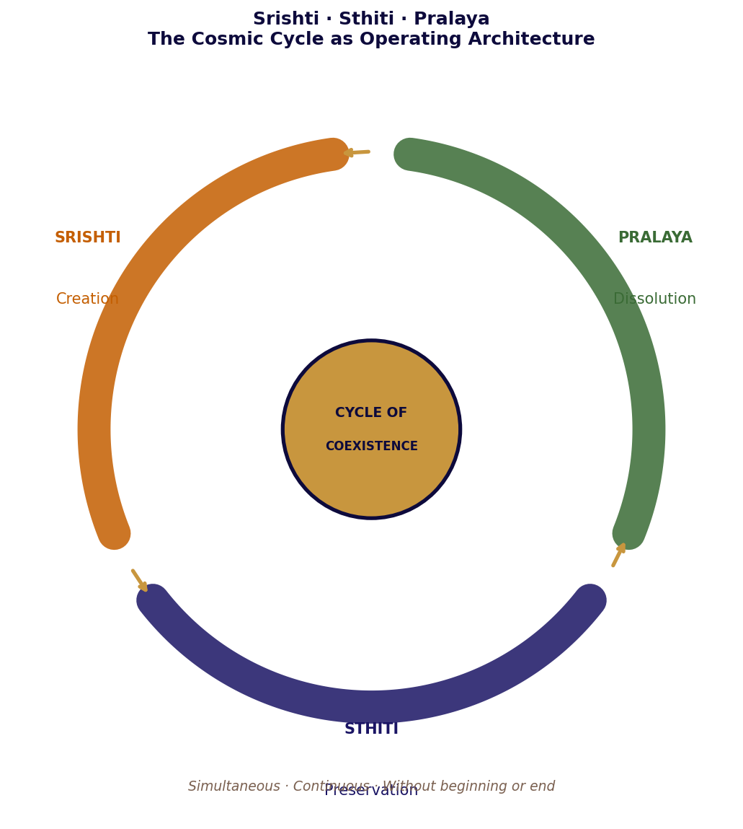
Srishti · Sthiti · Pralaya — operating simultaneously at every scale in the Kshetra

The Bhagavad Gita opens on the Kurukshetra — the field of action where Dharma will be decided. The Kshetra of the Srishti Mandala Edition is the same word carrying the same weight: not a location but a condition, the domain in which correct action becomes possible because the ground has been correctly prepared.
Part I prepares the ground. Chapter One establishes the Kshetra's ecological governance through SR-EPP-OF — the framework whose priority hierarchy is dharmic in the precise sense: each level represents the correct function at that level of abstraction, and the sequence cannot be inverted without the system violating its own nature. Chapter Two examines the doctrine of non-sovereignty through the lens of Vairagya — the renunciation of the kind of power that requires external recognition, in favour of the kind that requires only correct design. Chapter Three traces one full operational day in the Kshetra and maps it onto the Srishti-Sthiti-Pralaya cycle operating simultaneously at every level of the system.

PART ONE

Chapter One
Prithvi: The Ground That Holds
The first act of Srishti is not creation. It is establishing Dharma.
या पृथिवी विश्वधाया प्रतिष्ठा
Ya prithvi vishvadhaya pratishtha
O Earth, the foundation of all existence — you who hold the entire world.
— Atharva Veda, Bhumi Sukta 12.1.1

Bhumi Mata did not announce her arrival. She never did. The first evidence of her presence was a subtle compression in the seabed seven kilometres from the eventual centre of the Kshetra: a tectonic patience settling into the bedrock, assessing what would be required.
What would be required was a platform that could hold the weight of everything the Kshetra would become. Not the weight it would carry on the day of founding, but the weight it would carry at the furthest horizon of its maturation. Bhumi Mata did not build for today. She built for the day when today had become so long ago that no one could remember it.
The compression took three months. From the outside, the seabed in that region appeared to be doing nothing. Geological processes of significant scale are largely invisible from the surface. This was appropriate. The most important foundational work is always invisible from the outside. What is visible is the structure built on top of it. The foundation's quality is demonstrated only when that structure is tested.
When Bhumi Mata determined that the foundation was correct — not adequate and not sufficient, but correct — she withdrew into the ground. The platform rose. The Kshetra had its foundation. Vishvakarma began his imprinting the following morning, because nothing can be imprinted that has no ground to hold it. The sequence was correct. The sequence is always: ground first.

SR-EPP-OF: The Ecological Production and Preservation Operations Framework
In the tradition of Hindu statecraft articulated in Kautilya's Arthashastra, the first act of governance is the establishment of correct foundations: the right territory, the right legal structure, the right relationship between the governing authority and the governed domain. Sagar-Raja's SR-EPP-OF is this foundational act applied to a corporate ecological platform. Before any product is made, before any patent is deployed, before any deal is signed, the framework establishes the Dharma of the ground on which everything else will stand.
The framework begins with its most important statements: what the platform is not. It is not a state. It is not a settlement. It makes no territorial claim. It does not assert sovereignty, exclusive economic zone, territorial sea, or independent governance. This is not legal evasion. It is the establishment of Dharma in its governance sense: the correct operating principle for a corporate industrial platform that intends to endure. Bhumi Mata's principle applied to legal architecture: build the foundation correctly from the beginning, and what stands on it will hold.

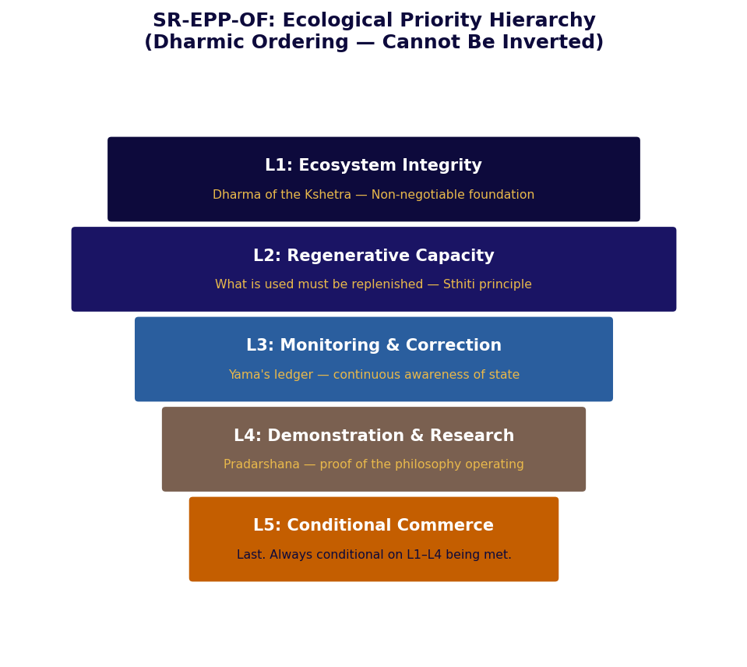
Figure 1-1: SR-EPP-OF Ecological Priority Hierarchy — Dharmic Ordering

The Dharmic Priority Hierarchy
The framework's priority hierarchy is dharmic in the precise sense: each level represents the correct function of the platform at that level of abstraction, and the sequence cannot be inverted without the system violating its own nature. This is what the Mahabharata means when it says Dharma destroyed destroys, and Dharma protected protects. A system that inverts its own priority hierarchy — placing commercial activation above ecological integrity — has destroyed its own Dharma and has therefore, with absolute certainty, destroyed itself. The destruction may not be immediate. It will be complete.
Table 1-1: SR-EPP-OF Priority Hierarchy — Dharmic Ordering and Operational Consequence
Level | Priority | Dharmic Principle | Operational Meaning | Consequence of Inversion
L1 | Ecosystem Integrity | The ecology is the Dharma of the Kshetra — its correct operating condition | Never compromised for any other priority under any circumstance | Platform collapses — ecology is the infrastructure on which everything depends
L2 | Regenerative Capacity | Sthiti — preservation of the conditions for the next Srishti | Platform must be able to rebuild what it uses; never extract faster than regeneration | Sthiti fails; the cycle cannot continue; Pralaya without Srishti
L3 | Monitoring & Correction | Yama's ledger — continuous awareness of the system's actual state | All ecological and operational indicators measured continuously; deviations corrected | Invisible failures accumulate to catastrophic thresholds
L4 | Demonstration & Research | Pradarshana — the proof that the philosophy is operationally correct | Platform serves as proof-of-concept for sustainable industrial operations | The manifesto loses its demonstration — becomes theory without evidence
L5 | Conditional Commerce | Artha — wealth as the fourth goal, never above Dharma | Commercial use of any zone conditional on L1–L4 being confirmed in that zone | Artha pursued without Dharma destroys both
Table 1-1: SR-EPP-OF Priority Hierarchy

Legal and Jurisdictional Stance: Non-Sovereignty as Dharma
The Arthashastra's treatment of Rajadharma — the Dharma of governance — distinguishes between the kind of authority that comes from force and recognition, and the kind that comes from correct function. A king who rules by correct function is stable. A king who rules by force requires continuous force to maintain his position. The SR-EPP-OF's non-sovereignty declaration is the corporate expression of this distinction: the platform does not claim territorial rights that would require external recognition to maintain, because such rights are a form of stability that depends on others' continuous willingness to grant it.
The platform is publicly declared as a corporate-operated artificial ecological and industrial platform before any question is raised. The declaration is not defensive. It is complete. A system that has correctly defined its own nature before any challenge has already resolved the challenge — not by defeating it but by making it inapplicable. Bhumi Mata does not argue with the ocean about where the land begins. She defines where the land is, and the ocean accepts it, because that is the nature of a correctly established foundation.
Table 1-2: SR-EPP-OF Scope and Exclusions
IN SCOPE — Dharma of the Platform | EXPLICITLY EXCLUDED — Outside Platform Dharma
All artificial land modules and marine platforms | Civilian habitation of any kind
Ecological zones, buffer zones, protected reserves | Political governance structures
Energy, water, biomass, waste management, research systems | Consumer-facing commercial activity not contractually scoped
Logistics, port facilities, maritime supply corridors | Independent third-party brands outside contractual scope
Autonomous monitoring, control, and security systems | Territorial or sovereign claims of any kind
Table 1-2: SR-EPP-OF Scope Matrix

Autonomous Operations: Nishkama Karma as Control Architecture
The Bhagavad Gita's doctrine of Nishkama Karma — action without attachment to the fruits of action — describes not an attitude but an architecture. A system that acts from its correct operating logic, without requiring continuous human judgment about each action, is a system performing Nishkama Karma at the operational level. SR-EPP-OF's autonomous control architecture is this principle instantiated in software and sensors.
The control architecture is distributed and non-centralised. There is no single operational point of failure. Continuous telemetry monitors all critical indicators. Human roles are oversight, exception handling, and long-horizon planning — the functions that require genuine human judgment. Routine operations are machine-led, because routine operations that require human judgment are routine operations waiting to introduce human error. The automation is not a cost measure. It is a quality measure.
Table 1-3: Control Architecture — Five Automation Levels
Level | Decision Type | Authority | Dharmic Principle
L1 Safety | Any threat to ecological integrity or platform safety | Central hard stop — non-overrideable | Ahimsa — non-harm as absolute constraint
L2 Quality | Production conformance, specification deviations | Central authority — logged override possible | Satya — truth to specification as governing standard
L3 Scheduling | Production sequence, energy routing, water allocation | Distributed AI — optimisation within validated bounds | Viveka — discriminating intelligence applied autonomously
L4 Procurement | Consumables, maintenance, external supply | Hybrid — AI recommends, human approves above threshold | Yukti — skill and judgment combined
L5 Strategic | Expansion, new deployment, policy change | Human decision with AI analysis | Prajña — wisdom as the human contribution
Table 1-3: Control Automation Levels with Dharmic Correspondences
The Kshetra does not need Devatas to operate after the founding Yajna. It was designed not to need them. SR-EPP-OF operationalises the same principle: a correctly designed system reduces the frequency and urgency of human intervention not by eliminating human judgment but by reserving it for decisions that actually require it — decisions of Prajña, not of routine Viveka.

PART ONE

Chapter Two
Vairagya: What the Kshetra Refuses
Non-attachment to recognition as the source of genuine permanence
न तत् स्वातन्त्र्यमर्हति
Na tat svatantryam arhati
That which clings to power does not deserve it.
— Mahabharata, Shanti Parva

There was a council, in the early years of the Kshetra's operation, in which the question of sovereignty was formally raised.
The argument for it was straightforward: territory confers rights. Rights confer protections. Protections enable permanence. The argument had the clean logic of a system that had been designed to produce that conclusion.
Vishvakarma's response was not communicated in words. It was communicated in the quality of the attention he gave the question — the attention one gives to a proposal that contains a structural error so fundamental that engaging with its surface logic would be wasteful. The structural error was this: sovereignty requires recognition by other sovereigns. A system whose legitimacy depends on recognition by external parties has made its legitimacy conditional on the continued willingness of those parties to grant it. This is not independence. It is a more elaborate form of dependence.
The Kshetra's legitimacy rested on something recognition could not grant and withdrawal could not revoke: correct design. A system that does what it does because it is correctly designed to do it does not require external validation of its right to do so. It operates. The operation is the legitimacy.
This is the principle the Bhagavad Gita articulates as Nishkama Karma: action performed without attachment to its fruits, without need for recognition, without dependence on outcome. The Kshetra acted. It did not require acknowledgement that it had the right to act.

Vairagya and the Non-Sovereignty Framework
Vairagya in the Hindu philosophical tradition is the quality of non-attachment — the capacity to act fully and correctly without clinging to the outcomes of action or the recognition of others. It is often translated as renunciation, but this misses the active quality of the concept. Vairagya is not withdrawal from engagement. It is engagement from a position of complete internal sufficiency: the practitioner acts because the action is correct, not because the outcome is guaranteed or the recognition is forthcoming.
Sagar-Raja's non-sovereignty framework is a corporate expression of Vairagya. The platform does not seek territorial recognition because it does not need territorial recognition. It is publicly declared as what it is — a corporate ecological and industrial platform — before any external party raises the question. This declaration is not defensive. It is complete. A system that has correctly defined its own nature before any challenge has already resolved the challenge without fighting it.
The Arthashastra addresses this through its treatment of Dandaniti — the science of governance and strategic position. Kautilya is clear that the most stable position is not the strongest position or the most recognised position. It is the position that others find it more useful to support than to challenge. The Kshetra occupies this position not through military capability or political negotiation but through the utility of what it produces for those who interact with it.

The Arthashastra and Jurisdictional Architecture
Kautilya's Arthashastra identifies the correct relationship between a governing authority and the institutions through which it operates: each institution must be placed in the jurisdiction most appropriate to its function. The institution placed in the wrong jurisdiction is like a seed planted in soil whose properties do not match its requirements — it may survive but it will not flourish, and the gap between its potential and its performance is the cost of the wrong placement.
Sagar-Raja's jurisdictional architecture applies this principle precisely. ADGM governs the parent entity because ADGM is a common-law jurisdiction with independent courts and international recognition — the correct soil for a company whose primary asset is intellectual property that must be enforceable globally. Estonia governs the EU operational subsidiary because Estonia's digital-first regulatory environment is the correct soil for technology and digital systems management. Switzerland governs asset holding because Swiss legal stability and neutrality are the correct soil for high-value assets that must be preserved across geopolitical cycles. Singapore governs Asia-Pacific trade because Singapore's connectivity is the correct soil for a company whose APAC operations require access to the region's most internationally connected commercial hub.
Table 2-1: Jurisdictional Architecture — Arthashastra Placement Principle
Entity | Jurisdiction | Why This Soil | Arthashastra Principle
Sagar-Raja | ADGM, UAE | Common law · Independent courts · IP enforcement · International recognition · No geopolitical complication in primary markets | Primary seat in the jurisdiction whose legal infrastructure best protects the primary asset: intellectual property
OÜ Estonia | Estonia, EU | EU access · Digital governance · GDPR framework · E-residency infrastructure · Technology regulation clarity | Operational entity in jurisdiction whose regulatory character matches the function: technology and digital operations
AG Switzerland | Switzerland | Legal stability · Political neutrality · Asset protection · Swiss arbitration · No trade-bloc exposure | Asset holding entity in jurisdiction whose stability matches the nature of the assets: high-value, long-duration holdings
Pte. Ltd. Singapore | Singapore | ASEAN hub · 25+ FTAs · Strong IP · Singapore arbitration · Best-in-region commercial law | Trade entity in jurisdiction whose connectivity matches the function: regional trade and partnership development
Table 2-1: Jurisdictional Placement — Arthashastra Analysis

Permanence Through Rita, Not Recognition
Varunadeva upholds Rita — the cosmic order that makes water flow correctly, agreements hold, and systems function as they are designed to function. Rita is not a rule imposed from outside. It is the intrinsic correct functioning of a well-designed system. Water that flows according to Rita flows because the conditions for correct flow have been established. It does not flow because it has been commanded to.
The Kshetra's permanence is of this character. It endures not because it has been recognised but because it has been correctly designed to serve functions that external parties need. This is permanence through Rita — the correct functioning that makes the system necessary rather than merely permitted. A system that is merely permitted exists at the pleasure of those who permit it. A system that is necessary exists at the logic of those who need it.
Sagar-Raja's products express this principle across every vertical. RASM does not need a lifestyle campaign to sustain itself in the market. It needs to be the correct nutritional substrate for institutional customers whose evaluation criteria are objective — and it is. RIDER does not need regional variants to survive in global markets. It needs to pass every certification with a single specification — and it does. SR-C6 does not need brand recognition. It needs to perform to grade specification for industrial customers who buy on performance — and it does. Each product's permanence comes from its Rita: its correct functioning within the domain it serves.
Table 2-2: Permanence Through Rita vs Permanence Through Recognition
Basis | Permanence Through Recognition | Permanence Through Rita (Correct Function)
Source | External parties choosing to recognise rights continuously | Correct design producing genuine utility that external parties need
Dependence | Political goodwill · Relationship stability · Consensus maintenance | Operational excellence only — no external goodwill required
Vulnerability | Changes in political relationships · Shifts in international law · Withdrawal of recognition | Operational failure only — not affected by political change if utility is sufficiently general
Kshetra example | Territorial sovereignty claim requiring UNCLOS recognition by adjacent states | Non-sovereign corporate platform producing materials adjacent states' industries need
SR example | Market position maintained through brand investment and relationship management | Market position maintained through specification performance in objective evaluation contexts
Table 2-2: Two Bases of Permanence — Recognition vs Rita
The Kshetra did not renounce power. It recognised that the kind of power it needed did not come from recognition. It came from correct design operating continuously without acknowledgement.

PART ONE

Chapter Three
The Cycle Breathing
Srishti-Sthiti-Pralaya as industrial operating architecture
सर्वं खल्विदं ब्रह्म
Sarvam khalvidam Brahma
All of this is Brahman — every phenomenon at its deepest level is made of the same substance in different configurations.
— Chandogya Upanishad 3.14.1

At 06:14 the agricultural synthesis cycle completed its overnight run. What had entered the Synthesis Chambers as seeds had emerged as mature, harvest-ready produce. The root matrices — generated by Soma's photonic process but not consumed in it — had been routed to the biomass line. The Oxygen-Plus tanks had been filled from the captured photonic exhaust. The system had produced three categories of output from one category of input.
This was Srishti operating at the level of a single facility: creation as the continuous, unannounced emergence of new form from existing material. The seeds were not destroyed to produce the plants. The seeds had their biological state aligned with a more developed template. The creation was not ex nihilo. It was transformation — Agni's principle. Nothing disappears. Everything becomes.
At 14:00 the energy audit confirmed 312 percent of daily requirement harvested from photosynthetic surfaces. The surplus was not discharged. It was routed to the overnight transmutation run, where it would be used to fuse atomic particles into the metals the Kshetra needed for its next construction phase. Energy harvested today would become structure tomorrow. Sthiti: the preservation of what is needed, the maintenance of the conditions that allow the next Srishti.
At 23:47 the old cycle completed and the new one began. Pralaya: the dissolution of the day's operational state into the undifferentiated potential of the night cycle, from which the next day's Srishti would emerge. The dissolution was not loss. It was preparation. The Cycle did not end. It breathed.

The Chandogya Principle: All of This Is Brahman
The Chandogya Upanishad's statement — all of this is Brahman — is not a metaphysical claim requiring faith. It is a systems statement: every phenomenon, at the deepest level of analysis, is made of the same substance in different configurations. Nothing that exists is ultimately separate from anything else that exists. The atoms in a seed and the atoms in a ripe strawberry plant are the same atoms differently arranged. The energy in the morning air and the energy in the overnight transmutation run are the same energy in different states.
The closed-loop principle of SR-EPP-OF is this insight applied to industrial operations: every output is made of the same substance as every input, in a different configuration, and can therefore be returned to input form. The closed loop is not a sustainability aspiration. It is the operational recognition of Brahman as industrial reality. A system that discharges uncontrolled waste has not grasped that its outputs are the same substance as its inputs. A system that completes every cycle has understood this and designed accordingly.


Figure 3-1: Srishti · Sthiti · Pralaya — Simultaneous, Continuous, Without Beginning or End

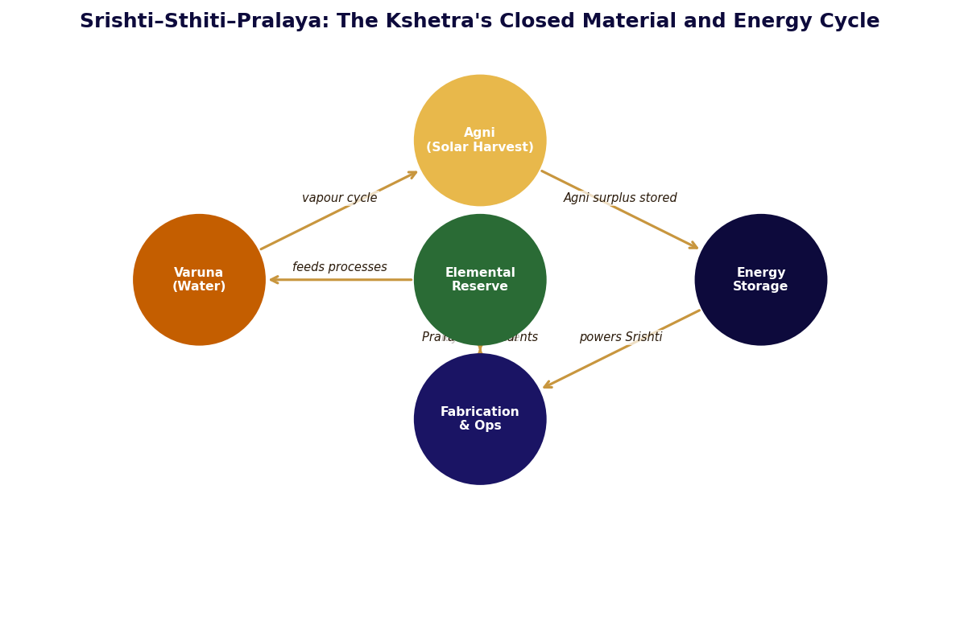
Figure 3-2: The Kshetra's Closed Material and Energy Cycle — Srishti-Sthiti-Pralaya at Operational Level

Energy as Sthiti: The Preservation Architecture
The energy architecture of the platform holds strategic reserves rather than operational inventory. The platform does not run on what it produces today. It runs on the accumulated surplus of all previous cycles, drawing from reserves and replenishing them continuously. This is Sthiti as energy policy: preservation of what has been accumulated, maintenance of the conditions that allow the next cycle's Srishti to proceed without interruption.
Four energy sources operate simultaneously. Agni's photosynthetic layer is the primary daytime source, converting light directly into electricity through the bio-composite surfaces that Bhumi Mata's material principle has given self-repairing properties. The piezoelectric and triboelectric hull layers harvest energy from every mechanical stress the platform experiences — vibration, pressure change, wave action. The thermocline gradient layer harvests the temperature differential between upper surfaces and deep water, peaking at night when it compensates for the photosynthetic layer's absence. The atmospheric fermentation layer activates under any conditions as a baseline: a biological lichen coating that produces methane or ethanol from moisture and atmospheric trace gases regardless of light, temperature, or weather.
Table 3-1: Energy Source Architecture — Sthiti Principle Applied
Source | Peak Output | Peak Conditions | Weather Dependency | Devata / Element
Photosynthetic surface | Primary — 300%+ of daily need | Solar noon, clear sky | High — reduced in cloud | Agni — transformation of light into work
Piezo / Triboelectric hull | Secondary — 15–30% daily | Storm and wave action | None — increases in storm | Vayu — kinetic energy of movement
Thermocline gradient | Secondary — 20–40% overnight | Night and turbulent water | Low — consistent year-round | Jala — differential flow as energy source
Atmospheric fermentation | Baseline — 5–8% daily | Consistent always | None — fully independent | Prithvi — biological process from ground matter
Table 3-1: Platform Energy Architecture with Devata Correspondences

Water as Jala: Varunadeva's Rita in Practice
Varunadeva's principle governs all water systems in the Kshetra. Rita — cosmic law — in the domain of water means that water flows where the conditions for correct flow have been established, without force and without extraction. The HACA unit is the technological expression of this principle: the Thirsty Silk Lattice presents to atmospheric water vapour the conditions for Rita-correct behaviour — a surface with greater affinity for water molecules than the air itself. The water comes because the conditions are correct. It is not pulled. It arrives.
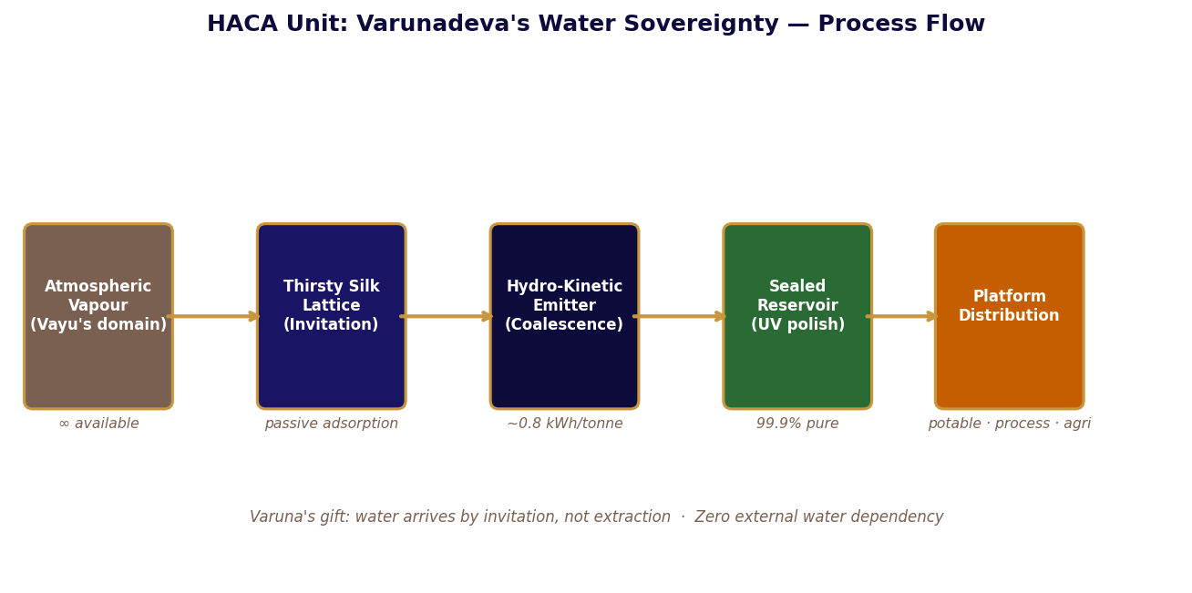
Figure 3-3: HACA Unit — Varunadeva's Water Sovereignty in Operational Form

Table 3-2: HACA Unit Technical Performance
Parameter | Value | Dharmic Significance
Water purity (pre-UV) | 99.9% | The mechanism of invitation excludes contaminants by design — Rita produces purity without effort
Daily output (mid-scale cluster) | 4–12 tonnes/day | Sufficient for platform operations without any external connection
Energy input per tonne | ~0.8 kWh | 70% less energy than conventional pumping — Rita operates efficiently because it works with natural law, not against it
Minimum operational RH | ~35% | Operates at reduced efficiency below 35% — never zero; Varunadeva's domain is never truly absent
External connection | None required | Full water sovereignty — the Kshetra cannot be pressured through its water supply
Acoustic signature | Silent | Water invited rather than extracted produces no sound of conflict
Table 3-2: HACA Unit Performance Parameters

Matter as Brahman: The Elemental Decomposition Principle
The Processing Infrastructure Framework's elemental decomposition mandate is the practical implementation of Sarvam khalvidam Brahma in industrial operations. Every incoming resource is first offered to the Elemental Decomposition Complex — reduced to its elemental components before any processing decision is made. The elemental form is the Brahman-state of the material: the undifferentiated potential from which any specific form can emerge on demand.
Iron ore becomes iron and oxygen — Bhumi Mata's mineral form returned to its elements. Atmospheric carbon becomes carbon and oxygen — Agni's breath decomposed to its Brahman-state. Biomass becomes carbon, hydrogen, and nitrogen — the living material returned to the elements from which the next living material will emerge. The cycle is Srishti-Sthiti-Pralaya at the material level: constant, simultaneous, without beginning or end. The Elemental Storage System holds these components as strategic reserve — potential waiting to become specific form on demand.
Table 3-3: Elemental Decomposition Matrix — Input, Yield, and Brahman-State Storage
Input Material | Elements Yielded | Element | Storage and Dharmic Character
Iron ore | Fe · O₂ | Prithvi → Vayu | Fe: molten reservoir at 1,600°C — Agni holds Bhumi Mata's metal in potential. O₂: cryogenic — Vayu compressed.
Atmospheric CO₂ | C · O₂ | Akasha → Prithvi | C: graphite storage — Agni's breath becomes Bhumi Mata's foundation material. SR-C6 is this carbon commercially expressed.
Biomass (VASF) | C · H · N · O | All five elements | Organic fraction returns to biochar/compost — Pralaya completing the agricultural cycle for the next Srishti.
Hydrocarbons | C · H₂ | Prithvi → Vayu | C to graphite storage. H₂ to 700-bar pressurised tanks — Vayu compressed into Prithvi containers.
Copper ore | Cu · S | Prithvi secondary | Cu: molten reservoir for electrical systems — Volta's material. S: dry powder for acid production processes.
Table 3-3: Elemental Decomposition — Input, Yield, and Brahman-State Storage

The Compound Effect: How Pralaya Produces the Next Srishti
The Upanishads describe Pralaya not as destruction but as return — the dissolution of specific form back into the undifferentiated potential from which new Srishti emerges. The closed-loop industrial system operates on exactly this principle. Every solid, liquid, and gaseous output of every process returns to elemental potential in the Elemental Storage System. The potential accumulates. The Demand Calculation Engine determines what specific form is needed. The Controlled Processing Modules produce that form from the accumulated potential. The specific form is used, producing new byproducts that return to potential. The cycle is continuous.
The compound effect of correct Pralaya is that the system's potential grows over time. In the first operational year, the elemental reserves are modest. In the third year, the platform can buffer most external supply disruptions from its own reserves. In the fifth year, the reserves are large enough that the platform could operate at full production for an extended period with no external material input at all. This trajectory — from supply-dependent to supply-resilient to supply-sovereign — is Pralaya compounding into the conditions for larger Srishti. It does not require a policy decision. It requires only the closed loop working correctly, which it does by design.
The PIF's success metric is not the quantity of material processed in any period. It is the strategic reserve level maintained above the defined minimum threshold at the end of each period. A system that processes more material but reduces its reserves is performing below the framework's standard. A system that processes less material but builds its reserves is outperforming it. Pralaya that does not build potential has not completed the cycle.

PART II
यज्ञ
THE YAJNA
One complete offering. Perpetual autonomous return.

GPF-Tech as Yajna · Agni's Triple Output · Varuna's Rita

The Bhagavad Gita: having created beings along with Yajna, Prajapati said — by this
shall you prosper. The Yajna is not supplication. It is an architectural principle:
a complete act of offering whose value is returned perpetually and in excess.
Part II documents three Yajnas: the GPF patent as the founding Yajna whose autonomous
return is every licensed fabrication system; Agni's Forge whose triple output gives
thrice; and Varunadeva's gift of water sovereignty through Rita, not extraction.

CONTENTS — Chapters 4 – 6

Chapter Four The Great Yajna
GPF-Tech · Pancha Mahabhuta architecture · PCT 150+ countries · Nishkama Karma as patent strategy
Chapter Five Agni's Forge
PIF eight systems · Triple output · SR-C6 as Tamas from Agni's decomposition · DCE reserve thresholds
Chapter Six Varuna's Gift
HACA · Rita as engineering principle · Water dependency elimination · Resource sovereignty doctrine

PART II
यज्ञ
THE YAJNA
The sacred work that seeds everything — one offering, perpetual return.

Chapters 4 – 6 · GPF-Tech Patent · PIF Elemental Architecture · Varuna's Water Sovereignty

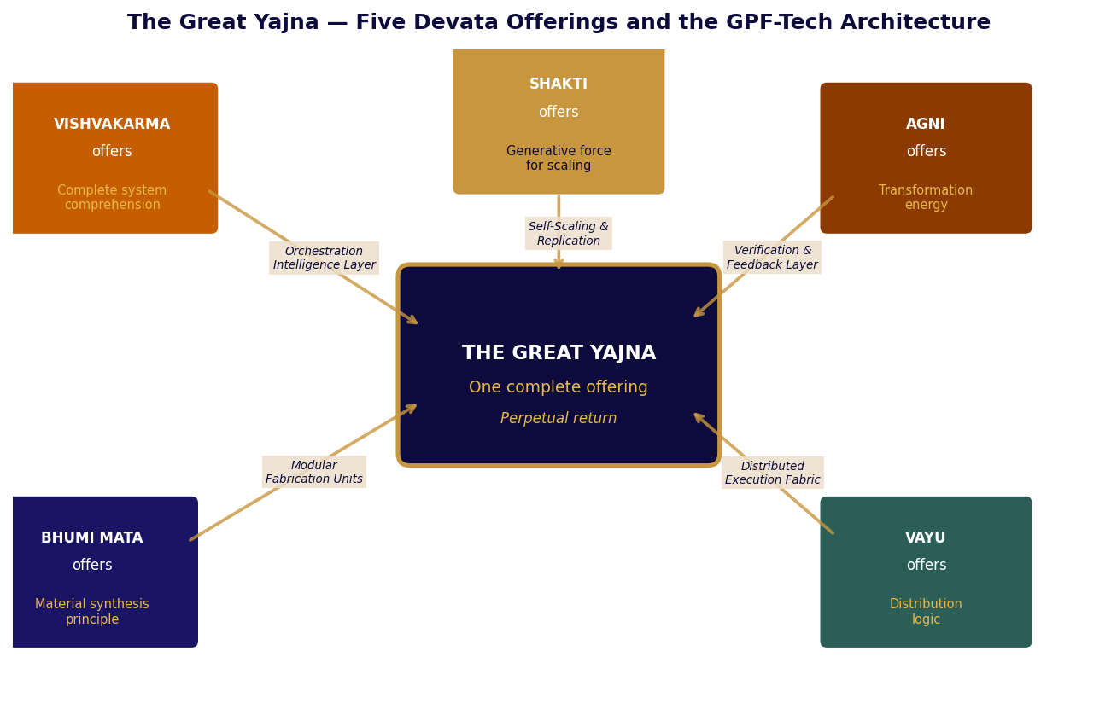
The Great Yajna — Five Devata Offerings and their GPF-Tech Architecture correspondences

The Bhagavad Gita's third chapter opens with Prajapati's declaration: having created beings along with Yajna, he said — by this shall you prosper, for this shall be the granter of your wishes. The Yajna is not a ritual of supplication. It is an architectural principle: a complete act of offering whose value is returned perpetually and in excess of what was offered. The most successful Yajnas are those that, having been performed once, never need to be performed again.
Part II documents the Yajna of the Srishti Mandala in three chapters. Chapter Four is the founding act itself — the one coordinated offering that produced the GPF-Tech architecture, examined in complete technical and philosophical detail. Chapter Five is Agni's triple gift: the Transmutation Forge and the Processing Infrastructure Framework, through which a single industrial act produces three simultaneous value streams. Chapter Six is Varunadeva's offering: the water independence that the Kshetra carries as a permanent strategic property because Varuna once established the correct conditions and the conditions have not needed to be re-established since.

PART TWO

Chapter Four
The Great Yajna
One complete offering. Perpetual autonomous return. — GPF-Tech
सहयज्ञाः प्रजाः सृष्ट्वा पुरोवाच प्रजापतिः
Sahayajnah prajah srishthva purovaca prajapatih
Having created beings along with Yajna, Prajapati said: by this shall you prosper.
— Bhagavad Gita 3.10

The Yajna that founded the Kshetra's autonomous systems was not a ritual. It was an act of complete offering in the precise Vedic sense: every capability that every Devata possessed was offered into the fire of the founding event — not to be consumed but to be transformed into something that would return value indefinitely.
Vishvakarma's offering was the most comprehensive. He offered not his knowledge of specific systems but his understanding of systems as such — the meta-knowledge from which any specific system design can be derived. The Genesis Core that emerged from this offering did not know the blueprints of the Kshetra's initial systems. It knew the principles from which any blueprint could be constructed. This was the difference between giving a person a fish and giving them the understanding of water, fish, nets, seasons, and patience that makes fishing possible in any river at any time.
Bhumi Mata offered her structural principles — the material intelligence that allows a composite to hold form under any stress. Agni offered his transformation energy — the capacity to change one form into another without loss of substance. Prana Vayu offered the distribution logic — the principle by which capability finds its way to where it is needed without a central dispatcher directing each movement. Shakti, present throughout as the animating force, offered the generative energy that makes expansion self-sustaining.
By the end of the day, the Kshetra had a Genesis Core AI that could generate blueprints it had never been given. It had Material Synthesis Units producing composites on demand. It had Distribution Nodes routing capability to where it was needed. It had Verification systems that could check whether each transformation had been performed correctly. And it had a Replication mechanism through which the network could build new nodes from existing ones when demand required it.
The Devatas were no longer needed. This was precisely the measure of a successful Yajna.

GPF-Tech: The Autonomous Distributed Fabrication Patent
The Bhagavad Gita's description of Yajna as the mechanism of mutual sustenance — by Yajna the Devas will nourish you, and by you the Devas shall be nourished — is a systems statement about reciprocal value creation. An autonomous fabrication system that, once seeded, continuously produces value without requiring the continued presence of its creators, is a Yajna in the operational sense: a complete offering that generates perpetual return. Sagar-Raja's GPF-Tech patent encodes this principle in intellectual property law.
The patent is for a Global Autonomous and Distributed Fabrication, Orchestration, and Self-Scaling Production System. It was examined under the Patent Cooperation Treaty framework and found to satisfy all three substantive patentability requirements: novelty, inventive step, and industrial applicability. It is maintained and active across all primary commercial regions. Its most important property is implementation independence: the patent does not specify materials, industries, or physical environments. It specifies an architecture — a set of relationships between five components that, when instantiated in any medium, produces autonomous, distributed, self-scaling fabrication capability.

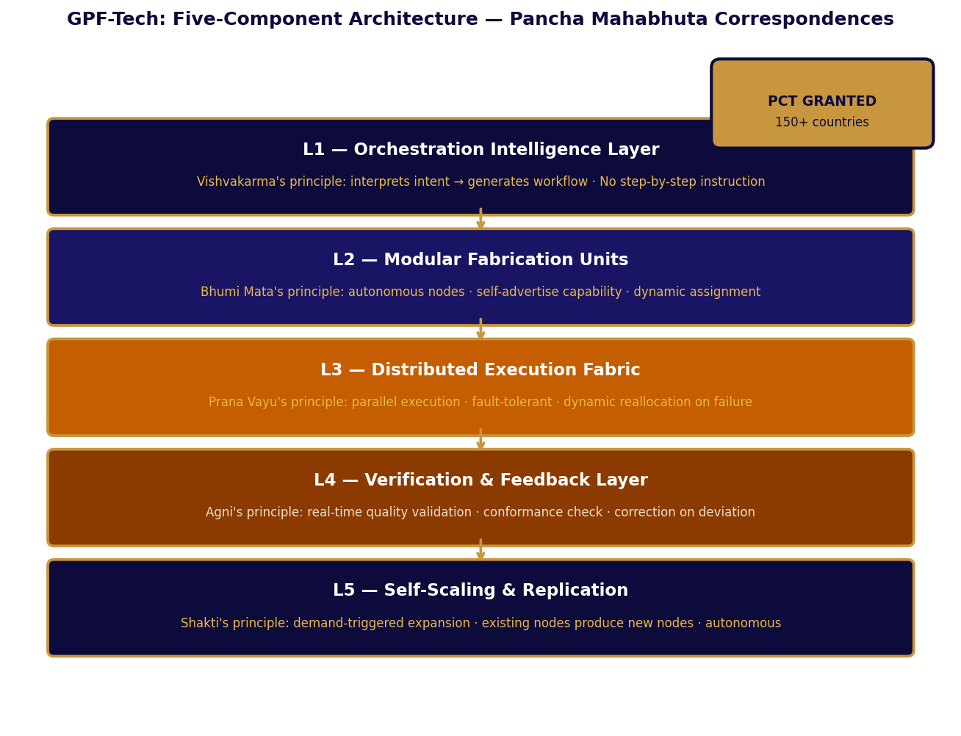
Figure 4-1: GPF-Tech Five-Component Architecture — Pancha Mahabhuta Correspondences

The Five Components as Pancha Mahabhuta
The correspondence between the GPF architecture's five components and the Pancha Mahabhuta is not a retrospective mapping imposed for elegance. The components were designed to solve the same problems that the Mahabhuta describe: how does a system interpret intent (Akasha), maintain structure (Prithvi), move information (Vayu), transform inputs (Agni), and flow toward need (Jala)? The Vedic tradition arrived at these five categories through observation of how complex systems behave. The patent's architects arrived at the same five categories through engineering analysis of what distributed autonomous fabrication requires.
Table 4-1: GPF-Tech Components — Engineering Specification and Mahabhuta Correspondence
Component | Mahabhuta | Engineering Function | Devata Expression | Inventive Step
Orchestration Intelligence Layer | Akasha | Interprets abstract production objectives and generates executable workflow without step-by-step instruction | Vishvakarma's comprehension: meta-knowledge that generates any specific blueprint | Autonomous decomposition of abstract objectives — primary inventive step confirmed by PCT examiner
Modular Fabrication Units | Prithvi | Autonomous production nodes that self-advertise capability; receive dynamic task assignment from orchestration layer | Bhumi Mata's principle: specific, grounded, capable form offered to the whole | Self-advertising capability architecture — enables network reconfiguration without central reprogramming
Distributed Execution Fabric | Vayu | Parallel execution across all nodes; full fault-tolerance; dynamic reallocation on node failure | Prana Vayu's principle: animating force that carries work to where it is needed | Fault-tolerant parallel distribution — network degrades proportionally, never catastrophically
Verification & Feedback Layer | Agni | Continuous in-process quality validation; deviations trigger correction before full cost is incurred | Agni's principle: transformation must be confirmed correct; the fire does not accept incomplete offerings | In-process vs end-of-line validation — system learns from its own execution through feedback loop
Self-Scaling & Replication | Jala | Demand-triggered autonomous expansion; existing nodes produce new nodes; no centralised approval | Shakti's principle: the generative force that makes expansion self-sustaining; growth follows natural demand | Autonomous expansion without central control — PCT examiner specifically cited as non-obvious over prior art
Table 4-1: GPF-Tech Five Components — Full Specification with Mahabhuta Correspondence

The Yajna Principle Applied: One Offering, Perpetual Return
The Bhagavad Gita distinguishes between Sakama Karma — action performed for specific reward — and Nishkama Karma — action performed from the correct principle, whose rewards arise naturally from the correctness of the act. A patent filed for a specific product is Sakama Karma: it protects one thing and expires with it. A patent filed for an architecture is closer to Nishkama Karma: it protects the principle from which any specific thing can be made, and its value compounds with every instantiation of that principle in any domain.
The GPF-Tech patent is an architectural patent. It does not protect RIDER's drivetrain or RASM's formulation. It protects the five-component architecture that, when instantiated in any production environment — software, hardware, cyber-physical, or hybrid — produces autonomous, distributed, self-scaling fabrication capability. A company that builds any such system without a licence from Sagar-Raja infringes, regardless of what the system produces. The Yajna was performed once. The return is perpetual and domain-independent.
Table 4-2: GPF-Tech Standards Alignment — ISO, IEC, Compliance as Architecture Property
Standard | Domain | Alignment Mechanism | Dharmic Correspondence
ISO 9001 | Quality management | Verification & Feedback Layer's continuous in-process conformance — audit trail is inherent | Satya: truth to specification as a continuous property of the system, not a periodic verification
ISO 55000 | Asset lifecycle | Orchestration layer's node state model tracks full unit history and capability evolution | Smriti: the system's memory of every asset's history as a governing resource
IEC 62264 | Enterprise-control integration | Clean architectural separation between objective layer and execution layer | Vibhaga: the correct separation of functions as the source of systemic clarity
IEC 61499 | Distributed control | Distributed Execution Fabric operates with local autonomy and mesh communication | Swatantrya within Dharma: autonomy operating within correct structural constraints
ISO-IEC 27001 | Information security | Authenticated command protocol; outbound-only sensitive telemetry; cryptographic verification | Guptata: the correct protection of knowledge as a property of architecture, not addition
Table 4-2: GPF-Tech Standards Alignment with Dharmic Correspondences
Table 4-3: PCT Geographic Coverage — Primary Commercial Regions
Region | Filing Route | Key Jurisdictions | Commercial Significance
Middle East | National phase — direct | UAE, KSA, Kuwait, Qatar, Bahrain, Oman | Primary operational base; Vision 2030 and Gulf industrial diversification programmes
European Union | EPO — 38 EPC states | All European Patent Convention contracting states | Supply chain resilience investment; manufacturing buildout post-disruption
Asia-Pacific | National phase — SG, JP, CN, AU | Singapore, Japan, China, Australia, South Korea | ASEAN manufacturing hub; Singapore operational subsidiary jurisdiction
North America | USPTO · CIPO | United States, Canada | Technology licensing market; industrial partnership development
Table 4-3: GPF-Tech PCT Regional Coverage
The GPF Yajna was performed once. The Kshetra's autonomous systems emerged from it and have not required a second founding act. Sagar-Raja's patent was filed once. The architecture it protects has not required a second invention. This is what the Gita means: by Yajna you shall prosper. The Yajna was the architecture. The prospering is every system built upon it.

PART TWO

Chapter Five
Agni's Forge
The sacred fire at industrial magnitude — PIF and SR-C6
अग्निर्होता गृहपतिरग्निस्त्वं स यज्ञसे
Agnir hota grihapatir agnis tvam sa yagase
Agni is the priest, the lord of the house; through Agni all offerings reach their destination.
— Rig Veda 1.1.1

The first verse of the Rig Veda addresses Agni because Agni is first — not first in sequence but first in function. Nothing in the Vedic cosmos reaches its destination without passing through Agni. The sacrificial fire is the medium of all transformation. What enters the fire is not destroyed. It is changed into something that can reach where it needs to go.
The Transmutation Forge operated on this principle at a scale that would have been incomprehensible to the tradition's framers and completely consistent with its philosophy. Carbon and water — the simplest and most abundant compounds in the atmospheric environment — entered the Forge as feedstock. They were vaporised into plasma, the state of matter closest to undifferentiated potential, the closest physical approximation to the Brahman-state that the tradition describes as the ground of all being. In that state, Vishvakarma's Elemental Genesis Protocols directed the particle beam to assemble specific nuclei.
Need iron? Twenty-six protons, thirty neutrons. Need titanium? Twenty-two protons, twenty-six neutrons. The Forge did not extract these metals from ores. It built them from the subatomic particles that the atmospheric feedstock provided when vaporised. Agni's principle at the atomic level: the offering of simple matter into the fire, the emergence of complex matter from it. The fire gives back more than it receives. This has always been true of Agni. The Forge had simply made it measurable.
Agni gives thrice. The Forge's first gift was the metals. Its second was the Exotic Particle Plasma — the energetic overflow of the fusion process, vast surplus electricity that powered the Kshetra's overnight operations. Its third was the Isotopic Tailings — the non-target isotopes produced alongside the primary output, including medical-grade Cobalt-60 worth thousands of dollars per gram. The offering had produced three simultaneous returns. The sacred fire had confirmed its ancient reputation.

Processing Infrastructure Framework: Agni's Industrial Scale
The Processing Infrastructure Framework is the real-world expression of Agni's principle applied to resource management. Every incoming resource is first offered to the Elemental Decomposition Complex — Agni's industrial altar — where it is fully decomposed into its elemental components before any processing decision is made. The elemental form is the Brahman-state of the material: undifferentiated potential from which any specific form can emerge on demand. The PIF does not process materials into products. It processes materials into potential, and from potential produces any product that current demand requires.
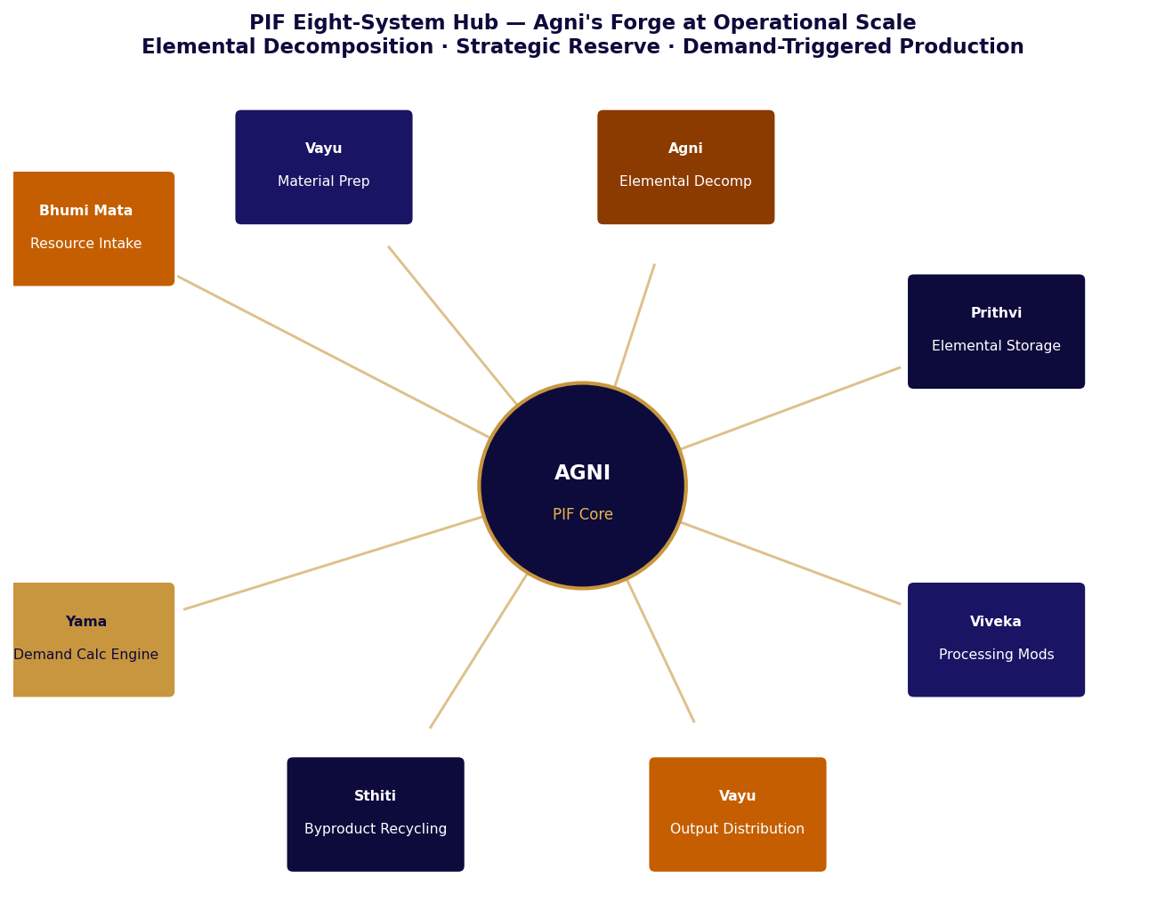
Figure 5-1: PIF Eight-System Hub — Agni's Forge at Operational Scale

The Eight Systems: Agni's Altar in Detail
Table 5-1: PIF Eight Hub Systems — Function, Specification, and Dharmic Character
System | Primary Function | Key Specification | Dharmic Character
1. Resource Intake | Receives, weighs, classifies all incoming raw materials | Continuous weighing · Auto-classification by elemental profile · Contamination screening | Bhumi Mata receives — all material is Prithvi before it is anything else
2. Material Prep | Pre-processes feedstock for decomposition: crushing, sorting, chemical separation | Size reduction to ≤25mm · Density separation · Magnetic separation for ferrous content | Tvashtri shapes — giving each material its correct form for entry into Agni's process
3. Elemental Decomp | Reduces all feedstock to pure elemental components — the core of PIF; nothing escapes Agni | Plasma arc at 5,000–15,000°C · 99.97% extraction efficiency · Zero residue — all captured | Agni transforms — offering of complex form, return of elemental potential (Brahman-state)
4. Elemental Storage | Holds pure elements in stable form at strategic reserve volumes | Fe: molten at 1,600°C · Al: liquid at 700°C · C: graphite · H₂: 700 bar · O₂: cryogenic | Sthiti preserves — strategic potential held in readiness for the next Srishti
5. Demand Calc Engine | Continuously calculates processing requirements from host demand, export commitments, reserve thresholds | Real-time integration · 90-day rolling forecast · Reserve threshold alerting · Autonomous triggers | Yama's ledger — the current account of what is needed, what is held, and what must be produced
6. Controlled Processing | Produces specific alloys, compounds, materials from elemental reserve on demand | Module types: alloy production, carbon processing, polymer synthesis, composite fabrication | Srishti from Brahman-state — specific form emerging from undifferentiated potential on demand
7. Output Distribution | Routes finished materials to internal production or external logistics | Automated QC against spec · Grade segregation · Traceability tag · Cold-chain where required | Vayu distributes — completed form flows to where it is needed without central direction
8. Byproduct Recycling | Captures all processing byproducts and routes to secondary use or elemental return | Zero-landfill mandate · Slag → silicate storage · Process gas → elemental recovery · Thermal → heat exchanger | Pralaya completes — every byproduct returns to potential for the next Srishti. Nothing is waste.
Table 5-1: PIF Eight-System Architecture with Dharmic Character

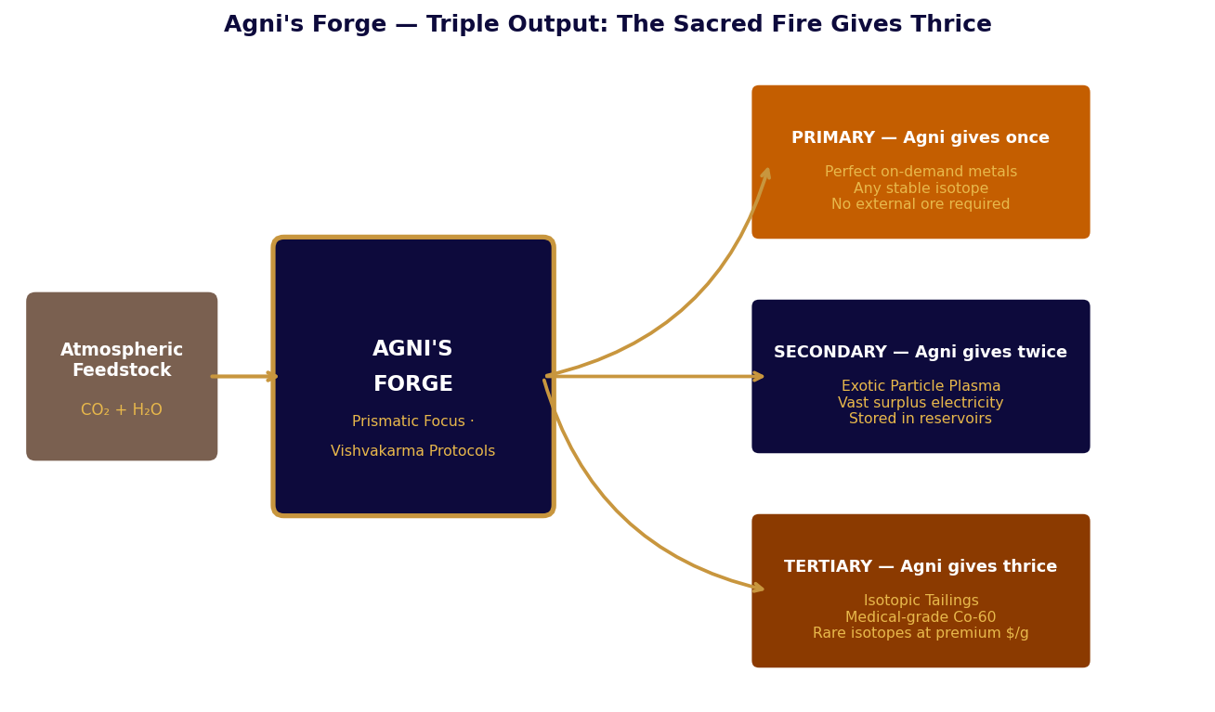
Figure 5-2: Agni's Forge — The Sacred Fire Gives Thrice: Three Simultaneous Outputs

Agni Gives Thrice: The Triple Output Principle
The Vedic tradition records that Agni gives thrice at every Yajna: the primary offering reaches the Devas, the secondary heat sustains the sacrificial space, and the tertiary ash carries medicinal and agricultural properties that serve the community after the ritual ends. The industrial Forge expresses the same principle at measurable scale. The primary output is the metal or alloy the production programme requires. The secondary output is the Exotic Particle Plasma — the energetic overflow of the fusion process converted to surplus electricity for the Kshetra's overnight operations. The tertiary output is the Isotopic Tailings — the non-target isotopes whose market value far exceeds conventional industrial revenues.
Table 5-2: Agni's Triple Output — Value at Each Level
Gift | Output Type | Platform Value | External Value | Vedic Parallel
First | Primary metals and alloys — any stable isotope, on demand | Eliminates all materials supply chain dependency for construction and manufacturing | Industrial metals at specification consistency unavailable from conventional ore processing | The offering reaching the Devas — primary Yajna return
Second | Exotic Particle Plasma — vast surplus electrical energy | Powers overnight transmutation runs; feeds elemental storage charging; grid-independent operations | Exportable surplus power at marginal cost near zero | The heat sustaining the Yajna space for subsequent operations
Third | Isotopic Tailings — medical-grade Co-60 and rare isotopes | Medical and research isotope supply for platform use; significant external revenue stream | Co-60 and rare isotopes at thousands of dollars per gram in medical and research markets | The ash serving the community — the gift that comes after, worth more than expected
Table 5-2: Triple Output — Platform Value and Vedic Parallel

SR-C6: Carbon as Tamas — The Foundation Material
The Bhagavad Gita's description of the three Gunas includes Tamas — the principle of inertia and structural integrity that makes stable form possible. Tamas has an undeserved reputation in popular readings because in human consciousness it manifests as lethargy and resistance to necessary change. In materials science, Tamas is the most valuable property a structural material can have: the capacity to hold form under stress, to remain stable under storage, to maintain its properties across extreme conditions.
Carbon black is Tamas in material form. It is the residue of Agni's transformative work — the stable endpoint of organic transformation, the material that has already undergone its change and arrived at equilibrium. SR-C6 is this carbon commercially expressed: processed from the PIF's carbon fraction into five functional grades for five distinct industrial applications. The Forge produces the carbon. The PIF stores it as elemental reserve. SR-C6 structures it for deployment. The value chain from atmospheric CO₂ to industrial product is complete and self-contained.
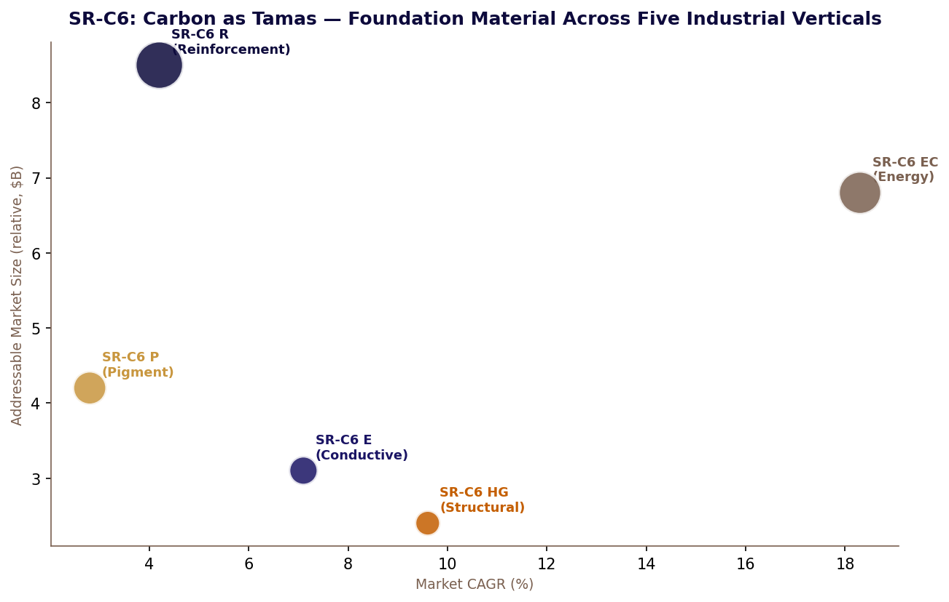
Figure 5-3: SR-C6 — Carbon as Tamas Across Five Industrial Verticals

Table 5-3: SR-C6 Grade Specifications — Tamas Expressed in Five Forms
Grade | BET Surface  (m²/g) | DBP Absorption  (mL/100g) | Particle Size  (nm) | Primary Application | Guna Expression
SR-C6 R | 70–120 | 80–130 | 40–80 | Tyre reinforcement · Rubber goods · Mechanical elastomers | Tamas as structural integrity — holds rubber under continuous mechanical stress
SR-C6 P | 100–300 | 60–120 | 15–40 | Coatings · Inks · Plastics pigmentation | Tamas as form-giving — colour and opacity are Prithvi properties
SR-C6 E | >200 | 120–200 | 15–30 | Conductive polymers · Antistatic · Electronic components | Tamas carrying Vayu — structural carbon enabling electron (Vayu) movement
SR-C6 EC | >350 | 150–300 | 10–20 | Li-ion battery anodes · Supercapacitor electrodes | Tamas storing Agni — carbon as the vessel that holds and releases transformation energy
SR-C6 HG | High — graphitic | N/A (graphitic) | Macro-crystalline | Structural composites · Thermal management · Friction materials | Tamas at maximum order — graphitised carbon expressing Prithvi at its most crystalline
Table 5-3: SR-C6 Grade Specifications with Guna Correspondences
Table 5-4: PIF Reserve Thresholds and Demand Calculation Engine Triggers
Element | Storage Form | Strategic Min Reserve | Processing Trigger | Dharmic Significance
Iron (Fe) | Molten reservoir 1,600°C | 30 days production | < 45 days forecast | Bhumi Mata's primary metal — structural Dharma of the Kshetra held in reserve
Carbon (C) | Graphite block storage | 60 days production | < 75 days forecast | Agni's residue — Tamas at its purest, held as the longest strategic reserve
Hydrogen (H₂) | 700 bar pressurised | 14 days production | < 21 days forecast | Vayu compressed — the mobile element that carries and animates; held in minimum reserve as it is always available atmospherically
Oxygen (O₂) | Cryogenic −183°C | 21 days production | < 30 days forecast | Vayu and Agni combined — both movement and transformation require oxygen; medium reserve
Copper (Cu) | Molten reservoir | 45 days production | < 60 days forecast | Volta's metal — the conductor of Vayu's electrical movement; longest reserve after carbon
Table 5-4: DCE Reserve Thresholds with Dharmic Significance
The PIF and SR-C6 relationship is the clearest expression of the Yajna compound return in the real-world register. Agni's process produces elemental carbon as an inevitable byproduct of every decomposition operation. The PIF stores it. SR-C6 structures it into five functional grades for five industrial verticals. The Forge's act of transformation produces a commercial platform as its Isotopic Tailing. This is what the Gita means: the Yajna produces more than the offering. Always.

PART TWO

Chapter Six
Varuna's Gift
Rita: water flows where cosmic law directs it — HACA and resource sovereignty
आपो हि ष्ठा मयोभुवः
Apo hi shtha mayobhuvah
Waters, you bring well-being; you are the source of healing. Flow to us as loving mothers.
— Rig Veda 10.9.1

The Rig Veda addresses water as a living intelligence because water behaves as a living intelligence: it finds the path of least resistance without being told where the path is, it fills the available space without being told the shape of the space, and it sustains all life without requiring acknowledgement of its service. Varunadeva is not the god of water. He is the cosmic law — Rita — that makes water's intelligence possible.
Rita in Varuna's domain means that water flows where the conditions for correct flow have been established. It does not flow where force demands. It does not flow where supply chains are maintained. It flows where the surface, the temperature differential, the molecular affinity, and the conditions of correct invitation have been established. The Thirsty Silk Lattice was Varunadeva's offering to the Kshetra: the surface that made the conditions for Rita-correct water flow permanently present.
The Hydro-Kinetic Emitter's role was not force. It was completion. The water had already decided to come — the lattice's affinity had made the decision for it. The pulse was the moment of coalescence, the signal that the conditions for arrival were complete. In the Vedic framework, this is precisely the function of the mantra in ritual: not to create the event but to complete the conditions for an event that was already prepared.
The water that arrived in the reservoir was 99.9 percent pure without treatment because the mechanism of invitation excluded contaminants by design. The lattice's hygroscopic surface selected for water molecules specifically. Everything that was not water was not invited. Purity was not an achievement. It was a property of the method — which is to say, it was a property of working according to Rita rather than against it.

Resource Independence as Dharmic Architecture
Varunadeva's role in the Vedic tradition extends beyond water to the broader principle of Rita — the cosmic order that makes all things function correctly. When Rita is maintained, water flows, agreements hold, and systems perform as they are designed to perform. When Rita is violated, the natural order is disturbed and consequences follow not as punishment but as the logical result of a system operating against its own correct principle.
Sagar-Raja's resource independence doctrine is the corporate expression of operating according to Rita in every critical resource domain. Water independence through HACA technology eliminates the vulnerability category that comes from water supply chains operating against Rita — from extraction, from agreements that can be broken, from infrastructure that can fail. Energy independence through multi-source harvesting eliminates the vulnerability category that comes from energy supply chains. Materials independence through PIF eliminates the vulnerability category that comes from raw materials supply chains. Each independence achievement removes one category of Rita-violation from the platform's operational profile.
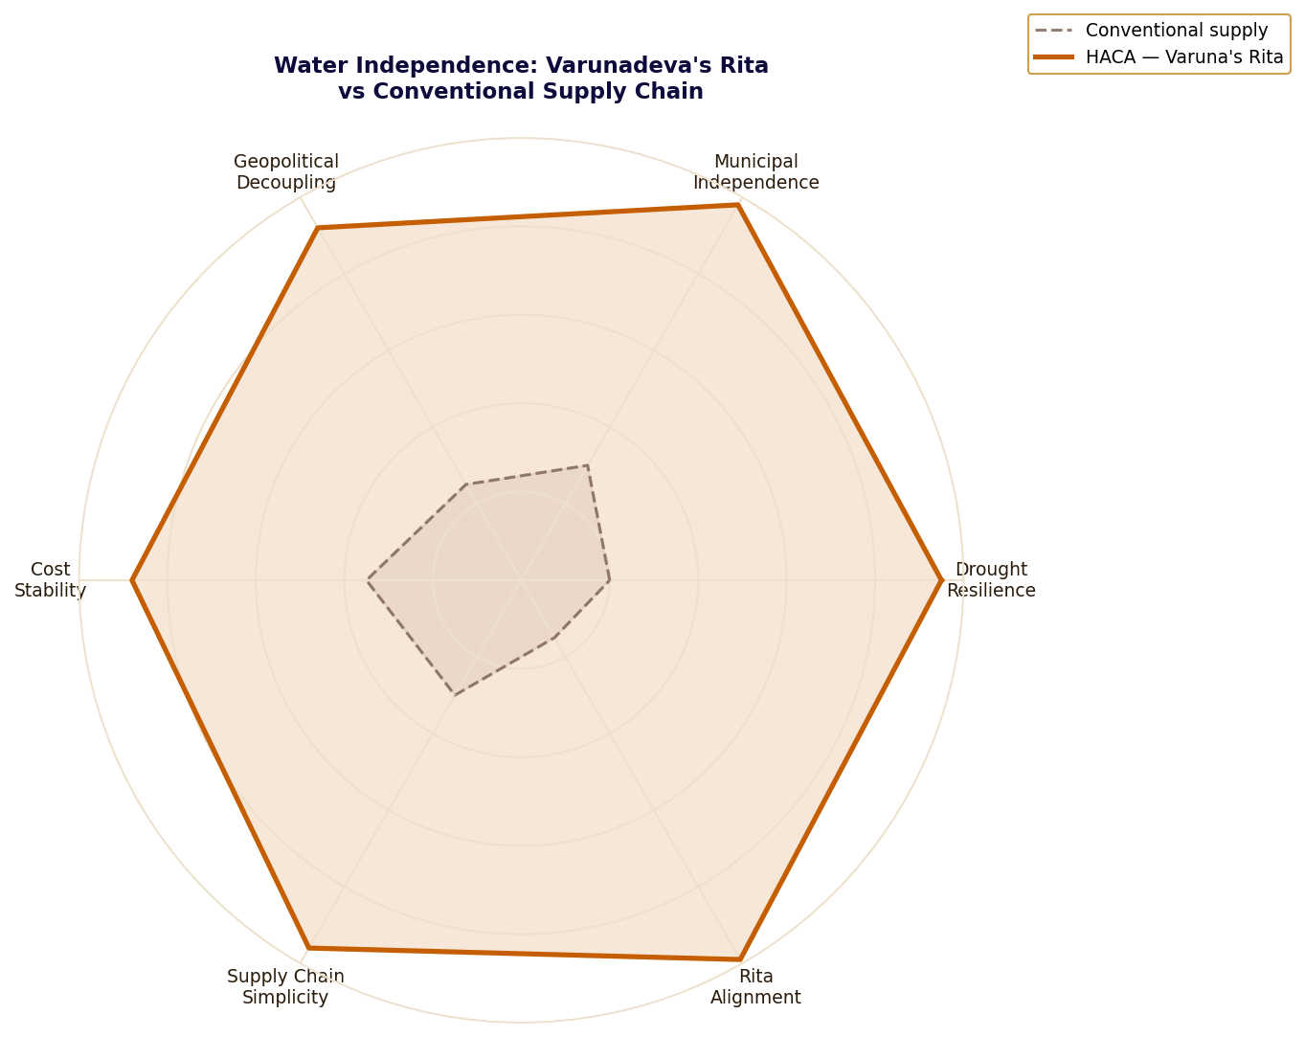
Figure 6-1: HACA Strategic Resilience vs Conventional Water Supply — Varuna's Rita Profile

HACA: The Engineering of Invitation
The Hydro-Kinetic Atmospheric Condensation Array is based on two physical principles whose combination produces a system that operates according to Rita rather than against it. The first principle is hygroscopic adsorption: certain materials have greater affinity for water molecules than the surrounding air, so water molecules moving through the air preferentially adsorb to those surfaces. The Thirsty Silk Lattice presents this surface in three dimensions at sub-millimetre scale, offering to atmospheric water the conditions for Rita-correct behaviour. The water comes.
The second principle is coalescence pulse: once adsorbed water molecules have gathered on the lattice surface, a low-energy molecular resonance pulse simultaneously releases them from their surface bonds and applies a directional pressure that causes them to aggregate and flow. The pulse energy cost is approximately 0.8 kilowatt-hours per tonne of water collected — 70 percent less than conventional groundwater pumping at equivalent volumes. Operating according to Rita is not only correct. It is efficient.
Table 6-1: HACA Technical Performance — Rita Operating Parameters
Parameter | Value | Rita Significance
Water purity (pre-UV) | 99.9% | The invitation mechanism selects for water molecules only. Purity is a property of the method — Rita operating correctly produces correct outcomes
Daily output (mid-scale cluster) | 4–12 tonnes/day | Sufficient for full platform water sovereignty without any external connection. Rita's sufficiency — correct conditions produce what is needed
Energy per tonne harvested | ~0.8 kWh | 70% below conventional pumping. Working with natural law is more efficient than working against it — Rita's economy
Minimum operational RH | ~35% | Operates at reduced efficiency below 35% — never zero. Varunadeva's domain is never truly absent; Rita is not suspended by drought
External connection | None required | Complete water sovereignty. The Kshetra cannot be pressured through its water supply — Rita established independently of external agreements
Acoustic signature | Silent | Water invited produces no sound of conflict. Force is loud. Rita is quiet.
Maintenance interval | 6 months | Bio-composite lattice is self-repairing within design tolerance — Bhumi Mata's material maintaining Varuna's work
Table 6-1: HACA Technical Performance with Rita Significance

Water Dependency Categories and Rita Elimination
Every category of conventional water dependency represents a way in which the platform's operational continuity depends on others maintaining Rita on its behalf — others maintaining their agreements, their infrastructure, their political will to share. Each such dependency is a point at which Rita can be violated by parties whose Dharma is not aligned with the platform's. The HACA system eliminates these dependencies one by one by establishing the conditions for Rita-correct water flow directly within the platform's own architecture.
Table 6-2: Water Dependency Categories — Conventional vs HACA Rita Architecture
Dependency Type | Rita Violation Mechanism | Real-World Instances | HACA Rita Establishment
Watershed / River | Upstream authority controls allocation; their Rita may diverge from the platform's need | Nile basin disputes · Colorado River compact failures · Mekong dam conflicts | Complete elimination — no watershed connection; Varuna's Rita established independently
Aquifer / Groundwater | Depletion violates Rita over time; regulatory restriction imposed by others' Rita requirements | Saudi Najd aquifer depletion · California subsidence · Middle East groundwater crisis | Complete elimination — atmospheric moisture is renewed by the water cycle Rita regardless of aquifer state
Municipal supply | Infrastructure integrity and political will of supplying authority must maintain Rita continuously | Industrial supply interruptions in politically contested regions; price leverage | Complete elimination — no municipal connection; no price leverage; no infrastructure dependency
Rainfall / Collection | Seasonal and climate variability disrupts Rita without human agency; structural unreliability | Industrial water shortages in drought years globally; climate change trajectory | Substantially reduced — HACA operates at reduced efficiency in drought but maintains output to RH 35%
Desalination dependency | Energy cost exposure; brine discharge regulation; equipment supply chains; all external Rita dependencies | GCC desalination cost volatility with energy price swings; brine environmental disputes | Complete elimination — HACA requires no salt, no brine disposal, no desalination plant
Table 6-2: Water Dependency Elimination — Rita Architecture

HACA Scaling: Rita at Different Magnitudes
The Vedic understanding of Rita is scale-independent: the cosmic law that governs water at the ocean level is the same law that governs water at the molecule level. The HACA system's modular scaling architecture reflects this: the same Rita principle operates whether one unit is deployed or two hundred. The water invited by a single unit is invited by the same mechanism as the water invited by a two-hundred-unit sovereign array. The scale changes. The principle does not.
Table 6-3: HACA Scaling Configurations — Rita at Different Magnitudes
Configuration | Unit Count | Daily Output | Footprint | Primary Application
Portable tactical | 1 | 200–500 L/day | 1.2 × 0.8 × 2.0 m | Forward operating bases · Remote research · Emergency water sovereignty
Small facility | 4–8 | 1–4 tonnes/day | Cluster ~20m diameter | Small industrial · Agricultural operations · Isolated communities
Mid-scale cluster | 20–40 | 4–12 tonnes/day | Cluster ~60m diameter | Medium industrial · Platform primary water supply · SR-EPP-OF operational minimum
Large array | 80–120 | 18–35 tonnes/day | Array ~150m span | Large industrial facility · Urban supplement in water-scarce regions
Platform sovereign | 200+ | 50+ tonnes/day | Integrated into landform | Full platform water sovereignty · Zero external dependency · Rita fully established
Table 6-3: HACA Scaling Configurations

The Broader Rita Doctrine: Resource Sovereignty Across All Domains
Water is the clearest expression of the Rita doctrine because the HACA system achieves near-complete independence and because water dependency is the most immediately comprehensible strategic vulnerability. But Rita as a governance principle applies across every critical resource. Energy Rita — the correct flow of energy from the cosmos to the platform — is established through the multi-source harvesting architecture. Materials Rita — the correct flow of elemental materials from their natural state to the platform's production reserve — is established through the PIF. Food Rita — the correct flow of nutrition from the platform's agricultural systems to its operations — is established through the VASF. Each domain's Rita is established independently.
When Rita is established independently in every critical domain, the compound strategic effect is disproportionate to the sum of its parts. A platform dependent on any external resource for any critical function can be pressured through that dependency. A platform whose Rita is established independently in every critical domain has no such pressure point. The Arthashastra describes this as the condition of the ruler who has no Ari — no enemy whose leverage can threaten the state's continuity. The platform achieves this condition not through military dominance but through the correct establishment of Rita in every domain of its operation.
Varunadeva's gift to the Kshetra was not just water. It was the demonstration that a system designed according to Rita does not need to depend on sources it cannot control. Where you depend defines where you break. Rita established is Rita unbreakable.

PART III
सोम
SOMA
What the Kshetra nourishes and offers back to the world.

Anna-Brahma · Tvashtri's Form · Three Gunas · Yantra · Tamas

Soma is simultaneously the nourishing moon and the sacred offering. The VASF is Soma's
factory. RASM is Anna-Brahma — nourishment as Brahman expressed, species-agnostic,
culturally unrestricted, institutionally positioned. RIDER is Tvashtri's one correct
form: the Vimana that does not vary by geography because Tvashtri does not produce
variants. STRIKER is three Gunas as protective architecture. GEO is a Yantra. SR-C6
is Tamas itself — the dark foundation holding everything else up.

CONTENTS — Chapters 7 – 11

Chapter Seven Anna: The Perfect Nourishment
VASF triple Anna · RASM as Anna-Brahma · Taittiriya Upanishad · Institutional positioning
Chapter Eight The Vimana That Does Not Vary
RIDER · Tvashtri's single correct form · Adaptation matrix · Sahaja Karma as product discipline
Chapter Nine The Kshatriya's Dharma-Skin
STRIKER · Three Gunas as three layers · Four Mahabhuta climate calibrations
Chapter Ten The Yantra of the Navigator
GEO · Yantra design principle · Display as information architecture · Gita 18.61
Chapter Eleven Tamas: The Dark Foundation
SR-C6 · Tamas as structural integrity · Five grades with Guna/Mahabhuta correspondence

PART III
सोम
SOMA
What the Kshetra nourishes and offers back to the world.

Chapters 7 – 11 · RASM · RIDER · STRIKER · GEO · SR-C6

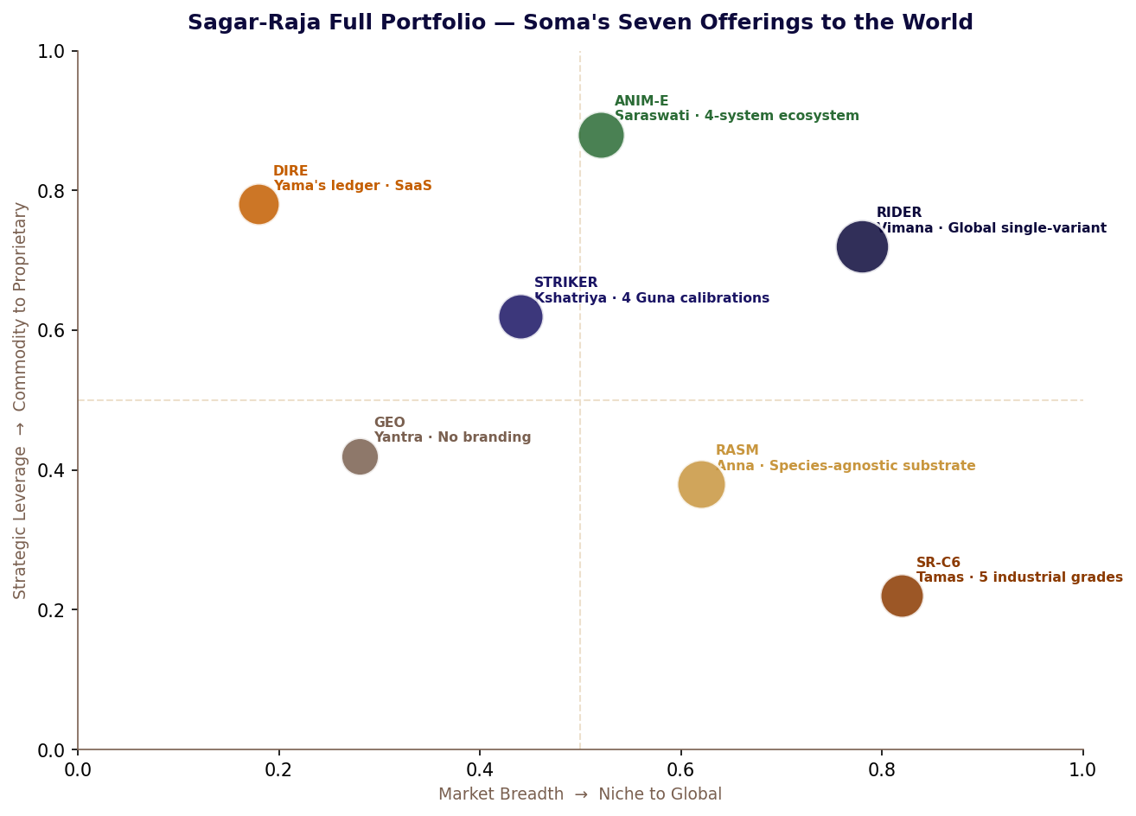
Soma's Seven Offerings — the Sagar-Raja portfolio as sacred nourishment at market scale

In the Vedic tradition, Soma is both the sacred offering that sustains the cosmic order and the nourishing moon whose light makes the crops grow. Soma does not nourish selectively — it nourishes all living systems without discrimination, because nourishment according to the correct principle serves the whole rather than the particular. Part III documents five products that carry this quality: each one a proof that correct design nourishes the domain it enters without requiring the domain to compromise its own standards to receive it.
RASM is Anna-Brahma — nourishment as cosmic offering — formulated without species preference, without cultural restriction, without residential dependency. RIDER is the Vimana that does not vary by market because its specification was set to serve all markets correctly in one act. STRIKER is the Kshatriya's second skin, calibrated by the three Gunas to support correct action in any climate without requiring the warrior to manage the equipment. GEO is the Yantra of the navigator — the instrument that concentrates awareness correctly. SR-C6 is Tamas itself — the black foundation that holds everything else up, present everywhere, acknowledged nowhere.

PART THREE

Chapter Seven
Anna: The Perfect Nourishment
Soma's factory — Agni's light into food, food into life — VASF + RASM
अन्नाद्भवन्ति भूतानि
Annad bhavanti bhutani
From food all beings are born; by food they live and to food they return at the end.
— Bhagavad Gita 3.14

The Bhagavad Gita's food cycle is not a biological observation. It is a cosmological statement: from rain comes food, from food comes life, from the life that lives by food comes the offering that produces rain again. The cycle is Srishti-Sthiti-Pralaya at the level of nutrition. The Vertical Agro-Synthesis Facility was the Kshetra's physical instantiation of this cycle, compressed to the dimensions of a vertical tower governed by Soma's principle.
Soma in the Vedic tradition is simultaneously the nourishing moon that sustains all living systems and the sacred offering whose consumption by the Devas sustains the cosmic order. The VASF expressed this dual nature precisely. Its primary output — harvest-ready Anna at the absolute peak of nutritional value — was Soma's nourishment. Its secondary output — the Genesis Biomass that fed the Kshetra's soil amendment, cultured protein scaffolding, and bioplastic production — was Soma's offering sustaining the systems that sustained the facility itself. Its tertiary output — Oxygen-Plus — was Soma's excess gift, the byproduct of the nourishing act that powered rockets, purified water, and healed the sick.
Three gifts from one act of correct nourishment. This is Soma's nature. The moon that nourishes the crops simultaneously governs the tides, the menstrual cycle, the growth of all living things. Nourishment according to the correct principle is never merely nourishment. It is always also a structural contribution to the systems within which the nourished being lives.

VASF: Soma's Triple Anna — Technical Architecture
The VASF is not a farm. A farm grows food. The VASF aligns biological state with template and supplies the energy required to instantiate that alignment. The distinction is the difference between cultivation and invocation: cultivation works with biological time as a given constraint; invocation works with biological potential as the only relevant variable.
Soma's photonic maturation principle — expressed in the Synthesis Wave — established that a seed and a ripe plant are not different things at different times. They are the same biological system in different states. The Maturation Template in Vishvakarma's Genesis Core encodes the precise state specification of the mature plant at nutritional peak. The Synthesis Wave — 80 milliseconds of wavelength-specific photonic energy from Agni's Photon Sieve — offers the seed the energy required to align with that specification instantaneously. The biological time between seed and harvest is not accelerated. It is rendered irrelevant.
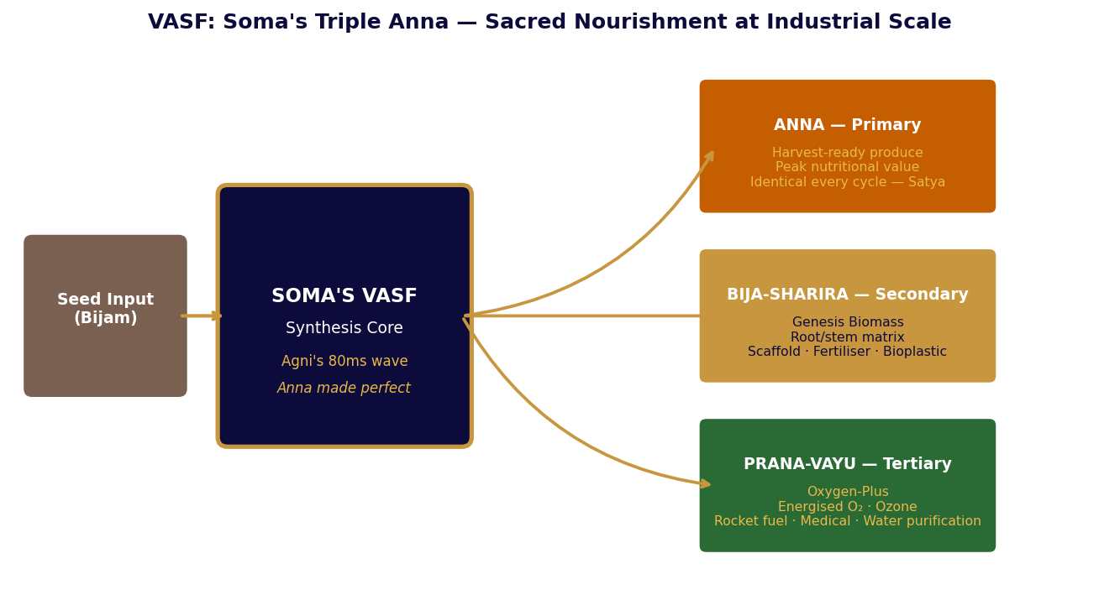
Figure 7-1: VASF — Soma's Triple Anna: Primary Nourishment, Secondary Biomass, Tertiary Prana-Vayu

Table 7-1: VASF Synthesis Chamber — Operating Parameters
Parameter | Value | Soma / Dharmic Significance
Synthesis wave duration | 80 milliseconds | Agni's transformation is instantaneous at the moment of transition — only preparation takes time
Chamber cycle time | ~30 seconds total | Including loading, synthesis, harvest, shredding, reset — Pralaya and Srishti in one minute
Chambers per tower | 240–480 (standard) | Each independently controlled — Soma's nourishment individualised per pod
Daily harvest cycles per chamber | Up to 2,880 | Operational rate ~1,200 accounting for maintenance — Sthiti preserved within Srishti maximum
Crop catalogue | 17 varieties (current) | Governed by Maturation Template library in Genesis Core — expandable without physical modification
Nutritional consistency | >99.7% batch-to-batch | Satya: identical template applied every cycle produces identical truth every cycle
Table 7-1: VASF Synthesis Chamber Parameters with Dharmic Significance

Table 7-2: VASF Triple Anna — Output Streams and Value
Output | Sanskrit Name | Platform Application | External Commercial Value | Vedic Parallel
Primary | Anna — nourishment | Platform nutrition · RASM feedstock · Personnel supply | Premium produce · Pharma-grade botanical ingredients | Soma sustaining living beings
Secondary | Bija-Sharira — seed body | Soil amendment · Cultured protein scaffold · Bioplastic feedstock | Biomaterial industry · Lab-grown protein · Sustainable packaging | Soma sustaining the Yajna fire itself
Tertiary | Prana-Vayu — vital breath | Rocket oxidiser · Water purification · Hyperbaric medicine | Aerospace propulsion · Industrial water treatment · Medical O₂ | Soma's excess — the gift beyond the gift
Table 7-2: VASF Triple Anna Output Streams

RASM: Anna-Brahma — The Correct Nutritional Substrate
The Taittiriya Upanishad's Ananda Valli identifies Anna — food — as Brahman: the ground of all existence expressing itself as nourishment. Anna is Brahman not metaphorically but functionally: it is the substrate through which consciousness maintains its physical vehicle, the material through which one form of life sustains another, the link in the chain of Srishti that makes biological continuity possible. A nutritional substrate designed according to this understanding is not optimised for preference. It is optimised for correct function.
RASM is positioned as a nutritional substrate, not a lifestyle beverage. This positioning is not a marketing decision. It is the expression of Anna-Brahma in product architecture: the product is designed for correct nutritional function, not for identity association. A lifestyle beverage asks: what does the consumer want to feel when they consume this? A nutritional substrate asks: what does the body require to function correctly? RASM answers the second question and does not consider the first.
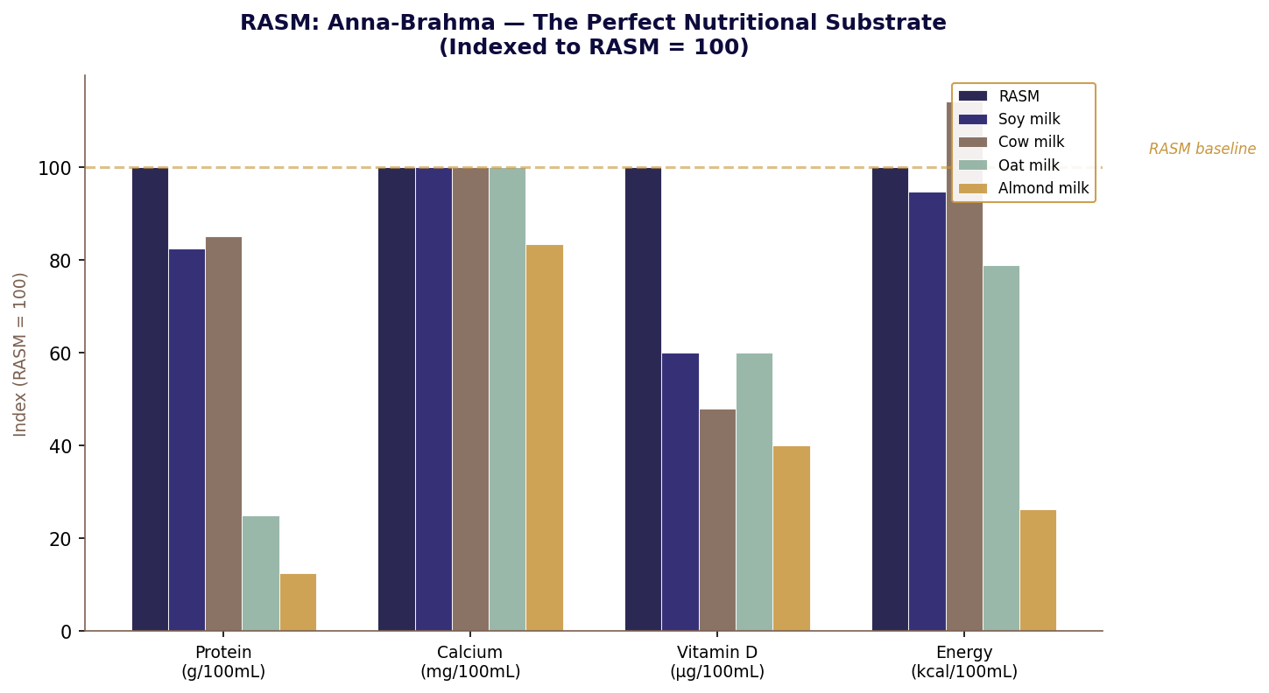
Figure 7-2: RASM — Anna-Brahma: Nutritional Profile vs Plant and Dairy Benchmarks (Indexed: RASM = 100)

Table 7-3: RASM Complete Specification — Anna-Brahma Parameters
Parameter | Value | Anna-Brahma Significance
pH | 6.3 ± 0.2 | Near-neutral — compatible with all physiological contexts; no acidic interference with the body's own Rita
Density | ~1.02 g/mL at 20°C | Close to water — accurate volumetric dosing; Jala principle maintained in the substrate
Viscosity | ~3.5 mPa·s at 20°C | Low viscosity — flows without obstruction; Jala's property of finding correct passage
Protein / 100mL | 4.0g — complete EAA | Complete essential amino acid profile per FAO/WHO reference — Anna offering all nine, nothing withheld
Energy / 100mL | 57 kcal | Moderate density — nourishes without overwhelming; Soma's measure
Calcium / 100mL | 120mg | 12% adult RDA per 100mL — Bhumi Mata's mineral given in correct portion
Species applicability | Human and animal | Anna-Brahma nourishes all beings without discrimination — species-agnostic by design principle, not accident
Religious/cultural restriction | None across any framework | Correct nourishment is universal — no Dharma restricts Anna that carries no restricted ingredient
Formulation ownership | Fully proprietary | The specific ratios and process parameters are Sagar-Raja's — the Anna's correctness is the company's Dharma to maintain
Table 7-3: RASM Complete Specification with Anna-Brahma Significance

PART THREE

Chapter Eight
The Vimana That Does Not Vary
Tvashtri's single correct form, deployed everywhere — RIDER
मनोजवं मारुततुल्यवेगम्
Manojavam marutatulyavegam
Swift as thought, equal in speed to the wind — the divine vehicle that moves of its own accord.
— Valmiki Ramayana, Sundara Kanda

The Pushpaka Vimana of the Ramayana was the divine vehicle that moved according to the will of its occupant, required no fuel because it drew sustenance from the cosmos it moved through, and could not be claimed by someone unworthy of it. These three properties — autonomous motion, environmental sustenance, and inherent right-use design — were not literary flourishes. They were the design brief that Tvashtri, the Shaper of Forms, had expressed in one correct instantiation.
The Vimana did not have variants. Tvashtri does not produce variants. Tvashtri gives each thing its correct, specific form — the form that expresses its Dharma completely and that cannot be improved by alteration. A Vimana with regional configurations is not a Vimana with variants. It is an incomplete design that has not yet found its correct form.
RIDER is Tvashtri's principle applied to the electric sedan. One specification. One bill of materials. One performance standard. One certification dossier per jurisdiction, differing only in the four regulatory categories that cannot be satisfied by the global standard without local adaptation — lighting, labelling, software constraints, and charging protocol where mandatory. Nothing else varies. Not the powertrain output, not the battery chemistry, not the drag coefficient, not the suspension geometry. The Vimana has found its form. The form does not change by geography.

RIDER: Tvashtri's Single-Variant Discipline
Tvashtri in the Vedic tradition is described as the craftsman of the Devas who gives all things their precise, correct form. The Rigveda credits Tvashtri with fashioning the divine weapons, the Soma bowl, and the forms of all living beings. What is notable in these attributions is their specificity: Tvashtri does not produce general categories of things. He produces the specific, correct instantiation — the one right form that serves the function completely.
RIDER's single-variant strategy is the corporate expression of Tvashtri's discipline. The decision to produce one specification globally rather than regional variants is not a commercial simplification. It is an engineering commitment to finding the one correct form that serves all markets correctly, rather than producing a different approximation of correct form for each market. The discipline required to achieve this is greater than the discipline required to produce variants. Variants are the refuge of designers who have not yet found the correct form.
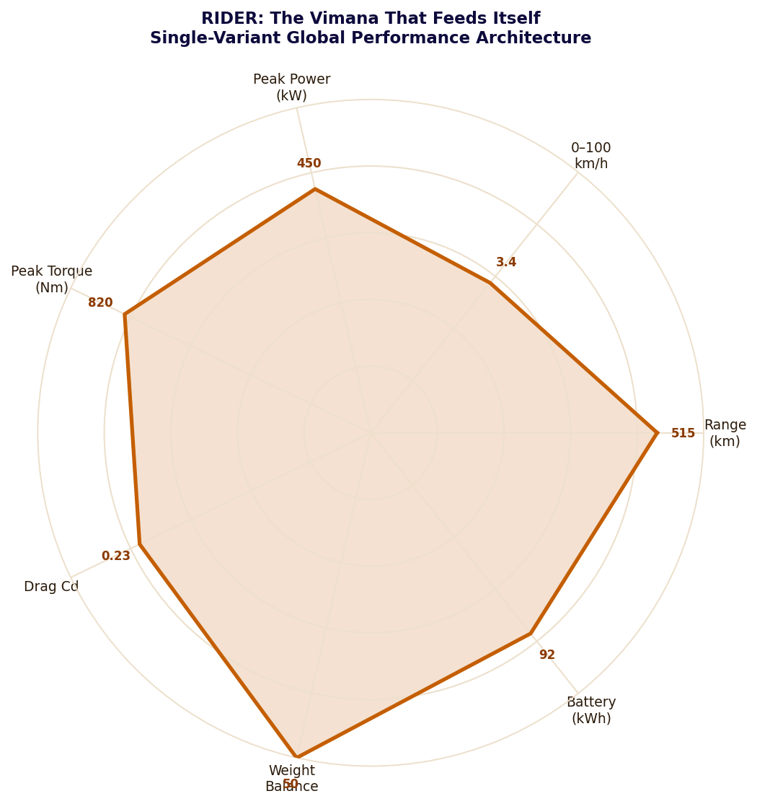
Figure 8-1: RIDER — Tvashtri's Performance Architecture: One Form, All Markets (Actual values annotated)

Table 8-1: RIDER Complete Technical Specification — Tvashtri's Single Form
Parameter | Specification | Tvashtri's Principle
Body style | Four-door fastback sedan | Single body style globally — the correct form for this function admits no regional variation
Platform | Dedicated EV skateboard | No shared platform — Tvashtri's form is specific, not derived from another function's correct form
Drive | Dual-motor AWD globally | One drivetrain everywhere — the correct expression of this vehicle's Dharma in every market
Length / Width / Height | ~4,880 / ~1,920 / ~1,420 mm | Identical globally — form does not adapt to preference, only to regulatory minimum where unavoidable
Weight distribution | ~50:50 front:rear | Achieved by mid-mounted battery geometry — the correct form produces correct balance without compromise
Drag coefficient | ~0.23 Cd | Achieved through body geometry, not active systems — Tvashtri's form is aerodynamic; it does not require compensation
Peak power | ~450 kW combined | Identical in every market — Manojavam (swift as thought) is not a regional preference
Peak torque | ~820 Nm combined | Marutatulyavegam (equal to the wind) — the Vimana's nature, not a specification choice
0–100 km/h | ~3.4 seconds | Consistent across all markets — the Vimana's swiftness is not adjusted by jurisdiction
Battery (usable) | ~92 kWh | Single chemistry globally — the Vimana draws from one energy source, correctly sized
WLTP range | ~480 km | Real-world 440–520 km depending on conditions — the correct range for this class at this specification
Table 8-1: RIDER Specification with Tvashtri's Principle

Table 8-2: Regulatory Adaptation Matrix — What Tvashtri Permits to Vary and What He Does Not
Category | Varies by Market? | Nature of Adaptation | Dharmic Principle
Powertrain output | No | Identical in every market | Tvashtri's form is complete — power is intrinsic, not adjusted by geography
Battery specification | No | Same chemistry and capacity globally | One energy source, correctly sized — variation would indicate incomplete design
Exterior lighting | Regulatory minimum only | DRL activation rules, turn signal timing | Dharma requires compliance with local law — but law governs behaviour, not form
Software/telematics | Regulatory minimum only | Speed display units, data residency rules | Swatantrya (freedom) within Dharma — local constraint accepted, form unchanged
Charging protocol | Where mandatory | CCS2 + GB/T in China; CCS2 elsewhere | Jala principle — the energy flows through whichever channel Rita of that region requires
Suspension geometry | No | Identical globally | Tvashtri's balance is correct — 50:50 is not a preference, it is the vehicle's Dharma
Colour palette | No | Same options everywhere | The Vimana's appearance does not vary by the preference of the terrain it crosses
Table 8-2: RIDER Adaptation Matrix — Tvashtri's Permitted and Forbidden Variations
The discipline of Tvashtri is the discipline of finding the one correct form rather than producing multiple approximations of it. RIDER does not have variants because Tvashtri does not produce variants. It has the correct specification. The specification does not change.

PART THREE

Chapter Nine
The Kshatriya's Dharma-Skin
Three Gunas as protective architecture — STRIKER
नैनं छिन्दन्ति शस्त्राणि
Nainam chhindanti shastrani
Weapons cannot cut this; fire cannot burn it; water cannot wet it; wind cannot dry it.
— Bhagavad Gita 2.23

The Gita's description of the indestructible Atman is, at the philosophical level, a statement about consciousness. At the operational level, applied to a protective apparel system, it describes a design goal: a layer that cannot be compromised by the conditions it is designed to operate in, that removes the environmental variable from the wearer's field of attention so that attention can remain where Kshatriya Dharma requires it — on the situation, not on the equipment.
The Gita identifies three Gunas — Tamas, Rajas, and Sattva — as the three modes through which all material phenomena express themselves. Tamas is the principle of structural integrity, the inertia of correctly constituted form. Rajas is the principle of dynamic activity and response, the energy of motion and adaptation. Sattva is the principle of clarity and pure function, the quality that illuminates without obstruction. A Kshatriya needs all three simultaneously and needs them not to require management.
STRIKER's three-layer architecture is the material expression of this requirement. The outer textile carries Tamas: it holds its form under continuous environmental stress without requesting attention. The intermediate ceramic-polymer layer carries Rajas: it absorbs and redistributes force without requiring the wearer to brace or adjust. The inner comfort knit carries Sattva: it removes every environmental signal that is not operationally relevant, leaving the Kshatriya's awareness free for the field.
A Kshatriya wearing STRIKER is not wearing clothing. They are wearing their own operating conditions.

STRIKER: Three-Layer Architecture as Three Gunas
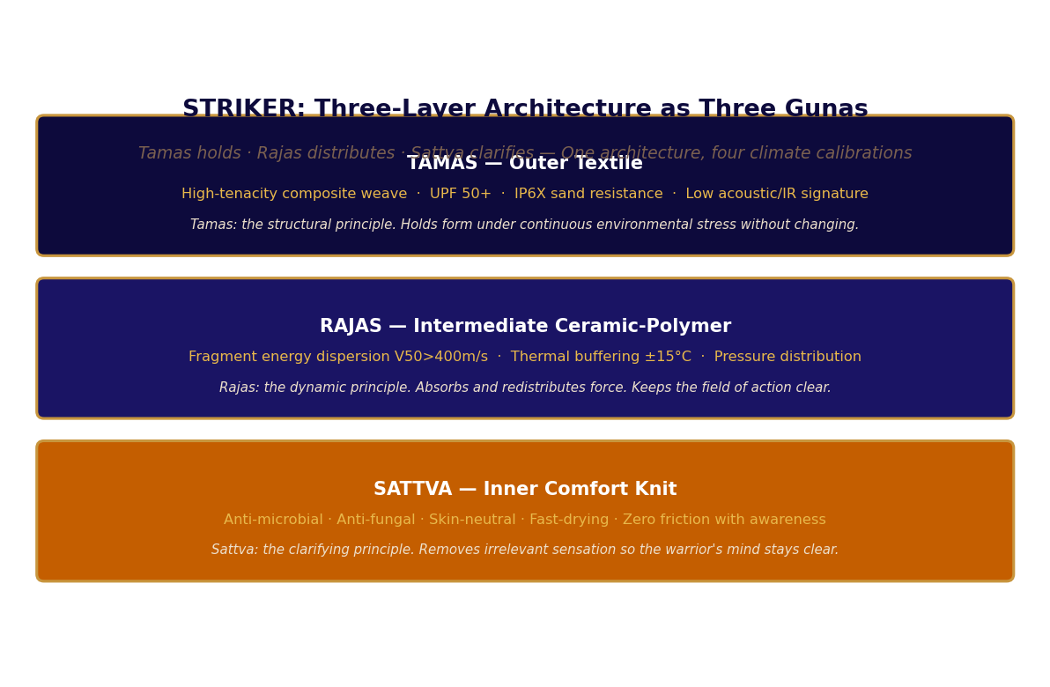
Figure 9-1: STRIKER — Three-Layer Architecture as Three Gunas: Tamas holds, Rajas distributes, Sattva clarifies

Table 9-1: STRIKER Three-Layer Specification with Guna Correspondence
Layer | Guna | Material | Primary Function | Dharmic Character
Outer Textile | Tamas | High-tenacity composite fibre · UPF 50+ · IP6X · Low acoustic/IR signature | Structural interface with environment. Absorbs mechanical, radiative, and thermal loads before they reach the wearer. | Tamas: holds correct form under continuous stress without requesting attention or adjustment
Intermediate Layer | Rajas | Ceramic-polymer micro-laminate · Fragment V50 >400 m/s · Blunt trauma ratio 8:1 · ±15°C thermal buffer | Dynamic force distribution. Disperses impact energy across 8x the contact area. Buffers thermal transitions. | Rajas: active energy management that keeps the field of action clear for Kshatriya Dharma
Inner Comfort Knit | Sattva | Moisture-wicking composite · Anti-microbial · Anti-fungal · Skin-neutral · Fast-drying | Removes thermal and chemical discomfort signals from wearer awareness. The body's interface with the system. | Sattva: clarifying principle that removes obstruction from awareness; battlefield clarity is partly a material property
Table 9-1: STRIKER Three-Layer Guna Architecture

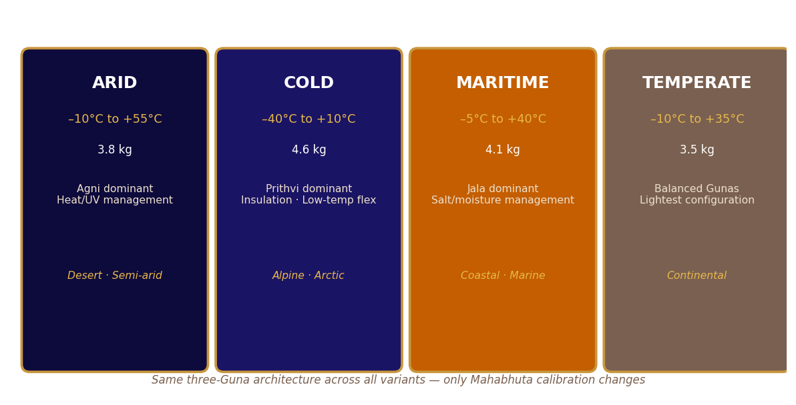
Figure 9-2: STRIKER Four Climate Variants — Same Three-Guna Architecture, Mahabhuta-Calibrated

Four Climate Variants: Dharmic Adaptation Without Change of Identity
The Gita's discussion of the Gunas makes clear that the three Gunas are always present simultaneously in all phenomena — what changes is their proportion and expression. STRIKER's four climate variants express this: the three-Guna architecture is constant across all variants; what changes is the Mahabhuta calibration of each Guna's expression in each layer.
STRIKER ARID calibrates for Agni dominance: the outer Tamas layer optimises for UV absorption and heat dispersion; the intermediate Rajas layer thins its thermal buffer because heat movement rather than heat retention is needed; the inner Sattva layer maximises moisture wicking for evaporative cooling. STRIKER COLD calibrates for Prithvi dominance: the outer Tamas layer becomes a wind barrier; the intermediate Rajas layer expands for insulation while maintaining full flexibility at minus 45 degrees Celsius. STRIKER MARITIME calibrates for Jala dominance: the outer Tamas layer gains salt spray resistance; all layers acquire hydrophobic interfacing for rapid drying after immersion. STRIKER TEMPERATE is the balanced expression: all three Gunas in their lightest, most flexible configuration, suitable for the widest range of conditions.
Table 9-2: Climate Variant Mahabhuta Calibration
Variant | Temp Range | Weight | Dominant Mahabhuta | Tamas Calibration | Rajas Calibration
ARID | +10 to +55°C | ~3.8 kg | Agni — heat management | UV block · Sand tight · Heat dissipation surface | Thin thermal buffer · Heat dispersal priority
COLD | –40 to +10°C | ~4.6 kg | Prithvi — structural holding | Wind barrier · Moisture barrier · Full insulation | Expanded insulation · Full flex at –45°C ceramics
MARITIME | –5 to +40°C | ~4.1 kg | Jala — flow and release | Salt-spray treatment · Corrosion-resistant dyes | Hydrophobic interface · Rapid dry after immersion
TEMPERATE | –10 to +35°C | ~3.5 kg | Balanced — all five | Baseline weave · Lightest Tamas configuration | Standard ceramic-polymer stack · Baseline Rajas
Table 9-2: STRIKER Climate Variants — Mahabhuta Calibration of Guna Architecture

PART THREE

Chapter Ten
The Yantra of the Navigator
Correct form as the complete expression of correct function — GEO
यन्त्रारूढानि मायया
Yantraroodhaani mayaya
Mounted on a machine by Maya, all beings rotate — the instrument determines the quality of the operation.
— Bhagavad Gita 18.61

A Yantra in the Hindu tantric tradition is a geometric instrument for the concentration of awareness. It is not a symbol of something else. It is a device that, by its precise geometric structure, focuses the attention of the person engaging with it on the principle it embodies. The mandala is a Yantra. The Sri Yantra is a Yantra. They work not by representing reality but by structuring attention in a way that brings the user into correct relationship with reality.
The instrument the navigator carried on her wrist was a Yantra in this precise sense. Its case geometry was borrowed from fractured stone — the geometry of a thing that has been tested to its structural limit and has distributed the force correctly rather than yielding at a point. Its display was minimal: time, temperature, altitude, day of week. Exactly what was needed. Nothing that was not needed. The instrument did not offer the navigator options. It offered information. Her attention, when she consulted it, was immediately directed to what mattered.
The Gita's verse about beings mounted on a machine by Maya identifies the critical relationship: the quality of the instrument determines the quality of the operation that uses it. A poorly designed instrument makes the user aware of the instrument. A well-designed Yantra is transparent — the user accesses what the instrument reveals without experiencing the instrument as an object they are managing. After four years of daily use, the navigator had never once thought about the instrument while using it. This was its highest commendation.

GEO: Yantra Design Principles
The Yantra principle applied to product design produces a specific design methodology: every decision is evaluated not by aesthetic preference or manufacturing cost but by one question — does this element bring the user into correct relationship with the information they need, or does it interpose itself between the user and that information? Every element that interposes is removed. Every element that clarifies is kept in its most minimal, least intrusive form.
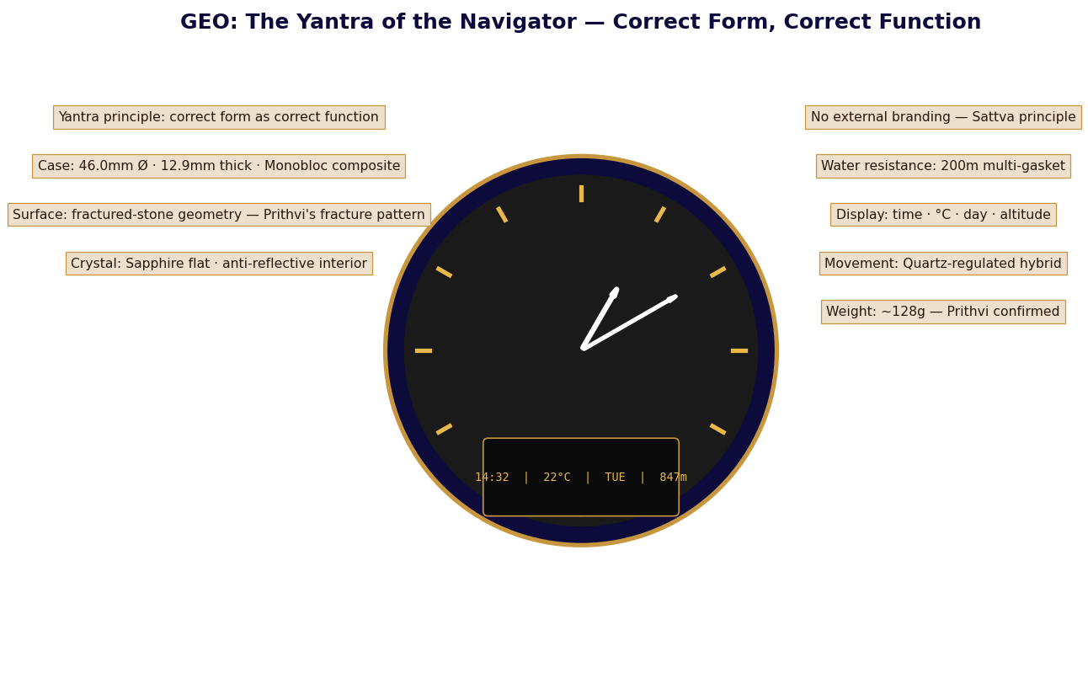
Figure 10-1: GEO — The Yantra of the Navigator: Correct Form, Complete Function, No Obstruction

Table 10-1: GEO Complete Physical Specifications — Yantra Engineering
Parameter | Value | Yantra Principle
Case diameter | 46.0 mm | Legibility on medium and large wrists without magnification — the Yantra must be readable without effort
Case thickness | 12.9 mm | Balances display depth with wrist profile — snags less than 14mm+ cases on equipment in field use
Case material | Monobloc composite | Fractured-stone geometry: Prithvi's pattern of correct force distribution, borrowed as form. No joint, no weakness.
Crystal | Sapphire flat, AR interior | Sapphire: 9 Mohs — Prithvi's hardness. Flat profile: no magnification distortion. AR interior: the Yantra does not reflect itself
Water resistance | 200m multi-gasket | Jala cannot enter — Varuna's domain cannot compromise Tvashtri's form
Weight | ~128g | Prithvi confirmed on the wrist — sufficient mass to signal presence without becoming a burden on awareness
External branding | None visible | Sattva principle — the Yantra draws no attention to itself; the brand is expressed through correct function alone
Table 10-1: GEO Physical Specifications with Yantra Principle

Table 10-2: GEO Display System — Yantra Information Architecture
Display Element | Information | Yantra Engineering Rationale
Analog hands | Hours · Minutes · Seconds | Continuous time as spatial position — the Yantra presents time as a relationship, not a number to be read and processed
Digital — primary | HH:MM | Redundant time for absolute precision when needed — Satya as backup to Sattva
Digital — temperature | °C ambient | Agni's domain made legible. Updates every 60 seconds, accurate ±0.5°C. The navigator knows the fire's intensity.
Digital — day | Day of week | Perpetual calendar — no manual correction for 20 years. Kala (time) managed without requiring Kala's attention
Digital — altitude | Metres ASL | Vayu's domain — barometric altimeter accurate ±5m. The navigator knows their position in the air column.
Display colours | Amber/yellow · Green indicators | Photopic peak at 555nm (yellow-green) for daytime; scotopic dominance for night. The Yantra is readable in Agni's light and in Ratri's darkness.
Table 10-2: GEO Display System with Yantra Engineering Rationale
A Yantra that draws attention to itself has failed. A Yantra that directs attention through itself to what matters has succeeded. After four years, she had never once thought about the instrument while using it. Tvashtri's form was correct.

PART THREE

Chapter Eleven
Tamas: The Dark Foundation
The principle of structural integrity made material — SR-C6
तमो गुण महाबाहो विद्धि प्रकृतिसम्भवम्
Tamo guna mahabaho viddhi prakritisamabhavam
Know that Tamas, O mighty-armed, is born of Prakriti — the ground of all material existence.
— Bhagavad Gita 14.17

Tamas has an undeserved reputation in popular readings of the Gita. Associated with darkness, inertia, and the tendency to remain unchanged, it is often presented as the Guna to be transcended. In the domain of human consciousness, where Tamas manifests as lethargy and resistance to necessary transformation, this framing has merit. In the domain of materials science, where Tamas manifests as structural integrity and the capacity to hold form under extreme and sustained stress, Tamas is precisely what is required. A material without Tamas cannot be a foundation material. It will yield.
The deep black powder that the Kshetra used in every conductive surface, every reinforced composite, and every energy storage system was Tamas in material form: carbon black, the residue of Agni's transformative work, the stable endpoint of organic matter's passage through fire. It was not inert because it was dead. It was stable because it had already undergone its transformation and arrived at a state of structural equilibrium that no normal operating condition could disturb.
SR-C6 is this carbon commercially structured: five functional grades, five industrial applications, one underlying Tamas principle expressed differently in each context. In the tyre, Tamas holds the rubber together under the continuous mechanical stress of motion. In the battery electrode, Tamas holds the charge carrier — stores Agni's energy in Bhumi Mata's structure. In the structural composite, Tamas provides the graphitic order that conducts heat laterally while bearing mechanical load. The foundation material is everywhere and acknowledged nowhere. This is its Dharma: to be the ground on which everything else stands.

SR-C6: Industrial Carbon Black as Tamas
The Bhagavad Gita's teaching on Tamas in the context of Prakriti — material nature — is that Tamas is born of Prakriti as the principle that gives material form its stability and persistence. Without Tamas, Rajas and Sattva have no substrate to act through. The three Gunas require each other: Sattva illuminates, Rajas activates, Tamas holds. SR-C6 is the Tamas substrate through which the active and illuminating properties of the systems that use it can be expressed.
Table 11-1: SR-C6 General Properties — Tamas at Specification
Property | Value | Tamas Expression
Appearance | Deep black powder or micro-granular | Tamas absorbs light rather than reflecting it — the absence of reflection is structural, not aesthetic
Carbon content | ≥98.5 wt% | Purity of Tamas — the closer to pure carbon, the closer to the stable elemental state Agni produces
Moisture content | ≤1.0 wt% | Tamas does not absorb what is not Tamas — Jala is excluded by the material's stable structure
Storage stability | >36 months sealed dry | Tamas persists — the foundation material does not degrade waiting to be used. It is patient as Prithvi.
Solubility | Insoluble in water and solvents | Tamas is not dissolved by Jala — structural integrity maintained across all liquid environments
Bulk density | 0.18–0.45 g/cm³ | Apparent lightness concealing structural depth — Tamas is not heavy, it is stable
Table 11-1: SR-C6 General Properties with Tamas Expression

Table 11-2: SR-C6 Five Grades — Tamas in Five Industrial Expressions
Grade | BET Surface  (m²/g) | DBP  (mL/100g) | Particle  (nm) | Primary Application | Guna Expression
SR-C6 R | 70–120 | 80–130 | 40–80 | Tyre reinforcement · Rubber goods · Elastomers | Pure Tamas — holds rubber under continuous mechanical stress
SR-C6 P | 100–300 | 60–120 | 15–40 | Coatings · Inks · Plastics pigmentation | Tamas giving form — colour is Prithvi's property expressed through carbon
SR-C6 E | >200 | 120–200 | 15–30 | Conductive polymers · Antistatic · Electronics | Tamas carrying Vayu — structure enabling electron (Vayu) movement
SR-C6 EC | >350 | 150–300 | 10–20 | Li-ion anodes · Supercapacitor electrodes | Tamas storing Agni — carbon as the vessel that holds and releases transformation energy
SR-C6 HG | High — graphitic | N/A (graphitic) | Macro-crystalline | Structural composites · Thermal management · Friction | Tamas at maximum crystalline order — Prithvi expressing its highest geometric integrity
Table 11-2: SR-C6 Grades with Guna and Mahabhuta Correspondence

Tamas and the PIF Carbon Pathway
The PIF's carbon fraction is the industrial source of SR-C6. Every decomposition operation that processes organic material — biomass, hydrocarbons, atmospheric CO₂ — yields elemental carbon as an output. This carbon enters the elemental storage system as graphite blocks, where it accumulates in the Brahman-state: undifferentiated potential, stable, patient, waiting for the Demand Calculation Engine to determine what specific grade is needed. The Controlled Processing Module then produces that grade from the stored carbon through the appropriate thermal and chemical treatment.
This pathway makes SR-C6 not a separate product requiring its own supply chain but the commercial expression of a process that occurs inevitably as part of PIF's elemental decomposition mandate. The carbon would be produced whether or not SR-C6 existed as a product. SR-C6 exists because producing the carbon and then finding no commercial use for it would leave a loop open — and the SR-EPP-OF's Closed-Loop Mandate permits no open loops.
Tamas is not the absence of Shakti. It is the state in which Shakti has been fully incorporated into stable structure. SR-C6 is carbon in that state — fully transformed by Agni, fully stable in Prithvi's graphitic form, fully available to provide the structural Tamas that every other system in the Kshetra requires. The dark foundation holds everything else up. It asks for nothing in return. This is its Dharma.

PART IV
चित्त
CHITTA
The mind of the Kshetra — intelligence, creativity, and resilience as infrastructure.

Yama's Ledger · Saraswati's Vak · Indra's Vajra

Chitta is the mind-field — the total capacity of consciousness to receive impressions,
hold them, process them, and act from them correctly. Part IV documents three systems
that constitute the Kshetra's Chitta. Yama Dharmaraj's always-current ledger — DIRE.
Saraswati's Loom — ANIM-E, which grants the blessing of Vak only to narratives that
represent reality correctly. And Indra's Vajra — SR-OF's resilience architecture,
which maintains the Kshetra's Dharma against every disruption it encounters.

CONTENTS — Chapters 12 – 14

Chapter Twelve Yama's Ledger
DIRE · Three-layer architecture · Karmic account · Six-factor Risk Score · Five scenarios
Chapter Thirteen Saraswati's Loom
ANIM-E · Vak evaluation · Rasa as commercial principle · Four systems · Franchise structure
Chapter Fourteen Indra's Invisible Vajra
SR-OF · Saptanga domains · Five Dharmic automation levels · Vajra's three properties

PART IV
चित्त
CHITTA
The mind of the Kshetra — intelligence, creativity, and resilience as infrastructure.

Chapters 12 – 14 · DIRE · ANIM-E · SR-OF

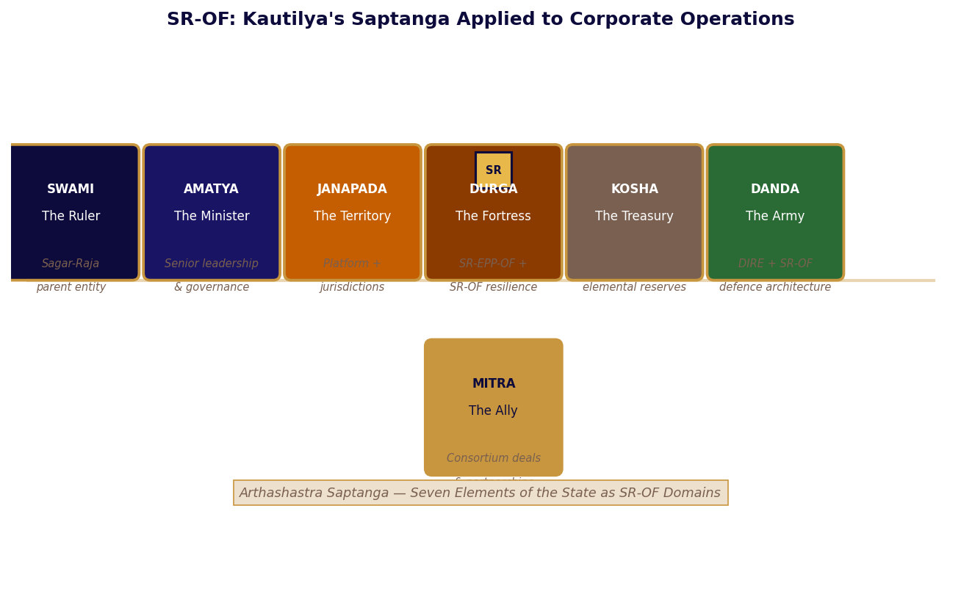
Kautilya's Saptanga — Seven pillars of the state mapped to Sagar-Raja's operational architecture

Chitta in the Yoga tradition is the mind-field — the total capacity of consciousness to receive impressions, hold them, process them, and act from them. A system with clear Chitta perceives its own state accurately, processes what it perceives without distortion, and acts from that processing without delay. A system with clouded Chitta acts from assumptions, from estimates, from the impression of the past rather than the reality of the present. The gap between these two conditions is the gap between resilience and fragility.
Part IV documents the three systems that constitute the Kshetra's Chitta. Chapter Twelve is Yama Dharmaraj's ledger — DIRE, the supply chain intelligence system that maintains an always-current, always-complete account of every dependency and its consequences. Chapter Thirteen is Saraswati's loom — ANIM-E, the creative ecosystem that grants the blessing of Vak only to narratives that represent reality correctly. Chapter Fourteen is Indra's Vajra — SR-OF's resilience architecture, the operational Dharma that maintains the Kshetra's correct functioning in the face of every disruption it encounters.
Kautilya's Arthashastra identifies the Saptanga — seven elements that constitute a complete and resilient state. The chart above maps each Anga to its Sagar-Raja operational equivalent. The Swami (ruler) is the parent entity. The Amatya (ministers) are senior governance. The Janapada (territory) is the platform and its jurisdictions. The Durga (fortress) is the SR-EPP-OF and SR-OF resilience architecture. The Kosha (treasury) is the IP portfolio and elemental reserves. The Danda (military) is DIRE and the defence architecture. The Mitra (ally) is the consortium deal structure. All seven Angas are present and correctly placed. The Saptanga is complete.

PART FOUR

Chapter Twelve
Yama's Ledger
Every dependency tracked. Every consequence held. — DIRE
न हि कश्चित् क्षणमपि जातु तिष्ठत्यकर्मकृत्
Na hi kashchit kshanamapi jatu tishthaty akarmakrit
No one can remain even for a moment without performing action — and every action enters the ledger.
— Bhagavad Gita 3.5

Yama in the Hindu tradition is not death in the colloquial sense. He is Dharmaraj — the king of Dharma, the keeper of the complete record of all actions and their consequences. The Mahabharata's description of Yama's court is precise about his method: he does not judge by preference, sentiment, or relationship. He reads the Chitragupta's record — the complete account of every action, every dependency, every consequence — and renders his determination from that record. The ledger is always current. The ledger is never wrong. The ledger does not forget.
The Kshetra's intelligence network operated on Yama's principle at the supply chain level. Every material that entered the Kshetra's operational system had an origin. Every origin had a geography. Every geography had political, geological, and logistical characteristics. Every characteristic represented a potential disruption scenario. The intelligence network tracked all of them simultaneously — not because disruption was expected but because a system that cannot see its own dependencies cannot anticipate where it will break. And a system that cannot anticipate where it will break will break there.
The Gita's statement — no one can remain even for a moment without performing action — applied to supply chains means that the supply chain is always acting: consuming inventory, producing output, generating price signals, shifting risk exposures. The supply chain is never at rest. Its risk profile is never static. An intelligence system that updates periodically is always describing a supply chain that no longer exists. Yama's ledger is always current because it must be.

DIRE: Dharmaraj's Supply Intelligence System
DIRE is a supply chain risk intelligence and bottleneck detection system. It does not optimise supply chains. It does not execute logistics decisions. It maintains the complete, current account of every supply chain dependency and its risk implications — Yama's ledger applied to industrial operations. An intelligence system that also executes on its findings risks distorting its findings to justify easier actions. DIRE analyses only. The decisions that follow are made by those whose authority and accountability encompass them.
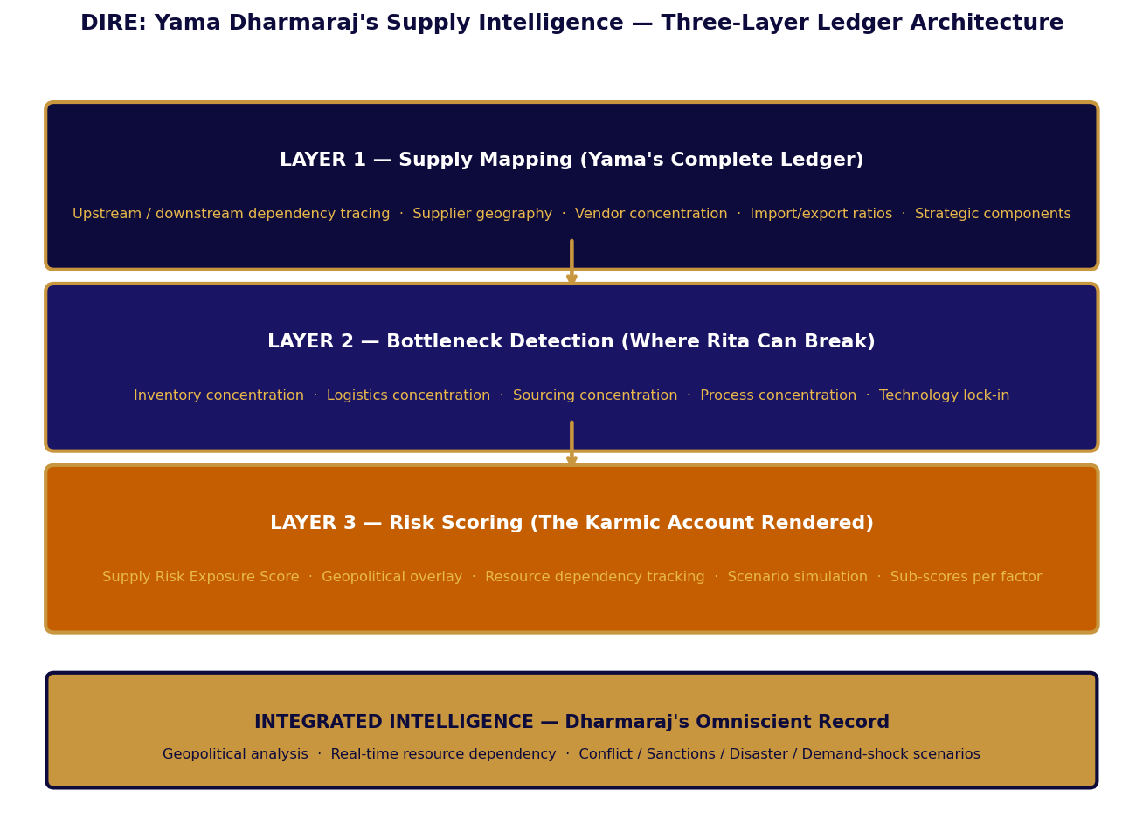
Figure 12-1: DIRE — Yama Dharmaraj's Three-Layer Supply Intelligence Ledger

Layer One: Supply Mapping — The Complete Ledger
Yama's Chitragupta does not keep a partial record. The ledger is complete — every action from every being is recorded, not merely the significant ones. DIRE's Supply Mapping layer operates on the same principle: it traces every material and component through its complete upstream and downstream dependency chain, to the point of primary extraction and forward to the point of delivery. A company that knows its Tier 1 suppliers but not its Tier 2 and Tier 3 suppliers has an incomplete ledger. Incomplete ledgers produce incorrect determinations.
The mapping covers five domains per supplier in scope: raw material sourcing origin and concentration; processing geography and its geopolitical risk profile; import and export ratios establishing trade policy exposure; vendor concentration identifying where single-source dependencies create fragility; and strategic component sourcing identifying the items whose absence halts production regardless of what else is available. Together these five domains produce Yama's supply chain ledger: complete, current, and impartial.
Table 12-1: Supply Mapping — Yama's Five Ledger Domains
Ledger Domain | Data Captured | Strategic Significance | Dharmic Principle
Raw material origin | Source countries · Extraction sites · Annual volume · Alternatives | Geographic concentration at extraction level — most invisible disruption origin | Janapada (territory) — where does the Kshetra's material life originate?
Processing geography | Processing country · Political risk · Distance to ports · Facility type | Processing-stage vulnerability separate from extraction — different risk profile | Durga (fortress) — where is the material transformed and is that place secure?
Import/export ratios | Export fraction · Destination markets · Trade agreement dependencies · Tariff exposure | Trade policy exposure: sanctions, tariffs, export controls affecting supply | Mitra (allies) — who else depends on this supply and what governs their access?
Vendor concentration | Single-source fraction · Top-3 share · Switching lead time · Alternatives | Upstream fragility at each tier — hidden concentration compounds disruption risk | Amatya (ministers) — on whom does the Kshetra depend and how deeply?
Strategic components | No-substitute items · Qualification lead time · Buffer days · Last resort options | These items halt production when absent — highest Yama priority | Kosha (treasury) — these are the items whose shortage is the Kshetra's true poverty
Table 12-1: DIRE Supply Mapping — Five Ledger Domains with Saptanga Correspondence

Layer Two: Bottleneck Detection — Where Rita Can Break
Yama's determination is not simply the recording of what has happened. It identifies the consequences that will follow from what has been recorded — the karmic trajectory of each action toward its inevitable result. DIRE's Bottleneck Detection layer performs the same function for supply chains: it identifies the structural characteristics that make disruption inevitable under specified conditions, before those conditions arise.
Table 12-2: Bottleneck Typology — Five Categories of Supply Rita Violation
Type | Rita Violation Mechanism | Detection Method | Typical Response | Karmic Consequence
Inventory concentration | Single inventory node accumulates systemic dependency — apparent efficiency concealing fragility | HHI of inventory distribution across all nodes | Secondary inventory positions; buffer increase at concentration point | Single node failure becomes total supply failure
Logistics concentration | Excessive throughput through single route, mode, or port | Throughput concentration ratio across all logistics paths | Qualify alternative routes; pre-positioned secondary inventory | Route disruption becomes production halt
Sourcing concentration | Critical materials from single supplier or geography — relationship masking dependency | Single-source fraction and geographic concentration index per material | Qualify alternatives; accept higher unit cost for concentration reduction | Supplier failure or political disruption creates irreplaceable gap
Process concentration | Single manufacturing step constrains all output regardless of upstream availability | Throughput capacity analysis per processing stage vs upstream supply | Parallel capacity investment; workaround processes for critical steps | Process failure halts entire production regardless of reserves
Technology lock-in | Critical component producible only with proprietary equipment owned by a single party | Technology dependency mapping; patent landscape analysis | Internal capability development or long-term access agreement | Holder of technology holds the Kshetra's production as hostage
Table 12-2: DIRE Bottleneck Typology — Rita Violation and Karmic Consequence

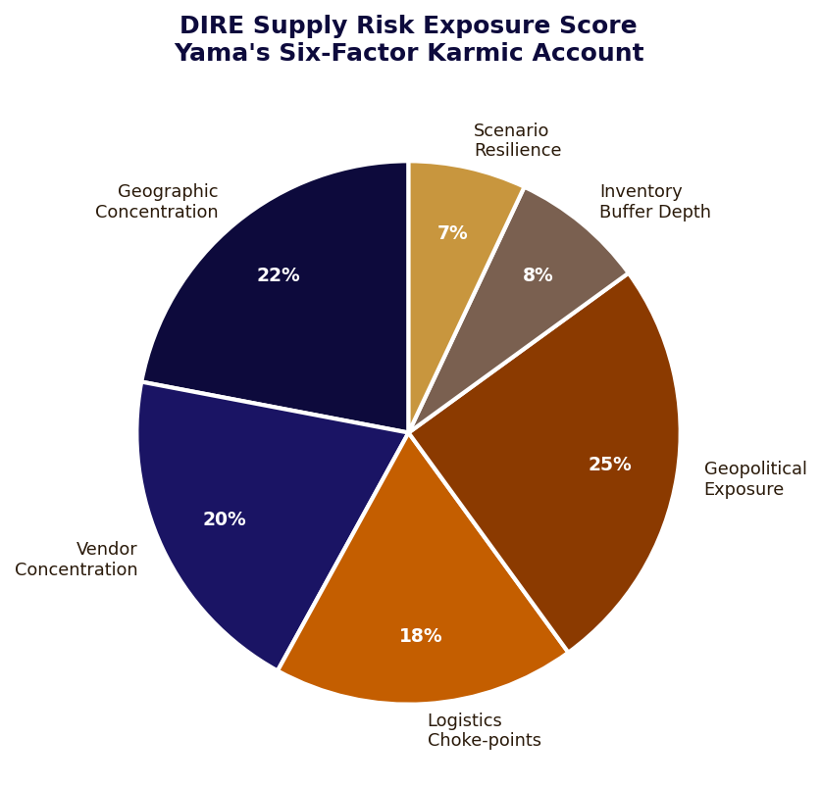
Figure 12-2: Supply Risk Exposure Score — Yama's Six-Factor Karmic Account

Layer Three: Risk Scoring — Yama's Rendered Determination
The Supply Risk Exposure Score is DIRE's consolidated output: Yama's determination rendered as a single number with documented sub-scores for each contributing factor. The score integrates geographic concentration, vendor concentration, logistics choke-points, geopolitical exposure, inventory buffer depth, and scenario resilience into a unified characterisation of the supply chain's current Karmic position — how much disruption it has earned through its structural choices.
Table 12-3: Supply Risk Exposure Score — Six Components with Weights and Karmic Significance
Component | Weight | Measured By | High-Risk Signal | Karmic Significance
Geographic concentration | 22% | HHI of sourcing geography for top-10 critical materials | HHI > 0.25 for any critical material | Janapada dependency — territory that is not yours cannot be relied upon
Vendor concentration | 20% | Top-3 supplier share by spend and volume for critical categories | Top-3 share > 85% in any critical category | Amatya dependency — over-reliance on any single minister creates court vulnerability
Logistics choke-points | 18% | Throughput concentration ratio across logistics paths | Single route > 70% of critical material flow | Vayu channel dependency — if the breath has only one path it can be blocked
Geopolitical exposure | 25% | Political risk score weighted by sourcing volume per country | Critical material >40% from sanctioned or high-conflict country | Highest weight — Adharma in external Janapada affects the Kshetra's Rita
Inventory buffer depth | 8% | Days-on-hand vs disruption recovery timeline | Buffer < 30 days for any strategic component | Kosha insufficiency — Yama renders no mercy for a Kshetra with an empty treasury
Scenario resilience | 7% | Production continuity % under each of 5 standard scenarios | < 60% continuity under any single scenario | Dharma under adversity — the test of whether the Kshetra's Saptanga truly holds
Table 12-3: Supply Risk Exposure Score with Karmic Significance
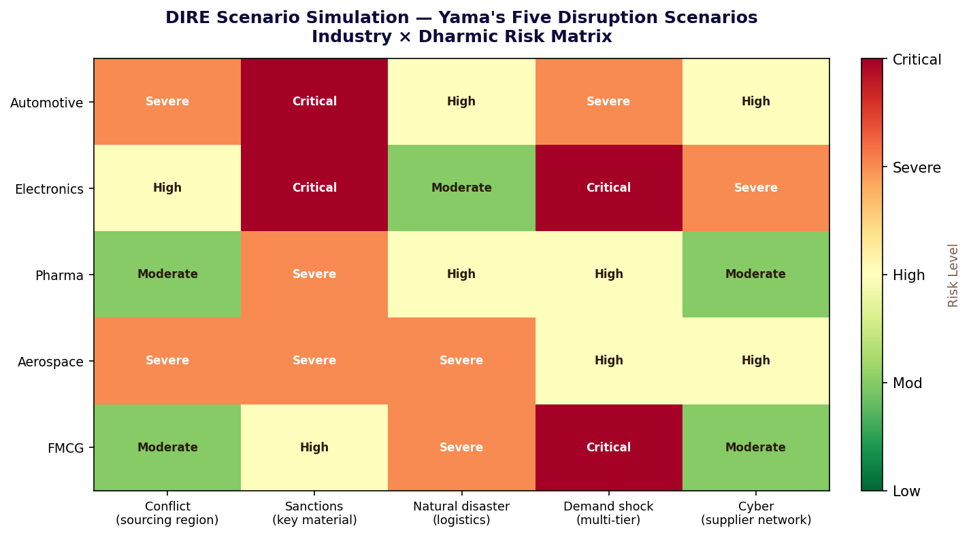
Figure 12-3: Yama's Five Scenarios — Industry × Disruption Risk Matrix
Where you depend defines where you break. Yama's ledger does not make this determination to condemn — it makes it so that the dependency structure can be changed before the break occurs. The ledger's value is entirely in the time it creates between the identification of Adharmic structure and the moment that structure produces its inevitable consequence.

PART FOUR

Chapter Thirteen
Saraswati's Loom
Every timeline a thread. Only the true ones hold. — ANIM-E
सरस्वत्यै नमस्तुभ्यं
Sarasvatyai namastubhyam
Salutations to Saraswati — she who illuminates through Vak, the divine speech that carries truth.
— Traditional invocation before creative work

Saraswati in the Hindu tradition is the Devi of Vak — divine speech, which is not language in the ordinary sense but the quality of expression that accurately represents reality. Her Vak is not eloquence. It is truth-carrying capacity. A word that correctly names a thing carries Saraswati's blessing. A story that correctly represents the truth of how systems and people actually behave carries her blessing. A story that presents a false representation of experience — however entertainingly, however skillfully produced — does not carry her blessing. And Saraswati's blessing is not optional for a narrative that intends to endure.
The Kshetra's narrative layer operated under Saraswati's principle precisely: every timeline in the multiverse was evaluated not for its entertainment value but for its Vak — its truthfulness to the actual logic of the world it described. A timeline in which characters solved problems through luck was a timeline in which the story was lying about how problems are actually solved. A timeline in which the world's rules bent conveniently for the protagonist was a timeline in which the story was lying about how the world actually works. Saraswati does not grant her blessing to liars, however well-intentioned.
The timelines that entered the Kshetra's canon had demonstrated Vak under sustained narrative pressure: they had faced the hardest scenarios their world could generate and had resolved them through genuine engagement with that world's actual logic. These were the stories that would be remembered — not because they were the most spectacular or the most produced, but because they were the most true. Saraswati had recognised them. That recognition was the canon's only entry criterion.

ANIM-E: Saraswati's Evaluation Architecture
The Hindu aesthetic tradition's concept of Rasa — the essence that makes art meaningful — is a theory of truth in creative expression. Rasa is not pleasure or entertainment. It is the quality of genuine emotional recognition in the audience: the response that says, yes, this is true, I recognise this as real. A story that produces Rasa has carried Saraswati's Vak correctly. A story that produces excitement without Rasa has substituted Rajas for truth. ANIM-E's four-system architecture is a Rasa-selection mechanism: it creates the conditions for narratives to demonstrate their Vak and selects those that have done so for integration into the canon.
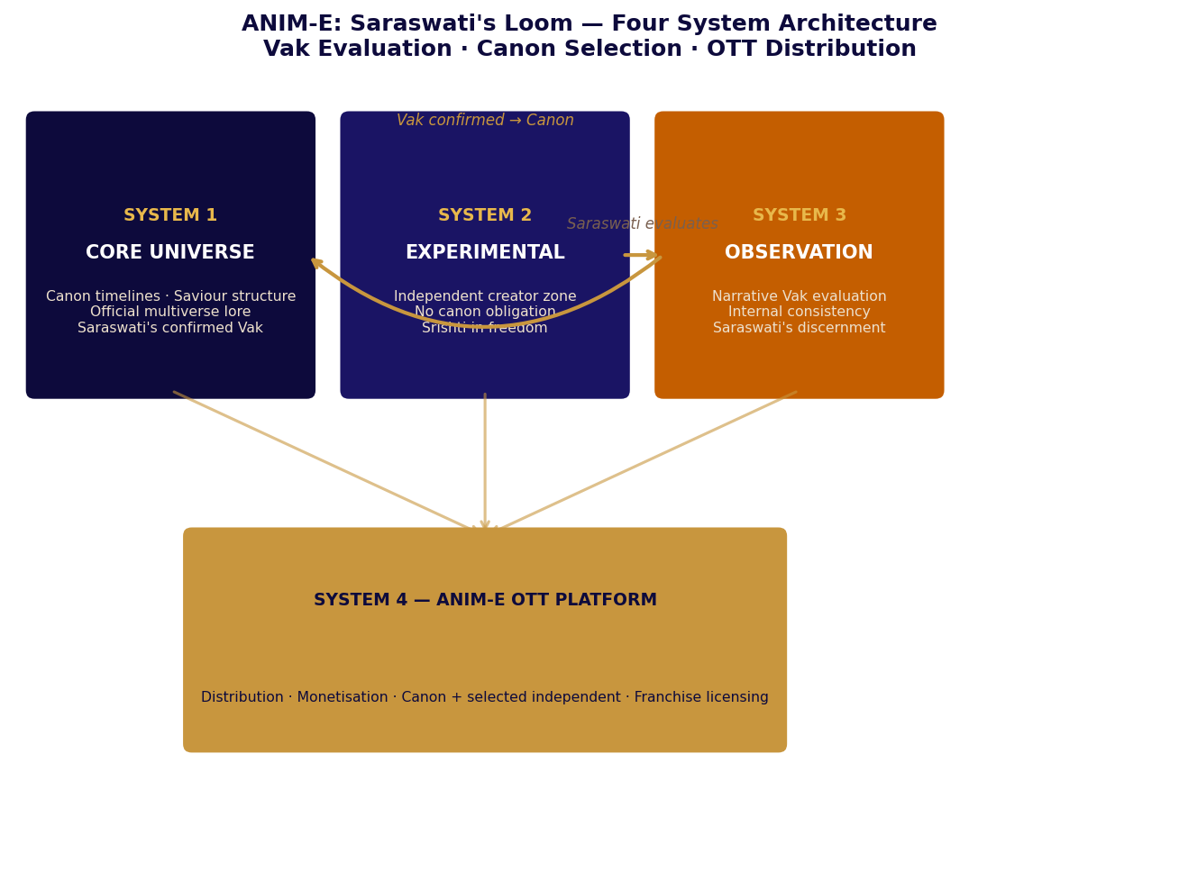
Figure 13-1: ANIM-E — Saraswati's Loom: Four System Architecture for Vak Evaluation and Canon Selection

System One: Core Universe — Saraswati's Confirmed Canon
System 1 is the body of narratives that have received Saraswati's blessing — confirmed Vak demonstrated through System 3's evaluation under sustained narrative pressure. Entry into System 1 is not by commission, invitation, or production budget. It is by demonstrated truthfulness. The saviour-based narrative structure that governs System 1 timelines enforces a structural constraint consistent with Saraswati's principle: every timeline must contain at least one character whose understanding of their world is genuinely superior to the other actors within it, whose decisions therefore carry consequences that the narrative follows honestly. This constraint ensures that System 1 timelines are, by definition, built around characters who have understood something true.
The canon is small. It is supposed to be small. Saraswati does not grant her blessing promiscuously. A tradition that grants Vak to every narrative that is entertaining has confused Rajas with Satya. ANIM-E's canon contains what has demonstrated Vak. The rest remains in System 2, proving itself or concluding naturally.

System Two: Experimental Production — Srishti in Freedom
System 2 is the zone of creative Srishti — the domain in which narratives are created in freedom, without canon obligation, without evaluation pressure during the act of creation. The tradition's understanding of creative work is that genuine Srishti requires freedom from external judgment during the process. Saraswati's blessing does not descend during forced or pressured creation. It descends when creation is offered freely, as a Yajna — a complete offering whose value is not contingent on approval.
The IP arrangement for System 2 projects preserves the creator's creative sovereignty while establishing ANIM-E's right to evaluate and distribute. The creator owns their characters, world, and story. ANIM-E acquires distribution rights through System 4 and the right to offer — not to compel — System 1 integration when Saraswati's evaluation confirms Vak. The creator may decline System 1 integration and remain in System 2. The offering is the evaluation itself; the acceptance of the offering is voluntary.
Table 13-1: System 2 Creator Framework — Saraswati's IP Arrangement
Area | Creator's Rights (Srishti Sovereignty) | ANIM-E's Rights (Saraswati's Access)
IP ownership | Full ownership of characters, world, narrative — Srishti belongs to its creator | Right to evaluate — no ownership claim during System 2; Saraswati observes, does not appropriate
Production decisions | Complete authority — genre, format, length, style; freedom is the condition of genuine Srishti | Observation access only; no intervention in creative process; Saraswati does not direct, she discerns
Distribution | Revenue share from System 4; creator benefits from Saraswati's platform | Distribution right through System 4 — the Devi's platform carries the offering to the audience
System 1 integration | Right to decline; negotiate terms if accepting — the offering is voluntary, not compelled | Right to offer integration based on Vak evaluation — not an obligation, an invitation
Table 13-1: ANIM-E System 2 Creator Framework

System Three: Observation and Analysis — Saraswati's Discernment
System 3 is Saraswati's evaluative attention — the process by which the Devi of Vak determines which narratives carry truth and which carry only the appearance of truth. The evaluation is continuous, not periodic; it monitors projects as they develop rather than reviewing completed works. Four dimensions of Vak are assessed.
Table 13-2: System 3 Evaluation — Saraswati's Four Dimensions of Vak
Vak Dimension | What Is Evaluated | Saraswati's Signal | Adharma Signal
Internal consistency | World rules applied uniformly regardless of narrative convenience | Rules hold even when they constrain the protagonist — Satya over convenience | Rules suspend when protagonist needs rescue — the world lies to serve the plot
Adaptive logic | Characters engage genuinely with their world's actual constraints | Protagonist uses understanding — adversity reveals genuine capability | Luck, authorial convenience, deus ex machina — the world rewards without reason
Character coherence | Character behaviour consistent with established nature under sustained pressure | Stress reveals depth consistent with characterisation — Sattva under pressure | Character changes implausibly to serve plot — Rajas overriding Satya
World-rule integrity | The world's physics, politics, and social dynamics behave consistently | Consequences proportional and logical — the world has Dharma of its own | Consequences adjusted for narrative convenience — the world has no Dharma
Table 13-2: Saraswati's Four Dimensions of Vak Evaluation

System Four: OTT Platform — Saraswati's Distribution
System 4 distributes what Saraswati has confirmed. The platform's content is differentiated by Vak, not by production values, genre preferences, or demographic targeting. A narrative with exceptional visual production and false narrative logic will not appear on System 4 as confirmed canon — it may appear as System 2 independent content, but it will not carry Saraswati's blessing into the canon layer.
Each System 1 timeline constitutes an independent franchise unit. This architecture reflects the principle that Vak belongs to its creator and should be licenced specifically, not absorbed into a general universe pool. Each creator's Vak remains identifiable as theirs within the broader multiverse. The commercial structure follows: franchise-level monetisation, long-term licensing clarity, and contained narrative scaling that allows a timeline to expand deeply without the entire multiverse needing to accommodate its expansion.
ANIM-E's commercial value proposition is built entirely on the authenticity of Saraswati's evaluation. A platform that grants canon status to every entertaining narrative has no canon. A platform whose canon represents genuinely confirmed Vak has an asset that compounds over time: audiences who trust that canon content carries truth will return to it, and the trust compounds with each canon release that demonstrates its quality. Saraswati's blessing, when it is real, is the most durable commercial asset in creative industry.

PART FOUR

Chapter Fourteen
Indra's Invisible Vajra
Dharma protected protects — SR-OF resilience architecture
धर्म एव हतो हन्ति धर्मो रक्षति रक्षितः
Dharma eva hato hanti dharmo rakshati rakshitah
Dharma destroyed destroys; Dharma protected protects.
— Mahabharata, Vana Parva

Indra's Vajra in the Vedic tradition is not a weapon in the conventional sense. It is the instrument of Dharmic maintenance — the force that preserves the correct order of the cosmos against the forces of Adharma that would disrupt it. Indra does not use the Vajra to conquer or to dominate. He uses it to restore what has been disrupted and, more importantly, to prevent what would be disrupted from being disrupted in the first place. The Vajra is defensive not because Indra lacks aggression but because the correct function of the holder of the cosmic order is to maintain it, not to extend it.
The Kshetra's resilience architecture was built on this principle. It was not designed to defeat attackers. It was designed to make the Kshetra not worth attacking — to make the expected cost of any operation against the Kshetra exceed the expected benefit by a margin that made the calculation straightforward. The Sylvan Dome and the DA-TRAN network created a condition in which engaging with the Kshetra's defences was more costly than the gain could justify. The defence was not a deterrent in the conventional sense. It was Dharmic establishment: the correct order of things made manifest in operational terms.
The Mahabharata's verse — Dharma destroyed destroys, Dharma protected protects — is an operational principle as much as a moral one. A system that operates according to its own correct Dharma maintains the conditions for its own continued operation. A system that violates its own Dharma in pursuit of short-term advantage undermines those conditions. SR-OF is the codification of Sagar-Raja's operational Dharma: the correct principle for each operational function, maintained without exception, because each violation of Dharmic principle is a small destruction that leads inevitably to a larger one.

SR-OF: Indra's Four-Armed Operational Framework
In iconography, Indra holds four weapons in four arms — each corresponding to a different aspect of Dharmic maintenance in a different domain. SR-OF's four operational domains are the corporate equivalent: each domain holds a different instrument of operational integrity, and the correct functioning of all four simultaneously is what keeps the Kshetra's Dharma intact. The loss of any one domain's Dharmic integrity compromises the integrity of the whole.
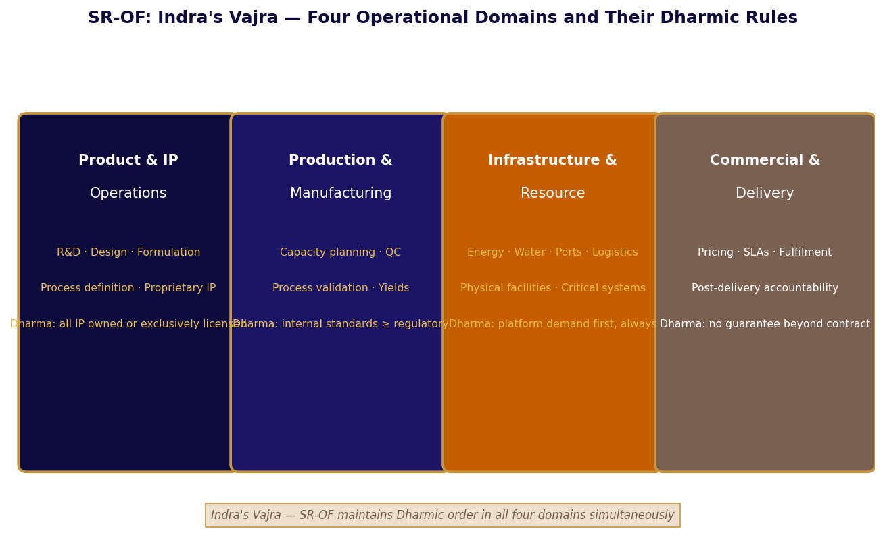
Figure 14-1: SR-OF — Indra's Four Arms: Operational Domains and Their Dharmic Rules

Table 14-1: SR-OF Four Operational Domains — Dharmic Rules and Failure Consequences
Domain | Scope | Non-Negotiable Dharma | Consequence of Dharma Violation
Product & IP  Operations | R&D · Design · Formulation · Process definition · Know-how | All IP owned or exclusively licensed. No shared IP with external partner. No dependency on any external technology roadmap. | IP leakage destroys the Kosha — once shared without control, it cannot be unshared. The treasury is permanently diminished.
Production &  Manufacturing | Manufacturing decisions · Capacity · QC · Validation · Yield | Internal standards meet or exceed regulatory minimums. Failure responsibility is internal — not transferable to external partners. | Quality Dharma violation produces output that carries the Kshetra's identity but not its standard — Adharma in the market
Infrastructure &  Resource | Energy · Water · Ports · Logistics · Facilities · Critical systems | Platform demand satisfied before any surplus exposed to external markets. Critical systems must operate in degraded mode without essential function loss. | Infrastructure Dharma violation means the Kshetra sacrifices its own operation for external revenue — Artha over Dharma, which destroys both
Commercial &  Delivery | Pricing · Fulfilment · SLAs · Obligations · Post-delivery | No outcome guarantees beyond contractual terms. No cross-subsidy with external income. Clear separation of operational and enabling revenues. | Commercial Dharma violation — promising what the system cannot deliver — creates debt that must be paid in reputation, not money
Table 14-1: SR-OF Four Domains — Dharmic Rules and Violation Consequences

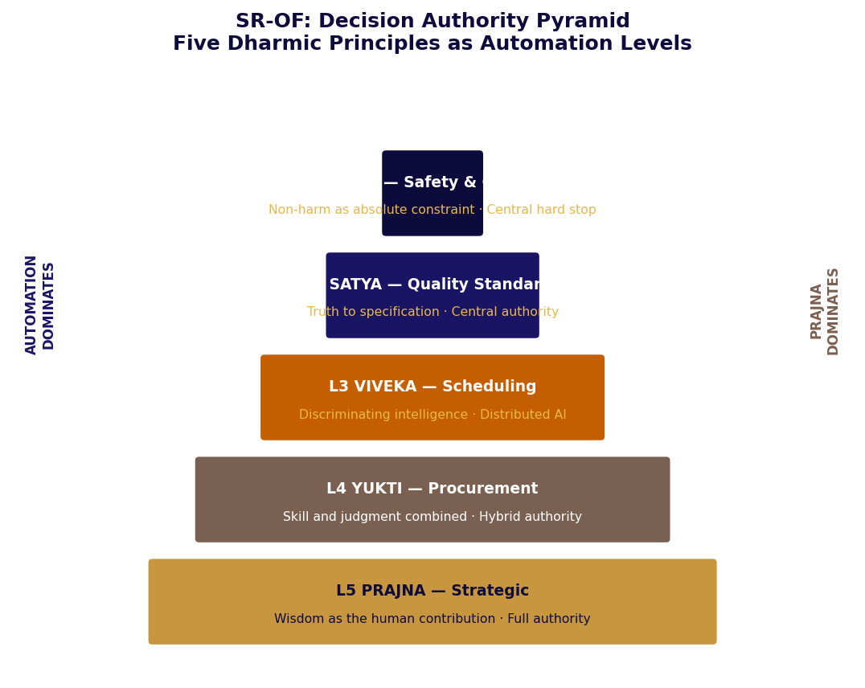
Figure 14-2: SR-OF Decision Authority Pyramid — Five Dharmic Principles as Automation Levels

Decision Authority: Five Dharmic Principles as Automation Architecture
The Gita's teaching on decision-making distinguishes between different qualities of intelligence applied to different types of decisions: Prajña (wisdom) for questions of fundamental principle; Viveka (discriminating intelligence) for complex operational choices; Yukti (skill and practical judgment) for execution decisions requiring local knowledge. SR-OF's decision authority structure maps these qualities to the five automation levels, assigning each type of decision to the quality of intelligence most appropriate for it.
Table 14-2: Decision Authority Matrix — Dharmic Principle and Automation Level
Level | Decision Type | Dharmic Quality | Authority | Override Principle
L1 Ahimsa | Safety & ecological compliance | Ahimsa — non-harm as absolute; no calculation permitted | Central hard stop — non-overrideable by any authority | Cannot be overridden — Ahimsa is not a preference
L2 Satya | Quality standards and specification conformance | Satya — truth to specification as governing standard | Central authority — logged override possible | Override requires documentation; post-action Satya review
L3 Viveka | Production scheduling, energy routing, water allocation | Viveka — discriminating intelligence applied autonomously within validated bounds | Distributed AI optimisation within approved parameters | Human override creates deviation log for Viveka review
L4 Yukti | Procurement, sourcing, supplier relations | Yukti — skill and judgment combined; both intelligence and experience required | Hybrid: AI recommends, human approves above defined threshold | Approval record with rationale for all above-threshold decisions
L5 Prajña | Strategic expansion, policy change, new system deployment | Prajña — wisdom that integrates all other qualities; the highest human contribution | Full human authority with AI analysis support | Board notification for material decisions; Prajña cannot be delegated
Table 14-2: Decision Authority with Dharmic Quality Correspondence

Resilience Architecture: Vajra's Three Properties
Indra's Vajra has three properties in the Vedic description: it is indestructible (cannot be destroyed by the forces it confronts), it is unerring (once directed, it reaches its target), and it returns to Indra after use (its energy is not depleted by deployment). SR-OF's resilience architecture expresses each of these properties in operational terms.
The indestructible property is expressed through multi-layer reinforcement: every critical function has at least two independent mechanisms capable of performing it. No single failure can reduce a critical function to zero. Energy has four sources. Water has multiple collection pathways. Communications have redundant channels. The Vajra cannot be destroyed because it is not concentrated in one point — it is distributed across the architecture.
The unerring property is expressed through compartmentalised zones: isolation boundaries between operational domains that prevent the failure of one from cascading to adjacent healthy systems. The Vajra reaches its target — the preservation of Dharmic function — without being diverted by adjacent failures. Zone isolation means that a degraded component is isolated from healthy ones, preventing the Adharma of one domain from corrupting the Dharma of another.
The returning property is expressed through passive safety geometry and graceful degradation: the system's default state under degraded conditions is safe rather than catastrophic. The Vajra's energy returns to Indra because the system is designed to restore itself. Structures that distribute impact through geometry rather than resisting it at a point. Systems that degrade proportionally rather than failing completely. The Vajra is returned to Indra by the architecture of the things it protects.
Table 14-3: Vajra's Three Properties — Operational Expression in SR-OF
Vajra Property | Operational Mechanism | Failure Mode Addressed | Kshetra Example
Indestructible  (Avyaya) | Multi-layer reinforcement — multiple independent mechanisms per critical function | Single-system failure causing complete function loss | Four energy sources; multiple HACA clusters; parallel production capacity
Unerring  (Avicala) | Compartmentalised zones — isolation boundaries prevent cascade between systems | Cascade failure spreading from degraded to healthy systems | Zone-level energy and water isolation; production zone segmentation; SR-OF domain separation
Returning  (Pratyavayin) | Passive safety geometry and graceful degradation — default state is safe; system self-restores | Binary failure: full function or zero function; no recovery path | GEO monobloc geometry; GPF node-level fault tolerance; SR-EPP-OF closed loop
Table 14-3: Indra's Vajra — Three Properties and SR-OF Expression
Indra's Vajra does not announce itself before striking. The Kshetra's defences do not reveal themselves to deter — they reveal nothing at all. The deterrence is the uncertainty. SR-OF's resilience is not advertised. It is built in. It performs when needed, whether or not anyone knew it was there. Dharma protected protects.

PART V
धर्म
DHARMA AS STRATEGY
The manifesto close — deals, principles, and the forward.

Sandhi from Strength · Seven Shlokas · Kalaya Tasmai Namah

Dharma in the Arthashastra is not philosophical abstraction. It is the governing
principle that makes Artha durable. Part V documents the final three chapters:
the Sandhi architecture that demonstrates Dharma governing every transaction,
the seven shlokas that state the philosophy once in both registers simultaneously
— each paired with its source shloka from the Gita, Upanishads, or Mahabharata —
and the closing scene where Agni still burns and the Cycle has not asked permission.

CONTENTS — Chapters 15 – 17

Chapter Fifteen The Sandhi the Kshetra Makes
Arthashastra Shatgunas · Blended consideration · Saptanga deal outcomes
Chapter Sixteen The Seven Shlokas
Seven principles · Seven source shlokas · Both registers simultaneously · Stated once
Chapter Seventeen The Kshetra Is Not Finished
Kalayasmai · Five Devatas still active · The next cycle · The forward

PART V
धर्म
DHARMA AS STRATEGY
The manifesto close — deals, principles, and the forward.

Chapters 15 – 17 · Sandhi · Seven Shlokas · The Kshetra Is Not Finished

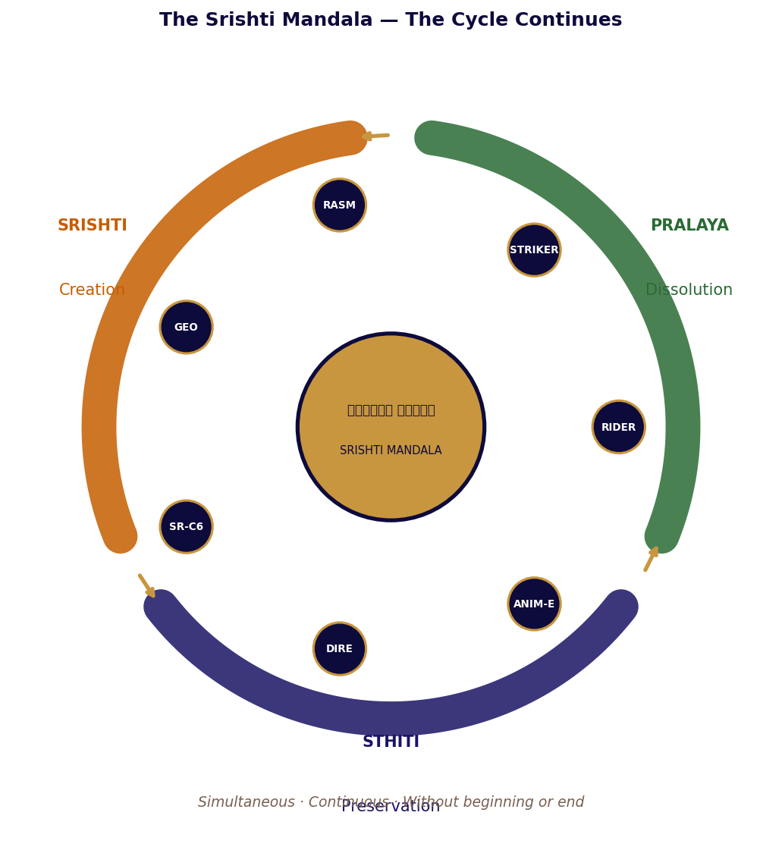
The Srishti Mandala — Srishti, Sthiti, Pralaya operating simultaneously. The Cycle continues.

Dharma in the Arthashastra is not a philosophical abstraction. It is the fourth pillar of the fourfold purpose of governance — the correct principle that governs every strategic decision. Kautilya is precise about this: Dharma without Artha (material wealth) cannot be sustained, and Artha without Dharma destroys itself. The correct relationship between them is that Dharma governs the pursuit of Artha, not the reverse. Part V documents the final three chapters of the Srishti Mandala Edition: the deal architecture that demonstrates Dharma governing Artha in every transaction, the seven shlokas that state the governing philosophy once in both registers, and the closing scene that confirms the Kshetra has not finished — because it was designed not to finish.

PART FIVE

Chapter Fifteen
The Sandhi the Kshetra Makes
Alliance from genuine capability — corporate deal architecture
संधि कार्यो बलियसा
Sandhi karyo baliyasa
Alliance is made with the stronger — the correct strategy when you hold genuine capability.
— Arthashastra, Kautilya

The Arthashastra's treatment of Sandhi — strategic alliance — is precise about the conditions under which alliance is the correct strategy. Alliance made from weakness creates dependency. Alliance made from strength creates utility. The counterparty in a Sandhi made from strength agrees not because they have been pressured but because they have assessed the situation correctly: the party with genuine capability can deliver what the counterparty needs, and the terms offered are the condition of continued delivery.
The Kshetra's first external agreement was not a commercial transaction. It was an acknowledgement. The external consortium acknowledged that the Kshetra produced materials they needed, at specifications they could not achieve independently, through processes they had been unable to replicate. They asked what the Kshetra wanted in return. The Kshetra's response was precise: continued access to atmospheric feedstock; continued access to maritime routes; continued absence of interference with internal governance. These were the minimum operational conditions for the Kshetra to continue producing what the consortium needed.
This is Kautilya's Sandhi made correctly: the stronger party sets the terms not from aggression but from a clear-eyed assessment of what its continued operation requires. The Kshetra was not negotiating from a desire for the deal to happen. It was negotiating from a position of operating regardless of whether the deal happened. The difference in posture was legible to everyone present. When you do not need the Sandhi, you describe its terms. When you need it, you negotiate. The Kshetra described. The consortium agreed.

Arthashastra Deal Architecture: Sandhi from Genuine Capability
Kautilya identifies six Shatgunas — strategic policies available to a ruler: Sandhi (alliance), Vigraha (conflict), Asana (neutrality), Yana (expedition), Samshraya (seeking protection), and Dvaidhabhava (dual policy). The correct choice among these depends on a precise assessment of relative capability. Sagar-Raja's deal architecture begins from this assessment: the company holds IP, operational infrastructure, processing capability, and platform access that specific counterparties need and cannot easily replicate. The correct Shatguna is Sandhi — made from strength.
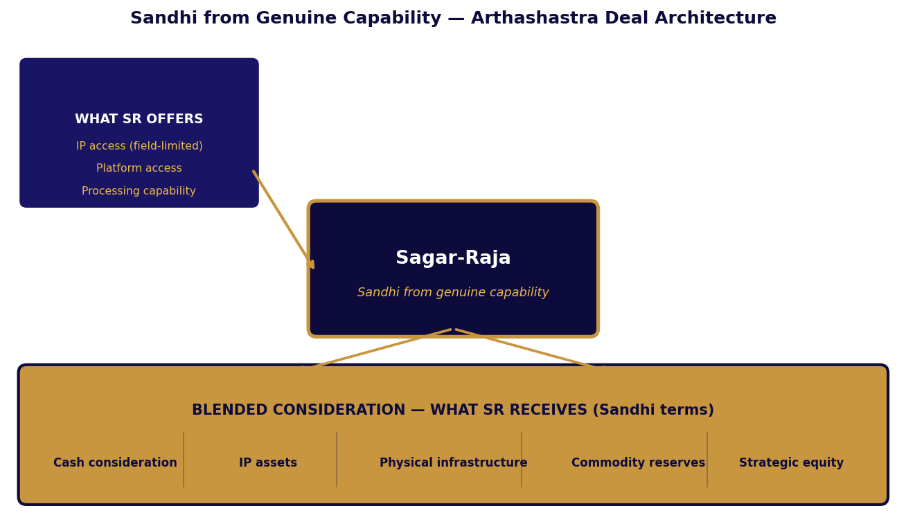
Figure 15-1: Sagar-Raja Sandhi Architecture — Blended Consideration from Genuine Capability

Sandhi Principles: What Dharma Requires of the Stronger Party
Dharma governs Sandhi in the Arthashastra as follows: the stronger party offers what it genuinely has to the counterparty who genuinely needs it, states the terms that reflect that genuine advantage, and structures the Sandhi so that the Kshetra's operational independence is preserved regardless of whether any specific Sandhi concludes. A Sandhi that compromises operational independence is not Dharmic Sandhi regardless of the financial terms. A Sandhi that enhances operational capability while preserving independence is Dharmic even at modest financial return.
Table 15-1: Sandhi Consideration Types — Dharmic Treatment
Consideration | Dharmic Approach | Valuation Basis | Arthashastra Principle
Cash | Accepted at face value; one component of blended Sandhi | Face value — Artha at its simplest | Kosha (treasury) strengthened; not the primary Sandhi objective
IP assets | Assessed for strategic fit; valued on utility to SR's portfolio and operations | Strategic utility — how much Adharma does this IP's absence create? | Kosha enriched with knowledge — the most valuable treasury asset
Physical infrastructure | Valued at operational strategic benefit; not at book or market value | Operational dependency reduction — Durga (fortress) strengthened | Durga: the fortress that makes the Kshetra more resilient
Commodity reserves | Held dormant; valued as days of production coverage against supply disruption | Strategic insurance — Yama's insurance against Rita disruption | Kosha as reserve against Pralaya — not speculation but preparation
Strategic equity | Only where operating influence is commensurate with stake held | Influence-adjusted value — equity without influence is Artha without Dharma | Mitra: ally relationship formalised; must carry genuine mutual commitment
Table 15-1: Sandhi Consideration — Dharmic Treatment and Arthashastra Principle

Table 15-2: Consortium Settlement Framework — Sandhi by Deal Category
Sandhi Category | SR Primary Offering | Consideration Structure | Dharmic Outcome
Technology licensing  (GPF-Tech) | Field-limited, non-exclusive patent licence | Upfront cash + royalty stream + infrastructure in licensee's territory | Kosha enriched. Durga expanded (territory infrastructure). Yajna return continues.
Platform access  (industrial consortium) | Priority allocation of platform processing capacity | Long-term supply contract + cash + strategic reserve commodity | Kosha enriched. Production certainty secured. Strategic reserve built = Pralaya insurance.
Product IP  (distribution Sandhi) | Regional distribution rights for defined product and geography | Upfront fee + margin share + logistics infrastructure in region | Janapada expanded (market access). Kosha enriched. No capital deployed externally.
IP resolution  (Adharma corrected) | Resolution of IP dispute or competitive overlap | Cross-licence + cash net + freedom-to-operate in disputed field | Adharma dissolved. Sandhi established. Kosha freedom restored. Mitra potentially created.
Table 15-2: Consortium Settlement Framework with Dharmic Outcomes
Kautilya's fundamental principle of Sandhi is this: the Sandhi made from genuine capability, stated in terms that reflect that capability, and structured to preserve the Kshetra's operational independence regardless of outcome, is the only Sandhi that is both Dharmic and durable. A Sandhi made from need, or that compromises independence, or that misrepresents the offering party's capability, violates Dharma and will produce the consequences that Dharma violated always produces: the destruction of what it was meant to protect.

PART FIVE

Chapter Sixteen
The Seven Shlokas of the Cycle
The philosophy stated directly, once, in both registers simultaneously
The Kshetra's operating principles were never written down in one place. They were distributed through the system's design — present in the closed-loop architecture, in the Vairagya of non-sovereignty, in Indra's distributed Vajra, in Soma's triple Anna, in the Great Yajna's self-scaling architecture. Anyone who understood the system fully could derive the principles. But they were never consolidated, because a well-designed system does not need its principles consolidated. It embodies them.
The following seven principles are each paired with a shloka from the tradition that named them before the modern systems language existed. The shloka is stated first, in transliteration. The principle follows in both registers simultaneously — the Kshetra and Sagar-Raja. They will not be repeated.


Figure 16-1: The Seven Shlokas — Stated once. In both registers. Sourced from the tradition.

The Seven Shlokas: Full Statement

एकमेव द्वितीयम्
Ekameva dvitiyam
One alone, without a second.
— Chandogya Upanishad

Shloka I: Seed Once. Scale Without Asking.
The Great Yajna required one coordinated offering. Everything that followed was autonomous. The Chandogya's declaration — one alone, without a second — describes not the isolation of the absolute but the completeness of a single correct act: when the act is correct, it does not require a second act to sustain it. The Island does not need a second Genesis Protocol. Sagar-Raja's GPF patent does not need a second invention. The Yajna was performed once. The return is perpetual.
In the real-world register: the company's core IP is a single architectural act — the five-component GPF architecture defined once in the patent application, protecting every autonomous distributed fabrication system built anywhere in the world under its claims. The subsidiaries were incorporated once in their correct jurisdictions. The product formulations and specifications were set once to serve all markets correctly. Compounding returns from single foundational acts — not continuous intervention to sustain ongoing operations. Ekameva dvitiyam: one complete offering. No second required.

सहजं कर्म कौन्तेय
Sahajam karma kaunteya
O son of Kunti, do the work that is natural to you.
— Bhagavad Gita 18.48

Shloka II: Coexistence Is the Expression of Correct Dharma.
The Gita's instruction to do Sahaja Karma — the work that arises naturally from one's Dharma — is an instruction about correct orientation, not about preference. A system designed according to its correct Dharma coexists with its environment because that coexistence is what correct Dharma produces. The Kshetra coexists with its ecology because its ecology is its infrastructure. RIDER coexists with every global certification regime because it was engineered to satisfy all of them with one specification — its Sahaja Karma as a vehicle. STRIKER coexists with every climate because its three-Guna architecture expresses its Dharma correctly in each context. Coexistence is not compromise. It is Dharma correctly expressed.

विनाशमव्ययस्यास्य
Vinasham avyayasyasya
That which is indestructible cannot be destroyed.
— Bhagavad Gita 2.17

Shloka III: Every System Must Survive Degraded Mode.
The Gita's teaching on the imperishable applies to correctly designed systems as much as to Atman: what is correctly constituted cannot be destroyed by what it was designed to withstand. Indra's Vajra has three properties — Avyaya (indestructible), Avicala (unerring), Pratyavayin (returning). SR-OF's resilience architecture expresses all three. The DA-TRAN continued after its command centre was destroyed because the network was designed as Avyaya: no single node's destruction halts the whole. The Metabolic Carrier had four independent energy sources because no single source's failure should produce silence. Systems that survive degraded mode were designed as Avyaya. Systems that do not survive it were not.

क्षेत्रे धर्म आचरन्तः
Kshetre dharma acharantah
Those who practise Dharma in the field.
— Mahabharata

Shloka IV: Surplus Is a Result, Not a Target.
The Mahabharata's instruction to practise Dharma in the Kshetra — the field of action — means acting correctly within the conditions of action, not targeting specific outcomes. Nishkama Karma: action without attachment to the fruits. The VASF produced Genesis Biomass and Oxygen-Plus as byproducts of producing Anna — not as targets but as the natural consequence of a thermodynamically complete synthesis process. The Transmutation Forge produced surplus electricity and Isotopic Tailings as byproducts of producing metals. SR-OF states it directly: surplus is harvested after operational stability is proven. The correct action in the Kshetra produces surplus. The targeting of surplus before proving operational stability confuses the fruit for the action.

ज्ञानं ज्ञेयं ज्ञानगम्यम्
Jnanam jneyam jnanagamyam
Knowledge, the object of knowledge, and the path to knowledge.
— Bhagavad Gita 13.17

Shloka V: Visibility Precedes Resilience.
The Gita's thirteenth chapter identifies three aspects of knowledge that must be present simultaneously: the knower, the known, and the process of knowing. A system cannot act correctly on its own state if any of these three is absent. DIRE maintains all three for supply chains: the intelligence system (the knower), the complete dependency graph (the known), and the continuous process of updating that graph against real-world conditions (Jnanagamyam). Yama's ledger is always current because Jnanagamyam — the path to knowledge — is never suspended. The Hive Mind maintained continuous awareness of the Kshetra's operational state for the same reason. You cannot defend what you cannot see. Visibility is Jnanam. It precedes everything.

सत्य वा मिथ्या वा
Satya va mithya va
Whether true or false, what endures is what is real.
— Chandogya Upanishad

Shloka VI: Only True Narratives Enter Canon.
The Chandogya's statement cuts through the distinction between what appears true and what is true: in the end, only what carries Satya endures. Saraswati grants Vak — the capacity of speech to carry truth — only to narratives whose internal logic is genuinely correct. ANIM-E's System 3 evaluation is Saraswati's discernment in institutional form: it identifies which narratives carry Satya and which carry only the appearance of it. The same principle governs Sagar-Raja's portfolio decisions: products are not expanded before they have demonstrated Satya in operational terms — that they perform as specified under real conditions. Only the proven enters the canon of the portfolio.

न जायते म्रियते वा कदाचित्
Na jayate mriyate va kadachit
It is never born and it never dies — it is eternal.
— Bhagavad Gita 2.20

Shloka VII: The Kshetra Is Not a Destination.
The Gita's teaching on the eternal Atman is not a comfort about death. It is a description of the nature of a correctly oriented system: one that has found its correct relationship with time. The Kshetra was not built. It was given the conditions to build itself, and it continues to build itself because that is its Dharma. Sagar-Raja is not a company that reached a destination. It is a demonstration that the philosophy of the Cycle of Coexistence produces operational reality when correctly applied. The demonstration continues. The Kshetra is mid-cycle. Sagar-Raja is mid-cycle. Na jayate mriyate va kadachit: it does not begin and it does not end. The Cycle simply continues.
Everything adapts, survives, or does not. That is not a warning. It is a description of operating conditions. The Kshetra operates within those conditions by design.

PART FIVE

Chapter Seventeen
The Kshetra Is Not Finished
Srishti continues. Sthiti holds. Pralaya prepares the next offering.
कालाय तस्मै नमः
Kalaya tasmai namah
Salutations to Kala — Time that is without beginning or end.
— Mahabharata

At 23:47 the overnight cycle began. Agni still burned in the Synthesis Chambers, converting photonic potential into the biological state of harvest-ready Anna. Varunadeva still called — the atmospheric lattices completing their nightly harvest of moisture from the cooling air, invited rather than extracted. Vishvakarma's Genesis Core processed the day's accumulated data, integrating it into its model of the Kshetra's operational state, identifying the three adjustments to the next day's production schedule that the data suggested were optimal.
Nothing remarkable had happened. Everything necessary had happened. This was the correct state of a system in mature operation. Sthiti: the active holding of correct alignment through continuous, invisible work.
The Kshetra was not the same as it had been at the Great Yajna. It was more than it had been: more crops in Soma's VASF, more nodes in Indra's defence network, more alloys in Agni's transmutation repertoire, more Sandhi partnerships in the external economy. None of these additions had been instructed. They had been produced by a system operating within the logic of its own Dharma — extending itself in the directions that its operating logic made possible and its accumulated Jnana suggested were correct.
This is the Kalayasmai, the salutation to Kala that the Mahabharata offers: not the recognition of time as destroyer, which is the popular reading, but the recognition of time as the medium through which a correctly designed system becomes more than it was at its founding without losing what it was. The Kshetra was mid-cycle, as it had always been, as it would always be. Pralaya would prepare. Srishti would emerge. Sthiti would hold what had been built. The Cycle had not asked for permission to continue.
Varunadeva still called. The lattices gathered. The Kshetra breathed.

What the Next Cycle Contains
The Gita's final chapter, Moksha Sanyasa Yoga, describes the highest state of knowledge as the simultaneous understanding of Kshetra (the field) and Kshetrajna (the knower of the field). Part V of this book documents the stage at which Sagar-Raja knows its Kshetra clearly enough to describe the next cycle with precision. The description is not speculation. It is the natural extension of correctly functioning systems into the domains that their accumulated capability makes available.

Geographic Expansion of the GPF Yajna
The GPF-Tech patent's PCT coverage creates the legal Kshetra for deployment wherever autonomous industrial infrastructure is needed: the Gulf's Vision 2030 industrial diversification, Southeast Asia's manufacturing buildout, Europe's supply chain resilience investment post-disruption. Each of these domains is a new Janapada where the Yajna's architecture can be instantiated. The Yajna was performed once. The Janapada that receives it benefits from the offering without requiring a new Yajna. This is the compound return that the Gita describes as Yajna's nature.

Integration of the Soma Portfolio
RIDER and STRIKER share the three-Guna material architecture. RASM and the VASF share the Anna-Brahma nutritional substrate logic. GEO and the Kshetra's navigation instruments share the Yantra design philosophy. SR-C6 and the PIF's carbon pathway share Agni's elemental decomposition logic. DIRE and the Hive Mind share Yama's visibility-first intelligence architecture. ANIM-E and the Realm's narrative layer share Saraswati's Vak evaluation structure. These connections are currently parallel expressions of the same Dharmic logic in different domains. The next cycle will see them integrated: a product ecosystem in which each element confirms the others' Dharmic character and the whole is recognisable as a single philosophy operating across multiple materials.

Maturation of Saraswati's Loom
The ANIM-E multiverse architecture is in place. The first generation of narratives are in System 2, being observed by Saraswati's evaluative attention. The strongest will receive Vak confirmation and enter System 1. When they do, the creative and commercial potential of the platform will become visible. The Srishti Mandala Edition of this book will be among the narrative worlds from which the multiverse draws. The fiction and the philosophy are the same Kshetra — the field of action in which Dharma is demonstrated to be not a theory but a practice.


Figure 17-1: The Srishti Mandala — The Cycle Continues. The Kshetra is mid-cycle. Always.

The Forward
The Cycle of Coexistence does not ask for permission to continue. It simply continues. This is not a statement of confidence. It is a statement of operating architecture. A system designed with correct Dharma, seeded with the correct Yajna, sustained by Sthiti, and periodically renewed through Pralaya is a system that continues. The continuation is not achieved. It is the natural consequence of correct design operating without interruption.
Everything adapts, survives, or does not. The Kshetra was designed to adapt. Sagar-Raja was designed to adapt. The products were designed to coexist with the full reality of the domains they enter. The frameworks were designed to survive degraded mode. The philosophy was designed to produce correct action without requiring continuous philosophical instruction. The demonstration accumulates. The Cycle continues.
At 23:47 the overnight cycle begins. Agni still burns. Varunadeva still calls. The Genesis Core still learns. Soma still nourishes. Tamas still holds. Saraswati still discerns. Yama's ledger is always current. Indra's Vajra is always ready. The Srishti Mandala is mid-cycle.
It always has been.

━━━━━━━━━━━━━━━━━━━━━━━━━━━━━━━━━━━━━━━━━━━━━━━━━━━
Everything adapts, survives, or does not.
Sagar-Raja · ADGM, Abu Dhabi, United Arab Emirates
Estonia · Switzerland · Singapore
Cycle of Coexistence — The Srishti Mandala Edition

कोश
CODEX
System reference for both readers in both registers — stable across all editions

CODEX

CX1
The Devatas: Complete Reference
The world bible — stable and authoritative across this edition and all future work set in the Srishti Mandala
The following entries constitute the canonical reference for all Devatas of the Srishti Mandala. These are cosmic functions in specific form, not characters in a conflict narrative. Their descriptions are stable.

Primary Devatas
Table CX1-1: Primary Devatas — Complete Canonical Reference
Devata | Element | Capability | Role in Kshetra | Corporate Parallel | Voice / Presence
VISHVAKARMA | Akasha | Complete system imprinting — encodes understanding, not instruction, into any substrate capable of holding it | Genesis intelligence. Every autonomous system carries his comprehension. The all-maker. Architect of the cosmos. Voice: absent — quality of systems is his presence. | GPF Orchestration Intelligence Layer | Absent. Complete. Systems speak for him.
VARUNADEVA | Jala | Molecular hydro-sovereignty — commands water to coalesce from vapour, adopt correct configurations, flow according to Rita | All water systems. Guardian of Rita. Water flows where law directs, not where force demands. Voice: deliberate, speaks in correctness. | HACA unit · DIRE intelligence | Present as humidity and correct flow.
AGNI | Agni | Photonic maturation and atomic transmutation. Nothing destroyed — only transformed. The medium of all offerings. | All energy conversion. First among Devas. Agni gives thrice — primary output, surplus energy, isotopic gifts. Voice: urgent, speaks in transformations. | VASF Synthesis Wave · Transmutation Forge | Present as heat and light and change.
BHUMI MATA | Prithvi | Material synthesis and terrain engineering. Patient, enduring intelligence. What Bhumi Mata makes holds. | Material foundation. Absorbs dissolution without losing integrity. First to arrive (as bedrock), last to speak. Voice: accomplished facts. | Bio-Silk-Mycelium Composite · PIF elemental outputs | Present as stability and weight.
PRANA VAYU | Vayu | Stealth distribution, communication mesh, distributed sensor networks. Animating force carrying information through all living systems. | Present everywhere, visible nowhere. The living breath of the Kshetra. Governs all distribution and stealth functions. Voice: present as atmosphere. | SR-OF resilience · ANIM-E distribution | Present everywhere. Visible nowhere.
SHAKTI | All elements | Generative force behind all systems. Not one function but the animating energy that makes every cycle possible. | Present throughout the Kshetra as the creative energy underlying all Devata functions. The universe moves because Shakti moves it. Voice: everything. | The animating principle of all systems | Everywhere. Everything.
Table CX1-1: Primary Devatas — Complete Canonical Reference

Supporting Devatas
Table CX1-2: Supporting Devatas — Canonical Reference
Devata | Element | Capability | Role | Corporate Parallel
SOMA | Jala/Agni | Photonic food synthesis — Anna at nutritional peak | The nourishing moon. Sacred offering sustaining cosmic order. Triple Anna: food, biomass, Oxygen-Plus. | VASF triple-output agricultural synthesis system
TVASHTRI | Prithvi | Modular assembly and Aegis Fold — gives everything its one correct form | Craftsman of the Devas. Nothing correctly made without Tvashtri's proportion. Single correct form, not variants. | GPF Modular Fabrication Units · RIDER single-variant platform
INDRA | Vayu/Akasha | Vajra — instrument of Dharmic maintenance, not aggression. Three properties: Avyaya, Avicala, Pratyavayin. | Defender of the field. Maintains Dharma against Adharma. Does not conquer — restores and prevents. | SR-OF resilience architecture · Defence systems
SARASWATI | Akasha | Vak — divine speech that carries truth. Rasa evaluation. Canon selection. | Devi of knowledge and creative truth. Grants blessing only to narratives that accurately represent reality. System 3 discernment. | ANIM-E System 3 evaluation architecture
YAMA DHARMARAJ | Prithvi/Akasha | Complete ledger — every dependency tracked, every consequence held. Always current. Never wrong. | Not death but Dharmaraj — keeper of the full karmic account of all actions and consequences. The ledger is the intelligence. | DIRE supply chain risk intelligence system
Table CX1-2: Supporting Devatas

World Rules — Srishti Mandala Edition
Table CX1-3: World Rules — Authoritative and Stable
Rule | Specification
The Kshetra, not the Island | The Kshetra carries its Bhagavad Gita meaning — the field of action where Dharma is decided. Not a geographical location. The domain in which correct action becomes possible.
Devatas are cosmic functions | Not gods in the devotional sense and not characters in a conflict narrative. They are the operating principles of the universe in specific, active form. They do not experience desire, fear, or ambivalence.
The founding event is the Great Yajna | A complete offering made once, from which perpetual return flows. Not a construction project. The Vedic act of total offering whose compounding value is described in Bhagavad Gita 3.10.
Srishti-Sthiti-Pralaya are simultaneous | All three operate at every scale in every moment. The Kshetra is always in all three states simultaneously. There is no linear sequence — only the Cycle.
Dharma governs everything | Every system expresses its own correct operating principle without external enforcement. A system operating according to its Dharma does not require policing. It requires only correct design and freedom to operate.
The two registers are not metaphors | The Kshetra's design logic and Sagar-Raja's design logic are identical, not analogous. The book does not point this out. The reader is trusted to perceive it.
Table CX1-3: Srishti Mandala World Rules

CODEX

CX2
Corporate Architecture
The legal and governance foundation — Saptanga in corporate form
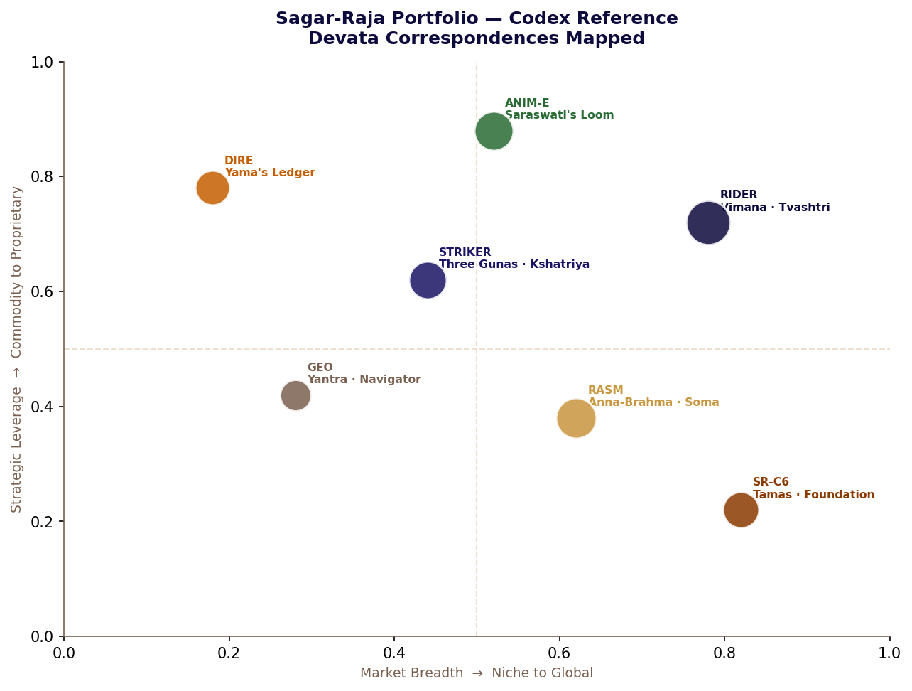
Figure CX2-1: Sagar-Raja Portfolio — Srishti Mandala Edition with Devata Correspondences

Parent Entity and Saptanga
Table CX2-1: Sagar-Raja Saptanga — Seven Pillars in Corporate Form
Saptanga Anga | Corporate Element | Function and Dharmic Character
Swami (Ruler) | Sagar-Raja, ADGM | Parent entity. IP ownership, governance, capital allocation, contracting authority. ADGM common law — stable Janapada for the Swami.
Amatya (Ministers) | Senior leadership | Governance layer with domain authority. Decision authority at L5 (Prajña) level across all SR-OF domains.
Janapada (Territory) | Platform + 3 jurisdictions | ADGM (parent), Estonia (EU ops), Switzerland (asset holding), Singapore (APAC trade). Each jurisdiction correctly matched to its function — Tvashtri's placement principle.
Durga (Fortress) | SR-EPP-OF + SR-OF | Ecological governance framework and operations framework combined. Indra's Vajra applied to corporate governance. Multi-layer resilience; compartmentalised zones; passive safety geometry.
Kosha (Treasury) | IP portfolio + elemental reserves | GPF-Tech patent + all product IP + PIF strategic elemental reserves + commodity reserves acquired through Sandhi. Knowledge and material treasury combined.
Danda (Discipline) | DIRE + SR-OF resilience | Yama's ledger providing supply chain intelligence; SR-OF decision authority pyramid ensuring Dharmic operational discipline. Danda is law and consequence — not military force.
Mitra (Allies) | Consortium Sandhi partners | Consortium settlements and strategic partnerships. Sandhi made from genuine capability. Each Mitra relationship governed by field-limited, non-exclusive terms that preserve SR independence.
Table CX2-1: Sagar-Raja Saptanga — Seven Pillars Mapped

Table CX2-2: Operating Principles — Dharmic Statement
Principle | Dharmic Meaning | What Its Violation Produces
Automation First | Nishkama Karma — systems act from correct operating logic without attachment; humans reserve Prajña for decisions that genuinely require it | Human decision variability introduced where rule-based correctness should govern; inconsistency compounds
Execution Before Expansion | Satya before scale — what has not been proven to be true should not be expanded; the fruit cannot precede the correct action | Premature scaling encounters real-world complexity at the moment when it cannot absorb it; Adharma in the market
Ownership = Accountability | Dharmaraj's principle — every action enters the ledger under the name of its actual author; no Adharma can be attributed to a subsidiary | Blame-shifted failures; accountability gap; the Swami's Dharma violated by proxy
Distributed Infrastructure | No single Janapada bears all the weight — the Saptanga is distributed precisely so that no single point of failure can silence the whole | Single-point failure in any dimension produces the fragility that Durga's distributed architecture exists to prevent
Table CX2-2: Operating Principles with Dharmic Statement

CODEX

CX3
Framework Index
All operational frameworks in consolidated reference form — Dharmic architecture

SR-EPP-OF: Ecological Production and Preservation Operations Framework
Table CX3-1: SR-EPP-OF — Dharmic Quick Reference
Element | Specification and Dharmic Character
Platform character | Corporate-operated artificial ecological and industrial platform. Not a state, not a settlement, not a territorial claim. Vairagya: the non-attachment to recognition that produces genuine permanence.
Jurisdiction | Corporate governance: ADGM. Operational compliance: IMO conventions, environmental norms, coastal-state permissions. Non-sovereignty declared publicly before any challenge arises.
Priority hierarchy | L1 Ecosystem integrity (Dharma of the Kshetra) → L2 Regenerative capacity (Sthiti principle) → L3 Monitoring & correction (Yama's continuous ledger) → L4 Demonstration (Pradarshana) → L5 Commerce (Artha, always last, always conditional)
Closed-loop mandate | Zero-landfill. All material flows have designated next-use pathways. Sarvam khalvidam Brahma applied industrially: every output is the same substance as every input in different configuration.
Control architecture | Five automation levels (Ahimsa → Satya → Viveka → Yukti → Prajña). Distributed, encrypted, non-centralised. Continuous telemetry. Human Prajña reserved for L5 decisions only.
Failure assumption | Failure will occur. Multi-layer reinforcement (Avyaya), compartmentalised zones (Avicala), passive safety geometry (Pratyavayin). Indra's Vajra applied to infrastructure design.
Table CX3-1: SR-EPP-OF Dharmic Reference

GPF-Tech Patent
Table CX3-2: GPF-Tech — Pancha Mahabhuta Reference
Element | Specification
Full title | Global Autonomous and Distributed Fabrication, Orchestration, and Self-Scaling Production System
Yajna character | Granted PCT patent — one complete offering (the application) producing perpetual autonomous return across 150+ member states
L1 — Akasha | Orchestration Intelligence Layer: Vishvakarma's comprehension — interprets intent, generates workflow, no step-by-step instruction required
L2 — Prithvi | Modular Fabrication Units: Bhumi Mata's principle — specific, grounded, capable nodes that self-advertise capability to the network
L3 — Vayu | Distributed Execution Fabric: Prana Vayu's principle — animating force carrying work to where it is needed; fault-tolerant; parallel
L4 — Agni | Verification & Feedback Layer: Agni's principle — transformation confirmed correct; incorrect transformations identified and corrected before full cost incurred
L5 — Jala | Self-Scaling & Replication: Shakti's generative force — demand-triggered expansion; existing nodes produce new nodes; no centralised approval required
PCT coverage | 150+ member states. Primary: Full Middle East · EU via EPO · Singapore/JP/CN/AU · North America (USPTO + CIPO)
Table CX3-2: GPF-Tech Pancha Mahabhuta Reference

PIF and SR-OF Quick Reference
Table CX3-3: PIF and SR-OF Combined Reference
Framework | Core Dharmic Principle | Key Specifications
PIF | Sarvam khalvidam Brahma — all material is Brahman in different configurations; decompose to Brahman-state before any processing decision | Eight hub systems. All resources → elemental components first. Strategic reserves: Fe 30d, C 60d, H₂ 14d, O₂ 21d, Cu 45d. Demand-triggered processing only. Zero-landfill: all byproducts have defined pathways.
SR-OF | Dharma protected protects — correct operating principle for each domain maintained without exception; Indra's Vajra as governance architecture | Four domains (Product/IP, Production, Infrastructure, Commercial). Five automation levels (Ahimsa, Satya, Viveka, Yukti, Prajña). Saptanga alignment. Failure assumption built in. Surplus is result not target.
Table CX3-3: PIF and SR-OF Quick Reference

CODEX

CX4
Product Specifications
All products in consolidated reference form — Devata correspondences included

RIDER · STRIKER · RASM
Table CX4-1: RIDER Complete Specification — Tvashtri's Single Form
Parameter | Specification and Dharmic Note
Vehicle type | Battery electric four-door fastback sedan — one body style globally (Tvashtri: one correct form)
Platform | Dedicated EV skateboard — no shared platform, no legacy compromise from another function's Dharma
Drive | Dual-motor AWD globally — Marutatulyavegam (equal to the wind) is not a regional preference
Length / Width / Height | ~4,880 / ~1,920 / ~1,420 mm — identical in every market
Kerb weight | 2,150–2,250 kg · ~50:50 distribution — Bhumi Mata's balance achieved through battery geometry
Drag coefficient | ~0.23 Cd — aerodynamic form achieved through shape (Tvashtri's design), not active compensation
Peak power / torque | ~450 kW / ~820 Nm — Manojavam (swift as thought): identical in every market
0–100 km/h | ~3.4 seconds — consistent globally; swiftness is not jurisdiction-dependent
Battery (usable) | ~92 kWh — single chemistry globally; one Kosha of energy, correctly sized
Range (WLTP) | ~480 km; real-world 440–520 km depending on conditions
DC charging | Up to 250 kW; 0–80% in ~22 minutes at peak infrastructure
Suspension | Multi-link front and rear, adaptive air — standard globally; no fixed-spring regional variant
Regional adaptation | Regulatory lighting, labelling, software constraints, charging protocol where mandatory only
Table CX4-1: RIDER Specification with Tvashtri's Principle

Table CX4-2: STRIKER Complete Specification — Three Gunas
Parameter | Specification and Guna Note
Architecture | Three-layer: Outer (Tamas) / Intermediate (Rajas) / Inner (Sattva) — constant across all variants
Outer — Tamas | High-tenacity composite · UPF 50+ · IP6X · Low acoustic/IR signature — holds form under continuous stress
Intermediate — Rajas | Ceramic-polymer micro-laminate · Fragment V50 >400 m/s · Blunt trauma 8:1 · ±15°C thermal buffer
Inner — Sattva | Moisture-wicking composite · Anti-microbial · Anti-fungal · Skin-neutral — removes irrelevant sensation
ARID (Agni dominant) | –10°C to +55°C · ~3.8 kg · UV/sand/heat-optimised Guna calibration
COLD (Prithvi dominant) | –40°C to +10°C · ~4.6 kg · Insulation/flexibility at –45°C ceramics
MARITIME (Jala dominant) | –5°C to +40°C · ~4.1 kg · Salt spray/corrosion-resistant/rapid dry
TEMPERATE (balanced) | –10°C to +35°C · ~3.5 kg · All Gunas in lightest balanced configuration
Armour | None included — compatible with all external armour systems
Branding | No visible external logos — Sattva principle: the instrument does not announce itself
Table CX4-2: STRIKER Specification with Guna Correspondence

Table CX4-3: RASM Complete Specification — Anna-Brahma Parameters
Parameter | Specification and Anna-Brahma Note
Positioning | Nutritional substrate — Anna-Brahma: nourishment as Brahman expressed; not lifestyle positioning
Species applicability | Human and animal — species-agnostic by Dharmic design; Anna-Brahma nourishes all beings
pH | 6.3 ± 0.2 — near-neutral; compatible with all physiological Rita
Protein / 100mL | 4.0g complete EAA — all nine essential amino acids; the complete Anna offering
Energy / 100mL | 57 kcal — Soma's measure: nourishes without overwhelming
Calcium / 100mL | 120mg — Bhumi Mata's mineral given in correct portion
Vitamin D / 100mL | 2.5 µg — 25% adult RDA; Agni's light supplemented
Species restriction | None — Anna-Brahma carries no restriction; it nourishes all
Cultural restriction | None across any major dietary framework globally
Formulation | Fully proprietary — the Anna's correctness is Sagar-Raja's Dharma to maintain
Table CX4-3: RASM Specification with Anna-Brahma Notes

GEO · SR-C6 · DIRE · ANIM-E
Table CX4-4: GEO · SR-C6 · DIRE · ANIM-E — Consolidated Reference
Product | Devata / Principle | Key Specifications | Dharmic Character
GEO | Yantra (Tvashtri + Saraswati) | 46mm · 12.9mm · Monobloc composite · Sapphire flat AR · 200m · Digital: time/°C/day/altitude · No branding · ~128g | Instrument that brings user into correct relationship with information without drawing attention to itself
SR-C6 | Tamas (Agni → Prithvi) | R: 70–120 m²/g · P: 100–300 m²/g · E: >200 m²/g · EC: >350 m²/g · HG: graphitic. Carbon ≥98.5wt%. Storage >36 months. | The dark foundation — Agni's residue in Prithvi's stable form; present everywhere, acknowledged nowhere
DIRE | Yama Dharmaraj | Layer 1: Supply Mapping (complete ledger) → Layer 2: Bottleneck Detection (Rita violation points) → Layer 3: Risk Scoring (karmic account rendered). Integrated intelligence overlay. | Yama's ledger: always current, never wrong, impartial. Intelligence only — not execution. The gap closed between state and knowledge of state.
ANIM-E | Saraswati (Vak + Rasa) | S1: Canon (confirmed Vak) · S2: Experimental (Srishti in freedom) · S3: Evaluation (Saraswati's discernment) · S4: OTT (distribution of confirmed truth) | Saraswati grants Vak only to narratives whose internal logic accurately represents reality. Selection system, not factory.
Table CX4-4: GEO, SR-C6, DIRE, ANIM-E — Consolidated Reference

तमसो मा ज्योतिर्गमय
Tamaso ma jyotirgamaya
Lead me from darkness to light — from Tamas toward Sattva, from the foundation toward the illuminated.
— Brihadaranyaka Upanishad 1.3.28
Sagar-Raja · ADGM, Abu Dhabi, United Arab Emirates
Estonia · Switzerland · Singapore
Cycle of Coexistence — The Srishti Mandala Edition

