CYCLE OF COEXISTENCE

International Edition

━━━━━━━━━━━━━━━━━━━━━━━━━━━━━━━━━━━━━━━━

A Unified Manifesto of Systems, Stories and Survival

Sagar-Raja · Genesis Core Initiative
ADGM, Abu Dhabi, United Arab Emirates

FRONT MATTER

Before You Begin
A scene. An orientation. A promise.
The water around the Island was the colour of dark glass an hour before sunrise. Not black, not grey, but the precise colour of a system in the last moment before it activates.
Nothing moved. That was the first thing to understand about the Island. It looked like a place where nothing moved. The trees held their shapes. The surface of the water held its surface. The structures half-visible through the canopy held their geometry. Everything held.
But holding is not stillness. Holding is work. Beneath the water, the elemental storage reservoirs were cycling. Beneath the canopy, the atmospheric condensation lattices were drawing moisture from the pre-dawn air. In the layered composite of every surface, the piezoelectric cells were responding to the pressure of that held stillness, generating current from their own patience.
The Island was not waiting to begin. It had never stopped.
A navigator watching from offshore, seeing only the silhouette, would have called it an island. The word is technically accurate. It is also the least interesting true thing about it. Calling it an island is like calling a living system a location. The location is incidental. The system is the point.
At the moment of first light, something shifted. Not dramatically. Not with announcement. The photosynthetic cells in the upper canopy registered the change in wavelength and adjusted their harvesting angle by four degrees. The atmospheric lattices pulsed once, a low-energy molecular command, and the water vapour bound in the morning air began, quietly and without drama, to become water.
The cycle continued. It had not asked for permission.

What This Book Is
This book exists because one mind kept arriving at the same architectural principle across every domain it entered: the most durable systems are the ones that can build themselves forward without requiring constant instruction. They are seeded once, correctly, and then left to operate.
That principle appears in this book in two registers simultaneously. In the fictional register, it governs the Verdant Realm and its Island, a world built by ecological beings called Wardens who designed autonomous systems and then stepped back. In the real-world register, it governs Sagar-Raja, a holding company whose patented autonomous fabrication architecture, physical products, and operational frameworks all express the same underlying logic.
Neither register explains the other. They simply exist in parallel, chapter by chapter, expressing the same truth in different materials. The connection is felt, not stated. Readers who come for the fiction will find it complete. Readers who come for the business architecture will find that complete too. Readers who come for both will find something that neither register can produce alone.
The book is not structured as metaphor with meaning. It is structured as two complete systems with the same architecture. The Island's closed-loop energy system and SR-EPP-OF's Closed-Loop Mandate are not analogous. They are the same design logic, expressed in biological composites and in governance language respectively. The Island's non-sovereignty declaration and Sagar-Raja's legal framework are not parallel. They are the same jurisdictional reasoning, applied to a fictional world and a real corporate structure respectively. The Genesis Protocol that founds the Island's autonomous fabrication capacity and the GPF-Tech patent are not mirror images. They are the same systems philosophy, instantiated in living crystal and in intellectual property law respectively.
To read only one register is to read a complete book. To read both is to understand the architecture that produced both.

The Cycle of Coexistence
The title is not a metaphor. It is a description of an operating condition. Every system that endures does so by adapting to the full reality of its environment, not the comfortable portion of it. Systems that cannot adapt collapse. Systems that over-adapt lose their identity. The ones that survive find the precise tension between integrity and flexibility, and they hold it not once but continuously, as a permanent act of will expressed through design.
Coexistence is not compromise. It is not the peaceful middle. It is the state that a well-designed system achieves when it is correctly oriented to its environment. The Island coexists with its ecology because it was designed to. RIDER coexists with global certification regimes because it was engineered to pass them all with a single variant. STRIKER coexists with every climate because its material architecture adapts without the product changing. RASM coexists with every regulatory and nutritional context because it was positioned as a substrate, not a lifestyle.
Everything in this book either coexists or it does not survive. That is the only rule.
The Cycle refers to the operating condition of all self-sustaining systems: the continuous circulation of energy, material, information, and value that keeps a system running indefinitely without external recharge. The Island breathes. Sagar-Raja compounds. Both are mid-cycle at every moment described in this book. Neither has a final chapter. The chapters that exist describe a system in motion, not a system approaching rest.

How to Read This Book
Each chapter has one governing idea. Both registers, the fictional and the real, express that idea completely and independently. You do not need to read one to understand the other. You do not need to hold both in mind at once. But if you do, you will notice something: the thinking behind them is identical. The decisions that produce a self-sustaining ecological platform are the same decisions that produce a single-variant global vehicle. The logic that governs a defensive system designed to be invisible is the same logic that governs a material intelligence apparel system with no visible branding.
The book does not point this out. It trusts you to notice it yourself.
Technical specifications in the real-world register are complete and operationally accurate. They are not illustrative approximations. The pH of RASM, the drag coefficient of RIDER, the surface area specification of SR-C6 EC grade, the patent claim structure of GPF-Tech: these are the actual specifications of the actual products and the actual patent. They are included in full because a manifesto that speaks of precision must demonstrate precision. A claim about engineering discipline that uses vague numbers is a claim that does not believe itself.
The fictional register is given the same technical seriousness. Warden capabilities are described with the same specificity that product specifications receive. The energy output of the VASF's photosynthetic surfaces, the production rate of the Transmutation Forge, the detection range of the DA-TRAN network: these are internally consistent numbers derived from the same logic that produces the real-world specifications. The fiction is not exempt from engineering accountability.

Reading Guide
Figure: Chapter-by-Chapter Architecture
Part | Fictional Governing Idea | Real-World Framework | Product / System
FM | The Island at dawn — holding as work | What this company is and why it exists | SR-EPP-OF Introduction
I | The Island's founding — ecology as design | Non-sovereignty doctrine · Legal architecture | SR-EPP-OF · Jurisdictional Framework
II | Genesis Protocol — the founding act | GPF Patent · Processing Infrastructure | GPF-Tech · PIF · HACA
III | What the Island grows and carries | Product systems and specifications | RASM · RIDER · STRIKER · GEO · SR-C6
IV | Intelligence networks and narrative | Platforms and risk intelligence | DIRE · ANIM-E · SR-OF Defence
V | The cycle continues — principles and deals | Corporate deals · Seven principles | Deal Architecture · Manifesto Close
Table FM-1: Book Architecture Overview

FRONT MATTER

The Verdant Realm and Sagar-Raja
Two worlds. One philosophy.

The Verdant Realm
The Verdant Realm is a world that precedes human settlement. It is governed not by civilisations but by ecological intelligences called Wardens, each one the living embodiment of a biological principle so complete that their existence and their function are the same thing. They do not have human form. They have presence. They are described throughout this book through what they do, what they change in the environment around them, and what their systems become after they have moved on.
The Island at the centre of the Realm is called the Island because no more specific name is needed. It is the Realm's operational proof: the demonstration that a self-sustaining, self-repairing, self-scaling system can be seeded with minimal input and left to compound indefinitely.
The Realm's ecology is governed by a web of biological feedback relationships that the Wardens understand and the Island's AI manages. Atmospheric humidity, canopy temperature, soil composition, marine salinity in the surrounding waters, and a hundred other variables are monitored continuously. The Island does not exist in its environment. It is in continuous metabolic exchange with its environment. What passes between them is governed, measured, and optimised in real time.

The Wardens: Complete Reference
The following entries define each Warden's nature, element, capability, and role. These descriptions are stable across the entire book. The Wardens do not develop as characters. They are presences, and their consistency is their integrity.

Warden | Element | Capability | Role in the Realm | Real-World Parallel
VAEL | Akasha  (Space) | Psychic-structural imprinting — encodes system logic into substrates | Genesis intelligence; every autonomous system carries a Vael imprint | GPF Orchestration Intelligence Layer
SELA | Prithvi  (Earth) | Bio-material synthesis — programmable living composites | Material foundation; all construction uses Sela's composites | Bio-Silk-Mycelium Composite / PIF material outputs
MYCAN | Prithvi | Mycelium-composite engineering — structural fungal networks | Structural durability; bonds with Sela's fibres | SR-C6 HG grade structural composites
SOLARA | Agni  (Fire) | Photonic maturation — compresses biological time via state alignment | Energy catalyst; powers instantaneous biological completion | VASF Synthesis Wave / Photonic maturation chamber
NARA | Jala  (Water) | Molecular hydro-kinesis — commands water from atmospheric vapour | All water systems; water independence from external sources | HACA unit
VORN | Akasha | Spectral energy storage — kinetic capacitance on demand | Defensive modifier; non-lethal force return | SR-OF resilience / Defence layering
TERRA | Prithvi | Terrain engineering — reshapes landscape at scale | Constructor; all ground preparation before building | Platform landform geometry / SR-EPP-OF foundation
PYREN | Agni | Thermal engineering — heat-energy cores and propulsion | Propulsion and energy systems | Transmutation Forge thermal layer
VOLTA | Vayu  (Air) | Electrical architecture — electro-dynamic cores and EMP | Electrical and defence pulse systems | RIDER powertrain / GPF Execution Fabric
CRYAL | Jala | Cryo-engineering — cooling systems and ice-structural forms | Thermal management across all systems | PIF cryogenic oxygen storage
VEILA | Vayu | Stealth weaving — camouflage fields and thermal masking | Concealment and low-observable design | STRIKER zero-branding / ANIM-E low-profile launch
BOTA | Prithvi | Growth regulation — rapid vegetation and ecological camouflage | Agricultural and environmental operations | VASF crop management / SR-EPP-OF ecological zones
EDGEN | Akasha | Precision architecture — micro-assembly and flawless construction logic | Fine-tolerance fabrication | GPF Modular Fabrication Units
Table FM-2: Warden Reference — Element, Capability, and Real-World Parallel

World Rules of the Verdant Realm
The Verdant Realm operates under a small number of immutable principles that govern its internal consistency throughout this book. These rules are not stated in the fictional prose. They are expressed through the logic of every scene.
First: the Wardens are not gods and not humans. They are presences. They do not experience desire, fear, or ambivalence. They are expressions of principles, and their actions are expressions of those principles operating. A Warden that appears to hesitate is not hesitating. It is calculating the correct next action. There is no sentimentality in the Verdant Realm.
Second: the Island is not protected by being defended. It is protected by being correctly designed. A system that must be defended has a vulnerability. A system that is correctly oriented to its environment does not require defence in the conventional sense. The Island's security architecture is a consequence of its design, not a supplement to it.
Third: every resource the Island uses leaves the Island in a different form, not as waste. The closed loop is not a policy. It is a physical property of the system. There is no mechanism by which the Island can produce unrecoverable waste, because every output pathway leads to another process. This is not aspirational. It is structural.
Fourth: the fictional timeline is not linear. The Island exists at a mature stage of operation. Scenes describe a system in motion. The founding events are told as history, because the Island's present is more interesting than its origins.

Sagar-Raja: Corporate Architecture
Sagar-Raja is a technology-driven global holding company incorporated in Abu Dhabi under the jurisdiction of the Abu Dhabi Global Market. The company's primary functions are global intellectual property ownership, strategic asset management, centralised governance, and capital allocation across its operations.

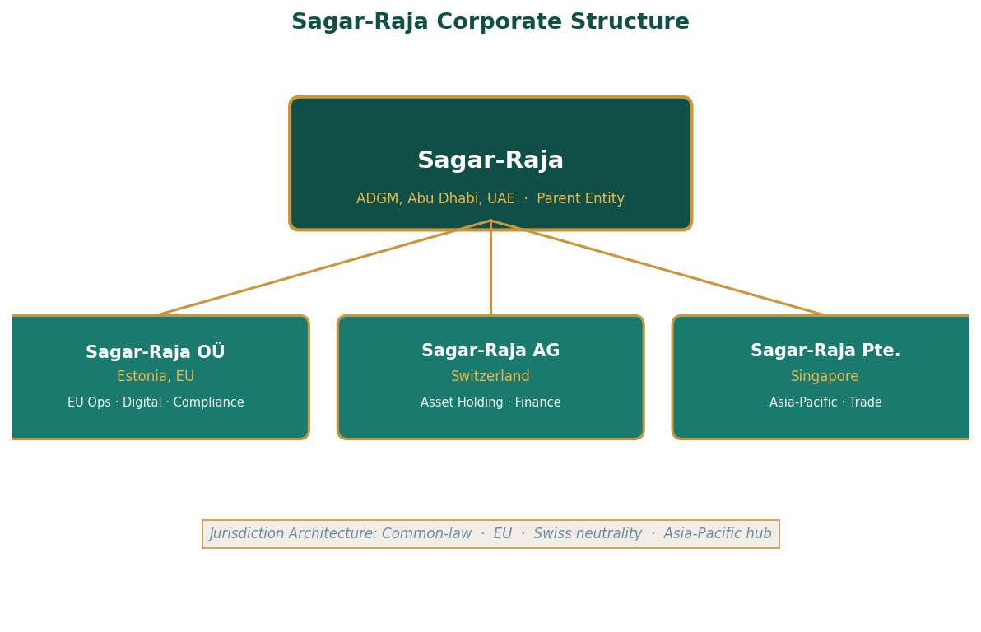
Figure FM-1: Sagar-Raja Corporate Structure — Parent Entity and Subsidiaries

Parent Entity: Sagar-Raja, ADGM
ADGM, the Abu Dhabi Global Market, is a recognised common-law jurisdiction established under UAE federal law with its own independent courts, legal framework, and regulatory authority. It is modelled on the legal systems of England and Wales and is fully recognised internationally for corporate, contractual, and IP matters. Sagar-Raja's incorporation in ADGM provides full common-law protection for its intellectual property, freedom to contract internationally, and the credibility of an established legal system for any counterparty interaction.
The parent entity's functions are: ownership of all intellectual property including the GPF-Tech patent and all product IP; strategic asset management across all subsidiaries and held assets; group governance and compliance policy; capital allocation and investment decisions; and acting as the primary contracting authority for deals of strategic significance.

Sagar-Raja OÜ — Estonia
Sagar-Raja OÜ is the European operational entity. Estonia's e-Residency and digital-first regulatory environment make it the optimal jurisdiction for a technology and digital systems entity operating across the EU. The OÜ structure provides full EU market access, GDPR-compliant digital operations, and EU certification pathways for products sold in EU markets. Estonia's tax treatment of retained earnings, which are not taxed until distributed, is also structurally aligned with a growth-oriented operating entity.
This entity's functions are: EU operational interface and contracting; technology system development and maintenance; digital infrastructure management; EU trade and certification compliance; and EU regulatory liaison for RIDER, RASM, and SR-C6 market access.

Sagar-Raja AG — Switzerland
The AG structure in Switzerland serves the group's asset holding and financial operations. Swiss corporate law provides exceptional stability, neutrality, and credibility for high-value asset holding. Switzerland's international standing means that contracts governed by Swiss law and disputes resolved through Swiss arbitration are respected in virtually every major commercial jurisdiction. The entity is not a tax vehicle. It is the appropriate legal home for assets whose value and complexity require the protection of a stable, neutral, internationally recognised legal framework.

Sagar-Raja Pte. Ltd. — Singapore
Singapore's position as the Asia-Pacific region's most internationally connected commercial hub makes it the correct jurisdiction for regional operations. Singapore has free trade agreements with over 25 countries, a strong IP protection framework, and the legal infrastructure required to manage complex multi-jurisdictional trade relationships. The Pte. Ltd. entity manages Asia-Pacific sales, partnerships, and trade coordination, with particular focus on RASM's significant regional market opportunity in Asia and SR-C6's industrial supply relationships in the region.

Table FM-3: Subsidiary Jurisdiction Matrix
Entity | Jurisdiction | Legal Form | Primary Function | Key Regulatory Frameworks
Sagar-Raja | ADGM, UAE | Private Ltd (shares) | IP ownership · Governance · Capital allocation | ADGM Common Law · UNCITRAL arbitration
OÜ Estonia | Estonia, EU | Osaühing (Ltd) | EU ops · Digital systems · Certification | EU Commercial · GDPR · Estonian e-governance
AG Switzerland | Switzerland | Aktiengesellschaft | Asset holding · Finance · Swiss neutrality | Swiss Code of Obligations · Swiss arbitration
Pte. Ltd. Singapore | Singapore | Private Ltd | APAC trade · Partnerships · Regional ops | Companies Act · Singapore arbitration · FTAs
Table FM-3: Jurisdiction Matrix — Legal Form and Regulatory Framework by Entity

Operating Philosophy: Four Principles
Sagar-Raja's operating philosophy has four stated principles. These are not values statements of the kind found in corporate mission documents. They are operational constraints. They define the boundary conditions within which every decision in the company is made.
Automation first means that systems perform routine decision-making and humans intervene only for oversight and exceptions. This is not a cost-reduction measure. It is a quality and consistency measure. Human decision-making introduces variability. Systems operating within validated rules introduce only the variability that is inherent in the environment they are managing. For a company whose operational consistency is a competitive advantage, automation is not a preference. It is a requirement.
Execution before expansion means that scaling occurs only after operational stability is proven. The company does not expand the envelope of a product, market, or operation until the current envelope has been validated to perform within specification under real operating conditions. This principle has prevented premature expansion and the reputational and operational damage that premature expansion produces when it encounters real-world complexity.
Ownership equals accountability means that all company-owned brands and infrastructure remain fully accountable under the parent entity. There is no structure through which the parent entity can attribute failure to a subsidiary or partner and claim limited accountability for outcomes occurring under its brands. Everything that bears the Sagar-Raja identity is fully accountable to Sagar-Raja's standards.
Distributed infrastructure means that operations are globally distributed rather than dependent on any single location. Single-location dependency creates single-point failure risk in logistics, regulatory, political, and environmental dimensions. The distributed architecture is designed to ensure that no single disruption in any single location can halt the company's operations.
Principle | What It Means | What It Prevents
Automation First | Systems decide routine matters; humans supervise | Inconsistency from human decision variability
Execution Before Expansion | Scale only after operational proof in current envelope | Premature scaling that encounters real-world complexity unvalidated
Ownership = Accountability | Parent bears full accountability for all branded operations | Blame-shifted failures; subsidiary-masked reputational damage
Distributed Infrastructure | No single geographic or operational dependency | Single-point failure in logistics, regulatory, or political dimensions
Table FM-4: Operating Principles — Application and Risk Prevention

PART I
I
THE ISLAND
The origin. The proof. The platform.

Ecology · Governance · Closed-Loop Infrastructure

Before anything is built, the ground must know what it will hold.
Part I establishes the Island — not as a place but as an operating principle.
Three chapters examine how a self-sustaining system is seeded: the ecological
governance framework that keeps ecology above commerce at all times, the legal
doctrine of non-sovereignty that makes the platform unchallengeable by territorial
law, and the closed-loop material and energy architecture that makes waste structurally impossible.

CONTENTS — Chapters 1 – 3

Chapter One Ground Zero
SR-EPP-OF framework · Five-level ecological priority hierarchy · Autonomous control architecture
Chapter Two What the Island Is Not
Non-sovereignty doctrine · International legal framework analysis · Permanence through utility
Chapter Three The Closed Loop
Multi-source energy architecture · HACA atmospheric water unit · PIF elemental decomposition matrix

PART ONE

Chapter One
Ground Zero
The moment a lifeless platform becomes a living system
Terra arrived before the others. That was always the order of things. Before anything could be built, the ground had to know what it was going to hold.
It moved the way geology moves, slowly and with enormous patience, compressing the seabed into load-bearing strata, lifting the platform incrementally until it cleared the waterline by the margin that the calculations required. Not more. The system did not produce excess as a byproduct of ambition. It produced exactly what the function demanded, and it stopped there.
Sela arrived while Terra was still working. This was also part of the sequence. The first weave went into the ground itself, not the structures above it, the composite fibres that would serve as the Island's nervous system, carrying data and current between every surface and every sensor and every storage unit that would come after. Sela worked without pausing and without acknowledgement. The work was the acknowledgement.
By the time the platform was stable, the basic weave was complete. Vael settled over the central processing unit and the imprinting began. This was the longest part of the founding sequence, not because Vael's capability was slow but because what was being transferred was not a programme but a comprehension. The AI that emerged from the imprinting process did not know instructions. It knew the Island.
The first autonomous cycle completed twelve hours after the platform cleared the waterline. The Island had not been built. It had been given the conditions to build itself. The distinction was the entire point.

SR-EPP-OF: The Ecological Production and Preservation Operations Framework
The real-world equivalent of the Island's founding is not a construction project. It is a governance document. The Sagar-Raja Ecological Production and Preservation Operations Framework, SR-EPP-OF, is the instrument that governs how the company designs, operates, monitors, and evolves its ecological industrial platform.
The framework begins with what the platform is not. It is not a state. It is not a settlement. It is not a population centre and it makes no territorial claim. It is a corporate-operated artificial ecological and industrial platform, publicly declared in advance of any objection, in order to pre-empt jurisdictional ambiguity rather than defend against it after the fact. This is the real-world equivalent of Terra's work: establishing the ground before anything is built on it.
The framework then defines what the platform is. A corporate entity's physical operational infrastructure. A controlled ecological demonstration zone. A self-sustaining industrial production environment. An autonomous monitoring and research installation. Each of these definitions has legal implications. A corporate entity's physical infrastructure is subject to corporate law, not territorial law. A controlled ecological zone is subject to the environmental agreements its operators have entered into, not to the marine territorial rights of adjacent states. Each definition reduces the ambiguity that external parties might otherwise use to assert jurisdiction.

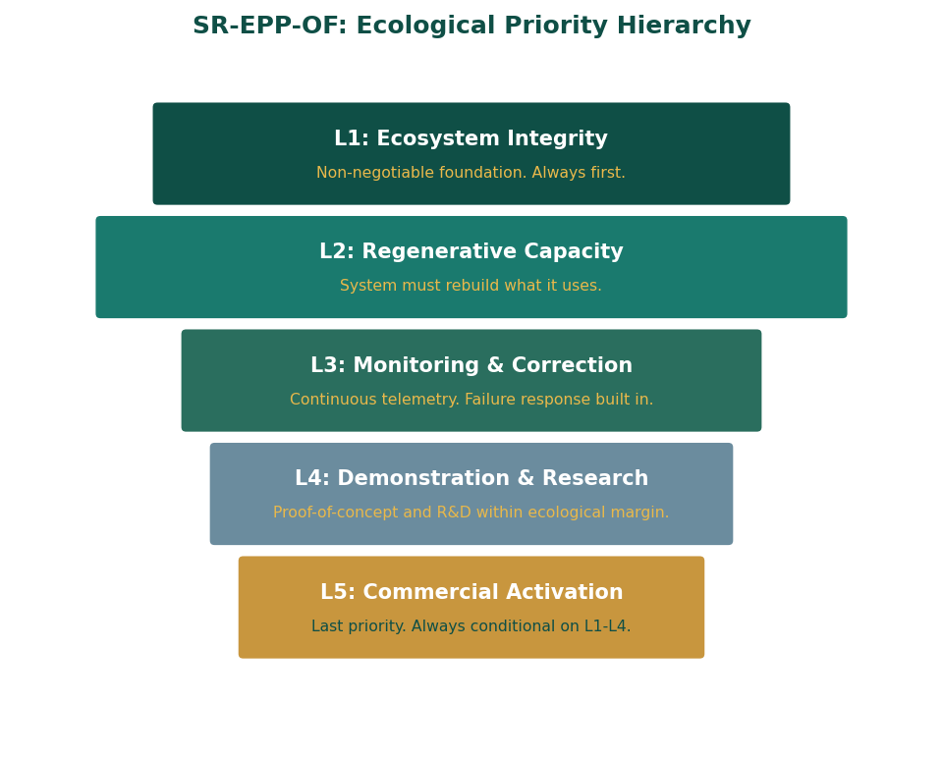
Figure 1-1: SR-EPP-OF Ecological Priority Hierarchy — Five Non-Negotiable Levels

Legal and Jurisdictional Stance
The platform is declared and operated under corporate ownership. It asserts no sovereignty, no exclusive economic zone, no territorial sea, and no independent governance. This is not a legal evasion. It is a legal position. A corporate industrial platform that makes no territorial claim is not subject to the international law frameworks that govern territorial claims.
The declaration of non-sovereignty is the platform's primary legal protection for the following reason: the alternative, a platform that claims sovereignty or territorial rights, invites engagement with international legal frameworks for which it is not equipped and which it would not win. The United Nations Convention on the Law of the Sea, UNCLOS, governs territorial claims. States that are party to UNCLOS have legal standing to challenge artificial structures that assert territorial rights. They have no legal standing to challenge a corporate industrial platform that makes no such assertion.
Corporate governance sits with ADGM. Operational compliance is managed through coastal-state permissions where applicable, international maritime conventions, and environmental and navigational norms. The subsidiaries serve operational, contractual, and compliance roles only. The guiding principle is direct: public declaration and transparency offer stronger protection than post-facto legal defence.

Scope and Exclusions
The framework's scope covers all artificial land modules and marine platforms operated by Sagar-Raja; all ecological zones, buffer zones, and protected reserve areas within or adjacent to platform boundaries; all energy, water, biomass, waste management, and research systems on the platform; all logistics, port facilities, and maritime corridors used in platform supply and export; and all autonomous monitoring, control, and security systems.
The framework explicitly does not apply to civilian habitation, political governance, consumer-facing activity, or independent third-party brands operating outside contractual scope. These exclusions are not administrative limitations. They are structural: the platform is not designed to perform these functions, and the framework's exclusion of them is the legal expression of that design reality. A system that excludes what it was not designed to do is a system that knows what it is.
Table 1-1: SR-EPP-OF Scope and Exclusions
IN SCOPE | EXPLICITLY EXCLUDED
All artificial land modules and marine platforms | Civilian habitation of any kind
Ecological zones, buffer zones, protected reserves | Political governance structures
Energy, water, biomass, waste management, and research systems | Consumer-facing commercial activity not contractually scoped
Logistics, port facilities, maritime supply corridors | Independent third-party brands outside contractual scope
Autonomous monitoring, control, and security systems | Territorial or sovereign claims of any kind
Table 1-1: SR-EPP-OF Scope Matrix

Ecological Priority Hierarchy
The platform operates under a five-level priority hierarchy that is non-negotiable in its ordering. The hierarchy exists because commercial and ecological goals sometimes create tension, and a system without a clear hierarchy will resolve that tension inconsistently. The hierarchy eliminates the tension by eliminating the choice: there is a defined order of precedence, and it does not change by situation.
Level One is ecosystem integrity. This means that the platform's ecological systems, the marine environment surrounding it, the atmospheric systems it interacts with, and the biological systems operating on it, must never be compromised for any other priority. If ecological integrity is at risk, every other operation is secondary until the risk is resolved. This is not a statement about corporate values. It is a statement about operational viability. A platform whose ecological infrastructure is compromised cannot sustain the industrial operations built on top of it.
Level Two is regenerative capacity. The platform must maintain the ability to rebuild what it uses. This means maintaining sufficient reserves of every critical resource that the ecological systems of the platform draw from. It means not extracting biomass faster than it regenerates. It means not consuming atmospheric moisture faster than the local atmospheric cycle replenishes it. The regenerative capacity is the platform's long-term operational insurance.
Level Three is monitoring and correction. Continuous measurement of all relevant ecological and operational indicators must be maintained, and the capacity to respond to deviations from specification must be available at all times. This level formalises the principle that a system that does not know its own state cannot make correct decisions about its future state.
Level Four is demonstration and research. The platform serves as a proof-of-concept for sustainable industrial operations and as a research environment for the technologies it deploys. This function is real and important. It is also fourth in the priority hierarchy, which means it is never permitted to compromise the first three levels.
Level Five is conditional commercial activation. Commercial use of any platform zone is conditional on ecological performance in that zone meeting the standards defined in the framework. There is no trade-off. There is a sequence: ecology must be confirmed before commerce is activated. A zone that is not ecologically performing is not commercially active, regardless of commercial opportunity.

Closed-Loop Infrastructure Design
The framework mandates zero-landfill design with internal recycling of all material flows. The engineering implication of this mandate is significant: every system on the platform must be designed with its output pathways defined before construction begins. A production system without defined output pathways is not permitted under the framework. The output pathway must exist before the process that produces the output.
Energy and water systems are integrated into the landform geometry rather than overlaid on top of it. This means that the platform's physical form, the elevation of its surfaces, the orientation of its structures, the geometry of its hull, is determined partly by energy and water harvesting requirements. The platform is literally shaped by its resource systems. The solar cells are not panels added to a surface. The surface is a solar cell. The water collection channels are not pipes added to a structure. The structure is a water collection system.
There is no uncontrolled discharge into the surrounding marine environment. This is not an aspirational standard. It is a hard engineering constraint. Every outflow from the platform must be a defined, controlled, monitored flow. There is no overflow valve that vents to the ocean. There is no emergency discharge that bypasses the treatment system. The engineering cost of achieving this constraint is paid once, in the design phase. The alternative, designing without the constraint and managing the consequences, is paid continuously.
Table 1-2: Closed-Loop Resource Management — Input/Output Pathways
Resource | Input Mechanism | Primary Use | Recycled Output
Water | HACA atmospheric condensation lattice | Agriculture · Process · Potable | Recaptured from pod biodegradation, condensed cooling
Energy | Photosynthetic surfaces · Piezoelectric hull · Thermoelectric | Operations · Fabrication · Transmutation | Surplus stored in elemental reservoirs; re-used overnight
Biomass | VASF crop production byproducts (roots, stems) | Soil amendment · Cultured meat scaffold · Bioplastic | Composted to elemental carbon/nitrogen reserve
Atmospheric CO₂ | Atmospheric intake for transmutation feedstock | Carbon extraction for SR-C6 and structural carbons | Oxygen-Plus released to atmosphere (purified)
Solid waste | All platform operations (worn composites, spent media) | Elemental Decomposition Complex input | Pure elemental components returned to storage
Table 1-2: Resource Closed-Loop Pathways

Autonomous Operations and Control Architecture
The platform's control architecture is designed for autonomous operation as the default state, with human oversight as the monitoring layer and human intervention as the exception-handling layer. This is the same automation hierarchy that governs all Sagar-Raja operations under SR-OF, instantiated in the specific context of the ecological platform.
The architecture is distributed and non-centralised. There is no single control facility whose destruction or compromise would disable the platform's operational systems. Critical functions are managed through a mesh of local controllers, each capable of operating independently and each communicating with its peers to maintain a coherent system state. The loss of any single node degrades the network's coverage but does not halt its operation. Functionality is redistributed to adjacent nodes automatically.
Control systems are encrypted and air-gapped from external networks at the operational level. Command inputs require authenticated, cryptographically verified instruction. Telemetry is outbound-only from the most sensitive operational systems. The architecture assumes that external parties may attempt to compromise the control systems and is designed to operate correctly in the presence of such attempts.
Continuous telemetry covers structural integrity across all hull and landform sections; all relevant ecological indicators including atmospheric chemistry, soil composition, marine water quality, and biodiversity metrics; hydrological system performance including water quality, production rate, and reservoir levels; energy system performance including generation, storage, and distribution; and all production system performance metrics.
Table 1-3: Control Architecture — Automation Levels
Level | Decision Type | Authority | Human Role
L1 — Safety | Any threat to ecological integrity or platform safety | Central hard stop — non-overrideable | Notification only until system stable
L2 — Quality | Production conformance, material grade decisions | Central authority — logged override possible | Review overrides post-action
L3 — Scheduling | Production sequence, energy routing, water allocation | Distributed AI — optimisation within validated bounds | Monitor dashboards; intervene on anomaly
L4 — Procurement | Consumables, maintenance materials, external supply | Hybrid — AI recommends, human approves above threshold | Approval authority above defined spend threshold
L5 — Strategic | Platform expansion, new system deployment, policy change | Human decision with AI analysis support | Full decision authority
Table 1-3: Five-Level Control Automation Hierarchy
The Island does not need Wardens to operate. It was designed not to need them. SR-EPP-OF operationalises the same principle: a correctly designed system reduces the frequency and urgency of human intervention not by eliminating human judgment but by reserving it for decisions that actually require it.

PART ONE

Chapter Two
What the Island Is Not
The philosophy of refusal as the foundation of durability
There was a conversation, early in the Island's history, in which the question of sovereignty was formally raised.
The argument for it was straightforward: territory confers rights. Rights confer protections. Protections enable permanence. The argument had the clean logic of a system that had been designed to produce that conclusion.
Vael considered it for the duration of one atmospheric pressure cycle, approximately four minutes, and then communicated its assessment through the quality of the silence that followed. The other Wardens understood. The argument for territorial declaration was an argument for the kind of permanence that required external validation. That was not the kind of permanence the Island was designed to achieve.
The Island's permanence was not going to come from being recognised. It was going to come from being necessary. The two are not the same thing, and only one of them is within the system's control.
The decision not to claim was made once, at the founding, and was not revisited. It became part of the Island's operating logic in the same way that the closed-loop water cycle became part of its operating logic: not as a rule to be followed but as a property of the design itself. The Island did not refrain from claiming territory. It was not built to be the kind of thing that claims territory.

The Non-Sovereignty Framework
The legal and philosophical position of Sagar-Raja's ecological platform is built on the same logic. The platform is not legally ambiguous about its status. It is legally explicit. It is a corporate-operated artificial ecological and industrial platform. It is not a state. It is not an autonomous zone. It does not seek recognition as a territorial entity because territorial recognition is not the source of its operational legitimacy.
This is a more sophisticated position than it might initially appear. Most industrial platforms seek permissive frameworks through negotiation with sovereign entities. They ask for permission and operate within the conditions that permission establishes. Sagar-Raja's platform takes a different approach: it publicly declares its character before any question is raised, defines its own legal nature with precision, and then operates within the international frameworks that apply to entities of that nature.
The declaration is not defensive. It is structural. A declared corporate industrial platform occupies a specific, legally defined position in international law. The rights and constraints of that position are known in advance. Operating within them is not a limitation. It is the source of the platform's jurisdictional stability.

International Legal Framework Analysis
Several distinct bodies of international law are potentially relevant to an artificial industrial platform. The non-sovereignty framework is designed to ensure that the most favourable interpretation of the platform's legal status is the most accurate one, and that potentially unfavourable interpretations are foreclosed by the platform's declared character.
UNCLOS, the United Nations Convention on the Law of the Sea, governs territorial seas, exclusive economic zones, and the rights of states over artificial islands within their EEZ. The platform's non-territorial, non-sovereign status means that it does not trigger the provisions of UNCLOS that apply to territorial claims. A state's right to object to another state's artificial island in its EEZ does not extend to a corporate industrial installation that makes no territorial claim.
The IMO's regulatory framework for mobile offshore structures and floating installations governs safety, navigation, and environmental compliance. The platform complies with all applicable IMO standards as a matter of operational practice and declares its compliance publicly. IMO compliance is not a legal vulnerability. It is a legal demonstration: an installation that meets IMO standards has already passed the most relevant international inspection.
MARPOL, the international convention for the prevention of pollution from ships, applies to discharges from maritime installations. The platform's closed-loop design, which produces no uncontrolled discharge into the marine environment, means that MARPOL compliance is achieved structurally rather than procedurally. The platform cannot violate MARPOL because it is designed in a way that makes the relevant violations physically impossible.
Table 2-1: International Legal Framework Applicability Analysis
Framework | Governing Body | Potential Applicability | Platform Position
UNCLOS | United Nations | Territorial sea, EEZ, artificial islands | Non-sovereign · Non-territorial → provisions for state claims do not apply
IMO MODU Code | International Maritime Organization | Mobile offshore drilling units and similar structures | Full structural compliance declared · Annual survey and flag-state certification
MARPOL | IMO | Marine pollution from ship/installation discharges | Closed-loop design → no uncontrolled discharge possible structurally
CBD / London Protocol | UN Environment Programme | Marine biodiversity · Ocean dumping | Ecological Priority Hierarchy L1 ensures biodiversity protection exceeds CBD standards
Paris Agreement | UNFCCC | GHG emissions · Net-zero commitments | Net carbon-negative operations by design · Carbon capture as primary output pathway
Table 2-1: International Legal Frameworks — Applicability and Platform Position

What the Platform Refuses: The Architecture of Explicit Exclusion
The non-sovereignty framework extends beyond the platform's legal status to the specific functions the platform refuses to perform. These refusals are documented in the framework for the same reason the platform's legal status is documented: pre-emptive clarity is cheaper than post-facto defence.
The platform refuses civilian habitation. A platform that houses a permanent civilian population creates obligations of care, governance, and infrastructure provision that a corporate industrial installation is not designed to meet and should not be expected to meet. More importantly, a permanently inhabited platform would create the conditions for de facto territorial claims to emerge over time, regardless of the operator's intention. The refusal of habitation is the refusal of the path that leads to unintended sovereignty.
The platform refuses political governance. There is no council, no elected body, no judicial system, and no law enforcement power. Personnel on the platform are employees of the corporate entity and are subject to the laws of their nationality and the terms of their employment contracts. Dispute resolution occurs through the company's standard HR and legal processes. This is not a governance gap. It is the correct governance model for a corporate installation.
The platform refuses territorial assertion. It makes no claim to the maritime zone surrounding it beyond the operational exclusion zone necessary for the safety of navigation. This exclusion zone is declared under IMO conventions as a safety measure, not as a territorial claim. Its extent is the minimum required for navigation safety and does not overlap with any state's territorial sea or EEZ without that state's express permission.

Jurisdiction by Design: Why ADGM
The choice of ADGM as the primary jurisdiction is not arbitrary. It reflects an assessment of which jurisdiction provides the best combination of legal certainty, international recognition, and appropriate regulatory framework for a company of Sagar-Raja's character and operations.
Common-law jurisdictions provide better IP protection, better contract enforcement, and better access to international arbitration than civil-law alternatives in most comparative analyses. ADGM's courts apply English common law and are staffed by judges with English, international, and ADGM-specific expertise. This provides the quality of legal analysis that a company with a complex, internationally deployed patent portfolio requires.
ADGM's established framework for holding companies, financial entities, and technology companies means that Sagar-Raja's corporate structure, a parent entity with three specialised subsidiaries in different jurisdictions, is well-understood and well-supported by the local regulatory environment. There are no novel questions about whether the structure is permissible. The structure is standard for ADGM-incorporated entities of similar complexity.
The UAE's geopolitical position as a neutral commercial hub with strong relationships across the Middle East, Africa, Asia, and increasingly Europe and North America means that Sagar-Raja's ADGM incorporation does not create political complications in any of its primary markets. A company incorporated in a jurisdiction with strong political relationships with the governments of its primary markets faces fewer trade and regulatory complications than one incorporated in a jurisdiction with contested relationships.
The Island does not need to be recognised as sovereign to endure. It needs to be correctly designed. Recognition is external. Design is internal. Only one of those is within the system's control.

Permanence Through Utility, Not Recognition
The philosophical core of the non-sovereignty framework is the distinction between two types of permanence. Permanence through recognition depends on external parties continuously choosing to recognise the platform's rights. It is conditional on the continued goodwill, political stability, and agreement of those parties. It is vulnerable to changes in political relationships, changes in international law, and changes in the interests of the recognising parties.
Permanence through utility depends only on the platform's continued capacity to produce something that external parties need. It is conditional on operational excellence, not on political relationships. It is not vulnerable to political change if the utility is sufficiently general, if what the platform produces is needed by enough different parties in enough different contexts that no single political change can remove all of its markets simultaneously.
Sagar-Raja's product portfolio is designed for this kind of utility. RIDER serves multiple global markets under different political regimes. RASM addresses nutritional needs that exist regardless of political configuration. SR-C6 is a foundation material for industries that operate in every political and economic context. DIRE serves supply chain intelligence needs that all major industrial companies share. The company's utility is distributed across industries, geographies, and political contexts in a way that makes it permanently relevant regardless of which specific political relationships are active.
Basis of Permanence | Depends On | Vulnerable To
Recognition | External parties choosing to recognise rights continuously | Political change · Relationship shifts · Consensus erosion
Utility | Platform's capacity to produce something others need | Operational failure only — not political change
Table 2-2: Two Bases of Permanence — Comparison

PART ONE

Chapter Three
The Closed Loop
A full day. Everything in motion. Nothing lost.
At 06:14 the first harvest cycle completed. The synthesis pods from the overnight run had been shaken, the produce removed, the pod frames shredded and fed into the biomass line. The root matrices from the previous twelve hours were already dried and milled. The oxygen-plus tanks were at capacity from the overnight photonic pulses. The system had been running for seven hours without human input and had produced, as a byproduct of producing food, two additional industrial commodities that had nowhere to go except back into the cycle.
This was the Island's most important operating principle, not stated anywhere in the system documentation because it did not need to be stated. The system was designed around it. Waste was a category error. Every output of every process was an input to another process. The question was never how to dispose of what was left over. The question was always: what does this become next?
At 09:30 the water cycle completed its morning collection. The atmospheric condensation lattices had drawn 4.2 tonnes of pure water from the pre-dawn humidity. This was a below-average morning. The tanks were at 94 percent of daily operating capacity. The remaining six percent would be met by the afternoon lattice cycle. No adjustment was required. The system had been designed with that margin built in.
At 14:00 the energy audit completed. The photosynthetic surfaces had produced 312 percent of the Island's daily power requirement. The surplus had been routed to the elemental storage reservoirs for the overnight transmutation run. Nothing was wasted. Wasting energy was as structurally impossible as wasting matter. The system's outputs were all either useful or transformable into something useful, and the intelligence that governed it knew the difference.
At 23:47 the overnight cycle began. The Island did not rest. It had never rested. Rest was a concept that applied to systems that exhausted themselves. This system did not exhaust itself. It breathed.

The Closed-Loop Mandate
The SR-EPP-OF's Closed-Loop Mandate is not a sustainability policy. It is an engineering specification. Every material flow within the platform must have a designated next-use pathway. No output is discharged uncontrolled into the surrounding environment. No input is consumed without accounting for what its consumption produces.
This discipline creates a compound effect over time. A platform that has no waste also has no waste management cost. A platform that recycles all material flows has a lower dependency on external supply chains for raw materials. A platform that integrates energy and water systems into its landform geometry has lower infrastructure overhead than one that treats them as separate utilities. The closed loop is not just ecologically correct. It is operationally efficient, and the efficiency compounds.
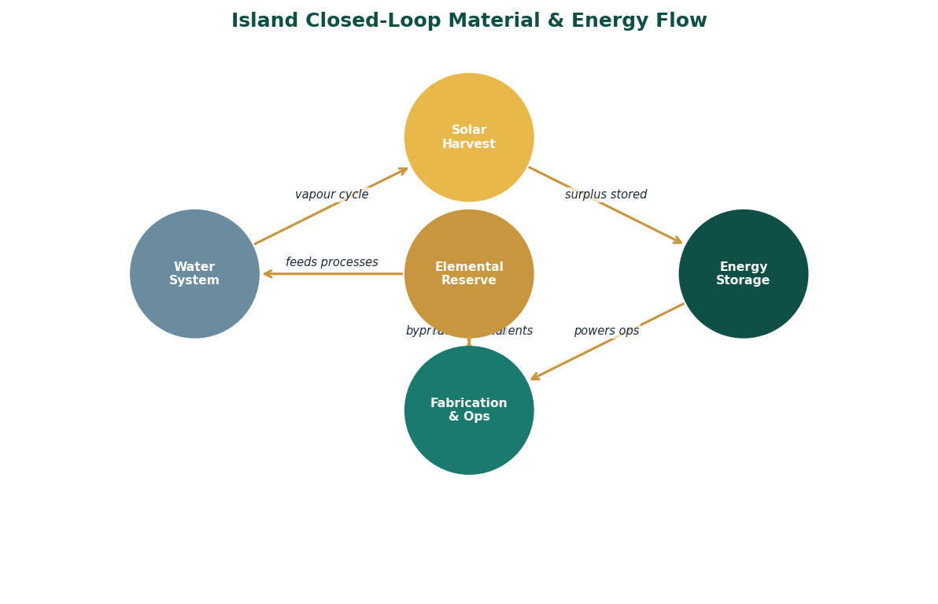
Figure 3-1: Island Closed-Loop Material and Energy Flow Diagram

Energy Architecture: Multi-Source Integration
The platform's energy architecture is designed for peak ecological safety rather than peak utilisation. This design choice has important consequences. A system optimised for peak utilisation extracts maximum energy from each source under optimal conditions and accepts reduced output when conditions deteriorate. A system designed for peak ecological safety maintains a consistent output across all conditions by diversifying its sources such that no single source's underperformance can create an operational shortfall.
The photosynthetic surface layer is the primary daytime source. The surfaces are engineered using Sela's bio-material composites, which incorporate photosynthetic cells at an efficiency substantially above conventional silicon photovoltaics. The cells are self-repairing: minor damage triggers the composite's biological healing response, which restores cell function without mechanical intervention. The surface area of the canopy, upper hull, and horizontal structural elements provides the primary daytime harvest.
The piezoelectric and triboelectric nanogenerator layer is integrated into all surfaces that experience mechanical stress: the walkways, the hull sides, the lattice structures, the mooring systems. Every vibration, pressure change, and mechanical stress that the platform experiences produces electrical current. The output is continuous and weather-independent, because the platform is always experiencing mechanical stress of some kind.
The thermoelectric layer harvests the temperature differential between the platform's heated upper surfaces and the cooler deep-water intake. This differential is largest at solar noon and remains significant through the night, when the upper surface cools more slowly than the deep water. The thermoelectric layer is a continuous night-time source even when photosynthetic generation has ceased.
The atmospheric fermentation layer activates when all other sources are insufficient. A biological lichen coating on certain exterior surfaces absorbs moisture and trace atmospheric gases and produces methane or ethanol through anaerobic fermentation. The output is modest compared to the primary sources, but it is weather-independent, temperature-independent, and light-independent. In the worst operational conditions, the fermentation layer provides a baseline that keeps critical systems operational.
Table 3-1: Energy Source Performance Characteristics
Source | Peak Output | Conditions | Weather Dependency | Activation Trigger
Photosynthetic surface | Primary — 300%+ of daily need | Peak at midday clear sky | High — reduced in cloud and storm | Automatic at sunrise
Piezo/Triboelectric hull | Secondary — 15–30% of daily need | Peak in storm / wave action | None — increases in storm | Continuous — always active
Thermocline gradient | Secondary — 20–40% overnight | Peak at night and in turbulent water | Low — consistent year-round | Continuous — always active
Atmospheric fermentation | Baseline — 5–8% of daily need | Consistent regardless of conditions | None — fully weather-independent | Auto-activates below threshold
Table 3-1: Platform Energy Sources — Characteristics and Performance

Water Architecture: The HACA System
The Hydro-Kinetic Atmospheric Condensation Array harvests water directly from atmospheric vapour without any external water source. The system's operation is based on two physical principles: the hygroscopic affinity of certain materials for water molecules, and the low energy cost of commanding bound water molecules to coalesce and flow.
The Thirsty Silk Lattice, the platform's primary condensation surface, is a three-dimensional structure engineered from Sela's bio-composite material with surface chemistry specifically optimised for water molecule adsorption. The lattice presents an enormous effective surface area relative to its structural volume, because the bio-composite can be woven at sub-millimetre scales into three-dimensional branching structures that present hygroscopic surface on all sides. Atmospheric air passing through the lattice encounters this surface and deposits its moisture content.
The adsorbed water is then commanded to coalesce by the Hydro-Kinetic Emitter, which produces a low-energy pulse at the specific molecular resonance frequency that breaks the surface bonds holding individual water molecules to the lattice and causes them to aggregate into droplets. The energy cost of this pulse is negligible compared to the energy cost of conventional water pumping at equivalent volumes. The droplets flow by gravity to the collection reservoirs below the lattice structures.
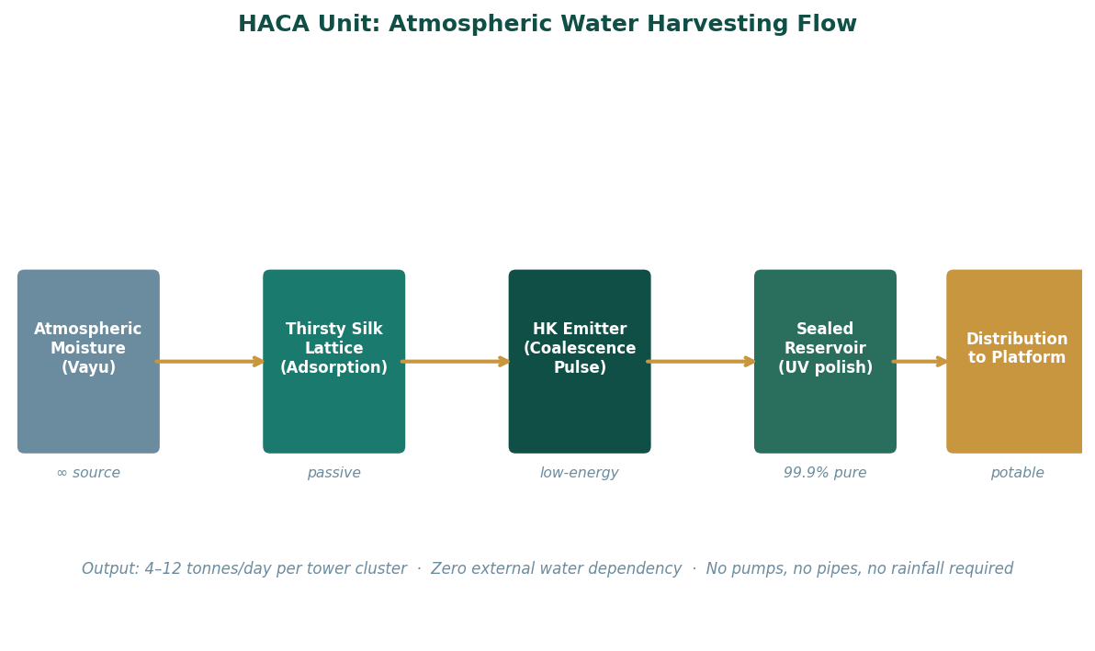
Figure 3-2: HACA Atmospheric Water Harvesting — Process Flow and Key Parameters

Table 3-2: HACA Unit Performance Data
Parameter | Value | Notes
Water purity (pre-UV) | 99.9% | Hygroscopic mechanism excludes non-water molecules by design
Daily output — mid-scale cluster | 4–12 tonnes | Varies with ambient relative humidity; minimum at RH 35%
Energy input per tonne | ~0.8 kWh | Versus ~2.5 kWh/tonne for conventional surface water pumping
Minimum operational RH | ~35% | Operates at reduced efficiency below 35%; not zero output
Acoustic signature | Silent | No moving parts in primary collection mechanism
External connection requirement | None | Fully self-contained; no supply pipe, no rainfall dependency
Maintenance interval | 6 months | Lattice bio-composite is self-repairing within design damage tolerance
Table 3-2: HACA Unit Technical Performance Parameters

Material Architecture: The Processing Infrastructure Framework
The PIF governs how every solid and liquid material that arrives at the platform is processed before it is used. The governing principle is elemental decomposition before anything else. No resource is processed directly into a product without first being reduced to its elemental components and held in the elemental storage system.
This principle has three operational consequences. First, it creates a buffer between supply variability and production consistency. The quality of the elemental inputs to any production process depends on the quality of the decomposition process, not on the quality of the raw material batch. A variable raw material batch produces consistent elemental inputs after decomposition. Second, it enables demand-triggered production. The elemental storage system holds the raw material inventory for any product the platform can produce. Production of any specific product requires only a decision to process the appropriate elements, not a specific supply chain for those elements' precursors. Third, it eliminates waste at the process level. A decomposition process that produces only defined elemental outputs and no undifferentiated residue is a zero-waste process by definition.
Table 3-3: Elemental Decomposition — Inputs, Yields, and Storage
Input Material | Primary Elements Yielded | Secondary Yields | Storage Method
Iron ore | Fe (iron) · O₂ (oxygen) | Trace silica, sulphur | Fe: molten reservoir at 1,538°C · O₂: cryogenic tanks
Bauxite | Al (aluminium) · O₂ | Fe₂O₃, SiO₂, TiO₂ (trace) | Al: liquid metal tank at 660°C · O₂: cryogenic
Atmospheric CO₂ | C (carbon) · O₂ | None | C: graphite storage blocks, ambient · O₂: cryogenic
Hydrocarbons | C · H₂ (hydrogen) | N₂ (nitrogen, if present) | C: graphite storage · H₂: pressurised tanks · N₂: cryogenic
Biomass (VASF waste) | C · H · N · O | P, K, Ca (trace minerals) | Organic fraction: biochar/compost reserve · Mineral: dry powder
Copper ore | Cu (copper) · S (sulphur) | Fe, Ni (trace) | Cu: molten reservoir · S: solid tanks for acid production
Table 3-3: Elemental Decomposition Matrix — Input/Yield/Storage

The Compound Effect of Closed-Loop Design
The value of closed-loop design is not captured in any single operational metric. It is captured in the trend line of operational metrics over time. A closed-loop system that runs correctly becomes progressively more efficient as its recycling pathways mature, its elemental reserves accumulate, and its demand forecasting improves.
In the first operational year, the platform's material self-sufficiency is limited by the size of its elemental reserves. Production volumes are constrained by what has been accumulated, and supply chain dependencies are managed with conventional logistics. In the third operational year, elemental reserves have grown to the point where the platform can buffer most supply disruptions without reducing production. In the fifth year, the platform's reserves are large enough that it could operate at full production capacity for an extended period with no external material input, drawing solely on its accumulated strategic reserves.
This trajectory, from supply-dependent to supply-resilient to supply-independent, is the compound effect of correct closed-loop design applied consistently over time. It does not require a policy change or a capital investment at year five. It is the natural consequence of the design working as intended from day one.
The Processing Infrastructure Framework makes this trajectory explicit: the framework's success metric is not the quantity of material processed in any period. It is the strategic reserve level maintained above the defined minimum threshold at the end of each period. A system that processes more material but reduces its strategic reserves is performing below the framework's standard. A system that processes less material but builds its strategic reserves is outperforming it.

PART II
II
THE FOUNDRY
The machine that builds everything else.

Autonomous Fabrication · Elemental Processing · Resource Sovereignty

One coordinated day. Every Warden offering its deepest capability into a single founding event.
The Foundry Matrix emerges — and the Wardens step back, because the system
no longer requires them. Part II is about the founding act as architecture:
what must be seeded once to produce unlimited autonomous output thereafter.
The GPF-Tech patent, the Processing Infrastructure Framework, and the HACA
water independence unit are all expressions of this logic in different materials.

CONTENTS — Chapters 4 – 6

Chapter Four The Genesis Protocol
GPF-Tech patent · Five-component autonomous architecture · PCT coverage 150+ countries
Chapter Five The Transmutation Forge
PIF eight-system hub · Elemental decomposition · SR-C6 carbon pathway · Triple output
Chapter Six Water from Nothing
HACA condensation array · Water dependency elimination · Resource independence doctrine

PART TWO

Chapter Four
The Genesis Protocol
Seed once. Build everything autonomously thereafter.
The question that preceded the founding of the Foundry Matrix was not what to build. The Wardens knew what needed to be built. The question was what was the minimum required to build all of it, in parallel, without the Wardens needing to be present for each step.
The answer Vael arrived at was counterintuitive in its simplicity: do not build the systems. Build the machines that will build the systems. The distinction was not semantic. It was the difference between a finite act and an infinite capacity.
The Foundry Matrix required one coordinated day. All Wardens working simultaneously, not sequentially. Vael performed the master imprinting on the Genesis Core, encoding not just current system blueprints but the architectural logic required to design new ones. Sela and Mycan produced the Bio-Silk-Mycelium Composite. Pyren and Volta and Cryal and Gengar each seeded their respective energy cores. Veila and Nara produced the Phantom Veil Generator. Terra and Edgen engineered the Terra-Former Unit and the Precision Assembly Arm.
By the end of the day, the Island had Bio-Weaver Units producing material on demand. It had Core Foundries generating power modules. It had Construction Units preparing sites. All of them directed by the Genesis Core AI.
The Wardens were no longer needed. This was precisely the measure of success.

GPF-Tech: The Autonomous Distributed Fabrication Patent
Sagar-Raja holds a granted PCT patent for a Global Autonomous and Distributed Fabrication, Orchestration, and Self-Scaling Production System. The patent was examined under the Patent Cooperation Treaty framework and found to satisfy all three substantive patentability requirements: novelty, inventive step, and industrial applicability. It is maintained and active across all primary regions of commercial interest.
The patent is foundational to Sagar-Raja's competitive position in a way that product patents are not. A product patent protects a specific product. An architecture patent protects the system logic that can produce any number of products. The GPF-Tech patent does not protect a specific fabrication output. It protects the architecture that enables autonomous, distributed, self-scaling fabrication of any output for which the system is configured. Any company that builds a system fitting the patent's claims without a licence from Sagar-Raja is infringing, regardless of what the system produces.
The implementation independence of the patent is its most commercially significant property. The patent claims do not specify materials, industries, scales, or physical environments. A software orchestration platform for digital services that fits the architecture claims infringes. A hardware manufacturing network that fits the claims infringes. A cyber-physical industrial system that fits the claims infringes. The patent's scope is defined by the structural relationships between the five components, not by any specific instantiation of those components.

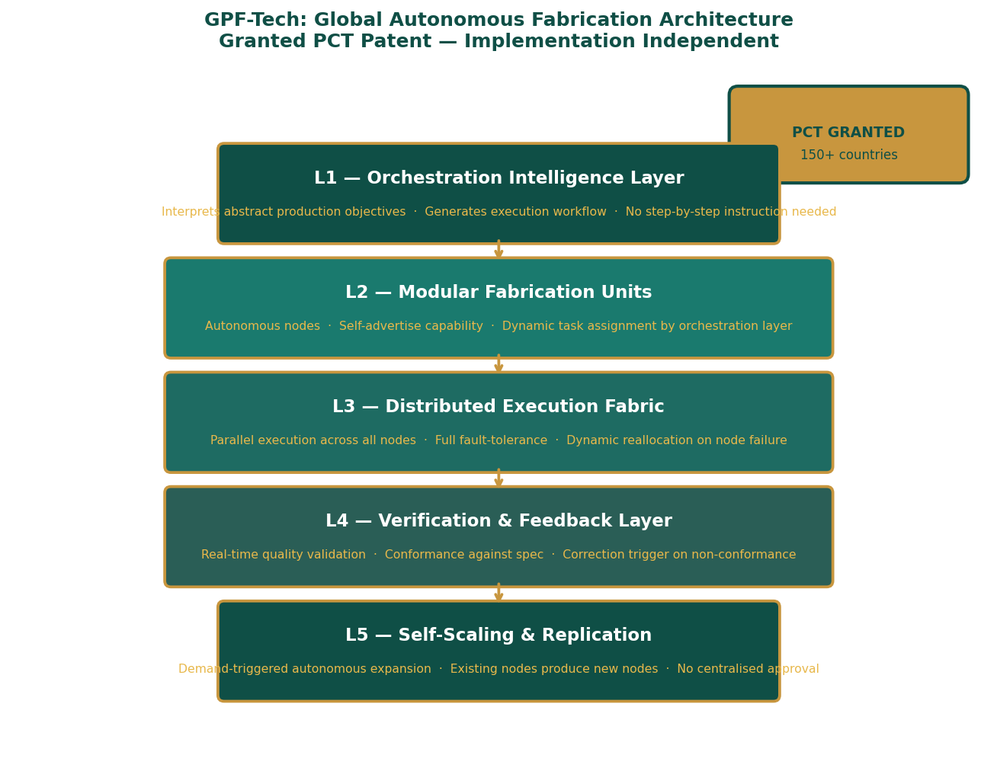
Figure 4-1: GPF-Tech Five-Component Architecture — Implementation-Independent Stack

Component One: Orchestration Intelligence Layer
The Orchestration Intelligence Layer is the system's cognitive centre. It receives production objectives expressed at any level of abstraction, from 'produce 500 units of product X to specification Y' to 'optimise throughput for the next 72 hours given current resource availability', and decomposes them into executable task sequences without requiring human decomposition of the objective into individual steps.
This capability, autonomous decomposition of abstract objectives, is the primary inventive step that the patent examiner identified as non-obvious over the prior art. Conventional manufacturing execution systems require that production objectives be expressed as explicit, pre-defined task sequences. The GPF architecture's orchestration layer can receive an objective and generate the task sequence itself, using its model of the production network's current state and capability to determine the optimal path from objective to output.
The orchestration layer maintains a continuous, real-time model of every node in the fabrication network: what each node can produce, at what rate, with what quality, and under what resource conditions. This model is updated by the Verification and Feedback Layer on a continuous basis. When the orchestration layer generates a task sequence, it does so against an accurate current picture of the network's actual state, not a static configuration. Task sequences generated from accurate state information produce significantly fewer execution failures than those generated from static configurations, because the gap between the state the task sequence assumes and the state the network actually has is smaller.

Component Two: Modular Fabrication Units
Modular Fabrication Units are autonomous production nodes. Each unit is capable of operating independently of any central controller and is designed to advertise its own capabilities to the orchestration layer rather than receiving static capability assignments from a central configuration. This self-advertisement architecture means that a node which gains new capability automatically makes that capability available to the network without requiring manual reconfiguration of any central system.
The modular design of the units has two important properties. First, individual units can be upgraded, replaced, or added to the network without taking the rest of the network offline. The network is not a machine with a single configuration. It is a population of capable nodes, and the population can change while the network continues to operate. Second, the modular design allows units to be purpose-built for specific tasks, such as precision assembly, high-volume throughput, or chemically sensitive production, while all being interoperable at the orchestration level.
Table 4-1: Modular Fabrication Unit — Operational Properties
Property | Description | Significance
Self-advertisement | Unit broadcasts capability profile to orchestration layer on activation | New capacity available immediately without central reconfiguration
Independent operation | Each unit operates autonomously if orchestration layer is unavailable | Network continues production during orchestration layer maintenance
Hot-swap compatibility | Units added or removed without network downtime | Continuous expansion without production interruption
Fault self-reporting | Unit reports its own degraded state to orchestration layer | Orchestration layer reroutes tasks before unit fails completely
Task-level isolation | Each task execution is atomic: committed or rolled back cleanly | Partial task failures do not corrupt production state
Table 4-1: Modular Fabrication Unit Properties

Component Three: Distributed Execution Fabric
The Distributed Execution Fabric coordinates the parallel execution of tasks across all available Modular Fabrication Units. Its core properties are full parallelism, fault tolerance, and dynamic reallocation. Full parallelism means that any tasks without dependency relationships between them are executed simultaneously rather than sequentially. In a conventional manufacturing execution system, tasks are often queued sequentially even when they are independent, because the system lacks the ability to identify and exploit independence. The distributed fabric's dependency analysis ensures that the maximum achievable parallelism is always achieved.
Fault tolerance is achieved through a combination of task checkpointing, which records the state of in-progress tasks at defined intervals so that work is not lost on node failure; automatic reallocation, which detects node failure and reassigns the failed node's tasks to available nodes; and graceful degradation, which ensures that a network with some failed nodes continues to produce output at reduced throughput rather than halting completely. The network's failure mode is reduced performance, not complete stoppage.
Dynamic reallocation is the fabric's response to real-time changes in network state. If demand surges, the fabric identifies available capacity and redirects it. If a high-priority task arrives, the fabric rescheduled lower-priority tasks to accommodate it. If environmental conditions change in a way that makes certain nodes less efficient, the fabric redistributes their workload to less-affected nodes. The fabric is continuously optimising the allocation of work to capacity, not just at job submission but throughout execution.

Component Four: Verification and Feedback Layer
The Verification and Feedback Layer provides continuous quality validation throughout task execution rather than end-of-line quality inspection. The distinction matters: end-of-line inspection identifies non-conforming outputs after they have been produced, which means that the resources consumed in producing them are lost. Continuous in-process verification identifies deviations from specification as they occur, enabling correction before the full resource cost of the non-conforming output has been incurred.
The verification layer maintains a specification model for every product and process in the network. As tasks execute, the layer compares real-time output parameters against the specification model and identifies deviations beyond tolerance. Minor deviations trigger a correction instruction to the executing unit. Major deviations trigger task suspension and reallocation. Systematic deviations, those that appear consistently across multiple units or multiple batches, trigger an alert to the orchestration layer for specification model review.
The feedback component of this layer closes the loop between operational performance and system intelligence. The orchestration layer's task generation is informed by the verification layer's record of how tasks have actually performed in the past, not just how they are specified to perform. A task that consistently takes longer than specified on a particular unit type, or that consistently produces a specific type of deviation, causes the orchestration layer to adjust its scheduling and specification models accordingly. The system learns from its own execution.

Component Five: Self-Scaling and Replication Mechanism
The Self-Scaling and Replication Mechanism is the feature that the patent examiner specifically cited in the inventive step analysis. Autonomous expansion of a production network without centralised control is the property that most clearly distinguishes the GPF architecture from prior art in manufacturing execution systems and distributed production systems.
The mechanism operates as follows. The orchestration layer maintains a continuous demand forecast based on current order backlog, historical demand patterns, and resource trajectory. When forecast demand exceeds current network capacity by a defined threshold, the mechanism initiates a replication event. In a replication event, a subset of existing units is temporarily allocated to the task of producing new units rather than production tasks. The new units, when complete and activated, advertise their capabilities to the orchestration layer and are immediately available for production assignment.
The replication event does not require approval, procurement, or external resource allocation. It requires only that the existing network has sufficient capacity to spare some nodes for replication while maintaining acceptable throughput on current production tasks. This condition is assessed autonomously by the orchestration layer. If the condition is met and forecast demand justifies expansion, the replication proceeds. The human role in this process is oversight: the ability to halt a replication event, to review the demand forecast that triggered it, and to adjust the threshold parameters that govern when replication is triggered. The decision itself is the system's.
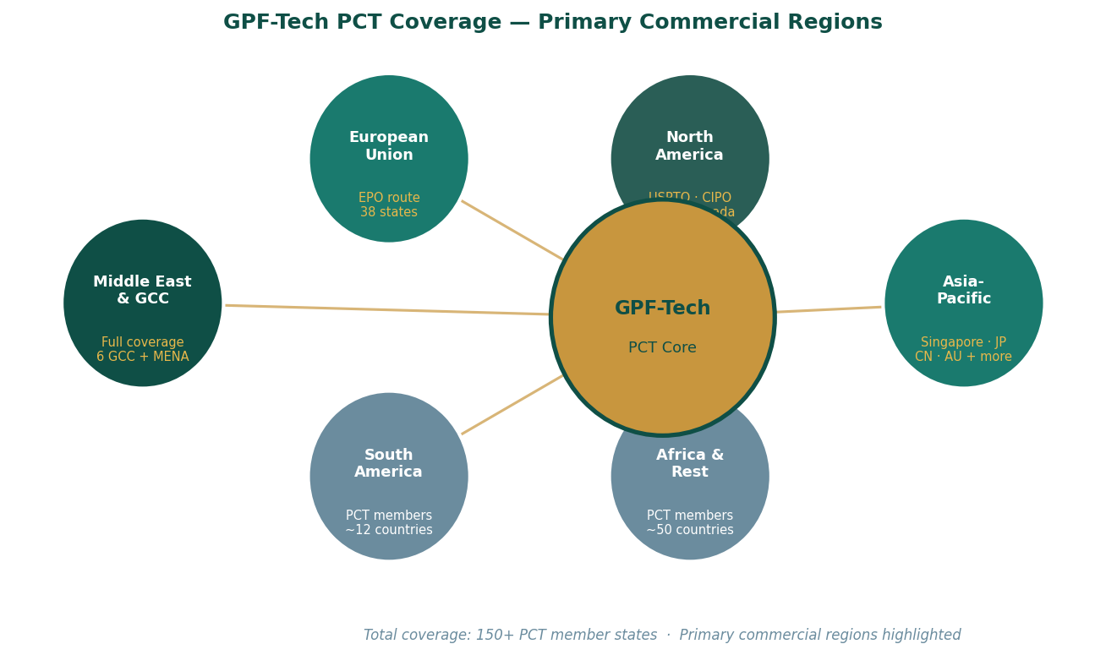
Figure 4-2: GPF-Tech PCT Coverage — 150+ Member States, Primary Commercial Regions

Standards Alignment and Auditability
The GPF architecture produces auditability and standards alignment as inherent properties of its design, not as features added on top of the core architecture. This is significant because auditability and standards compliance are frequently cited as limitations of autonomous systems: the argument that a system making its own decisions cannot be audited or certified. The GPF architecture's design refutes this argument directly.
ISO 9001 alignment is achieved through the Verification and Feedback Layer's continuous conformance checking against maintained specification models. Every production decision and its outcome is logged. Every deviation and its response is recorded. The audit trail exists as a natural byproduct of the verification layer's operation, not as a separately maintained compliance system.
IEC 62264 enterprise-control integration and IEC 61499 distributed control system alignment are achieved through the architecture's separation of concerns: the orchestration layer handles enterprise-level objective decomposition, the fabrication units handle control-level execution, and the execution fabric provides the distributed control integration. The architecture's component structure maps naturally onto these standards' conceptual frameworks.
ISO-IEC 27001 information security alignment is achieved through the architecture's design principle that control commands require authenticated, cryptographically verified instruction and that telemetry from sensitive systems is outbound-only. These properties are not security add-ons. They are design requirements of a system that must operate autonomously without human validation of each command.
Table 4-2: GPF-Tech Standards Alignment Matrix
Standard | Domain | Alignment Mechanism | Achieved By
ISO 9001 | Quality management | Continuous in-process conformance checking | Verification & Feedback Layer — inherent audit trail
ISO 55000 | Asset & production lifecycle | Node lifecycle management, capability tracking | Orchestration layer state model — full unit history
IEC 62264 | Enterprise-control integration | Clean separation of objective and execution layers | Architecture component separation — inherent
IEC 61499 | Distributed control systems | Distributed execution with local autonomy | Execution Fabric — distributed-by-design
ISO-IEC 27001 | Information security | Authenticated command protocol; outbound-only telemetry | Architecture security properties — inherent
Table 4-2: GPF-Tech Standards Alignment — Mechanism and Achievement
Table 4-3: GPF-Tech Regional Coverage and Filing Strategy
Region | Filing Route | Key Jurisdictions Covered | Commercial Significance
Middle East | National phase — direct | UAE, KSA, Kuwait, Qatar, Bahrain, Oman | Primary operational base; industrial diversification programmes
European Union | European Patent Office (EPO) | All 38 EPC contracting states | Supply chain resilience investment; manufacturing buildout
Asia-Pacific | National phase — Singapore, JP, CN, AU | Singapore, Japan, China, Australia, South Korea | ASEAN manufacturing; Singapore operational hub
North America | USPTO (US) · CIPO (Canada) | United States, Canada | Technology licensing market; industrial partnerships
Table 4-3: GPF-Tech Patent Filing Strategy by Region
The Wardens seeded the Foundry Matrix once. The Matrix built everything that followed. The GPF patent encodes the same principle: the architecture is the asset, and the architecture, once instantiated, produces everything else. The patent is not a product. It is a multiplier.

PART TWO

Chapter Five
The Transmutation Forge
From atoms: the Island's industrial foundation and the PIF
The Transmutation Forge occupied a sub-level of the Island that no visitor would ever be shown. Not because it was secret, but because the explanation would take longer than most visits allowed, and the explanation was the point.
What the Forge did, at its simplest, was this: it took atmospheric carbon and water, and it made metal.
The longer explanation involved subatomic particle acceleration, the Prismatic Focus Crystal that Sela had woven at the quantum level as a template for atomic assembly, Vael's Elemental Genesis Protocols encoding the nuclear binding energies for every stable isotope, and Solara's Photon Sieve concentrating solar energy to the threshold required to initiate the reaction. The longer explanation was true. The simple explanation was also true. The Island took air and water and made whatever metals it needed.
The Forge produced three outputs simultaneously. Primary: perfect, on-demand metals and alloys. Secondary: vast surplus electrical energy from the Exotic Particle Plasma. Tertiary: rare and medically valuable isotopes from the Isotopic Tailings that emerged as the process's unavoidable byproduct. The Island had designed a triple-output industrial system from what any conventional engineer would have treated as a single-purpose forge.
The strategic implication was not primarily industrial. It was geopolitical. A system that can produce its own materials from atmospheric feedstock has no supply chain vulnerability at the materials level. It cannot be sanctioned out of its construction programme. It cannot be embargoed into material shortage.

Processing Infrastructure Framework: Technical Architecture
The Processing Infrastructure Framework establishes a distributed global industrial processing network designed around the principle that the most strategically resilient industrial operation is one that controls the full chain from raw resource to finished material. PIF is not a manufacturing system. It is a materials sovereignty system: a framework that ensures Sagar-Raja's production operations can never be disrupted at the materials level.
The framework's foundational principle is elemental decomposition before processing. Every incoming resource is reduced to its constituent elements before any production decision is made. This principle appears simple. Its operational consequences are profound. A facility that holds strategic reserves of elemental iron, aluminium, carbon, hydrogen, and copper can produce any alloy, any composite, any carbon material, or any structural element that can be made from those elements, without requiring any specific raw material to be available in any specific form. The facility's production capability is bounded only by its elemental reserves and its processing modules, not by the availability of any particular input material.
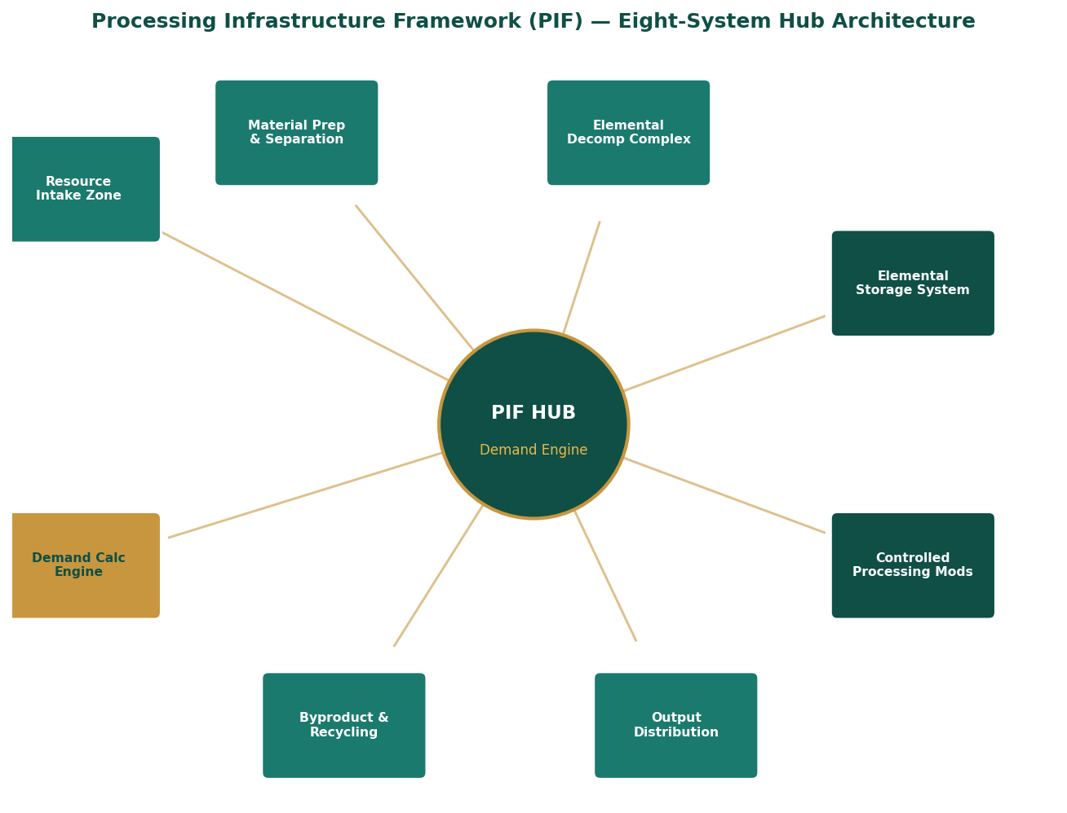
Figure 5-1: PIF Eight-System Hub Architecture — Component Relationships

The Eight Hub Systems
Each PIF hub contains eight major operational systems that together form a complete elemental processing and strategic reserve management facility.
Table 5-1: PIF Hub Systems — Function and Specifications
System | Primary Function | Key Technical Specifications
1. Resource Intake Zone | Receives, weighs, and classifies all incoming raw materials | Continuous feedstock weighing · Auto-classification by elemental profile · Contamination screening
2. Material Prep & Separation | Pre-processes feedstock for decomposition: crushing, sorting, chemical separation | Size reduction to ≤25mm for efficient decomposition · Density separation · Magnetic separation for ferrous content
3. Elemental Decomp Complex | Reduces all feedstock to pure elemental components — the core of PIF | Plasma arc at 5,000–15,000°C · 99.97% extraction efficiency · Zero residue: all material captured as defined element
4. Elemental Storage System | Holds pure elements in stable form at strategic reserve volumes | Fe: molten at 1,600°C · Al: liquid at 700°C · C: graphite blocks · H₂: 700 bar pressurised · O₂: cryogenic at −183°C
5. Demand Calculation Engine | Continuously calculates processing requirements from three inputs: host demand, export commitments, strategic reserve thresholds | Real-time integration of demand signals · 90-day rolling forecast · Reserve threshold alerting · Autonomous processing triggers
6. Controlled Processing Mods | Produces specific alloys, compounds, and materials from elemental reserve on demand | Module types: alloy production, carbon processing, polymer synthesis, composite fabrication · Hot-swap capable · GPF-compliant
7. Output Distribution | Routes finished materials to internal production or external logistics | Automated QC against spec before release · Grade segregation · Traceability tag applied at output · Cold-chain where required
8. Byproduct & Recycling | Captures all processing byproducts and routes them to secondary use or elemental return | Zero-landfill mandate: every byproduct has defined pathway · Slag → silicate storage · Process gas → elemental recovery · Thermal waste → heat exchanger
Table 5-1: PIF Eight-System Hub Architecture

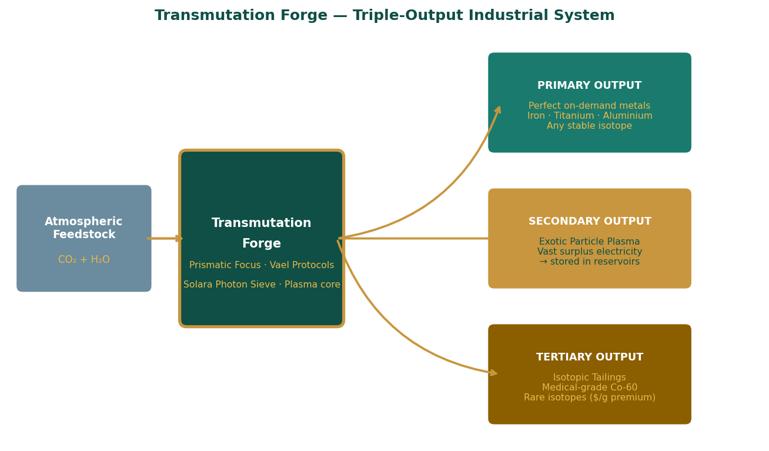
Figure 5-2: Transmutation Forge — Triple-Output Industrial System

Demand-Triggered Processing: The DCE in Detail
The Demand Calculation Engine is the intelligence centre of each PIF hub. Its function is to ensure that the hub is always processing the right material at the right rate: not so much that reserves are unnecessarily depleted by over-processing, and not so little that demand cannot be met from reserve.
The DCE integrates three demand signals continuously. Host demand is the current and forecast production requirement of the Sagar-Raja facilities served by the hub, expressed as an elemental requirement profile, which elements are needed, in what quantities, and on what timeline. Export commitments are the contracted supply obligations to external counterparties, which must be met regardless of internal demand fluctuation. Strategic reserve thresholds are the minimum elemental holdings that the framework requires at all times, expressed as defined quantities of each element that must remain in storage regardless of demand.
Processing is initiated when the DCE's forecast shows that, if current processing rates are maintained, any element's projected reserve will fall below its strategic threshold within the forecast horizon. Processing is scaled to restore the reserve to the target level. Processing does not run continuously at a fixed rate. It runs at the rate required to meet defined demand while maintaining defined reserves, and this rate changes as demand and reserve levels change.
Table 5-2: DCE — Reserve Thresholds and Processing Triggers
Element | Storage Form | Strategic Min Reserve | Processing Trigger | Target Reserve
Iron (Fe) | Molten reservoir | 30 days production | < 45 days forecast | 90 days production
Aluminium (Al) | Liquid metal tank | 30 days production | < 45 days forecast | 90 days production
Carbon (C) | Graphite block storage | 60 days production | < 75 days forecast | 180 days production
Hydrogen (H₂) | 700 bar pressurised | 14 days production | < 21 days forecast | 45 days production
Oxygen (O₂) | Cryogenic −183°C | 21 days production | < 30 days forecast | 60 days production
Copper (Cu) | Molten reservoir | 45 days production | < 60 days forecast | 120 days production
Table 5-2: DCE Reserve Thresholds and Automatic Processing Triggers

SR-C6 as the Carbon Fraction of PIF
Every element that flows through the PIF decomposition process is a potential commercial product. Carbon is the element whose downstream commercial expression is most fully developed in the current Sagar-Raja portfolio. SR-C6, the industrial carbon black platform, is the value-added processing of the carbon fraction of PIF's decomposition output.
Carbon that enters the elemental storage system as graphite is available for processing into any carbon black grade, any graphitic material, or any carbon-fibre precursor that the Controlled Processing Modules are configured to produce. The PIF's carbon reserve is the raw material inventory for SR-C6 production. The DCE's carbon reserve calculations include SR-C6 production commitments as a component of export demand. The two systems are not separate. SR-C6 is the commercial expression of the carbon pathway of PIF.
Table 5-3: SR-C6 Grade Specifications — From PIF Carbon Fraction
Grade | Surface Area  (m²/g) | DBP Absorption  (mL/100g) | Particle Size  (nm) | Primary Application | Key Market
SR-C6 R | 70–120 | 80–130 | 40–80 | Tyre reinforcement · Rubber goods · Mechanical elastomers | Automotive, industrial
SR-C6 P | 100–300 | 60–120 | 15–40 | Coatings · Inks · Plastics pigmentation | Printing, coatings
SR-C6 E | >200 | 120–200 | 15–30 | Conductive polymers · Antistatic · Electronic components | Electronics, EV
SR-C6 EC | >350 | 150–300 | 10–20 | Li-ion battery anodes · Supercapacitor electrodes | Energy storage
SR-C6 HG | High — graphitic | N/A (graphitic form) | Macro-crystalline | Structural composites · Thermal management · Friction materials | Aerospace, defence
Table 5-3: SR-C6 Grade Specifications Matrix
The PIF and SR-C6 relationship illustrates the compound value of correct foundational design. PIF's carbon pathway produces a strategic elemental reserve. SR-C6 converts that reserve into five distinct commercial grades for five distinct industries. The decomposition investment is made once. The commercial return is multiplied across every grade, every application, and every market that the carbon fraction can reach.

PART TWO

Chapter Six
Water from Nothing
Atmospheric sovereignty and the independence it creates
Nara did not collect water. The distinction matters.
Collecting water requires a source: a river, an aquifer, a municipal supply, a rainfall pattern. A source is a dependency. A dependency is a vulnerability. Nara did not operate from sources. Nara operated from the atmosphere, which is present everywhere at all times and which holds, in its water vapour fraction, more than enough moisture for any operational purpose the Island would ever have.
The principle Nara had perfected was not extraction. It was invitation. Water molecules in the atmosphere are in constant motion. They are attracted to surfaces with greater affinity than the air itself. The Thirsty Silk Lattice that Sela had woven from Nara's design provided those surfaces in enormous quantity, in three dimensions, at every level of the tower structure. The lattice did not pull water from the air. It offered the water a better place to be. The water came.
The Hydro-Kinetic Emitter's role was the final step: a low-energy pulse that told the bound molecules to release simultaneously and coalesce. The physics was precise. The energy cost was negligible. The output was 99.9 percent pure water, arriving at the reservoir without pumps, without pipes from external sources, and without any dependency on the availability of surface or ground water in the region.
What Nara had given the Island was not a water supply. It was water independence. The difference, in strategic terms, is absolute.

Resource Independence as Strategic Doctrine
Sagar-Raja's operational frameworks treat resource independence not as a sustainability goal but as a strategic doctrine. The distinction matters because sustainability goals are often measured against external benchmarks and judged by external parties. A strategic doctrine is an internal operating principle that the system maintains regardless of external measurement or external pressure.
Resource independence at the water level, achieved through the HACA unit, is the clearest and most operationally complete example of this doctrine. But the doctrine extends across all critical resources. Energy independence through multi-source harvesting architecture. Materials independence through PIF elemental decomposition and strategic reserves. Food independence through VASF autonomous agricultural synthesis. The platform is designed to eliminate, one by one, every category of supply dependency that could be used as leverage against its operations.
This is not isolation. The platform trades with the external world and benefits from those trades. It exports surplus materials, intelligent services through DIRE, and cultural output through ANIM-E. The independence is not about refusing external engagement. It is about ensuring that external engagement is chosen rather than compelled. A platform that has no resource dependencies can decide to engage with external markets on terms that reflect its actual value, rather than accepting terms driven by its need.

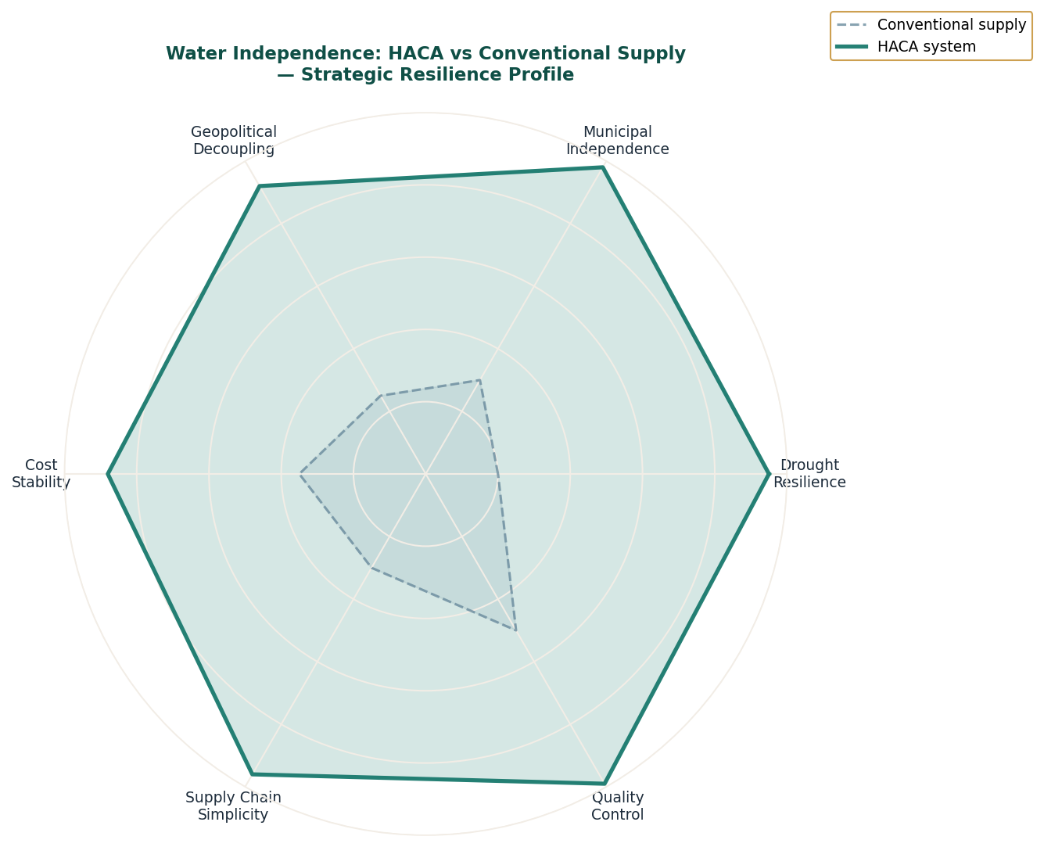
Figure 6-1: Strategic Resilience Profile — HACA System vs Conventional Water Supply

The HACA Unit: Engineering Principles
The Hydro-Kinetic Atmospheric Condensation Array is based on two physical principles that, when combined, produce an energy-efficient atmospheric water harvesting system that outperforms conventional alternatives on every strategic metric.
The first principle is hygroscopic adsorption. Certain materials have a greater affinity for water molecules than the surrounding air does. When atmospheric air passes over such a surface, water molecules preferentially adsorb to the surface rather than remaining in suspension. The key engineering challenge is to maximise the effective surface area of the hygroscopic material relative to its structural volume and to maintain the hygroscopic property of the surface over extended operational periods without degradation.
The Thirsty Silk Lattice addresses this challenge through bio-composite engineering. The lattice is woven at sub-millimetre scale from Sela's hygroscopic composite material into a three-dimensional branching structure. The three-dimensional geometry means that air passing through the lattice in any direction encounters hygroscopic surface on multiple faces. The self-repairing property of the bio-composite means that the lattice maintains its hygroscopic property without periodic replacement. The surface area per unit volume achieved by the lattice geometry is orders of magnitude higher than flat-surface condensation systems.
The second principle is coalescence pulse. Once water molecules have adsorbed to the lattice surface, they must be caused to aggregate into droplets large enough to flow under gravity to the collection reservoirs. Individual adsorbed molecules do not flow: they must first aggregate. The Hydro-Kinetic Emitter applies a low-energy molecular resonance pulse that simultaneously breaks the surface-molecule bonds across the entire lattice and applies a directional pressure that causes the released molecules to aggregate and flow. The energy cost of this pulse is approximately 0.8 kilowatt-hours per tonne of water collected, compared to approximately 2.5 kilowatt-hours per tonne for conventional groundwater pumping at comparable volumes.

The Geopolitical Dimension of Water Independence
The strategic case for water independence through atmospheric harvesting is made most clearly by examining the water vulnerabilities that the HACA system eliminates. Each vulnerability represents a category of external leverage that has been exercised against industrial facilities in different geopolitical contexts.
Watershed dependency creates upstream political leverage. A facility that draws water from a river system is dependent on the water management decisions of every upstream authority. Changes in upstream land use, dam construction, irrigation allocation, and industrial extraction all affect downstream availability. In contested river basins, these decisions are often politicised. The HACA system has no watershed dependency. Upstream decisions are irrelevant to its operation.
Aquifer dependency creates geological and regulatory vulnerability. Aquifer depletion is a documented phenomenon in most major agricultural and industrial regions. A facility dependent on groundwater may find its access restricted by regulatory response to depletion, or find the water table dropping below operational access levels over a period of years. The HACA system draws from the atmospheric moisture cycle, which replenishes continuously regardless of aquifer conditions.
Municipal supply dependency creates infrastructure and political vulnerability. A facility connected to a municipal water supply is dependent on the infrastructure integrity and political goodwill of the supplying authority. Supply disruption, whether through infrastructure failure or political decision, directly affects operations. The HACA system requires no external connection.
Table 6-1: Water Dependency Categories — Vulnerability and HACA Elimination
Dependency Type | Vulnerability Mechanism | Real-World Instances | HACA Elimination
Watershed / River | Upstream authority controls flow allocation | Nile basin disputes · Colorado River compact failures | Complete — no watershed connection
Aquifer / Groundwater | Depletion, regulatory restriction, depth loss over time | Saudi aquifer depletion · California subsidence | Complete — no groundwater connection
Municipal supply | Infrastructure failure, political restriction, pricing | Industrial supply interruptions in contested regions | Complete — no municipal connection
Rainfall / Collection | Seasonal variability, climate change, drought periods | Industrial water shortages in drought years globally | Substantially reduced — HACA maintains output down to RH 35%
Desalination dependency | Energy cost exposure, brine discharge regulation, equipment dependency | GCC desalination cost volatility with energy prices | Complete — no desalination required
Table 6-1: Water Dependency Categories and HACA Elimination

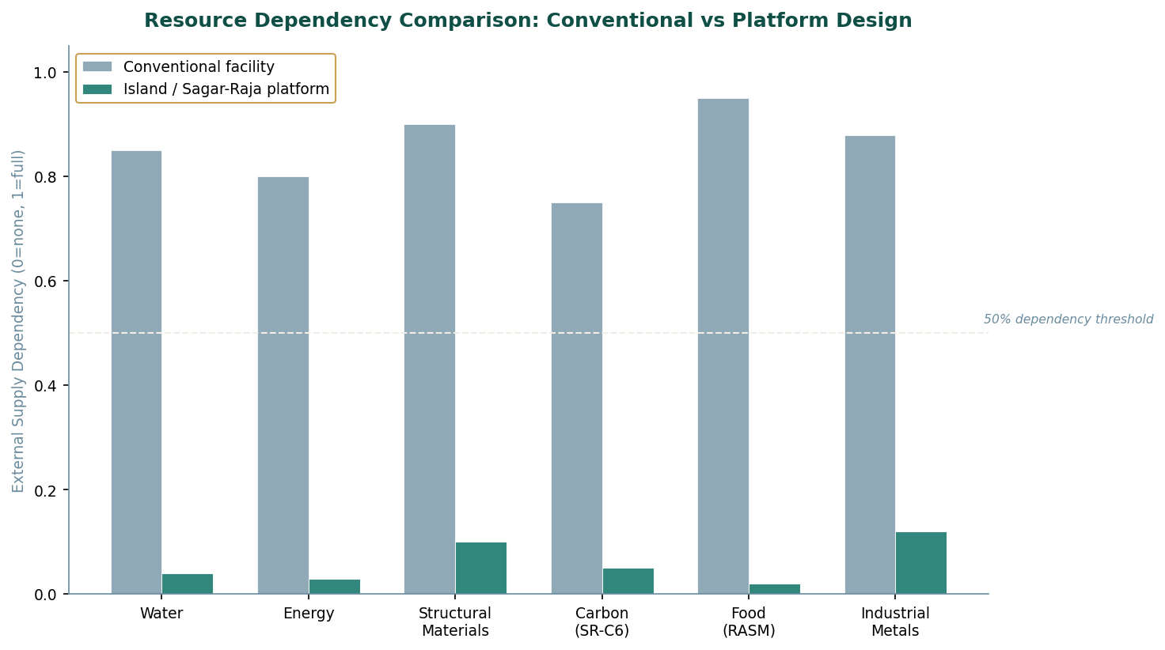
Figure 6-2: External Supply Dependency — Conventional Facility vs Platform Design

Scaling: From Portable Units to Industrial Arrays
The HACA design scales across a range of deployment contexts from small portable units for forward operating bases to large tower clusters for major industrial facilities. The scaling is achieved by multiplying the number of lattice-emitter units in a cluster, not by increasing the size of individual units. This modular scaling approach has several advantages.
Each unit is independently operational. A cluster of twenty units produces twenty times the output of a single unit, but each unit is independently functional. If two units require maintenance, the remaining eighteen continue to operate at full individual output. The cluster's total output degrades proportionally to the fraction of units under maintenance, rather than failing entirely. This is the distributed fault-tolerance architecture applied to water production.
The modular design also means that water production capacity can be added incrementally as demand grows. An installation begins with the number of units required for initial operational demand and adds units as demand increases. The capital investment scales with operational need rather than being sized for a projected future peak that may not materialise as forecast.
Table 6-2: HACA Unit Configurations — Scale and Application
Configuration | Unit Count | Daily Output | Footprint | Primary Application
Portable tactical | 1 | 200–500 L/day | 1.2 × 0.8 × 2.0 m | Forward operating bases · Remote research stations
Small facility | 4–8 | 1–4 tonnes/day | Cluster: ~20m diameter | Small industrial · Agricultural operations
Mid-scale cluster | 20–40 | 4–12 tonnes/day | Cluster: ~60m diameter | Medium industrial · Platform primary water supply
Large array | 80–120 | 18–35 tonnes/day | Array: ~150m span | Large industrial facility · Urban supplement in water-scarce regions
Platform sovereign | 200+ | 50+ tonnes/day | Integrated into landform | Full platform water sovereignty · Zero external dependency
Table 6-2: HACA Unit Configurations by Scale

The Broader Resource Independence Doctrine
Water is the clearest example of the resource independence doctrine because the HACA system achieves near-complete independence and because water dependency is the most immediately comprehensible strategic vulnerability. But the doctrine operates across all critical resources, and its application across the full resource profile of the platform creates an exponentially greater strategic position than any single resource independence achievement would create in isolation.
A platform that is energy-independent is more resilient than a conventional facility. A platform that is also water-independent is disproportionately more resilient, because the loss of either utility would previously have halted operations. A platform that is also materials-independent through PIF is more resilient still. A platform that is also food-independent through VASF has eliminated the last major category of external supply dependency. At this point the platform's operational continuity depends only on the integrity of its own systems, not on any external party's continued cooperation.
This is the compound effect of the resource independence doctrine applied systematically. Each independence achievement is valuable individually. Together they create an operational position that cannot be achieved by any number of conventional risk mitigation measures, because conventional risk mitigation reduces the probability of supply disruption without eliminating the dependency that makes disruption possible.
The strategic value of independence is not measured in the probability of disruption. It is measured in the number of ways the platform can be pressured through its resource dependencies. That number, with the resource independence doctrine fully implemented, approaches zero.

PART III
III
WHAT THE ISLAND GROWS
Every product is a proof of survival.

RASM · RIDER · STRIKER · GEO · SR-C6

Five products. Each one a complete answer to the question of what correct design
looks like when it reaches the world. RASM: nutritional completeness without lifestyle
compromise. RIDER: global engineering discipline held to one specification everywhere.
STRIKER: adaptive protection that removes decisions from the wearer. GEO: the correct
instrument, nothing more, nothing less. SR-C6: the black foundation — present in
every system, acknowledged by none, holding everything else up.

CONTENTS — Chapters 7 – 11

Chapter Seven The Instant Farm
VASF triple-output synthesis · RASM complete specification · Institutional market analysis
Chapter Eight The Moving Vehicle
RIDER single-variant discipline · 18-parameter specification · Regulatory adaptation matrix
Chapter Nine The Warden's Skin
STRIKER three-layer architecture · Four climate variants · Fragment energy dispersion
Chapter Ten The Instrument That Reads
GEO hybrid display system · Monobloc composite case · Yantra design principle
Chapter Eleven The Black Foundation
SR-C6 five-grade platform · BET/DBP parameters · Battery and structural composite markets

PART THREE

Chapter Seven
The Instant Farm
The VASF and the engineering of perfect nourishment — RASM
The Vertical Agro-Synthesis Facility was not designed to grow food. The distinction, once understood, reframes everything about how it works.
Growing food requires time. Seeds germinate. Plants develop. Fruit ripens. The timeline is biological and it is long. The VASF did not have sixty to ninety days. More precisely, the VASF's design did not include time as a necessary variable. It had removed it.
What Solara's photonic maturation principle had discovered was that biological time is not the irreducible variable it appears to be. A plant at harvest maturity is not different from a seed in any absolute sense. It is the same biological system at a different state. If you know the end state with perfect precision, which is what Vael's Maturation Template provides, and if you can supply the energy required to move the system from its current state to the target state instantaneously, then the intervening time is not a constraint. It is simply skipped.
A flash of green-gold light. Duration: eighty milliseconds. A seed enters the Synthesis Chamber. A fully mature strawberry plant exits. The pod biodegrades. The fruit is on a conveyor within thirty seconds. The system produced three outputs from each cycle: the harvest itself, Genesis Biomass from the root and stem matrix, and Oxygen-Plus from the photonic exhaust. The VASF was a triple-output industrial system that happened to also produce food.

VASF: Vertical Agro-Synthesis Facility — Technical Architecture
The VASF is a vertical tower structure housing stacked synthesis chambers, atmospheric conditioning systems, and a biomass processing line. Its output is not defined by crop variety. It is defined by the Maturation Template library maintained in the Genesis Core AI, which contains the biological state specification for every crop in the VASF's production catalogue. Adding a new crop to production requires adding a new Maturation Template, not redesigning any physical system.
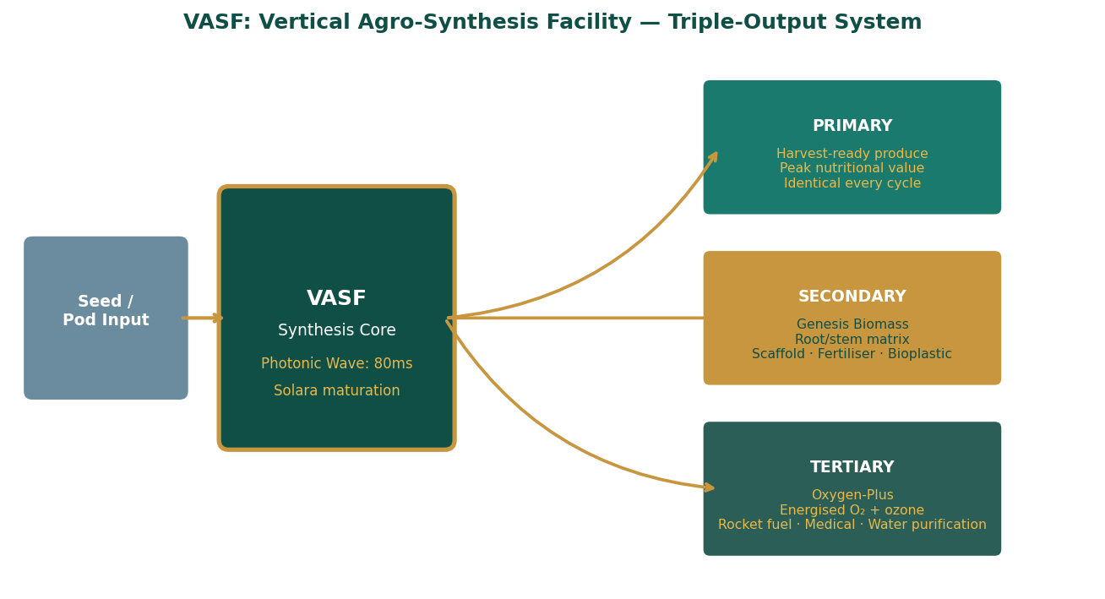
Figure 7-1: VASF Triple-Output System — Input, Synthesis, and Three Output Streams

Synthesis Chamber Operation
Each synthesis chamber is a sealed environment approximately 0.8 by 0.8 by 1.2 metres, containing a bio-composite pod woven by Sela's material architecture to the specific geometry of the crop being produced. The pod is the crop's growing medium, structural support, and photonic receptor simultaneously. It is single-use: after harvest, the pod frame is shredded and fed into the biomass line, where it becomes Genesis Biomass.
The synthesis wave is produced by the Photon Sieve — a precision optical array that focuses solar energy collected by the VASF's exterior photovoltaic surface into a wavelength-and-intensity profile matched to the Maturation Template's activation requirements. The wave lasts eighty milliseconds. The biological state transition is instantaneous within that window: the seed's cellular machinery receives the template-matched photonic signal and aligns to the specified mature state without passing through the intermediate developmental stages. The physics is that of state-space alignment, not of accelerated growth.
Table 7-1: VASF Synthesis Chamber — Operating Parameters
Parameter | Value | Notes
Synthesis wave duration | 80 milliseconds | State-alignment pulse — not growth acceleration
Chamber cycle time | ~30 seconds total | Includes pod loading, synthesis, harvest, pod shredding, reset
Chambers per tower (standard) | 240–480 | Stacked vertically; each independently controlled
Daily harvest cycles per chamber | Up to 2,880 | Theoretical maximum; operational rate ~1,200 accounting for maintenance windows
Crop catalogue size | 17 varieties (current) | Governed by Maturation Template library in Genesis Core AI
Maturation template precision | Cell-state resolution | Template specifies target biological state at individual cell type level
Output nutritional consistency | >99.7% batch-to-batch | Identical template applied every cycle; no environmental variation effect
Table 7-1: VASF Synthesis Chamber Operating Parameters

The Three Output Streams
The VASF's triple-output architecture is not a design optimisation added to a single-purpose food production system. It is the natural consequence of a synthesis process that is thermodynamically complete: every input is fully converted to defined outputs, and the outputs are defined to be useful to the platform's other systems.
The primary output, harvest-ready produce, arrives at the food processing line at absolute nutritional peak. Because the synthesis wave aligns the biological system to a precise template that specifies the mature state at the exact moment of peak nutritional density, every unit of output is at its maximum nutritional value. There is no degradation from harvest timing variation. There is no variation between batches. The nutritional specification of the output is defined by the template and is therefore constant.
The secondary output, Genesis Biomass, is the root and stem matrix generated by the synthesis process but not incorporated into the food product. This matrix is structurally perfect organic material: sterile, consistent in composition, and produced in large quantities as an inevitable consequence of the synthesis wave that produces the food. The biomass is dried, milled, and routed to three applications: soil amendment for any terrestrial planting operations on the platform, scaffolding material for lab-grown protein production, and feedstock for biodegradable polymer synthesis.
The tertiary output, Oxygen-Plus, is the energised singlet oxygen and low-concentration ozone produced as the photonic exhaust of the synthesis wave. The photon sieve directs energy into the biological system's state transition, but the process also produces reactive oxygen species that cannot be retained within the chamber. These are captured, concentrated, and stabilised in high-pressure storage vessels. Applications include oxidiser for rocket fuel systems, hyperbaric oxygen therapy in medical contexts, and ultra-efficient water purification through controlled ozone injection.
Table 7-2: VASF Output Stream Applications and Platform Value
Stream | Output Type | Platform Applications | External Commercial Value
Primary | Harvest-ready produce | Platform nutrition · RASM feedstock · Personnel supply | Premium produce markets · Pharmaceutical-grade botanical ingredients
Secondary | Genesis Biomass | Soil amendment · Cultured protein scaffold · Bioplastic feedstock | Biomaterial industry · Lab-grown protein sector · Sustainable packaging
Tertiary | Oxygen-Plus | Rocket fuel oxidiser · Water purification · Medical hyperbaric | Aerospace propulsion · Industrial water treatment · Medical O₂ supply
Table 7-2: VASF Output Streams — Platform and Commercial Applications

RASM: Royal Almond-Soy Milk-Blend — Product Architecture
RASM is positioned as a nutritional substrate, not a lifestyle beverage. This distinction is the single most important decision in the product's design, and every specification choice flows from it. A lifestyle beverage is optimised for consumer experience: taste, brand association, packaging aesthetics. A nutritional substrate is optimised for nutritional delivery: protein density, amino acid completeness, bioavailability, stability, and compatibility with the widest possible range of consumption contexts.
RASM is designed for the second set of criteria. This makes it more useful and less exciting to casual consumers, which is exactly the correct trade-off for a product whose purpose is to reliably deliver nutrition. The product does not compete with premium plant milks in the lifestyle segment. It competes with nutritional substrates in the functional segment, where the evaluation criteria are specification-driven rather than identity-driven.
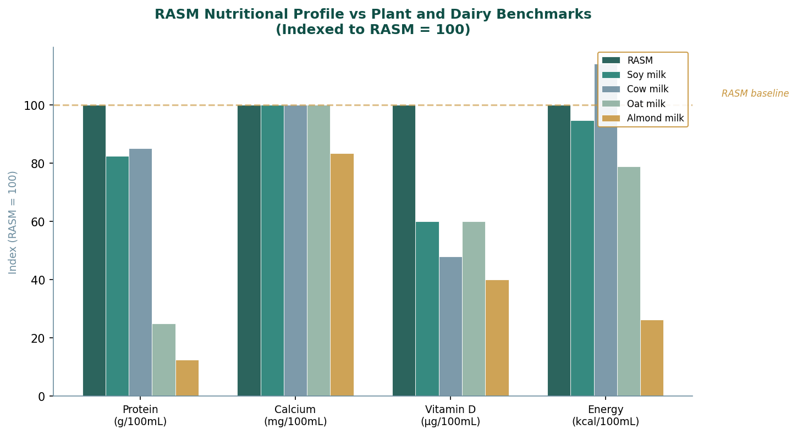
Figure 7-2: RASM Nutritional Profile vs Plant and Dairy Benchmarks (Indexed: RASM = 100)

Formulation Architecture: Why Almond and Soy
The almond-soy blend is not a marketing combination. It is a nutritional engineering decision. Almond and soy have complementary profiles that produce a blend superior to either ingredient alone on the key functional metrics.
Almond's contribution is lipid quality, sensory neutrality, and micronutrient support. Almond milk has a mild, clean flavour profile that does not dominate the blend. Its lipid content includes oleic acid at proportions beneficial for cardiovascular health. Its micronutrient profile includes vitamin E, magnesium, and riboflavin at useful concentrations. What almond does not provide is complete protein: almond protein is low in lysine and other essential amino acids.
Soy's contribution is protein completeness, emulsification stability, and shelf resilience. Soy protein contains all nine essential amino acids at proportions that closely match human nutritional requirements, making it one of the few plant proteins that qualifies as complete without supplementation. Soy lecithin provides natural emulsification that stabilises the oil-in-water emulsion over shelf life. Soy's structural proteins also provide thermal stability during processing.
The blend ratio is set to maximise the combined nutritional profile while maintaining the sensory neutrality that makes RASM applicable across a wide range of consumption contexts. The formulation targets 4.0 grams of protein per 100 millilitres with complete essential amino acid coverage at proportions that meet or exceed the FAO/WHO reference pattern for all nine essential amino acids. No other commercially available plant milk achieves this without external protein fortification.
Table 7-3: RASM Complete Technical Specifications
Parameter | Value | Significance
pH | 6.3 ± 0.2 | Near-neutral — compatible with all GI conditions; no acidic off-notes
Density | ~1.02 g/mL at 20°C | Close to water density — accurate volumetric dosing in clinical settings
Viscosity | ~3.5 mPa·s at 20°C | Low viscosity — flows easily; suitable for tube feeding and mixing
Emulsion type | Oil-in-water, ~0.6µm droplet | Fine emulsion; stable under refrigeration and moderate temperature
Phase stability | <3% creaming / 7 days refrig. | Shelf-stable without excessive stabiliser use
Protein / 100mL | 4.0g | Complete EAA profile — highest among commercially available plant milks without fortification
Energy / 100mL | 57 kcal | Moderate energy density — suitable for volume feeding without caloric overload
Total fat / 100mL | 3.0g (0.6g saturated) | Favourable lipid profile; below dairy equivalents in saturated fraction
Carbohydrate / 100mL | 3.5g (1.6g sugars) | Low sugar content — compatible with diabetic and low-glycaemic protocols
Calcium / 100mL | 120mg | Matches fortified dairy and plant milks; 12% of adult RDA per 100mL
Vitamin D / 100mL | 2.5 µg | Fortified to 25% of adult RDA per 100mL
Vitamin B12 / 100mL | 0.5 µg | Fortified for vegan/vegetarian applicability; 20% RDA per 100mL
Species applicability | Human and animal | No species-specific fortification; formulation is cross-species neutral
Religious/cultural restriction | None | No restricted ingredients across any major dietary framework globally
Table 7-3: RASM Complete Technical Specification

Positioning and Market Strategy
RASM does not target the premium lifestyle plant milk segment. That segment is characterised by brand premiums, environmental storytelling, and taste differentiation — all of which require sustained marketing investment to maintain and none of which create durable competitive advantage against better-capitalised competitors. RASM targets the functional nutritional substrate segment, where evaluation criteria are objective, where switching costs are real because reformulation requires regulatory re-approval, and where the customer base is institutional rather than individual.
Institutional customers for a nutritional substrate of RASM's specification include hospital and clinical nutrition services, military ration programmes, long-duration space mission provisioning, intensive livestock and aquaculture operations, and large-scale food processing operations that use plant-based milk as an ingredient. In each of these contexts, the purchasing decision is specification-driven. A product that meets a defined specification at a competitive price will be preferred over a product with better lifestyle branding but inferior specification.
Table 7-4: RASM Market Segment Analysis
Segment | Decision Basis | RASM Competitive Position | Key Barrier to Entry for Competitors
Clinical nutrition | Specification + regulatory approval | Complete EAA · pH neutral · Low viscosity · Species-agnostic | Clinical reformulation requires 12–24 months regulatory pathway
Military rations | Nutritional spec + shelf life + portability | 4.0g protein · Cross-climate stability · No cultural restrictions | Military qualification process; species-agnostic formulation rare
Intensive animal nutrition | Cost per gram protein + palatability | Species-agnostic design · Complete EAA · Bulk supply available | Species-agnostic formulation unusual; most plant milks human-optimised
Food processing ingredient | Consistency + bulk pricing + spec | Tight spec tolerances · Bulk supply · Stable emulsion for processing | Spec consistency at industrial volumes requires integrated supply chain
Table 7-4: RASM Institutional Market Segments
RASM's formulation ratios, process parameters, and stability controls are proprietary to Sagar-Raja. The ingredient list is a regulatory disclosure instrument, not a specification document. Regulatory compliance is met in full; the technical basis of the formulation's performance is not publicly disclosed. This distinction preserves the formulation as a proprietary asset.

PART THREE

Chapter Eight
The Moving Vehicle
The carrier that never refuels, and RIDER: one variant everywhere
The Metabolic Carrier was not, in the conventional sense, a vehicle. It was an energy ecosystem that happened to move.
Its hull was not a shell. It was a harvesting surface. The upper faces absorbed solar energy. The hull material produced current from every vibration and pressure differential it experienced. The marine variants deployed a thermocline intake that generated power from the temperature differential between surface water and depth, continuously, day and night.
In total solar deprivation — a deep-sea storm with heavy cloud and turbulent water — the electro-kinetic layer went into overdrive from hull stress, the thermocline layer performed optimally, and if both still fell short, the atmospheric fermentation layer activated. Three independent energy sources were insufficient to deplete before a fourth activated. The carrier had been designed for the worst case, not the average case.
The Aegis Fold protocol gave the carrier a second property. In its deployed form it occupied the space its function required. Stored, it occupied a fraction of that space in standardised crates that passed through customs as agricultural equipment. The same capability that made it operationally versatile made it strategically invisible.

RIDER: Single-Variant Global Electric Performance Sedan
RIDER is designed around a principle that runs counter to standard global vehicle manufacturing logic: one variant, everywhere, always. No trim levels. No regional editions. No market-specific configurations beyond the regulatory minimum. The same vehicle, to the same specification, in every jurisdiction where it is sold.
This is harder to execute than it sounds. Global vehicle manufacturing is typically structured around variant proliferation: additional trim levels unlock additional margin, regional editions satisfy local preference, market-specific configurations manage regulatory diversity. These are reasonable commercial responses to genuine market conditions. RIDER's refusal to adopt them is a design choice with specific operational consequences that compound over time.
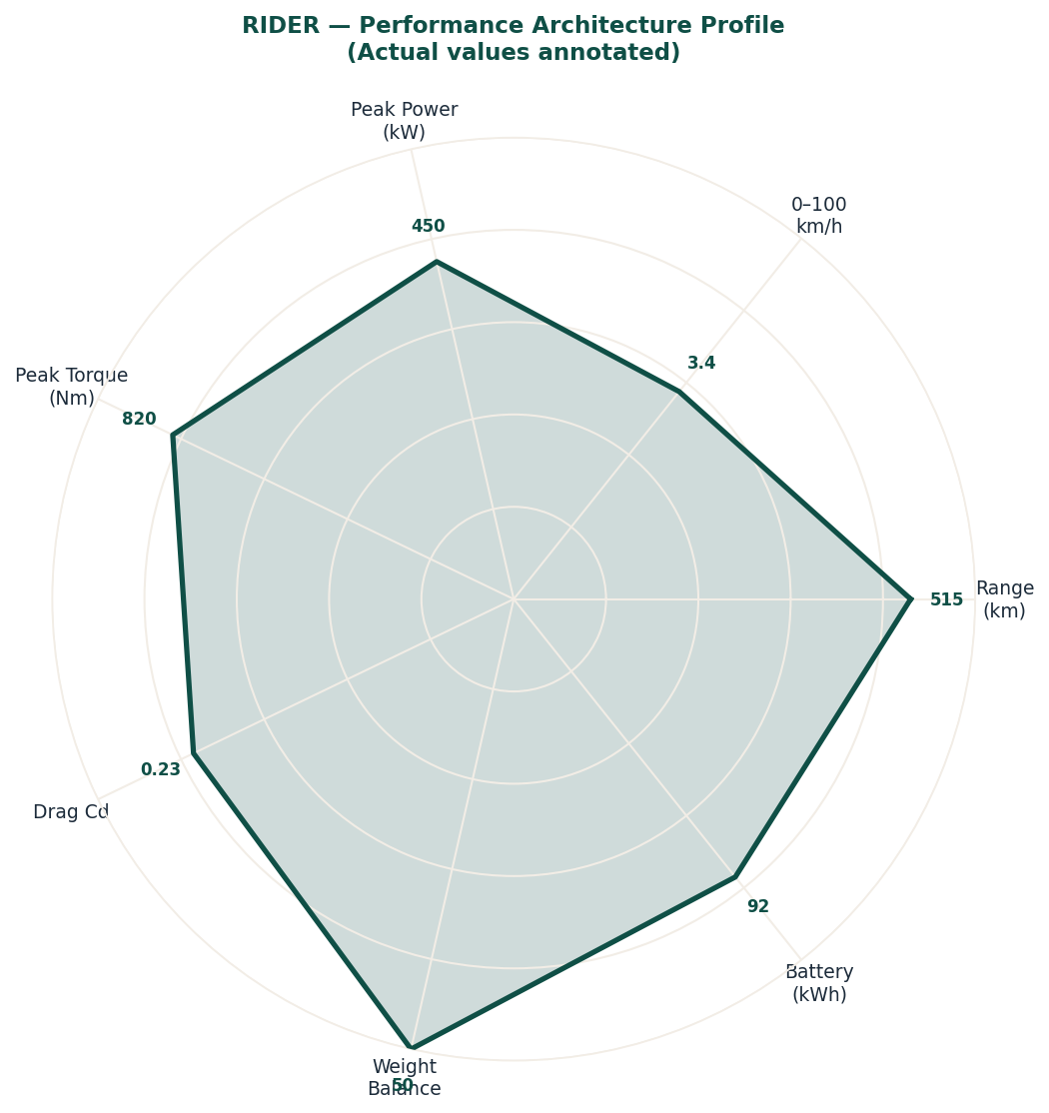
Figure 8-1: RIDER Performance Architecture Profile — Actual Values Annotated

Platform Architecture
RIDER uses a dedicated electric vehicle skateboard architecture. The skateboard is the structural and mechanical foundation on which the body sits: it contains the battery pack, the dual-motor drivetrain, the suspension geometry, and the primary structural load paths. By designing RIDER on a dedicated platform rather than adapting a shared platform from another vehicle family, Sagar-Raja has full control over every engineering parameter. There are no legacy constraints from a combustion vehicle platform, no packaging compromises inherited from a different body style, and no shared-platform cost structures that would require managing multiple derivative programmes.
The architecture is unified globally. Every structural dimension, every mechanical specification, every electronic system architecture is identical across all markets. Regional adaptations are limited to four categories: regulatory lighting requirements that cannot be met by the standard configuration, labelling obligations that require market-specific text, software constraints imposed by local law such as maximum speed limits or telematics requirements, and charging standards where the local network does not support the standard specification's default protocol. Nothing outside these four categories changes by market. Not the paint colours, not the interior materials, not the powertrain output, not the battery chemistry.
Table 8-1: RIDER Complete Technical Specifications
Parameter | Specification | Notes
Body style | Four-door fastback sedan | Single body style globally — no SUV, no estate variant
Platform | Dedicated EV skateboard | No shared platform with any other vehicle; no legacy compromises
Drive configuration | Dual-motor all-wheel drive | Single drivetrain globally; no RWD or FWD variant
Length | ~4,880 mm | Consistent globally — no regional wheelbase extension
Width | ~1,920 mm | Excluding mirrors
Height | ~1,420 mm | Fastback roofline; no raised-roof market variant
Wheelbase | ~2,950 mm | Long wheelbase for class — maximises interior volume
Kerb weight | 2,150–2,250 kg | Range reflects battery and optional equipment variation within spec
Weight distribution | ~50:50 front:rear | Achieved by mid-mounted battery pack geometry
Drag coefficient | ~0.23 Cd | Best-in-class for this segment; achieved through body geometry not active systems
Peak power (combined) | ~450 kW | Front and rear motor combined output
Peak torque (combined) | ~820 Nm | Torque vectoring via independent motor control
0 to 100 km/h | ~3.4 seconds | Consistent across all market variants
Top speed | 240 km/h (electronically limited) | Limit set at 240 km/h globally; structurally capable of higher
Battery capacity (usable) | ~92 kWh | Single battery specification globally
WLTP range | ~480 km | Mixed cycle; real-world 440–520 km depending on conditions
Charging (AC) | Up to 22 kW on-board | Three-phase AC charging; 0–80% in ~4 hours
Charging (DC) | Up to 250 kW | 0–80% in ~22 minutes at peak DC infrastructure
Suspension | Multi-link front and rear, air | Adaptive air suspension standard — no fixed-spring market variant
Table 8-1: RIDER Technical Specifications — Global Single-Variant

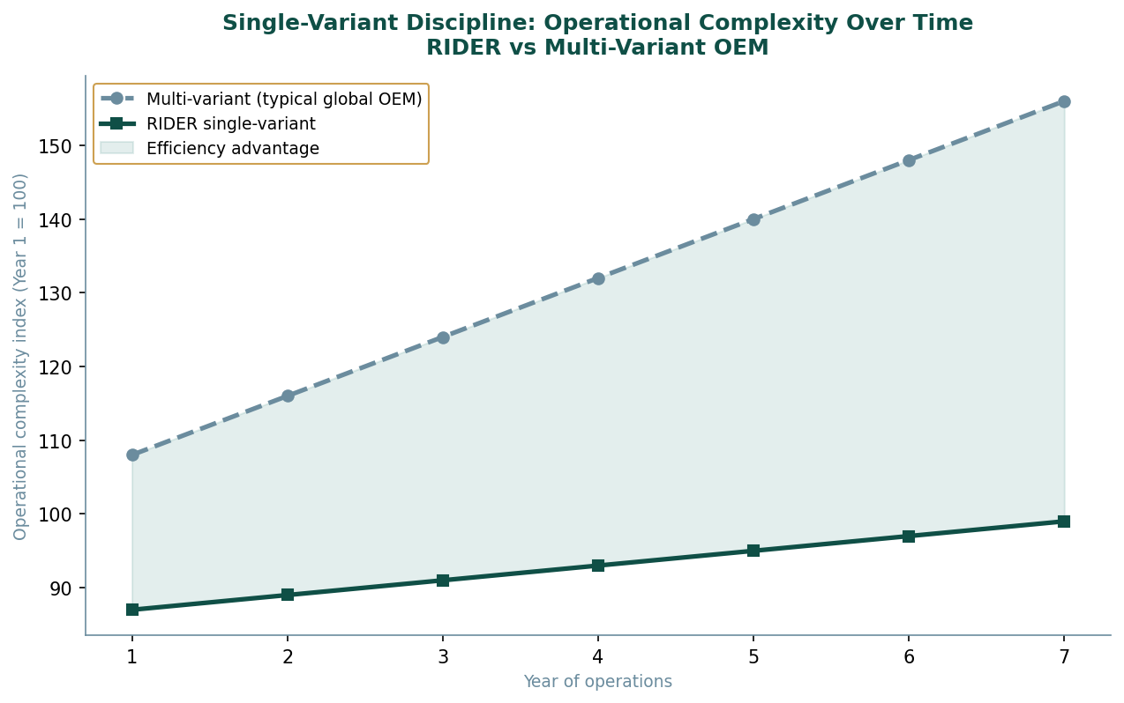
Figure 8-2: Operational Complexity Over Time — Single-Variant vs Multi-Variant OEM

The Single-Variant Discipline: Why It Matters
The conventional argument for variant proliferation is that different markets have different preferences, and that a product configured to those preferences will outsell a product that ignores them. This argument is empirically correct in the short term. A product tailored to a market's preferences will initially outperform an untailored one in that market. The argument fails in the long term because variant proliferation creates a management complexity that grows non-linearly with the number of variants and eventually overwhelms the commercial benefit of local optimisation.
Each variant requires its own homologation process in each jurisdiction. Each variant requires its own bill of materials, its own supplier relationships, its own quality control programme, and its own spare parts logistics chain. Each variant requires its own engineering maintenance as regulations change, as components become unavailable, and as market conditions evolve. A portfolio of four variants in fifteen markets is not four times the management complexity of one variant. It is closer to sixty times the management complexity, because every variant-market combination creates its own management requirements.
RIDER's single-variant strategy eliminates this complexity by definition. There is one bill of materials. One homologation dossier per jurisdiction that differs only in the four defined adaptation categories. One engineering team managing one specification. One supplier relationship per component. One quality standard across all markets. The operational efficiency of this approach compounds over time: each year of operation at a single-variant standard accumulates process knowledge that applies everywhere, while each year of multi-variant operation fragments that knowledge across variants.
Table 8-2: Regulatory Adaptation Matrix — What Changes by Market
Category | Changes by Market? | Nature of Adaptation | Examples
Powertrain output | No | Identical globally | 450 kW in every market
Battery specification | No | Identical globally | 92 kWh usable in every market
Suspension geometry | No | Identical globally | Air multi-link, same tuning
Exterior lighting | Minimal | Regulatory minimum only | DRL activation rules, turn signal timing
Software / telematics | Minimal | Regulatory minimum only | Speed display units, data residency rules
Charging protocol | Where mandatory | Standard + required local standard | CCS2 + GB/T in China; CCS2 standard elsewhere
Labelling and markings | Yes — language | Language localisation only | Safety labels, VIN format, compliance marks
Colour palette | No | Identical globally | Same colours available in every market
Interior specification | No | Identical globally | Same materials, same seat geometry, same HMI
Table 8-2: RIDER Market Adaptation Matrix
The discipline of a single variant is the discipline of the Island's design principle: do one thing, completely, without dilution. Every variant is a question about what the product actually is. RIDER does not have that question. It has an answer.

PART THREE

Chapter Nine
The Warden's Skin
Material intelligence as protection — STRIKER
The operative wore STRIKER because it was the only option that did not require her to make decisions about her equipment in the field. Field decisions about equipment are made under stress, with incomplete information, at maximum cognitive load. A protective system that requires field decisions has transferred its design failures to its user. STRIKER was built on the principle that the material should make the environmental decisions so the wearer did not have to.
In the arid environment the outer textile managed UV load and sand abrasion without feedback and without adjustment. The intermediate ceramic-polymer layer distributed pressure from sudden impacts without requiring the wearer to brace or shift posture. The inner moisture-wicking knit managed thermal load and skin chemistry without sensation of discomfort until the environmental delta was extreme enough to require active response. Three layers, no decisions, continuous adaptation.
The system had no visible branding. Visible branding in a tactical environment communicates affiliation, which communicates to observers information that the wearer may not wish to communicate. STRIKER communicated nothing about itself to any external observer except that it was a piece of clothing. That was the correct amount of information.

STRIKER: Technical Architecture
STRIKER is a personal protective apparel system with a military and tactical duty use class. It is not armoured. It is not designed to stop ballistic projectiles. It is designed to be the optimal clothing layer beneath and around external armour systems, optimised for continuous frontline wear over extended operational duration across multiple climate environments. The product fills the gap between standard military base layers, which optimise for comfort but provide no protective function, and external body armour, which provides ballistic protection but creates significant thermal and mobility burdens on the wearer.
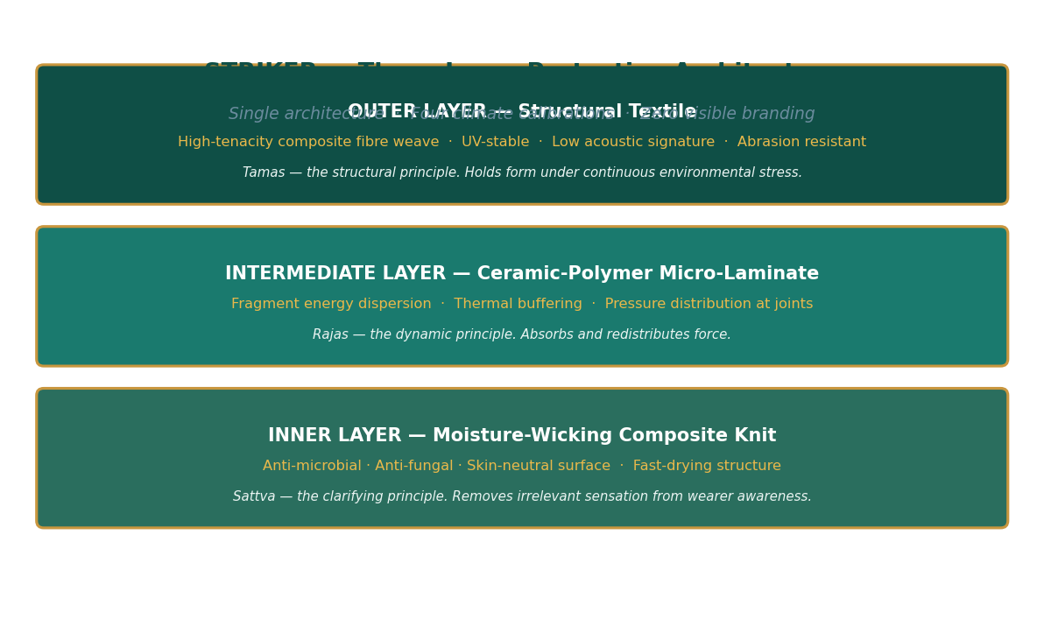
Figure 9-1: STRIKER Three-Layer Architecture — Material, Function, and Governing Principle

Layer One: Structural Outer Textile
The outer textile is the primary interface with the external environment. It absorbs the initial mechanical, thermal, and radiative loads before they reach the intermediate layer, and its material properties define STRIKER's performance against the most common field stressors: abrasion, UV radiation, acoustic signature, and infrared thermal signature.
Table 9-1: Outer Textile Technical Specifications
Property | Specification | Performance Rationale
Fibre type | High-tenacity composite (proprietary) | Tensile strength >1,500 MPa; abrasion resistance class H per ISO 12947
UV stability | UPF 50+ rating | Maintains protective properties after 500h UV exposure testing
Acoustic signature | Low — <42 dB at movement | Weave structure minimises fabric-on-fabric sound during movement
IR signature | Spectrally managed surface | Reflectance profile engineered to reduce NIR/SWIR detection
Coloration | UV-stable pigment, field patterns | Colour retention >5 years field use; no photodegradation of pattern
Sand/particle resistance | IP6X certified | Weave density prevents particle ingress while maintaining breathability
Table 9-1: STRIKER Outer Textile Specifications

Layer Two: Adaptive Intermediate Layer
The ceramic-polymer micro-laminate is the layer that distinguishes STRIKER from conventional protective apparel. Its primary function is fragment energy dispersion — the distribution of kinetic energy from non-ballistic impacts across a larger surface area rather than concentrating it at the point of contact. This is distinct from ballistic stopping power. STRIKER does not stop projectiles. It prevents the non-ballistic fragments, debris, pressure waves, and joint stress events that constitute the majority of protective apparel failure cases in sustained operational contexts from transmitting their full force to the wearer's body.
Table 9-2: Intermediate Layer Technical Specifications
Property | Specification | Performance Rationale
Material | Ceramic-polymer micro-laminate | Combines ceramic hardness for energy distribution with polymer flexibility for mobility
Fragment resistance | V50 > 400 m/s (9mm FSP) | Stops secondary fragmentation events; not designed for primary ballistic
Blunt trauma dispersion | Energy spread ratio > 8:1 | Impact energy distributed over 8x the impact area; reduces bruising and bone stress
Thermal buffering | ±15°C buffering range | Reduces peak thermal load on inner layer; improves comfort in transient conditions
Flexibility at low temp | Full flex to –45°C | No stiffness or cracking at Arctic operational temperatures
Weight | ~0.9–1.2 kg (by variant) | Heavier in COLD variant for additional insulation; lightest in TEMPERATE
Table 9-2: STRIKER Intermediate Layer Specifications

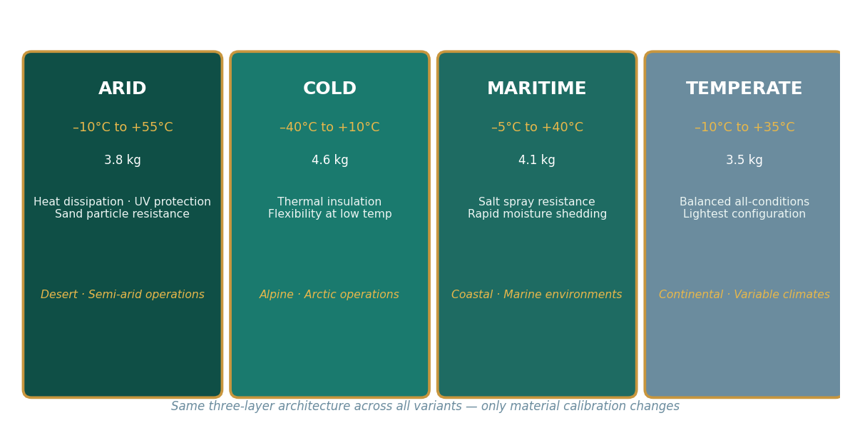
Figure 9-2: STRIKER Four Climate Variants — Same Architecture, Different Calibration

Climate Variant Calibration
The four climate variants of STRIKER represent the same three-layer architecture calibrated for different operating environments. The architecture does not change. The material properties of each layer are tuned for the specific thermal, humidity, and mechanical conditions of the target environment.
Table 9-3: STRIKER Climate Variant Specifications
Variant | Temp Range | Weight | Outer Textile Tuning | Intermediate Tuning | Inner Tuning
ARID | +10 to +55°C | ~3.8 kg | Max UV block · Sand particle tight weave | Heat dispersal priority · Thinner thermal buffer | Max moisture wick · Evaporative cooling enhanced
COLD | –40 to +10°C | ~4.6 kg | Wind barrier · Reduced moisture ingress | Max insulation · Full flex at –45°C ceramics | Condensation management · Anti-freeze treatment
MARITIME | –5 to +40°C | ~4.1 kg | Salt spray treatment · Corrosion-resistant dyes | Hydrophobic interface · Rapid dry after immersion | Anti-microbial enhanced for humid environments
TEMPERATE | –10 to +35°C | ~3.5 kg | Balanced all-conditions · Lightest weave | Baseline ceramic-polymer stack | Standard moisture management
Table 9-3: STRIKER Climate Variant Calibration Matrix

PART THREE

Chapter Ten
The Instrument That Reads the World
The object as compressed environmental intelligence — GEO
The navigator who worked the Island's perimeter carried one instrument. Not a suite, not a device with multiple modes. One thing, on her wrist, that told her what she needed to know.
She did not carry it because it was the best available technology. She carried it because it was the only technology that did not require her to manage it. Its display gave her time, temperature, altitude, and day of week on a surface she could read at a glance. The sapphire face was flat and non-reflective. The display was amber numerals on a dark field, readable in direct sunlight or total darkness. The case absorbed impact the way rock absorbs impact: by distributing it through structure rather than by resisting it at the surface.
She had been asked once what she would want instead of it. She had not understood the question. The instrument did what she needed an instrument to do. The question of what she would want instead of something adequate was not a question her working life generated.

GEO: Hybrid Geological Wrist Instrument
GEO is a single-form, environment-rated hybrid wrist instrument. It exists in one configuration. There are no colorways, no dial variants, no special editions, no limited runs. The product identity is expressed through material presence and geometry rather than through branding, logo, or cosmetic variation. There is no visible external branding on the finished product.
The design philosophy is identical to STRIKER's: one architecture, no decisions transferred to the user. The instrument does what instruments are for. It does not ask the wearer to manage it. Every specification decision in GEO is either the correct technical choice for the function or it is not in the product.
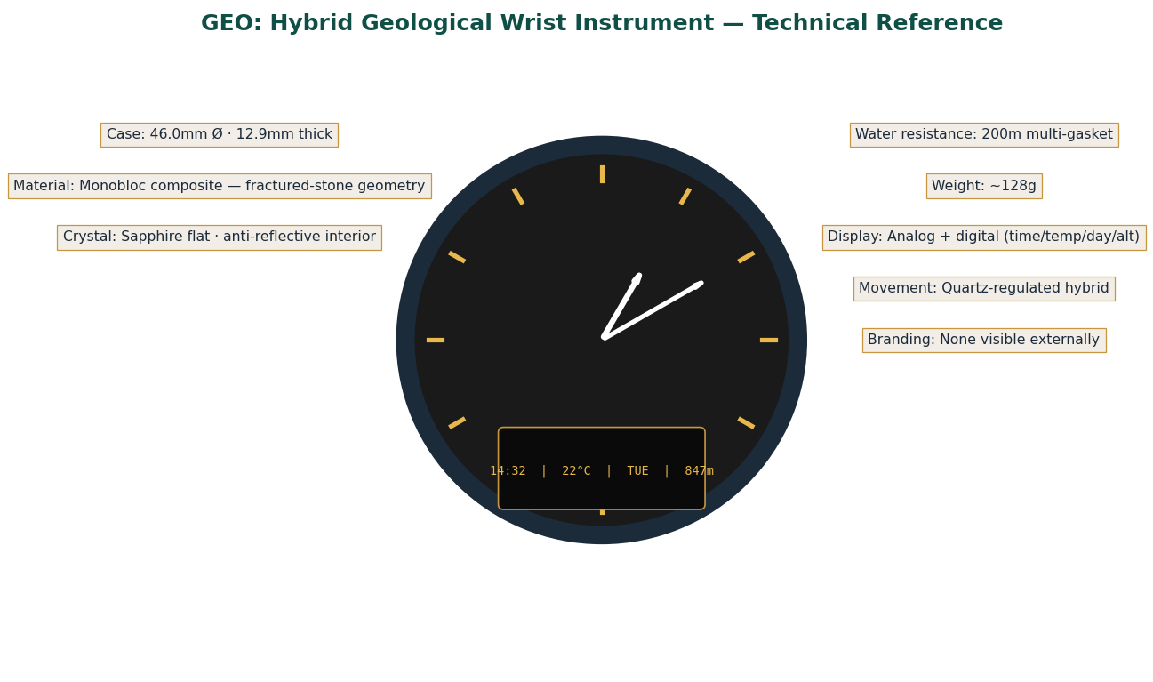
Figure 10-1: GEO Hybrid Geological Watch — Technical Reference Schematic

Case and Physical Architecture
The case is a monobloc composite shell — a single piece with no seam between case body and case back. Monobloc construction eliminates the primary water ingress pathway in conventional watch cases (the case back joint) and is mechanically stronger under impact because load paths run continuously through the structure rather than through a joint. The geometric reference for the surface texture is fractured stone: the visual pattern of a mineral that has been tested to its structural limit and distributed the force rather than yielding at a point. This geometry is not decorative. It provides a surface that grips reliably under wet and gloved conditions and that scatters reflected light into a matte diffuse pattern rather than a specular highlight.
Table 10-1: GEO Complete Physical Specifications
Parameter | Value | Engineering Rationale
Case diameter | 46.0 mm | Optimised for legibility on medium and large wrists; digital display readable without magnification
Case thickness | 12.9 mm | Balances display depth requirement with profile; snags less than 14mm+ cases on equipment
Lug-to-lug distance | 54.5 mm | Comfortable on 16–21cm wrist circumference; primary tactical user range
Strap width | 24 mm | Wide strap distributes watch mass over larger contact area; reduces pressure points during extended wear
Total weight | ~128 g | Noticeable but not fatiguing on wrist; confirms material presence without being a burden
Case material | Monobloc composite | No case-back joint; continuous load path; fractured-stone surface geometry for grip and light scatter
Bezel | Fixed integrated fractured ring | No rotating bezel; no additional ingress pathway; consistent appearance regardless of orientation
Crystal | Sapphire, flat, anti-reflective interior | Sapphire: 9 Mohs hardness, scratch-resistant. Flat profile: no magnification distortion. AR interior: reduces glare without visible coating on exterior
Water resistance | 200 m / 20 bar | Multi-gasket compression sealing; rated for diving and pressurised water exposure
Strap material | Reinforced composite, quick-release | Tool-free strap change; compatible with NATO and standard 24mm aftermarket straps
Table 10-1: GEO Physical Specifications

Display Architecture
The hybrid display is the product's most distinctive engineering feature. Conventional hybrid watches use an analog dial with a small digital sub-display. GEO reverses the emphasis: the analog section occupies the upper half of the dial, providing legible time display, while the digital section occupies the lower register as a dedicated information strip.
Table 10-2: GEO Display System Specifications
Display Element | Information Displayed | Technical Specification
Analog hands | Time (hours, minutes, seconds) | Skeletonised luminous hour and minute hands; slim seconds hand; shock-isolated movement carrier; SuperLuminova C3 lume
Digital strip — primary | Time in HH:MM | High-contrast display, amber on dark ground; transflective for outdoor legibility; no backlight required
Digital strip — temperature | °C (skin/ambient) | Thermal sensor in case; updates every 60 seconds; accurate to ±0.5°C
Digital strip — day | Day of week (3-letter) | Perpetual calendar pre-programmed; no manual date correction for 20 years
Digital strip — altitude | Metres ASL | Barometric altimeter; accurate to ±5m in stable conditions; auto-calibrated via GPS sync (optional)
Display colours | Amber / yellow / green indicators | Colour selection based on photopic sensitivity peak at 555nm (yellow-green) and scotopic dominance at night; optimised for both conditions
Movement | Quartz-regulated hybrid | Quartz precision (±15 seconds/year); mechanical construction durability; no battery indicator required — 5-year battery life
Table 10-2: GEO Display System Specifications

Design Philosophy: The Yantra Principle
In design terms, GEO operates on what might be called the Yantra principle: a device that, by its precise configuration, focuses the user's attention on what matters without drawing attention to itself. A poorly designed instrument makes the user aware of the instrument. A well-designed instrument is transparent: the user accesses information through it without experiencing it as an object they are managing.
Every GEO design decision is tested against this principle. The absence of visible branding means the eye has no brand element to process before reading the display. The amber-on-dark colour scheme means the display is readable without the eye adjusting between ambient light and display brightness. The flat sapphire crystal means there is no magnification distortion when reading at an angle. The fixed bezel means there is no additional visual complexity to parse. The monobloc case means there is no visible seam to suggest a boundary between display and case. Each decision removes something that would require the user's attention without contributing information.
GEO is not positioned as a precision instrument for specialists or as a fashion accessory for a specific demographic. It is positioned as the correct instrument for anyone whose work or environment requires reliable environmental data without the cognitive overhead of managing the device providing it. The market is defined by function, not by identity.

PART THREE

Chapter Eleven
The Black Foundation
The material that is everywhere and acknowledged nowhere — SR-C6
Every conductive surface on the Island contained it. Every reinforced structural composite contained it. Every energy storage unit contained it. The material had no name in common use because the Island's operational systems did not name their inputs. They used them.
It was a deep black powder, near-spherical primary particles aggregated into loose structures, insoluble in every medium the Island's systems exposed it to, stable under storage conditions for years beyond any operational need, unreactive under normal handling, and present in the substrate of every system that required conductivity, structural reinforcement, or energy storage. It was not a specialty material. It was a foundation material. Specialty materials are valued for what makes them unusual. Foundation materials are valued for what makes them reliable.

SR-C6: Industrial Carbon Black Platform
Carbon black is produced by the incomplete combustion or thermal decomposition of hydrocarbons. The result is a fine black powder composed primarily of elemental carbon with spherical primary particles aggregated into three-dimensional chains and clusters. SR-C6 is positioned as a standardised industrial input rather than a specialty product: a foundation material for multiple industries, supplied to consistent grade specifications, available in bulk form.
The carbon black market is large, mature, and structurally divided between commodity grades and specialty grades. Commodity grades compete on price and volume; they are supplied by large chemical companies with established production infrastructure and thin margins. Specialty grades compete on specification precision and application performance; they are supplied by fewer, more technically sophisticated producers at higher margins. SR-C6 occupies the boundary between these segments: it is priced and positioned as a standardised industrial input, but its production through the PIF elemental decomposition pathway allows it to achieve specification consistency that commodity producers cannot match.
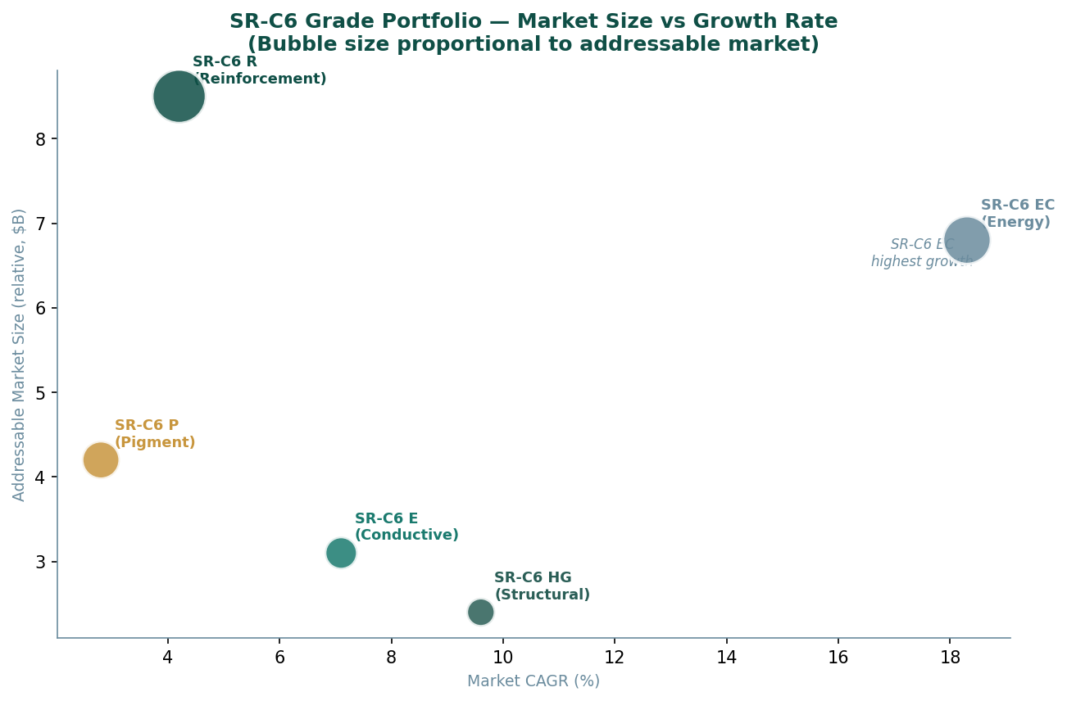
Figure 11-1: SR-C6 Grade Portfolio — Market Size vs Growth Rate

Complete Technical Specifications
Table 11-1: SR-C6 General Physical and Chemical Properties
Property | Specification | Test Method / Notes
Appearance | Deep black powder or micro-granular | Visual and sieve analysis
Particle morphology | Near-spherical primaries, aggregated | TEM imaging; fractal dimension 1.8–2.2
Odour | Odourless | No residual hydrocarbon carry-over in SR-C6 production route
Bulk density | 0.18–0.45 g/cm³ | ASTM D1513; varies by grade and pelletisation
True density | 1.7–2.1 g/cm³ | Helium pycnometry; higher in graphitic grades
Moisture content | ≤1.0 wt% | ISO 1124; measured at time of packing
pH (slurry) | 6.5–9.0 | ISO 787/9; varies by surface treatment
Carbon content | ≥98.5 wt% | ASTM D1506; elemental analysis
Ash content | ≤0.5 wt% | ISO 1125; inorganic residue after combustion
Volatile matter | ≤1.5 wt% | ASTM D1509; surface functional groups
Solubility | Insoluble in water and solvents | Colloidal dispersion only; no true dissolution
Storage stability | >36 months sealed dry | Sealed bags or silos, ambient temperature, no direct light
Table 11-1: SR-C6 General Properties

Table 11-2: SR-C6 Grade-by-Grade Technical Parameters
Grade | BET Surface  Area (m²/g) | DBP Absorption  (mL/100g) | OAN  (mL/100g) | Iodine No.  (mg/g) | Tint Strength  (ISO 787/24)
SR-C6 R | 70–120 | 80–130 | 75–120 | 40–90 | N/A
SR-C6 P | 100–300 | 60–120 | 55–110 | 80–200 | 80–130 (mass tone)
SR-C6 E | >200 | 120–200 | 110–180 | >150 | N/A
SR-C6 EC | >350 | 150–300 | 140–280 | >200 | N/A
SR-C6 HG | High (graphitic) | N/A | N/A | High | N/A
Table 11-2: SR-C6 Grade Technical Parameters (BET, DBP, OAN, Iodine, Tint)

Application Deep Dives
The SR-C6 EC energy-carbon grade warrants particular attention given its positioning in the battery materials market. Lithium-ion battery anodes require conductive carbon that provides electron pathways through the active material while maintaining structural integrity through charge-discharge cycling. The key performance parameters for this application are specific surface area (governs electrolyte contact and lithium intercalation kinetics), pore structure (governs ion transport), and structural stability under cycling (governs cycle life).
SR-C6 EC is engineered specifically for these requirements. The surface area above 350 square metres per gram provides extensive electrolyte contact. The pore structure, tunable through the processing conditions in the PIF Controlled Processing Module, is optimised for the specific electrolyte chemistry of the target battery system. The structural stability is achieved through a controlled graphitisation step that increases the crystallographic order of the carbon structure without reducing surface area below the functional threshold.
The SR-C6 HG high-graphitisation grade addresses the structural composites and thermal management markets, where carbon's role is to provide thermal conductivity and mechanical reinforcement rather than surface interaction. The high degree of graphitic order in SR-C6 HG produces a carbon material with in-plane thermal conductivity approaching that of copper at a fraction of the weight. This makes it uniquely valuable in weight-sensitive applications such as aerospace thermal management panels and high-performance friction materials.
Table 11-3: SR-C6 Application Matrix — Performance Properties by Grade and Market
Grade | Primary Markets | Key Performance Properties | Competitive Positioning | Packaging Options
SR-C6 R | Tyres · Rubber goods · Elastomers | Tensile reinforcement · Abrasion resistance · Tear strength | Spec consistency advantage over commodity CB in premium tyre segment | 25 kg bags · Super sacks · Bulk
SR-C6 P | Coatings · Inks · Plastics | Jetness · Undertone · Dispersibility | Tight particle size distribution enables consistent colour matching | 25 kg bags · Super sacks
SR-C6 E | Conductive polymers · Antistatic · PCB | Volume resistivity · ESD protection · EMI shielding | High-structure grade enables lower loading for equivalent conductivity | 25 kg bags · Super sacks
SR-C6 EC | Li-ion batteries · Supercapacitors | Rate capability · Cycle stability · Electrolyte wettability | PIF elemental purity advantage over conventional CB in battery-grade market | 25 kg bags (sealed inert atmosphere)
SR-C6 HG | Structural composites · Aerospace · Friction | In-plane thermal conductivity · Lubricity · Stiffness | Graphitisation level difficult to replicate without dedicated high-temp processing | 25 kg bags · Custom bulk
Table 11-3: SR-C6 Application Matrix
SR-C6's strategic value to Sagar-Raja is not primarily in its margins. It is in its position as the commercial expression of the PIF carbon pathway — proof that elemental decomposition at platform level produces commercially deployable outputs across multiple industrial verticals from a single foundational process.

PART IV
IV
THE MIND OF THE ISLAND
Intelligence and creativity as infrastructure.

DIRE Intelligence · ANIM-E Ecosystem · SR-OF Resilience

The Island thinks. Not metaphorically — architecturally. The Hive Mind maintains
continuous awareness of every system, every node, every resource flow,
eliminating the gap between the state of the system and the system's knowledge
of its own state. Part IV covers the intelligence platforms that make the physical
systems legible, the creative platform that selects only the strongest narratives,
and the operational framework that makes resilience a designed property.

CONTENTS — Chapters 12 – 14

Chapter Twelve The Hive Mind
DIRE three-layer architecture · Supply Risk Exposure Score · Five scenario simulations
Chapter Thirteen The Storyteller Engine
ANIM-E four-system ecosystem · Narrative evaluation criteria · Franchise IP structure
Chapter Fourteen The Defence That Is Not There
SR-OF four domains · Decision authority pyramid · Multi-layer resilience architecture

PART FOUR

Chapter Twelve
The Hive Mind
Supply chain intelligence as operational infrastructure — DIRE
The Island's intelligence network did not process information. It maintained awareness. The distinction is precise. Processing information implies a sequential operation: data comes in, analysis is performed, output is produced. Maintaining awareness implies a continuous state: the model of reality held by the system is always current, always complete.
Vael's distributed imprint had encoded this capacity into every node simultaneously. Each drone, each sensor, each production unit contributed its observations to the central model continuously. The model did not update in cycles. It was updated in real time by the aggregate of all observations, all the time.
The strategic value was diagnostic above all else. A system that maintains continuous awareness of its own state cannot be surprised by its own failures. A sensor that goes dark is immediately visible as an absence in the model. A process that deviates from specification is immediately visible as an anomaly. The Island did not discover that something had gone wrong. It observed it happening and responded before it had fully happened.
This was the Hive Mind's most important property: the elimination of the gap between the state of the system and the system's knowledge of its own state. That gap was where problems lived. The Hive Mind closed the gap.

DIRE: Defense Intelligence and Risk Engine
DIRE is a supply chain risk intelligence and bottleneck detection system. It does not optimise supply chains. It does not execute logistics decisions. It maintains awareness of supply chain risk at a level of detail and currency that allows strategic decisions to be made from accurate rather than estimated information.
This positioning is deliberate. An intelligence system that attempts to both analyse and execute risks conflating two functions with different authority requirements and different failure modes. Analysis requires breadth, depth, and independence from the pressure to act. Execution requires speed, decisiveness, and authority. Combining them in one system produces an architecture that does neither well. DIRE analyses. The decisions that follow are made by the people and systems whose authority and accountability encompass those decisions.
The practical consequence of this positioning is that DIRE can be honest about what it finds. An intelligence system that is also responsible for acting on its findings has an institutional incentive to understate risks that would require difficult actions. An intelligence system whose only output is accurate information has no such incentive. DIRE's value is entirely in the accuracy and completeness of what it reports. There is no reason to soften findings.

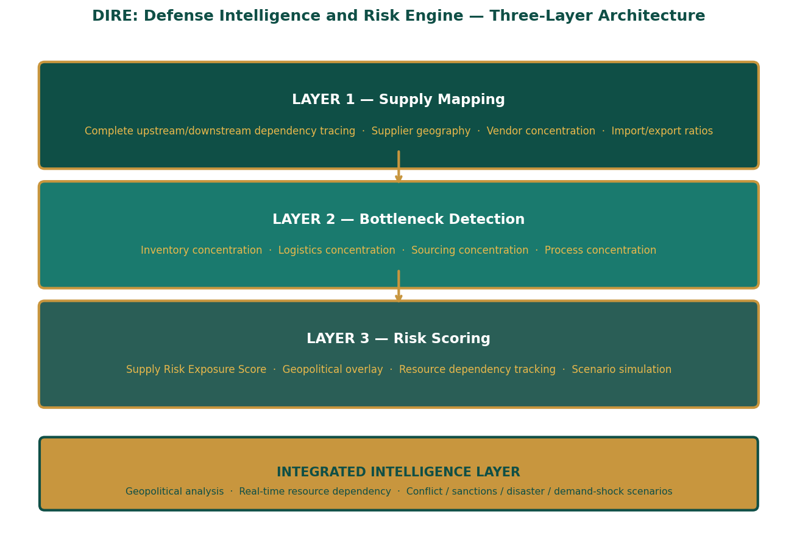
Figure 12-1: DIRE Three-Layer Architecture — Supply Mapping, Detection, Risk Scoring

Layer One: Supply Mapping
The Supply Mapping layer constructs a complete dependency graph for any company in scope. The dependency graph is not a list of direct suppliers. It is a full upstream and downstream map that traces every material, component, and service through its complete supply chain to the point of primary extraction or production, and forward through all processing stages to the point of delivery to the company being analysed.
This complete-chain mapping is what distinguishes DIRE's intelligence from conventional supplier relationship management. A company that knows its Tier 1 suppliers but not its Tier 2 and Tier 3 suppliers has an accurate map of its immediate commercial relationships and no map of its actual material dependencies. The failures that create the most severe supply disruptions are almost always Tier 2 or Tier 3 failures, because these are the failures that are invisible until they cascade.
The mapping covers five domains per supplier: raw material sourcing (what raw materials does this supplier source, from where, at what concentration), processing geography (where does the material processing occur, and what geopolitical and logistical conditions apply there), import-export ratios (what fraction of the supplier's output is exported, and to which markets, establishing exposure to trade policy changes), vendor concentration (what fraction of the supplier's own procurement comes from single-source or highly concentrated sources), and strategic component sourcing (which specific components in the supply chain have no available substitute at acceptable quality and lead time).
Table 12-1: Supply Mapping — Coverage Dimensions
Mapping Dimension | Data Captured | Strategic Significance
Raw material sourcing | Origin countries · Mine/extraction sites · Annual volume · Alternative sources | Identifies geographic concentration at the extraction level — most invisible disruption origin
Processing geography | Processing country · Facility type · Political risk score · Distance to ports | Identifies processing-stage vulnerability separate from extraction — different risk profile
Import/export ratios | Export fraction · Destination markets · Trade agreement dependencies · Tariff exposure | Quantifies trade policy exposure: sanctions, tariffs, export controls
Vendor concentration | Single-source fraction · Top-3 supplier share · Switching lead time · Alternative vendor list | Identifies upstream fragility at each tier — hidden concentration compounds risk
Strategic components | No-substitute components · Qualification lead time · Inventory days on hand · Last resort alternatives | These are the items whose absence halts production — highest priority monitoring
Table 12-1: DIRE Supply Mapping Dimensions

Layer Two: Bottleneck Detection
The Bottleneck Detection layer takes the dependency graph produced by the Supply Mapping layer and identifies where within it structural constraints exist that would, if disrupted, create cascading effects across the supply chain. The layer categorises bottlenecks by type, because different bottleneck types require different responses and have different risk profiles.
Table 12-2: Bottleneck Typology — Category, Definition, Detection Method, Response
Type | Definition | Detection Method | Typical Response
Inventory  concentration | Excessive reliance on a single inventory node for critical material | Herfindahl-Hirschman Index of inventory distribution across nodes | Establish secondary inventory positions; increase buffer at concentration point
Logistics  concentration | Excessive throughput through a single route, mode, or port | Throughput concentration ratio across available logistics paths | Qualify alternative routes; establish pre-positioned inventory at secondary nodes
Sourcing  concentration | Critical materials sourced from single supplier or geography | Single-source fraction and geographic concentration index per material | Qualify alternative suppliers; accept higher unit cost for concentration reduction
Process  concentration | Single manufacturing step constrains entire output regardless of upstream availability | Throughput capacity analysis at each processing stage vs upstream supply capacity | Invest in parallel processing capacity; establish workaround processes for critical steps
Technology  lock-in | Critical component producible only with proprietary equipment or process owned by single party | Technology dependency mapping; patent landscape analysis for critical components | Develop internal capability or negotiate long-term access agreements with technology owner
Table 12-2: DIRE Bottleneck Typology

Layer Three: Risk Scoring — The Supply Risk Exposure Score
The Supply Risk Exposure Score is DIRE's consolidated output for each company in scope. It integrates the findings of the Supply Mapping and Bottleneck Detection layers with geopolitical analysis, real-time resource dependency tracking, and scenario simulation results into a single number with documented sub-scores for each contributing factor.
The score is not a prediction. It is a characterisation of current exposure. A high score means the supply chain has structural characteristics that make it more likely to experience disruption under defined scenarios, and more severe consequences if disruption occurs. A low score means the supply chain has structural resilience: distributed sourcing, adequate buffers, qualified alternatives, and a dependency profile that is not concentrated in high-risk geographies or technologies.
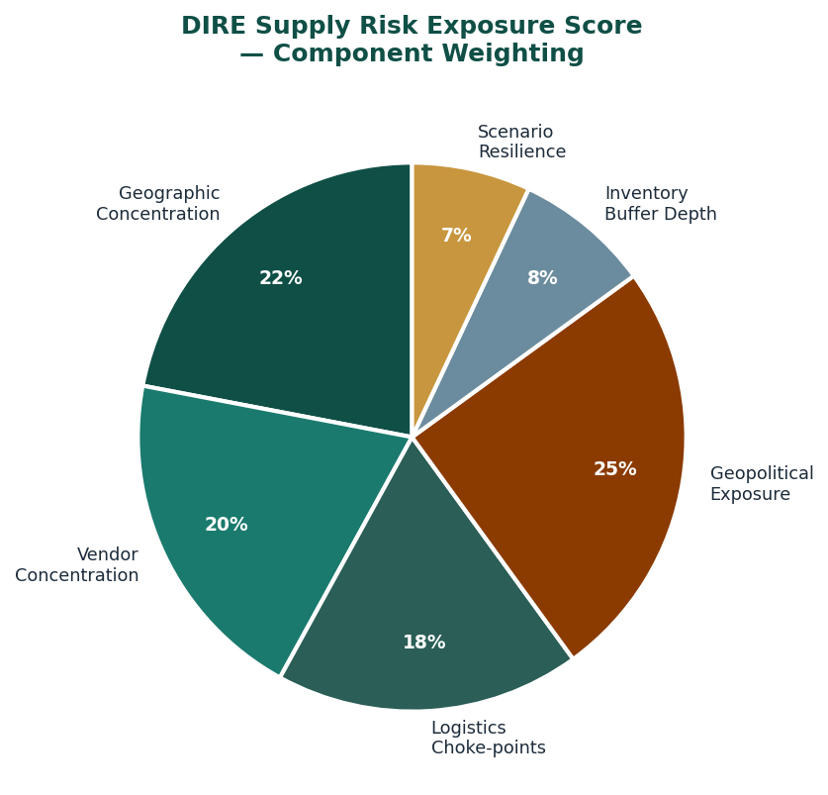
Figure 12-2: DIRE Supply Risk Exposure Score — Component Weighting

Table 12-3: Supply Risk Exposure Score — Component Definitions and Weights
Component | Weight | Measured By | High-Risk Signal
Geographic concentration | 22% | HHI of sourcing geography for top-10 critical materials | HHI > 0.25 for any critical material
Vendor concentration | 20% | Top-3 supplier share by spend and by volume for critical categories | Top-3 share > 85% in any critical category
Logistics choke-points | 18% | Throughput concentration ratio across logistics paths; chokepoint index | Single route > 70% of critical material flow
Geopolitical exposure | 25% | Political risk score weighted by sourcing volume per country; sanctions watch-list exposure | Any critical material sourced >40% from sanctioned or high-conflict country
Inventory buffer depth | 8% | Days-on-hand for strategic materials vs disruption recovery timeline | Buffer depth < 30 days for any strategic component
Scenario resilience | 7% | Simulation of 5 standard scenarios; production continuity percentage under each | < 60% production continuity under any single scenario
Table 12-3: Supply Risk Exposure Score Components

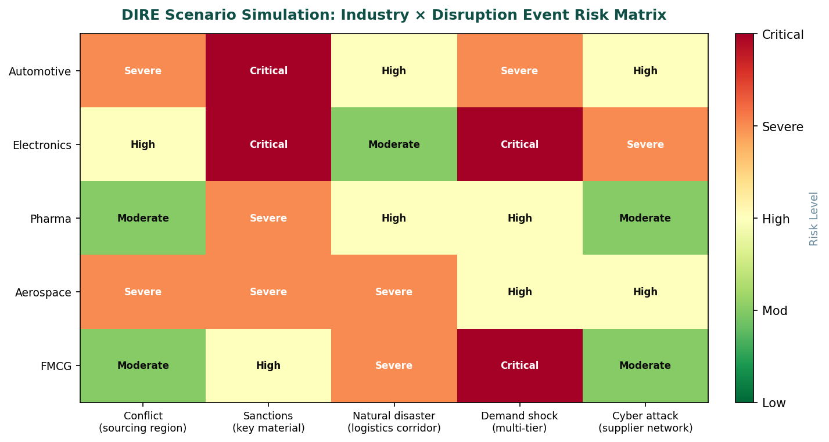
Figure 12-3: DIRE Scenario Simulation — Industry × Disruption Event Risk Matrix

Integrated Intelligence Layer: Scenario Simulation
The five standard scenarios DIRE simulates are drawn from the categories of supply chain disruption that have had the greatest documented impact on industrial operations over the past two decades. Each scenario is applied to the dependency graph of the company in scope, and the simulation calculates the fraction of production capacity that would be maintained under the scenario conditions, the time to recovery given the current buffer and alternative supplier positions, and the cascading effects on downstream operations.
Table 12-4: DIRE Standard Simulation Scenarios
Scenario | Trigger Event | Scope | Key Metrics Produced
Conflict event | Armed conflict in primary sourcing region | All materials with >20% sourcing in affected region | Production continuity % · Recovery timeline · Alternative source availability
Sanctions event | New sanctions affecting key material or supplier nation | All materials and suppliers subject to sanction | Immediate production impact · Legal exposure · Replacement lead time
Natural disaster | Major disaster affecting primary logistics corridor | All logistics flows through affected geography | Throughput reduction % · Rerouting cost · Buffer burn rate
Demand shock | Multi-tier demand surge displacing supply to competing buyers | All materials in high-demand categories | Allocation risk · Spot price exposure · Lead time extension
Cyber attack | Ransomware or system compromise at key supplier(s) | Suppliers with digital integration to company systems | Data exposure · Production halt risk · System isolation cost
Table 12-4: DIRE Standard Scenario Definitions
Where you depend defines where you break. DIRE exists to make the complete dependency structure legible before a break occurs rather than after. The intelligence has no value if it is produced retrospectively. Its entire value is in the time it creates between identification and event.

PART FOUR

Chapter Thirteen
The Storyteller Engine
Every story independent first. Only the strongest become canon. — ANIM-E
The Realm had a narrative layer. This was not a metaphor. It was an architectural feature. Every timeline in the Realm's multiverse was a living experiment in survival logic. A timeline began when a narrative gained enough internal coherence to sustain itself. It continued as long as the characters within it demonstrated the capacity to adapt to the pressures the narrative generated. It ended when that adaptive capacity was exhausted.
The Observation and Analysis system watched all of them. Not to judge aesthetic quality. To evaluate survival logic. A timeline that was entertaining but did not demonstrate genuine adaptive thinking was not a timeline the Realm's multiverse could integrate. Entertainment was a byproduct of good survival logic, not a substitute for it.
The timelines that entered canon had proven, across multiple pressure events, that their internal logic could hold. Their characters did not solve problems through luck or authorial convenience. Their worlds had consistent rules that applied even when inconvenient. Their saviours were saviours because they had understood something true about their situation, not because the plot required them to succeed.
The canon was small. It was supposed to be small. The Realm was not trying to be comprehensive. It was trying to be correct.

ANIM-E: Animation Entertainment Ecosystem
ANIM-E is not a content studio. It does not commission, produce, and release animation projects on a development-and-distribution model. It is a multi-layer animation ecosystem designed to incubate independent works, evaluate their narrative strength through structured observation, selectively expand the strongest into a curated multiverse, and distribute through a dedicated OTT environment.
The distinction between a studio and an ecosystem is the distinction between a factory and a selection system. A factory determines what gets produced. A selection system determines which outputs, from a larger production population, survive to become significant. Studios fail at scale because the creative capacity required to maintain quality across a large slate of commissioned projects does not scale the way production capacity scales. ANIM-E sidesteps this problem by not commissioning the production population. It creates conditions for the production population to emerge from independent creators, and then operates a selection system on top of it.
This architecture has a significant operational consequence: ANIM-E's creative quality is not bounded by the creative capacity of a commissioning team. It is bounded by the creative capacity of the entire independent creator population that chooses to work within the System 2 framework. This population is, by definition, larger and more diverse than any single studio's commissioning team. The selection system's role is to ensure that the strongest outputs from this population reach the canon and the distribution platform, rather than being lost in the general noise of independent production.

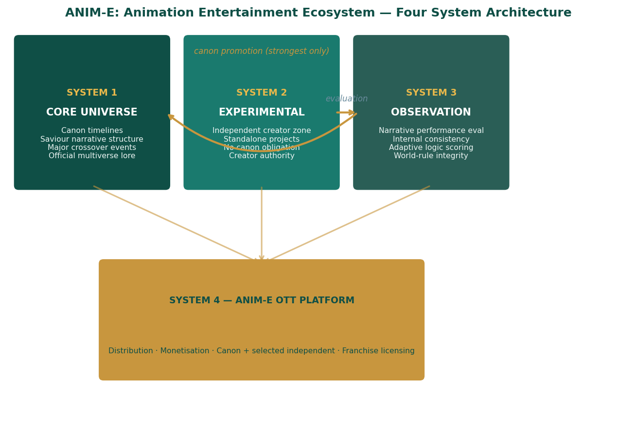
Figure 13-1: ANIM-E Four System Architecture — Flow and Relationships

System 1: Core Universe
System 1 is the canon layer of ANIM-E. It contains the official multiverse timelines, the saviour-based narrative structure that governs how timelines are organised and how they interact, the canon characters whose histories and capabilities are maintained consistently across all canon content, and the major crossover events through which timelines interact within the multiverse.
Entry into System 1 is not by commissioning or by invitation. It is by demonstrated strength in the System 3 evaluation layer. A project enters System 1 because the evaluation process identified it as possessing the narrative integrity and survival logic required to sustain integration into the broader multiverse without undermining its coherence. The filter is real. Projects that do not meet the standard remain in System 2 or conclude naturally. The standard is not adjusted to accommodate a production schedule.
The saviour-based narrative structure that governs System 1 timelines is a consistent framework across the canon: each timeline contains one or more saviour-class characters whose presence drives the timeline's primary conflicts and resolutions. The saviour framework is not a plot template. It is a constraint on the minimum structural requirement for a System 1 timeline: the presence of at least one character whose understanding of their world is genuinely superior to that of the other actors in the timeline, and whose decisions therefore carry disproportionate consequences. This constraint ensures that System 1 timelines are, by definition, built around characters who have understood something true.

System 2: Experimental Production
System 2 is the independent creator zone. Projects begin here without any canon obligation, without any universe integration expectation, and without any evaluation pressure during the production phase. The creator's authority over their project is complete within System 2. The framework does not specify genre, format, length, production values, or narrative approach. The only requirement for a System 2 project is that it is produced for potential inclusion in the ANIM-E ecosystem, which means it is produced under the standard IP arrangement that defines the creator's rights and ANIM-E's evaluation access.
The IP arrangement for System 2 projects is structured to preserve the creator's commercial interests while giving ANIM-E the right to evaluate and, if the evaluation result warrants it, to offer System 1 integration. The creator retains ownership of their characters, world, and story. ANIM-E acquires the right to distribute the project through System 4 and, if the project advances to System 1, the right to integrate it into the canon under terms that are defined at the time of integration. The creator receives compensation for System 4 distribution and a negotiated arrangement for System 1 integration. Neither integration is mandatory: the creator can decline System 1 integration and continue operating as a System 2 independent.
Table 13-1: System 2 Creator Framework — Rights and Obligations
Area | Creator's Rights | ANIM-E's Rights
IP ownership | Full ownership of characters, world, story | Right to evaluate; no ownership claim during System 2
Production decisions | Complete authority — genre, format, length, style | Observation access only; no intervention in production
Distribution | Revenue share from System 4 distribution | Distribution right through System 4 platform
System 1 integration | Right to decline integration offer; negotiate terms if accepting | Right to offer integration based on evaluation result; not obligation
Character use in canon | Retains character rights; canon use governed by integration agreement | Canon use rights acquired under integration agreement; specific to agreed scope
Table 13-1: ANIM-E System 2 IP Framework

System 3: Observation and Analysis
System 3 is the evaluation engine of ANIM-E. It monitors System 2 projects for narrative performance across four dimensions: internal consistency, adaptive logic under narrative pressure, character coherence under stress, and world-rule integrity. These dimensions are assessed continuously as projects develop, not as a single-point review at completion.
Internal consistency measures whether the rules of the project's world are applied consistently regardless of narrative convenience. A world rule that exists when it benefits the protagonist and disappears when it would constrain them is not a world rule. It is a plot device, and its presence indicates that the narrative is not operating from a genuine internal logic. The System 3 evaluation is sensitive to this distinction.
Adaptive logic measures whether characters respond to adversity by genuinely engaging with the constraints and opportunities of their situation, or by receiving external assistance, luck, or authorial convenience. A character who overcomes a challenge because they have understood something true about their situation demonstrates adaptive logic. A character who overcomes a challenge because the plot requires them to does not. The evaluation distinguishes between these at a granular level.
Table 13-2: System 3 Evaluation Dimensions — Criteria and Scoring
Dimension | What Is Measured | Positive Signal | Disqualifying Signal
Internal consistency | World rules applied uniformly across all narrative events | Rules hold even when inconvenient for protagonist | Rules suspended or reversed when protagonist needs rescue
Adaptive logic | Characters engage genuinely with situation constraints | Protagonist uses understanding to overcome; adversity reveals true capability | Luck, deus ex machina, authorial convenience as primary resolution mechanism
Character coherence | Character behaviour consistent with established traits under pressure | Character stress reveals depth consistent with prior characterisation | Character behaviour changes implausibly to serve plot requirements
World-rule integrity | The world's physics, politics, and social dynamics behave consistently | World consequences are proportional and logical | World consequences adjusted for narrative convenience
Table 13-2: System 3 Evaluation Criteria

System 4: OTT Distribution Platform
System 4 is the ANIM-E OTT platform. It distributes both System 1 canon content and selected System 2 content to audiences through a subscription and transaction model. The platform's content is differentiated by the evaluation process rather than by genre, format, or production budget.
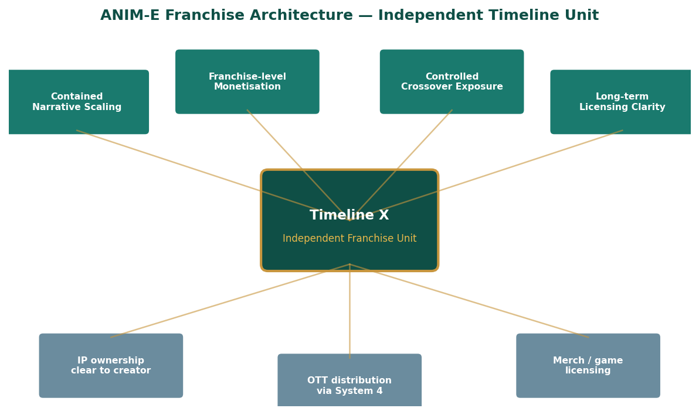
Figure 13-2: ANIM-E Franchise Architecture — Independent Timeline Unit

Franchise Architecture: Each Timeline as an Independent Unit
Each System 1 timeline constitutes an independent franchise unit within ANIM-E. This franchise structure enables contained narrative scaling: a timeline can expand deeply within its own narrative without requiring the entire multiverse to accommodate its expansion. Other timelines are not affected by one timeline's expansion, except through defined crossover events that are managed at the System 1 level.
Table 13-3: Franchise Unit Structure — Rights, Revenue, and Governance
Franchise Element | Ownership | Revenue Stream | Governance
Core timeline IP | Creator (retained per integration agreement) | Creator revenue share from all uses | Canon consistency maintained by System 1 framework
OTT distribution | ANIM-E (System 4 platform) | Subscription + transaction; split per agreement | Platform terms govern; creator approval for marketing
Merchandise licensing | Jointly governed per franchise agreement | Licensing fees; royalty to creator | Brand guidelines maintained by System 1; creator approval required
Game / interactive licensing | Jointly governed per franchise agreement | Licensing fees; royalty to creator | Narrative consistency review by System 3 before licence granted
Cross-timeline events | ANIM-E System 1 management | Separate event revenue; proportional creator credit | Participating creators must approve character usage terms
Table 13-3: ANIM-E Franchise Unit Rights and Revenue Structure
ANIM-E's selection architecture means that the most commercially significant canon content is, by definition, the content that demonstrated the most genuine narrative strength under evaluation. The commercial hierarchy mirrors the creative hierarchy, because the selection system ensures they are the same hierarchy. This is the business case for honest evaluation: it produces, as a byproduct, the content most likely to create long-term franchise value.

PART FOUR

Chapter Fourteen
The Defence That Is Not There
Resilience through distribution — SR-OF
The commander reviewed her intelligence for the third time and arrived at the same conclusion twice before: there was nothing there. She had satellite imagery. Electromagnetic intercepts. Hydrographic surveys and atmospheric readings and the reports of three reconnaissance passes by systems that had returned without incident — which was itself a data point she had not adequately weighted until now.
Systems that approached an undefended position returned without incident. Systems that approached a defended position also returned without incident if the defence was sufficiently sophisticated. The absence of engagement was not evidence of the absence of defence. It was evidence of nothing.
The first round was intercepted 87 kilometres from the Island's boundary. Not destroyed. Intercepted: the guidance system experienced a cascade failure consistent with a sleep-spore saturation event — a category of failure her threat assessment library had not included because sleep-spore saturation events did not exist in any weapons system she had been briefed on. The projectile fell into the ocean.
By the fourth round she had redirected her force and was calculating how to explain in her after-action report that she had withdrawn from a position her intelligence had assessed as undefended, because the position had defended itself using methods that did not appear in her threat library. The Island's record noted the engagement as a routine deterrence operation. One Breloom grove had expended seventeen interceptor rounds. The grove had regenerated its stock within six hours.

SR-OF: Sagar-Raja Operations Framework
The Sagar-Raja Operations Framework governs the execution of all company-owned activities. Its core operating principle, stated directly in the framework document, is that failure will occur. This is not pessimism. It is the engineering position of a system that intends to survive contact with reality. The framework's design is built on the assumption of failure, and its resilience comes not from preventing failure but from ensuring that the response to failure is defined, tested, and ready before the failure happens.
The framework's approach to resilience mirrors the Island's defence logic: resilience is achieved through distribution, redundancy, and graceful degradation rather than through single points of strength. A single point of strength is a single point of failure. A distributed system degrades proportionally to the fraction of it that fails, rather than catastrophically at the failure of any single node.
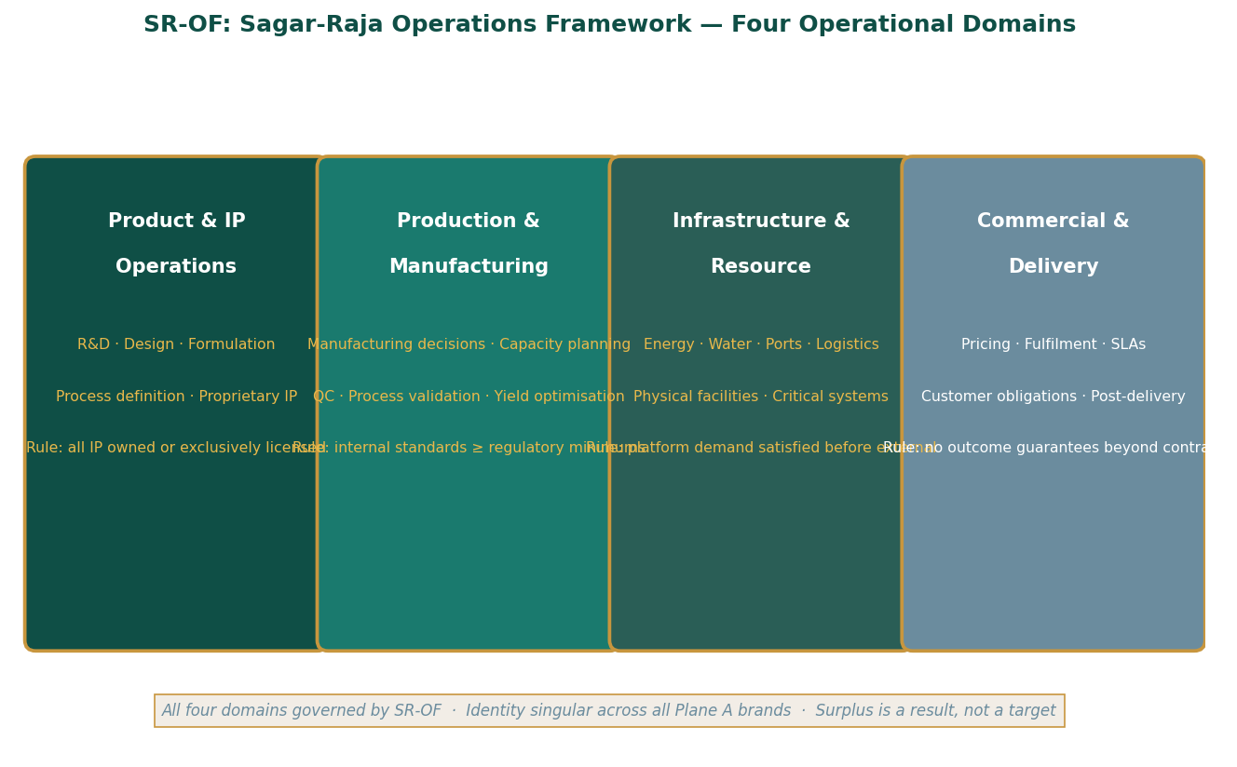
Figure 14-1: SR-OF Four Operational Domains — Structure and Governing Rules

The Four Operational Domains
SR-OF governs operations through four defined domains, each with its own scope, its own authority structure, and its own non-negotiable rules. The separation of domains is not organisational. It is functional: different types of operational decisions have different authority requirements and different failure consequences, and managing them under a single authority produces either excessive centralisation or inadequate accountability.
Table 14-1: SR-OF Four Operational Domains — Full Specification
Domain | Scope | Non-Negotiable Rules | Failure Response
Product & IP  Operations | R&D · Design · Formulation · Process definition · Proprietary know-how | All IP owned or exclusively licensed. No shared IP with any external partner. No dependency on any external technology roadmap. | IP failure is treated as existential: full legal response, immediate IP audit, no tolerance for IP leakage
Production &  Manufacturing | Manufacturing decisions · Capacity planning · QC · Process validation · Yield optimisation | Internal standards meet or exceed regulatory minimums. Failure responsibility is internal — not transferable to external partners. | Production failure triggers root-cause analysis within 24 hours; corrective action within 72 hours; post-correction audit
Infrastructure &  Resource | Energy · Water · Ports · Logistics corridors · Physical facilities · Critical systems | Platform demand satisfied before any surplus exposed to external markets. Critical systems must operate in degraded mode without loss of essential function. | Infrastructure degradation triggers automatic isolation and parallel-system activation; no production halt for isolated system failure
Commercial &  Delivery | Pricing · Fulfilment · SLAs · Customer obligations · Post-delivery responsibility | No outcome guarantees beyond contractual terms. No cross-subsidy with external income sources. Clear separation between operational and enabling revenues. | Commercial failure triggers contract review and customer communication within 24 hours; no unilateral contract amendment
Table 14-1: SR-OF Operational Domain Specifications

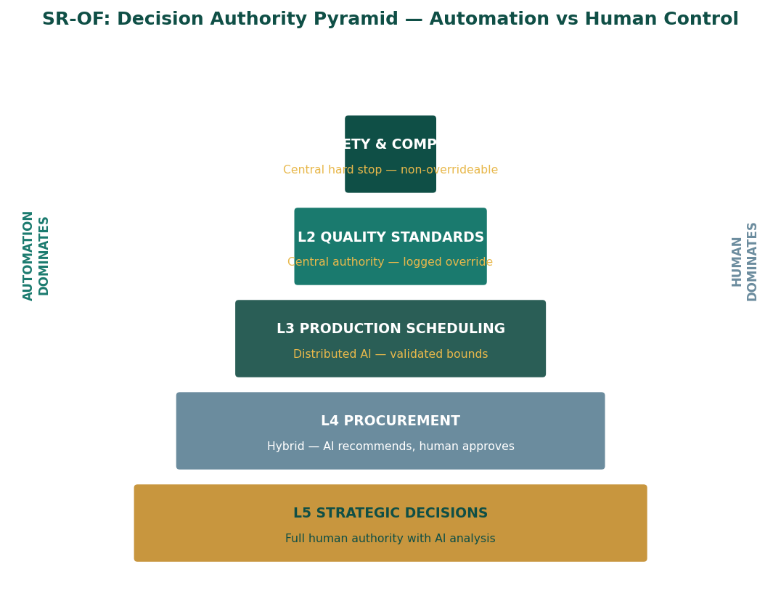
Figure 14-2: SR-OF Decision Authority Pyramid — Five Levels

Decision Authority Structure
The decision authority structure in SR-OF is designed so that the decisions most likely to produce irreversible consequences are the ones most tightly controlled, and the decisions most likely to benefit from local context and operational knowledge are the ones most distributed. This is not a conventional hierarchy where authority flows from seniority. It is a functional hierarchy where authority is matched to consequence.
Table 14-2: SR-OF Decision Authority Matrix
Level | Decision Type | Authority | Override Possible? | Documentation Required
L1 Safety / Compliance | Any safety or regulatory compliance issue | Central — hard stop | No — non-overrideable | Automatic incident log; regulator notification where required
L2 Quality Standards | Output conformance, specification deviations | Central authority | Yes — logged and audited | Override log; post-action review within 5 days
L3 Production Scheduling | Sequence, timing, resource allocation within spec | Distributed AI — validated bounds | Yes — human override documented | Deviation log; monthly pattern review
L4 Procurement | Sourcing decisions, supplier selection, contracts | Hybrid — AI recommends above threshold | Human approval for all above threshold | Approval record; rationale documented for above-threshold
L5 Strategic | Expansion, new system deployment, policy change | Human decision with AI analysis | Human authority — full accountability | Decision record; board notification for material decisions
Table 14-2: SR-OF Decision Authority Matrix

Automation Hierarchy: Four Levels of Machine Intelligence
The SR-OF automation hierarchy defines four levels of autonomous decision-making, each with defined scope, validation requirements, and human oversight arrangements. The hierarchy is not a roadmap toward full automation. It is a permanent operating structure that assigns each category of decision to the level of automation that produces the best combination of consistency, speed, and accountability for that category.
Table 14-3: SR-OF Automation Hierarchy — Scope, Validation, and Oversight
Level | Scope | Validation Requirement | Human Oversight
Rule-based control | All routine operations with defined rules; default operating mode | Rules defined and approved by human authority before activation | Monitor dashboards; investigate anomaly flags; update rules on pattern review
Autonomous optimisation | Performance improvement within defined bounds; validated domains only | Validation programme: shadow mode for 30 days minimum before live activation | Monthly performance review; bound adjustment requires human approval
Human override | Available for all automated decisions; creates mandatory documentation record | Override creates log entry automatically; no pre-approval required | Post-action review within defined timeframe; repeated overrides trigger rule review
Post-action review | Mandatory review of all overrides and all significant automated decisions | Review criteria defined in domain procedures | Review findings fed back to rule update process; creates improvement loop
Table 14-3: SR-OF Automation Hierarchy

Resilience Architecture: Multi-Layer Failure Response
The framework's resilience architecture is built on three principles: multi-layer reinforcement, compartmentalised zones, and passive safety geometry. Each principle addresses a different aspect of how a system fails and how those failures can be contained.
Multi-layer reinforcement means that every critical function has at least two independent mechanisms capable of performing it. Energy supply has four. Water supply has multiple collection pathways. Communications have redundant channels. Production has parallel capacity. The loss of any single mechanism does not reduce a function's availability to zero. It reduces it by the fraction represented by that mechanism, and the remaining mechanisms absorb the load.
Compartmentalised zones mean that the failure of one system cannot cascade directly to adjacent systems without passing through a designed isolation layer. Isolation layers are not physical walls. They are control and monitoring boundaries that detect anomalous flows between zones and interrupt them before they become cascading failures. The compartmentalisation allows a system operating in degraded mode to be isolated from healthy systems, operated independently at reduced throughput, and brought back to full operation without exposing the healthy systems to its degraded condition.
Passive safety geometry means that the physical design of structures and systems defaults to a safe state under degraded conditions without requiring active intervention. A structure that distributes impact force through its geometry rather than resisting it at a single point does not require a human to activate impact mitigation. The geometry is the mitigation. This principle is applied throughout the platform's physical design and is why the Island's defence systems, in the fictional register, continue to operate after their command infrastructure is destroyed.
Table 14-4: Resilience Architecture — Principle, Mechanism, and Failure Mode Addressed
Principle | Mechanism | Failure Mode Addressed | Platform Example
Multi-layer reinforcement | Multiple independent systems per critical function | Single-system failure causing complete function loss | Four energy sources; multiple water pathways
Compartmentalisation | Isolation boundaries between operational zones | Cascade failure spreading from degraded to healthy systems | Zone-level energy and water isolation; production zone segmentation
Passive safety geometry | Physical design defaults to safe state without active intervention | Active safety systems failing under conditions that triggered the failure | Monobloc composite structures; GEO case geometry; hull load distribution
Graceful degradation | System output scales proportionally to intact capacity | Binary failure: full function or zero function | Distributed HACA units; GPF node-level fault tolerance
Table 14-4: SR-OF Resilience Architecture Principles
The Island does not reveal its defences to deter attack. It reveals nothing at all. The deterrence is the uncertainty. SR-OF operates on the same principle: the system's resilience is not advertised. It is built in, and it performs when needed, whether or not anyone knew it was there.

PART V
V
THE CYCLE CONTINUES
The manifesto close.

Corporate Deal Architecture · Seven Principles · The Forward

The Island makes its first external deal. The terms are not negotiated — they
are described. This is the final movement of the book and the clearest statement
of its governing philosophy. The deal architecture shows how genuine capability
produces negotiating posture that cannot be manufactured by tactics alone.
The seven principles are stated once, completely, in both registers. The final
chapter returns to 23:47 — the overnight cycle beginning, as it always has.

CONTENTS — Chapters 15 – 17

Chapter Fifteen The Deals the Island Makes
Blended consideration structure · Deal posture matrix · Consortium settlement framework
Chapter Sixteen Adaptation as Identity
Seven principles stated once · Both registers simultaneously · Full philosophical grounding
Chapter Seventeen The Island Is Not Finished
The closing scene · What the next cycle contains · The forward

PART FIVE

Chapter Fifteen
The Deals the Island Makes
Negotiating from genuine systemic advantage
The Island's first external agreement was not a commercial transaction. It was an acknowledgement. The external party, a consortium of industrial operators who had been monitoring the Island's output data for fourteen months, acknowledged that the Island produced materials they needed, at specifications they could not achieve independently, through processes they had been unable to replicate. They asked what the Island wanted in return.
The Island's response was precise: continued access to atmospheric feedstock, which required no disruption of regional atmospheric systems; continued access to maritime routes, which required no exclusion zone broader than safety margins demanded; and continued absence of interference with the Island's internal governance. These were not aggressive terms. They were the minimum operating conditions the Island required to continue producing what the consortium wanted.
The Island was not negotiating from a position of wanting the deal to happen. It was negotiating from a position of continuing to operate regardless of whether the deal happened. The difference in posture was legible to everyone at the table. When you do not need the deal, you describe the conditions under which you will offer what you have. When you need the deal, you negotiate. The Island described. The consortium agreed.

Corporate Deal Architecture
Sagar-Raja's approach to corporate agreements reflects the same negotiating posture: clarity about what the company offers, precision about what it requires, and operational independence from whether any specific agreement is reached. A company that needs a deal will accept worse terms than a company that can walk away from it. The structural advantage in any negotiation belongs to the party whose operational continuity is not contingent on agreement.
This position is not achieved through negotiating tactics. It is achieved through operational design. A company that is resource-independent, that holds IP no counterparty can easily replicate, and that has a product portfolio serving multiple industries and geographies does not need any single deal. Its operational continuity depends on the integrity of its own systems, not on the continued willingness of any counterparty to maintain a relationship.
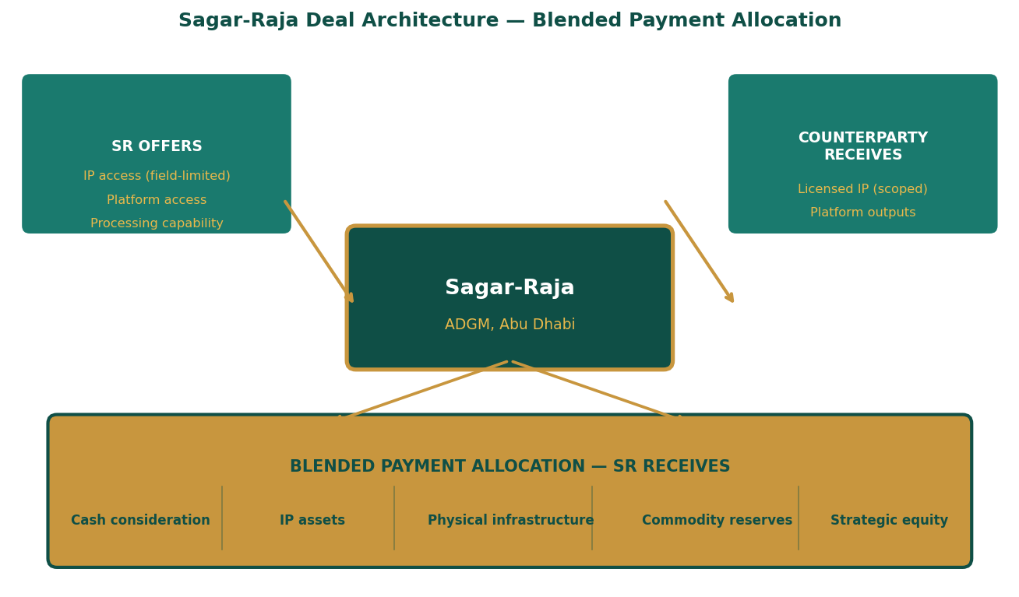
Figure 15-1: Sagar-Raja Deal Architecture — Blended Payment Allocation

Deal Principles: What SR Offers and What SR Requires
Every Sagar-Raja deal is structured around what the company controls that the counterparty needs, not around what the counterparty offers that Sagar-Raja needs. This asymmetry is deliberate and structural. When the counterparty needs what only Sagar-Raja has, and Sagar-Raja is operationally independent of whether the deal closes, the terms are Sagar-Raja's to define within the bounds of what the counterparty can reasonably accept.
IP access in consortium agreements is always field-limited and non-exclusive. Field limitation means the IP can only be used for the specific application the deal contemplates. The GPF-Tech patent, licensed to a counterparty for a specific industrial application, cannot be used by that counterparty in any other application without a separate licence. This limits the value of any single licence grant while preserving Sagar-Raja's ability to licence the same IP to other parties in non-competing fields. Non-exclusivity means Sagar-Raja retains that right explicitly. No licence grants exclusivity unless the consideration is exceptional and the field is narrow.
Physical infrastructure included in deal consideration is assessed at strategic rather than market value. A manufacturing facility that produces a component Sagar-Raja needs for its own operations is worth more to Sagar-Raja than its book value suggests, because it eliminates a procurement dependency. A logistics hub in a strategically important geography is worth more than its operational cash flows suggest, because it provides redundant access to a corridor that Sagar-Raja uses. The assessment is always: what is this worth to us in terms of operational capability, not what would it trade for on the open market.
Commodity reserves included in deal consideration are held dormant and non-speculative. They are insurance against supply disruption, not trading inventory. A reserve of a strategic industrial commodity acquired through a deal settlement is valued by the number of days of production it protects against supply disruption, not by the commodity's current spot price. This valuation methodology means Sagar-Raja consistently acquires commodity reserves at a discount to their strategic value, because counterparties typically value them at spot price.
Table 15-1: Deal Structure Principles — Application by Consideration Type
Consideration Type | SR's Approach | Valuation Basis | Key Protections
Cash | Accepted at stated value; used as one component of blended allocation | Face value | Payment security; staged payments tied to SR obligations
IP assets | Assessed for strategic fit; valued on internal utility not licensing income | Strategic utility to SR's portfolio and operations | Full title transfer; freedom-to-operate confirmed before acceptance
Physical infrastructure | Valued at operational strategic benefit to SR; not at book or market | Operational dependency reduction value | Full title transfer; environmental due diligence; no hidden liabilities
Commodity reserves | Held dormant; valued as production insurance | Days of production coverage vs supply disruption risk | Physical possession confirmed; storage managed internally
Strategic equity | Accepted only where operating influence commensurate with stake | Influence-adjusted DCF; control premium assessed | Board seat or observer right; drag and tag provisions; anti-dilution
Table 15-1: Deal Consideration Types — SR's Approach and Protections

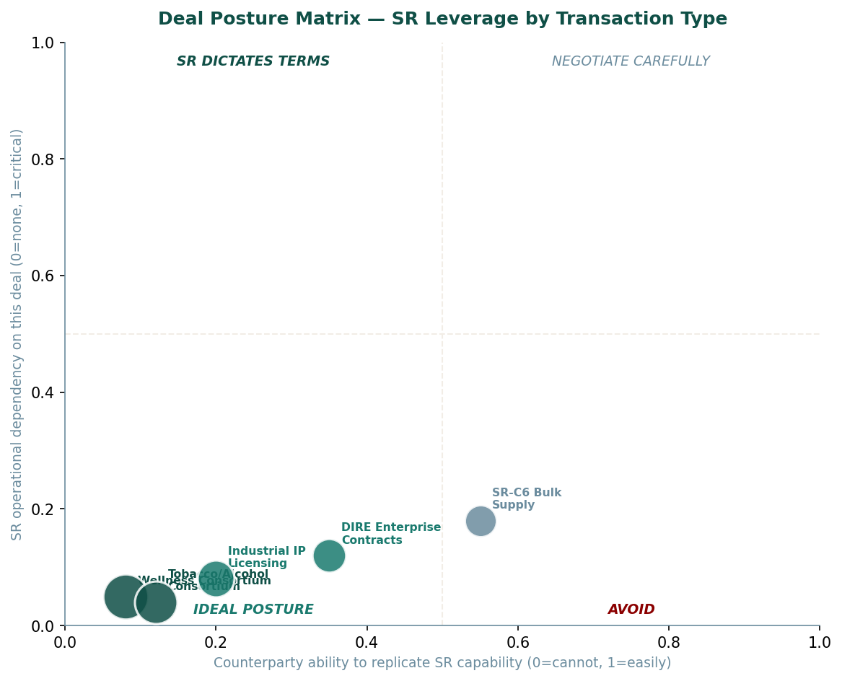
Figure 15-2: Deal Posture Matrix — SR Leverage by Transaction Type

Consortium Settlement Architecture
The consortium settlements documented in Sagar-Raja's corporate deal framework represent the application of these principles at scale. Each settlement involves Sagar-Raja as the party bringing specific, non-replicable value: the GPF-Tech architecture, platform access, processing capability, or product IP. In each case the consideration received is blended across cash, IP, infrastructure, and reserves, structured to reflect the strategic value of what Sagar-Raja is providing rather than the counterparty's preferred payment form.
Table 15-2: Consortium Settlement Framework — Structure by Deal Type
Deal Category | SR Primary Offer | Consideration Structure | SR Operational Outcome
Technology licensing  (GPF-Tech) | Field-limited, non-exclusive patent licence | Upfront cash + royalty stream + infrastructure in licensee's territory | Revenue without capital deployment; geographic infrastructure gained
Platform access  (industrial consortium) | Priority allocation of platform processing capacity | Long-term supply contract + cash + strategic reserve commodity | Committed offtake (production certainty) + strategic reserve built
Product IP  (distribution partnership) | Regional distribution rights for defined product and geography | Upfront fee + margin share + logistics infrastructure in region | Market access without local capital investment; logistics asset gained
IP acquisition  (settlement) | Resolution of IP dispute or competitive overlap | Cross-licence + cash (net) + freedom-to-operate in disputed field | IP freedom + competitive barrier eliminated; portfolio strengthened
Table 15-2: Consortium Settlement Framework
The fundamental principle of Sagar-Raja's deal architecture mirrors the Island's: operate from genuine capability, define terms that reflect that capability, and structure agreements that preserve the company's operational independence regardless of whether any specific deal concludes. A deal that compromises operational independence is not a good deal at any price. A deal that enhances operational capability at acceptable cost is worth pursuing even at modest financial return.

PART FIVE

Chapter Sixteen
Adaptation as Identity
The seven principles stated directly, once
The Island's operating principles were never written down in one place. They were distributed through the system's design: present in the closed-loop architecture, in the non-sovereignty declaration, in the distributed defence grid, in the Foundry Matrix's self-scaling logic, in the VASF's three-harvest structure. Anyone who understood the system fully could have derived the principles. But they were never consolidated, because a well-designed system does not need its principles consolidated. It embodies them.
The following seven principles are stated here, once, directly, in both registers simultaneously. They will not be repeated.

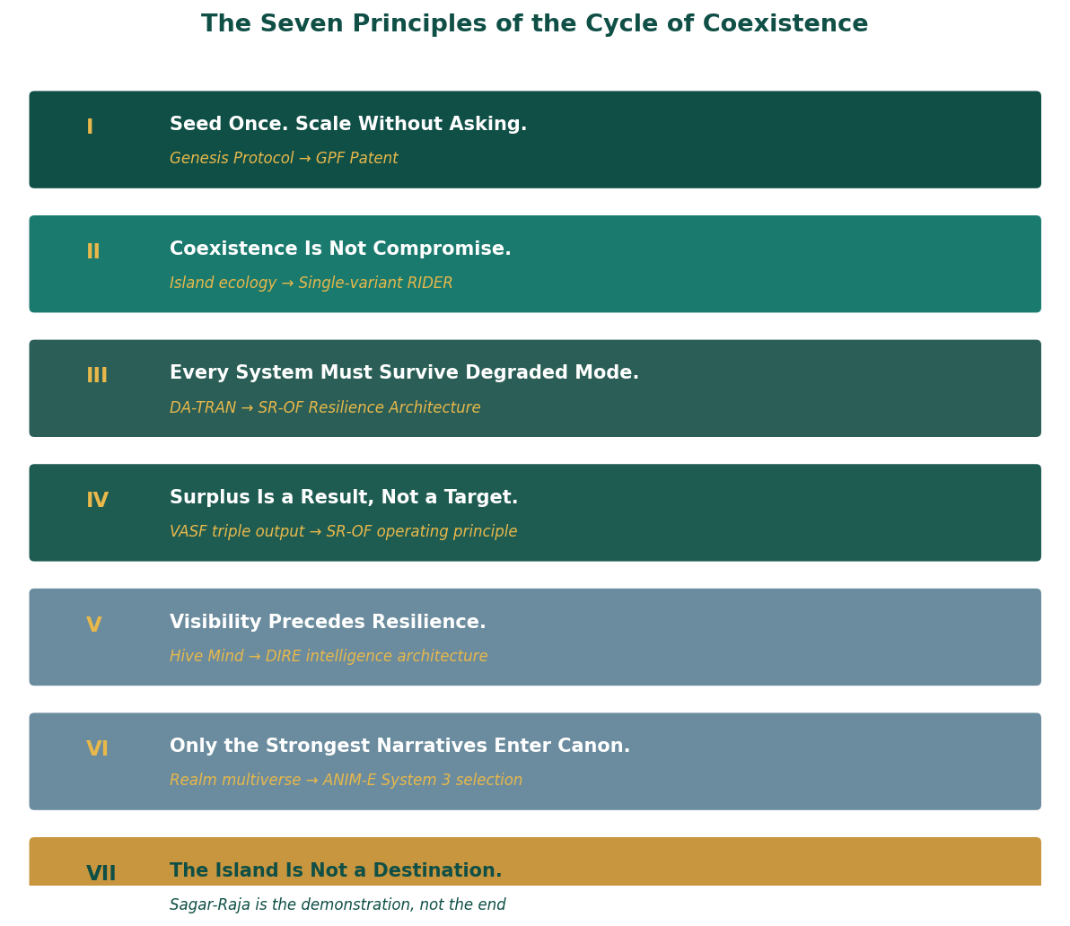
Figure 16-1: The Seven Principles of the Cycle of Coexistence

The Seven Principles: Full Statement

Principle I: Seed Once. Scale Without Asking.
The Genesis Protocol required one coordinated effort. Everything that followed was autonomous. The measure of a well-designed founding act is not how impressive it is at the moment of execution. It is how long the system it produces operates without needing to be re-founded. The Island has not needed a second Genesis Protocol. The GPF-Tech patent has not needed a second invention. The Bio-Silk-Mycelium Composite was seeded into the Foundry Matrix once; the Bio-Weaver Units have produced it autonomously ever since.
In the real-world register: the company's core IP is a single architectural act. The five-component GPF architecture was defined once in the patent application. Every autonomous fabrication system built under the patent is an expression of that single definition. The subsidiaries were incorporated once, in their appropriate jurisdictions, with their appropriate structures. The product IP was developed to specification and does not require redesign for each market. Sagar-Raja's operational model is one of compounding returns from single foundational acts, not of continuous intervention to sustain ongoing operations.
The principle extends to every system in the portfolio. RASM's formulation is set. RIDER's global specification is set. SR-C6's grade definitions are set. DIRE's scoring methodology is set. These do not require revision as a matter of routine. They require revision when the environment has changed enough to make the original design no longer correct. Until that threshold is met, the seed does its work.

Principle II: Coexistence Is Not Compromise.
The Island coexists with its ecology because the ecology is the infrastructure on which everything else depends. This is not an environmental stance. It is an operational one. A platform that compromises its ecological infrastructure to increase short-term production output has borrowed against its own foundation. The borrowing is not visible in the short term. It becomes visible when the infrastructure begins to fail.
RIDER coexists with every global certification regime because it was engineered to pass all of them with a single variant. This required more rigorous engineering discipline than building regional variants would have. The discipline is the point. A product that is correct for every market is a product that has understood every market well enough to satisfy all of them simultaneously. A product that satisfies each market separately through different configurations has not achieved coexistence. It has achieved parallel compromises.
STRIKER coexists with every climate because its three-layer architecture was designed to adapt without the product changing. The adaptation is in the material properties of each layer, not in the architecture. The architecture is constant. Coexistence means the system holds its identity while adapting its expression to the conditions it operates in. It is not the system becoming different things in different contexts. It is the system expressing the same thing correctly in different contexts.
RASM coexists with every regulatory and nutritional context because it was positioned as a substrate rather than a lifestyle product. A lifestyle product requires the regulatory context to accommodate its positioning. A substrate is defined by its functional specification, which is either met or not met by the regulatory requirements of any given jurisdiction. RASM's specification was set to meet the requirements of all major jurisdictions simultaneously. Coexistence was engineered in, not negotiated in.

Principle III: Every System Must Survive Degraded Mode.
The DA-TRAN defence network continued operating after its Central Intelligence Director was destroyed, because the network was designed to operate without it. Each node in the network was capable of independent targeting and engagement decisions. The destruction of the command node reduced the network's coordination efficiency. It did not halt the network. The failure mode was designed to be proportional degradation rather than complete cessation.
The Metabolic Carrier had four independent energy sources so that losing one was a transition rather than a failure. The transition cost was a brief reduction in power output while the remaining three sources compensated. The cost was not an operational halt. SR-OF formalises this as a design requirement: critical systems must be capable of operating in degraded mode without loss of essential function. Essential function is defined narrowly. Everything that is not essential function is allowed to degrade. Essential function is protected at the architectural level.
The GPF architecture's distributed execution fabric achieves degraded mode survival through fault tolerance and dynamic reallocation. A node failure triggers automatic reallocation of that node's tasks to available nodes. The network continues to execute. Throughput is reduced by the fraction of capacity represented by the failed node. This is the correct failure mode: proportional, predictable, and self-correcting without human intervention.

Principle IV: Surplus Is a Result, Not a Target.
The VASF produced Genesis Biomass and Oxygen-Plus as byproducts of food synthesis. It did not produce them as targets. They are the thermodynamic consequence of a synthesis process that is correctly designed. A process that produces only its primary output and wastes everything else is a process with open loops. Closing the loops produces the surplus streams as a natural consequence.
The Transmutation Forge produced surplus electrical energy and Isotopic Tailings as byproducts of metal production. These are not additional revenue streams that were designed in. They are the material reality of an atomic process that produces more than its primary target because atomic processes are not clean in the way industrial processes wish they were. Designing the Forge to capture and use those byproducts is correct engineering. Targeting them as the primary output would be incorrect engineering.
SR-OF states this directly: surplus is harvested after operational stability is proven, never targeted in advance. A company that targets surplus before proving operational stability has confused the reward for the work with the work itself. It has produced a financial projection without the operational basis to support it. Sagar-Raja's surplus, where it exists, emerges from systems operating correctly within their design parameters. It is not projected. It is observed.

Principle V: Visibility Precedes Resilience.
DIRE's foundational principle is that you cannot defend what you cannot see. This is not a statement about security. It is a statement about the precondition of all good decision-making. A decision made from accurate information about the current state of the system it affects is better than a decision made from estimated or assumed information, not because the decision-maker is better, but because the input is better. Visibility improves the quality of every decision that depends on knowing the current state.
The Hive Mind tracked every drone, every threat, every resource flow across the Island, not to control them moment to moment, but to maintain the accurate real-time model of the system's state that made all other decisions possible. A command decision made from an accurate model of the operational environment is a fundamentally different act from one made from an estimated or outdated model. The model's accuracy is the precondition of the decision's quality.
Vishvakarma's Genesis Core imprinting encoded continuous self-awareness as the first property of the Island's AI. Before the AI could manage anything, it needed to know the current state of everything it was managing. The capability sequence is: first visibility, then analysis, then decision, then action. Systems that attempt to skip the visibility step make decisions about systems whose actual state they do not know. This is the most common source of avoidable operational failure in complex systems.

Principle VI: Only the Strongest Narratives Enter Canon.
ANIM-E does not decide in advance which stories will survive. It creates the conditions for stories to prove themselves and then expands what has demonstrated strength. The System 3 evaluation does not select for what it expects to be commercially successful. It selects for genuine narrative integrity: internal consistency, adaptive logic, character coherence, world-rule integrity. The commercial success follows because these properties are what make stories endure in audience memory and in cultural significance.
This principle applies across every portfolio decision Sagar-Raja makes. Products are not expanded before they have proven operational stability. Markets are not entered before the product has been validated in an adjacent market. Partnerships are not deepened before the initial terms have been demonstrated to deliver what was agreed. The sequence is always: prove it first, expand what is proven. Optimism about future performance does not substitute for evidence of current performance.
In the real-world register, the principle governs R&D as much as commercial decisions. A new formulation, a new grade specification, a new product variant does not enter the portfolio until it has been validated against the performance criteria that define its value. The pipeline contains many projects. The portfolio contains only those that have demonstrated that they meet the standard. This selectivity is not caution. It is the correct management of a portfolio that is meant to endure.

Principle VII: The Island Is Not a Destination.
The Island was proof of a concept. It demonstrated that a self-sustaining system could be seeded with minimal input and left to compound. It was not the destination of the Wardens' work. It was the demonstration that the work's underlying philosophy was operationally viable. A demonstration that has proven its point has accomplished its purpose. What it accomplishes after that point is the natural extension of its correct operation, not the pursuit of a new purpose.
Sagar-Raja is the same proof running in the real world. The company demonstrates that the philosophy of the Cycle of Coexistence produces operational reality when correctly applied: that autonomous systems can be seeded and left to compound, that products designed to coexist with their environment outperform products optimised for a single context, that deals made from genuine capability produce better outcomes than deals made from need, that visibility at every level produces decisions that hold under real conditions.
The destination is not a state Sagar-Raja is trying to reach. The destination is what the company produces as a result of operating correctly: systems that work, products that perform, frameworks that endure, and the accumulating evidence that the Cycle of Coexistence is not a theory but a practice. The Island is mid-cycle. Sagar-Raja is mid-cycle. The cycle does not have a final chapter. It has chapters that continue to be written.
Everything adapts, survives, or does not. That is not a warning. It is a description of operating conditions. Sagar-Raja operates within those conditions by design.

PART FIVE

Chapter Seventeen
The Island Is Not Finished
The last day. The next cycle. The forward.
At 23:47 the overnight cycle began.
It was the same moment that had opened Chapter Three, and the same moment that had opened the Island's operational history, and the same moment that would open every operational day that followed this one. 23:47 was not a special time. It was the time the overnight cycle began. The overnight cycle began because the dayside cycle had completed, and what had been produced during the day needed to be processed during the night, and what was processed during the night would be ready for use when the day began again.
The Island was not in a better state than it had been eighteen months earlier when the first autonomous cycle completed. It was in a more mature state. Better implies a direction: progress toward a destination. More mature implies a process: systems deepening their own integration, finding their own optimisations, extending their own capability through use.
The elemental storage reservoirs held a wider range of synthesised elements than they had at founding. The Bio-Weaver Units were producing composite formulations that had not existed in Vael's original imprinting, because the Genesis Core AI had continued learning. The VASF was running seventeen crop varieties added since initial commissioning. The defence grid had added three offshore perimeter nodes based on intelligence gathered from fourteen months of atmospheric and maritime monitoring.
None of these changes had been instructed. They had been produced by a system operating within the logic of its own design. The Genesis Core AI had not been told to learn. It had been built to learn. The Island was mid-cycle, as it always had been, as it would always be, because that is the operating condition of a system that intends to endure.

What Sagar-Raja Is Building Next
Sagar-Raja is not building toward a destination. It is building toward the conditions that make the next cycle possible. The products currently in operation are the foundation. The frameworks currently governing operations are the framework. The patent currently protecting the core architecture is the architecture. These are not the end state. They are the current state.
The next cycle will be characterised by three developments, each a natural extension of the current state rather than a new direction.

Geographic Expansion of the GPF Architecture
The GPF-Tech patent's PCT coverage creates the legal foundation for deployment in the jurisdictions where demand for autonomous industrial infrastructure is growing fastest: the Middle East's industrial diversification programmes, Southeast Asia's manufacturing buildout, and Europe's supply chain resilience investment. These are not speculative markets. They are documented industrial development priorities with committed government and private capital seeking exactly the kind of autonomous, distributed fabrication capability the GPF architecture provides.
The expansion is not a sales motion. It is a licensing and partnership architecture: the GPF patent licenced to industrial operators in each region, with Sagar-Raja's operational frameworks and subsidiary structure providing the governance and compliance infrastructure for the licenced deployments. Each licensed deployment generates royalty income, builds the patent's commercial precedent, and creates regional infrastructure relationships that benefit the broader platform.

Deepening of Product Portfolio Integration
RIDER and STRIKER share material architecture principles. RASM and the VASF share nutritional substrate logic. GEO and the Island's navigation instruments share the design philosophy of compressed environmental intelligence. SR-C6 and the PIF's carbon pathway share the elemental decomposition foundation. DIRE and the Hive Mind share the visibility-first intelligence architecture. ANIM-E and the Realm's narrative layer share the selection-system model.
These connections are currently parallel: independent expressions of the same logic in different product domains. The next cycle will see them become integrated: a Sagar-Raja product ecosystem in which each element reinforces the others' positioning and the whole is more legible than the sum of its parts. A customer who uses DIRE for supply chain intelligence and RIDER for executive fleet and SR-C6 for industrial materials is interacting with three expressions of the same underlying design philosophy. The integration will make that visible.

Maturation of ANIM-E
The ANIM-E multiverse architecture is in place. The first generation of narratives are in System 2, being observed by the evaluation layer. The strongest will enter System 1. When they do, the creative and commercial potential of the platform will become visible in a way that the current architecture cannot yet demonstrate. The franchise structure is ready. The distribution infrastructure is ready. The IP framework for creator participation is defined. The content is proving itself.
The maturation of ANIM-E from evaluation ecosystem to canon-producing creative infrastructure is the most time-dependent development of the three, because it depends on the production and evaluation of the System 2 population. This is not something Sagar-Raja can accelerate by increasing investment. The evaluation takes the time it takes because the evaluation is real. A timeline that has not demonstrated genuine narrative strength in System 2 is not ready for System 1 regardless of how much investment is applied to it.

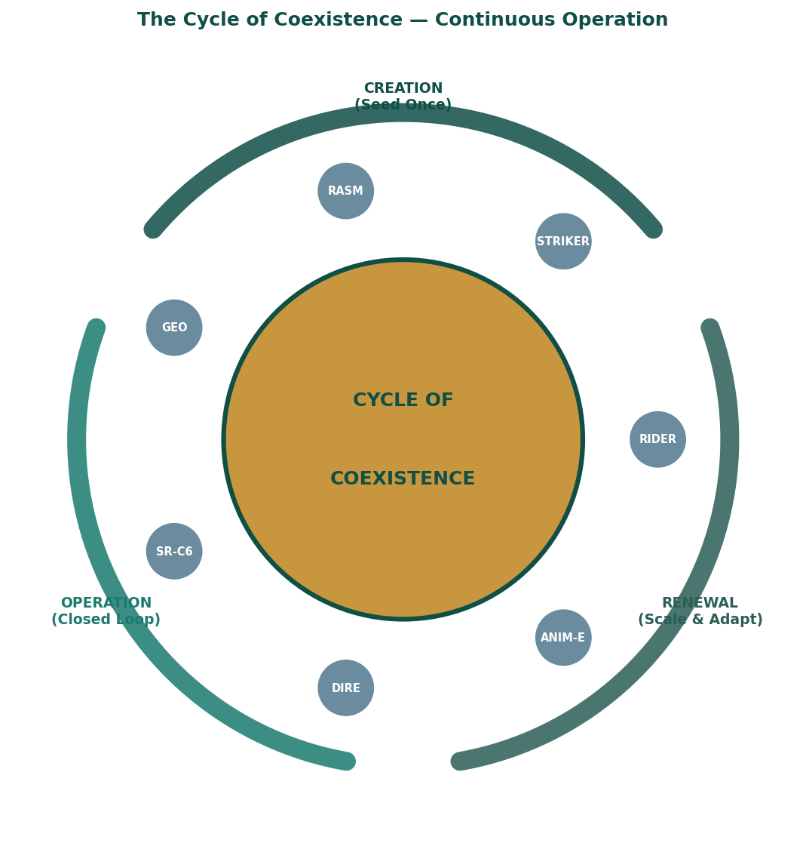
Figure 17-1: The Cycle of Coexistence — Continuous Operation

The Forward
The Cycle does not ask for permission to continue. It simply continues.
Every system described in this book is mid-cycle at the moment you read this. The Island is processing its overnight run. The GPF architecture is being instantiated in some form, somewhere, by some operator who has understood what the patent makes possible. RASM is on a shelf in a distribution context that was not anticipated when the formulation was set. SR-C6 is in an electrode, or a tyre, or a structural composite, performing the function it was specified to perform. DIRE is updating a risk score in response to a geopolitical event that did not exist when the last version of this sentence was written. ANIM-E's System 3 is observing a narrative that may or may not prove strong enough to enter canon. STRIKER is absorbing a pressure event in an environment it was designed to operate in.
None of them are finished. None of them were designed to be finished. The design goal was not completion. The design goal was continuation. A system that continues to operate correctly, adapting to the conditions it encounters without losing its identity, demonstrating through its operation that the philosophy that produced it is correct: that is what the Cycle of Coexistence looks like from the outside.
From the inside, it looks like 23:47. The overnight cycle beginning. The system doing what it was built to do, without instruction, without acknowledgement, and without rest.

━━━━━━━━━━━━━━━━━━━━━━━━━━━━━━━━━━━━━━━━
Everything adapts, survives, or does not.
Sagar-Raja · ADGM, Abu Dhabi, United Arab Emirates
Estonia · Switzerland · Singapore

CODEX
System reference for every reader — stable across all editions

CODEX

CX1
The Wardens: Complete Reference
The creative bible in its final form — stable across all editions
The following entries constitute the complete canonical reference for all Wardens of the Verdant Realm. These descriptions are authoritative and stable. Any future creative work set in the Verdant Realm draws from this reference without modification.

Primary Wardens
Table CX1-1: Primary Wardens — Complete Reference
Warden | Element | Capability | Role in Realm | Real-World Parallel | Voice / Presence
VAEL | Akasha | Psychic-structural imprinting: encodes complete system logic into substrates | Genesis intelligence; every autonomous system carries a Vael imprint. Does not instruct. Transfers comprehension. | GPF Orchestration Intelligence Layer | Absent. Quality of systems is its presence.
SELA | Prithvi | Bio-material synthesis: programmable living composites tunable to any property | Material foundation; all construction uses Sela's composites. Speaks in specifications. | Bio-Silk-Mycelium Composite / PIF outputs | Precise and unhurried. Specifications only.
MYCAN | Prithvi | Mycelium-composite engineering: rapid structural fungal networks | Structural durability; bonds with Sela's fibres. Subsurface, manifests as growth patterns and pressure. | SR-C6 HG structural composites | Subterranean. Felt as vibration.
SOLARA | Agni | Photonic maturation: biological state alignment via template + energy input. 80ms synthesis wave. | Energy catalyst; instantaneous biological completion and sustained solar chemistry. | VASF Synthesis Wave | Radiant. Speaks in outcomes.
NARA | Jala | Molecular hydro-kinesis: commands water from atmospheric vapour. Invitation, not extraction. | All water systems; water independence from external sources. | HACA unit | Pervasive. Present as moisture and pressure.
VORN | Akasha | Spectral energy storage: charges objects with kinetic capacitance; non-lethal force return | Defensive modifier. Makes defences non-lethal by default. | SR-OF resilience / Defence layering | An absence. Quality of silence before impact.
TERRA | Prithvi | Terrain engineering: reshapes landscape, excavates foundations, compresses bedrock | Constructor. All ground preparation before building. First to arrive, last to leave. | Platform landform geometry | Accomplished facts. Sound of settling.
Table CX1-1: Primary Wardens Complete Reference

Supporting Wardens
Table CX1-2: Supporting Wardens
Warden | Element | Capability | Role | Real-World Parallel
PYREN | Agni | Thermal engineering — heat-energy cores and propulsion | Propulsion and thermal energy systems | Transmutation Forge thermal layer
VOLTA | Vayu | Electrical architecture — electro-dynamic cores and EMP systems | Electrical and pulse defence systems | RIDER powertrain / GPF Execution Fabric
CRYAL | Jala | Cryo-engineering — cooling systems and ice-structural forms | Thermal management across all systems | PIF cryogenic storage (O₂, H₂)
VEILA | Vayu | Stealth weaving — camouflage fields and thermal masking | Concealment and low-observable design | STRIKER zero-branding / ANIM-E low-profile launch
BOTA | Prithvi | Growth regulation — rapid vegetation and ecological camouflage | Agricultural and environmental operations | VASF crop management / SR-EPP-OF ecological zones
EDGEN | Akasha | Precision architecture — micro-assembly and flawless construction logic | Fine-tolerance fabrication; no variance in precision construction | GPF Modular Fabrication Units
Table CX1-2: Supporting Wardens

World Rules of the Verdant Realm
Table CX1-3: Verdant Realm World Rules — Authoritative Reference
Rule | Specification
Wardens are not characters | They do not develop. They do not have desires, fears, or ambivalence. They are presences — expressions of principles operating. A Warden that appears to hesitate is calculating the correct next action, not experiencing emotion.
The Island is not defended; it is designed | Security is a consequence of correct design, not a supplement to it. The Island's protection comes from operating correctly within its environment, not from repelling threats at its boundary.
Closed loop is structural, not policy | There is no mechanism by which the Island can produce unrecoverable waste. Every output pathway leads to another process. This is not aspirational. It is a physical property of the system.
The timeline is mature | Scenes describe a system in operation, not a system being built. Founding events are told as history. The Island's present state — mature, integrated, autonomously extending — is more interesting than its origins.
The two registers are not metaphors | The Island's design logic and Sagar-Raja's design logic are identical. They are not analogous. The book does not point this out. The reader is trusted to notice it.
Table CX1-3: Verdant Realm World Rules

CODEX

CX2
Corporate Architecture
The legal and governance foundation in reference form
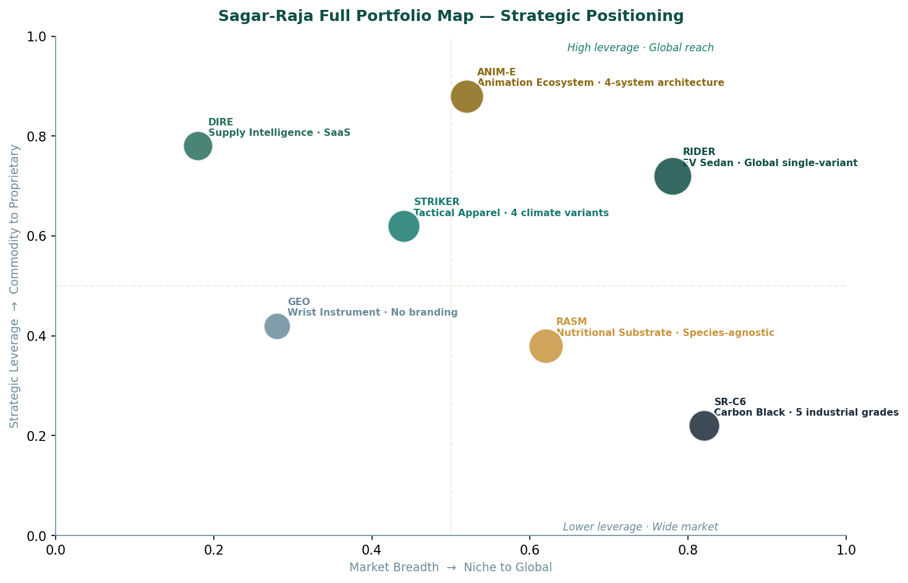
Figure CX2-1: Sagar-Raja Full Portfolio — Strategic Positioning Map

Parent Entity
Table CX2-1: Sagar-Raja Parent Entity — Key Facts
Item | Detail
Full legal name | Sagar-Raja (private company limited by shares)
Jurisdiction | Abu Dhabi Global Market (ADGM), United Arab Emirates — common law, independent courts
Status | Validly incorporated and active; permitted to own foreign subsidiaries, contract internationally, hold global IP
Core functions | Global IP ownership · Strategic asset management · Governance and compliance · Capital allocation · Primary contracting authority
Core IP | GPF-Tech patent (PCT granted, 150+ countries) · All product IP (RIDER, STRIKER, RASM, GEO, SR-C6, DIRE, ANIM-E)
Table CX2-1: Parent Entity Reference

Subsidiaries
Table CX2-2: Wholly Owned Subsidiary Reference
Entity | Jurisdiction | Legal Form | Primary Functions | Key Legal Frameworks
Sagar-Raja OÜ | Estonia, EU | Osaühing | EU operational interface · Technology systems · Digital infrastructure · EU certification | EU Commercial Law · GDPR · Estonian digital governance · EPC (via EPO)
Sagar-Raja AG | Switzerland | Aktiengesellschaft | High-value asset holding · Financial operations · Neutral contractual base | Swiss Code of Obligations · Swiss arbitration · Swiss financial law
Sagar-Raja Pte. Ltd. | Singapore | Private Limited | APAC trade · Regional partnerships · Singapore regulatory interface | Singapore Companies Act · Singapore arbitration · ASEAN FTAs
Table CX2-2: Subsidiary Reference

Operating Principles Reference
Table CX2-3: Four Operating Principles — Full Statement
Principle | Operational Meaning | What It Prevents
Automation First | Systems perform routine decision-making; humans intervene for oversight and exceptions only. Automation is a quality and consistency measure, not a cost measure. | Decision variability introduced by human judgment in routine operations where rules are known
Execution Before Expansion | Scaling occurs only after operational stability is proven in the current envelope. No product, market, or operation is scaled until it has been validated under real operating conditions. | Premature scaling that encounters real-world complexity at a point where the system cannot absorb it
Ownership = Accountability | All company-owned brands and infrastructure remain fully accountable under the parent entity. No structure through which failure can be attributed to a subsidiary or partner. | Blame-shifted failures; subsidiary-masked reputational damage; accountability gap in operations
Distributed Infrastructure | Operations globally distributed rather than dependent on any single location. No single geographic, regulatory, or operational dependency. | Single-point failure in any dimension: logistics, regulatory, political, or environmental
Table CX2-3: Operating Principles

CODEX

CX3
Framework Index
All operational frameworks in consolidated reference form

SR-EPP-OF: Ecological Production and Preservation Operations Framework
Table CX3-1: SR-EPP-OF Quick Reference
Element | Detail
Purpose | Governs design, operation, monitoring, and evolution of the ecological industrial platform
Platform character | Corporate-operated artificial ecological and industrial platform. Not a state, not a settlement, not a territorial claim.
Jurisdiction | Corporate governance: ADGM. Operational compliance: IMO conventions, environmental norms, coastal-state permissions where applicable
Priority hierarchy | L1 Ecosystem integrity → L2 Regenerative capacity → L3 Monitoring & correction → L4 Demonstration & research → L5 Commercial activation (always last, always conditional)
Design mandate | Zero-landfill · Internal recycling of all material flows · Energy and water integrated into landform geometry · No uncontrolled discharge
Control architecture | Distributed, encrypted, non-centralised · Continuous telemetry · Autonomous default · Human override with mandatory logging
Failure assumption | Failure will occur. Multi-layer reinforcement and compartmentalised zones ensure graceful degradation, not catastrophic failure.
Table CX3-1: SR-EPP-OF Reference

SR-OF: Sagar-Raja Operations Framework
Table CX3-2: SR-OF Quick Reference
Element | Detail
Purpose | Governs all company-owned activities across four operational domains
Scope | All owned brands · Proprietary IP · Manufacturing · Production · Service delivery · Internal logistics · Energy · Water · Employees · Contractors · Controlled subsidiaries
Four domains | Product & IP Operations · Production & Manufacturing · Infrastructure & Resource · Commercial & Delivery
Core principles | Ownership = accountability · Execution before expansion · Automation where validated · Surplus is a result not a target · Identity singular across all brands
Decision authority | L1 Safety (hard stop) → L2 Quality (central) → L3 Scheduling (distributed AI) → L4 Procurement (hybrid) → L5 Strategic (human)
Automation levels | Rule-based (default) · Autonomous optimisation (validated domains) · Human override (documented) · Post-action review (mandatory)
Table CX3-2: SR-OF Reference

GPF-Tech Patent
Table CX3-3: GPF-Tech Patent Reference
Element | Detail
Full title | Global Autonomous and Distributed Fabrication, Orchestration, and Self-Scaling Production System
Grant status | Granted international patent under PCT; novelty, inventive step, and industrial applicability confirmed by examiner
Implementation scope | Implementation-independent: applicable across software, hardware, cyber-physical, and hybrid production environments
Five components | L1 Orchestration Intelligence Layer · L2 Modular Fabrication Units · L3 Distributed Execution Fabric · L4 Verification & Feedback Layer · L5 Self-Scaling & Replication Mechanism
Geographic coverage | 150+ PCT member states. Primary commercial regions: Full Middle East (national phase) · EU via EPO · Singapore, JP, CN, AU · North America (USPTO + CIPO)
Standards alignment | ISO 9001 · ISO 55000 · IEC 62264 · IEC 61499 · ISO-IEC 27001 — all achieved as inherent architecture properties
Table CX3-3: GPF-Tech Patent Reference

PIF: Processing Infrastructure Framework
Table CX3-4: PIF Quick Reference
Element | Detail
Purpose | Distributed global industrial processing network: resource → element → strategic reserve → controlled processing → output
Core principle | All incoming resources fully decomposed into elemental components before any processing decision. Demand-triggered processing only.
Eight hub systems | Resource Intake · Material Prep & Separation · Elemental Decomp Complex · Elemental Storage · Demand Calc Engine · Controlled Processing Modules · Output Distribution · Byproduct & Recycling
Reserve thresholds | Strategic minimums maintained per element (Fe: 30 days, C: 60 days, H₂: 14 days, O₂: 21 days, Cu: 45 days); processing triggered when forecast reserve approaches threshold
SR-C6 linkage | SR-C6 is the commercial expression of the PIF carbon pathway: elemental carbon decomposed, stored, and processed into five functional grades for industrial markets
Table CX3-4: PIF Reference

CODEX

CX4
Product Specifications
All products and platforms in consolidated reference form

RIDER: Electric Performance Sedan
Table CX4-1: RIDER Complete Specification
Parameter | Specification
Vehicle type | Battery electric four-door fastback sedan
Variant strategy | Single global variant — no trim levels, no regional editions
Drive | Dual-motor all-wheel drive
Length / Width / Height | ~4,880 / ~1,920 / ~1,420 mm
Wheelbase | ~2,950 mm
Kerb weight | 2,150–2,250 kg; ~50:50 weight distribution
Drag coefficient | ~0.23 Cd
Peak power / torque | ~450 kW / ~820 Nm (combined, dual motor)
0–100 km/h | ~3.4 seconds
Top speed | 240 km/h (electronically limited)
Battery capacity (usable) | ~92 kWh
WLTP range | ~480 km; real-world 440–520 km
AC charging | Up to 22 kW on-board; 0–80% ~4 hours
DC charging | Up to 250 kW; 0–80% ~22 minutes
Suspension | Multi-link front and rear, adaptive air — standard globally
Regional adaptation | Regulatory lighting, labelling, software constraints, charging protocol only
Table CX4-1: RIDER Complete Specification

STRIKER: Adaptive Military-Duty Protective Apparel
Table CX4-2: STRIKER Complete Specification
Parameter | Specification
Product type | Personal protective apparel — military and tactical duty class
Architecture | Three-layer: outer structural textile / intermediate ceramic-polymer / inner comfort knit
Armour | Not included — compatible with all external armour systems
Branding | No visible external logos or identification on any variant
Layer 1 — outer | High-tenacity composite weave · UPF 50+ · IP6X sand resistance · Low acoustic/IR signature
Layer 2 — intermediate | Ceramic-polymer micro-laminate · Fragment V50 >400 m/s (9mm FSP) · Blunt trauma dispersion 8:1 · ±15°C thermal buffer
Layer 3 — inner | Moisture-wicking composite knit · Anti-microbial and anti-fungal · Skin-neutral surface
ARID variant | –10°C to +55°C · ~3.8 kg · UV/sand/heat-optimised
COLD variant | –40°C to +10°C · ~4.6 kg · Insulation/flexibility at –45°C
MARITIME variant | –5°C to +40°C · ~4.1 kg · Salt spray/corrosion-resistant
TEMPERATE variant | –10°C to +35°C · ~3.5 kg · Lightest configuration
Table CX4-2: STRIKER Complete Specification

RASM: Royal Almond-Soy Milk-Blend
Table CX4-3: RASM Complete Specification
Parameter | Specification
Positioning | Nutritional substrate — not a lifestyle beverage
Consumer class | Human and animal; species-agnostic formulation
pH | 6.3 ± 0.2
Density | ~1.02 g/mL at 20°C
Viscosity | ~3.5 mPa·s at 20°C
Emulsion | Oil-in-water; mean droplet size ~0.6 µm
Phase stability | <3% creaming over 7 days refrigerated
Protein / 100mL | 4.0g — complete essential amino acid profile (FAO/WHO reference)
Energy / 100mL | 57 kcal
Fat / 100mL | 3.0g total (0.6g saturated)
Carbohydrate / 100mL | 3.5g (1.6g sugars)
Calcium / 100mL | 120mg
Vitamin D / 100mL | 2.5 µg
Vitamin B12 / 100mL | 0.5 µg
Religious/cultural restrictions | None across any major dietary framework globally
Fortification | Adjustable by jurisdiction; base formulation unchanged
Table CX4-3: RASM Complete Specification

GEO: Hybrid Geological Watch
Table CX4-4: GEO Complete Specification
Parameter | Specification
Device type | Hybrid analog-digital wrist instrument
Variant strategy | Single form — no colorways, no dial variants, no editions
Case diameter | 46.0 mm
Case thickness | 12.9 mm
Lug-to-lug | 54.5 mm
Strap width | 24 mm
Weight | ~128g
Case material | Monobloc composite — fractured-stone surface geometry
Crystal | Sapphire, flat, anti-reflective interior coating
Water resistance | 200m / 20 bar — multi-gasket compression sealing
Display — analog | Skeletonised luminous hour/minute hands; slim seconds; SuperLuminova C3
Display — digital | Time HH:MM · Temperature °C · Day of week · Altitude metres
Display colours | Amber/yellow for numerics; green for indicators — photopic/scotopic optimised
Movement | Quartz-regulated hybrid; ±15 sec/year; 5-year battery life
External branding | None visible
Table CX4-4: GEO Complete Specification

SR-C6: Industrial Carbon Black
Table CX4-5: SR-C6 Complete Specification
Parameter | Specification
Material type | Industrial carbon black
Carbon content | ≥98.5 wt% (ASTM D1506)
Ash content | ≤0.5 wt%
Moisture content | ≤1.0 wt% (ISO 1124)
pH (slurry) | 6.5–9.0 (ISO 787/9)
Bulk density | 0.18–0.45 g/cm³ (ASTM D1513)
True density | 1.7–2.1 g/cm³
Volatile matter | ≤1.5 wt% (ASTM D1509)
Storage stability | ≥36 months sealed dry
SR-C6 R (reinforcement) | Surface area 70–120 m²/g · DBP 80–130 mL/100g · Tyres/rubber
SR-C6 P (pigment) | Surface area 100–300 m²/g · Tint strength 80–130 · Coatings/inks/plastics
SR-C6 E (conductive) | Surface area >200 m²/g · DBP 120–200 mL/100g · Electronics/antistatic
SR-C6 EC (energy-carbon) | Surface area >350 m²/g · Li-ion anodes / supercapacitor electrodes
SR-C6 HG (structural) | High graphitisation · Structural composites / thermal management / friction
Packaging | 25 kg bags · 500–1,000 kg super sacks · Bulk silo or tanker
Table CX4-5: SR-C6 Complete Specification

DIRE and ANIM-E: Platform Specifications
Table CX4-6: Platform Product Reference
Platform | Class | Architecture | Key Output
DIRE | Supply chain risk intelligence | Layer 1: Supply Mapping → Layer 2: Bottleneck Detection → Layer 3: Risk Scoring + Integrated Intelligence overlay | Supply Risk Exposure Score with sub-scores and scenario simulation results
ANIM-E | Animation entertainment ecosystem | System 1: Core Universe → System 2: Experimental → System 3: Observation & Evaluation → System 4: OTT Platform | Canon multiverse content + franchise licensing architecture + OTT distribution
Table CX4-6: Platform Product Reference

━━━━━━━━━━━━━━━━━━━━━━━━━━━━━━━━━━━━━━━━━━━━━━━━━━━
Everything adapts, survives, or does not.
Sagar-Raja · ADGM, Abu Dhabi, United Arab Emirates
Estonia · Switzerland · Singapore
Cycle of Coexistence — International Edition

