­­­­­­

Introduction

Overview

This report discusses the result of the work done in development of “Photo Sync Mobile application” on Cross Platform.

There are few photo syncing mobile applications are available in the field but there aren’t any which can be categorized under the cross platform.

This mobile app was developed to share one’s photos taken from his/her one device to his/her other devices that are logged in to this mobile app under same username. As an advantage a backup photo is stored in online server under his/her specific username with required securities.

Using this mobile application, the user can give commands to sync their photos via a background process or upload them via manually and separately. In the automatic background process, the app only shares new photos that are taken after the previous upload.

In the manual process the app will be shown separately what are the shared and not shared within the other devices.

Background

Cross platform developing is a new trend nowadays. The mobile application via cross platform is part of this new trend.

What are these cross platform mobile applications?

Cross platform mobile application development refers to the development of mobile apps that can be used on multiple mobile platforms such as Android, IOS, Windows, BlackBerry which uses a single code for all these platforms. Using this type of mobile application development, it increases the speed at which apps are developed and it decreases the total cost. In addition, cross platform mobile development tools are generally quite simple to use as they are based off of the common languages for scripting, including CSS HTML and JavaScript.

This project is to poke such a trend and find out what are we capable of and how can we code, attract, what will be the difficulties that come forward etc.

Not only the mobile application, but also have to maintain an online storage to handle the photos that are being uploading. To that we had to use HTML + PHP development.

Problem definition

The main problem that we faced is that if we have several mobile devices and when we took a photo using one device and if we wanted to share it with other devices, what we have to do is share the photo using Bluetooth or direct Wi-Fi. That won’t be a problematic if we have one extra mobile device. But if we use few devices such as mobile phones, tablets we have to share the photo separately. This only valid if the all the mobile devices close each other.

What if we want share some photos with other devices but the devices are not in a close range?

What if a teacher wants to share some photos with his students instantly? Can we extend any solutions such situations?

Proposed solution

The idea of synchronize or share the photos with other selected devices. Via online storage, sync the required photos with the devices that are allowed, was the solution that we have concluded.

According to that a mobile app was developed that can be run on any mobile platform using cross platform method.

­

CLOUD

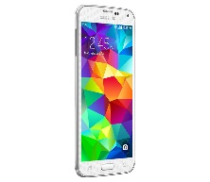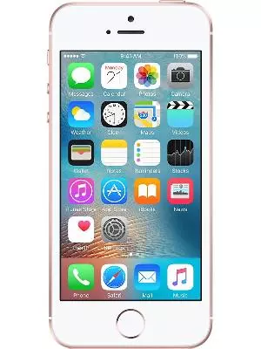

Design

The design that is using in this application was created using Ionic Cordova. The Ionic builds on top of Cordova. Apache Cordova takes care of packaging HTML5 app as a native app that can run in Android, IOS and other platforms.

But if someone simply take an existing website and package it as a mobile app the result will looks nothing like a native app: users will notice very quickly that the style and behaviors are pretty different.

That missing piece that Ionic provides: a set of front-end components (HTML /CSS /JavaScript and AngularJS) that let the programmer write an HTML5 app that looks like a native app. Using that features “Pera Sync” was developed.

The design is described here is using an android platform in the manual process.

An image is added to the loading screen for better appearance. The name of “Pera Sync” was created for give some uniqueness to the mobile application. The loading screen will be displayed like below.

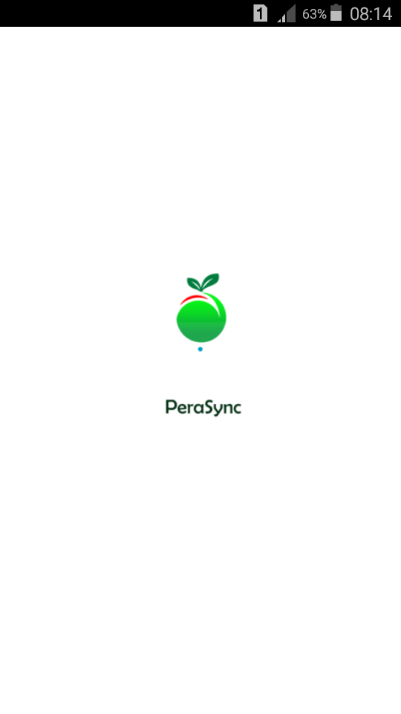

For the new users the Sign up will be needed. So when a user signed up, the cloud storage that uses for store photos will create a new folder for each user separately. This will be the storage that the user can share with his other mobile devices. A database basic system is followed here in cloud storage.

When the user log in to his account it will show the photos that are taken from the device where the photos are available in camera folder and it will also show what are the already uploaded to account by other devices. By choosing photos on user’s preference he can upload the photos that are wanted to sync with his other devices. And also he can download what are already uploaded by other devices

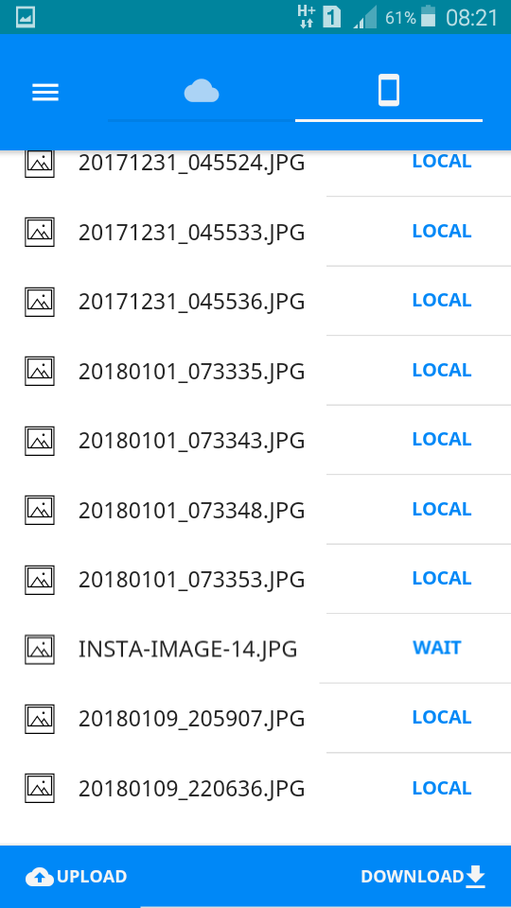

The uploaded images to online storage is shown in below. The above uploaded image is available to synchronize with any other devices that are logged under same username. The word “Cloud” defines that the image is available in the online storage and can be seen by other devices.

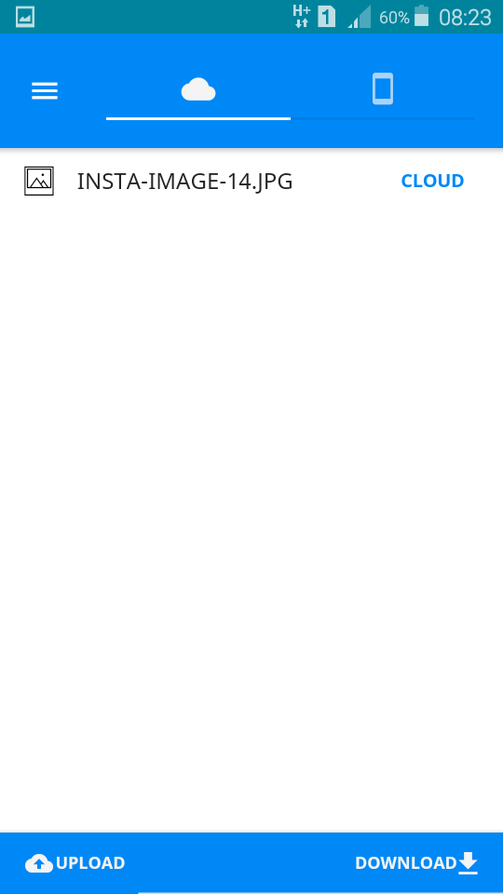

In additionally few settings were added to the application and they can be defined as below.

“One touch Access” can be defined as the refresh button.

“Settings” gives access to several changes of the mobile application

If the user wants to keep the original photo at the device that photo was taken, then he can apply “Keep original at Device”.

If the user wants to keep a backup photo in cloud, then the user can apply the button given here named, “Keep original at Cloud”.

And if the user wants to delete all the photos in cloud he can press the button “Delete” here. Then anyone wants to logout from the application button “Logout” will process it.

In addition to that few error messages were added to the application to display as alerts to give better appearance to mobile application.

Results

According to the mobile application that was developed here is successfully up to some point. We were able to build the application that runs in manually. The background scenario is still under construction.

The mobile application is still working with android platform. That is because we could able to build the application only for android and for IOS, we couldn’t build the code as the lack of the facilities.

The any device that is logged into same account can be downloaded the all photos at once and if the user wants to delete all the photos in cloud there is also a facility to perform it.

Future works

Though the mobile application was built up to some point, it has many features to develop. Having said that, we had a limited time schedule to complete this application and we will probably not be able to implement all the functionalities that we have planned to.

The background process is one of them. Thought the mobile application works manually, the automatic background scenario is not developed until now. Before build that we have to give some improvements to the mobile application. It has to recognize similar photos and only the best of them should be synchronized with other devices.

We have to improve the security of the database that we maintain online.

Only the android platform is added to the mobile application. We have to add other platforms to run the mobile application on them. Consider here nothing will be changed in the code that is used to develop the application.