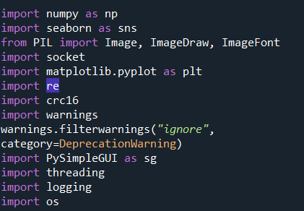

We have use numpy for creating image array

Seaborn for visualization

PIL for creating Bitmap Image with fonts

Socket for sending data

Crc 16 for checksum

Warning for stop unwanted warning

Pysimple GUI for alert

Threading for create multi threads for display

Logging for create error logs

Os for getting system fonts

We have 3 module

1. Direct Message



1. Signal Message



1. Threading with signals



1. BitMapMaker

**x = BitMapMaker(ip = "192.168.1.94", port = 9999, text = yh2 , fontSize = 10, display = True, language = "Hindi", fontStyle = "poppinsItalic") #ip, port, text, font, fontSize, language**

**x.output()**

1. SignalBitMapDisplay

**x = SignalBitmapDisplay(ip = ip, port = port, fontSize = 10, overFlowDisplay = True, display = True, language = "Hindi", fontStyle = "poppinsNormal" , counter = counter, stationName = stationName2)**

**x.output()**

1. Threading with multi-signal

**Iplist = ["192.168.1.93","192.168.1.94","192.168.1.95"]**

**datalist = ["Ahmad", "कभी लगता है इस जिन्दगी में खुशियां बेशुमार है,", stationName ,"Rochak"]**

**counter = [": 10", ": 50", ": 20"]**

**print(BitmapSignalingMultiSender.getFontList())**

**c = BitmapSignalingMultiSender(ip = Iplist, port = port, fontSize = fontSize, overFlowDisplay = False, display = False, language = None, fontStyle = None , counter = counter, stationName = datalist, sysFont = "NirmalaB")**

**c.output()**