**Course: PH202 Lab**

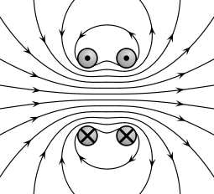Figure 3: Magnetic field produced by Helmholtz coil

**Semester: III**

**Experiment 2: Production of magnetic field by one and two coils**

“*Historically Helmholtz coil is a device famous for producing a region of nearly uniform magnetic field which is named after the German physicist Hermann Von Helmholtz. Besides creating uniform magnetic fields, Helmholtz coils are also used in scientific apparatus to cancel external magnetic fields, such as the Earth's magnetic field.* ***Hermann Ludwig Ferdinand von Helmholtz*** *(August 31, 1821 – September 8, 1894) was a German physician and physicist who made significant contributions to several widely varied areas of modern science. He is known for his theories on the conservation of energy, work in electrodynamics, chemical thermodynamics, and on the mechanical foundation of thermodynamics. The largest German association of research institutions, the Helmholtz Association was named after him.*”

Objectives: To study the magnetic field inside a single coil, and inside two coils at different distances. We check the properties of Helmholtz coil.

1. Measure the magnetic field through along the z-axis of a single coil and evaluate its number of turn.
2. Measure the z-component of the magnetic field intensity along the z-axis of two circular coils for different distances.
3. Measure the z-component of magnetic field intensity along the radial direction of Helmoltz coils.
4. Measure the radial component of the magnetic field along the z-axis of Helmoltz coils.

*Equipment provided:*

*- pair of coils and their current power supply*

*- Digital Gaussmeter with probe.*

*- supports, holders*

**THEORY:**

A magnetic field is created whenever charge is in motion, either moving in some space, conductor or spinning around itself. A moving charge in space or in a conductor constitutes what is called a "current" (denoted by the symbol *I*) and is measured in *coulombs/sec* or *amperes*. The strength of magnetic field is measured at a point in space (often called the *field point)*.



Figure 1: Magnetic field of a coil

**Magnetic field created by a single coil on its axis.**

Steady current produce magnetic fields which are constant in time. The magnetic field of a steady line current is given by the Biot-Savart law, from which one can derive the magnetic field produced along an axis through the centre of the coil:

Where:

- μ0 is the vacuum permeability: μ0 = 4π10-7 N/A2

- I is the intensity of current in the coil

- N is the number of loops in the coil

- R is the radius of the coil

- , the unit vector along the axis of the coil

In the derivation of equation (1), the assumption made is that the origin is located at the coil centre. If the origin does not coincide with the centre of the loop, but is instead a distance z0 from the loop centre, we must replace *z* in equation (1) by *(z - z0)*. Equation 1 becomes:

For more details see: David J Griffiths – *Introduction to electrodynamics*

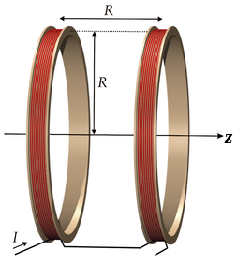**Helmholtz coils**

Helmholtz coils are constructed from two circular coils of wire, each perpendicular to the same axis, and each carrying the same amount of current in the same direction. As shown in Fig. 3, the coils are separated by a distance *R*, which is also the radius of each coil. Their fields add up. We can thus use Eq. 2 to find an expression for the *B* field at any point P on the axis of the coils.

At the mid-point of this pair, we have a situation where the field B1 due to one coil is decreasing linearly with z while B2 due to the other coil is increasing linearly with z at the same rate. B1 and B2 add up to produce a field which is almost constant in this region. Such a pair is called a pair of Helmholtz coils and its field is uniform within 1% over a range of 0.6R along the common axis.

Figure 2: Helmoltz coils

One can show that the intensity at the mid-point between the two coils is given by:

A S Mahajan, A A Rangwala. - *Electricity and Magnetism*

**EXPERIMENTAL PROCEDURE:**

**I- Magnetic field produced by a single coil on its axis**

- Measure the radius of a coil R = ........± ......... mm

- Connect only one coil to the power supply.

- The current magnitude through the coils is to be fixed at 0.5A.

- Arrange the probe on the support as shown in the picture below.

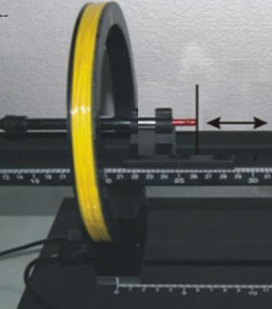

Figure 3: Setup to study B(r=0,z), magnetic field along the axis of the coil.

- Measure the magnetic field B(z) on the axis of the coil at 11 different positions z on both sides of the coil, including z = 0

**Observations:**

|  |  |  |  |  |
| --- | --- | --- | --- | --- |
| z (cm) |  |  |  |  |
| B(r=0,z) (G) |  |  |  |  |

**Data analysis:**

- Plot BVS z.

- Can we use a single coil to produce a constant magnetic field?

- Measure several times the magnetic field at z=0 and determinate the experimental error.

B ( r=0, z=0 ) = ……… ± ………… T (1 Gauss = 10-4 T )

- Using Equation 1 at z = 0, calculate the number of turns and estimate the experimental error:

N = ........... ± ...............

*Reminder: propagation of error:*

*Relative errors add up in case of multiplication or division of readings. Example: For , experimental error on f is given by*

*For more details on experimental errors, see* Lab manual write up*, available on Moodle.*

**II- Magnetic field produced by a pair of coaxial coils on their axis Bz (z,r=0)**

- Connect the two coils to the power supply as shown in Figure 4(a), such that the current flows in the same direction for both coils.

We assume that the two coils are exactly the same. (same R, same N)

- Arrange the probe as in part I- (Fig 4.)

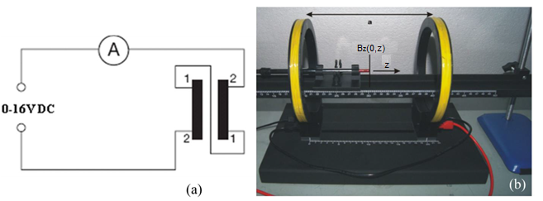

Figure 4: Schematics showing (a) the electrical circuit for Helmholtz coil experiment and (b) Helmholtz coil arrangement for B field along z-axis

- Set the coils at a distance d = 1.5R

- Measure the z-component magnetic field Bz (r=0, z) on the axis of the coils at 11 different positions z around de two coils.

- Repeat the experiment for d = R and d = R/2, d = 3R/4, d=2R, d = R/2

**Observations:**

|  |  |  |  |  |  |
| --- | --- | --- | --- | --- | --- |
| **Distance *x* (cm)** | ***B* at *a = R*/2 (Gauss)** | ***B* at *a =* 3*R*/4 (Gauss)** | ***B* at *a = R* (Gauss)** | ***B* at *a =* 1.5*R* (Gauss)** | ***B* at *a =* 2*R* (Gauss)** |
|  |  |  |  |  |  |
|  |  |  |  |  |  |
|  |  |  |  |  |  |

- Plot B VS z for

**Data analysis:**

- Comment the graphs. Which configuration(s) would be called as Helmholtz coils? Justify.

- Check whether the two statements given in the theory are verified for Helmholtz coils:

1) The intensity at the mid-point between the two coils is given by:

2) Its field is uniform within 1% over a range of 0.6R along the common axis.

**III- Magnetic field Bz(r,z=0) produced by Helmholtz coils along the radial direction**

- Arrange the probe as in the figure 5 below. Keep the distance between the Helmoltz coils d = R

- Measure Bz (r, z=0) for different distances along r

**Observations:**

|  |  |  |  |
| --- | --- | --- | --- |
| z (cm) |  |  |  |
| Bz(r, z=0) (Gauss) |  |  |  |

**Data analysis:**

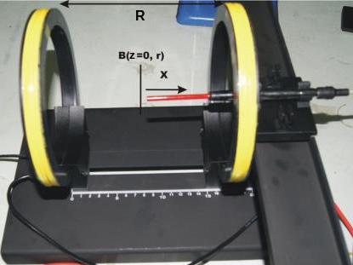

Figure 5: Configuration to probe magnetic flux along the radial direction Bz (r, z=0)

- Is the field uniform along r? Plot B VS r and comment its variation.

**IV- Radial component of the magnetic field Br(r,z=0) produced by Helmholtz coils along the z-axis**

- Turn the pair of coils through 90º (see figure below). Now probe is in a direction perpendicular to the first configuration, hence it measure the radial component of the magnetic field along the z-axis Br (r=0, z)

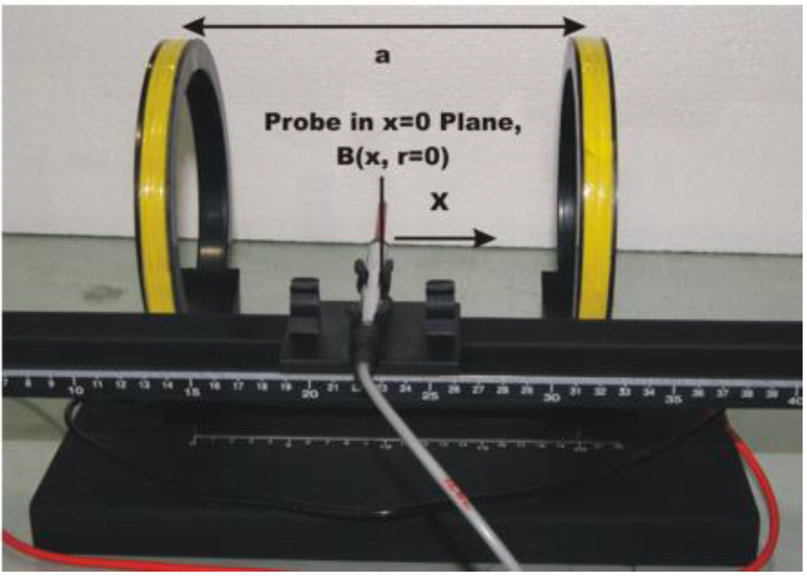

Figure 6: Configuration to probe radial component of the magnetic flux along the z-axis Br (r=0, z)

- Measure Bz (r, z=0) for different distances along r

**Observations**:

|  |  |  |  |
| --- | --- | --- | --- |
| z (cm) |  |  |  |
| Bz(r, z=0) (Gauss) |  |  |  |

**Data analysis:**

- Plot Bz (r, z=0) with respect to z.

- Draw your own conclusions and remarks about the experiments and results obtained by you.