**Course: PH202 Lab**

**Semester: III**

**Experiment 3: Refractive index measurement using optical spectrometer**

“*Newton set up a prism near his window, and projected a beautiful spectrum 22 feet onto the far wall. Further, to prove that the prism was not coloring the light, he refracted the light back together*”

[www.webexhibits.org/colorart/bh.html](http://www.webexhibits.org/colorart/bh.html)

“*In 1672, Isaac Newton reported to the Royal Society his observations on the dispersion of sunlight as it passes through a prism. Newton concluded that sunlight is composed of light of different colors which are refracted by glass to different extents*”

 From Optics by Ajoy Ghatak

Prisms can serve as a dispersing device, or to affect the direction of propagation of a beam. Coupled to a spectrometer device, it can be used to analyse a polychromatic light or to determine refractive indexes.

**OBJECTIVE:** determine the refractive index of the material of a provided prism for a single wavelength: λ = 589.3 nm, with the help of an optical spectrometer.

*Equipment provided:*

*- optical spectrometer*

*- prism*

*- sodium light*

**THEORY:**

**Angle of minimum deviation**

A dispersing prism is characterized by its apex angle *A*, and its refractive index *n* (see Figure 1) When a ray of monochromatic light passes through a prism, it is refracted twice, once as it enters, and again as it leaves the prism, as shown in Figure 1. As a result, it will be deflected from its original direction (angle of incidence θ1) by an angle *δ*, known as the angular deviation.

The deviation suffered by a monochromatic beam on traversing a given prism (*n* and *A* fixed) is a function of the incident angle at the first face *θ1*. It exhibits a minimum angle of deviation *δm*.

One can show the relation between the minimum angle of deviation *δm*, the apex angle *A* and the refractive angle *n*:

$$n=\frac{sin[{(δ_{m}+A)}/2]}{sin(A/2)}$$

This equation forms the basis of one of the most accurate techniques for determining the refractive index of a transparent substance. Effectively, one fashions a prism out of the material in question, and then, measuring A and δm(λ), n(λ) is computed employing the above equation at each wavelength of interest.

Eugene Hecht, A.R. Ganesan - *Optics*

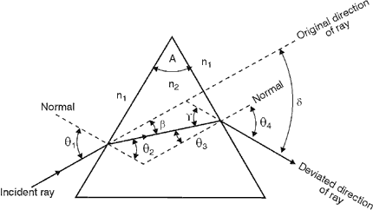

Figure 1: Determination of the deviation of a prism

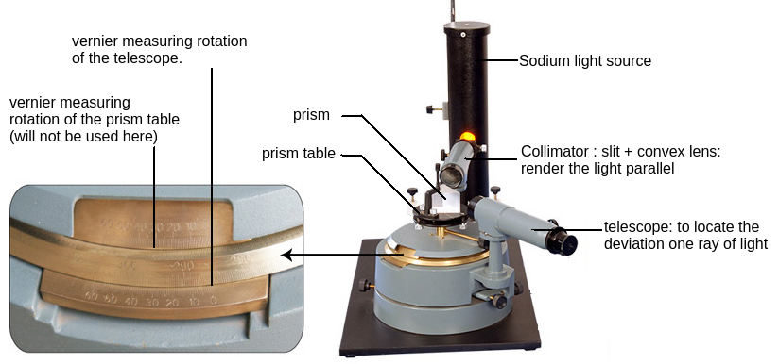

Figure 2: Description of the optical spectrometer and equipment provided

**Manual optical spectrometer**

Generally, an optical spectrometer is an instrument employed for analysing the spectra of radiations. The glass-prism spectrometer is suitable for measuring ray deviations and refractive indices. The light to be examined is rendered parallel by a collimator consisting of a tube with a slit of adjustable width at one end and a convex lens at the other. The parallel beam of light from the collimator passes through a glass prism standing on a prism-table which can be rotated, raised or lowered, and levelled. (Note: we will not be using the vernier associated to the prism-table for this experiment). The prism deflects the component colours of the emitted light and is examined by means of a telescope, which is mounted on a rotating arm and moves over a divided angular scale, called vernier.

*http://www.cmi.ac.in/~debangshu/lab1/spectrometer.pdf*

**How to read a vernier?**

The vernier associated to the spectrometer is composed of:

- the main scale: fixed part, graduated from 0 to 360°. It is divided into one third degree units, i.e. 20' units

- the vernier scale: moving part, graduated from 0 to 20'. It is divided into half minutes.

1) Locate the zero line on the vernier scale, and write down which division is immediately before (172° 20' in the example)

2) Scan along the line where the main and vernier scales meet, and note which vernier scale division is directly in line with a main scale division (12.5' in the example)

3) Add the main and vernier scale readings to obtain the final reading. (172° 20' + 12.5' = 172° 32.5' in the example)

4) If you need to substitute any read angles in a formula, do not forget to convert it in decimal degrees. Reminder: 60' = 1°. (172 + 32.5/60 ≈ 172.54° in the example)

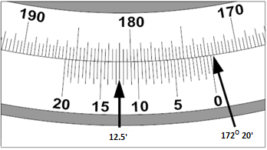

Figure 4: Example of readings on a thirty second direct vernier

*http://labs.physics.dur.ac.uk/level1/ISE/AngularVernierScale.php*

**EXPERIMENTAL PROCEDURE:**

**I- Adjustment of a spectrometer**

An optical spectrometer consists of mainly three parts, namely, a collimator, a prism table and a telescope (Fig. 3). The description and adjustements of the different parts are as follows

1) The telescope: It is an astronomical telescope consisting of an achromatic objective lens and an eyepiece. The telescope is mounted on a vertical stand capable of rotation about the central axis of the spectrometer.

- It should be focused at infinity: point the telescope towards a wall a few metres away. Adjust rack & pinion arrangement P2 (see Figure 3) of the telescope to get a bright field of view.

- Move the eyepiece of the telescope smoothly in or out to focus the cross-wires. In this position eyepiece is focused on the cross wires.

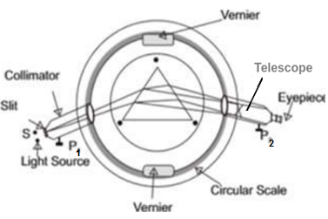

Figure 3: Top view diagram of the spectrometer. The light incident on a prism through the collimator undergoes deviation through the prism, which is finally captured using a telescope on the other side.

2) The collimator: It consists of a horizontal metal tube which is provided with a vertical rectangular slit of adjustable width at its one end. This tube can be moved in or out of another tube using a rack and pinion arrangement, P1 (see Fig. 3). An achromatic convex lens is provided at the other end of the collimating tube.

- Adjust the collimator (P1) such that the image of the slit seen in the telescope is sharp. Make also the slit as narrow as possible.

3) The prism table: It consists of circular plane table with adjustable height. It can be rotated about its own axis. The angle by which the prism table is rotated can be measured on the graduated circular scale with the help of two vernier scales.

- place the prism as in Figure 5. Look for the image of the slit. It should lie at the centre of the field of view.

Repeat the above procedures during the experiment whenever necessary.

**II- Measure of the angle of prism A:**

- Place the prism on the prism table as shown in Fig. 4 with its refracting angle ‘*A*’ towards the

Collimator.

- Move the telescope to one side to receive the light, which is reflected from one face of the prism.

- Carefully position the telescope until the slit image is in the center of the focal plane of the telescope and the cross wire is aligned with the slit image.

- Clamp the telescope in this position 1 and note the readings of the two Vernier scales.

- Swing the telescope around to receive the light reflected from the other face PR of the prism and similarly (c and d above) note down the readings of the two Vernier scale in position 2 of the telescope. Write down your readings in a table such as the one below.

- The difference between the two angles is 2A. Deduce A.

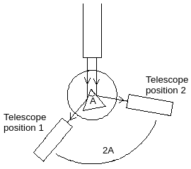

Figure 4: Determining the angle of the prism A

- Repeat the experiment 4 times.

**Observations:**

|  |  |  |  |  |  |
| --- | --- | --- | --- | --- | --- |
| Sample nº | Vernier | Position 1 of the telescope | Position 2 of the telescope | A = difference between positions 1 and 2 divided by 2 | Average and experimental error. |
| 1 | V1  V2 |  |  |  | A = ………..±  ………….. |
| 2 | V1  V2 |  |  |  |
| 3 | V1  V2 |  |  |  |
| 4 | V1  V2 |  |  |  |

**III- Measure of the angle of minimum deviation δm**

- Place the prism on the prism table so that its centre nearly coincides with the centre of one of its face, making an angle of incidence less than 45° with the light coming from the collimator, as shown in Fig. 6

- Rotate the telescope and set it in the position of the slit image formed due to refraction i.e. Position 2 on Fig.6.

- Slowly turn the prism table in such a direction that the angle of deviation decreases. In order to keep the slit image in its field of view, the telescope is to be moved towards the direction of the collimator axis. On reaching the minimum deviation position, the slit image comes to rest momentarily and further rotation of the prism table makes the slit image to move back in the opposite direction. Adjust the prism table as well as the telescope until a position is found where the image just reverses its motion.

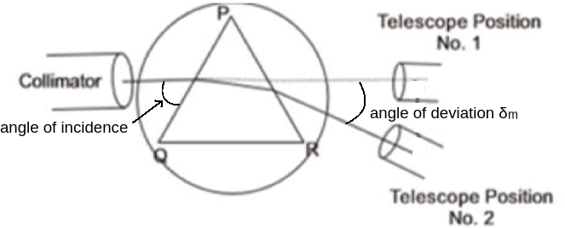

Figure 6: Determining the minimum angle of deviation δm

- Clamp the telescope in the position 2 and note the reading of the two Verniers.

- Remove the prism from the prism table and position it in the line of the collimator. See the slit directly, through the telescope and set the vertical cross wire on the slit image.

- Clamp the telescope in the position 1 and note the reading of the two Verniers.

- Repeat the whole experiment 4 times, and write down your results in a table as the one below.

**Observations:**

|  |  |  |  |  |  |
| --- | --- | --- | --- | --- | --- |
| Sample nº | Vernier | Position 1 of the telescope | Position 2 of the telescope | Angle of minimum deviation δm | Average and experimental error. |
| 1 | V1  V2 |  |  |  | δm = ………..±  ………….. |
| 2 | V1  V2 |  |  |  |
| 3 | V1  V2 |  |  |  |
| 4 | V1  V2 |  |  |  |

- Obtain the angle of minimum deviation δm by subtraction of the two angles.

**IV- Conclusion: calculation of the refractive index n**

Calculate the refractive index: $$n=\frac{sin[{(δ_{m}+A)}/2]}{sin(A/2)}$$

Calculate the experimental error: $$∆n=\frac{cos[{(δ_{m}+A)}/2]}{2sin(A/2)}×{∆δ}_{m}+\frac{sin({δ_{m}}/2)}{2\sin^{2}(A/2)}×∆A$$