**Course: PH202 Lab**

**Semester: III**

**Experiment 7: Hall Effect in semiconductors**

The Hall Effect is the production, across a conductor, of a voltage difference (the Hall voltage) transverse to an electric current across the conductor and a magnetic field perpendicular to the current. It was discovered by Edwin Hall in 1879.It has proved to be especially useful in the study of semiconductors, since it allows revealing directly both the density and the sign of the charge carriers. It is also widely used in Gaussmeter probes, to determine the magnetic field at a certain point.

**Objectives:** Determine the Hall types of charge carriers, whether it is *n*-type or *p*-type and determine the charge carrier density.

*Equipment provided:*

*- Hall probe Ge crystal n or p type*

*- Hall Effect setup: millivoltmeter and constant current source for the Hall Probe*

*- Electromagnet and its constant current power supply*

*- Calibration curve for the electromagnet*

**Semiconductor**

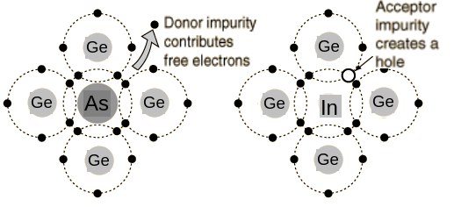 The addition of a small percentage of foreign atoms in the regular crystal lattice of silicon or germanium induces an excess or a lack of electrons. Electric conduction is thus made possible through motion of electrons (negative charges) or holes (lacks of electron, positive charges). They are respectively called n-type and p-type semiconductors.

[*http://hyperphysics.phy-astr.gsu.edu/hbase/solids/dope.html*](http://hyperphysics.phy-astr.gsu.edu/hbase/solids/dope.html)

**Document 2: Hall Effect – principle**

The basic physical principle behind the Hall Effect is Lorentz force. When an electron moves in an applied magnetic field, it experiences a force acting normal to both the magnetic field and direction of motion of electron. When this happens, electrons and holes will be separated by opposite forces (as shown in Fig.1). They will in turn produce an electric field (*Eh*) which depends on the cross product of the magnetic intensity, *B* and the current density, *J*.

$E_{h}=RJ×B$ (1)

where *R* is called the Hall Coefficient.

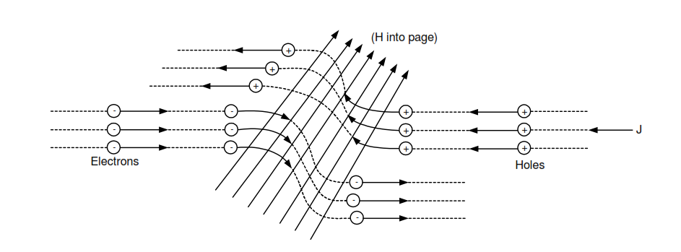

Figure : Carrier separation due to magnetic field

Now, let us consider a bar of semiconductor (Fig.2), having dimension, *x*, *y* and *z*. Let *J* be directed along *x* direction and *B* along z then *Eh* will be along *y*.

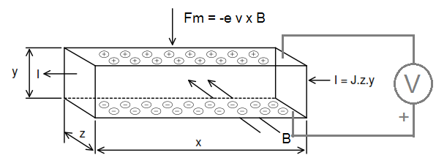

Figure 2: Hall effect for negative charge carriers. Here the magnetic field points inward, the velocity of the charge carriers is from left to right. Therefore, the magnetic force causes the negative charge carriers to pile up at the bottom.

Then we can write,

$R=\frac{{V_{h}}/y}{JB}=\frac{{zV}_{h }}{IB}$ (2)

Where *Vh*is the Hall voltage appearing between the two surfaces perpendicular to y and $I=Jyz$. In The magnetic force on the carriers is $F_{m}=q(v ×B)$ and is compensated by the Hall field $F_{h} = qE_{h}$, where v is the drift velocity of the carriers.. Assuming the direction of various vectors as before

$$v ×B =E_{h}.$$

From simple reasoning, the current density *J* is the charge multiplied by the number of carriers traversing per unit area in unit time, which is equivalent to the carrier density multiplied by the drift velocity i.e $J = q n v$. By putting these values in equation (2)

$R=\frac{{V_{h}}/y}{JB}=\frac{E_{h }}{JB}=\frac{v B}{qnvB}=\frac{1}{nq}$ (3)

From this equation it is clear that the sign of Hall coefficient depends upon the sign of q. This means, in a p type specimen the R would be positive, while in the n- type specimen it would be negative. Important remark: for this statement to be correct, direction of B, I and connections of the voltmeter, must be as in figure 2. Also for a fixed magnetic field and input current, the Hall voltage is proportional to 1/n or its resistivity. When one carrier dominates, the conductivity of the material is σ = nqµ, where µ is the mobility of the charge carriers. Thus

$µ = Rσ$ (4)

Equation (4) provides an experimental measurement of mobility; *R* is expressed in cm3 coulomb-1 thus *µ* is expressed in units, of cm2 volt-1 sec-1.

**The electromagnet**

Two coils are wound on non-magnetic formers with uniform layer of copper wire. It is supplied with flat pole pieces. The air-gap between the pole pieces is continuously variable with two way knobbed wheel screw adjusting system.

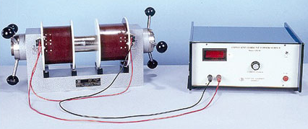

Figure 2: The electromagnet and its constant current power supply

By applying a current into the coil, a magnetic field is generated between the two poles. For small air-gap between the poles, and far from the edges of the poles we can consider the magnetic field to be straight and constant. The calibration table for the electromagnet is provided for a given distance between the plates. Do not change the distance.

[*http://www.sestechno.com/pro1/1g.htm*](http://www.sestechno.com/pro1/1g.htm)

**EXPERIMENTAL PROCEDURE:**

**I- Change in the Hall Voltage by change in the magnetic field keeping the current going through the semiconductor constant (*VH* vs *B)***

- connect the Hall Effect setup to the Hall effect probe: current generator lengthwise (Red-Black wires of Hall probe connected to current terminals), and millivoltmeter width wise (Green-Yellow wires of Hall Probe connected to voltage terminals)

- Place the Hall Effect probe (the semi-conductor) in between the two plates. It has to be kept perpendicular to the direction of the magnetic field.

- Switch on the electromagnet power supply and set it to a desired current I, corresponding to a given magnetic field B (see the calibration table).

- Switch on the power supply/voltmeter setup, and adjust the current knob to 0. Switch the Current/Voltage switch to Voltage. Note the offset voltage when the current applied through the semiconductor probe source is zero.

- Shift the Current/Voltage switch to Current. Adjust the current knob to I = 2mA in the probe

- Shift the Current/Voltage switch to Voltage. Write down the induced Hall voltage.

- Slowly change the magnetic field by changing the current in the constant current and repeat the procedure to determine the offset voltage and the induced hall voltage VH

- Take at least 10 measurements, for 10 different magnetic field B.

Observations: for current through the semi-conductor **I = …… mA**

|  |  |  |  |
| --- | --- | --- | --- |
| ***B*(mT)**  **1Gauss = 0.1 mT** | ***VH’*(mV)** | **Offset**  **(mV)** | **Corrected (*VH*- Offset)(mV)** |
|  |  |  |  |
|  |  |  |  |
|  |  |  |  |

- Plot *V****H*** VS *B*

**II- Change in the Hall Voltage by change in the current, keeping the magnetic field constant (*VH VS I)***

- Keep the wire setup unchanged

- Adjust the current value of the constant current source a desired value, this value corresponds to the Magnetic field B and will remain unchanged.

- Now, adjust the current value on the Hall Setup to the required value and note the corresponding value of Hall voltage by switching to Voltage using the current/voltage switch each time and note down the value.

- As previously, measuring and subtract the offset voltage, when the current I through the probe is 0

Observations: **For B = ….. mT**

|  |  |  |  |
| --- | --- | --- | --- |
| **Current through the probe**  **I (mA)** | ***VH’*(mV)** | **Offset**  **(mV)** | **Corrected (*VH*- Offset)(mV)** |
|  |  |  |  |
|  |  |  |  |
|  |  |  |  |

- Plot VH VS I

**III- Data analysis**

(a) From the graph *VH* VS *B* and *VH* vs *I* calculate Hall coefficient by using equation (2). Estimate the error. Compare the Hall coefficients from both the curves.

(b) Determine the type of majority charge carriers, i.e. whether the crystal is *n* type or *p* type.

Hint: Use figure 3 below.

(c) Calculate charge carrier density and its experimental error from the relation

$$R=\frac{1}{nq} n=\frac{1}{qR}$$

*Reminder: propagation of error:*

*Relative errors add up in case of multiplication or division of readings. Example: For $(A,B,C) =\frac{A B}{C}$, experimental error $Δf$ on f is given by $\frac{Δf}{\left|f\right|}= \frac{ΔA}{\left|A\right|}+ \frac{ΔB}{\left|B\right|}+ \frac{ΔC}{\left|C\right|}$*

*For more details on experimental errors, see* Lab manual write up*, available on Moodle.*

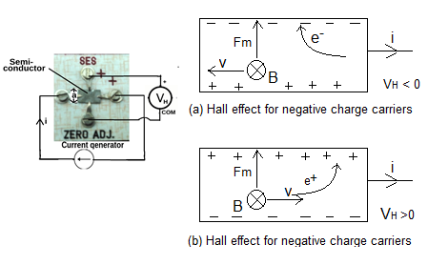

Figure 3: Determination of the charge carriers type. In this example, B is pointing inward, the current is from left to right, and the positive connection of the voltmeter is at the top.