**Course: PH202 Lab**

**Semester: III**

**Experiment 9: Equivalent focal length of combination of lenses**

“*In dealing with a system of lenses we simply chase the ray through a succession of lenses. That is all there is to it*. ” - Richard Feynman in *Feynman Lectures on Physics*

Lenses are transparent optical devices that affect the focus of a light beam through refraction. Their capacity for deflecting the light is quantify by their focal length.

**OBJECTIVES:**

* To find the focal length of a lens.
* To find the equivalent focal length of a combination of lenses when separated by a definite distance. Such combinations of lenses are sometimes termed as compound lens also.

In the lab session, you will measure the focal length of a thin convex lens with different methods, as well as the focal of a combination of thin convex lenses.

*Equipment provided:*

*- optical bench*

*- lens of focal length 20 cm*

*- light source*

*- lens of unknown focal length*

*- object*

*- screen*

**What is the focal length?**

If a collimated beam of light (beam composed of parallel rays of light) passing through the lens converges to a spot (a *focus*) behind the lens, the lens is called a *positive* or *converging* lens. The distance from the lens to the spot is the focal length of the lens, which is commonly abbreviated *f* in diagrams and equations.

*https://en.wikipedia.org/wiki/Lens_(optics)*

**Focal length measurements**

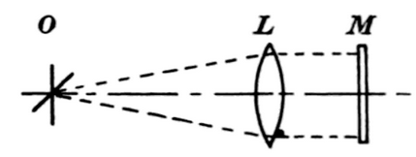a) Infinite object method:

The principle of this method is to receive the image by the lens of a distant object on a screen. The distance between the screen and the lens is the focal length.

b) Auto-collimation method:

It consists of placing the lens in front of an illuminated object and a mirror behind the lens. Then, one should move both lens and mirror with respect to the object until the image of the object is sharply focused on the plane of the object itself (the mirror may require tilting slightly). In this situation, the light coming of the lens is parallel, so the distance between the lens and the object is the focal length of the lens.

c) Thin lens equation method:

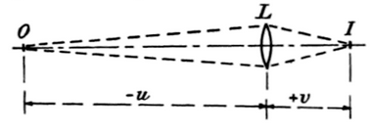The relation connecting the position of object and image, and the focal length of the lens f is:

$$\frac{1}{f}=\frac{1}{v}-\frac{1}{u}$$ where:

- *f* is the focal length

- *u* is the object distance (negative if the object being before the lens)

- *v* is the image distance (positive if the image is formed after the lens)

The measure of u and v allows determining *f*, by direct calculation or by graphical method.

B K Johnson- *Optics and optical instruments*

**Compound thin lenses**

* **Lenses in contact:**

Consider f1 and f2 to be the focal lengths of two convex lenses. If the lenses are in contact, the separation between them would be very small as compared to their focal lengths.

In that case for lens L1, I1 is the image of the object as shown in Fig. 1 below.

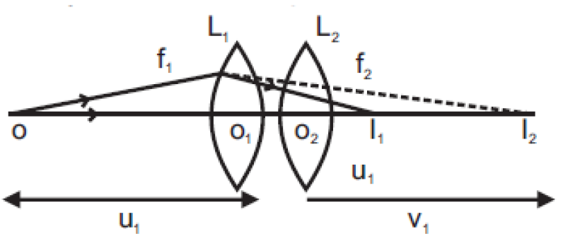

Figure : Schematic showing the position of the image for a fixed object

Therefore,

$$\frac{1}{f_{1}}=\frac{1}{v_{1}}+\frac{1}{u_{1}}$$

For the lens L2, I1 is the object (virtual) and I2 is the image and hence $$\frac{1}{f_{2}}=\frac{1}{v_{2}}-\frac{1}{v_{1}}$$

Adding Eqs. (1) and (2),

$$\frac{1}{f_{1}}+\frac{1}{f_{2}}=\frac{1}{v_{2}}+\frac{1}{u_{1}}$$

Now if we replace the two lenses of focal lengths *f*1 and *f*2 by a single lens of focal length *f*, such that it forms image at a distance *v*2 of an object, which is kept at a distance *u* as shown in the figure below, such lens is called an equivalent lens.

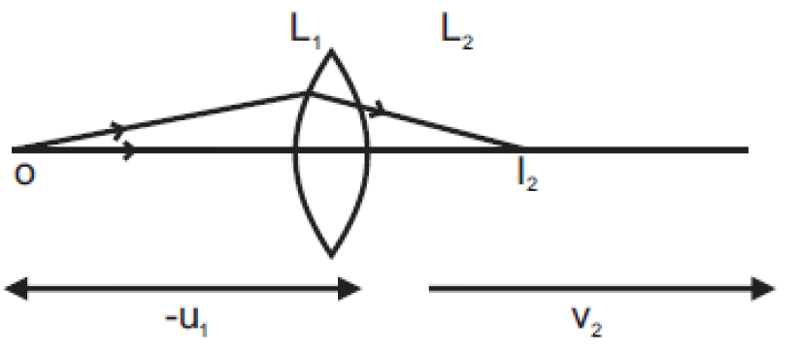

Figure : Schematic showing the equivalent lens

* **Lenses separated by a distance *d*:**

If the two lenses are separated by a distance *d* then,

$$\frac{1}{f}=\frac{1}{f_{1}}+\frac{1}{f_{2}}-\frac{d}{f_{1}f_{2}}$$

Therefore,

$$f=\frac{f_{1}f_{2}}{f_{1}+f_{2}-d}$$

One can calculate the propagation of error through this formula (see *Lab manual write up* for more details)

$$∆f=f × \left(∆d+\left|\frac{f_{2}}{f_{1}}(f_{1}+f_{2}-d)-1\right| ×∆f_{1}+ \left|\frac{f_{1}}{f_{2}}(f_{1}+f_{2}-d)-1\right| ×∆f_{2}\right)$$

**EXPERIMENTAL PROCEDURE:**

**I- Measure of the focal length of an unknown lens**

1) Estimate the focal length of the unknown lens provided with the infinite object method

- Take the lens and the screen out of its support and make the sharp image of a very far illuminated object on the screen.

- Measure the distance between the screen and the lens at position of sharp image on the wall.

- Repeat the experiment several times and evaluate the errors. Discuss the possible source(s) of experimental error. Give a first estimation of the focal length

f = ..... ± ....... m

2) Determine the focal length the single lens using the thin lens equation method.

- Place the lamp at one end of bench.

- Place the object nearby the lamp at a distance of about 1 to 2 cm from the lamp.

- Place the lens at distance *u* (where *u* must be greater than the focal length) from the object slit.

- Now move the screen from other end of the bench toward lens, and find the position of sharp image of the object on the screen.

- Measure *v,* the distance between the lens and the screen at position of sharp image.

- Repeat the experiment for 5 different distances *u*.

|  |  |  |  |
| --- | --- | --- | --- |
| *│u│* (cm) | *│v│* (cm) | *1/f = 1/│u│ + 1/│v│*(cm-1) | *f* (cm) |
|  |  |  |  |
|  |  |  |  |

- Take the average and estimate the experimental error. f = …….. ± ……….

**II- Measure of the focal length of a compound lens**

- Set the two focal lenses at a minimum distance *d* from each other.

- Move the screen move the screen from other end of the bench toward lens, and find the position of sharp image of the object on the screen.

- Measure *u*, the distance from the object to the mid-point between the lenses

- Measure *v*, the distance the mid-point between the lenses and the screen.

- Deduce the focal lens f as above.

- Repeat the experiment for 5 different distances *u*, same d

- Use the same procedure to determine the focal lens for two others different distance *d* between the lenses.

**Observations:** For d = …… ± ………… cm

|  |  |  |  |
| --- | --- | --- | --- |
| *│u│* (cm) | *│v│* (cm) | *1/f = 1/│u│ + 1/│v│*(cm-1) | *fexp* (cm) |
|  |  |  |  |
|  |  |  |  |

**Theoretical calculation:**

Use formula $f_{th}=\frac{f_{1}f_{2}}{f_{1}+f_{2}-d}$ to determine theoretically the focal lens of the compound lens for the difference distances *d*

**Comparison/Conclusion:**

Present your results in a table such as below:

|  |  |  |  |
| --- | --- | --- | --- |
| Distance *d* between lenses (cm) | | Experimental determination of the equivalent focal length *f*exp (cm) | Theoritical calculation of the equivalent focal length *f*th (cm) |
| …… ± ……. | …… ± ……. | …… ± ……. |
| …… ± ……. | …… ± ……. | …… ± ……. |
| …… ± ……. | …… ± ……. | …… ± ……. |

Compare theoretical values of fth and experimental values of fexp. Is the theory matching with the experience? Comment.