**Course: PH202 Lab**

**Semester: III**

**Experiment 1: Faraday and Lenz's laws – BH curve**

This lab session consists of two experiments with two different experimental setups: one is to study Faraday and Lenz’s law, the other one is to study the property of a material plotting the B-H curve.

**PART 1: FARADAY AND LENZ’S LAWS**

“*Heinrich Friedrich Emil Lenz was a precise and devoted scientist pioneering the field of electromagnetics while leading the way in recording and preparing his experiments, now known as scientific method. The detailed and complete methods of his work have given researchers the world over a standard to live up to. …. Lenz is best regarded as a precise investigator rather than a gifted innovator. His dutiful research led him to the Law that bears his name.*”

J. B. Tooker (http://www.jtooker.com/files/Lenz.pdf)

**“Faraday's law of induction** *is a basic law of electromagnetism predicting how a magnetic field will interact with an electric circuit to produce an electromotive force (EMF)—a phenomenon called electromagnetic induction., which governs the working of electrical motors, generators and solenoids. Michael Faraday explained electromagnetic induction using a concept he called lines of force. However, scientists at the time widely rejected his theoretical ideas, mainly because they were not formulated mathematically. An exception was James Clerk Maxwell, who used Faraday's ideas as the basis of his quantitative electromagnetic theory. In Maxwell's papers, the time-varying aspect of electromagnetic induction is expressed as a differential equation which Oliver Heaviside referred to as Faraday's law even though it is different from the original version of Faraday's law, and does not describe motional EMF. Heaviside's version is the form recognized today in the group of equations known as Maxwell's equations.*”

[https://en.wikipedia.org/wiki/Farada’s_law_of_induction](https://en.wikipedia.org/wiki/Farada's_law_of_induction)

**Objectives:**

- To observe an induced electromotive force and explain it with Lenz’s law and Faraday’s.

- To measure of the induced voltage impulse *Up-p* and the area of the curve in different situations (velocity of the falling magnet, coil)

*Equipment provided:*

*- two coils*

*- magnet*

*- stand and clamps*

*- voltage sensor*

*- LabQuest Mini*

*- Logger Lite Pro, software.*

*- alternative current generator*

*- current sensor.*

*- nested solenoids*

**THEORY:**

When a permanent magnet falls with different velocities through a coil, the change in the magnetic flux generates an induced voltage impulse *U*. The induced voltage impulse *Up-p* is recorded with the voltage probe through a computer interface system LabQuest Mini. Depending on the polarity of the permanent magnet the induced voltage impulse is negative or positive.

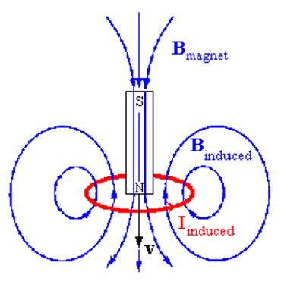

*Figure 1: Magnetic field line distributions arising due to two coils of equal diameters in Helmholtz coils.*

The changing magnetic field can give rise to an electrical current, a phenomenon we call *electromagnetic induction*. The mathematical law that relates the changing magnetic field to the induced current (or, more accurately, the induced voltage or emf) is called Faraday's Law.

The magnetic flux through a surface in a magnetic field *B* is

 (1)

where *U* is a unit vector perpendicular to area element *dA* note that if *B* is constant and the surface is a plane with area *A*, this reduces to

 (2)

A conducting loop which has voltage or Current probe attached to it will register a voltage or current if the magnetic flux through the loop changes with time. The change may arise from motion of a magnet. Faraday noted that the emf induced in a loop is proportional to the rate of change of magnetic flux though it,

 (3)

where *ε* is the electromotive force induced (measured in volts) and *N* is the number of turns of the coil. Provided each turn of the coil is sized and oriented like the others, its contribution is simply additive; hence the appearance of the coefficient *N* in front of the flux derivative. Notice the negative sign. Lenz's Law states that the induced emf (and current) will be in a direction such that the induced magnetic field opposes the original magnetic flux change. Keep in mind that the induced current will now produce an induced magnetic field. The direction of that magnetic field will be opposite to the direction the flux is changing.

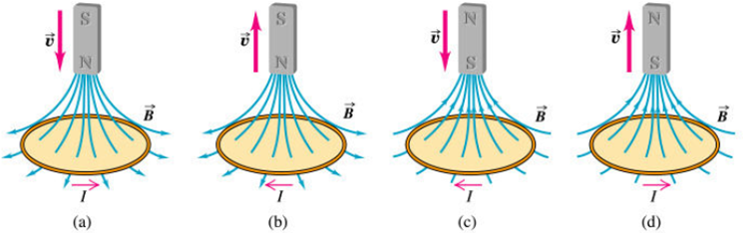

*Figure 2: Direction of induced current because of change in magnetic flux. This is achieved in this experiment through the falling magnet.*

The direction of the induced current changes with change in the magnetic field as shown in Fig. 3. Lenz’s Law helps us determine the DIRECTION of this induced current.

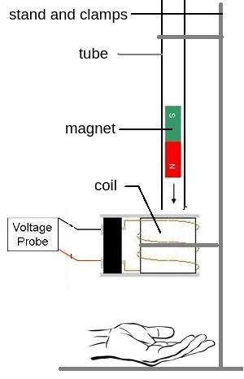

Figure 3: Setup of experiment I-

**EXPERIMENTAL PROCEDURE:**

- Set up the experiment according to Figure 3.

- Start Logger Lite Pro on the PC, to record the variation of voltage in the coil through PC

- Go to data collection: set the measuring time at 5 second and sampling rate 1000 sample/sec.

- Initially set the voltage at ZERO.

- Start the collection of data. Introduce the tip of the north pole of the magnet in the glass tube, let it fall, catch it with one hand under the coil.

- Draw quickly the graph obtained, and explain the trend observed (draw a diagram to illustrate your explanation. Is the Lenz's verified?

- Measure the maximum and the minimum amplitude Umax and U min of the induced voltage.

- Mark the positive (F1) and the negative (F2) parts of the curve separately. Calculate the areas of each part separately with the “Show integral” icon at the top. Finally, add the values of the two partial areas.

- Repeat the experiment with the magnet dropped from the other side.

- Repeat the experiment with a different coil (exchange with the other group)

- Repeat the experiment without the plastic tube, trying to throw the magnet with lower velocity through the coil.

**Observations:**

|  |  |  |  |  |
| --- | --- | --- | --- | --- |
| Setup | Graph obtained | Umax | Umin | Areas |
| 1) North pole first  Coil: R = …....  N= ……….. |  |  |  | A+ =  A- =  Sum = |
| 2) South pole first  Coil: R = …....  N= ……….. |  |  |  |  |
| 3) North pole first  Coil: R = …....  N= ……….. |  |  |  |  |
| 4) North pole first  Coil: R = …....  N= ………..  Dropped with lower velocity. |  |  |  |  |

**Interpretation:** Comment the differences observed on the curve and explain it theoretically with Faraday’s law and Lenz’s law.

**PART 2: B-H CURVE**

*“Hysteresis means ‘remaining’ in Greek, an effect remains after its cause has disappeared. Hysteresis, a term coined by Sir James Alfred Ewing in 1881, a Scottish physicist and engineer (1855-1935), defined it as: when there are two physical quantities M and N such that cyclic variations of N cause cyclic variations of M, then if the changes of M lag behind those of N, we may say that there is hysteresis in the relation of M to N. The most notable example of hysteresis in physics is magnetism. Iron maintains some magnetization after it has been exposed to and removed from a magnetic field.”*

**Objectives: -** To study the phenomena of magnetic hysteresis using B-H curve

- To study the permeability Curve.

**THEORY:**

**FERROMAGNETISM AT THE ATOMIC LEVEL**

A number of neutral atoms, in the region of the periodic table close to iron and elsewhere, have incompletely filled inner shells, with an unpaired electron spin. This gives the atom a residual magnetic moment, which defines an axis vector. As always in quantum mechanics, once a direction is chosen then other properties of the atom (e.g. the electron configurations in the outermost shells) can be aligned along the same axis.

In solids there is a strong short-range force between neighboring atoms due to the interaction of their outermost shells. They will choose the configuration, which gives the lowest potential energy under the action of this force. In ferromagnetic materials this turns out to be with nearest neighbor axes parallel to one another. In anti-ferromagnetic materials the nearest neighbor axes opposite to one another. There are subtle variations. It can be even subtle in three dimensions.

Linear arrays of spin illustrating possible

**a.** Ferromagnetic

**b.** Anti-ferromagnetic and

**c.** Ferrimagnetic orderings.

These kinds of ordering are only possible if the thermal excitations in the material are not too big. If thermal vibrations at the atomic level have more energy than the small potential difference due to alignment with the neighboring atom, then the alignment will not be able to persist. Above some critical temperature it is observed that ferromagnetic solids, with a linear susceptibility that obeys the Curie law. The critical temperature is called the Curie temperature for ferromagnetic (or ferrimagnetic) materials and the Neel temperature for anti-ferromagnetics.

**THE HYSTERESIS LOOP**

Figure 1 is a plot of magnetization M against applied field H. On application of a field to a demagnetized sample, M increases with H, reaching the saturation magnetization (Ms) if a sufficiently large field id applied. When H is reduced and subsequently cycled between positive and negative directions, M follows a hysteresis loop. A hysteresis loop is one in which the Ms of the material is reached. The parameters most commonly used to characterize hysteresis are the field Hc required to reduce M to zero, the value MR of M when H=0 and the hysteresis energy loss WH which is determined from the area enclosed by the loop. Hs the field at which M= Ms.

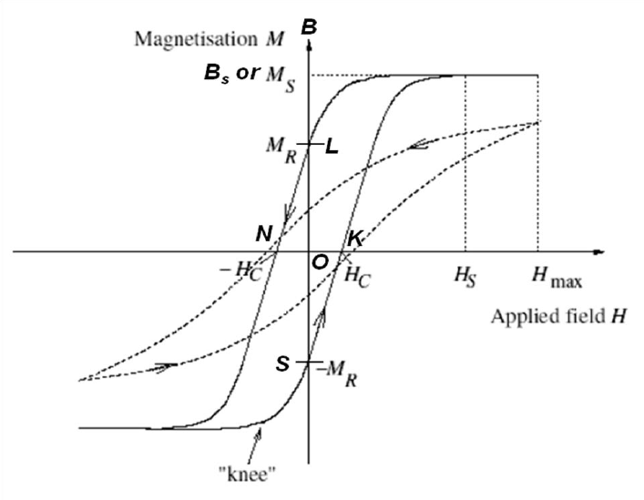

Figure 1: The Hysteresis loop

The Hysteresis loop is showing the coercive field Hc, Remanence MR and saturation magnetization Ms. The arrow shows the direction of magnetization.

**PERMEABILITY**

Magnetic permeability is related in physical terms most closely to electric permittivity, it is probably easier to think of permeability as a sort of ‘resistance to magnetic flux’, just as those materials with high conductivity let electric current through easily so material with high permeability allow flux through more easily than others. The durability with electric world is as follows:

|  |  |  |
| --- | --- | --- |
| **Duality with the electric world** | | |
| **Quantity** | **Unit** | **Formula** |
| Permeability | Henry per meter | $$μ=L/d$$ |
| Permittivity | Farad per meter | $$ε=C/d$$ |

The magnetic permeability, μ, of a particular material is defined as the ratio of flux density to field strength within it.

$$μ=\frac{B}{H}$$

This information is most easily obtained from the magnetization curve. Figure 2 shows the permeability (in solid) derived from the magnetization curve using above equation. Note carefully that permeability so defined is not the same as slope of a tangent to the B-H curve except at the peak (around 80 A.m-1 in this case). The latter is called differential permeability, μ'=dB/dH.



Figure : Permeability derived from the magnetization curve

If you use a core with a high value of permeability, then fewer turns will be required to produce a coil with a given value of inductance. You can understand why by remembering that inductance is the ratio of flux to current. For a given core B is proportional to μ: the ratio of B to H. This form of permeability, called absolute, is seldom quoted in engineering texts. Instead a variant is used called relative permeability described next.

$$μ= μ_{0}×μ_{r}$$

**RELATIVE PERMEABILITY**

Relative permeability is a very frequently used parameter. It is more useful to us because it makes clearer how the presence of a particular material affects the relationship between flux density and field strength. The term ‘relative’ arises because this permeability is defined in relation to the permeability of a vacuum, *μ0*.

μ=μ/μ0

For example, if you use a material for which *μr*=3 then you know that the flux density will be three times as great as it would be if we just applied the same field strength to a vacuum.

Note: unlike *μ0* , *μr* is not constant and changes with flux density. Also, if the temperature is increased from, say, 20-80ºC then a typical ferrite can suffer a 25% drop in permeability.

**HYSTERESIS GRAPH PARAMETERS**

A Hysteresis graph is used to measure the hysteresis loop of a magnetic material, generating as its output a hysteresis curve.

**MAGNETIC FLUX DENSITY (B) (F/A):** Flux density induced in the magnetic material under test. It equals total induced flux (F) divided by the cross-sectional area of the sample. The units of B are Gauss (G) in the CGS system, and Weber per Square Meter, or Tesla (T), in S.I. units.

**MAGNETIC FIELD STRENGTH (H) (NI):** Magnetic field used to induce a magnetic flux in the material under test. Units are Oersted (Oe) in the CGS system and Ampere per meter (A/m) in S.I. units, N=No of turns per unit length.

**SATURATION FLUX DENSITY (Bs):** Maximum magnetic flux density that can be induced in the material, regardless of the magnitude of the externally applied magnetic field, H.

**REMANENCE (Br) (OL or OS):** Induced magnetic flux density (B) that remains in the material after the externally applied magnetic field (H) is returned to zero during the generation of the hysteresis loop.

**COERCIVE FORCE (HC) (ON or OK):** Value of H found at the intercept of the H-axis with the hysteresis loop. This represents the external field required to cause the induced flux density (B) to reach zero during the measurement cycle of a hysteresis loop. He is symmetrical with the positive and negative H axis.

**INITIAL PERMEABILITY (**μr**):** Ratio of induced magnetic flux density (B) to applied field (H), as H approaches zero. In general, it is the ratio of B to H at any point on the hysteresis loop. It is a nonlinear function of the magnetic material being tested and can be vary with temperature, stress, H drive level and other factors. It is a dimensionless quantity.

**MAXIMUM AMPLITUDE PERMEABILITY (*μa*) (MAX):** Maximum ratio of B to H on the first quadrant positive cycle of the hysteresis loop. It may be found graphically by drawing a straight line from the origin to the tangent of the hysteresis curve in the first quadrant. It is a dimensionless quantity.

**HYSTERESIS LOSS PER CYCLE (Wh):** Area enclosed by the hysteresis loop is a measure of the hysteresis loss per cycle. Other core loss parameters are calculated from this parameter. Units are ergs in the CGS system and Joules in the S.I system.

**MAGNETIC INDUCTION IN A TRANSFORMER CORE:**

In a transformer core (Ferro-magnet), the Magnetic induction is given by

$$B= μ_{r}×μ_{0}×H$$

Where:

$μ_{0}=4π×{10}^{-7}$ Volt-second/Ampere-meter

$μ_{r}$ = Relative permeability

*H* =Magnetic field strength

*B* = Magnetic field induction

$μ_{0}$ = Permeability in vacuum

When B reaches a saturation value Bs as the magnetic field strength (H) increases. In the experiment, a current I1 in the primary coil of the transformer which increases (or decreases) linearly over time generates the magnetic field strength

$H = (N_{1}×I_{1})/L$------- Ampere/meter

Where:

*L* = Effective length of iron core

$N_{1}$ = Number of windings of primary coil

$I_{1}$ = Current in primary coil

The corresponding magnetic induction value B is obtained through integration of the voltage V2 induced in the secondary coil of a transformer:

$B= (\int{V_{2}} dt)/N_{2}A$------- Volt-second/meter2

Where:

A = Cross-section area of iron core

$N_{2}$ = No of windings of the secondary coil

$V_{2}$ = Induced voltage of secondary coil

By exciting the primary coil with sinusoidal or triangular wave of low frequency and then measuring the current (*I1*) and induced voltage (*V*2), one can plot the B-H curve from measurements as shown in figure. One can analyze the values of *Br* (Remanence), *Hc* (Coercive force), *μI* (initial permeability), *μa*(max) (Maximum amplitude permeability) and area of enclosed loop giving rise to Hysteresis loss.

**INITIAL MAGNETIZATION AND PERMEABILITY CURVES:**

The magnetic permeability *μ*r is defined as the ratio of flux density to field strength as follows:

$$μ_{r} =B/( μ_{0}×H)$$

This form of permeability is called absolute permeability and is seldom quoted in engineering text. Instead a variant is used called Relative permeability which is given by

$$μ=μ_{0}× μ_{r}$$

Where $μ_{0}=4π×{10}^{-7}$ Volt-second/Ampere-meter and *μr* = Relative permeability of material.

One can therefore apply a sweep excitation and plot B vs H to show the initial magnetization curve. One can also plot μr (=B/( μ0×H)) vs H to show the change in permeability at different field strengths or flux density. Figure 3 shows the initial magnetization curve.



Figure : Typical soft magnet material hysteresis

For conducting the experiment, the experimental setup is connected in the same way as for B-H curve measurements. A sweep voltage is then applied at the primary coil varying from 0-Vmax to provide a rising magnetic field excitation. The induced voltage is recorded at the secondary coil to calculate B.

**EXPERIMENTAL PROCEDURE:**

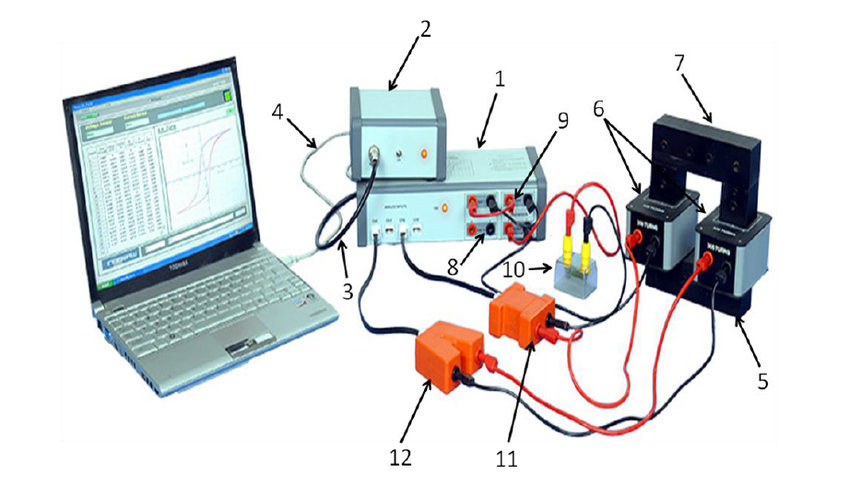

Figure : experimental setup

1. Data logger 7- I core
2. Power unit 8- DAC@ analog output
3. 3 pin DIN connector 9- Current booster section
4. USB cable 10- Resistor
5. U core 11- Current sensor module
6. Coil module 12- Voltage sensor module

**1.** Switch on the power supply unit (no. 2).

**2.** Now click computer start→ All programs→ BH curve 4.0 icon

**3.** Look for red OPEN button and click on it, now the button becomes green.

**4.** Small software window is seen where the inbuilt parameters are set up.

**5. Software settings:** Now go to the experiment and click experiment start.

**i. Waveform:** The exciting waveform of sine or triangular can be applied to the circuit. The parameters are user controllable and are explained as follows:

**ii. Amplitude:** Defines the maximum value of amplitude (in volts) to be applied to the circuit over the DC offset. Maximum limit is 10V.

**iii. Sample:** Defines the maximum number of samples in the experiment.

**iv. Calibration:** Used to calibrate the sensors.

**v. Core and coil settings:** Used to set the parameters (length, cross section area and coil turns) for U-I frame transformer with primary and secondary coils.

**vi. Graph options:** Graph can be plotted either in line.

**6. Analysis:** Using software tools (figure 5), find the ‘permeability curve’ click plot → permeability curve and to find the coercivity and remanence click plot → B-H curve.

**i. Positive Saturation:** You can analyze the maximum positive value.

**ii. Negative Saturation:** You can analyze the minimum positive value.

**iii. Remanence:** Average remanence value can be analyzed.

**iv. Coercivity:** Average coercivity value can be analyzed.

**7. Enclosed area:** analyze the value of the area covered by hysteresis loop or area under the curve by selecting the sub-menu item ‘area under the curve’ or ‘closed area’. Before starting new run, demagnetize the core (sample) properly by taking I core (7) and striking it with U core (5) 2-3 times. This is done in order to get a proper shape.

**8. Report:** Reproduce the curve on your report. Label on the curve the different readings noted before (positive saturation, negative saturation, remanence, coercitivy, …etc)

**9.** Plot the permeability curve and include it to the report

**10.** Repeat the experiment by changing the position of the sample (rotation of I-core) and removing it.

**11. Conclusion:** Compare the different curves obtained and comment.