**Course: PH202 Lab**

**Semester: III**

**Experiment 4: Diffraction and interferences with monochromatic light**

*“No one has ever been able to define the difference between interference and diffraction satisfactorily. It is just a question of usage, and there is no specific, important physical difference between them. The best we can do is, roughly speaking, is to say that when there are only a few sources, say two, interfering, then the result is usually called interference, but if there are a large number of them, it seems that the word diffraction is more often used.”*

*Richard Feynman*

**NOTE:** This experiment is divided into two parts, namely single slit and double slit experiments, respectively. *Wave particle duality* of light is now well established. Physical explanation to the phenomena of *interference* and *diffraction* of light conclusively proved its wave nature as distinct from its particle nature (e.g. in photoelectric effect)

*Equipment provided:*

*- He-Ne laser of wavelength 632.8 nm*

*- Optical bench*

*- White screen*

*- slit slide*

*- Double slit slide*

**PART I: The Fraunhofer diffraction, or the single slit experiment**

**Objective:** To examine the diffraction pattern formed by light from a diode laser passing through a single slit and to determine the width of the slit.

**THEORY:**

**What is diffraction?**

Diffraction refers to the characteristic behaviours that are exhibited when a wave (light for example) encounters an obstacle or a slit that is comparable in size to its wavelength. [...]

Diffraction arises because of the way in which waves propagate; this is described by the [Huygens–Fresnel principle](https://en.wikipedia.org/wiki/Huygens–Fresnel_principle) and the [principle of superposition of waves](https://en.wikipedia.org/wiki/Superposition_principle). The propagation of a wave can be visualized by considering every particle of the transmitted medium on a wavefront as a point source for a secondary [spherical wave](https://en.wikipedia.org/wiki/Wave_equation#Spherical_waves). The wave displacement at any subsequent point is the sum of these secondary waves. When waves are added together, their sum is determined by the relative phases as well as the amplitudes of the individual waves so that the summed amplitude of the waves can have any value between zero and the sum of the individual amplitudes. Hence, diffraction patterns usually have a series of maxima and minima.

**Fraunhofer diffraction**

In fraunhofer diffraction, the source and the screen are at infinite distance from the aperture.

From theory**,** by calculating the path difference between the light coming from the top and bottom of the slit that reach a point on the screen one can show that the intensity distribution is given by: $$I=I_{0}\frac{\sin^{2}β}{β^{2}} ; β=\frac{πasinθ}{λ}$$ 
where $θ$ is the angle of the diffracted rays from the normal to the slit, a is the width of the slit, λ the wavelength and I0 represents the intensity at $θ=0$

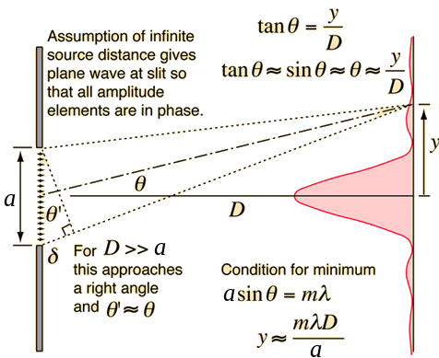We can have a very good approximation of fraunhofer diffraction choosing a large distance D between the object and the screen, $\frac{a}{Dλ}≪1$. In such case, the angles are very small: $sinθ∼tanθ=\frac{y}{D}$, where y is the distance on the screen from the center of the pattern to the mth minimum.

Figure : The slit of width a could be considered as consisting of many point sources each of which gives rise to a wave front whose overlap results in the diffraction pattern at a distance D >>> a. Most of the diffracted light is confined at the central region surrounded on either side by a symmetric secondary pattern of alternate dark and bright spots (of much lower intensity).

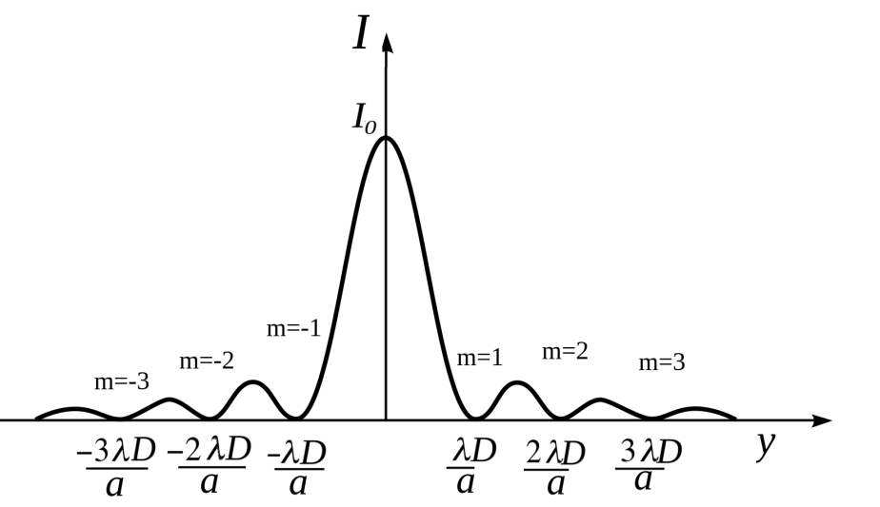The position y of the mth minimum of intensity will thus be given by:

$$y_{m}= \frac{mλD}{a} ;m=±1, 2, 3…$$

where λ is the wavelength, D the distance between the slit and the screen, and the width of the slit.

The plot of the intensity on the screen is given in figure besides

Figure : Diffraction pattern for a single slit of width a, wavelength λ. Distance between the slit and the screen is D.

For more details: Ajoy Ghatak – *Optics*

**EXPERIMENTAL PROCEDURE:**

**1) First estimation of the width slit**

- Set up the diode laser at one end of the optical bench and place the slit of unknown width about 5 cm in front of the laser,

- Place the screen at the opposite end of the optical bench. Adjust a sheet of paper on it.

- Measure the distance D from the slit to the screen

- Measure the width Δy of the central spot on the screen.

- Calculate the width of the slit. Hint: observe figure 2, how broad is the central spot?

Write the report for this experiment and evaluate the errors. How could these errors be minimized?

*Reminder: propagation of error:*

*Relative errors add up in case of multiplication or division of readings. Example: For $(A,B,C) =\frac{A B}{C}$, experimental error $Δf$ on f is given by $\frac{Δf}{\left|f\right|}= \frac{ΔA}{\left|A\right|}+ \frac{ΔB}{\left|B\right|}+ \frac{ΔC}{\left|C\right|}$*

*For more details on experimental errors, see* Lab manual write up*, available on Moodle.*

**2) Precise determination of the width slit**

- Place the screen at about 50 cm from the end of the bench.

- Measure the distance D between the screen and the slit.

- Mark with a pencil the minima m=-2, m=-1, m=+1 and m=+2, (see figure 2)

- Measure the distance Δy1 between m=-1 and m=+1 and the distance Δy2 between m = -2 and m = +2

- Repeat the experiment for at least 10 different distances D. To do so, move the slit and the diode laser along the bench.

Observations:

|  |  |
| --- | --- |
| D (mm) | Δy1 = │y-1 – y1│(mm) |
|  |  |
|  |  |

For m=1:

|  |  |
| --- | --- |
| D (mm) | Δy2 │y-2 – y2│(mm) |
|  |  |
|  |  |

For m=2:

- Plot Δy1 VS D and Δy2 VS D on two different graphs

- Is the Fraunhofer approximation valid for all the chosen distances? Justify your answer.

- Determinate the width slit *a* each graphs (see Figure 2 and equation besides). Evaluate the experimental error. a = ……. ± …….

**PART II: Interferences, or the double slit experiment**

**Objective:** To examine the diffraction pattern formed by light from a diode laser passing through a double slit and to determine the distance between the two slits.

**THEORY:**

In this case instead of one slit there are two identical slits one below the other placed at the same plane. The resultant interference pattern observed on a screen, whose intensity distribution from theory is given by:

$$I=4I_{0}\frac{\sin^{2}β}{β^{2}}\cos^{2}γ ; β=\frac{πasinθ}{λ} ; γ=\frac{πdsinθ}{λ}$$ where $θ$ is the angle of the diffracted rays from the normal to the slit, *a* the width of each slit, *d* the distance between the slits (centre to centre), and I0 the intensity at $θ=0$

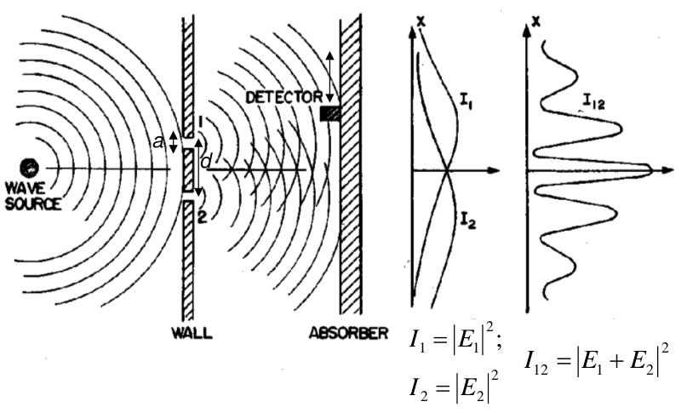The first ratio corresponds to a single slit diffraction pattern and the second term $\cos^{2}γ$ represents the interference pattern produced by two point sources separated by d. (See Figure 3)

Figure 3: Schematic of the interference pattern due to two identical slits separated by d

Intensity maxima (bright fringes) in the interference pattern will appear at angles $θ$ through the relation $dsinθ=my$; m = 0,1,2...Since the angles involved are typically small, it can be assumed that sin θ ~ tan θ as before. Thus, $$y=\frac{mλD}{d}\text{, where }m=±0,1,2,3,…$$ 
where d is the slit separation, y is the distance on the screen from the center of the pattern to the mth maximum, λ is the wavelength of the light, and D the distance from the slits to the screen as shown in Fig. 4

If detected with high spatial resolution, the net pattern would be described by product of the single slit diffraction term and the interference term, which yields the following intensity distribution showing the envelope as seen in Fig. 5.



Figure 4: Formation of interference pattern due to two slits, each of width a separated by d



Figure 5: Diffraction envelope of the interference between two point sources; it can be noted that certain orders are missing in this resultant pattern

**EXPERIMENTAL PROCEDURE:**

- Use the same set up as before.

- Place the double slit slide instead of the single slit one. Choose a large distance D.

- Draw roughly the interference pattern observed on the screen. Specify which minima are due to interference phenomenon (two slits) and which minima are due to diffraction phenomenon (finite width of each slit). Hint: see Figure 5.

- Measure the distance D from the slit to the screen

- Mark the position of the maxima m =-2 and m = 2 on both sides of the central one.

- Measure the distance Δy2’ between the two marks.

- Repeat the experiment for different at least 10 different distances D.

|  |  |
| --- | --- |
| D (mm) | Δy2’ (mm) |
|  |  |
|  |  |

Observations:

- Plot Δy2’ VS D

- Determine the distance d (center to center) between the two slits. Evaluate the experimental error.

d = …… ± ………