**Course: PH202 Lab**

**Semester: III**

**Experiment 5: Newton's rings**

*“Newton’s rings” were first observed in 1704 by Boyle and Hook and so named because Newton gave an explanation based on corpuscular theory of light, which however was later found to be unsatisfactory. Almost 100 years later, in 1802, Thomas Young could successfully explain formation of these rings based on wave theory of light.*

*(See the book ‘Optics’ 5th edn by Ajoy Ghatak, McGraw Hill Education)*

Interferometry is a family of techniques in which waves are superimposed in order to extract information about the waves (frequency, path length difference). Optical interferometry is widely used in science and industry for the measurement of small displacements, refractive index changes and surface irregularities.

**Objectives:**

1. Measure the radius of curvature of a plano convex lens using Newton's rings apparatus (interferometry method)
2. Measure the radius of curvature of a plano convex lens with a spherometer (direct method).

*Equipment provided:*

*- Newton's ring apparatus*

*- spherometer*

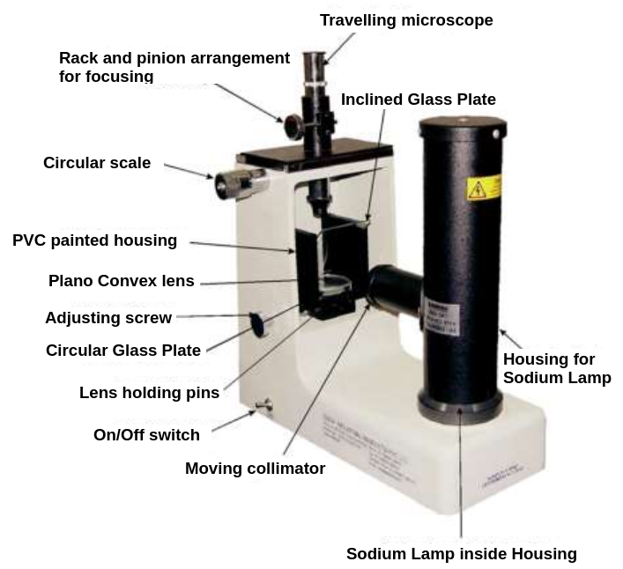

Figure 1: Newton's Rings Apparatus

**THEORY:**

**Interferences – superposition of waves**

Interference is a phenomenon in which two waves superpose to form a resultant wave of greater, lower, or the same amplitude. Interference usually refers to the interaction of waves that are correlated or coherent with each other, because they come from the same source and have the same frequency. To satisfy this requirement, one possibility is to use an amplitude-division system.

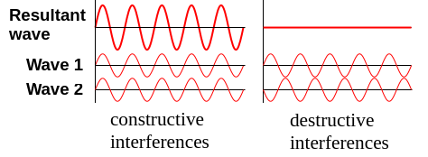

Figure 2: Concept of interferences

In an amplitude-division system, a beam splitter is used to divide the light into beams travelling in different directions, which are then superimposed to produce the interference pattern.

*https://en.wikipedia.org/wiki/Interference_(wave_propagation)*

**Newton's rings**

It consists of placing a plano convex lens on a plane glass surface. A thin film of air is formed between the curved surface of the lens (AOB) and the plane glass plate (POQ) (see Figure 3). Interference takes place between the rays of light reflected from the upper and the lower surfaces of the

wedge shaped air film enclosed between lens (AOB) and glass plate (POQ) and circular interference fringes (alternate dark & bright) called Newton's rings are produced as shown in Fig. 4.

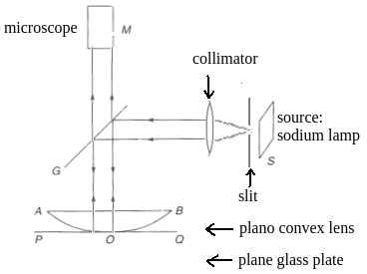

Figure 3: An arrangement for observing Newton's rings

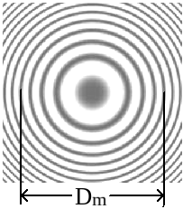

Figure 4: Interference pattern. m = 4

The center will be dark because at the center, lens is in contact with the glass plate and thickness of air film at the center is zero. By Stokes law, a phase change of  takes place due to reflection at the lower surface of the air film (Fig. 4) as the ray of light passes from rarer to denser medium.

As we proceed outwards from the center, the thickness of the air film gradually increases being the same all along the circle with the center at the point of contact. The fringes are circular due to the fact that air film is symmetrical about the point of contact. The locus of all the points at same thickness is a circle i.e. all the points where the air film has a given thickness lie on a circle whose center is at 'O'.

The fringes can be viewed by means of a low power traveling microscope 'M' as shown in Fig.1.

From theory, one can show that a constructive or destructive interference will occur depending on the path difference between the two waves. For near-normal incidence of the beam conditions are:

for constructive interference, maxima (1)

for destructive interference, minima (2)

where: - *n* is the refractive index of the film (n=1 in this case, since air is between the two glass plates)

- *d* is the thickness of the air film

- *m* is a positive integer: m = 0, 1, 2, 3,...

- *λ* the wavelength of the source. For sodium lamp: *λ* = 589.3 nm

Above equations take into account the phase change of that is accumulated by a reflected light when it suffers reflection while propagating in a rarer medium and falls at an interface between this rarer medium and a denser medium of larger refractive index.

Let '*R*' be the radius of curvature of the surface of plano-convex lens in contact with the glass

plate P, *t* is the air film thickness, and *r*m is the diameter of the *m*th dark ring. Then:

Therefore:

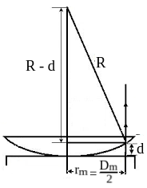

Figure 5: To deduce the diameter of the mth dark rings

Calculation in Figure 5 and relation (2) give the general condition for a dark ring to be formed:

where *R* is the radius of curvature of the surface of the plano convex lens, *λ* the wavelength of the source and m refers to the mth dark ring observed from the centre.

***If white light is used*** in place of monochromatic light, a few colored rings are observed. Each color gives rise to its own system of rings. These colored rings soon superimpose and overlap thereby resulting in almost uniform illumination after a few rings.

***If a plane mirror*** is placed in place of glass plate below the plano-convex lens, a uniform illumination is observed as whole of light gets reflected from the mirror.

**Spherometer**

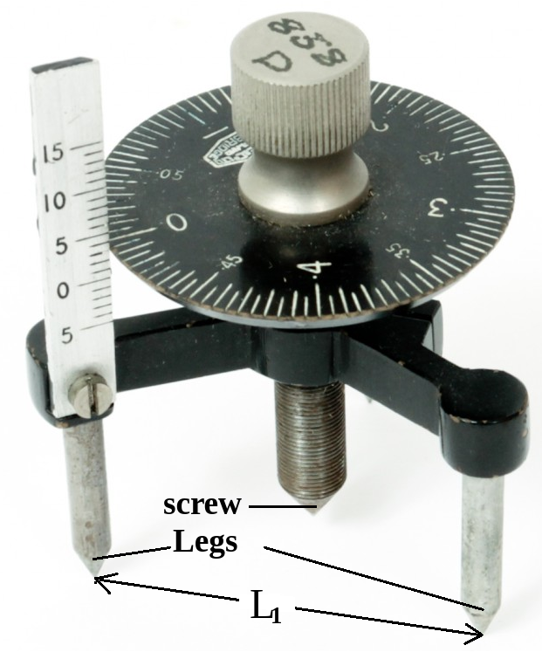

Figure 6: Spherometer

# A spherometer is an instrument for the precise measurement of the radius of curvature of a spherical surface:

# where *L* is the distance between the three legs of the spherometer, and *h* is the difference in height between the screw and the legs.

# [*https://www.youtube.com/watch?v=MRTJjd-NN_E*](https://www.youtube.com/watch?v=MRTJjd-NN_E)Radius of curvature by a spherometer *Cbse*

**EXPERIMENTAL PROCEDURE:**

**I - Measure of the curvature of the plano-convex lens with interferometry method (Newton's rings)**

- Find the least count of the micrometre scale. Precaution: to avoid errors due to back slash, the micrometre screw must be moved always in the same direction for all the readings.

- Clean the surface of the plane glass plate and the plano-convex lens. Put them in position as shown in figure 3 in front of the sodium lamp.

- Switch on the sodium lamp and check that only parallel beam of light coming from the convex lens falls on the beam splitting glass plate.

- Adjust the position of the microscope so that it is positioned vertically above the centre of the plano-convex lens. Focus the microscope so that alternate dark and bright rings are clearly visible.

- Adjust the position of the microscope till the point of intersection of the cross-wires is perpendicular to the horizontal scale.

- Move the microscope to the left with the help of a micrometre screw so that the vertical cross wire lies tangentially at one end of the 24h dark ring.

- Slide the microscope with the help of the micrometre screw and go on noting the readings when the cross wire lies tangentially on the left side of the 20th, 16th, 12th, 8th, 6th and 4th rings

- continue sliding the microscope in the same direction and note the readings when the vertical cross wires lies tangentially a lie other end of 4th, 6th, 8th, 12th, 16th, 20th and 24th rings.

- Calculate the diameter of the rings from the microscope readings.

- Repeat the experiment by moving the micrometre scale from right to left.

- Calculate the average between the two diameters obtains for one ring and evaluate the experimental error.

Observations:

|  |  |  |  |  |  |  |  |  |  |
| --- | --- | --- | --- | --- | --- | --- | --- | --- | --- |
| Ring no.  m | Microscope readings when moving from left to right (mm) | | Diameter (mm) |  | Microscope readings when moving from right to left (mm) | | Diameter (mm) |  | Mean diameter  squared |
| Left Lm | Right Rm | Dm1 |  | Right Rm’ | Left Lm’ | Dm2 |  | Dm2 |
| 24  20  16  12  … |  |  |  |  |  |  |  |  |  |

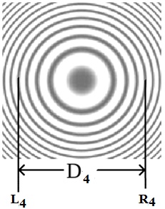

Figure 7: Determination of the left side of the ring, and of the right side of the ring, for the 4th ring

- Plot a graph of Dm2 VS m (ring no.).

- Deduce the curvature of the plano-convex lens from the slope. Estimate the experimental error.

**II - Measure of the curvature of the plano-convex lens with a spherometer.**

- Raise the central screw of the spherometer and press the spectrometer gently on a sheet of paper so as to get the pin pricks of the three legs.

- Measure the three distances between the tips of the legs of the spherometer *L1*, *L2* and *L3*. Deduce the mean distance *L*, and evaluate the experimental error: L = …………± ………….

- Find the least count of the spherometer A. Find the vertical pitch of the spherometer, corresponding to one turn B.

- Raise the screw sufficiently upwards.

- Place the spherometer on the convex surface so that its three legs rest on it.

- Gently turn the screw downwards till the screw tip just touches the concave surface.

- Note the reading of the circular disc scale which is in line with the vertical (pitch) scale.

- Remove the spherometer from over the convex surface and place it over the plane glass plate.

- Turn the screw down wards and count the number of complete rotations made by the disc (one rotation becomes complete when the reference reading crosses past the pitch scale.)

- Continue till the tip of the screw just touches the plane surface of the glass slab.

- Note the reading of the circular scale which is finally in line with the vertical (pitch) scale.

- Deduce the number of circular (disc) scale division in the last incomplete rotation.

- Repeat the measurement at least three times. Calculate the mean and evaluate the error.

h = ……….. ± ………….

- Calculate the radius of curvature and its experimental error using the relations:

# where *L* is the distance between the three legs of the spherometer, and *h* is the difference in height between the screw and the legs.

**Conclusion:** Compare the two results for the curvature obtained and comment the two methods. What are their limits of validity?