**Course: PH202 Lab**

**Semester: III**

**Experiment 6: Polarization of light**

Polarization is a fundamental property of life. Understanding and manipulating polarized light led to many applications: sunglasses, photography, 3D movies, LCD screens, study of optical activity of substances, measure of material stresses…

**Objectives:** - learn how to produce and analyse different polarized lights

- verify the Malus's law.

*Equipment provided:*

*- Optical bench*

*- Quarter wave plate*

*- Light sensor connected to the computer*

*- Polarizer*

*- Light source and its power supply*

*- Two unknown elements affecting the polarization of light.*

**THEORY:**

**What is polarization?** Light is a transverse electromagnetic wave: Electric field E and magnetic field B oscillate in a plan perpendicular to the propagation of the wave as shown in Figure 1.

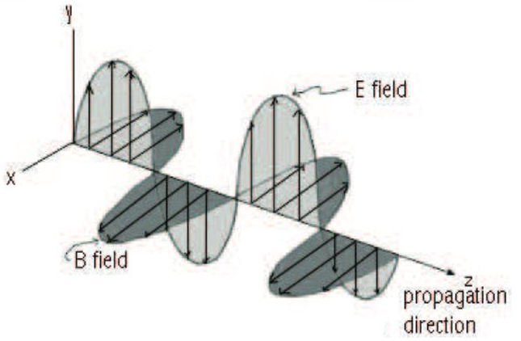

Figure 1: Light, a transverse electromagnetic wave

However, light emitted from an actual source consist of many such electric field vectors. The polarization of light is defined in terms of the direction of oscillation of electric field vectors.

An ordinary source of light (such as the sun) emits light waves in all directions. Consequently, the electric field vector vibrates randomly in all directions. Such sources of light are called as un-polarized (Fig. 3a). Partially polarized light occurs if the E vectors have a preferred direction of oscillation (Fig. 3b). Light is linearly polarized if all the electric field vectors oscillate in the same direction (Fig 3c, 3d and 4). Light can also be circularly polarized, or elliptically polarized, for which the direction of polarization rotates (Fig. 2)

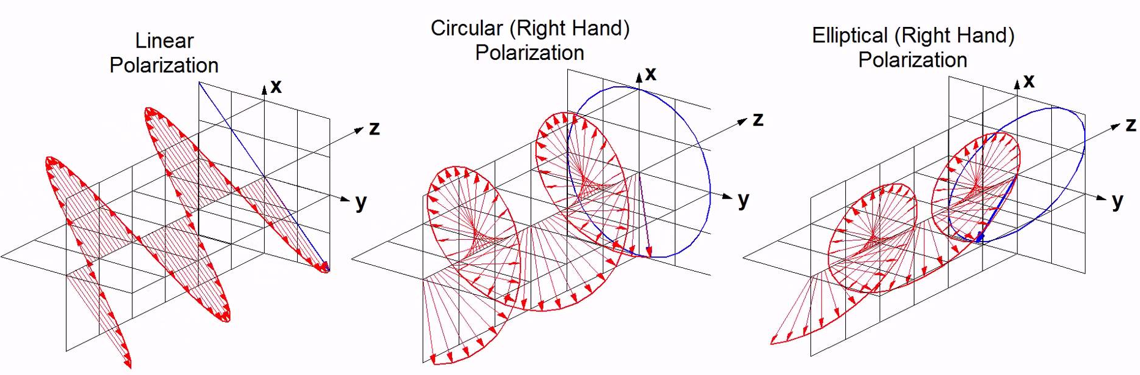

Figure 2: Different types of polarization of light.

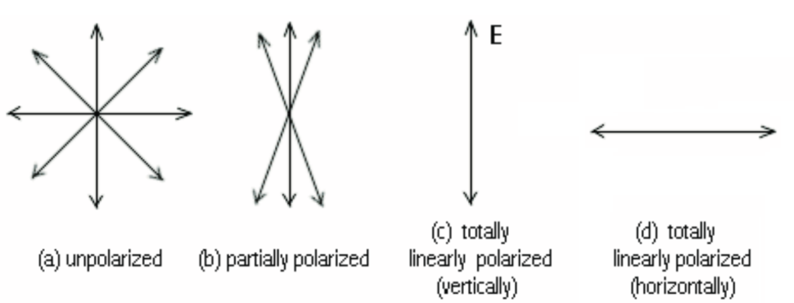

Figure 3: Polarization of light represented in a plane perpendicular to the direction of propagation.

The polarization behaviour of an electromagnetic wave can be studied by resolving its electric field vector into two orthogonal components. The phase relationship between these two components can explain the different states of polarization.

For example, if the phase relationship is random, but more of one component is present, the light is partially polarized. More specifically, if the phase relationship between the two orthogonal components is 0 or 180 degrees, the light is linearly polarized (Fig. 4). If the phase difference is 90 or 270 degrees, and both the components have equal amplitude , the light is circularly polarized. If any phase difference other than 0, 90, 180 or 270 exists and/or the amplitudes of the two components are not equals, then the light is elliptically polarized.

There are two directions of circularly (or elliptically) polarized light. Right-handed circularly polarized light is defined such that the electric field is rotating clockwise as seen by an observer towards whom the wave is moving. Left-handed circularly polarized light is defined such that the electric field is rotating counter clockwise as seen by an observer towards whom the wave is moving.

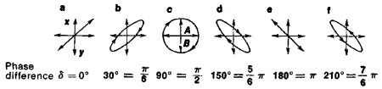

Figure 4: Some phase differences between the x and y component of the electric field, for different polarization state. In these cases,

**Linear polarizers**

A **polarizer** has the property of transmitting only the component of the electric field vector parallel to its transmission axis. Therefore, light emerging from a polarizer is linearly polarised in the direction of its transmission axis. They are manufactured by sketching long-chained polymer molecules after which they are saturated with dichroic materials such as iodine. The component perpendicular to the transmission axis is completely absorbed.

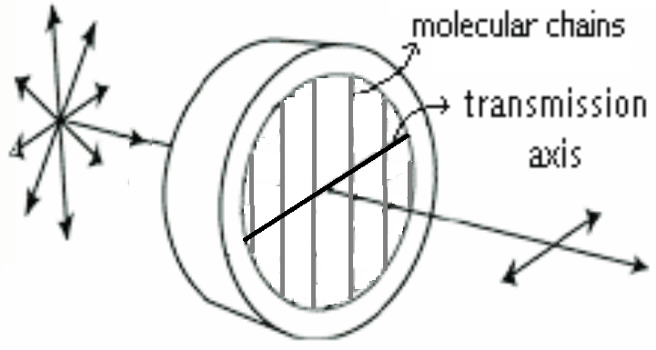

Figure 5: Transmission through a linear polarizer. Before the polariser, light is unpolarised. After the polariser, light is polarized along the transmission axis.

If a polarizer is placed in the path of a linearly polarized light of amplitude E0, it will only transmit the projection of E0 along its transmission axis: E=E0 cos α, where α is the angle between the incoming light and the transmission axis (Figure). Hence, the intensity of light after it passes through the polarizer is **I=I0 cos2α**. This equation is called **Malus's law**. (In practice, if the light is not totally linearly polarized, the transmitted intensity has the form: I = A cos2 α + B, where A and B are constants.)

**Retarders**

A **retarder (or wave-plate)** produces a phase shift (also called phase retardation) between the two perpendicular components of the electric field. Depending on the induced phase difference, the transmitted light may have a different type of polarization than the incident beam. Note that the retarders do not polarized unpolarised light and ideally they don’t reduce the intensity of the incident light beam.

To understand how retarders function, one has to consider the nature of the materials used in their construction, and the width of the wave plate. A material such as glass has an index of refraction *n*, which is the same in whatever be the directions of propagation through the material. Therefore, when light enters glass, its speed will be same in all directions (v = c/n). Such materials, having one index of refraction, are called **optically isotropic**. Certain materials such as quartz exhibit double refraction of birefringence and are characterized by two indices of refraction (along directions of crystal symmetry): an ordinary index and an extraordinary index. These materials are called **anisotropic/ birefringent** and the speed of light through them is in general different in different directions.

Normally, as light enters such a material, it splits into two components: an ordinary ray along the ordinary axis (o) and an extraordinary ray along an extraordinary axis (e). These components travel at different speeds along different directions, which result in a phase difference between them.



Figure 5: Splitting of linearly polarized light into two components as it enters a birefringent crystal. Light split into two components parallel and perpendicular to the optic axis. A phase shift between the two components is induced.

There are many types of retarders. Some common retarders are quarter-wave (λ/4) and half-wave (λ/2). A **quarter-wave plate** is used to convert linear polarization to circular polarization and vice versa, since it introduces a phase difference of 90° between the two components of the incident light. To produce circular polarization, one has to set the optic axis of the retarder with an angle of 45° with the direction of polarization of the incident light (see Fig. 6). A **half-wave plate** can function as a polarization rotator for linearly polarized light, since it introduces a phase difference of 180° between the two components of the incident light.

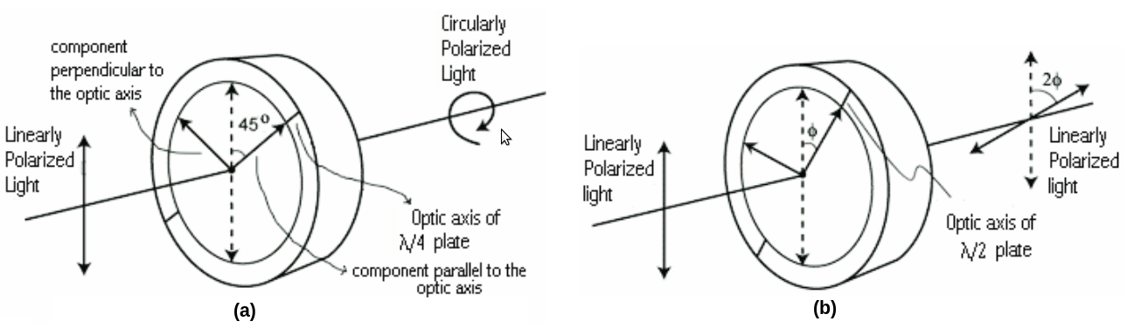Figure 6: (a) Conversion between linear and circular polarization by a quarter-wave plate. (b) Rotation of linear polarization by a half-wave plate

Marko Horbatsch – York University [*http://www.yorku.ca/marko/PHYS2212/Lab8*](http://www.yorku.ca/marko/PHYS2212/Lab8)

**Analysis of polarized light**

To the naked eye, all the states of polarizations will appear to be the same. The diagram below shows a general procedure for determining the state of polarization of any light beam.

Two

Extinctions

**unpolarized**

It could be circularly polarized or

unpolarised. Insert a QWP between

the light source and the polarizer.

Rotate the polarizer.

Insert a QWP between the light and

the polarizer with its optic axis parallel

to the pass-axis of the polarizer.

Rotate the polarizer.

Two extinctions

**Linearly**

**Polarised**

No variation

of intensity

Variation of intensity

without complete

extinction

**Elliptically**

**polarized**

No variation

Extinction

in two

positions

**Circularly**

**Polarized**

**Mixture of**

**Circularly**

**polarized**

**and**

**unpolarised**

Different

minima of

intensity

Variation

without

extinction

**Mixture of**

**linearly**

**polarized**

**and**

**unpolarised**

Same minima

of intensity

as before

**Mixture of elliptically**

**polarized and**

**unpolarized**

Introduce a polarizer on the path of the light and rotate it.

Ghatak - *Optics*

Figure 7: General procedure to determine the state of polarization of an unknown light

**EXPERIMENTAL PROCEDURE:**

**I- Production and analysis of polarized light**

*Experiment 1: Analysis of different light sources.*

* Take a polarizer out of the bench. Look at the ceiling lightening through the polarizer while rotating it. Write down your observations in a table as below Does the ceiling lightening emit a linearly polarised light, an unpolarised light or a partially polarized light? Justify your answer. In the case of linearly of partially polarised light, specify the direction of polarisation (vertical, horizontal …)
* Repeat the procedure for: the sunlight, a computer screen light, the reflection of the ceiling lightning on the floor (far from where you stand) , the light source provided on the bench (do not look directly at the light source, but observe the light going out from the side of the lamp.

|  |  |  |
| --- | --- | --- |
| **Light source** | **Observations** | **Polarisation** |
| Ceiling lightening |  |  |
| Computer screen light |  |  |
| Reflection of the ceiling lightning on the floor (far from where I stand) |  |  |
| Light source on the bench |  |  |

*Experiment 2:* *What is element 1?*

- Place only the unknown element 1 on the path of the light.

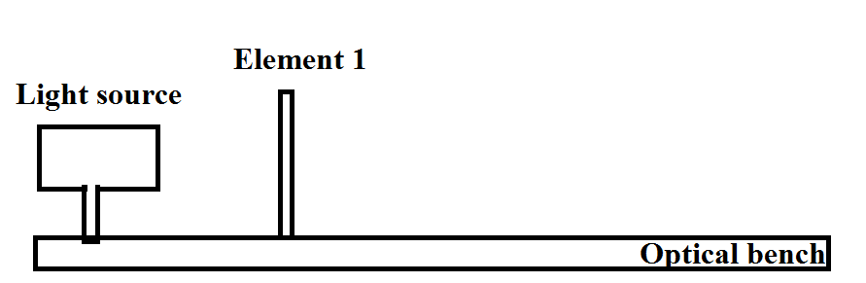

- Determine the polarization state of the outgoing light using Figure 7. First test the outgoing light with a polariser only (to be rotated). If extinctions are not obtained, test the outgoing light with a quarter plate followed by a polarizer (to be rotated).

- Write down your observations

- What is the state of polarization of the light coming out of element 1?

- Deduce what is element 1.

*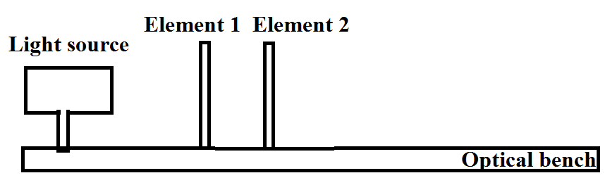Experiment 3: What is element 2?*

*-* On the bench, insert element 1 and then element 2 on the path of the light, with an angle of 45° between their transmission axes.

- Determine the polarization state of the outgoing light using Fig.7. - Determine the polarization state of the outgoing light using Figure 7. First test the outgoing light with a polariser only (to be rotated). If extinctions are not obtained, test the outgoing light with a quarter plate followed by a polarizer (to be rotated).

- Write down your observations

- What is the state of polarization of the light coming out of element 1 followed by element 2?

- Deduce what is element 2.

**II- Verification of the Malus's law.**

- Set up the equipment as shown in Figure 8, setting the polarizer 1 at 0 degree.

Important: Check that the lamp power supply is set at 6V

- The light will pass through the polarizer and analyser and will be detected by the light sensor. Make sure the alignment of all this elements is correct.

- Open Logger Pro on the computer. The transmitted intensity measured by the light sensor is shown at the bottom of the window.

- Set both the polarizer and analyser to 0°. In this state, the polarizing axes of the polarizer and analyser are parallel. The light intensity measured by the light sensor is maximized. The intensity reading can be seen at the bottom left of the computer.

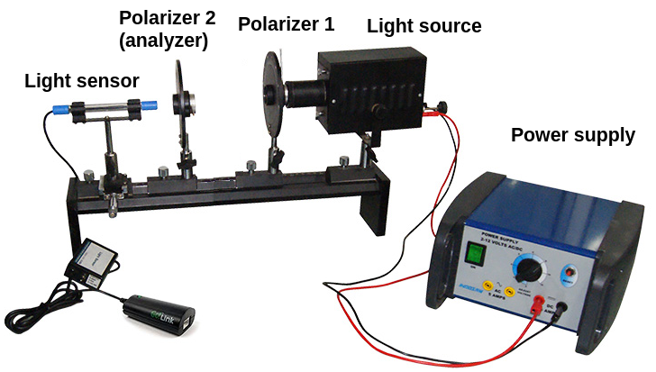

Figure 8: Set up for studying Malus's law

- Keep the polarizer at 0° and rotate the analyser to 90°. In this state the polarizing axes at right angles.

- Check that the light sensor displays a minimum of intensity. If not, rotate the polarizer to obtain a minimum of intensity. Keep the analyser at 90°

- Why is the intensity not zero? Define this light level as zero by clicking Ø zero. The intensity reading at the bottom left of the window should now be near zero.

- Rotate the analyser to an angle of 80° and write down the light intensity

- Repeat the same procedure for position of analyser at 70, 60, … 10,0°.

**Observations:**

|  |  |  |
| --- | --- | --- |
| Analyser position *θ* | (cos *θ*)2 | Light intensity *I* (lux) |
| 90° | 0 | 0 |
| 80° |  |  |
| ... |  |  |

**Data analysis:**

- Plot the intensity *I* with respect to (cos *θ*)2

- Are your data consistent with the Malus’ law? Discuss the graph obtained.

- Repeat the above procedure with a fixed quarter wave plate placed between the polarizer and the analyser, with an angle of 30, 60 and 90º between the polariser and the quarter wave plate.

**Observations:**

|  |  |  |  |  |
| --- | --- | --- | --- | --- |
| *θ* | (cos *θ*)2 | Angle QWP-analyser: 30º Light intensity *I* (lux) | Angle QWP-analyser: 60º Light intensity *I* (lux) | Angle QWP-analyser: 30º Light intensity *I* (lux) |
| 90° | 0 |  |  |  |
| 80° |  |  |  |  |
| ... |  |  |  |  |

**Data analysis:**

- Plot the intensity I with respect to *θ*

- Plot the intensity *I* with respect to (cos *θ*)2

- Are your data consistent with the Malus’ law? Discuss the graphs obtained.