Kanithi Sivasai

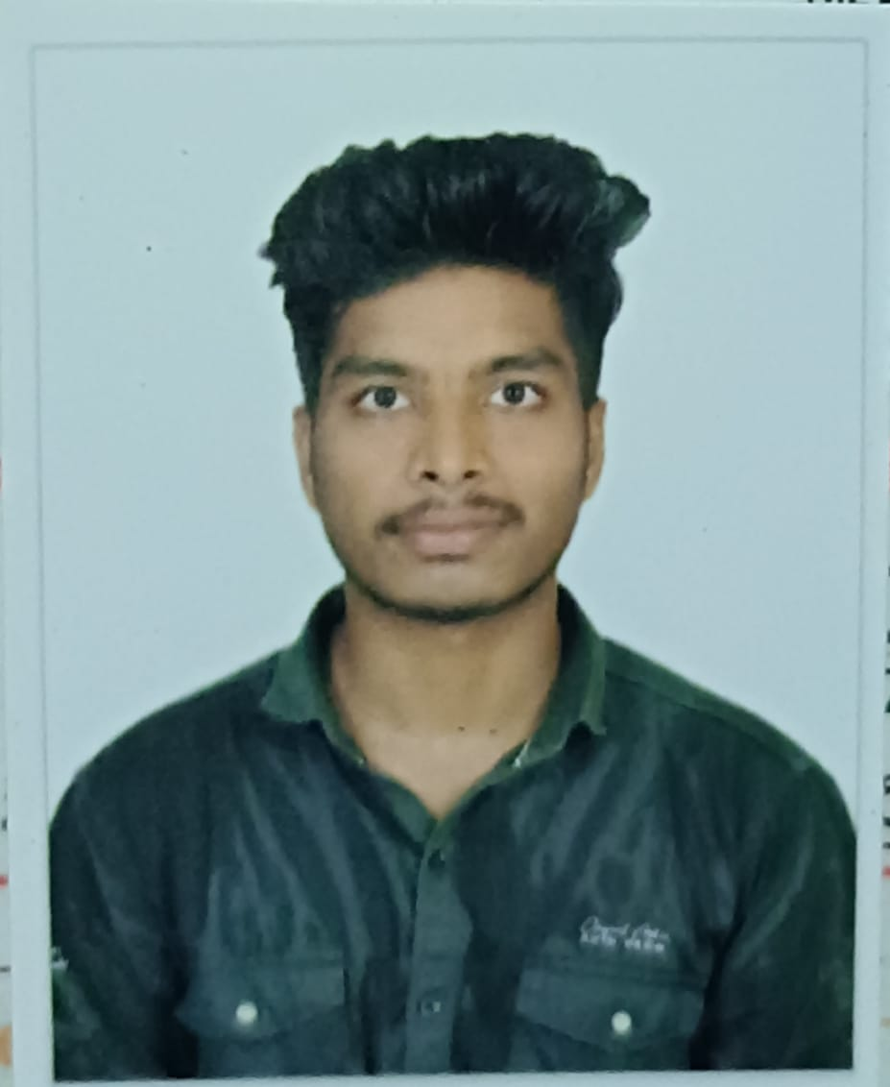

Full Stack Developer

+91 9494781431 ◇ [sivakanithi8848@gmail.com](mailto:sivakanithi8848@gmail.com)

◇ India ◇ [Linkedin](https://www.linkedin.com/in/kanithi-sivasai-87b695289?lipi=urn%3Ali%3Apage%3Ad_flagship3_profile_view_base_contact_details%3BOM6fP%2B7gQ9SuCzZUMRqYTg%3D%3D) ◇ [CodeChef](https://www.codechef.com/users/siva8848) ◇ [leetcode](https://leetcode.com/u/siva8848/) ◇ [GitHub](https://github.com/Sivakanithi)

**CAREER OBJECTIVE**

Aspiring MERN Stack Developer with hands-on experience in full-stack web development.Skilled in MongoDB, Express.js, Angular, Node.js, and building RESTful APIs. Familiar with JWT authentication, debugging, performance optimization, and tools like Postman.Eager to contribute to scalable, data-driven applications and grow in a tech-driven environment.

# EDUCATION

**BTech Information Technology**, GMR INSTITUTE OF TECHNOLOGY (GPA: 8.52) **INTERMEDIATE in MPC**, EASTERN VISAKHA JUNIOR COLLEGE (GPA: 9.25) **SSC**, ZILLA PARISHAD HIGH SCHOOL (GPA: 9.8)

# EXPERIENCE

**Intern** HippoCloud

 Built a Django-based placement predictor with 30% improved accuracy using ML models.  Reduced system latency by 25% and delivered 20% faster data insights for users.

# PROJECTS

2022 — Present Rajam, India 2020 — 2022

Visakhapatnam, India

2019 — 2020

U.K Gumada, India

Jun '24 — Jul '24 Visakhapatnam, India

**FITINTEL** [Link](https://github.com/Sivakanithi/Fitintel.git)

 Description: A healthy food and exercise recommendation application by using machine learning

 Technologies: Node.js, React.js, PostgreSQL, HTML, CSS, JavaScript,XGBoost, Random Forest, Decision Tree.

 Outcome: Developed a diet recommendation web app that improved user engagement by 60% using ML algorithms **Personal Blog** [Link](https://github.com/Sivakanithi/Blog-Page.git)

 Description: React + Node.js blog app with MongoDB, JWT auth, image uploads, and full CRUD posts

 Technologies: React, Node.js, Express.js, MongoDB, JWT, Axios

 Outcome: A responsive full-stack blog app that enables secure user authentication, image uploads, and complete blog post management through an intuitive interface.

**Country quiz** [Link](https://github.com/Sivakanithi/country_quiz.git)

 Description: Created an interactive quiz application to test users' knowledge about countries worldwide  Technologies: Node.js, Express.js, PostgreSQL, HTML, CSS, JavaScript.

 Outcome: Built an engaging and scalable application that enhances user knowledge through an interactive learning

experience.

# SKILLS

**Languages Known :** C, C++, Python, JAVA

**Frontend Technologies:** HTML, Bootstrap, JavaScript, ReactJS, Angular

**Backend Technologies:** Node.js, Express.js, PostgreSQL, php, Flask, JWT authentication, Django **Tools:** GitHub, Git (Version Control System), VS Code

**Languages :** English, Telugu **CERTIFICATIONS**

**Programming in Modern C++**, NPTEL Oct '24

**Python with DJANGO**, HippoCloud Jul '24

[**SQL (Intermediate) Certificate**](https://www.hackerrank.com/certificates/b36fb76f1c16), HackerRank Aug '25

[**React (Basic) Certificate**](https://www.hackerrank.com/certificates/8a1a7706c074), HackerRank Aug '25

# PUBLICATIONS

**Fitintel: A Healthy Food & Exercise Recommendation Application Using Machine Learning.**

Kanithi Sivasai Nov '24