OpenGlass : Project Documentation
Overview
OpenGlass is an open-source, image-level backup and replication platform for libvirt/QEMU virtual machines, built in the spirit of Veeam Backup & Replication. It reads guest-logical disk bytes over NBD, splits them into content-defined chunks, and stores them in a restic-style content-addressable repository (SHA-256 dedupe, zstd compression, AES-256-GCM encryption).
Core capabilities:
- Full and incremental backups of shut-off domains, using QEMU dirty bitmaps to read only changed blocks
- Live backups of running domains via a suspend/snapshot/commit cycle that pauses the guest for seconds, not minutes
- Instant recovery — boot a transient domain straight off a restore point
- File-level extraction and read-only mounting of a restore point, no full restore needed
- Distributed execution — a controller publishes backup jobs over NATS, workers execute them, and results land in a Postgres catalog with a full metrics history

Architecture
OpenGlass separates three planes: control (NATS carries jobs out and results back, push-based, no polling), data (QEMU image → NBD → chunker → compress/encrypt → content-addressed repository), and state (Postgres catalog plus an append-only metrics-history event stream).
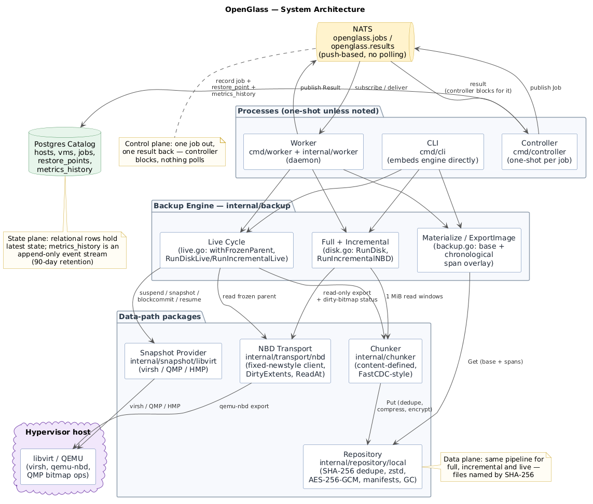
The CLI embeds the backup engine directly and runs anywhere. The controller is one-shot per job; the worker is a long-running daemon that executes the exact same engine code the CLI does. From the engine, work fans out into the snapshot provider (libvirt), the NBD transport, the chunker, and the repository — all converging on the hypervisor host.

Restore points: full backups vs. incremental spans
A full restore point is an ordered list of content-defined chunks (Manifest.Chunks) covering the entire guest-logical disk. An incremental point stores only what changed since its parent, as spans (Manifest.Spans = {offset, chunk hashes}) with Parent set.
Chains of any depth replay chronologically at restore time: newer spans overwrite older ones, so overlapping dirty ranges always converge to the correct result. Full and incremental points share one address space, so any incremental restores cleanly onto any ancestor full.
Point type | Holds | Restore
Full | Chunks (whole disk) | Write the chunks in order
Incremental | Spans (offset + chunk hashes) + Parent | Write the full base, then overlay each ancestor's spans in chronological order

How a live incremental backup job flows
This is the most involved path end to end: a controller publishes a live incremental job, a worker executes it, and the guest is paused only across a short freeze window.
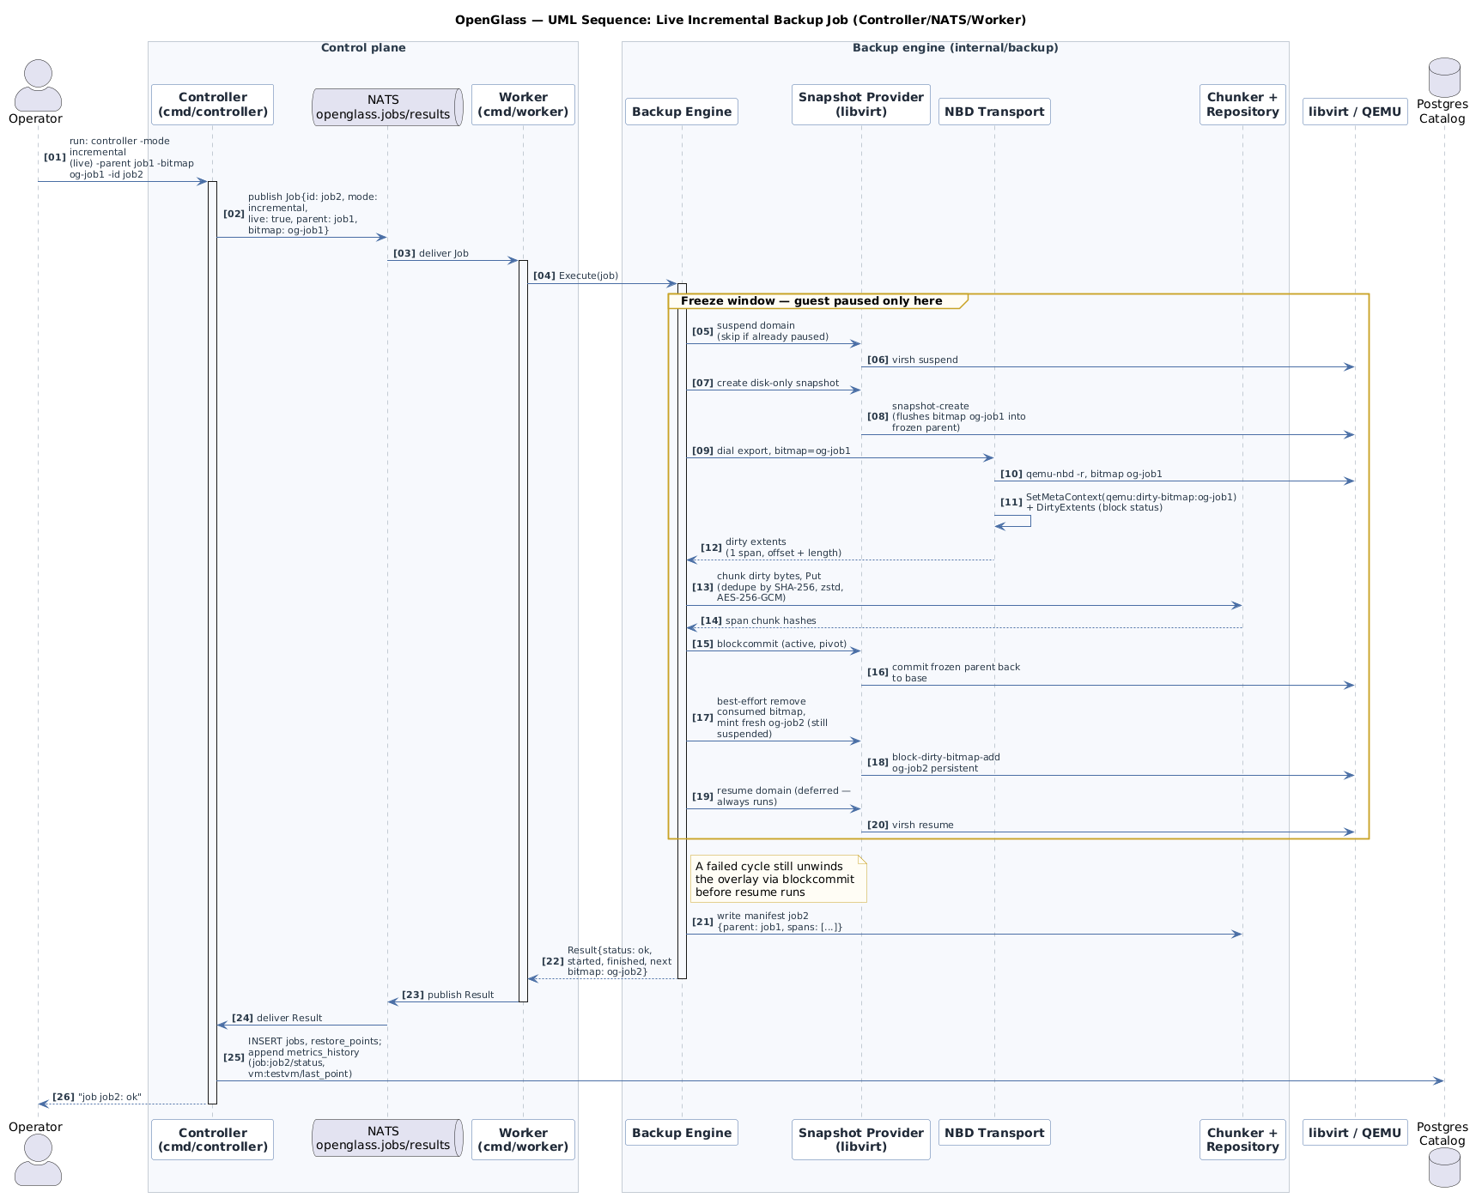
The freeze window: suspend the domain → take a disk-only snapshot (which flushes the dirty bitmap into the now-frozen parent) → read the dirty extents over NBD → chunk and store them → blockcommit --active --pivot the snapshot back into the base image → mint a fresh bitmap for next time → resume. Resume is deferred, so it always runs, even on failure; a failed cycle first unwinds the overlay via blockcommit before resuming.

Quick CLI reference
Command | What it does | Example
init | Create a repository + encryption key | openglass init -repo ~/repo
backup | Full, incremental (--incremental --parent --bitmap), or live (--live) backup | openglass backup -repo ~/repo -vm testvm -src /tmp/vmdisk.img -id snap1
restore | Restore a point to a raw image | openglass restore -repo ~/repo -id snap1 -dst /tmp/restored.img
export | Materialize a point to a raw image (byte-identical) | openglass export -repo ~/repo -id snap1 -dst ./disk.img
files | Extract one file from a raw ext4 point via debugfs, no mount | openglass files -repo ~/repo -id snap1 -path /etc/hostname -dst ./hostname
mount / unmount | Read-only NBD mount of a point | openglass mount -repo ~/repo -id snap1 -mountpoint /mnt/og -fstype ext4
snapshot | Create or delete a libvirt snapshot | openglass snapshot --vm testvm --action create
recover | Boot a transient domain off a point | openglass recover -repo ~/repo -id snap4 -name ogrectest

Current constraints and test coverage
Stated as ceilings, not silent failures:
- Single-disk (vda) VMs only; multi-disk needs per-disk specs
- Shut-off incrementals need a pre-existing QEMU dirty bitmap in the image
- QMP nbd-server-start/nbd-server-add against a live guest is rejected on QEMU 6.2 — the snapshot/commit cycle is the supported live path
- The controller is one-shot per job; no scheduler or worker heartbeats yet
- metrics_history needs scheduled retention (90 days)
- NATS runs without auth and the repo key is a local file — a single-host trust model
Test coverage:
- internal/chunker, internal/repository/local, internal/backup, internal/snapshot/libvirt — unit tests covering dedupe, span replay (including 3-level chains), and live freeze/thaw choreography against a faked virsh
- Full end-to-end on WSL/QEMU 6.2 — file-mode incrementals, live full + incremental + bitmap rotation with a byte-compare gate, and instant recovery
- Metrics pipeline verified worker → NATS → controller → Postgres

