HOW TO USE MY CODE

FOLLOW THESE STEPS :

To begin you need to start the file named « Untilted-1.py ». Open it with an editor like Syder for example.

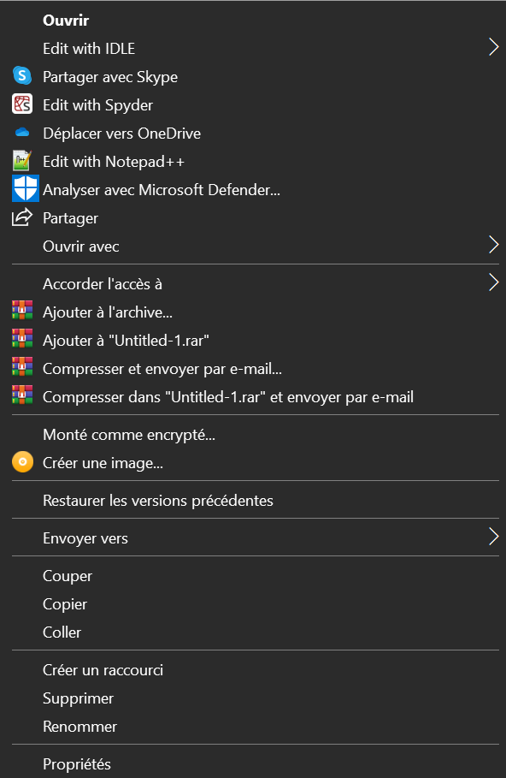

Right Click on the file.

After the file is open you have the code in front of you.

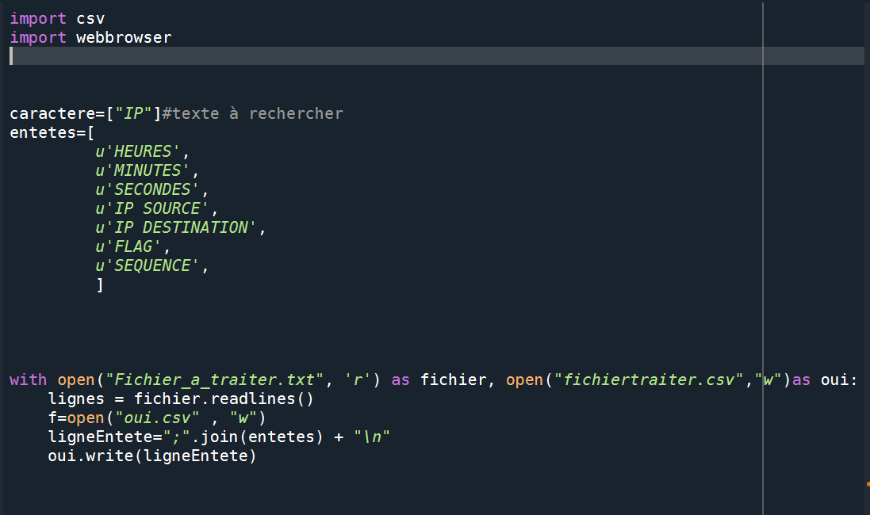

For analyse the document you want you juste had to change one line.

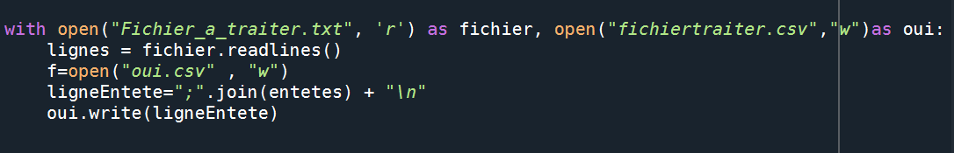

Change the name of this file juste the name and not the « ‘r’ », don’t forget the extension of your file. In this screenshot you can see that the file name is « Fichier_a_traiter.txt » the extension of the file si « .txt » don’ts forget yours.

After make the changement you just have to save the file and run the program.

Now you have files that have been created. This files need to analyse your first file that you put in the program.

The files that were created are :

- fichiertraiter.csv

-fichiertraiter2.csv

-fichieratraiter.txt

-fichieripsource.txt

-fichieripdestination.txt

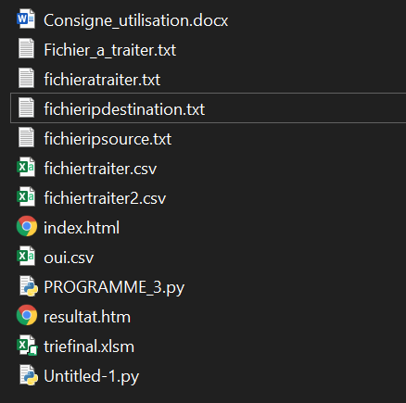

Open the file named « triefinal.xlsm » you have this.

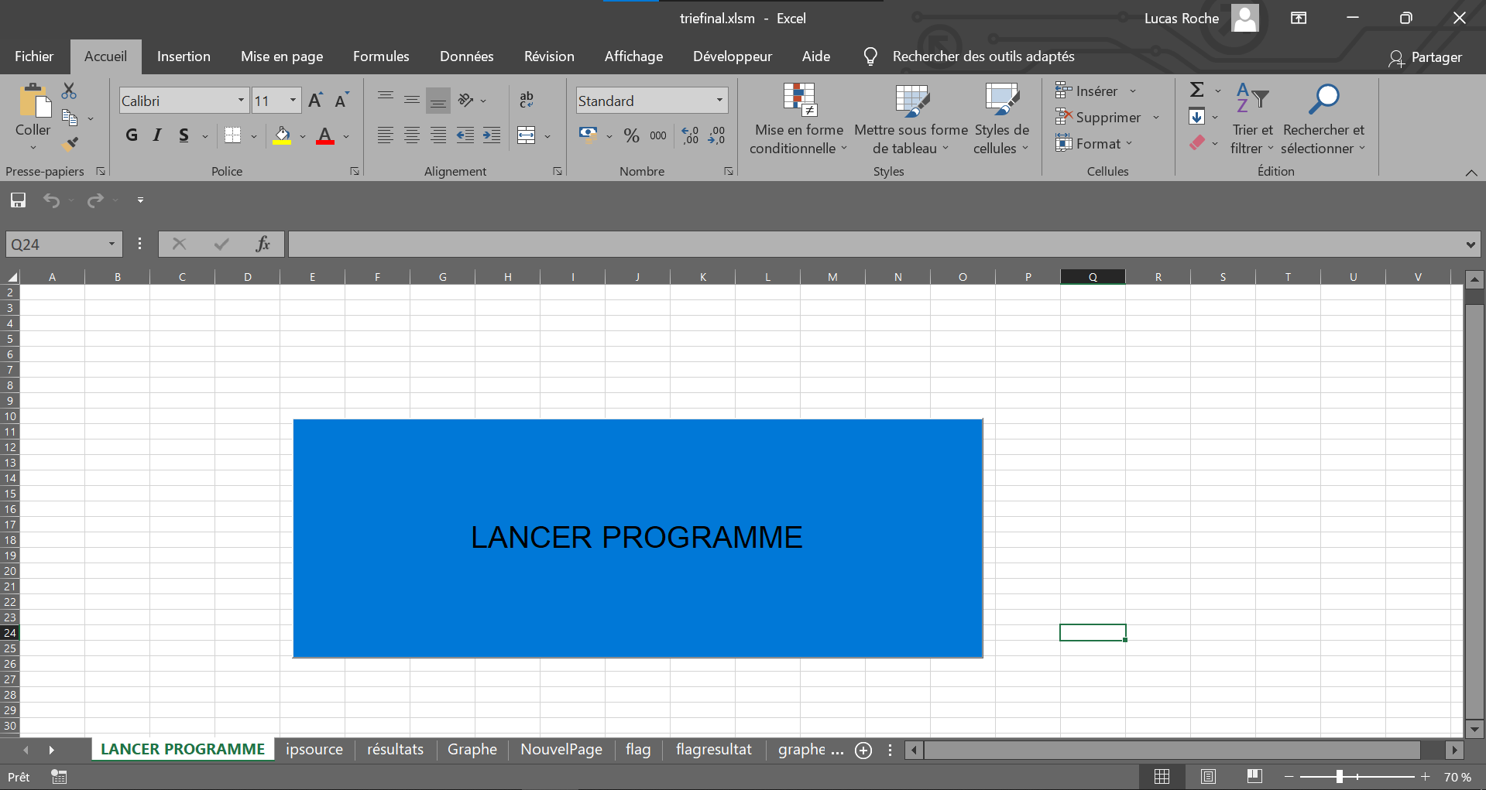

Before run the program we have to do some modifications.

Go on the affichage tab and click on « Macro » and after on « Afficher les macros »

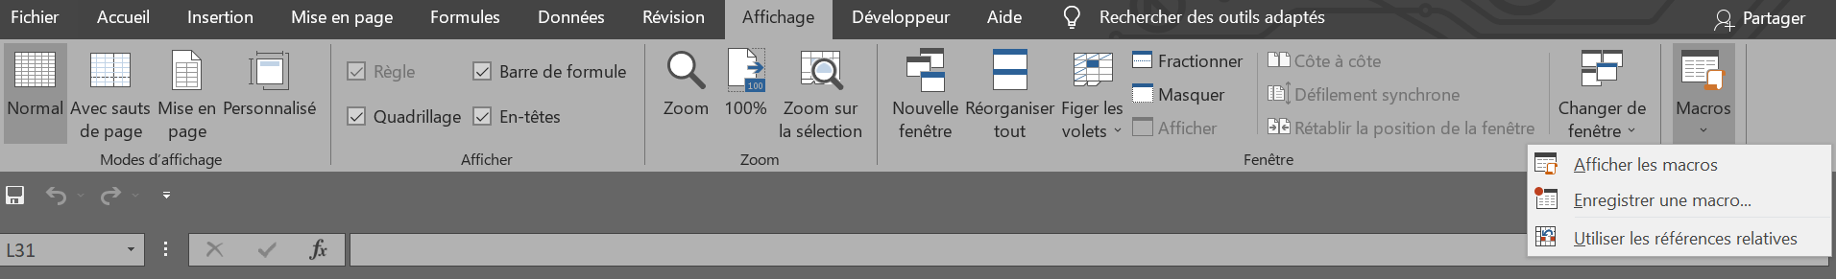

You have this pop-up

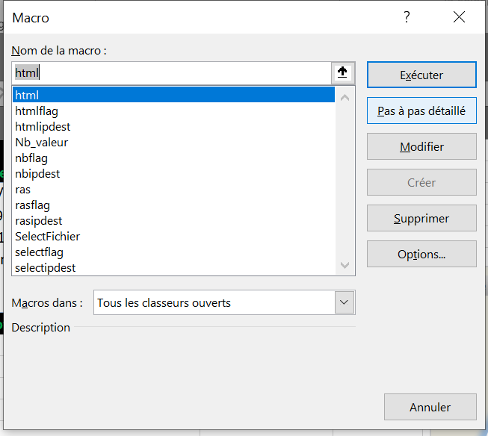

You need to modify every macro because the way to your document is not good because it’s mine.

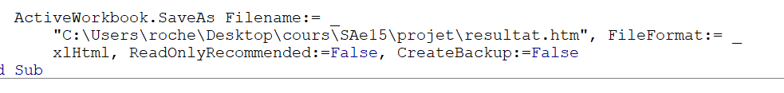

You juste need to modify this and put your way to your document.

Do this in every macro you have.

Now you can Run your Program.

To run the program you just have to click on the blue button « LANCER PROGRAMME »

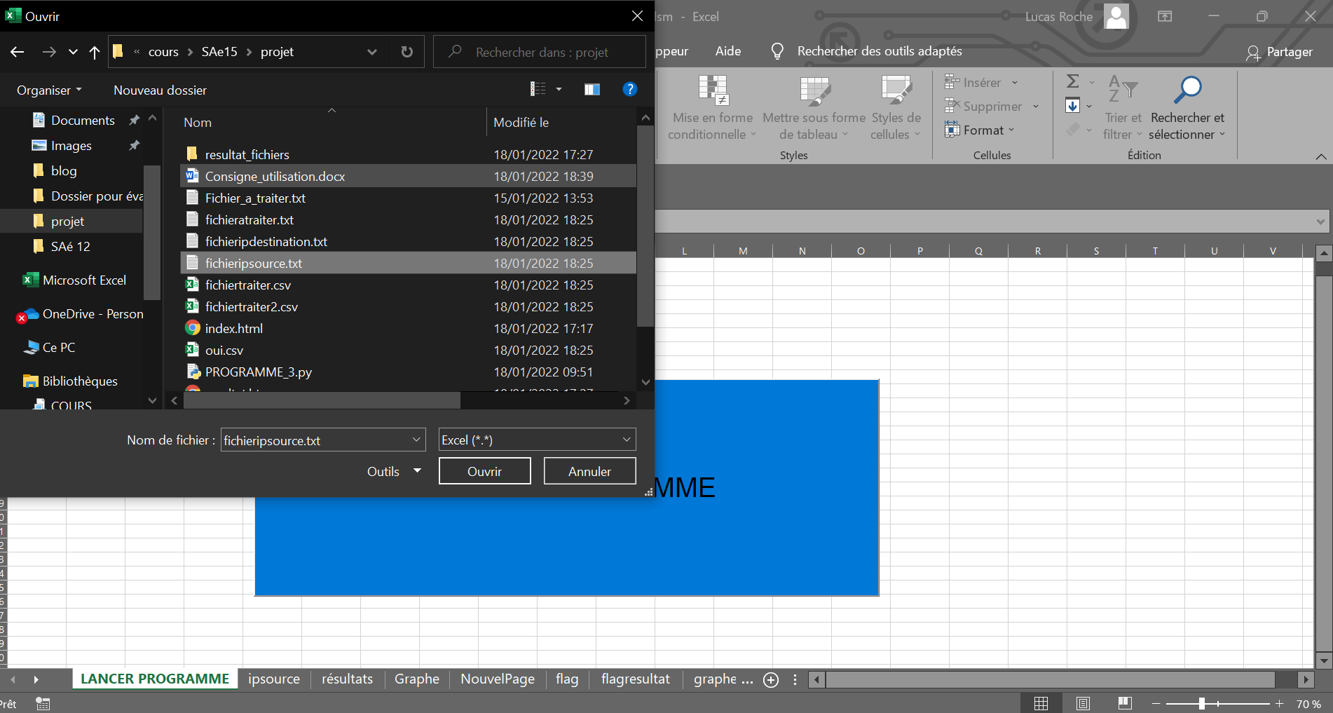

Your file explorer is now open you need to choose the « fichieripsource » file.

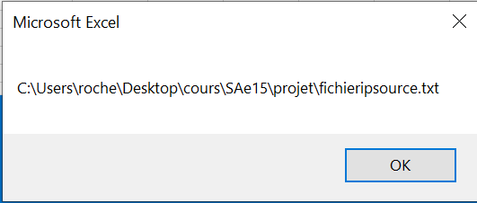

You have this page who pop-up on your screen you have to say OK to continu.

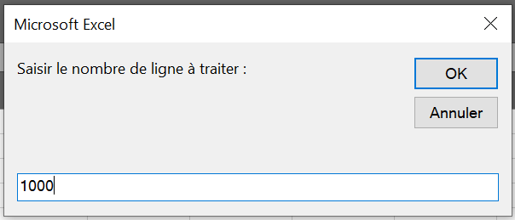

A second pop-up appear, you have to choose how many line you want to analyse.

Her ewe want thousand lines. Click on « OK » to continu.

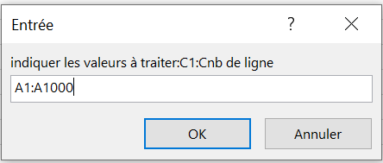

Now a third Pop-up appear and you have to put the lines you want so here we want lines from 1 to 1000 so we write «  A1 :A1000 » and Click on OK.

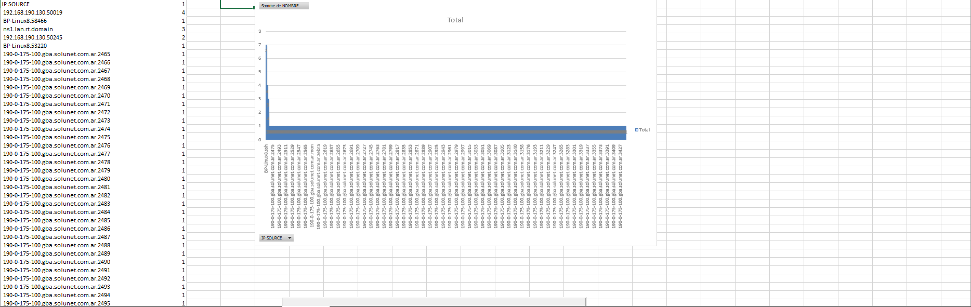

Now you have something like that with at le left every IP address you analyse and a diagram who repertory every IP adress and the number of time there get repeat.

If you go down the page you have an other button, click on it.

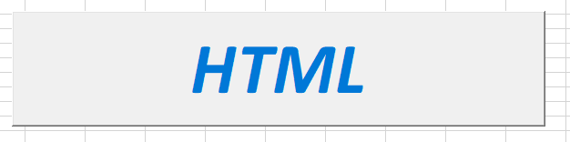

When you click on it a web page is created in your file explorer name  « resultat.htm »

Open it and you have this :

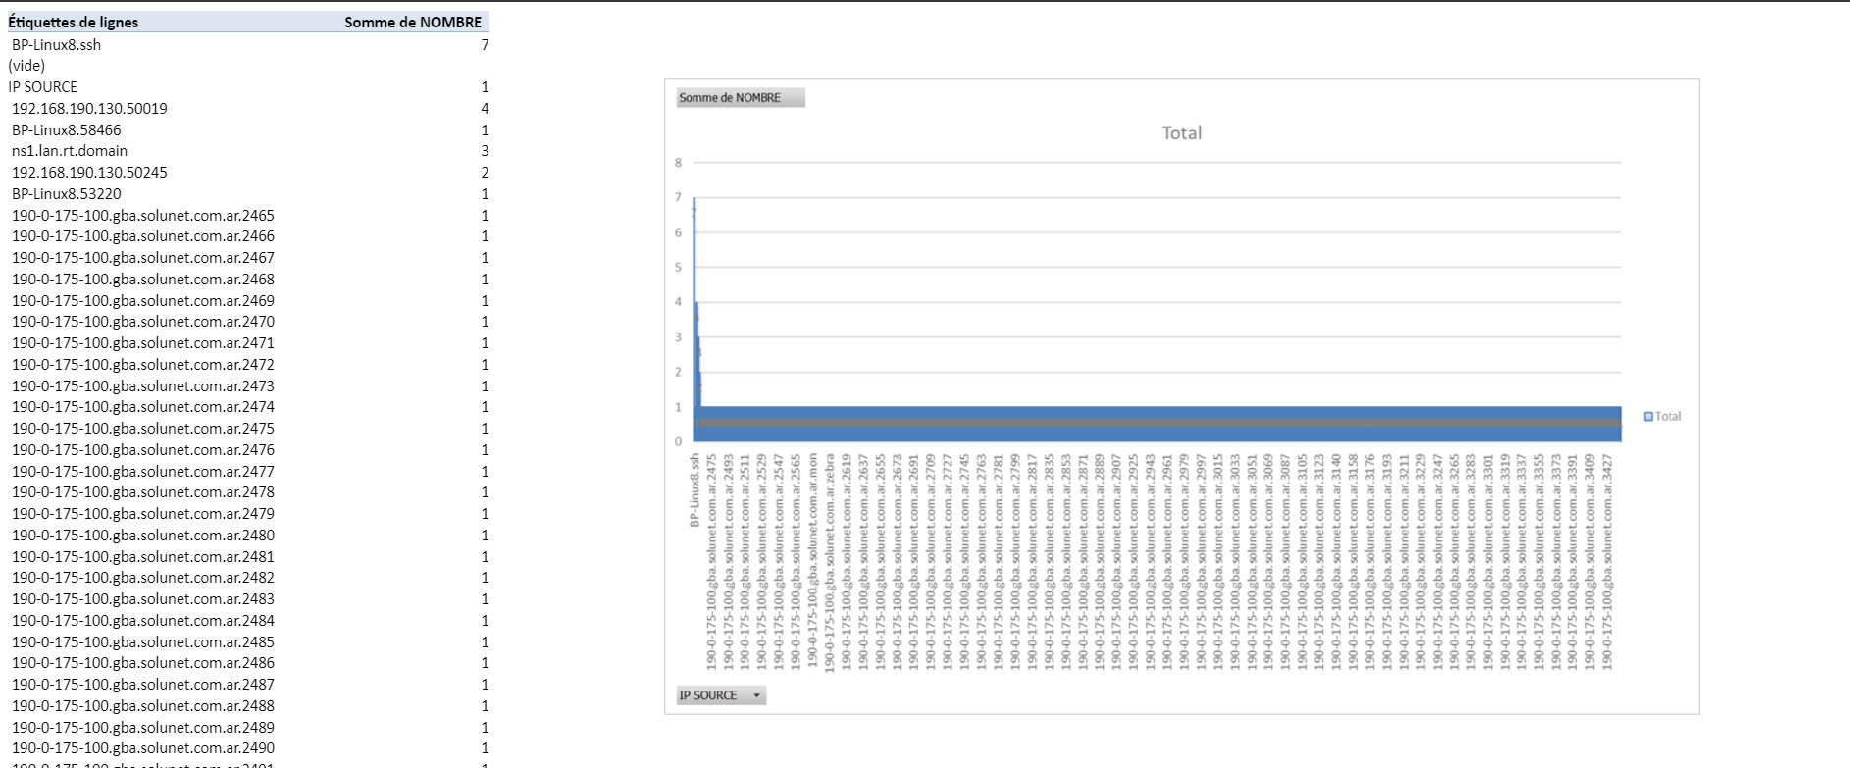

IF YOU D’ONT HAVE THE SAME THINGS THAN YOUR XLSM FILE YOU NEED TO REFRESH YOUR XLSM FILE GO ON THE TAB « Données » AND ACTUALISER TOUT.

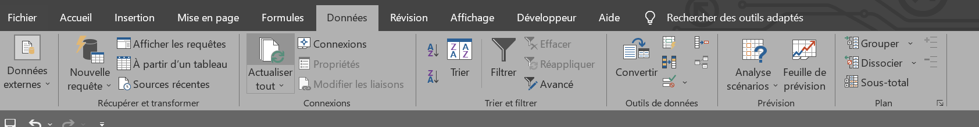

So here you have the same diagram than the other one on the xlsm file.

And now we will see with the Destination IP address. You need to close the web page and the file page.

And re open the « triefinal.xlsm », go on ipdestination page.



Click on the blue button « IP DESTINATION » and you need to do the same things as for the source IPs but choose the file named « fichieripdestination.txt » and you got an other HTML button for the web page.

For the last information that we have to analyse, we need to close the file again and re open it again.

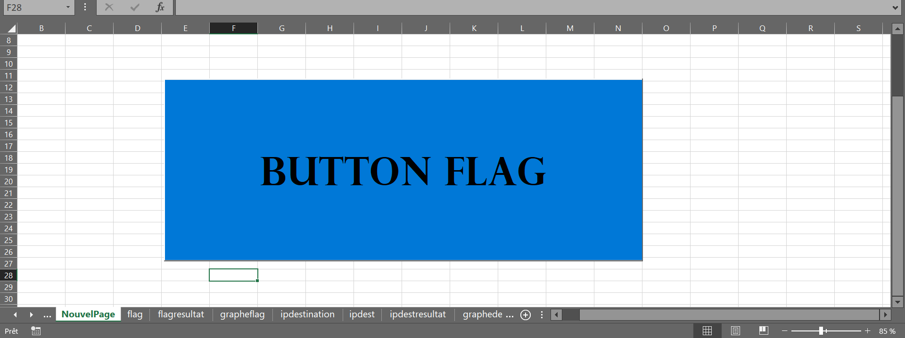

For this one you need to go on the « NouvelPage » click on the Blue button again and choose the file named « fichieratraiter » same things for this page click on the HTML button for the web page.