**Repository location:** <https://data.wa.gov/Education/State-Art-Collection-Published-2016-05-25/xx9k-ku4q>

**Overview**

This dataset, housed at data.wa.gov (Washington State’s open data portal) is titled “State Art Collection,” and holds information about the Washington State Art Collection. The collection was acquired as part of the Art in Public Places program and is owned, sited, and selected by the public of Washington State. The Art in Public Places program was established in 1974 by the Washington State Legislature in order to “acquire artwork for K-12 public schools, colleges, universities, and state agencies” (“Public Art” 2017).

The data was provided by Washington State Arts Commission (ArtsWA). According to their website, ArtsWA “[speaks] up for the public value of the arts…[builds] leadership in and for the arts…[strengthens] arts education …[documents] the impact of the arts…and [shares] the findings, [builds] participation in the arts, and [acquires and cares] for artwork in the State Art Collection” (“About Us” 2017) and accomplishes these goals through a number of community programs as a nonprofit organization, and in tandem with the National Endowment for the Arts.

There are three major clues about the purpose of this dataset. First, ArtsWA’s website points to the dataset as a source for “mapped locations of artworks around the state” (“State Art Collection” 2017) (as opposed to seeing images of the art or learning about the artists, which can be accomplished through the “My Public Art Portal” and the Facebook photo gallery). Second, on the dataset page there is a section called “Related Content Using this Data,” which directs the user to two pages (“[P]uget [S]ound artworks” [Data.wa.gov (2016). *puget sound artworks*] and “Map View State Art Collection” [Data.wa.gov (2016). *State Art Collection*]) that were created in August of 2016 using this dataset to map art locations. Third, half of the data points about the artwork in the dataset are location-based. Therefore, with this evidence, the purpose of this dataset appears to be keeping tabs on the geographical aspect of this collection.

**Context**

In this dataset, each row is an individual artwork in Washington State. There are 871 rows, and, therefore, 871 artworks covered. This is barely 20% of the 4,500 artworks that are in the full collection (“State Art Collection” 2017). There are 14 columns for descriptive data about each artwork, which are split broadly into identification information and location information:

|  |  |  |  |
| --- | --- | --- | --- |
| **ID** | **Example** | **Location** | **Example** |
| ID number | WSAC2003.071.000 | Artwork City | Aberdeen |
| Artist | Blomberg, Cecilia | Artwork Address | 1620 Edward P Smith Dr. |
| Title | The Grays Harbor College Tapestry | Zip code | 98520 |
| Date | 2004 | Artwork latitude | 46.953347 |
| Materials | Cotton and wool fiber tapestry | Artwork site | Grays Harbor College |
| Measurements | 4 1/2 ft x 13 ft | Specific location | Library, 2nd floor behind reference desk |
| Credit line | This artwork is a part of the State Art Collection and was acquired by the Washington State Arts Commission in partnership with Grays Harbor College | location 1[1] | (46.953347°, -123.803312°) |

The metadata claims that it is updated quarterly, but this dataset was uploaded on May 25th, 2016 (almost a year ago) and has not been updated since (Data.wa.gov (2016). *State Art Collection).* This may be explained by the fact that the “dataset owner,” Valerie Peterman, was only hired by ArtsWA in April of 2016 (“Staff Biographies” 2017). She may have posted this dataset intending to update it quarterly, but that has evidently not come to pass. She continues to be employed by ArtsWA, so there is hope for the future (Peterman, Valerie 2017).

**Methods**

The data for this dataset seems to have been sourced from the My Public Art Portal database (“My Public Art Portal” 2017). When one has searched for a particular artwork, the resulting page contains the data that is organized in the data set. In fact, the only piece of data that is missing is the “credit line” information, which would either be available within the company records. The image below shows the results when “Grays Harbor College Tapestry” was searched, and every data point except for credit line is represented:

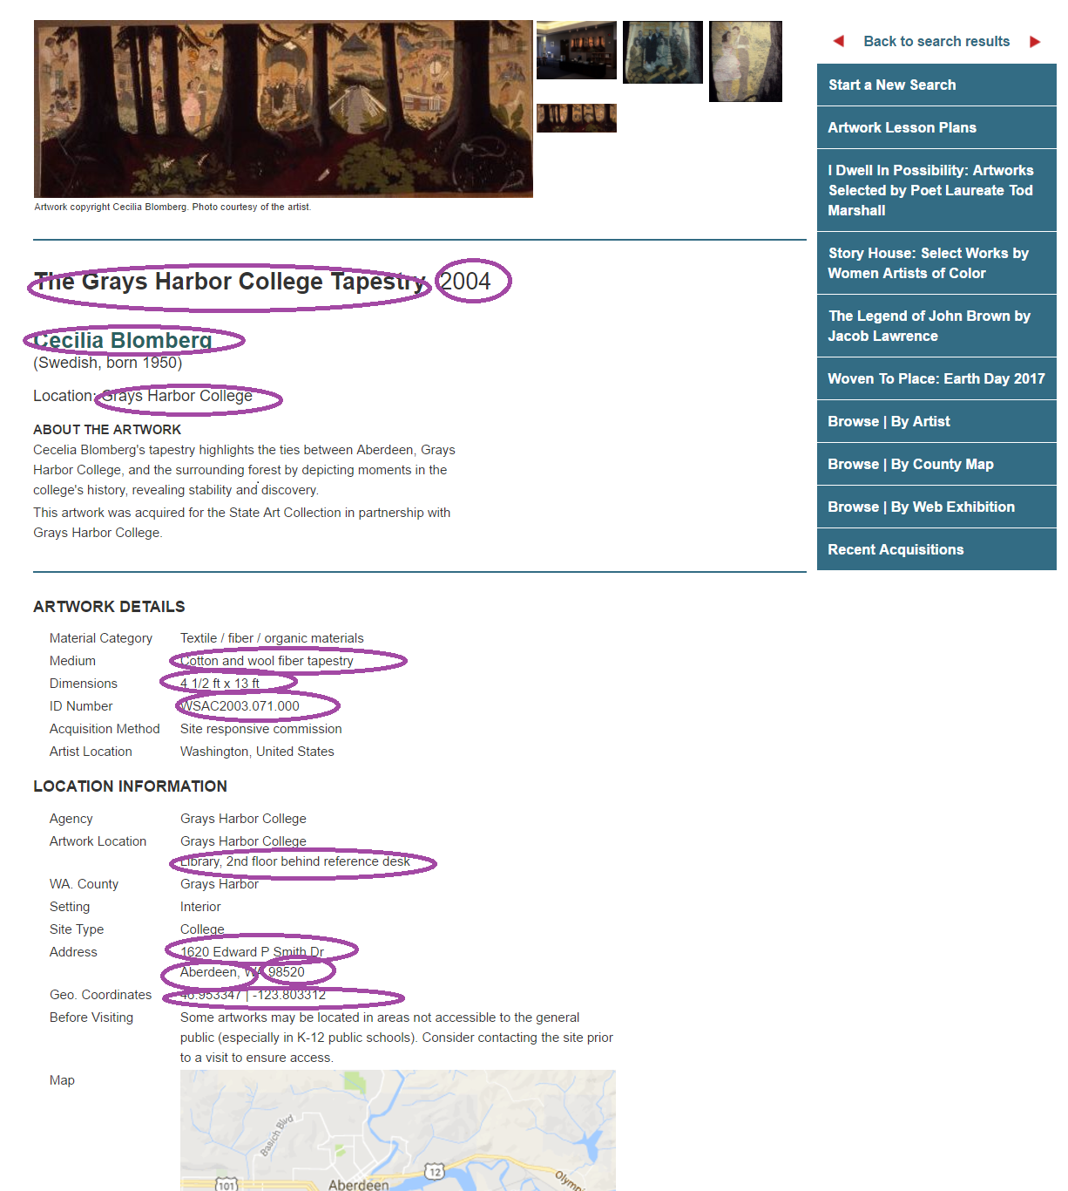

That said, there is no formal attribution within the dataset metadata regarding where Valarie Peterman obtained the data. Only a third of the collection is online and “more will be added every week” (“My Public Art Portal” 2017) so perhaps Ms. Peterman is finding this information in ArtWA’s records (which most certainly exist privately) of each art transaction and adding them to the database and the dataset from there.

**Dataset Description** (source: Data.wa.gov (2016). *State Art Collection)*

* Data type is described as part of the context (above).
* Creation date: May 25, 2016
* Dataset Owner: Valarie Peterman
* Language: English
* License: Public Domain
* The dataset is available in these formats:

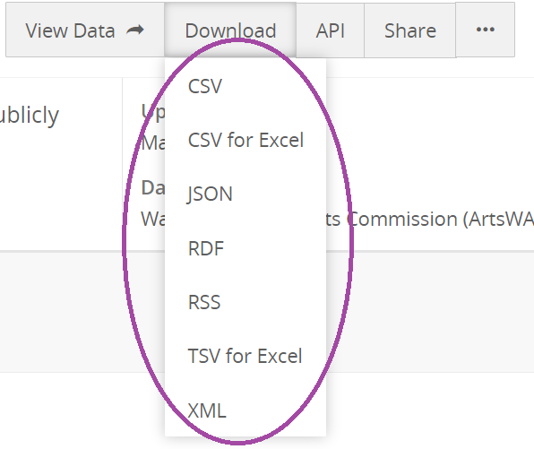

* The dataset is classed under the category “Education,” and is assigned these tags:

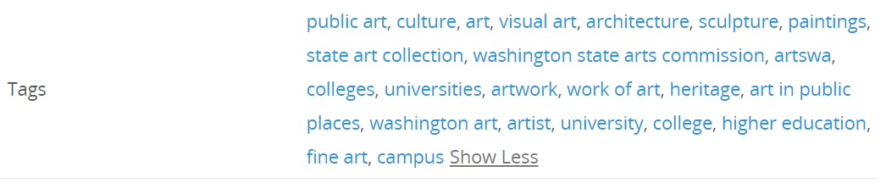

**Reuse Potential:**

This dataset was created in order to create map/geographic representations of the art in the State Art Collection. Potential future users of this information include (but are not limited to):

* Employees of ArtWA
  + To see where the State Art Collection is spread around the state when making decisions about where to put more art
* School children
  + To learn about what a dataset is, and how to use this one
  + To learn about the State Art Collection
* Members of the public
  + To decide where to go see parts of the State Art Collection
  + To track down where a particular part of the collection that they have heard about lives
* Members of Washington State legislature
  + To evaluate the funds going into the State Art Collection based on how and where they are being used

The only limitation to reuse is the size of the data itself, e.g. that the number of items in the dataset only comprise 20% of the collection, and that there are only 14 data points per item. With more of the items included and/or more data points per item, there might be more options for reusing the data as a representation of the full collection.

**Curation needs:**

The curation that is required is to have more of the art (ideally 100%, but at least a representative majority) included in the data set. Because the data comes from the database, and the database claims to have one third of the collection cataloged, the curator could start with adding the rest of the cataloged items to the dataset. However, after that, the necessary curation would include not only adding items to the dataset, but to the database itself. Of course, the method of collection stated in this paper is pure conjecture based on the existence of the database; one ideal curation improvement would be for the metadata to include from whence the information in the dataset was sourced.

In addition to information about the State Art Collection itself, ArtsWA keeps a Public Artist Roster (“a registry of artists who are eligible for a public art commission through ArtsWA” [“Public Artist Roster” 2015]) and a Curator Roster (a list of professional curators with whom the selection committee may choose to work in acquiring existing—not commissioned—artworks [“Public Artist” 2017]). Perhaps ArtsWA could either include some of this data in the dataset or create a new set that could be cross-referenced in order to better use the existing rosters. A good addition to the dataset would be a data point for each item indicating the provenance of that item—whether it was commissioned specifically or already existed, and if so, which curator helped to place it in the Collection.

**Sources:**

“About Us” (2017). ArtsWA. Retrieved from <http://www.arts.wa.gov/about-us>.

Data.wa.gov (2016). *Map View State Art Collection Published* [data file]. Retrieved from <https://data.wa.gov/Education/Map-View-State-Art-Collection-Published/jcys-zc95>.

Data.wa.gov (2016). *puget sound artworks* [data file]. Retrieved from <https://data.wa.gov/Education/puget-sound-artworks/vehm-giqd>.

Data.wa.gov (2016). *State Art Collection Published 2016* [data file]. <https://data.wa.gov/Education/State-Art-Collection-Published-2016-05-25/xx9k-ku4q>.

“My Public Art Portal” (2017). ArtsWA. Retrieved from <http://www.arts.wa.gov/public-art/my-public-art-portal>.

Peterman, Valerie. (2017). Profile [LinkedIn page]. Retrieved from <https://www.linkedin.com/in/valerie-joy-mackinnon-peterman-0a45432b>.

“Public Art” (2017). ArtsWA. Retrieved from <http://www.arts.wa.gov/public-art>.

“Public Artist and Curator Rosters” (2017). ArtsWA. Retrieved from <http://www.arts.wa.gov/public-art/pages/public-artist-and-curator-rosters>.

“Public Artist Roster” (2015). ArtsWA. Retrieved from <http://www.arts.wa.gov/media/dynamic/docs/2015%20ArtsWA%20Public%20Aritst%20Roster.pdf>.

“Staff Biographies and Contact Information” (2017). ArtsWA. Retrieved from <http://www.arts.wa.gov/about-us/who-we-are/staff-biographies-and-contact-information>.

“State Art Collection” (2017). ArtsWA. Retrieved from <http://www.arts.wa.gov/public-art/state-art-collection>.

1. Given in longitude/latitude coordinates