A BOOK can have many AUTHORS.

An AUTHOR can have many BOOKS.

A BOOK can have many PUBLISHERS.

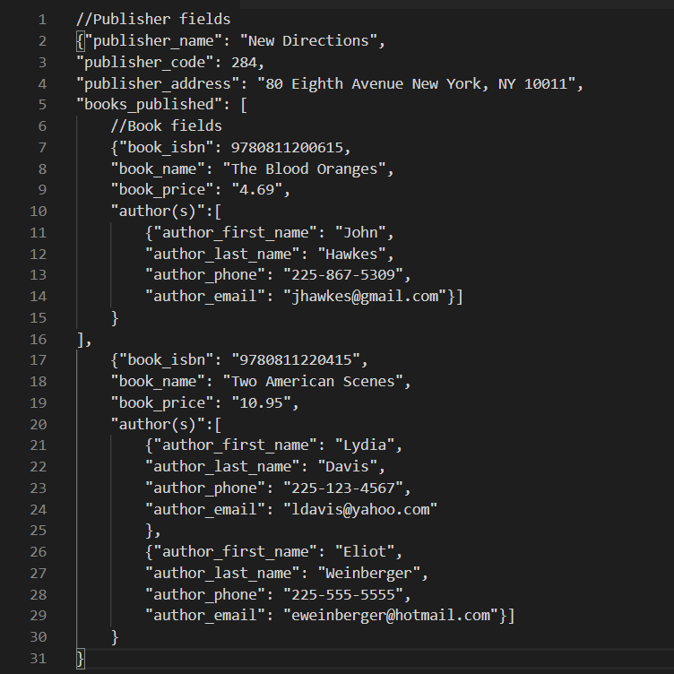PUBLISHERS publish many BOOKS.

