Bob’s Computer Repair Shop

TECHNICAL DESIGN DOCUMENT

|  |  |
| --- | --- |
| **Author** | Rochelle Markham |
| **Last Updated** | 10/28/2020 8:47 PM |
| **Version Number** | 1.0 |

**Version History**

|  |  |  |  |
| --- | --- | --- | --- |
| Name | Date | Reason for Change | Version |
| Rochelle Markham | 10/28/20 | Created Document | 1.0 |
|  |  |  |  |
|  |  |  |  |
|  |  |  |  |
|  |  |  |  |
|  |  |  |  |
|  |  |  |  |
|  |  |  |  |
|  |  |  |  |
|  |  |  |  |

Table of Contents

SECTION 1: INTRODUCTION 3

Purpose 3

Terminology 3

Related Documents 3

Reviewers 3

Required Skills 3

SECTION 2: Architecture 4

Physical Architecture 4

Logical Architecture 4

SECTION 3: PROCESS DESIGN 5

Object Relational Diagram(s) 5

NoSQL Data Structure 5

Wireframes 6

SECTION 4: REFERENCES 6

# SECTION 1: INTRODUCTION

## Purpose

Bob’s Computer Repair shop needs an application to perform calculations and print invoices for customers. They need to be able to select multiple services using a checkbox system and have the totals added to the invoice. They also need form entry boxes for adding in a calculated hourly rate for the service charge and for the cost of parts required for the repair. They also need a calculate button that will produce a summary that can be printed to be given to customers. The application will be created using Angular and the UI will be created with Angular Material, utilizing flex-layout. Angular forms will be used to create entry boxes and other application elements.

## Terminology

|  |  |
| --- | --- |
| **Name** | **Comments** |
| Angular | https://angular.io/docs |
| UI | User Interface |
| Angular Material | <https://material.angular.io/> |
| Flex-layout | <https://github.com/angular/flex-layout> |
| Angular Forms | https://angular.io/guide/forms-overview |

## 

## Pc Repair Logo Images, Stock Photos & Vectors | ShutterstockRelated Documents

Bob’s Computer Repair Shop Logo

## 

## Reviewers

|  |  |  |
| --- | --- | --- |
| **Approvers** | **Name** | **Date** |
| **Approved By (**Client Acceptors, can be more than one) | Bob | 10/27/20 |
| **Approved By** (Solution Architect) | Professor Krasso | 10/27/20 |
| **Approved By (**Development Team) | Peter Itskovich | 10/27/20 |

## 

## Required Skills

To build this application, the developer must have a good knowledge of Angular and Angular Materials. It also requires developers to be familiar with flex layout and Angular Forms.

# SECTION 2: Architecture

## Physical Architecture

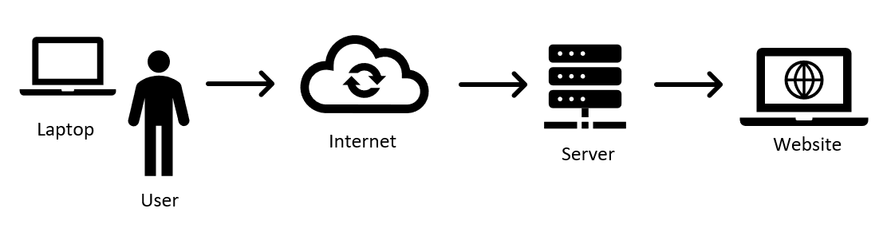

## Logical Architecture

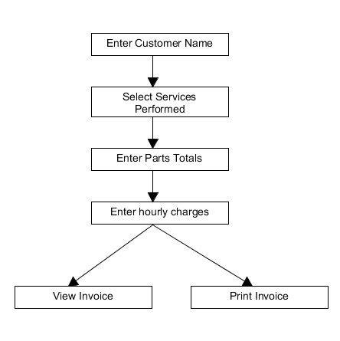

# SECTION 3: PROCESS DESIGN

## Object Relational Diagram(s)

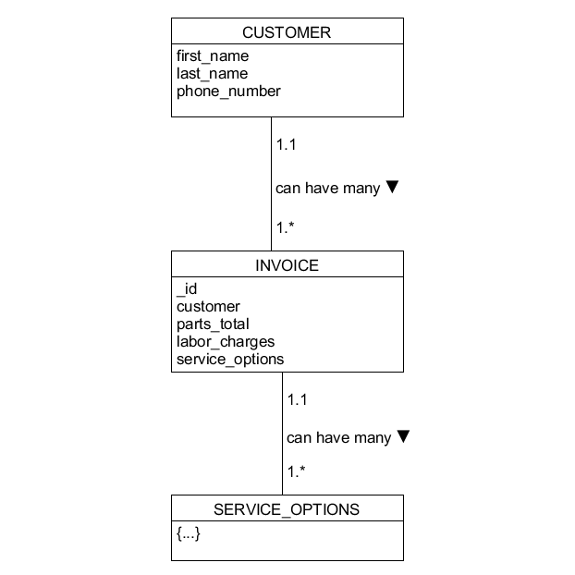

## NoSQL Data Structure

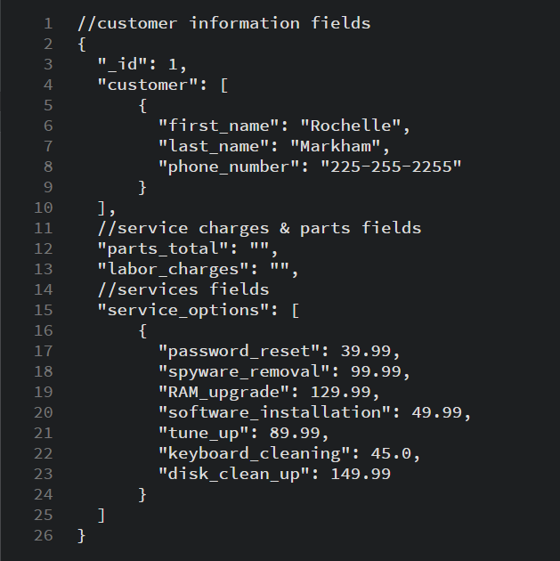

## 

## Wireframes

# 

# SECTION 4: REFERENCES

<https://material.angular.io/>

<https://angular.io/>

<https://angular.io/guide/forms>