# 2023 AP Computer Science Programming Competition

Welcome to AP Computer Science Battle of the Classes, otherwise known as “May Mayhem”!!!

The ViE volunteers are excited to work with the students at Mayo High School and CTECH for a programming competition! The competition will determine the bragging rights among the cyber techies within the Rochester School District!

This year's project is the popular game [**Battleship**](https://en.wikipedia.org/wiki/Battleship_(game)) – a common board game where pairs of players hide ships on a two-dimensional grid representing the ocean. Players shoot at their opponent’s ships by guessing the coordinates of the enemy ships. The winner of a game is the player to sink (fully cover with hits) all the opponents ships first.

Your goal is to create a set of boards for your fellow classes to play against and program a player to shoot at the opponent’s ships by guessing the coordinates. Additionally, your class will create boards for other classes to play against!

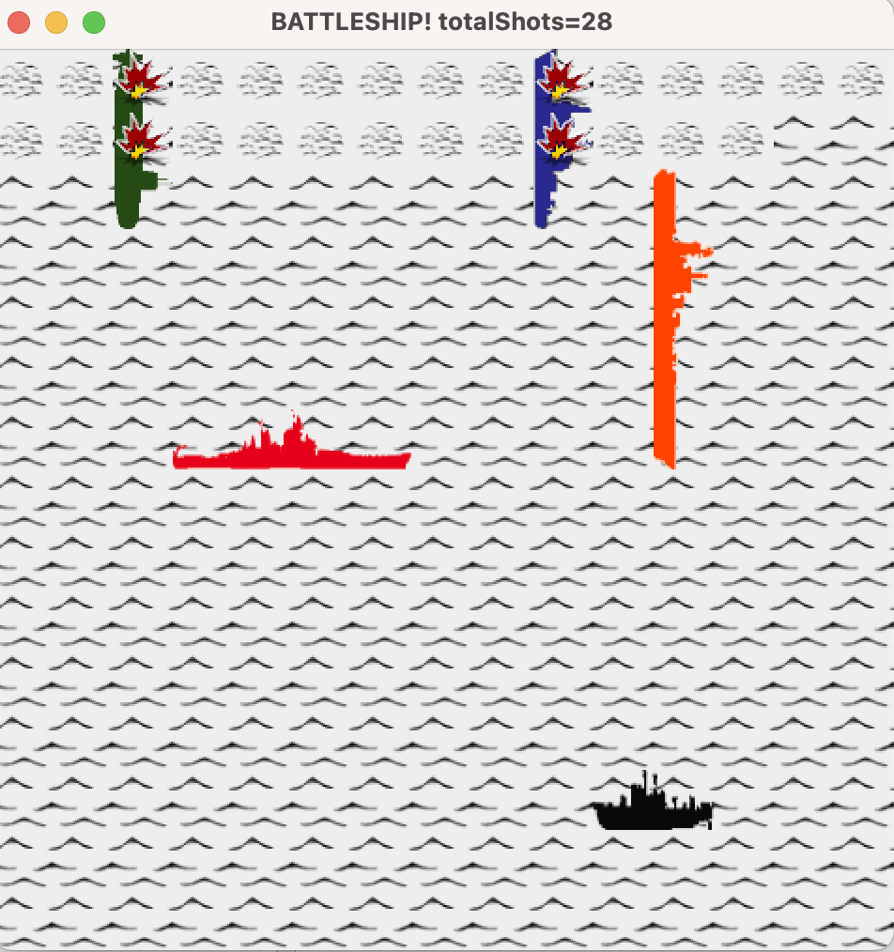

### Project Details

The game will be a “classic game” of Battleship. Each board is comprised of a 15x15 grid with 5 ships:

* 1x5 aircraft carrier
* 1x4 battleship
* 1x3 submarine
* 1x3 cruiser
* 1x2 patrol boat

A player’s score for a board is the number of shots taken to sink all the ships.

Unique to this project, shots outside of the board’s boundaries AND multiple shots to the same location DO count against you.

A few sample boards will be provided to you for testing. You also can create your own boards and test against them.

### Competition Details

The competition is a team (class) effort and will be conducted in two phases.

The first phase is board creation. The goal for your team is to submit a set of boards that the other classes will be scored against for the competition. Your player solutions will NOT be scored against your own boards. Each class will need to submit 20 unique boards.

The second phase is the game player solution. Each student will submit a solution and be scored against all boards submitted by opponent classes. The class with best scores will be declared the winner and bestowed the official AP Computer Science Competition Belt traveling trophy!

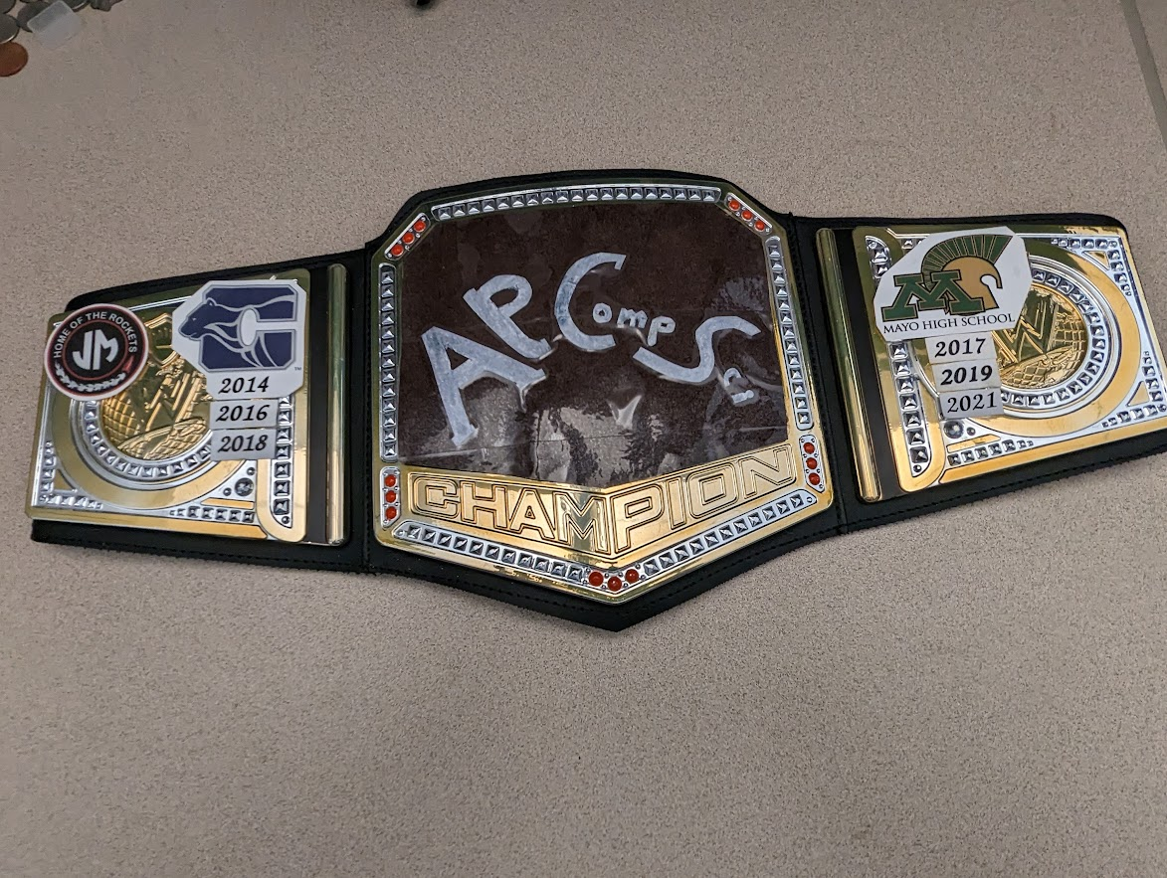

In addition to the team competition, the ViE volunteers will evaluate each individual’s solution to determine special awards. Individual prizes will be awarded in the following categories:

* Top Performer
* Best Team Player
* Best Program Structure
* Most Elegant Solution

## Schedule

* **Monday, May 15**

Competition files will be posted for students by teacher. ViE Tutors will be in class to kick off the competition.

* **During competition**

ViE helpers will be available in class to help answer any questions about programming or the competition. Any questions outside of class should be sent to your teacher.

* **Friday, May 19**

Boards must be submitted to your teacher by end of class period.

* **Friday, May 26**

Projects must be submitted to your teacher by end of class period. Late submissions will not be accepted. Your teacher will validate submission times.

* **Wednesday, May 31**

ViE tutors will be present the results.

## Rules

1. Board submissions must be unique.
2. Solutions must be in Java.
3. Students will submit one implementation of the **TemplatePlayer** class for the competition. See the detailed instructions in **SubmissionGuide.pdf** for submission packaging.
4. Discussions among students on board submissions and playing algorithms are STRONGLY encouraged to eliminate duplicity of solutions.
5. Projects will be evaluated using the criteria defined in the section below.

## Judging

### Team Competition

Individuals will compete for their class. The three lowest scoring players per board will earn points for their class. Six points are awarded **per board**. The points for a board will be distributed as follows:

Fewest number of shots: 3 points

Second fewest number of shots: 2 points for their class

Third fewest number of shots: 1 point for their class

Ties will “split” the accumulated points. For example, if 3 students from 3 different class all tie with the lowest score, then each class is awarded 2 pts (6 / 3). The class with the greatest number of points at the end will be declared the winner.

**Note:** Due to the Engineering altruism that all designs have a trade-off, it is likely impossible for a single algorithm that wins every time. Therefore, the team which ultimately wins will likely have the most diverse set of algorithms.

### Individual Honors

In addition to the priceless team award, individual awards will be provided:

1. **Top Scorer**: The individual whose algorithm scores the most points for their team.
2. **Best Team Player:** The student who solved the most unique ship placement strategy for their team.
3. **Best Program Structure**: Each student's **TemplatePlayer** class will be reviewed for organization of internal methods/functions, use of variables, use of data structures, flow of the code, and source code documentation.
4. **Most elegant solution**: Each game algorithm will be reviewed looking for the algorithm which has an innovative design that balances code complexity (quantity) and shot effectiveness (score).

Any questions about evaluation criteria should be asked during class time or communicated through your teacher. Answers for this type of question will be cross posted to all classes.

### Special Note

1. The judges reserve the right to disqualify implementations that require an excessive number of resources to run (e.g. time, memory, etc), or that do unscrupulous things.

### Getting Started

The project is provided in a zip file depending on what IDE you’d like to use.

* If you want to use DrJava, download **student-v1.0.zip**
* If you want to use VS Code, download **student-vscode-v1.0.zip**

Inside the zip, you will find:

1. This overview document (**battleship_2023/doc/2023APProgrammingProjectOverview.pdf**)
2. Either a DrJava project file (**battleship_2023/drjava/battleship_2023.drjava**) or a VS Code project folder (**battleship_2023/battleship_vscode**)
3. JavaDoc for information and framework APIs available to the player (**battleship_2023/doc/javadoc/index.html**)
4. Your solution Java file (**…/student/player/TemplatePlayer.java**) which implements a basic algorithm. This file contains comments within which you should follow when writing your player solution.
5. A description of the boards and a guide on how to make your own boards (**battleship_2023/doc/BoardGuide.pdf**)

The first phase of the competition is about ship placement, so start with the BoardGuide first!