Blackjack 2019 Setup, Submission, Reference Guide

Table of Contents
Setup 2
Download 2
Extract Files 2
DrJava 3
Ensure Project is Configured Correctly 4
Compile and Run 4
Submission 5
Create a Jar 5
Reference 6
Javadoc 6
Running the Game 6
IBM-Supplied Source Code 6
Class Diagram 7
blackjack_2019 Contents 7

Setup

Download
- Download the student-v1.0.zip file from Moodle
  - Save it to a location like the Desktop or to your personal drive (recommended, e.g. X: drive).

Extract Files
- Once the ZIP file is downloaded, a window (shown below) may open showing the contents.
  - If no window pops up, find and double-click on student-v1.0.zip to open it.
  - The window should show blackjack_2019 and LICENSE.txt inside the .zip.

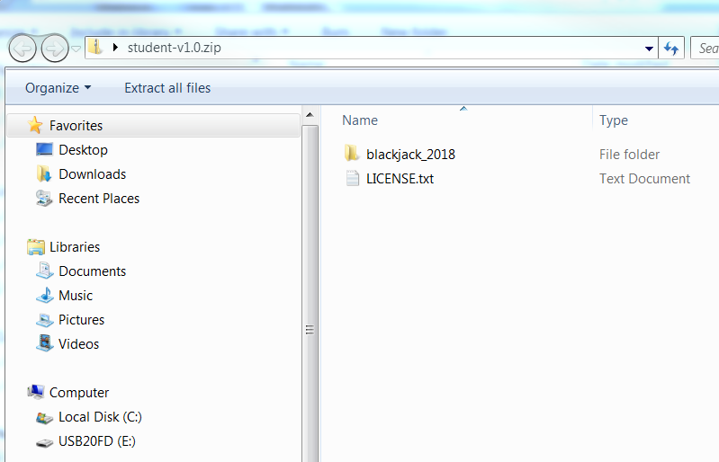

- In the window, click ‘Extract all files’

- A dialog box (shown below) will appear asking where to extract the files.

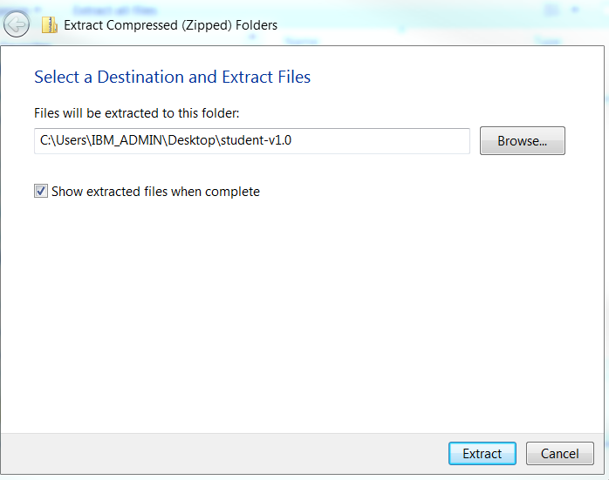

- Click ‘Extract’. The folder and file should now be extracted to the listed location. Remember this location!

DrJava
- Open DrJava

- Under Project, click Open… to get the following dialog box (DO NOT click File → Open)

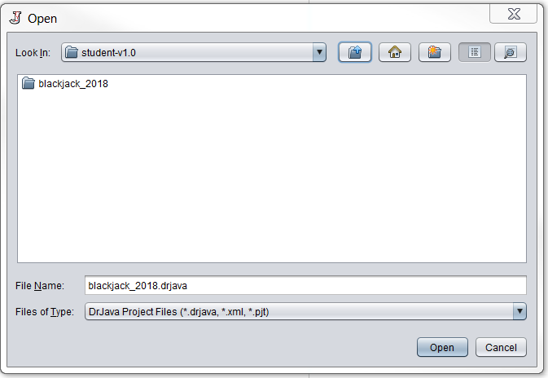

- Navigate to your remembered location where you extracted the files

- Enter the blackjack_2019 → drjava folder

- Select the blackjack_2019.drjava file and click Open

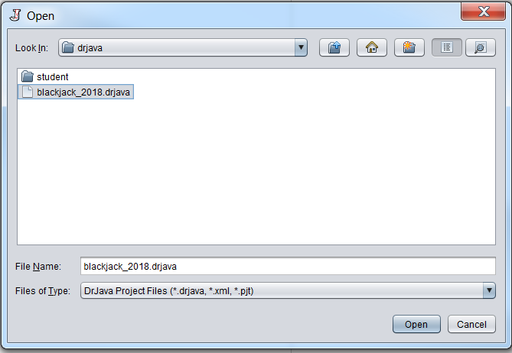

- The Blackjack project should now be in your DrJava workspace with the MyPlayer ready for you to code. However, before you start, let’s ensure a couple of things

Ensure Project is Configured Correctly
- In your DrJava workspace, right click on the new project and select ‘Project Properties’

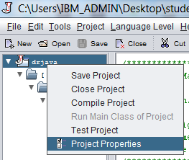
- A dialog box should appear with several items.
  - Ensure the ‘Main Class’ property is set to MyPlayer
  - Ensure the ‘Extra Classpath’ has one property set with <YourLocation>\blackjack_2019\drjava\..\lib\blackjack.jar AND ‘Absolute’ is not checked
  - If these mentioned items aren’t correct, you won’t be able to run your program!

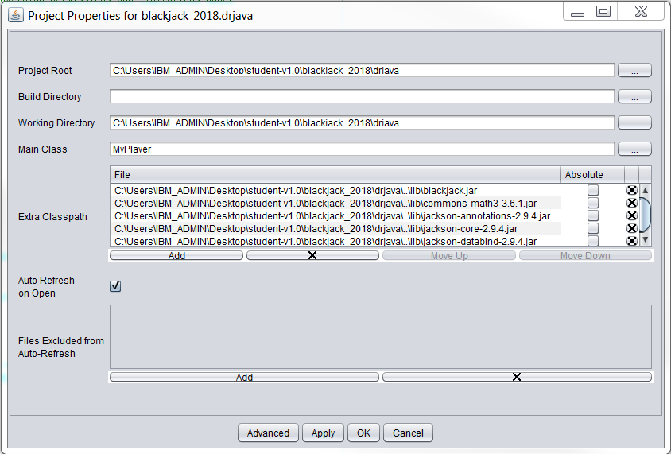

- Click OK to exit the dialog box

Compile and Run
- First, change the getStudentName method in MyPlayer to return a string with your first and last name.
  - If this is not done, the game framework will abort with “java.lang.Error: You must set your first name and last name in your player's getStudentName method”
- You MUST compile the blackjack project by clicking ‘Compile Project’
- Click ‘Run’ once your project is compiled to test that the application works
- Happy coding!!!!

Submission

Create a Jar
- In DrJava under Project, click ‘Create Jar File from Project…’

- A dialog box (shown below) will open. Ensure ‘Jar All Files’ is selected

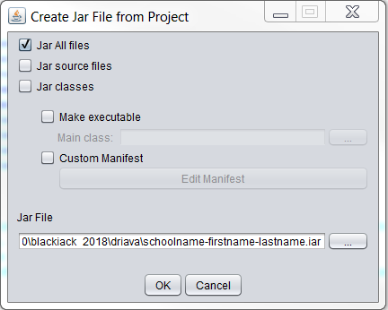

- Edit the ‘Jar File’ line changing schoolname, firstname, and lastname
  - Be sure to keep hyphens '-' between the fields!
  - e.g., <path>\blackjack_2019\drjava\ibm-paul-gerver.jar

- Click OK
  - A window should pop up saying the jar creation was successful. Click OK.

- The jar should be located at the <YourLocation>\blackjack_2019\drjava\ folder

- Submit this JAR file to your teacher, as instructed by them!

Reference

Javadoc
To view the javadoc, you will need to go to the blackjack_2019\doc\javadoc folder and open index.html. The documentation should open in a web browser (Firefox, Internet Explorer). The web page allows users to view all interfaces and classes in Blackjack.
If you have any questions about an interface, class, or method, the Javadoc should be your first stop! For example, the Javadoc for the initial MyPlayer can be found here and links to other classes that it uses.

Running the Game
See the main method in the MyPlayer for instructions and code on running the game. Main invokes Casino.playBlackjackInteractive to get you running quickly. When you run the project, the Blackjack GUI will appear.

IBM-Supplied Source Code
The class student.player.MyPlayer is provided as a skeleton for you to create your implementation. It uses a very naïve algorithm. You may copy it and make the modifications as indicated by the TODOs in the code.
The IBM volunteers provide javadoc and source code for the blackjack game code, sample player implementations, sample game boards, and class diagrams. Areas of interest include:
- “com.ibm.vie.blackjack.player” is the main Java package that contains the interfaces and classes the student program will use. The blackjack.jar will contain the executable classes and properties files.
- “com.ibm.view.blackjack.casino” contains the backend of the game which handles running a Blackjack game, statistics, exceptions, hand, table configurations, etc.
  - com.ibm.view.blackjack.casino.Casino is the main control class that orchestrates the player and game(s).

Class Diagram
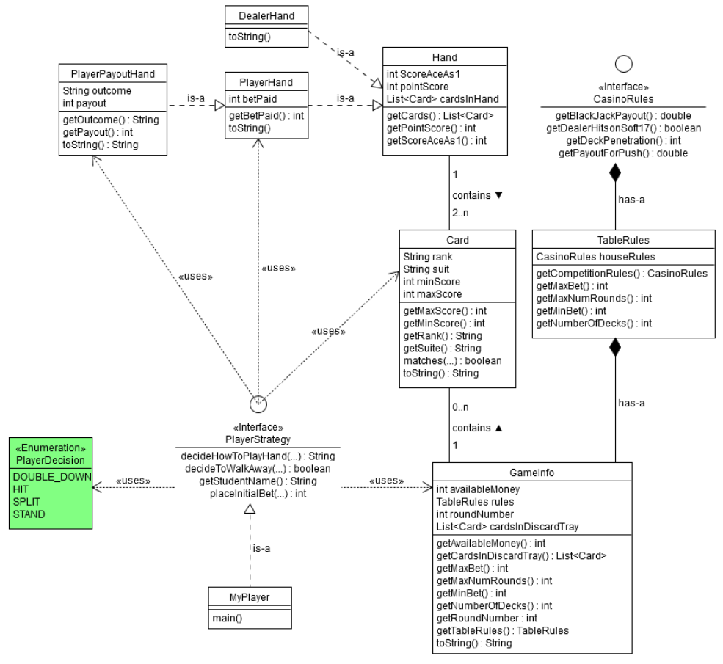

blackjack_2019 Contents
- doc – All helpful documentation about and for the Blackjack competition. Be sure to read these or you’ll hurt ol’ Paul’s feelings.
  - javadoc – Has several HTML files about the classes used in Blackjack. Don’t be alarmed! See the Javadoc reference for more info.
- drjava – The DrJava project and the MyPlayer that you get to implement.
- lib – Contains the blackjack.jar which contains all the compiled code to play Blackjack. It really does make the world go round.
- misc
  - src – Houses all source code used for the Blackjack game.

Note: While we IBMers strive for engineering excellence in code modularity and maintainability, there may be some areas of code that could be improved

